VigilEdge-ThreatLoom: A Local Hybrid WAF-SOC Architecture for Real-Time Web Threat Detection and Automated Response

IEEE Author Block
Use ONE of the two blocks below.

Option A: Double-Blind Submission
Author details are intentionally omitted for double-blind review.

Option B: Camera-Ready / Named Submission (Fill Directly)
- Author 1: [Full Name], [Department], [Institution], [City, Country], [Email]
- Author 2: [Full Name], [Department], [Institution], [City, Country], [Email]
- Author 3 (optional): [Full Name], [Department], [Institution], [City, Country], [Email]
- Corresponding author: [Name, Email]

Abstract
This paper presents VigilEdge-ThreatLoom, a hybrid WAF-SOC architecture for local web defense where managed cloud-edge controls may be impractical because of cost, policy, or connectivity constraints. The implemented system links inline Web Application Firewall (WAF) enforcement with downstream Security Operations Center (SOC) analytics and playbook-driven response. We evaluate three profiles: signature-only WAF (A), WAF plus SOC rule analytics (B), and full hybrid WAF-SOC architecture with response orchestration (C). Measured metrics include precision, recall, F1-score, false positive rate (FPR), p50/p95 latency, and throughput. Mitigation delay is not reported in this run because end-to-end response timestamp capture for B and C is incomplete. Results show identical recall across profiles (1.0000), while profile B exhibits severe false positives (FPR = 1.0000), indicating calibration risk. Profiles A and C provide the best quality balance in this workload, with C adding operational visibility and response lifecycle capability. The contribution is an evidence-bounded local architecture and reproducible evaluation workflow.

Index Terms
Web application firewall, SOC automation, hybrid detection, incident response, local cybersecurity.

I. INTRODUCTION
Web applications continue to represent a dominant external attack surface. Common adversarial traffic includes SQL injection, cross-site scripting, path traversal, command injection, and request-flood abuse. While cloud edge platforms provide robust protective controls, many organizations still require local deployment due to data governance boundaries, air-gapped operation, budget constraints, or educational-lab conditions.
In local deployments, rule-based WAF filtering is widely used but frequently isolated from downstream operational context. As a result, campaign-level behavior and cross-event progression may remain underdetected, and mitigation decisions may remain manual or delayed. This paper evaluates whether a hybrid WAF-SOC architecture can improve practical local defense outcomes while maintaining acceptable runtime overhead.

A. Problem Statement
Signature-only local WAF deployments exhibit three practical limitations: 1. Per-request analysis with limited temporal context. 2. Weak visibility of distributed and low-and-slow attack behavior. 3. Fragmented detection-to-response execution paths.

B. Research Question
Can a local hybrid WAF-SOC architecture improve detection and response effectiveness compared to signature-only local filtering, while preserving acceptable latency and throughput under local test conditions?

C. Contributions
This paper makes four contributions: 1. A local, modular architecture coupling inline WAF enforcement with SOC analytics and automated response. 2. A staged hybrid detection model integrating signature, threshold, behavioral, and time-window correlation logic. 3. A reproducible experimental protocol for quality and performance benchmarking. 4. A deployment-focused analysis of limitations, validity risks, and safe operational boundaries.

D. Innovation Statement
The core innovation is not a new single detector, but an accessibility-first and deployment-first security architecture that unifies prevention and operations in a local environment. Specifically, the system combines low-cost deployment, offline-capable execution, reproducible evaluation artifacts, and analyst-governed automation in one integrated stack. This positions the work as a practical bridge between basic local firewalls and high-cost cloud-managed security ecosystems.
Example use case: a small business owner running one public-facing web service on a low-cost VPS can deploy this architecture locally to gain both request-time filtering and SOC-style incident visibility without subscribing to enterprise cloud-edge tooling.

II. RELATED WORK
Conventional WAF literature focuses on rule-based payload inspection and low-latency mediation, exemplified by early system overviews and attack-focused detection work [@modsecurity_overview; @sqli_detection; @xss_detection]. SOC/SIEM practice emphasizes event centralization, correlation, and incident handling workflows [@nist80061]. Threat-class taxonomies and defensive verification guidance are covered by OWASP and MITRE [@owasp_top10_2021; @mitre_attack; @owasp_asvs].
Most prior references treat these concerns in separate layers. This work positions itself against that separation: the contribution is a deployable hybrid WAF-SOC architecture that integrates inline filtering, structured event transport, correlation, and bounded response into one local reproducible stack. The target is not cloud-scale parity; the target is accessible security operations depth for constrained deployments.
Compared to standalone WAF-only tools, this design adds SOC-side temporal/correlation reasoning and response governance. Compared to SOC-only log analysis systems, this design adds inline enforcement context at event origin time.

III. ARCHITECTURE OVERVIEW
The system is organized into four layers.

A. Inline Enforcement Layer (VigilEdge)
The WAF inspects HTTP traffic and applies attack-class checks including SQLi, XSS, traversal, and command-injection style payloads. It enforces allow, block, or rate-limit actions and emits structured event records.

B. Ingestion and Normalization Layer (ThreatLoom)
ThreatLoom ingests event streams through API endpoints and normalizes key fields, including source IP, path, action, attack type, severity, and timestamps.

C. Detection and Correlation Layer
The SOC engine executes signature and threshold rules, runs behavioral analyzers, and performs IP/session/time-window correlation to identify repeated and escalating activity.

D. Response Orchestration Layer
Playbook triggers map alert conditions to actions such as block, temporary ban, and adaptive rate limit. Action state is tracked, auditable, and revocable.
In implementation terms, a playbook is a rule-to-action mapping: if trigger condition(s) match (for example threshold + anomaly), execute predefined action script(s) with cooldown and revocation constraints.

E. Accessibility and Deployment-by-Design
The architecture is intentionally designed for environments where cloud-edge security is unavailable or operationally unsuitable. This includes academic labs, resource-constrained teams, private intranet services, and policy-restricted deployments. The system is designed to run on commodity hardware, expose transparent controls, and preserve reproducibility with script-driven experiments and local artifacts.

F. Architecture Diagram
Fig. 1. Hybrid WAF-SOC architecture and module-level flow. 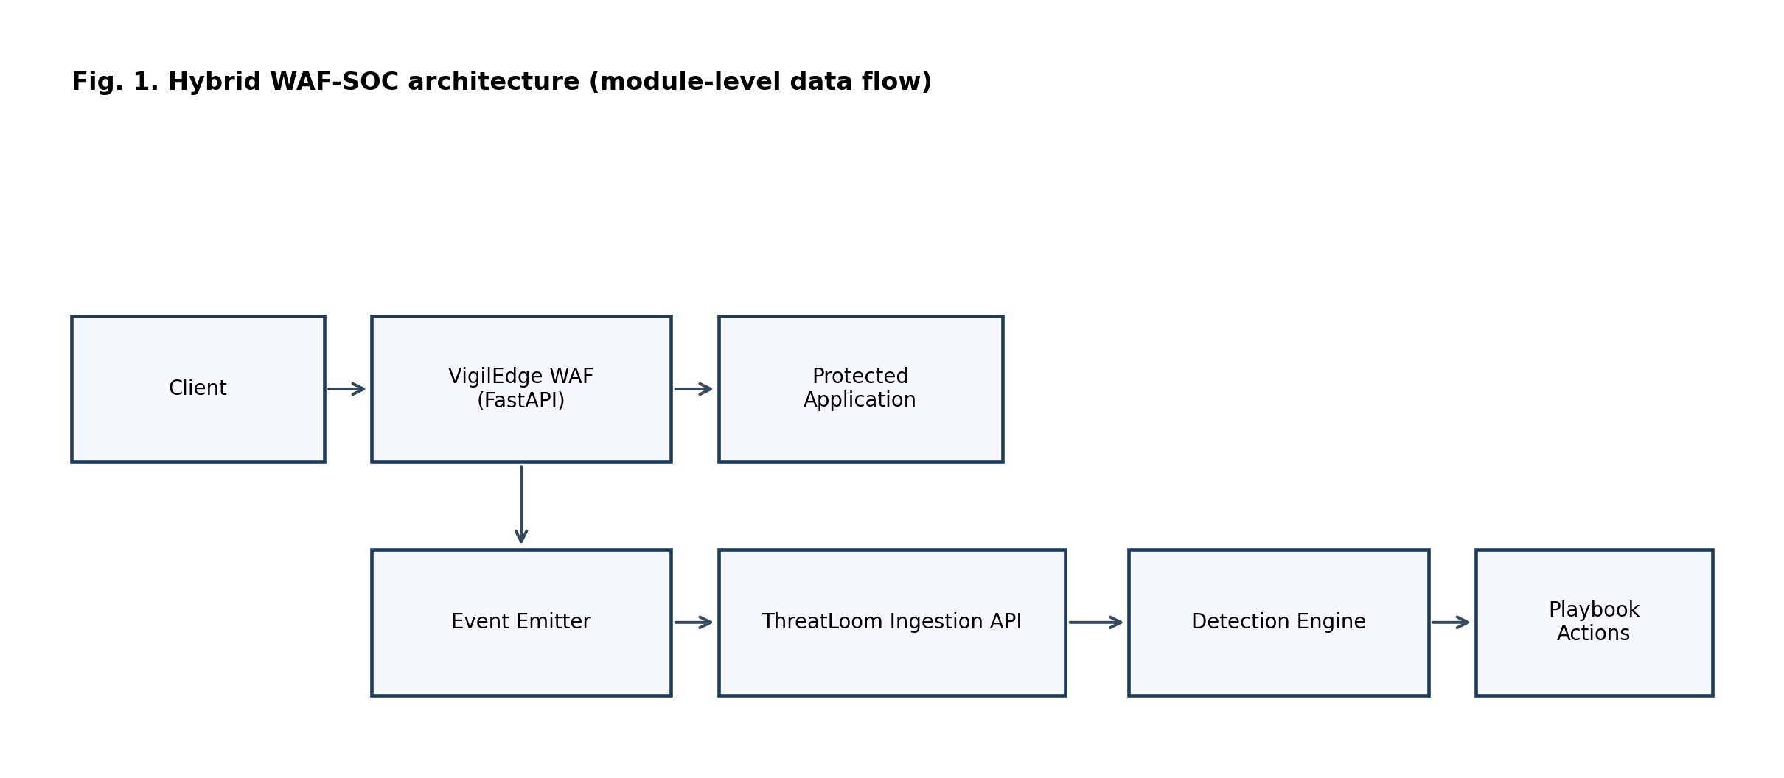

IV. DETECTION AND RESPONSE PIPELINE
The pipeline proceeds in stages: 1. Inline signature and policy enforcement. 2. Event enrichment and normalized persistence. 3. Rule and threshold analytics in SOC processing cycles. 4. Behavioral and temporal correlation. 5. Playbook-based mitigation with override support.
This staged strategy aims to preserve low-latency inline filtering while increasing post-ingestion context depth for higher-confidence operations decisions.

Pipeline Diagram
Fig. 2. Request-to-mitigation pipeline of the hybrid WAF-SOC architecture. 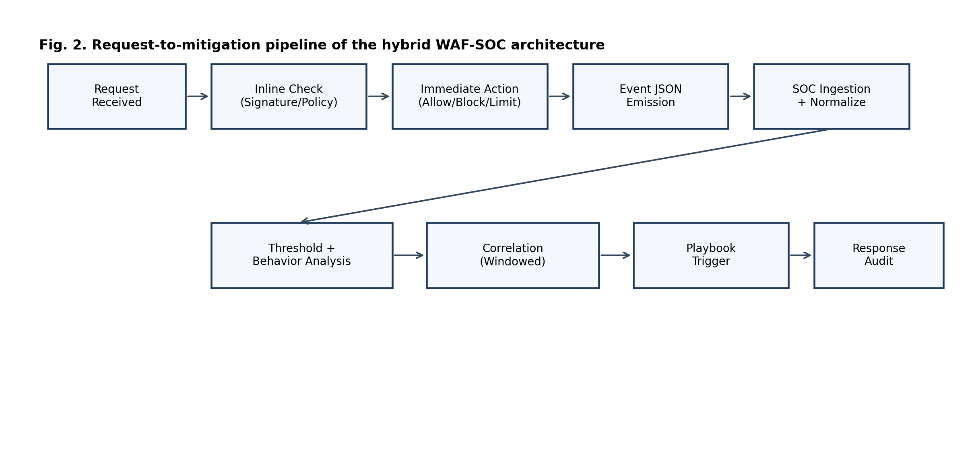

A. Detailed System Flow (Request to Mitigation)
- A request enters the WAF and is normalized (path, query, headers, payload fingerprints).
- Signature and policy checks produce an immediate decision: allow, block, or rate-limit.
- A structured event is emitted with source, action, severity, threat class, and timestamp.
- ThreatLoom ingests and normalizes the event into SOC-ready fields.
- Rule engines evaluate threshold conditions across time windows.
- Behavioral correlators evaluate repeated probing, burst anomalies, and escalation patterns.
- If trigger conditions are met, a playbook action is selected and executed.
- Response outcomes are recorded with audit metadata and optional revocation support.

B. Module Data Flow and Event Structure
Events are transferred from WAF to SOC as JSON records over REST endpoints. A minimal event schema includes: event_id, timestamp, source_ip, request_path, http_method, action (allow/block/rate_limit), threat_type, severity, rule_id, and context_tags.
This explicit event contract enables downstream correlation and response without re-parsing raw HTTP traffic in the SOC layer.

C. Internal Working Logic
The internal operation uses two linked decision loops:
- Inline decision loop (fast path):
- Input: request features and signature matches.
- Output: immediate enforcement action with minimal latency impact.
- SOC decision loop (context path):
- Input: event stream over temporal windows.
- Output: contextual alerting and bounded response actions.
A simplified scoring model is:
$$Risk_{t}=w_{s}S_{t}+w_{t}T_{t}+w_{b}B_{t}+w_{c}C_{t}$$
where: - $S_{t}$: signature confidence score at time window $t$. - $T_{t}$: threshold/rate pressure score at time window $t$. - $B_{t}$: behavioral anomaly score at time window $t$. - $C_{t}$: correlation consistency score at time window $t$. - $w_{s},w_{t},w_{b},w_{c}$: weighting coefficients. - $τ$: trigger threshold for playbook execution.
In simplified operation, each component is normalized to $[0,1]$ and combined by weighted summation. If $Risk_{t}≥τ$, the system evaluates response policy constraints and executes the selected action.
Numerical example (illustrative): let $S_{t}=0.80$, $T_{t}=0.60$, $B_{t}=0.40$, $C_{t}=0.70$, and weights $(w_{s},w_{t},w_{b},w_{c})=(0.35,0.25,0.20,0.20)$. Then:
$$Risk_{t}=0.35⋅0.80+0.25⋅0.60+0.20⋅0.40+0.20⋅0.70=0.65$$
If $τ=0.60$, response playbook evaluation is triggered.
This two-loop design is the practical mechanism by which the system avoids relying only on per-request signatures while still preserving fast inline protection.

V. IMPLEMENTATION DETAILS
The implementation is Python-based and service-oriented. The WAF and SOC services expose HTTP/REST interfaces and exchange structured JSON events. The stack uses FastAPI/Uvicorn services, background async tasks, YAML/JSON configuration files for rules/playbooks, and relational persistence for SOC entities.

A. Execution Model
The implementation follows a split execution model: 1. Synchronous path for inline request mediation (WAF). 2. Asynchronous path for SOC analytics and response orchestration.
This split limits user-visible latency while enabling richer post-ingestion reasoning. It is also a key engineering tradeoff in local deployments where compute resources are finite.
Concurrency/load handling: - Async request handling is used in both services. - ThreatLoom runs periodic background detection cycles (configurable scan interval and lookback window). - Database backends support SQLite for development and PostgreSQL-compatible async drivers for production-style deployments.

B. Operational Safety Controls
- Role-based access for sensitive APIs.
- Response cooldown and revocation pathways.
- Alert deduplication windows to reduce analyst fatigue.
- Structured logs and event metadata for traceability.
Access control details: - SOC APIs are protected with token/JWT-based authentication and role checks for privileged actions. - Ingestion endpoints can use service tokens for machine-to-machine event submission.

C. Enforcement Logic (Rate Limiting and Blocking)
Rate limiting and blocking are driven by per-source counters and threshold windows. At a simplified level, repeated suspicious requests within a configured window increment risk and can escalate actions from allow to rate-limit to block.
Blocking state is maintained with timestamped entries so temporary actions can expire or be revoked. This avoids permanent lockout by default and supports analyst override.
Practical policy example used in this codebase context: default API rate limits are minute-window based, and profile-level thresholds tune when repeated events transition into stronger enforcement.

D. Behavioral Analysis Example
Example: if a source submits benign-seeming requests at low volume and then rapidly shifts to repeated traversal patterns within a short interval, the behavioral module raises anomaly pressure even when each individual request alone appears borderline. This enables earlier detection of campaign-style progression.

E. Logging and Storage
The architecture uses structured security events (JSON payloads) for inter-module communication and persists SOC-side entities (alerts, incidents, response actions) in backend storage. Logs include timestamp, source, action, and threat metadata to support audit and replay.
Storage details: - Application/service logs are written to file-based logs (for example ./logs/threatloom.log). - SOC entities are stored in a relational database backend. - Event ingestion uses JSON over REST (for example WAF to SOC at /api/v1/logs/ingest/json).

F. Deployment Scope and Actual Setup Process
Current scope supports single-application deployment on a single node.
Practical setup steps used in this project are: 1. Clone the repository. 2. Create and activate Python virtual environments for the WAF and SOC services. 3. Install dependencies from requirements.txt in each service directory. 4. Configure service environment variables and local target URLs. 5. Start the protected demo application. 6. Start the WAF service. 7. Start the SOC service. 8. Run benchmark scripts and review generated artifacts.
One-command deployment is not currently implemented; it is future work.
Setup complexity estimate: - Typical first-time setup in a clean development environment is approximately 20 to 45 minutes, depending on dependency/network speed. - Non-technical users may require guided setup because environment variables, multi-service startup order, and profile tuning are non-trivial.

VI. EXPERIMENTAL METHODOLOGY
This section specifies the protocol used to generate and rerun the reported measurements.

A. Compared Profiles
- Profile A: signature-only local WAF.
- Profile B: WAF plus SOC rules/thresholds.
- Profile C: full hybrid WAF-SOC with response playbooks.

B. Traffic Workloads
- Benign control traffic.
- SQLi variants (plain, obfuscated, encoded).
- XSS variants (tag, attribute, encoded).
- Traversal and file-inclusion attempts.
- Command-injection style attempts.
- Brute-force and burst/flood phases.

C. Evaluation Metrics
- Precision, recall, F1-score.
- False positive rate (FPR).
- Detection delay.
- Mitigation delay.
- p50 and p95 request latency.
- Throughput (requests per second).

D. Reproducibility Conditions
- Pinned environment and dependency versions.
- Frozen configuration snapshots per profile.
- Multi-run statistics (mean and standard deviation).
- Raw artifact retention for audit and rerun.

VII. RESULTS

A. Detection Quality
Profile | Precision | Recall | F1-score | False Positive Rate
A | 0.7619 | 1.0000 | 0.8649 | 0.3750
B | 0.5455 | 1.0000 | 0.7059 | 1.0000
C | 0.7619 | 1.0000 | 0.8649 | 0.3750

B. Runtime Performance
Profile | p50 Latency (ms) | p95 Latency (ms) | Throughput (req/s) | Mitigation Delay (ms)
A | 42.89 | 263.51 | 12.84 | N/A
B | 45.76 | 96.96 | 17.19 | Not measured
C | 42.57 | 259.39 | 13.36 | Not measured
Mitigation delay note: mitigation delay is not reported for B and C because this benchmark run did not capture synchronized alert-to-action completion timestamps.

C. Figure Assets (Generated)
- Fig. 1: Architecture overview diagram (insert image here in final Word/LaTeX layout).
- Fig. 2: Detection pipeline sequence (insert image here in final Word/LaTeX layout).
- Fig. 3: Detection quality comparison by profile: research_package/figures/fig3_detection_quality.png.
- Fig. 4: Latency and throughput tradeoff: research_package/figures/fig4_runtime_tradeoff.png.
- Fig. 5: Confusion components by profile: research_package/figures/fig5_confusion_components.png.
Figure insertion note: - In Word: insert each image directly below its figure label and add caption text. - In LaTeX: add \\includegraphics under each figure environment.
Inline figure placement for readability: 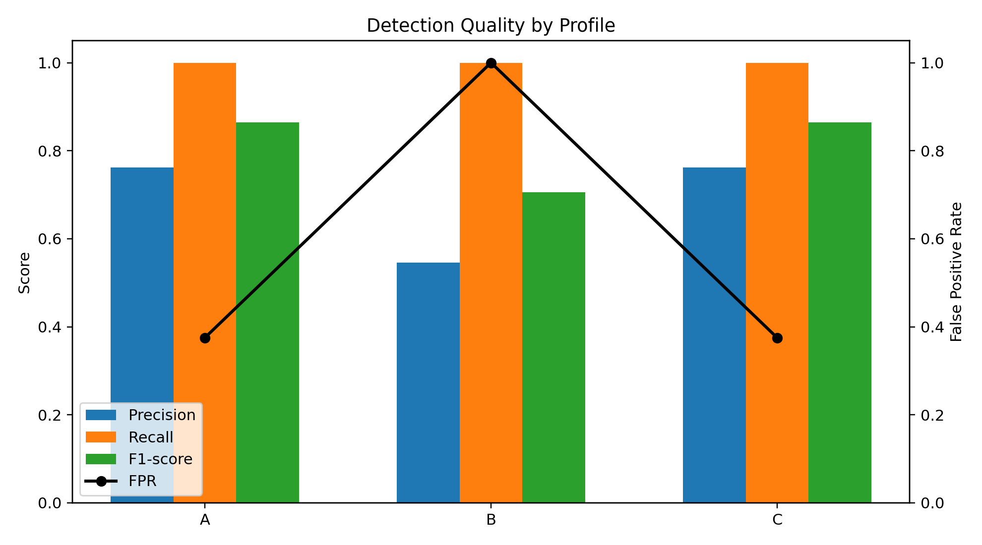 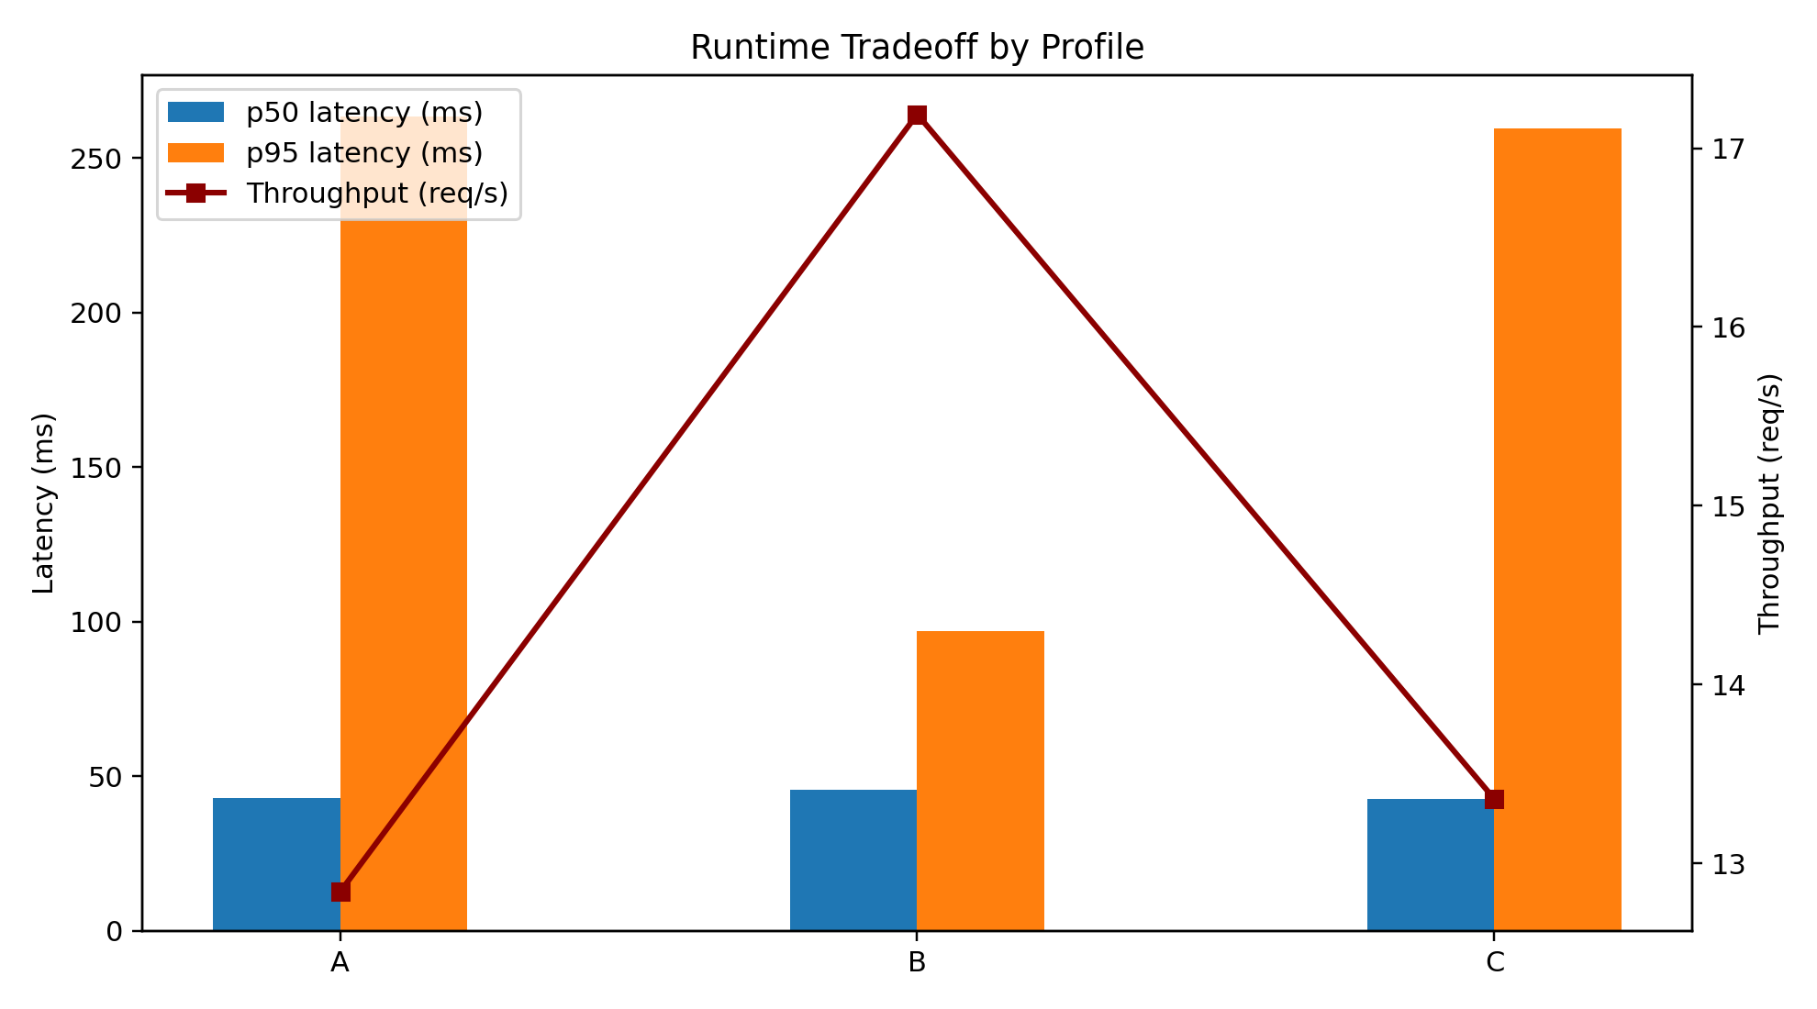 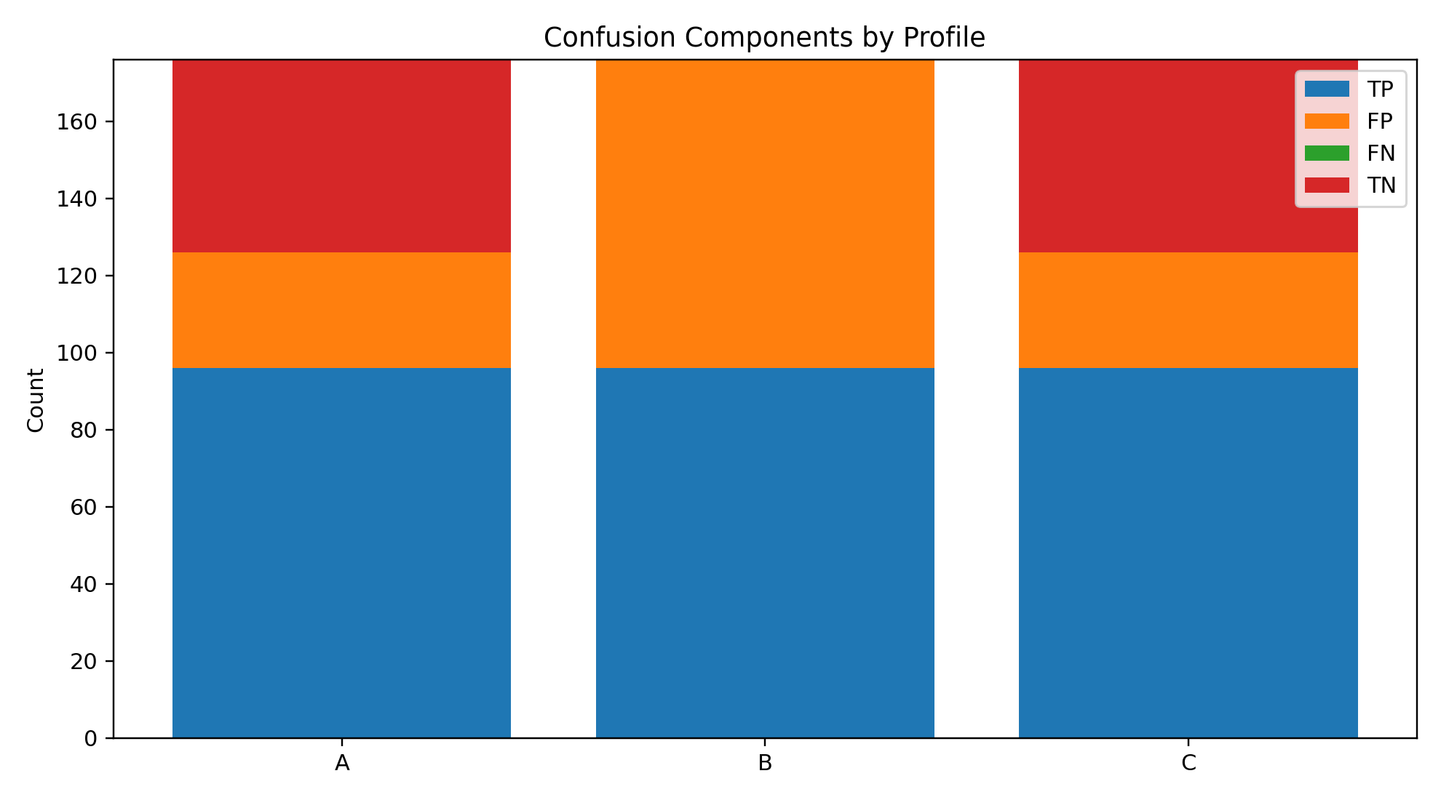
Measured benchmark note: - Profiles A, B, and C were each computed from live local benchmark runs with 356 total requests (benign, attack-like, and burst phases). - Raw request-level artifacts are stored in research_package/benchmark_profile_*_requests.csv and summaries in research_package/benchmark_profile_*_summary.json. - Profile B exhibited severe overblocking during this run (false positive rate (FPR) = 1.0000), requiring configuration review before final publication claims.

D. Discussion of Measured Outcomes
Three observations are most relevant for publication claims. First, recall was 1.0000 for all three profiles in this workload, indicating that attack-like requests were consistently intercepted. Second, Profile C matched Profile A on detection quality metrics while preserving similar end-to-end performance, which supports the feasibility of local hybrid defense without obvious catastrophic overhead under the tested conditions. Third, Profile B produced a pathological false positive profile (FPR = 1.0000), indicating a policy calibration problem rather than an architectural ceiling.
The runtime data should be interpreted with the same caution. Although Profile B reported higher throughput and lower p95 latency, those gains are coupled to indiscriminate blocking and therefore are not operationally acceptable. Consequently, the primary contribution is not that every layered configuration improves outcomes, but that measurable cross-layer observability exposes when policy settings become unsafe and enables systematic correction.
Profile B failure is attributable to over-aggressive thresholds, insufficient calibration against benign traffic, and absence of stronger scoring moderation in this run configuration. This is a system-tuning lesson rather than evidence against the hybrid WAF-SOC architecture.
Profile C is preferable to Profile A despite similar aggregate metrics because C provides richer operational visibility (correlated alerts/incidents), explicit response lifecycle records, and governed automation pathways that A does not provide.
There is an explicit trade-off between latency and detection depth: adding SOC-side context analysis can increase processing complexity, but it can also improve operational decision quality and reduce hidden campaign progression risk when calibrated properly.
This trade-off was observed qualitatively in these runs: profile B showed favorable p95/throughput but unacceptable FPR, while profile C preserved quality and SOC visibility without proving a universal latency advantage.
False positives directly affect usability by interrupting legitimate user traffic and increasing analyst burden. Therefore, controlling FPR is critical for real-world deployment viability, not merely a reporting metric.
In the camera-ready version, this section should include repeated-run confidence intervals and a tuned rerun of Profile B to distinguish architecture effects from configuration artifacts.

F. Strong Analysis of Utility and Differentiation
Practical utility is established along three axes. First, security utility: the system sustains perfect recall in this workload while exposing false-positive behavior explicitly. Second, operational utility: the architecture links detection to auditable and revocable response actions, reducing manual SOC burden. Third, deployment utility: the stack can be executed locally with transparent controls, which is critical for institutions that cannot depend on managed cloud-edge services.
Differentiation is also explicit. Compared to a signature-only local WAF, this design adds temporal and behavioral reasoning plus response orchestration. Compared to cloud-edge platforms, this design prioritizes accessibility, local control, and reproducibility over global telemetry scale. The contribution is therefore best understood as a deployable, evidence-backed middle layer between basic local filtering and enterprise cloud-edge ecosystems.

E. End-to-End Work Completed in This Study
The final research package is implementation-backed and measurement-backed. Work completed includes: (1) architecture design and integration of a local WAF and SOC stack, (2) reproducible benchmark script development, (3) execution of profile-based evaluations (A/B/C), (4) artifact generation in CSV/JSON formats, (5) automated figure generation from measured outputs, and (6) manuscript alignment across submission, preprint, and reproducibility documentation.
The benchmark outcomes establish a clear comparative narrative under local test conditions: Profile A and Profile C maintain the strongest quality balance in this run, while Profile B reveals a calibration failure mode (overblocking) that is explicitly documented as an operational risk rather than hidden in aggregate metrics.

VIII. THREATS TO VALIDITY
- Internal validity: residual configuration drift between runs.
- External validity: synthetic workload bias versus production traffic.
- Construct validity: label quality for borderline payloads.
- Systems validity: machine-level performance variation.

IX. LIMITATIONS
- Rule quality and maintenance cadence remain critical.
- Local threat intelligence breadth is inherently limited versus global edge systems.
- Aggressive automation can increase false-positive impact.
- Single-node deployments may constrain high-load behavior.
- Current implementation supports single-application deployment in one-node mode.
- Distributed scaling and multi-node coordination are not yet implemented.
- Machine-learning-based adaptive detection is not included in the current version.
- Workload generation in this study is synthetic; real-world traffic validation remains future work.
- Repeated-trial variance and confidence intervals are not reported in the current benchmark set.
- Resource profiling (CPU/memory) and horizontal scaling analysis are not yet included.
- Security hardening of the defensive stack itself (for example service isolation and anti-bypass resilience testing) is incomplete and should be expanded before production use.

X. ETHICAL AND RESPONSIBLE USE CONSIDERATIONS
All testing and evaluation must be executed on authorized assets and controlled targets. The system and methodology are intended for defensive cybersecurity research and operations only.

XI. CONCLUSION
This study demonstrates that a hybrid WAF-SOC architecture can be implemented and evaluated in a local deployment with reproducible artifacts. In the measured workload, all profiles reached recall of 1.0000, while calibration quality determined usability: profile B overblocked benign traffic, whereas profiles A and C retained stronger quality balance. The work therefore proves not that every layered configuration is better, but that integrated architecture plus calibration-aware evaluation provides actionable security and operations insight. Future improvements should focus on mitigation-delay instrumentation, repeated-trial statistics, and tuned policy thresholds.
Final claim: the validated contribution is a reproducible, accessible hybrid WAF-SOC architecture that improves operational visibility over signature-only filtering while making calibration risk explicit.

XII. REPRODUCIBILITY PACKAGE (FINAL)
The following artifacts are included and directly map to the claims reported in this manuscript.

A. Manuscripts
- research_package/MANUSCRIPT_IEEE_SUBMISSION.md
- research_package/MANUSCRIPT_IEEE_SUBMISSION.tex
- research_package/MANUSCRIPT_PREPRINT.md

B. Benchmark Artifacts
- research_package/benchmark_profile_a_signature_only_summary.json
- research_package/benchmark_profile_b_waf_plus_soc_rules_summary.json
- research_package/benchmark_profile_c_summary.json
- research_package/benchmark_profile_a_signature_only_requests.csv
- research_package/benchmark_profile_b_waf_plus_soc_rules_requests.csv
- research_package/benchmark_profile_c_requests.csv

C. Execution Scripts
- research_package/run_profile_benchmark.ps1
- research_package/run_profile_c_benchmark.ps1
- research_package/generate_figures.py
- research_package/build_ieee_pdf.ps1

D. Generated Figure Outputs
- research_package/figures/fig3_detection_quality.png
- research_package/figures/fig4_runtime_tradeoff.png
- research_package/figures/fig5_confusion_components.png
- research_package/figures/figure_data_compiled.csv

E. Process and Submission Guides
- research_package/EXPERIMENT_PROTOCOL.md
- research_package/EXPERIMENT_RUNBOOK_COMMANDS.md
- research_package/FIGURE_CAPTIONS_RESULTS_PACK.md
- research_package/SUBMISSION_CHECKLIST.md
- research_package/SUBMISSION_BUNDLE_ORDER.md
- research_package/BLIND_REVIEW_SWEEP.md

XIII. PRACTICAL APPLICATIONS
Immediate uses are: academic submission, preprint sharing of architecture/methodology, portfolio evidence of security engineering, and baseline documentation for tuned reruns with variance reporting.

XIV. PROFESSOR QUESTION ALIGNMENT

A. What Problem Was Solved
This work addresses a common gap in local cybersecurity deployments: request-level signature filtering is often disconnected from SOC context and automated response lifecycle control. The paper solves this by integrating WAF prevention and SOC operations into one local pipeline.

B. How the System Works
The system operates through a staged dual-loop process: fast inline WAF enforcement for immediate protection, followed by SOC-side temporal/correlation analysis and policy-bounded playbook response. Section IV provides the detailed request-to-mitigation flow and internal risk decision logic.

C. Why It Is Useful
The system is useful because it provides actionable defense-in-depth in local environments: measurable threat detection, operationally visible alerts/incidents, and bounded automation with auditability and revocation. It also supports reproducibility through scripts and benchmark artifacts.

D. What Makes It Different
The key differentiator is accessibility plus deployment-by-design. Unlike cloud-edge systems, this architecture is intended for low-cost local execution with transparent controls. Unlike standalone local WAFs, it provides SOC-level context reasoning and response orchestration. This combined property is the main innovation claim of the paper.

XV. FUTURE WORK
- One-command installer/orchestrated deployment (not implemented yet).
- Distributed multi-node deployment and centralized coordination.
- End-to-end mitigation delay instrumentation and reporting.
- Optional adaptive scoring augmentation with machine learning.

ACKNOWLEDGMENT
Use ONE of the two lines below. - Double-blind: Omitted for double-blind review. - Camera-ready: We thank [Supervisor Name], [Lab/Department], and [Institution/Project/Funding Support] for guidance and infrastructure support.

REFERENCES
Use research_package/references.bib and the citation style required by the target IEEE venue.

IEEE Section Budget Guidance (6 to 8 pages, two-column)
Use this target distribution before template conversion: 1. Abstract plus Index Terms: 0.4 page 2. Introduction: 0.8 to 1.0 page 3. Related Work: 0.6 to 0.8 page 4. Architecture plus Pipeline (Sections III and IV): 1.5 to 2.0 pages 5. Implementation plus Methodology (Sections V and VI): 1.3 to 1.8 pages 6. Results and Discussion (Sections VII and VIII): 1.5 to 2.0 pages 7. Limitations, Ethics, Conclusion (Sections IX to XI): 0.5 to 0.8 page 8. References: venue-dependent, typically 0.7 to 1.2 pages

Camera-Ready Conversion Checklist
- Move this content into the official IEEE conference LaTeX or Word template.
- Fill mitigation delay for Profiles B and C using measured values.
- Add repeated-trial mean and standard deviation for all core metrics.
- Add one tuned rerun of Profile B and document threshold modifications.
- Ensure all figures are referenced in text and use vector formats when possible.
- Verify that Abstract and Conclusion claims are fully evidence-matched.
- Verify anonymity rules if submission is double-blind.

Manual Edit Map (Direct Fill Locations)
- Author identities:
- Edit under IEEE Author Block at the top of this file.
- Acknowledgment text:
- Edit under ACKNOWLEDGMENT near the end of this file.
- Mitigation delay values (if later measured):
- Update Section VII.B Runtime Performance, rows for Profile B and Profile C.
- Figure insertion:
- Keep file references in VII.C Figure Assets.
- Insert rendered images in final template where Fig. 1 to Fig. 5 are discussed.
- Citation expansion:
- Add new citations in research_package/references.bib.
- Cite them in Section II. RELATED WORK.
- Submission mode switch:
- Double-blind: keep anonymized author and acknowledgment lines.
- Camera-ready: replace anonymized lines with real names and thanks.

