Myanna Harris
Quinn Walters
HW10

AWS

User name: group1

Node: i-6f48acf2

SSH: ssh -i ~/.ssh/group1key.pem ec2-user@ec2-52-87-156-168.compute-1.amazonaws.com
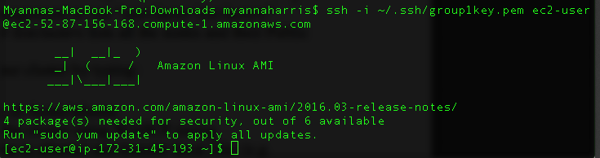

SFTP: sftp -i ~/.ssh/group1key.pem ec2-user@ec2-52-87-156-168.compute-1.amazonaws.com
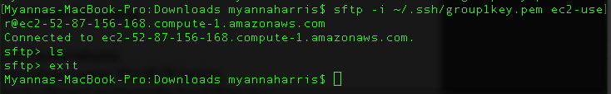

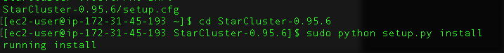

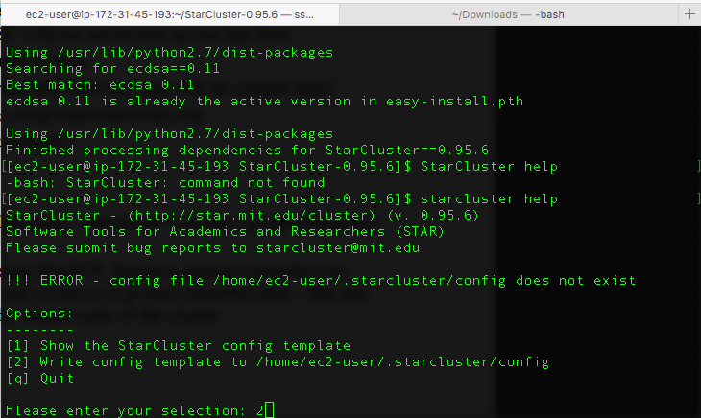

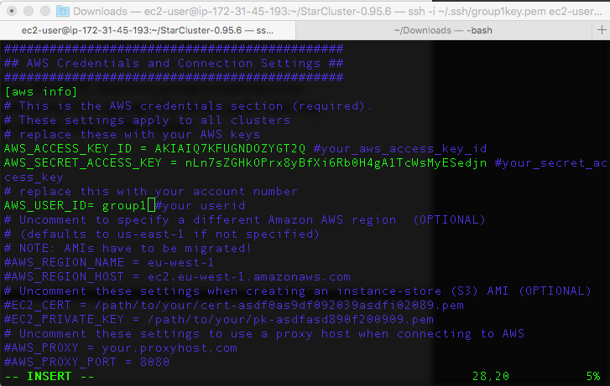

1)
Created cluster:

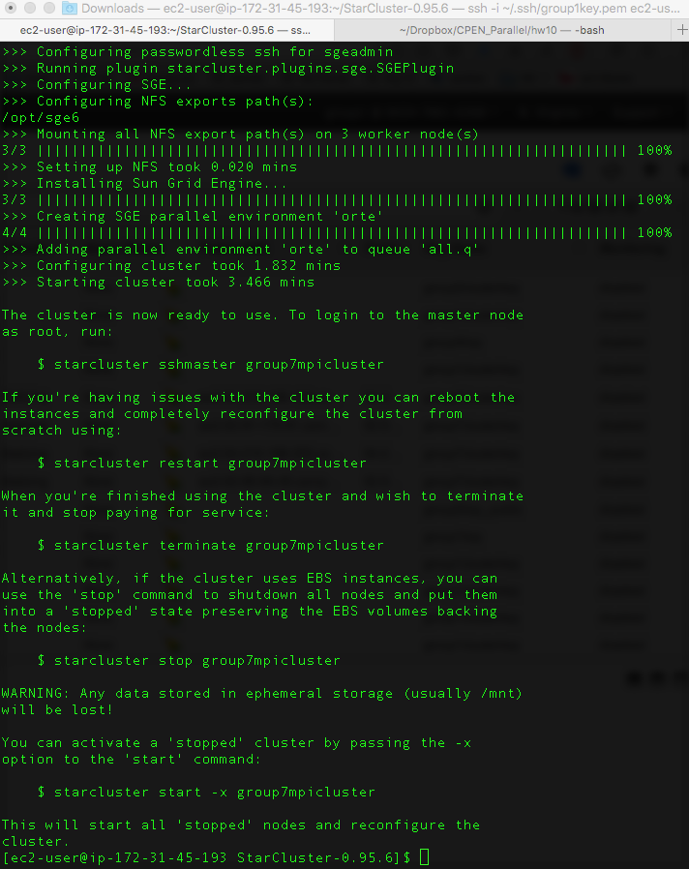

Master hostname: ec2-52-90-94-45.compute-1.amazonaws.com
Cluster key: group7clusterkey
Cluster: group7mpicluster

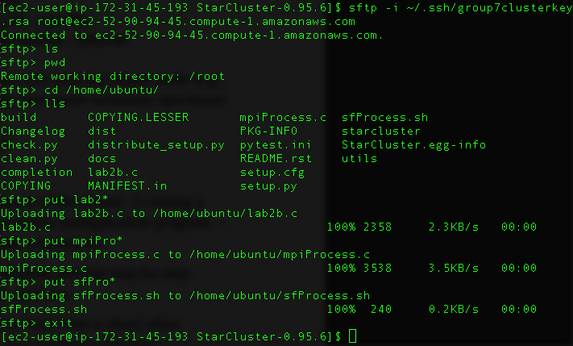

Pthreads program:
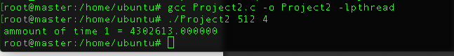

MPI program:
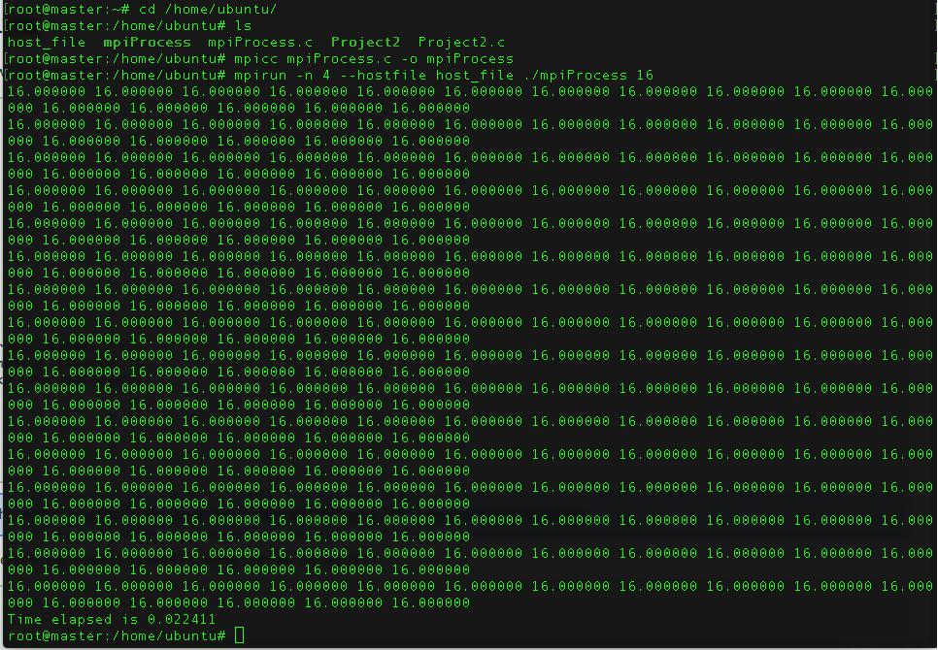
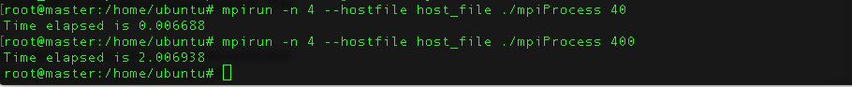

Terminate cluster:
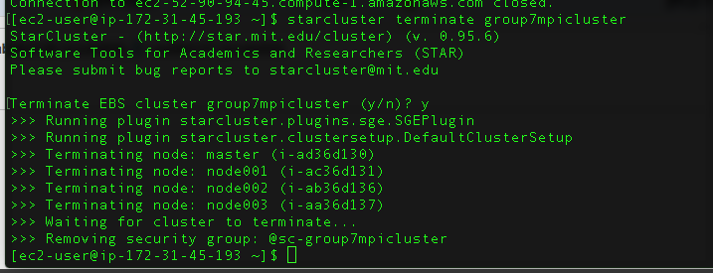

3)
The biggest advantage to Cloud computing is the scalability for cost. Instead of a cluster, which has a very high initial cost, with the cloud you are only paying for what you use, as you use it. This also affects the performance, if you need more computation for a small time it would cost a great deal for a cluster, but only cost more for the amount of time you use it on the cloud. Another advantage is the maintenance and security are ensured by service providers. This means you do not have to spend added money fortifying your own system. The downsides are mostly due to the software used, a simple machine built yourself can be customized to your needs for absolute best performance, where cloud computing machines are much more complex due to their flexibility, and this leads to slower code execution and more difficult to use environments as well as restrictions such as what languages or operating systems may be used depending on the type of cloud computing you are considering.

4)
Myanna used her laptop to set up the platform and run the programs.
Quinn Helped troubleshoot the platform setup and helped run the programs and document the outcomes.

