Myanna Harris
CPEN
Lab #5

- 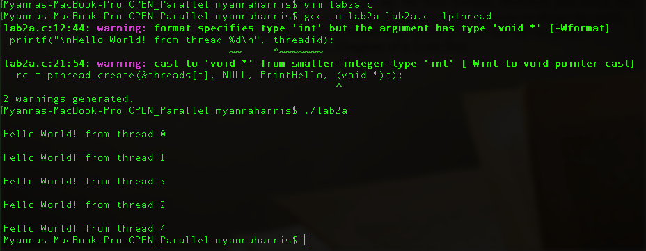
- Table
- More data requires more time to process. The more threads, the less time it takes, except when there are too many threads.
 | 1 thread | 2 thread | 4 thread | 8 thread
n=512 | 406.000000 | 372.000000 | 296.000000 | 783.000000
n=1024 | 414.000000 | 381.000000 | 337.000000 | 1417.000000

