An End-to-End Companion Application for a

Sensor-Embedded Athletic Mouthguard

by

Myat Phone Tha

A thesis submitted in partial fulfillment
of the requirements for the degree of
Bachelor of Science in Computer Science

Department of Computer Science and Engineering
College of Engineering
University of South Florida

Major Professor: [Name], Ph.D.
[Committee Member], Ph.D.
[Committee Member], Ph.D.

Date of Approval:
[Defense date]

Keywords: mobile interface, activity labeling, Bluetooth Low Energy, wearable telemetry, sideline display

Copyright © 2026, Myat Phone Tha

Dedication
To the athletes, trainers, and families who inspired this work.

Acknowledgments
I thank my major professor and committee for their review of this undergraduate thesis. Their names belong on the title page before the manuscript is submitted. I also thank the people who discussed the mouthguard hardware and the mobile interface while the software was being written. This opening follows the GuardSync screens as they appear on an Android development build, including paths that are still placeholders and views that still use simulated people. Responsibility for that account, and for any error in it, is mine.

Table of Contents
Right-click and choose Update Field in Word to populate this Table of Contents.

List of Tables
Table 2.1 Screens in the interface pipeline
Table 2.2 Athlete dashboard color zones
Table 2.3 Metric card order by activity mode
Table 2.4 History chart marks treated as critical
Table 2.5 Which photographed screens read a live stream

List of Figures
Figure 2.1 Role selection
Figure 2.2 Athlete profile setup
Figure 2.3 Activity selection after the holder board is connected
Figure 2.4 Athlete dashboard during a game session
Figure 2.5 The same dashboard when readings enter warning and danger zones
Figure 2.6 Mode-change prompt on the athlete dashboard
Figure 2.7 Performance history with the activity strip and a mode prompt
Figure 2.8 History charts for heart rate and blood oxygen
Figure 2.9 History charts for blood oxygen and body temperature
Figure 2.10 Parent read-only view of one athlete
Figure 2.11 Trainer roster for a simulated team
Figure 2.12 Trainer detail sheet for one athlete

List of Abbreviations
BLE Bluetooth Low Energy
BPM Beats per Minute
NUS Nordic UART Service
SpO2 Peripheral Oxygen Saturation
UART Universal Asynchronous Receiver-Transmitter

Abstract
GuardSync is the phone companion for a teaching prototype of a sensor-embedded athletic mouthguard. This thesis begins with the interface, because that is the path a person follows before any sample is stored. After sign-in the user chooses Athlete, Parent or Guardian, or Trainer or Coach. The athlete path continues through a profile placeholder, device pairing, a calibration sequence that advances labels without writing a baseline, and a required choice of Training, Game, or Sleep. The live dashboard then shows the latest sample from the holder board: head acceleration, a display band titled Concussion Risk, bite force, heart rate, oxygen saturation, and body temperature. Card order follows the confirmed activity. Colors mark interface zones chosen in the client. The risk band is a cut on the relative head-acceleration integer, at 90 and at 120. Clinical recognition of concussion remains a medical judgment [3]. If recent samples disagree with the confirmed activity, the dashboard and the history screen ask before the label changes and before recent phone rows are relabeled. History draws the measurements on one timeline, with a one-, three-, or five-minute window, an activity strip, and a count of points the charts treat as critical. The parent screen and the trainer roster in the accompanying figures are simulated views. They do not read the Bluetooth stream. The figures in Chapter Two are photographs of these screens on an Android development build. The line format, storage, and a bench evaluation remain future work. The contribution of this thesis is a traceable account of the interface pipeline, tied to the screens and to the client that draws them.

Chapter One: Introduction

Why the Interface Comes First
Contact sports produce short head impacts that a person on the sideline can miss. Clinical recognition and management of concussion remain a medical process [3]. Instrumented mouthguards have been built as research devices that estimate head kinematics from sensors held by the upper teeth [1], [2]. A reading still has to reach a person. GuardSync is the phone layer for a teaching prototype of that wearable. The board on the bench is a Particle Argon holder for a Nordic nRF52840, the chip planned for the mouthguard [4]. The phone discovers that holder, shows the latest sample, and keeps an activity label the athlete confirms.
The manuscript is organized so that a reader meets the screens before the packet format. The photographs make visible which numbers are live, which labels the athlete chose, and which rosters are still simulated. Chapter Two walks through photographs of the Android development build in the order a person meets them [5]. Chapter Three states what each photograph is connected to in the client, so a simulated roster stays distinct from a sideline deployment.

Problem Statement
The interface has to do four things at once. It has to separate the athlete who wears the mouthguard from a parent and from a trainer. It has to make the athlete choose Training, Game, or Sleep, because a later analyst should inherit that choice and not a silent guess. It has to show the latest sample in zones a person can read quickly, without speaking as if a color were a medical finding. And it has to ask before it changes the activity label. This opening specifies those screens for GuardSync version 1.0.0. It does not certify a medical device, and it does not report a headform study.

Objectives of This Opening
The first objective is to document the three role paths as they are implemented. The second is to document the athlete sequence from profile setup through activity selection, the live dashboard, and history. The third is to record the color zones, the card order, and the confirm-before-switch prompt that the photographs show. The fourth is to mark which of those photographs read the holder board and which are fixed or randomly updated stand-ins. A supervised impact classifier, a packet delivery rate, and a finished parent link are outside this opening.

Organization
Chapter Two is the pipeline. Each major screen in the photograph set appears once, with the route that draws it and the action that leaves it. Chapter Three relates those screens to Bluetooth, local storage, and the cloud, and it lists the screens that were not photographed. The references and the required disclosures follow. Chapters on the line format, the insert payload, and a bench evaluation are the next writing, not part of this file.

Chapter Two: User Interface Pipeline

How the Screens Fit Together
GuardSync is an Expo Router application. A file under app/ is a route. Sign-in lives at the root. A stored session sends the user to role selection. From there the pipeline splits. The athlete continues to a profile placeholder, then to pairing, calibration, activity selection, the dashboard, and history. The parent and the trainer each have a profile placeholder and then a dashboard of their own. Figure 2.1 through Figure 2.12 are photographs of that build. Each photograph includes the Android status bar and the system navigation bar. The application content is the region between them. Table 2.1 names the route for every step, including the two athlete steps that sit between the profile photograph and the activity photograph and were not part of this set.
Table 2.1. Screens in the interface pipeline.
Order | Who | Screen | Route | In the figures
1 | All | Choose a role | /role | Figure 2.1
2 | Athlete | Profile setup | /profile | Figure 2.2
3 | Athlete | Device pairing | /onboarding | Described in prose
4 | Athlete | Calibration | /calibration-flow | Described in prose
5 | Athlete | Choose an activity | /usage-mode | Figure 2.3
6 | Athlete | Live dashboard | /dashboard | Figures 2.4 to 2.6
7 | Athlete | History | /history | Figures 2.7 to 2.9
8 | Parent | Read-only athlete view | /parent-dashboard | Figure 2.10
9 | Trainer | Team roster and sheet | /trainer-dashboard | Figures 2.11 and 2.12
Note. Parent and trainer profile, linking, and invite routes exist as placeholders and are not photographed here.

Choosing a Role
Role selection is the fork. The screen title is Choose Your Role, and the subtitle asks how the person will use GuardSync. Three cards are offered. Athlete is for tracking one's own performance and health metrics. Parent or Guardian is for monitoring a child's safety and health data remotely. Trainer or Coach is for overseeing a team's stats, managing athletes, and reviewing risks. A card must be selected before Continue is enabled. Athlete continues to profile setup. Parent continues to the parent profile. Trainer continues to the trainer profile. The back control returns to sign-in. Figure 2.1 shows the screen before a card is selected, with Continue still unavailable.
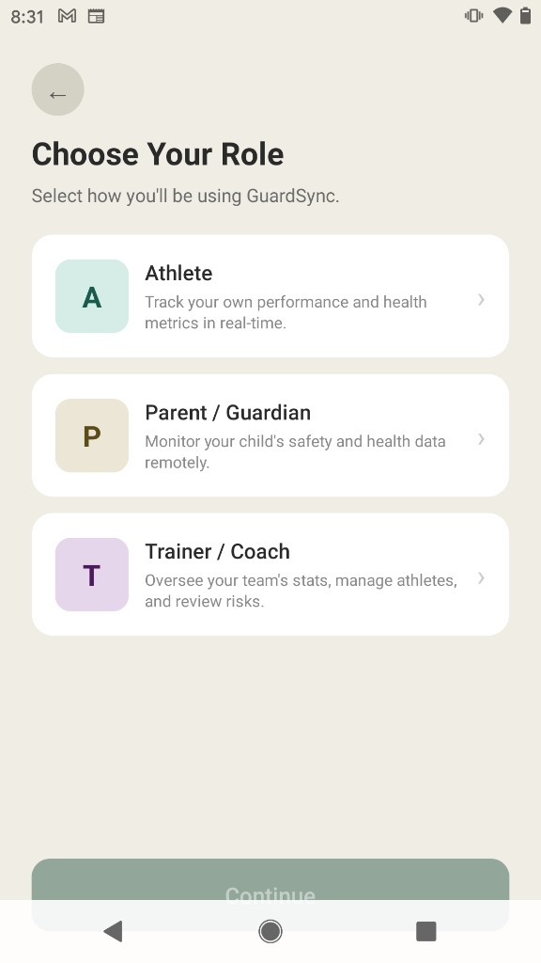
Figure 2.1. Role selection. Continue stays unavailable until Athlete, Parent or Guardian, or Trainer or Coach is selected.

Athlete Profile
The athlete profile screen is a placeholder. Its title is Profile setup. The subtitle states that the fields are meant to mirror a web profile screen, and those fields are not on this screen yet. The name, sex, weight, and height shown later on the dashboard are literals in the dashboard component, not values collected here. Two actions are available. Back leaves the screen. Continue to device pairing opens onboarding. A short note at the bottom says that calls and notifications will vibrate. Figure 2.2 is that screen.
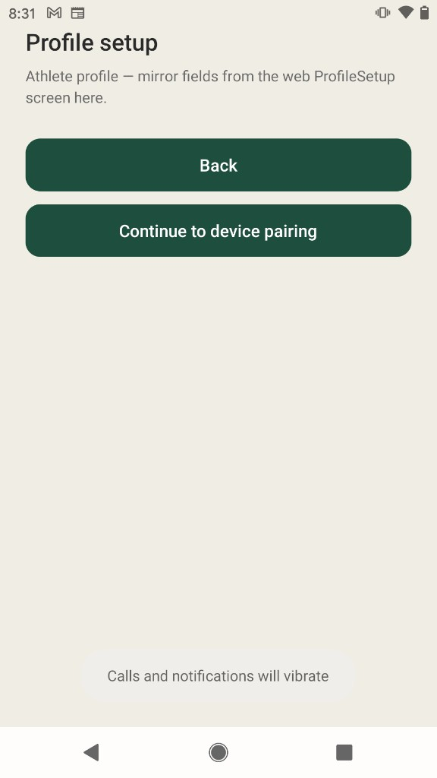
Figure 2.2. Athlete profile setup. The screen collects no profile fields. Continue opens device pairing.
Onboarding scans for the Nordic UART Service, or it can save a demonstration sample when the holder board is not advertising. After one sample is stored, calibration shows five labels in order: Intro, Bite force, Resting jaw, Baseline vitals, and Done. Next advances the label. Finish replaces the route with activity selection. No baseline measurement is written. Those two screens are part of the pipeline and are not in the photograph set.

Choosing the Session Activity
Activity selection is the last step before the dashboard. The title asks what the athlete is doing today. The subtitle states that the Argon is connected and that, after calibration, an activity should be picked so that metrics and alerts match the session. Three choices are shown. Training is described as practice and drills, with attention to effort and intensity. Game is described as competition, with attention to impact and concussion risk. Sleep is described as rest and recovery, with attention to vitals overnight. Continue to dashboard stores the choice as a manual selection, starts a session identifier, and replaces the route with the dashboard. Figure 2.3 shows the three choices before one is selected.
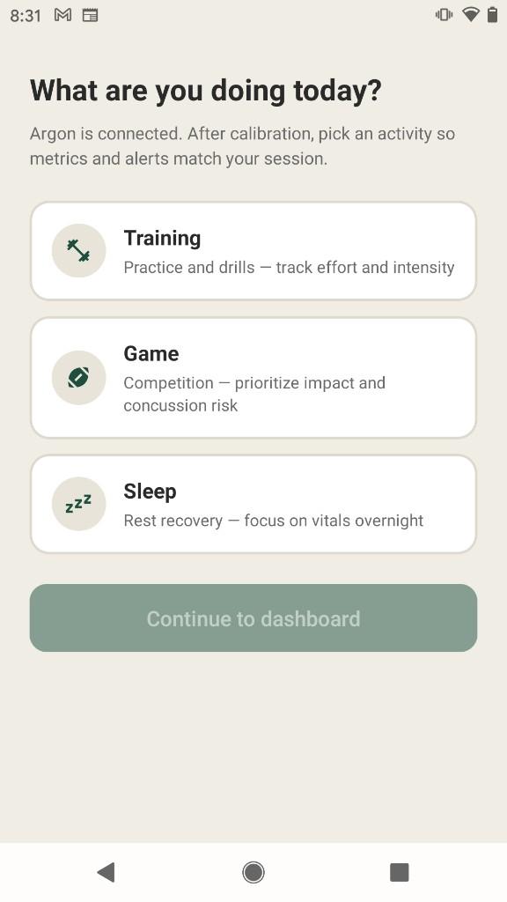
Figure 2.3. Activity selection after the holder board is connected. The athlete chooses Training, Game, or Sleep for the session.
The stored label is the one later rows carry as the confirmed mode. A detector may disagree. It does not replace the label on its own. The dashboard and the history screen are where that disagreement is shown.

Athlete Dashboard
The dashboard is the sideline view for the athlete. The header shows a stand-in name, John Smith, and a Bluetooth mark. A status card reports Connected when a device identifier is stored, together with the fixed profile lines Sex: Male, Weight: 247 lbs, and Height: 6' 2". Under Activity, a segmented control repeats Training, Game, and Sleep. The hint under that control says the mode is set after calibration when the Argon is paired, and that the athlete will be asked on this screen if live stats suggest a different activity. The athlete can also change the mode by pressing a segment. The bottom bar moves between Dashboard and History.
Figure 2.4 is a game session with ordinary readings. Game is the selected segment, so the first cards are head acceleration and the risk band. The photograph shows 66g and Low. The next row shows bite force at 111 N and heart rate at 81 BPM. SpO2, body temperature, and the sport card sit below the fold on this layout. The sport card is the constant Football.
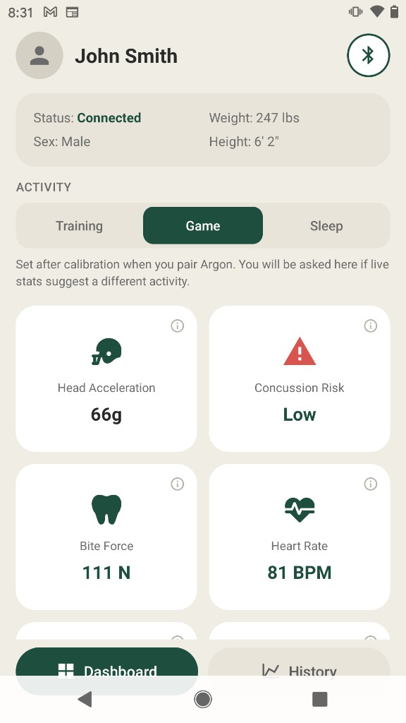
Figure 2.4. Athlete dashboard during a game session. Head acceleration is 66g and the display band reads Low.
Figure 2.5 is the same screen scrolled to a session whose readings have entered the warning and danger colors. Head acceleration reads 149g and the risk band reads High. Bite force reads 240 N in the warning color. Heart rate reads 177 BPM in the warning color. SpO2 reads 89 percent in the danger color. Body temperature reads 99.7 F in the warning color. Table 2.2 is the rule behind those colors. Table 2.3 is the card order. The cuts are interface choices. For head acceleration and bite force they are applied to the relative integers the parser stored, and the g and N suffixes are labels on those integers. The risk band is the display named Concussion Risk. It is a cut at 90 and at 120. It is a reading aid on this screen. Clinical recognition of concussion remains the process described in the Berlin consensus statement [3].
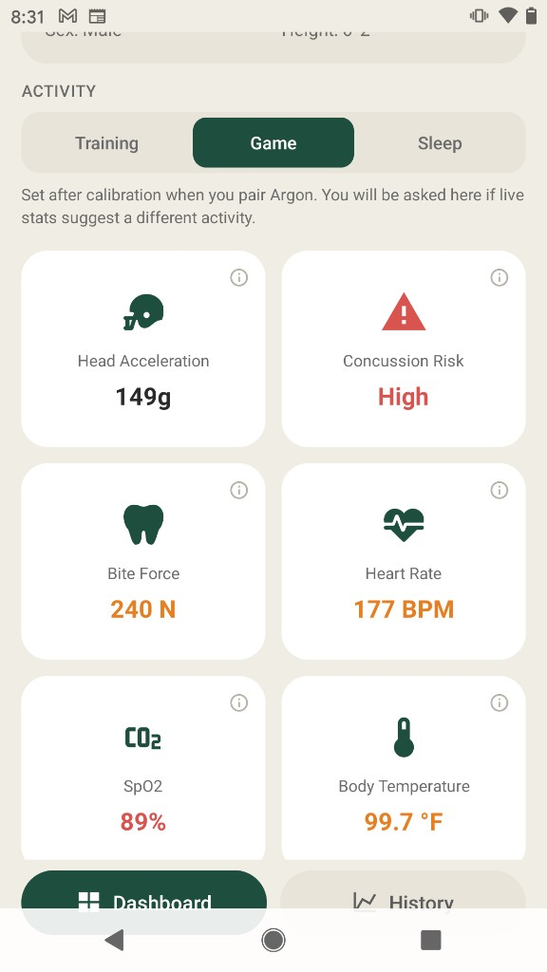
Figure 2.5. The game dashboard when readings enter warning and danger zones. Head acceleration is 149g and the display band reads High.
Table 2.2. Athlete dashboard color zones.
Signal | Warning color | Danger color
Head-acceleration display band | Relative value at least 90, labeled Moderate | Relative value at least 120, labeled High
Heart rate | At least 150 BPM | At least 190 BPM
SpO2 | Below 95 percent | Below 92 percent
Body temperature | Above 99.5 F | Above 100.4 F
Bite force | Relative value at least 200, labeled N | Relative value above 300, labeled N
Note. Below the warning cut, the card uses the default green. The risk card reads Low under 90.
Table 2.3. Metric card order by activity mode.
Mode | Order of cards
Game | Head acceleration, risk band, bite force, heart rate, SpO2, temperature, sport
Training | Heart rate, head acceleration, risk band, SpO2, temperature, bite force, sport
Sleep | Heart rate, SpO2, temperature, head acceleration, risk band, bite force, sport

Asking Before a Mode Change
Samples keep the activity the athlete confirmed. A deterministic detector in the client may decide that the recent window looks like a different activity. When it does, a banner is placed above the activity control. The banner does not change the mode. Figure 2.6 shows that banner on the dashboard while Training is still the selected segment. The title says that recent stats look like Game. The reason line says that repeated or high head impacts were detected, with a noticeable change in recent vitals. The hint states that the athlete is set to Training and asks whether to switch and update recent samples. Switch to Game confirms the new label, starts a new session identifier, and relabels local rows in the prompting window. Keep Training dismisses the banner and leaves the label as it was. Rows already inserted in the database are not rewritten by that confirmation. In the photograph the training card order is in effect, so heart rate at 95 BPM precedes head acceleration at 53g.
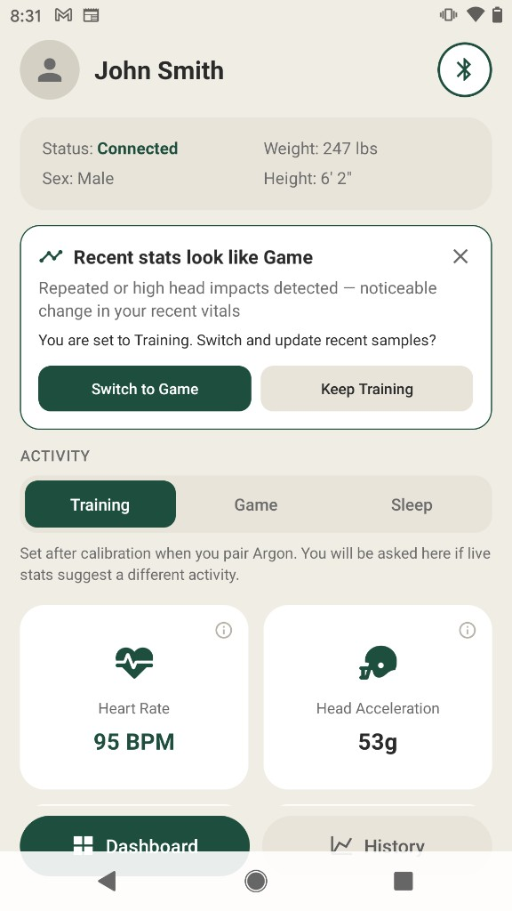
Figure 2.6. Mode-change prompt on the athlete dashboard. Training remains selected until the athlete chooses Switch to Game or Keep Training.

History
History is the second athlete destination on the bottom bar. Its title is Performance History, and the subtitle says that the metrics below share one timeline. The athlete picks a one-, three-, or five-minute window. A badge counts points the charts treat as critical. Figure 2.7 shows that badge reading 36 Alerts for the window that was loaded when the photograph was taken. The same screen can show the mode banner. In that photograph the athlete is set to Sleep, the detector suggests Game, and the actions are Switch to Game and Keep Sleep. A line under the banner reports that 20 samples from this device were synced to the cloud. An activity strip then colors the shared timeline. Dark green is Training and orange is Game. The strip in the photograph runs from 0 s to 44 s.
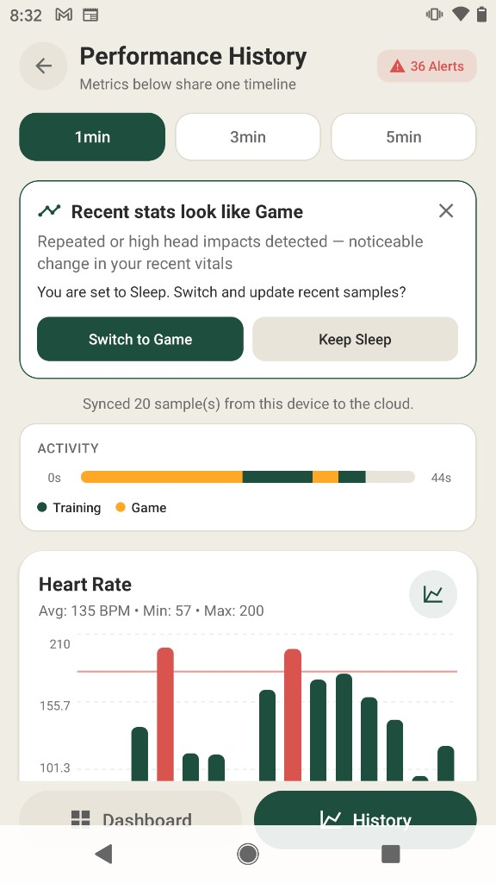
Figure 2.7. Performance history. The window is 1 minute, the alert badge reads 36, and the activity strip marks Training and Game on one timeline.
Each measurement is a bar chart with its own vertical scale, a horizontal threshold line, and a summary of average, and where the chart computes them, minimum and maximum. A bar uses the series color when the point is inside the chart's mark, and red when the point is treated as critical. Heart rate and SpO2 use green for the series color. Body temperature uses orange, which is why Figure 2.9 shows orange bars as well as red ones. Figure 2.8 is the heart-rate chart, with average 135 BPM, minimum 57, and maximum 200, followed by the SpO2 chart with average 94 percent. Figure 2.9 continues the scroll at SpO2 and then body temperature. Table 2.4 is the critical rule. Those marks are independent of the dashboard colors in Table 2.2. Head acceleration is marked above 80 on the chart and above 90 on the dashboard. The two screens are two scales.
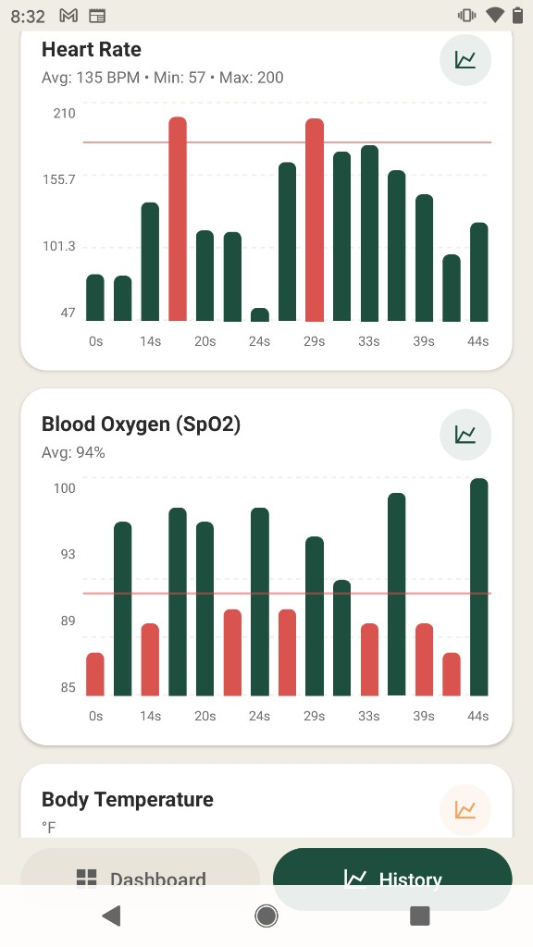
Figure 2.8. History charts for heart rate and blood oxygen. Red bars are points the chart treats as critical. The horizontal line is the chart threshold.
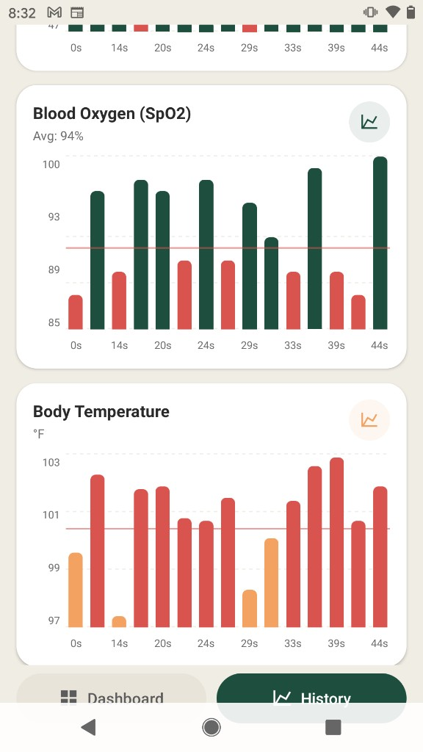
Figure 2.9. History charts for blood oxygen and body temperature. Temperature uses an orange series color. Red bars remain the critical mark.
Table 2.4. History chart marks treated as critical.
Series | Critical when
Heart rate | Above 180 BPM or below 50 BPM
SpO2 | Below 92 percent
Temperature | Above 100.4 F
Head acceleration | Relative value above 80
Bite force | Relative value above 220
Note. The alert badge is the count of these points across the loaded series. It is not a count of medical events.

Parent View
The parent dashboard is a different screen from the athlete dashboard. Figure 2.10 shows the photograph used in this opening. The header names Alex Smith, age 16, football, quarterback. A banner reads Concussion Risk, High Risk, and Real-time monitoring active. Six tiles follow: heart rate 185 BPM, last impact 86g one minute ago, SpO2 97 percent, body temperature 99.9 F, bite force 172 N, and head acceleration 53 g. A footer states that the view is read-only and that profile changes go through the athlete. The bottom bar again offers Dashboard and History.
The people and the numbers on this screen are generated in the parent component. A timer replaces heart rate, temperature, SpO2, bite force, head acceleration, and the last-impact line about every three seconds, and it sets the banner from those drawn values. The screen does not subscribe to the holder board, and it does not read the athlete's stored rows. The empty state for an unlinked athlete exists in the component and is not reachable, because the linked flag is a constant. Figure 2.10 is the intended layout of a remote view. It is not evidence that a parent can see a child's stream.
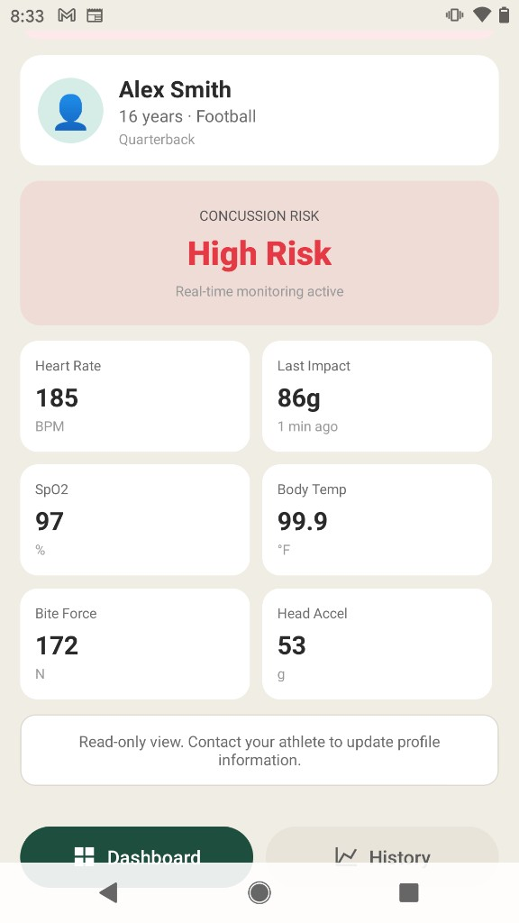
Figure 2.10. Parent read-only view of one athlete. The name, the risk banner, and the tile values are simulated in the client.

Trainer View
The trainer dashboard is a roster. Figure 2.11 shows Varsity Football with five athletes. Filter chips read All (5), High (1), Mod (2), Low (2), and Off (1). A team-status row repeats those counts. Each row gives a name, a position, a risk label, a last-impact integer, and a connection mark. In the photograph, Alex Martinez is a quarterback at high risk with 89g and the cause Impact event. Jordan Lee and Casey Wilson are at moderate risk with the cause Abnormal vitals. Taylor Brown is at low risk. Morgan Davis is at low risk and carries the disconnected mark. An athlete can appear in a risk count and in the Off count together, because those filters test different fields. The roster is a fixed array in the trainer component. It does not update from Bluetooth.
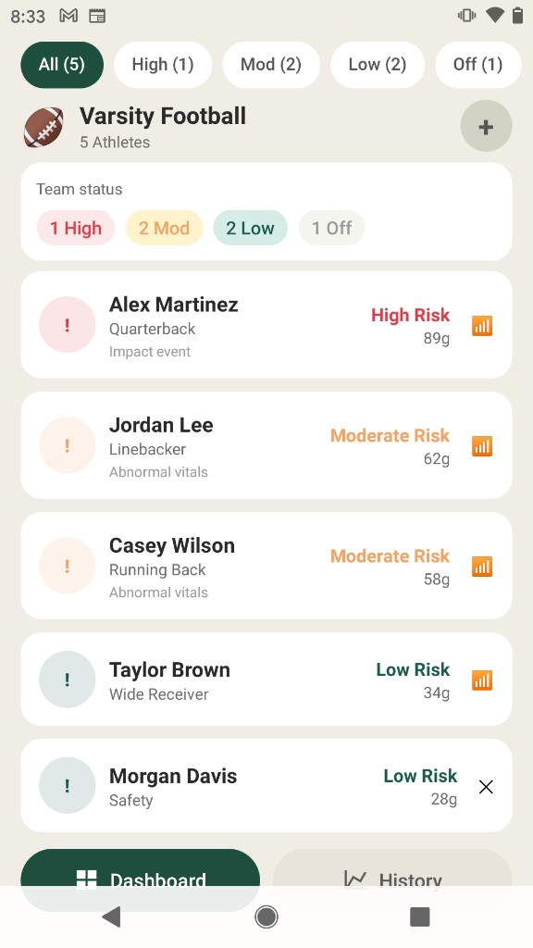
Figure 2.11. Trainer roster for a simulated varsity football team. Filters count risk and a disconnected device separately.
Pressing a row opens a sheet. Figure 2.12 is that sheet for Alex Martinez, age 17, quarterback. It repeats the current risk, heart rate 185 BPM, last impact 89 g, and Device: Connected. View full history closes the sheet and opens the history route. Closing the sheet returns to the roster. The sheet reads the same fixed record as the row. It does not open a live stream for that name.
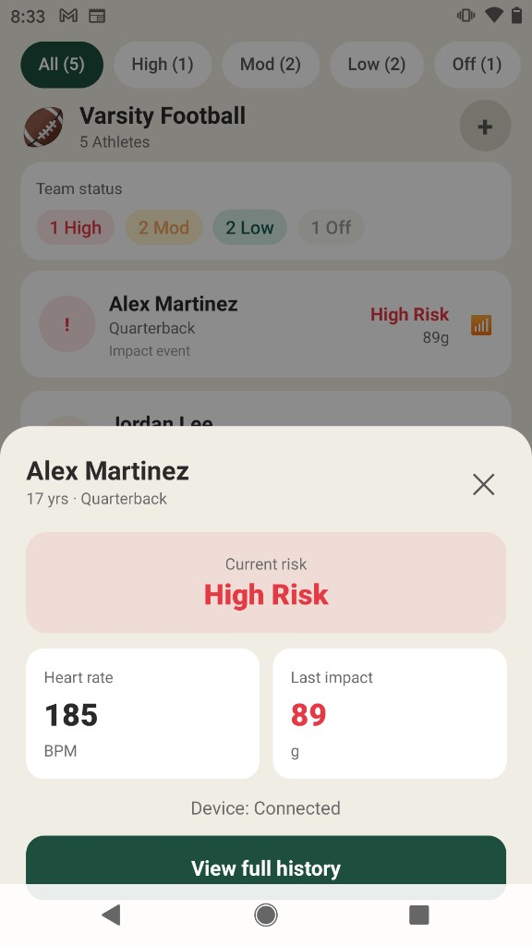
Figure 2.12. Trainer detail sheet for one simulated athlete. View full history opens the history route.

What the Photographs Do and Do Not Show
Table 2.5 is the boundary around this chapter. The athlete dashboard and history are wired to the sample path: a notify line updates the cards, and history merges phone rows with cloud rows. The values in Figures 2.4 through 2.9 are whatever that path held when the photographs were taken. The parent and trainer photographs document layout and copy. They do not document a live mouthguard.
Table 2.5. Which photographed screens read a live stream.
Figure | Screen | Data on the screen
2.1 | Role selection | Static choices. The selection is held until Continue.
2.2 | Profile setup | Placeholder. No fields are stored.
2.3 | Activity selection | The chosen mode is stored as a manual selection.
2.4 to 2.6 | Athlete dashboard | Cards follow the latest parsed sample. The name and body size are literals.
2.7 to 2.9 | History | Phone rows and cloud rows on one timeline. The alert count is chart marks.
2.10 | Parent view | A timer draws new tile values. No Bluetooth subscription.
2.11 and 2.12 | Trainer roster and sheet | A fixed list of five athletes.

Chapter Three: What the Screens Are Connected To

The Athlete Sample Path
Behind Figures 2.4 through 2.9 the holder board notifies one text line on the Nordic UART transmit characteristic. The phone, through react-native-ble-plx, decodes that value and parses a seven-field line, or a legacy three-field line [6]. A parsed line updates the dashboard cards immediately. About every two seconds the client writes a snapshot and an outbox entry on the phone and, when a user is signed in, inserts a row. History loads a one-, three-, or five-minute window from the phone copy and from the cloud, drops duplicates, and draws the charts. Leaving the dashboard removes the subscription.
The activity label on those rows is the label from Figure 2.3, or a later press on the dashboard segments, or a confirmation of the banner in Figure 2.6. The detector that raises the banner looks at a short buffer of recent samples. It can suggest Game, Training, or Sleep. Confirmation rewrites local rows in the prompting window and leaves rows already inserted in the database on their old label.

Screens Still Outside the Photograph Set
Sign-in, the pairing scan, the five-step calibration sequence, and the parent and trainer profile placeholders are in the client and are not in Chapter Two's figures. Calibration advances a label and does not record a baseline. Pairing can store one demonstration sample when the holder is not found, and that sample can appear on the dashboard, so a connected-looking screen is not by itself proof that a mouthguard was in the mouth. Parent linking, trainer invites, and athlete approval are titles on placeholder routes.

What This Opening Leaves for Later Chapters
The line format, the parser outcomes, the columns of the insert, the duplicate-insert path, and a bench protocol for packet delivery are specified by the same client and are not re-derived here. They belong in the chapters that follow this interface account. So does any comparison between the rule-based detector and a trained model. No labeled human-subjects set was collected for this manuscript, so no classifier score is stated. Angular head kinematics are not computed from the current line.

Chapter Four: Conclusion

Summary
This opening of the thesis documents the GuardSync interface as a pipeline of screens. A person chooses a role. An athlete passes a profile placeholder, pairing, and a calibration sequence that does not store a baseline, then chooses Training, Game, or Sleep. The dashboard shows the latest sample in an order that depends on that choice, and it colors zones defined in the client. A banner can suggest another activity and waits for confirmation. History places the same session on one timeline and counts chart marks. The parent view and the trainer roster show the layout planned for remote reading, using simulated people. The photographs are the evidence for that account. The software is a foundation for sideline display. Clinical recognition of concussion remains a medical judgment [3].

Next Chapters
The next writing returns to the holder-board contract and to storage. When the mouthguard board replaces the Argon holder, field types, units, and the Bluetooth service may change, and the cards in Figures 2.4 and 2.5 will have to move with them. Calibration should record a baseline, or the activity screen should stop saying that calibration has prepared the session. Parent and trainer views should read shared rows only after a consent and linking design, in place of the timer and the fixed roster in Figures 2.10 through 2.12. Until those chapters are written, Table 2.5 is the limit on what the photographs may be said to show.

References
[1] D. B. Camarillo, P. B. Shull, J. A. Mattson, R. Shultz, and D. R. Garza, “An instrumented mouthguard for measuring linear and angular head impact kinematics in American football,” Ann. Biomed. Eng., vol. 41, no. 9, pp. 1939–1949, 2013, doi: 10.1007/s10439-013-0801-y.
[2] Y. Liu, A. G. Domel, S. A. Yousefsani, J. Kondic, G. Grant, M. Zeineh, and D. B. Camarillo, “Validation and comparison of instrumented mouthguards for measuring head kinematics and assessing brain deformation in football impacts,” Ann. Biomed. Eng., vol. 48, no. 11, pp. 2580–2598, 2020, doi: 10.1007/s10439-020-02629-3.
[3] P. McCrory et al., “Consensus statement on concussion in sport—the 5th international conference on concussion in sport held in Berlin, October 2016,” Br. J. Sports Med., vol. 51, no. 11, pp. 838–847, 2017, doi: 10.1136/bjsports-2017-097699.
[4] Particle Industries, “Argon datasheet.” [Online]. Available: https://docs.particle.io/reference/datasheets/wi-fi/argon-datasheet/
[5] Expo, “Development builds — Introduction.” [Online]. Available: https://docs.expo.dev/develop/development-builds/introduction/
[6] dotintent, “react-native-ble-plx,” version 3.5, software library. [Online]. Available: https://github.com/dotintent/react-native-ble-plx

Appendix A: Disclosure of Generative AI Use
The Office of Graduate Studies asks students who use generative models in an electronic thesis to obtain committee permission, to name the model and version, to review the output, and to remain responsible for the manuscript. This appendix records the use. It does not by itself prove that the committee has granted permission. That permission should be confirmed and, if required, noted here before submission.
Generative tools were used while preparing this thesis and the GuardSync client. In Cursor, Grok 4.7, accessed in September 2026, was used to read the repository, to draft and revise mobile-application structure, and to draft this manuscript from that source and from photographs of the Android screens. The manuscript was checked against the client so that placeholder screens and simulated rosters were not described as a live mouthguard stream. The photographs were taken on the development build. The author remains solely responsible for the accuracy and integrity of the thesis and the software.

Appendix B: Disclosure of Assistive AI Use
Assistive use of the same tool, Cursor Grok 4.7, accessed in September 2026, included suggestions for grammar, heading consistency, and organization of the chapters. Suggestions were accepted only when they matched the source or a cited paper. Committee permission for assistive use should be confirmed with the permission noted in Appendix A. Responsibility for the manuscript remains with the author.

Appendix C: Copyright Permissions
The tables in this manuscript were written for this thesis. The figures are photographs of the author's GuardSync screens on an Android development build. No figure, table, or long quotation is reproduced from a publisher, so no permission letter is attached. If a later draft adds a published figure, that figure needs a permission letter or a completed USF fair-use worksheet, and the chapter that uses it must carry the citation the copyright holder requires.

Appendix D: Supplementary Notes for Later Chapters
This opening does not repeat the parser, the notify handler, or the insert payload. Those listings belong with the chapters on the holder-board contract and on storage. Until they are restored, the repository remains the source for the screens in Chapter Two. No institutional-review letter is attached. This thesis does not report a human-subjects dataset.

About the Author
Myat Phone Tha completed this undergraduate thesis in computer science at the University of South Florida. The software described here is GuardSync, a mobile companion for a mouthguard prototype. This opening of the manuscript documents the interface pipeline from role selection through the athlete dashboard, history, and the simulated parent and trainer views.

