**STAR VALLEY VILLAGE LOTS 153-232 HOMEOWNERS ASSOCIATION**

**DESIGN REVIEW GUIDELINES**

The governing documents – Covenants, Conditions & Restrictions (CC&Rs) – require that any modification or addition to property within Star Valley Village Lots 153-232 be approved by either the Architectural Review Committee (“ARC”) or the Board of Directors, prior to construction or installation. Below are guidelines for such changes.

**COLORS – CC&R, Article IV, Section 4.06**

Body and trim paint color choices should be chosen from the approved color schemes. See “Appendix A” for the list of approved color schemes.

1. Body and trim colors not permitted are reds, black and purple.

2. Structures and enclosures attached to the house should be painted to match the color of the house and must have ARC approval.

3. All color changes must be approved by the ARC Committee.

4. Use of the original exterior colors for repainting shall not require ARC approval.

**BLOCK WALLS / FENCING – CC&R, Article II, Section 2.17 and Third Amendment, Page 3**

1. Block walls shall be maintained as originally installed. Replacements are permitted without the approval of the ARC, when such replacement matches exactly the masonry installed at the time of development. Any variation from the original installation must be submitted to the ARC for review.

2. Rear yard enclosures (dog enclosures, décor, play areas, pool enclosures) shall be confined to the back yard and installed in a manner that is not visible from the street in front of the home.

3. Decorative fencing/walls in the front yard require ARC approval, prior to installation.

4. Any block wall exceeding six (6) feet requires county permit and ARC approval.

5. All fencing material must look new and be installed in a professional manner.

6. Chain link, chicken wire, snow fence, livestock fencing or other temporary type fences are not allowed. Fencing to enclose a construction area does not need approval, but must be removed as soon as the construction site is safe to do so.

**FRONT YARDS PLANTINGS – CC&R, Article IV, Section 4.08**

The landscape concept is based on a philosophy of compatibility with the Sonoran Desert and a commitment to low water usage vegetation. Front yard plantings shall be maintained in a manner consistent with that originally installed and shall be kept free of weeds and debris. The use of ornamental desert plants is encouraged.

1. No planting of grass is permitted.

2. Yard accents (i.e., Saltillo tile, Pavers, Flagstone bird baths, Fountains, Statues, etc.) may be used if the colors are compatible with desert hues and other natural colors.

3. For a list of drought tolerant plants go to: http://www.azwater.gov/azdwr/WaterManagement/AMAs/documents/2010TAMA_apha_botanical_PLANTLIST.pdf

**FRONT YARD GRAVEL COVERING**

Front yard gravel covering must be within the pre-approved colors of the ARC. Sizing may range from ¼” to 1”. Accents colors will be the pre-approved colors of the ARC. See “Appendix A” for the list of preapproved colors.

**REAR YARDS**

Rear and side yard lighting shall be confined to patio, pool and landscaped areas, and shall not cause excessive glare or light spillage onto adjacent lots. Use of light deflecting fixtures may be required. Bright spotlights are not permitted.

**TRASH / RECYCLE CONTAINERS – CC&R, Article II, Section 2.11**

Trash cans and recycle containers must be stored so they are concealed from public and/or neighboring view on non-collection days. Trash can/recycle containers may be set out twelve (12) hours prior to scheduled pickup day and must be put away the same day of collection.

**FRONT DOORS & SECURITY BARS**

1. Wrought iron doors are pre-approved by the ARC when painted to match the color of the stucco or fascia or black.

2. Aluminum and/or wooden screen doors are not permitted.

3. Security bars are pre-approved by the ARC when painted the same color as the surface upon which they are mounted or black.

**AWNINGS & SUNSCREENS**

1. Awnings are not permitted.

2. Sunscreens are pre-approved by the ARC, if they are appropriately installed and match the body or trim of the home or are black.

**RAIN GUTTERS & DOWNSPOUTS**

Rain gutters and downspouts are pre-approved by the ARC. Rain gutters must be painted to match the color of the trim and downspouts must be painted to match the surface upon which they are mounted or the trim.

**REAL ESTATE SIGNAGE – CC&R, Article II, Section 2.07**

Each owner shall be entitled to place one (1) mounted real estate sign in his/her front yard stating the property is being offered for sale or lease as long as the following are met:

1. Signs will be standard real-estate industry size.

2. All signs shall conform to Arizona statute 33-1261C.

**ADVERTISING & SECURITY NOTIFICATION SIGNAGE – CC&R, Article II, Section 2.07**

1. Advertising signs are not permitted (including swimming pool companies).

2. One (1) security notification sign is permitted but shall not exceed 12” X 12”.

**PATIO COVERS**

Patio covers must be submitted for ARC approved and meet the following guidelines: Covers shall conform to the appearance and colors established on dwellings throughout the community. They must be installed to withstand common wind gusts and other weather.

**STORAGE SHEDS**

Storage sheds over 100 square feet must be submitted for ARC approval, and meet the following guidelines:

1. Sheds must not exceed 11 ft in height from the ground level to peak of roof.

a) Sheds up to 100 square feet do not require ARC approval

b) Sheds 100 square feet up to 200 square feet require a Pima County zoning permit and ARC approval.

c) Sheds 200 square feet and larger require a Pima County building permit and ARC approval.

2. Colors and materials of storage enclosures must match colors and materials of existing home according to ARC standards. (Note: Prefabricated sheds up to 100 square feet must closely approximate the color of the trim or body of the home or be a shade of white.

3. Roof shingles (if applicable) must match those on dwelling roof.

4. Sheds must be located in the enclosed portion of rear yard, so as to minimize visibility from neighboring properties. The entrance of the shed should be facing away from nearest neighbor and in location most unobtrusive to neighbors and the street. Sheds may also be placed on the enclosed portion of a side yard provided the overall height does not exceed 11 feet.

5. For sheds located in back yards, turbines must not exceed overall maximum height of 12 feet.

**GATES**

Natural wood gates, with or without a wrought iron frame and metal gates with privacy mesh which are black or painted to match the body or trim are pre-approved. All other types of gates must be approved by the ARC.

**SWING/PLAYSETS/SPORTS EQUIPMENT**

1. Swing/play sets and trampolines that do not exceed 8½ ft in height from ground level are pre-approved for enclosed back yard installation. All others must be submitted for ARC approval. Other permanent play/sports equipment must be submitted for ARC approval.

2. Basketball hoops must be in upright position.

**SEASONAL LIGHTINGS & DECORATIONS**

Seasonal lighting and decorations are permitted one (1) month prior to holiday and shall be removed within one (1) month after the holiday.

**WINDOW COVERINGS**

Draperies, curtains, blinds, etc., must be completed within four (4) months of move-in date. The use of foil, sheets, blankets, Styrofoam®, etc., in windows at any time is prohibited. Commercial protective film may be applied to inside of windows for sun blockage when approved by ARC.

**OTHER EXTERIOR IMPROVEMENTS**

All other exterior improvements not specifically covered in these guidelines must be submitted to the ARC for approval prior to installation.

**PETS – CC&R, Article II, Section 2.08**

1. No animals other than dogs, cats and other household pets may be kept on the lots providing they are not kept, bred or maintained for commercial purposes.

2. No animals shall be kept on a lot which results in any annoyance or is obnoxious to residents in the vicinity.

3. All dogs shall be kept on a leash when outside its owner’s lot and, at no time, be allowed to run free while inside the confines of the Association. It is recommended that pets have identifying tags or microchips to facilitate their return to their owners.

4. It is the responsibility of pet owners to remove any droppings from pets anywhere within the Association.

5. All pet owners must follow the laws of Pima County concerning the proper care of their pets.

**MISCELLANEOUS – CC&R, Article II, Section 2.14**

1. Retractable clotheslines are permitted to be installed. However, they must be retracted when not in use and at the end of the day.

**NOISY EQUIPMENT**

Except in an emergency, no equipment giving off disturbing sounds or loud noises shall be operated on any part of the property except in a reasonable and non-offensive manner.

**PARKING – CC&R, Article II, Section 2.13**

NOTE: The International Fire Code requires “an unobstructed width of not less than 20 feet exclusive of shoulders”. Therefore, street parking is not recommended unless that restriction can be met.

The term “vehicle” applies to any car, truck, boat and/or RV/camper trailer. Vehicle parking should be observed using the following guidelines:

1. Vehicles must be parked in the garage.

2. If garage parking is not possible, parking on the driveway will be permitted.

3. No parking will be allowed on gravel areas next to driveways, or front yards or on easements except for up to 72 hours for guests. Any longer requires written notification to the management company (email is acceptable).

4. If the backyard is not completely enclosed, ONE (1) vehicle may be parked in the back yard as long as it is not clearly visible from the street or entrance of the development.

5. If additional vehicles need to be parked in your back yard, the yard must be completely enclosed. No more than one (1) of each type vehicle may be parked within the back yard unless it cannot be seen from the street.

6. If additional driveway parking is needed, it must be concrete and have ARC approval.

7. This policy will be strictly enforced in order to keep the parking situation under control.

**APPENDIX A**

**COLOR SCHEMES**

**Approved Paint Color Schemes**

The following is a list of approved Dunn Edwards paint color schemes. See following page for a visual display. Most hardware stores can duplicate the colors if given the Dunn Edwards number and name.

If you are not changing the color of your home, you do not need ARC approval. If you are changing the color, you do need ARC approval.

|  |  |  |  |  |  |  |  |
| --- | --- | --- | --- | --- | --- | --- | --- |
| **Scheme** | **One** | **Two** | **Three** | **Four** | **Five** | **Six** | **Seven** |
| **Body** | DE6073 New Wool | DE6122 Dry Creek | DE6213 Fine Grain | DEC715 Sandal | DEC716 Stonish Beige | DE6143 Almond Latte | DEC717 Baked Potato |
| **Fascia/Trim** | DEC750 Bison Beige | DE6069 Bannister Brown | DE6214 Pigeon Gray | DE6096 Homestead | DE6090 Western Red | DE6124 Whole Wheat | DE6229 Calico Rock |
| **Pop-outs** | NA | NA | NA | NA | DEC755 Cocoa | DE6110 Warm Hearth | DE6128 Sand Dune |

**Front Yard Gravel**

Gravel colors should fall within the same pallet as the approved paint colors. Colors which fall outside the approved colors must be submitted for ARC approval.

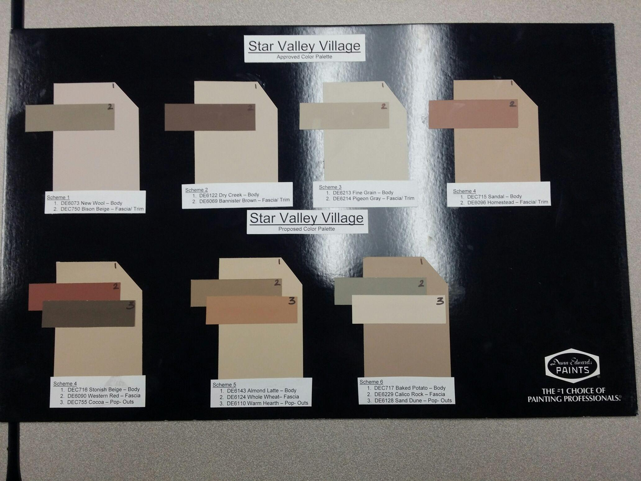

Scheme 5

1. DEC716 Stonish Beige—Body

2. DE6090 Western Red—Fascia

3. DEC755 Cocoa—Pop-Outs

Scheme 6

1. DE6143 Almond Latte—Body

2. DE6124 Whole Wheat—Fascia

3. DE6110 Warm Hearth—Pop-Outs

Scheme 7

1. DEC717 Baked Potato—Body

2. DE6229 Calico Rock—Fascia

3. DE6128 Sand Dune—Pop-Outs

Scheme 1

1. DE6073 New Wool—Body

2. DEC750 Bison Beige—Fascia/Trim

Scheme 2

1. DE6122 Dry Creek—Body

2. DE6069 Bannister Brown—Fascia/Trim

Scheme 3

1. DE6213 Fine Grain—Body

2. DE6214 Pigeon Gray—Fascia/Trim

Scheme 4

1. DEC 715 Sandal—Body

2. DE6096 Homestead—Fascia/Trim

Star Valley Village

2 Color Approved Color Palette

Star Valley Village

3 Color Approved Color Palette