CS9053
Assignment 8
Prof. Dean Christakos
Nov. 7th, 2025
Due: Nov 17th, 2025 11:59PM

Creating a pipeline
You have a file called transactions.csv. This contains a transaction id, and account id, a timestamp, and a price in cents.
You’re going to create a pipelining system where each module in the pipeline is working in a separate thread.
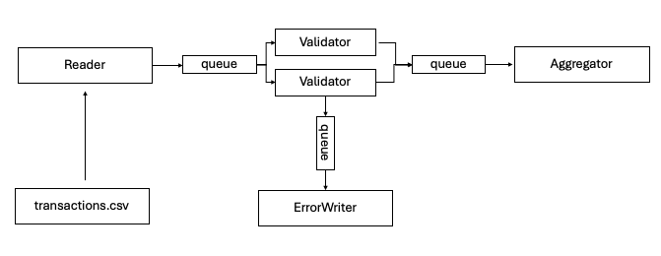
These 4 threads, Reader, Validator, ErrorWriter, and Aggregator, all connected by queues.
These queues should have a capacity of 256 and block if they’re full.
The Reader reads data from the transactions file and creates a Tx (transaction) object and then places the transaction in a MsgTx (message) object. Tx and MsgTx are written for you.
The Reader puts a MsgTx object on a queue to the Validator threads.
The Validator threads share a queue and each remove any MsgTx objects and make sure that the data in the Tx object is valid and that there is no data missing. If there is, then it puts that data in a queue to the ErrorWriter thread.
If the Tx data is valid, then they put that MsgTx object on the outgoing queue to the Aggregator thread.
The ErrorWriter thread outputs error transactions to a file called errors.csv with the transaction data and what data is missing.
The Aggregator thread looks at each transaction and aggregates the total transaction value for each user and day. It should aggregate data to produce results like this, indexed by AggKey, a type already provided to you which combines user id and date.
Top 10 aggregates:
a5 @ 2024-11-03 -> 5000 cents
a3 @ 2024-11-03 -> 4700 cents
a1 @ 2024-11-02 -> 3799 cents
a2 @ 2024-11-02 -> 3597 cents
a4 @ 2024-11-03 -> 1498 cents
a3 @ 2024-11-02 -> 999 cents
a2 @ 2024-11-03 -> 600 cents
a1 @ 2024-11-03 -> 600 cents
a1 @ 2024-11-04 -> 300 cents
a4 @ 2024-11-02 -> 0 cents

You can make any number of choices about how to fit these together. You must use queues, but you can use or design any kind of queue that has a capacity and blocks if the queue Is full. Using classes like BlockingQueue is allowed.
When the file is done reading, the Reader puts Stop message(s) on the queue to the Validator(s), and ends its thread. When the Validator(s) get a Stop message from the queue, they pass those Stop messages on to the ErrorWriter queue and the queue to the Aggregator and stop their thread(s). Likewise, the ErrorWriter and Aggregator will stop their Threads when they receive a Stop message from their incoming queues.
Once the threads are all done (join() is good for this), print out the output of the Aggregated data and any errors.
THERE MUST BE NO RACE CONDITIONS. Figure out synchronization, particularly given that there are two Validator threads.
A parse method and validate method are provided in the Reader and Validator threads.

