**PART0**

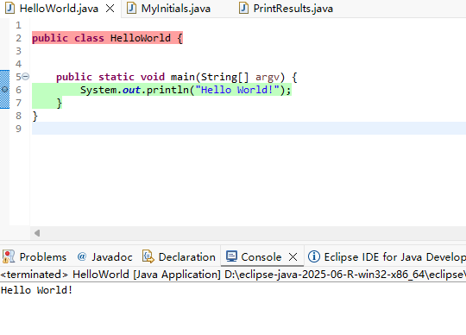

**PART1**

1. My name is Meng Hong Dao, so the short is MHD.

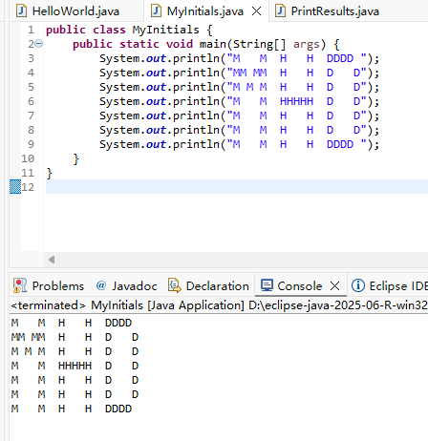

2.

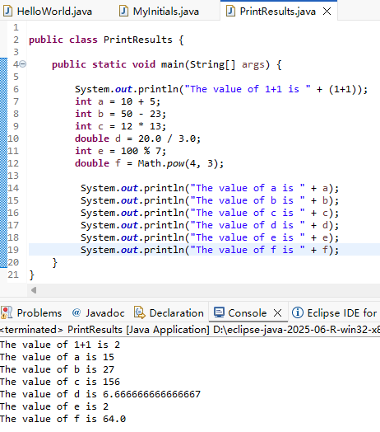

**PART2**

1.

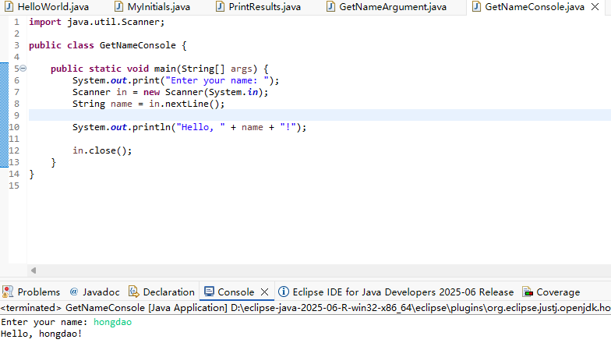

2.

Before arguments input:

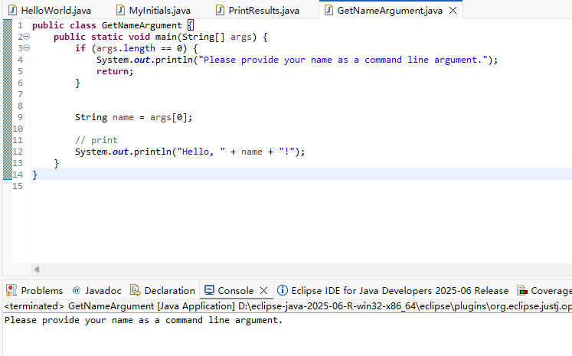

After arguments input:

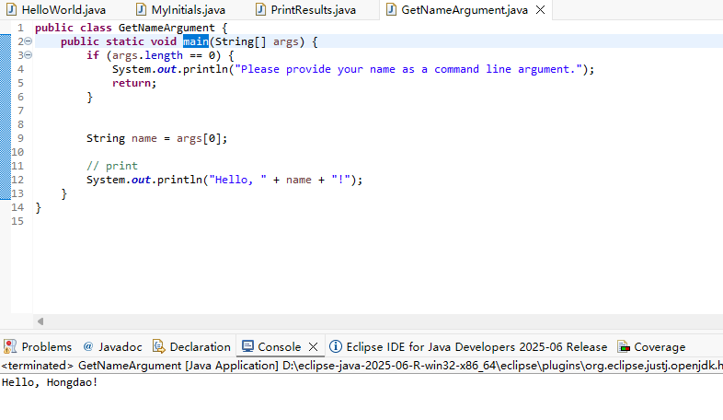

**PART3**

I for the Sun is 2.2384776791764395E-8

I for Betelgeuse is 6.369364076653014E-9

