Lab A
Has already listen the video.

Lab B
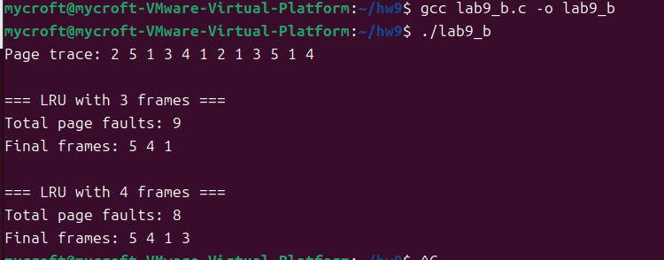
I.
The number of page faults with 3 frames is 9.
II.
With 3 frames, the pages that reside in memory at the end of the page trace are: 5, 4, 1.
III.
The number of page faults with 4 frames is 8.
IV.
With 4 frames, the pages that reside in memory at the end of the page trace are: 5, 4, 1, 3.

Lab C
In this page trace, increasing the number of frames from 3 to 4 reduces the number of page faults from 9 to 8. This is consistent with the fact that LRU is a stack algorithm, so adding more frames cannot increase the number of page faults. Therefore, with the LRU page replacement algorithm it is not possible to encounter Belady’s anomaly.

