Lab6_a:
In Part 1, I reimplemented Assignment 5B using a TCP/IP socket instead of a pipe.
The parent process acts as a TCP server: it creates a socket, binds to port 50000 on 127.0.0.1, sleeps up to 6999 ms, then listens and accepts the connection.
The child process acts as a TCP client: it repeatedly attempts connect() until the server is ready, then sends n double values using write().
The parent receives each double with read() and prints the values as they arrive.

Output:
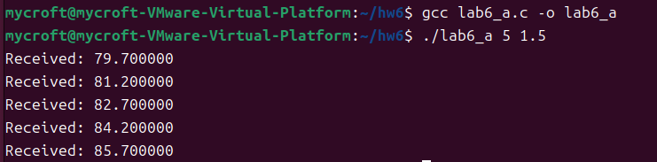

Lab6_b:
I implemented a multi-threaded Monte-Carlo program using 4 threads. Each thread generates one million random points, checks whether each point falls inside the unit circle, and updates a shared counter protected by a semaphore. After all threads finish, the program uses the ratio of inside points to total points to estimate the value of π.
