Make
sudo insmod lab7.ko
sudo ./lab7_user
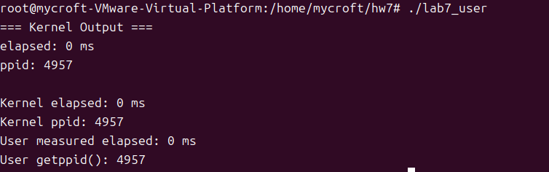

In this assignment, I implemented a Linux kernel module that registers as a misc character device /dev/lab7dev and provides open() and read() operations. The open() function records the current jiffies value, and the first read() call returns a C-string containing the elapsed time in milliseconds (computed from jiffies) and the parent PID obtained from current->parent->pid. A user-space program was written to open the device, read the kernel-generated data, measure its own elapsed time using gettimeofday(), and compare the kernel-reported parent PID with the result of getppid(). The outputs match correctly, demonstrating proper timing measurement, parent PID retrieval, and user–kernel communication via a misc character device.

