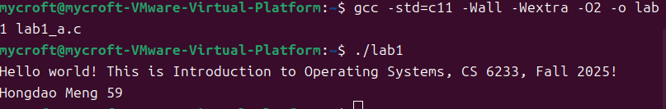

Use gcc to compile the c file, and output correctly.