1. Create input.txt

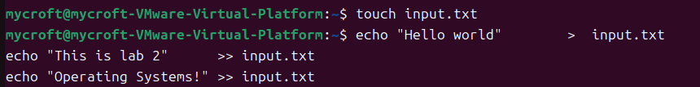

1. Create mycat.c

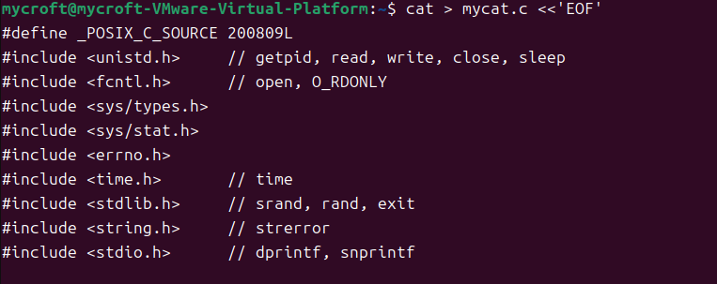

1. compile and run

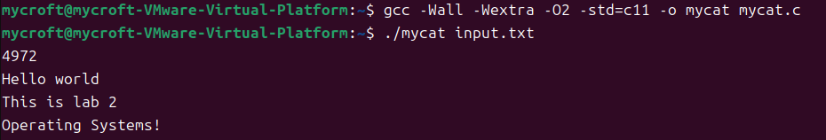

1. Change input content and run

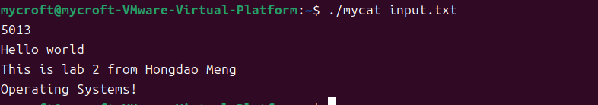

1. What are the system call names for getting the process ID, opening a file, closing a file, reading a file, printing to the console and sleeping?

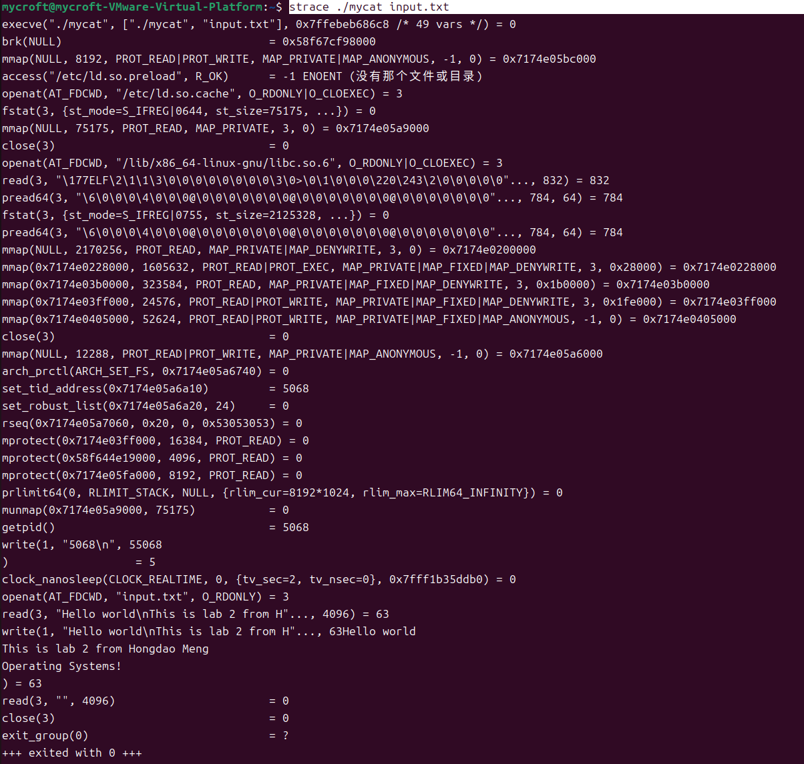

Getting the process ID → getpid

Opening a file → openat

Closing a file → close

Reading a file → read

Printing to the console → write

Sleeping → nanosleep

1. What are the number of system calls for opening, closing and reading the file(s) (i.e. how many times each was called).

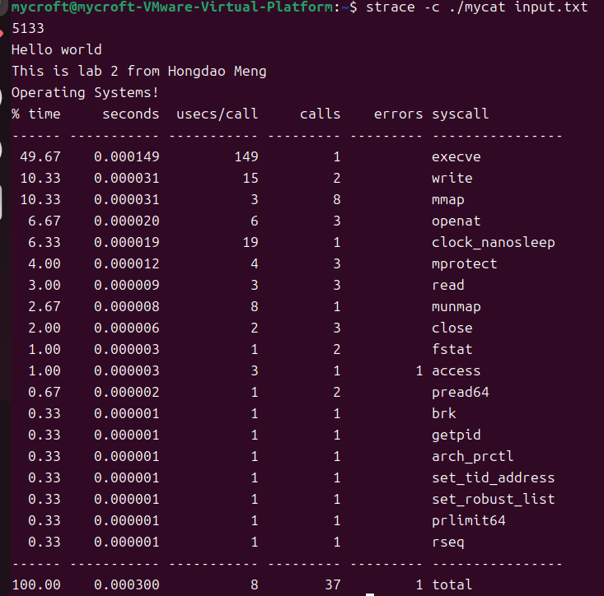

openat → 3

close → 3

read → 3

1. What are the number of system calls for printing to the screen? (count each individually. You may either use strace options to aid you in doing so, or you may use grep).

Printing to the screen use ‘write’

write→ 2

4) What was the value of the file descriptor of your read file (please review the lecture slides before asking what this means)?

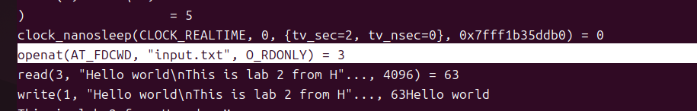

The value of the file descriptor for the read file (input.txt) was **3**.