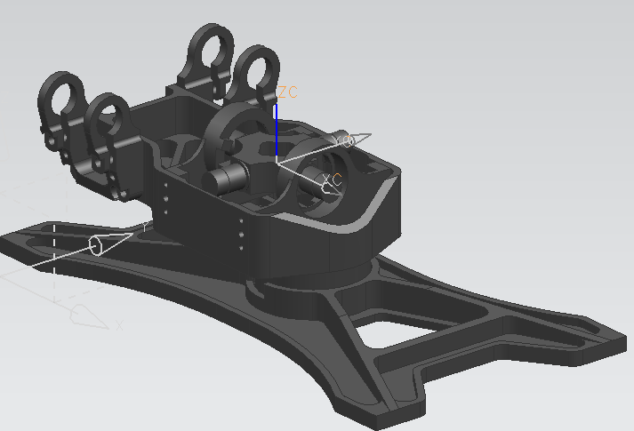

Information Units kg - m

Displayed Mass Property Values

Volume = 0.000196290 m^3

Area = 0.120984824 m^2

Mass = 0.589284455 kg

Center of Mass

Xcbar, Ycbar, Zcbar = 0.003616028, 0.000275946, -0.029612515

Moments of Inertia (WCS)

Ix, Iy, Iz = 0.001062219, 0.002349891, 0.002062137

Moments of Inertia (Centroidal)

Ixc, Iyc, Izc = 0.000545430, 0.001825442, 0.002054387

Products of Inertia (WCS)

Iyz, Ixz, Ixy = -0.000006003, -0.000242703, 0.000005100

Products of Inertia (Centroidal)

Iyzc, Ixzc, Ixyc = -0.000001187, -0.000179602, 0.000004512

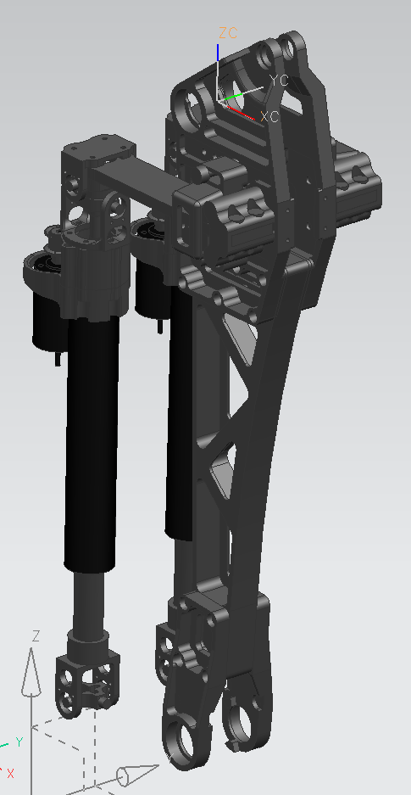

Information Units kg – m

Displayed Mass Property Values

Volume = 0.000603205 m^3

Area = 0.430377426 m^2

Mass = 2.239063803 kg

Center of Mass

Xcbar, Ycbar, Zcbar = -0.025656333, -0.000475219, -0.126284289

Moments of Inertia (WCS)

Ix, Iy, Iz = 0.057457393, 0.064210348, 0.012057882

Moments of Inertia (Centroidal)

Ixc, Iyc, Izc = 0.021748921, 0.027028523, 0.010583518

Products of Inertia (WCS)

Iyz, Ixz, Ixy = 0.000170006, 0.012144261, 0.000083302

Products of Inertia (Centroidal)

Iyzc, Ixzc, Ixyc = 0.000035634, 0.004889713, 0.000056002

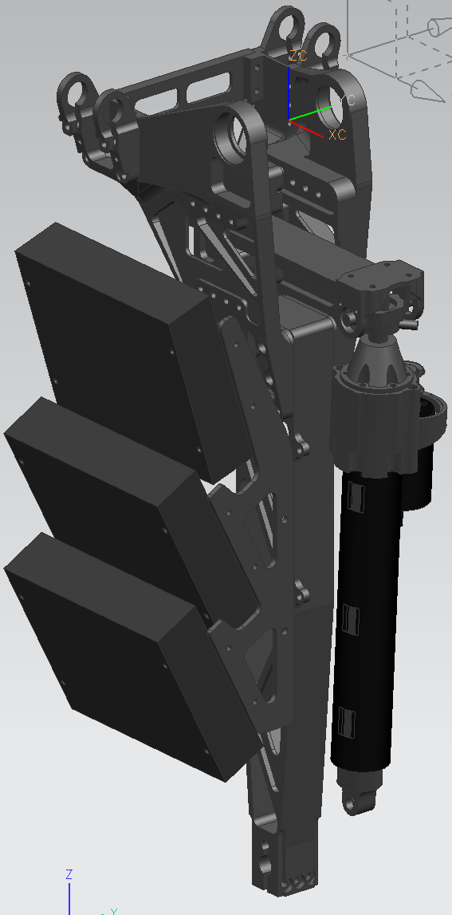

RIGHT LEG – INVERT Y-COMPONENTS FOR LEFT LEG

Information Units kg – m

Displayed Mass Property Values

Volume = 0.001338454 m^3

Area = 0.405932041 m^2

Mass = 2.214889327 kg

Center of Mass

Xcbar, Ycbar, Zcbar = -0.009015634, -0.016546555, -0.159241491

Moments of Inertia (WCS)

Ix, Iy, Iz = 0.077913472, 0.080412725, 0.009544086

Moments of Inertia (Centroidal)

Ixc, Iyc, Izc = 0.021142224, 0.024067859, 0.008757645

Products of Inertia (WCS)

Iyz, Ixz, Ixy = 0.007586665, 0.002172404, 0.002422276

Products of Inertia (Centroidal)

Iyzc, Ixzc, Ixyc = 0.001750657, -0.001007431, 0.002091864

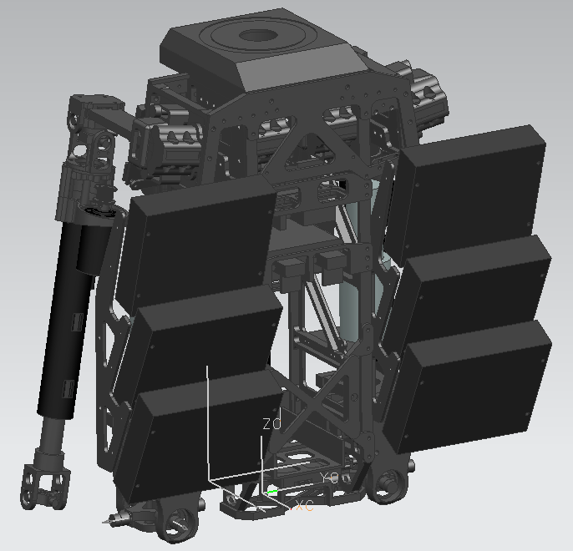

Information Units kg – m

Displayed Mass Property Values

Volume = 0.004126178 m^3

Area = 1.495246592 m^2

Mass = 9.846994362 kg

Center of Mass

Xcbar, Ycbar, Zcbar = 0.009821043, 0.000461078, 0.205279880

Moments of Inertia (WCS)

Ix, Iy, Iz = 0.576790898, 0.536594363, 0.121141360

Moments of Inertia (Centroidal)

Ixc, Iyc, Izc = 0.161838147, 0.120693934, 0.120189496

Products of Inertia (WCS)

Iyz, Ixz, Ixy = 0.001261292, 0.019701106, 0.000490759

Products of Inertia (Centroidal)

Iyzc, Ixzc, Ixyc = 0.000329275, -0.000151051, 0.000446170

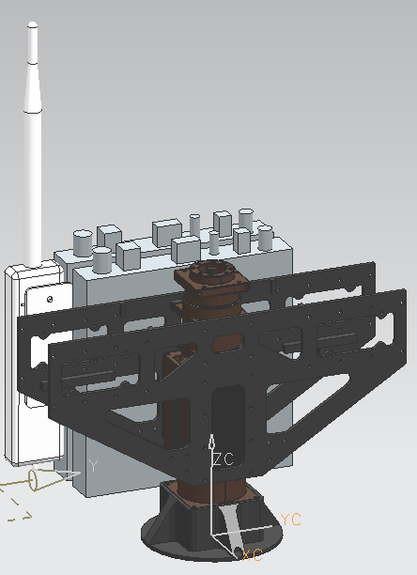

Information Units kg - m

Displayed Mass Property Values

Volume = 0.001976219 m^3

Area = 0.352335309 m^2

Mass = 3.339282487 kg

Center of Mass

Xcbar, Ycbar, Zcbar = -0.036092089, -0.002796037, 0.100620268

Moments of Inertia (WCS)

Ix, Iy, Iz = 0.048654895, 0.052096069, 0.016272686

Moments of Inertia (Centroidal)

Ixc, Iyc, Izc = 0.014820430, 0.013937830, 0.011896701

Products of Inertia (WCS)

Iyz, Ixz, Ixy = -0.001364607, -0.013012592, 0.000616885

Products of Inertia (Centroidal)

Iyzc, Ixzc, Ixyc = -0.000425140, -0.000885669, 0.000279902

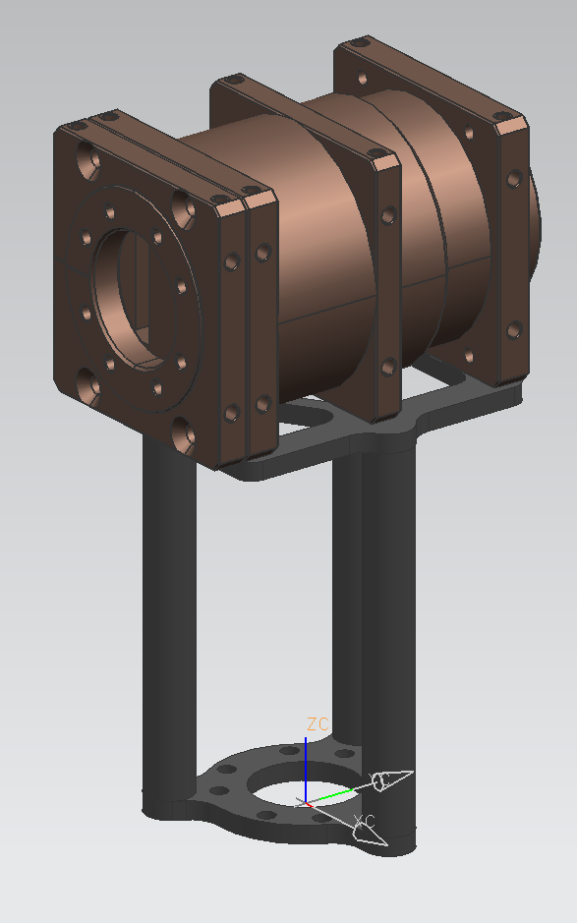

Information Units kg – m

Displayed Mass Property Values

Volume = 0.000098305 m^3

Area = 0.037643498 m^2

Mass = 0.322276395 kg

Center of Mass

Xcbar, Ycbar, Zcbar = 0.000062353, -0.001514090, 0.083856504

Moments of Inertia (WCS)

Ix, Iy, Iz = 0.002483858, 0.002424110, 0.000143209

Moments of Inertia (Centroidal)

Ixc, Iyc, Izc = 0.000216899, 0.000157889, 0.000142469

Products of Inertia (WCS)

Iyz, Ixz, Ixy = -0.000042940, 0.000001872, -0.000000552

Products of Inertia (Centroidal)

Iyzc, Ixzc, Ixyc = -0.000002022, 0.000000187, -0.000000522

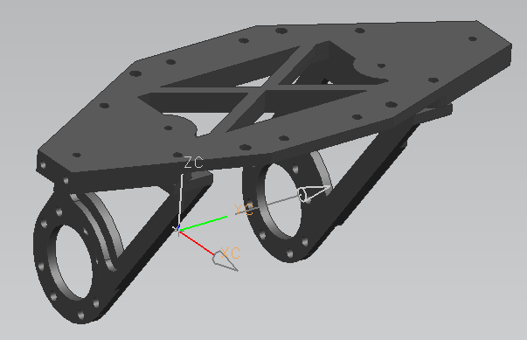

Information Units kg – m

Displayed Mass Property Values

Volume = 0.000028876 m^3

Area = 0.025276724 m^2

Mass = 0.078283874 kg

Center of Mass

Xcbar, Ycbar, Zcbar = 0.027972587, -0.000000037, 0.041796053

Moments of Inertia (WCS)

Ix, Iy, Iz = 0.000270262, 0.000247000, 0.000195288

Moments of Inertia (Centroidal)

Ixc, Iyc, Izc = 0.000133507, 0.000048991, 0.000134033

Products of Inertia (WCS)

Iyz, Ixz, Ixy = -0.000000000, 0.000104978, -0.000000000

Products of Inertia (Centroidal)

Iyzc, Ixzc, Ixyc = -0.000000000, 0.000013453, -0.000000000