Agent 1 — Scenario Agent
Architecture, tech stack and data flow
Project | Education Workforce Policy Simulation & Recommendation (MVP)
Component | Agent 1 of 5 — Scenario Agent
Purpose | Convert a natural-language question into a validated policy scenario
Date | 2 July 2026
Status | Decision-support prototype — outputs require human review

1. What this agent does
The Scenario Agent is the entry point of the system. Its single job is to turn a person’s everyday question into a structured, validated policy scenario that the rest of the pipeline can act on. It understands language — it does not calculate any results.
For example, the sentence “Forecast Science teacher demand in Johor for 2027 with a 70% subject-option ratio” is converted into clear fields: subject = SAINS, state = JOHOR, policy = option ratio, target = 0.70.

2. Architecture at a glance
The agent follows the same three-layer shape as the rest of the application: an input layer (the user interface), a processing layer (the business logic), and an output layer.
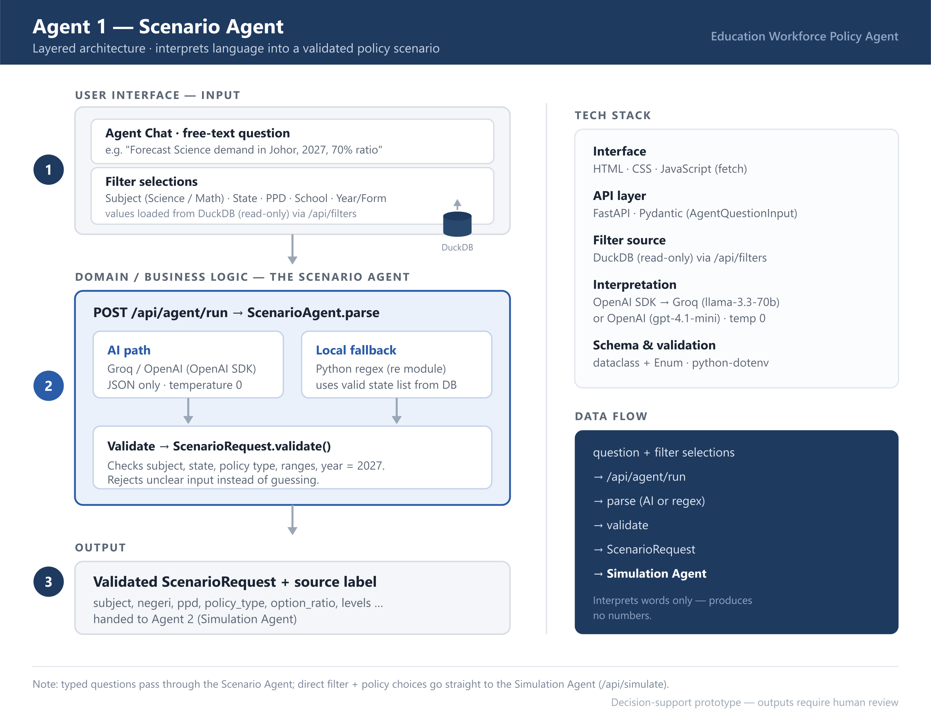
Figure 1. Scenario Agent — layered architecture.

3. The three layers explained

Layer 1 — User Interface (input)
The input arrives through two channels:
- Free-text question — the user types a plain-language question into the Agent Chat box; frontend/app.js sends it as JSON: { question, lang }.
- Filter selections — dropdowns for Subject (Science / Math), State, PPD, School and Year/Form. Their selectable values are loaded from the DuckDB database (read-only) through GET /api/filters/{field}.
These filters matter to the Scenario Agent in two ways. First, the list of valid states from the database is handed to the agent when it starts (ScenarioAgent(states)), so it can recognise the state named in a question. Second, filter choices act as defaults that seed any field the question does not mention.
Two entry paths: a typed question passes through the Scenario Agent (/api/agent/run); a direct filter + policy selection skips parsing and goes straight to the Simulation Agent (/api/simulate).

Layer 2 — Domain / Business Logic (the Scenario Agent itself)
The request arrives at POST /api/agent/run, is checked by the Pydantic model AgentQuestionInput, then passed to ScenarioAgent.parse. The agent has two ways to understand the question:
- AI path — when an API key is configured, it asks Groq or OpenAI to extract the fields as JSON only, at temperature 0 (so the reading is consistent). The model is instructed never to calculate.
- Local fallback — if no AI key is available (or the AI call fails), a pure Python regular-expression parser reads the question instead. This keeps the app working offline.
Whatever path is used, the result is turned into a ScenarioRequest and passed through .validate(), which enforces the rules: allowed subjects and states, valid policy type, sensible ranges, and target year 2027. If the question is unclear, the agent refuses it rather than guessing a policy.

Layer 3 — Output
- A validated ScenarioRequest object containing every field needed to run a simulation.
- A source label recording how it was interpreted (e.g. “Groq Scenario Agent” or “Local fallback parser”), for transparency.
- This object is handed to Agent 2, the Simulation Agent, which produces the actual numbers.
Key design principle: The Scenario Agent only interprets language. It never performs any calculation. All numbers are produced later by deterministic Python logic in the Simulation Agent, which keeps the policy results transparent and reproducible.

4. Tech stack
Layer / concern | Technology used
Interface | HTML, CSS, JavaScript (fetch call to the API)
API layer | FastAPI endpoint /api/agent/run; Pydantic model AgentQuestionInput
Filter source | DuckDB (read-only) via /api/filters — supplies subject, state, PPD, school and year/form values
Interpretation | OpenAI SDK, calling Groq (llama-3.3-70b-versatile) or OpenAI (gpt-4.1-mini), temperature 0
Fallback | Pure Python regular expressions (re module)
Schema & validation | Python dataclass + Enum (schemas.py: ScenarioRequest)
Configuration | python-dotenv, loading provider settings from .env

5. Data flow (step by step)
- The filter dropdowns are populated from the DuckDB database via /api/filters.
- The user types a question in the Agent Chat box (filter selections provide the defaults).
- The browser sends it to POST /api/agent/run.
- The Orchestrator calls ScenarioAgent.parse.
- The question is read by the AI path, or by the regex fallback.
- The result is validated into a ScenarioRequest.
- The validated scenario is passed to the Simulation Agent (Agent 2).

6. Architecture mapped to the live system
The table below places each architecture layer beside the matching part of the running application (http://127.0.0.1:8002/app/), so the design can be checked against the finished system. The screenshots were captured live from a real run.
Architecture layer | In the finished system — live screenshots
① Input — Filter panel  Subject, State, PPD, School and Year/Form. The selectable values are loaded from DuckDB via /api/filters. | 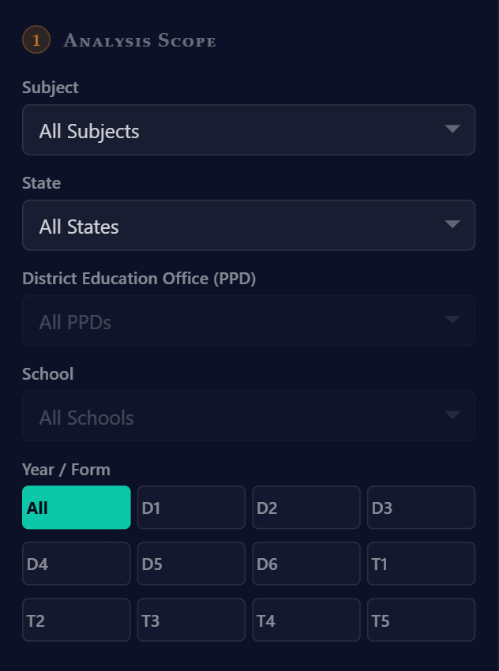
① Input — Agent Chat  The free-text question typed by the user, sent to POST /api/agent/run. | 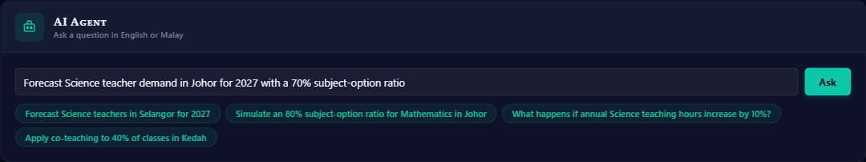
② Business Logic — interpret
The question becomes structured fields. This banner reads Year 2027 · Science · Johor · Subject-Option Ratio, and shows it was interpreted by the local fallback parser.
③ Output — result, source & trace  The validated scenario drives the results. The agent trace confirms the Scenario Agent ran, and the source label shows which engine interpreted the request. | 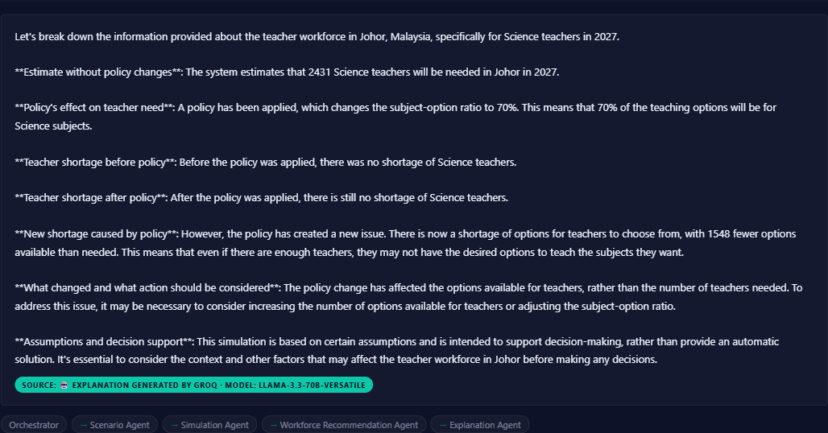

7. How to test this agent on its own
Open tests/agent_tests.ipynb and run the “Agent 1 — Scenario Agent” cells. The first cell parses a full sentence and prints the extracted fields; the second cell confirms the agent correctly refuses an ambiguous question instead of inventing a policy.
Files involved: agents.py · main.py · api_models.py · schemas.py · config.py

