Lab 9

Test for Preemptive Priority
testPrio.in
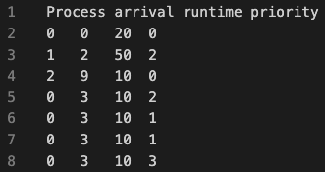
- First it will go through all of the processes. Find the largest one and latest of them. Then it will run that to completion. In this case it will be the process with priority “3”. Then set the starttime to 0, and endtime to starttime+runtime.
- Then it will reset the variables. The current_process that is used to loop, will be set to what it started with
- Then it will do step 1 again (not choose a process that is done)

Result is this in the terminal
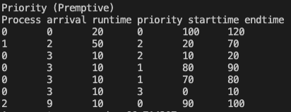
And this in the testPrio.out
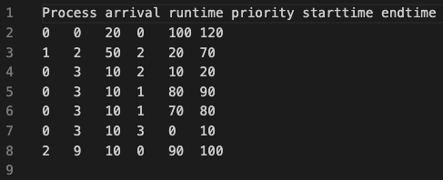
- As you can see, it did what I told you

Did not make any test on the other algorithms

