**Design Documents**

**for**

**Film Reviews Website**

# Version 1.0 approved

**Prepared by:**

**Nguyen Huu Hoan Phuc**

**Thai Thi My Huong**

**Ho Thi Diem**

**Computer Science Department**

**Troy University**

**Date Submitted**

**12/07/2018**

# Index

1. Feasibility Study in Brief 2
   1. Technology 2
   2. Finance 2
   3. Time 2
   4. Resources 2
      1. Human Resources 2
      2. Reusable software 2
      3. Environment 2
2. Cost Estimation 3
   1. General Assumptions 3
   2. LOC-Based Estimation 3
      1. Estimation Table 3
      2. Project Estimation 3
   3. FP-Based Estimation 3
      1. Data Flow diagram 3
      2. Function Point Count 4
      3. Complexity Adjustment Table 4
      4. Project estimation 5
3. Project Schedule 6
   1. Task Table 6
   2. Dependency Graph 6
   3. Project Schedule 6
4. UML Diagrams 7
   1. Use Cases Diagram 7
      1. Use cases diagram 7
      2. Use cases model 7
   2. Class Diagram 10
   3. Sequence Diagram 13
   4. ER Diagram 15

## Feasibility Study in Brief

## Technology

* The software will be written in PHP programing language that has many classes that already available.

## Finance

* The project will serve as social network, and we can take a part of profits from attracting advertisers when having stability users, so we can deal with the finance problem.
* Let us assume for having enough budget to spend on this project although we will detail the cost of doing in the Cost Estimation Section.

## Time

* We will to sort out features according priority level and implement high priority features first. To assure of submitting the project on time, some low priority features will remove if necessary.
* The project will follow software engineering principles with construct SRS before planning, design and then coding which is complemented with testing. The project will be correctly calculated for complete at the end of the course.

## Resources

* + 1. *Human Resources:*
       - We have 3 people working on the project. Although 2 people did not learn much PHP language programing, but we have a foundational basic on coding, and each member can take charge of several parts that fits them most.
       - Our group also has a member who has much experience on coding so this is a chance for us to training tasks and help each other improve more through the project.
    2. *Reusable software:*
       - The software is about popular class like login, logout, register, post, like/comment, chat box, etc. Moreover, we can find out easily.
    3. *Environment:*
       - The system will be developed that compatible with popular browser such as Internet Explorer, Mozilla Firefox, Google Chrome or Opera Web Browser. Therefore, it requires available internet connection for access.
       - Nowadays, those requirements are easily response.

## Cost Estimation

## General Assumptions

|  |  |  |
| --- | --- | --- |
| Labor rate | $1500.00 | /person/pm |
| Average productivity |  |  |
| Line of code | 1700.00 | /person/pm |
| Function point | 6.5 | /person/pm |

## LOC-Based Estimation

* + 1. *Estimation Table*

|  |  |  |
| --- | --- | --- |
|  | **Functions** | **Lines of code** |
| 1 | Authentication | 400 |
| 2 | Manage Profile | 200 |
| 3 | Post reviews | 500 |
| 4 | Like | 200 |
| 5 | Comment | 500 |
| 6 | Receive notifications | 400 |
| 7 | Connect with other people | 400 |
| 8 | Chat box | 600 |
| 9 | GUI Images | 200 |
| 10 | Database system | 400 |
|  | Total | 3800 |

* + 1. *Project Estimation*

|  |  |  |
| --- | --- | --- |
| Cost per LOC | $0.3 | /line |
| **Total** | **$1140.00** |  |
| Total time for 1 person to do the project | 0.75 | months |
| Team member | 3 | people |
| Total time to do the project as a team | 0.25 | months |

## FP-Based Estimation

* + 1. *Data Flow diagram*

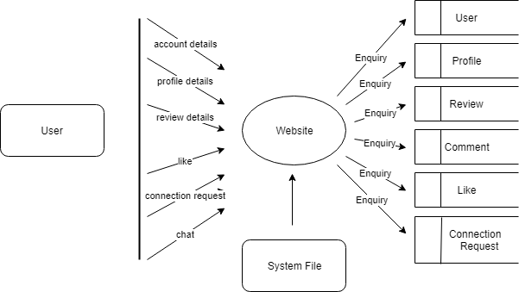

Figure : Data Flow diagram

* + 1. *Function Point Count*

|  |  |  |  |
| --- | --- | --- | --- |
| **Function Point Base Estimation** | **Count** | **Weighing**  **Factor (Average)** | **FP**  **Estimate** |
| Number of external inputs (EIs) | 2 | 4 | 8 |
| Number of external outputs (EOs) | 0 | 5 | 0 |
| Number of external inquiries (EQs) | 5 | 4 | 20 |
| Number of internal logical files (ILFs) | 8 | 6 | 48 |
| Number of external interface files (EIFs) | 0 | 7 | 0 |
| **Total** |  |  | **76** |

* + 1. *Complexity Adjustment Table*

|  |  |  |
| --- | --- | --- |
| 1 | Does the system require reliable backup and recovery? | 2 |
| 2 | Are data communications required? | 4 |
| 3 | Are there distributed processing functions? | 3 |
| 4 | Is performance critical? | 5 |
| 5 | Will the system run in an existing, heavily utilized operational environment? | 1 |
| 6 | Does the system require on-line data entry? | 4 |
| 7 | Does the on-line data entry require the input transaction to be built over multiple screens or operations? | 3 |
| 8 | Are the master files updated on-line? | 1 |
| 9 | Are the inputs, outputs, files or inquiries complex? | 1 |
| 10 | Is the internal processing complex? | 3 |
| 11 | Is the code to be designed reusable? | 4 |
| 12 | Are conversion and installation included in the design? | 0 |
| 13 | Is the system designed for multiple installations in different organizations? | 0 |
| 14 | Is the website designed to facilitate change and ease of use by the user? | 3 |
|  | **Total** | **34** |
|  | **Value Adjustment Factor** | **0.99** |

* + 1. *Project estimation*

|  |  |  |
| --- | --- | --- |
| Function point estimated | **75.24** |  |
| Labor rate | $1500.00 | /person/month |
| Time needed | 0.25 | months |
| Money needed | $1125 |  |
| Team member | 3 | people |
| Time to do project | 0.25 | months |

## Project Schedule

## Task Table

|  |  |  |  |  |  |
| --- | --- | --- | --- | --- | --- |
| **No.** | **Task Name** | **Start** | **End** | **Duration (days)** | **Dependency** |
| 1 | Authenticate user | 08/12/2018 | 08/12/2018 | 0.5 | 7 |
| 2 | Manage reviews | 08/12/2018 | 08/12/2018 | 1 | 1, 6, 7 |
| 3 | Receive notifications | 09/12/2018 | 09/12/2018 | 1 | 1, 2, 4, 7 |
| 4 | Connect with other people | 10/12/2018 | 10/12/2018 | 1 | 1, 7 |
| 5 | Chat box | 11/12/2018 | 11/12/2018 | 1 | X |
| 6 | GUI Images | 07/12/2018 | 14/12/2018 | 7 | 0 |
| 7 | Database system | 07/12/2018 | 14/12/2018 | 7 | 0 |
| 8 | Manage profile | 14/12/2018 | 14/12/2018 | 1 | 1, 6, 7 |

As stated in SRS document, although chat box features are high priority features, the time is limited. Therefore, we mark them as “X” in the dependency table, which means that we will do those features if we have enough resources. But if those features cannot be done on time, the project will continue without them.

## Dependency Graph

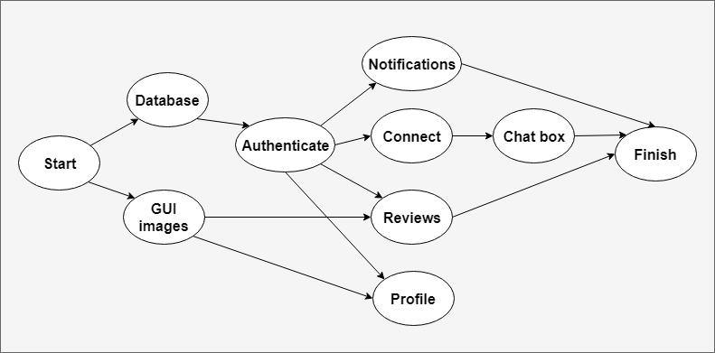

## Project Schedule

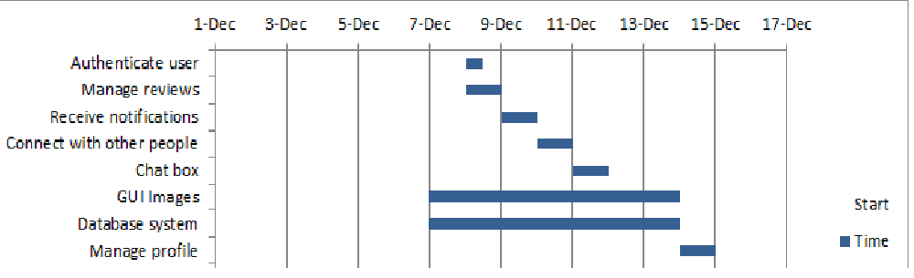

## UML Diagrams

## Use Cases Diagram

* + 1. *Use cases diagram*

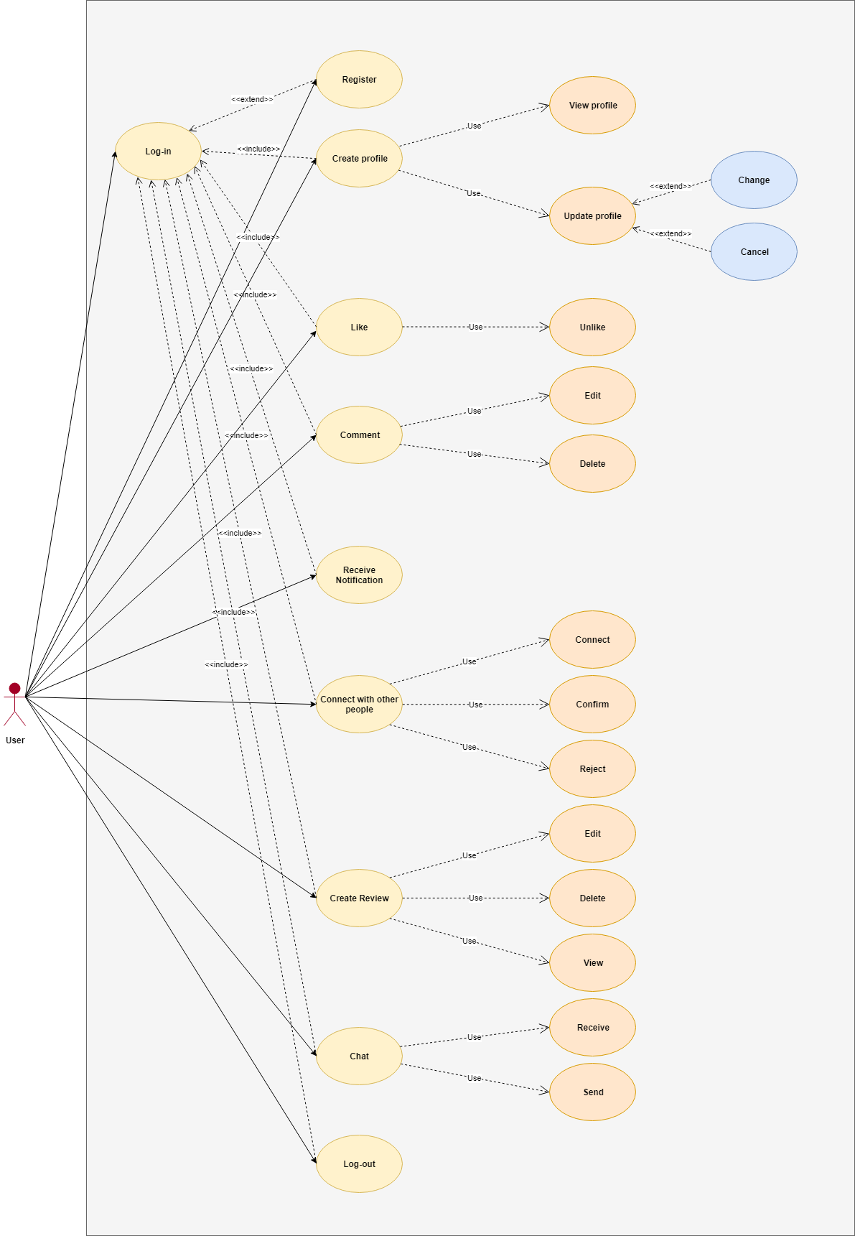

* + 1. *Use cases model*

|  |  |  |
| --- | --- | --- |
| Use case ID | UC1 | |
| Name | Registration | |
| Description | This use case describes the process of registering an account in the Film reviews Website. | |
| Actors | Users | |
| Pre. Condition | * There is an available internet connection | |
| Basic flow of events | User | Website System |
|  | Step 1: Click to registration button  Step 3: Enter and select information includes:  - First name (required)  - Last name (required)  - E-mail address (required)  - Password (required)  - Retype password (required)  Step 4: Click submit | Step 2: Move to registration interface.  Step 5: Check e-mail address:  - If false, display “E-mail don’t exist.” and turn back to step 3.  - If true, move to next step.  Step 6: Check all other required information:  - If true, save and display “Successful registration!”  - If users miss any required information, turn red this feature and display “Please fill full information” and turn back to step 3(keep other entered information).  - If user name is existed, announce “You enter a registered user name, please re-register!” and turn back to step 3(keep other entered information).  - If password is shorter than 6 characters, request to re-enter password by announcing “Please re-enter password that is longer than 6 characters” and turn back to step 3 (keep other entered information) |

|  |  |  |
| --- | --- | --- |
| Use case ID | UC2 | |
| Name | Login | |
| Description | This use case describes process of how users log in the Film reviews Website by their accounts. | |
| Actors | Users | |
| Pre. Condition | * People who want to log in must have registered accounts. * There is an available internet connection. | |
| Basic flow of events | Users | Website System |
|  | Step 1: Access to the website.  Step 3: Enter ID user, password.  Choose “Remember me” option if you want to remember account for the next access. | Step 2: Display box with “ID user” and “password” are required, and “Remember me” (optional).  Step 4: Check ID user and password: - If true, system allows user to access to the website and remember the account (if choose “Remember me”). - If false, display “The ID or password is incorrect” and return Step 2. |

|  |  |  |
| --- | --- | --- |
| Use Case ID | UC3 | |
| Name | Create user’s profile | |
| Description | This use case describes how users create their profile | |
| Actor | Users | |
| Pre- condition | * Users must log in their account * There is an available internet connection | |
| Basic flow of event | Users | Website System |
| Step 1: Choosing the feature “Create profile”.  Step 3: Fill out information:   * Gender (Male or Female) * Day of birth (dd/mm/yyyy) * Phone number   Step 4: Click “Upload photos” to add profile picture.  Step 6: Click “borrow” button to choose the picture on the computer.  Step 7: Click:   * “Save” button. * “Cancel” button. | Step 2: Display “Fill out your information” with information:   * Gender (Male or Female) * Day of birth (dd/mm/yyyy) * Phone number   Step 5: Display “borrow” button.  Step 8:   * Save user’s information. * Cancel all the action before. |

|  |  |  |
| --- | --- | --- |
| Use Case ID | UC4 | |
| Name | Updating user’s profile | |
| Description | This use case describes how users update their profile | |
| Actor | Users | |
| Pre- condition | * Users must log in their account * There is an available internet connection | |
| Basic flow of event | Users | Website System |
| Step 1: Choosing the feature “Update profile”.  Step 3: Click “edit” in the information that want to change.  Step 4: Click “Upload photos” to add profile picture.  Step 6: Click “borrow” button to choose the picture on the computer.  Step 7: Click:   * “Save” button. * “Cancel” button. | Step 2: Display all of information fill out before.  Step 5: Display “borrow” button.  Step 8: Implement:   * Save user’s information. * Cancel all the action before. |

|  |  |  |
| --- | --- | --- |
| Use Case ID | UC5 | |
| Name | Like reviews | |
| Description | This use case describes how users like a review. | |
| Actor | Users | |
| Pre- condition | * Users must log in their account * There is an available internet connection | |
| Basic flow of events | Users | Website System |
| Step 1: Click blue “Like” button on the bottom of reviews.  Step 3: Click red “Like” button. | Step 2:   * Transfer blue “Like” button into red button. * Count 1+ like for this reviews.   Step 4:   * Transfer red “Like” button into blue button. * Count 1- like for this reviews. |

|  |  |  |
| --- | --- | --- |
| Use Case ID | UC6 | |
| Name | Comment reviews | |
| Description | This use case describes how users comment in a review. | |
| Actor | Users | |
| Pre- condition | * Users must log in their account * There is an available internet connection | |
| Basic flow of events | Users | Website System |
| Step 1: Click “Comment” button on the bottom of reviews.  Step 3: Write comment:   * Click “Save” button * Click “Cancel” button   Step 5: Click “…” in this comment to change or delete:   * Click “Delete” button * Click “Change” button   + Click “Save” button  + Click “Cancel” button | Step 2: Display box to write.  Step 4:   * Save comment and display below review. * Count 1+ comment for this review. * Cancel all the action before.   Step 6:   * Delete this comment, count 1- comment for this review. * Display box of comment to change   + Save information  + Cancel all the action before. |

|  |  |  |
| --- | --- | --- |
| Use Case ID | UC7 | |
| Name | Receive notifies | |
| Description | This use case describes how users receive their notifications. | |
| Actor | Users | |
| Pre- condition | * Users must log in their account * There is an available internet connection | |
| Basic flow of events | Users | Website System |
| Step 1: Click “Notify” button in the top of page. | Step 2: Display all notifies that users have:   * New notifies will have red color. * Old notifies will have blue color. |

|  |  |  |
| --- | --- | --- |
| Use Case ID | UC8 | |
| Name | Connect with other people | |
| Description | This use case describes how users send a request to connect with the other user | |
| Actor | Users | |
| Pre- condition | * Users must log in their account * There is an available internet connection | |
| Basic flow of events | Users | Website System |
| Step 1: Access to the user’s factory that want to connect.  Step 3: Click “Connect with…” button in the top of page.  Step 4: Input writing to send a request and waiting for confirming. | Step 2: Display user’s factory that want to connect.  Step 4: Display the chat box with guide” Say hello to…”  Step 5: Send this request. |

|  |  |  |
| --- | --- | --- |
| Use Case ID | UC9 | |
| Name | Interact with other user | |
| Description | This use case describes how users confirm or reject a request of other users | |
| Actor | Users | |
| Pre- condition | * Users must log in their account * There is an available internet connection | |
| Basic flow of events | Users | Website System |
| Step 1: Click “Connect with other people” on the Home page.  Step 3: Click “…” button beside the user whom you want to interact.  Step 4: If user:   * Click “Confirm” * Click “Reject”   Step 7: Press out | Step 2: Display all of users who send a request to you.  Step 4: Display two options:   * Confirm * Reject   Step 6: Implement:   * Display “*Now you and … connected with each other*” * Display the chat box with guide” *Are you sure to reject this person?*”   Step 8: Keep the content without change |

|  |  |  |
| --- | --- | --- |
| Use Case ID | UC10 | |
| Name | Create reviews | |
| Description | This use case describes how users create a review. | |
| Actor | Users | |
| Pre- condition | * Users must log in their account * There is an available internet connection | |
| Basic flow of events | Users | Website System |
| Step 1: Click “+” button on the center of page or click on the chat box with guide “*I am sure you enjoyed a good film. Do you want to share that…*”  Step 3: Choose any types that you want to write and display on your factory  Step 5: After complete writing:   * Click “Save” button * Click “Cancel” button   Step 7: Before complete posting, if you want to change or delete review, click “…” button beside the review.  Step 9: If user:   * Click “Delete” button * Click “Change” button   + Click “Save” button  + Click “Cancel” button | Step 2: Display box with option:   * Post picture * Actor/Actress * Main content * My feeling * Voting   Step 4: Display the features that the user click to writing  Step 6: Implement:   * Save reviews and display on user’s wall * Cancel all the action before.   Step 8: Display two options:   * Delete * Change   Step 10: Implement:   * Delete this review * Display box of comment to change   + Save information  + Cancel all the action before. |

|  |  |  |
| --- | --- | --- |
| Use Case ID | UC11 | |
| Name | Chat box | |
| Description | This use case describes how the user can chatting with other user | |
| Actor | Users | |
| Pre- condition | * Users must log in their account * There is an available internet connection * Two of users must to be connected with each other | |
| Basic flow of events | Users | Website System |
| Step 1: Access to the user’s factory that want to chat.  Step 3: Click “Chat box” button in the top of page.  Step 4: Input writing.  Step 6: Click “Send” button. | Step 2: Display user’s factory that want to chat.  Step 4: Display the chat box.  Step 5: Display writing.  Step 7: Send message to other user. |

|  |  |  |
| --- | --- | --- |
| Use Case ID | UC12 | |
| Name | Receive message | |
| Description | This use case describes how users receive message from other users. | |
| Actor | Users | |
| Pre- condition | * Users must log in their account * There is an available internet connection | |
| Basic flow of events | Users | Website System |
| Step 1: Click “Chat” button in the top of page. | Step 2: Display all messages that users have:   * New messages will have red color. * Old messages will have blue color. |

|  |  |  |
| --- | --- | --- |
| Use case ID | UC13 | |
| Name | Logout | |
| Description | This use case describes process of how users log out the Film reviews Website | |
| Actors | Users | |
| Pre. Condition | * People who want to log out must login first. * There is an available internet connection. | |
| Basic flow of events | Users | Website System |
|  | Step 1: Click logout in the leaf top of page. | Step 2: Bring user back to login page. |

## Class Diagram

## 

Figure 2: Class diagram

## Sequence Diagram

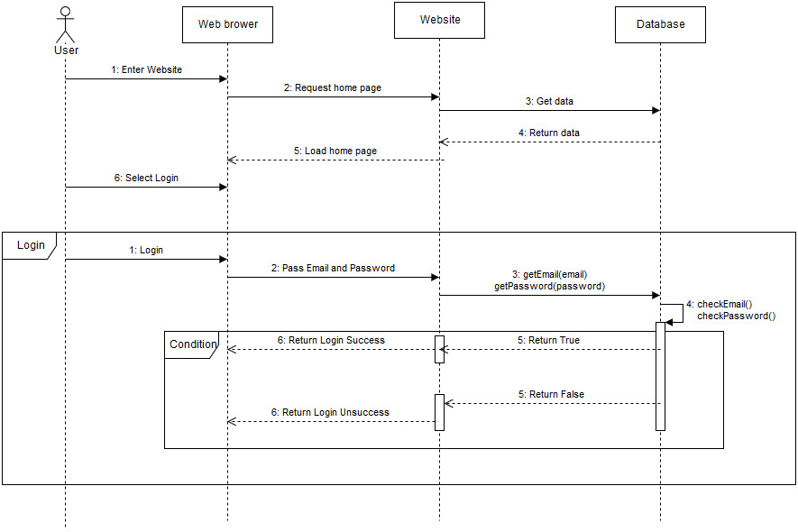

Figure 3: Login

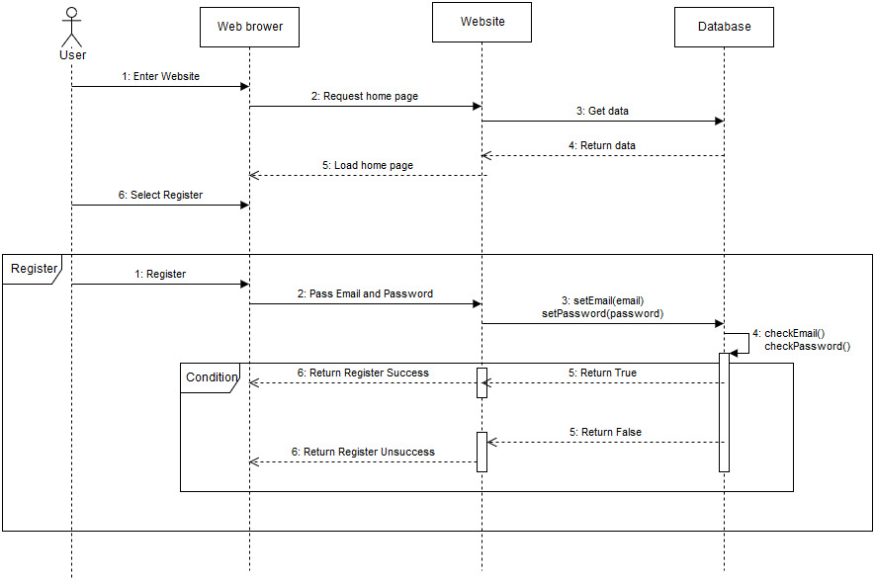

Figure 4: Register

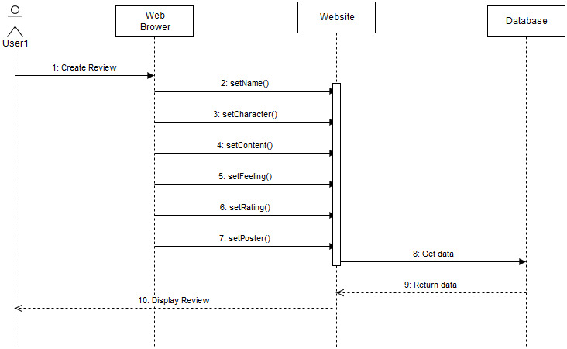

Figure 5: Create Review

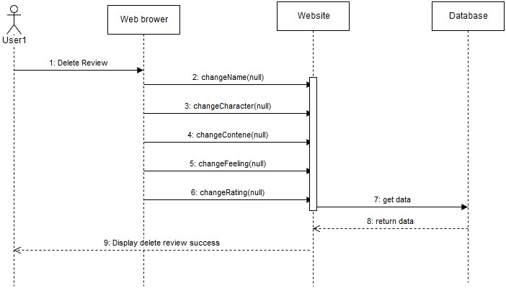

Figure 6: Delete Review

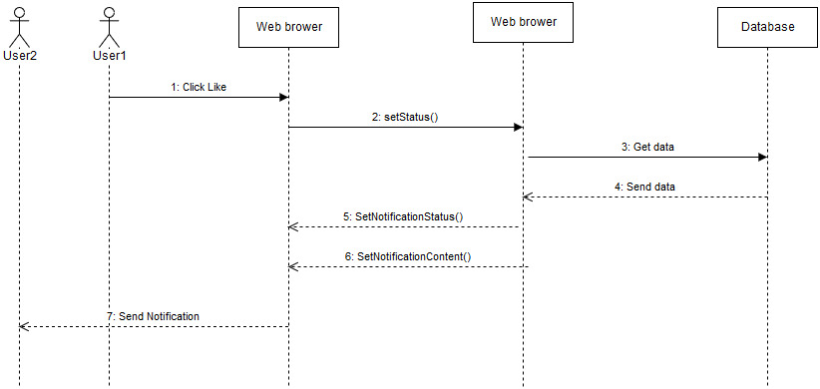

Figure 7: Like

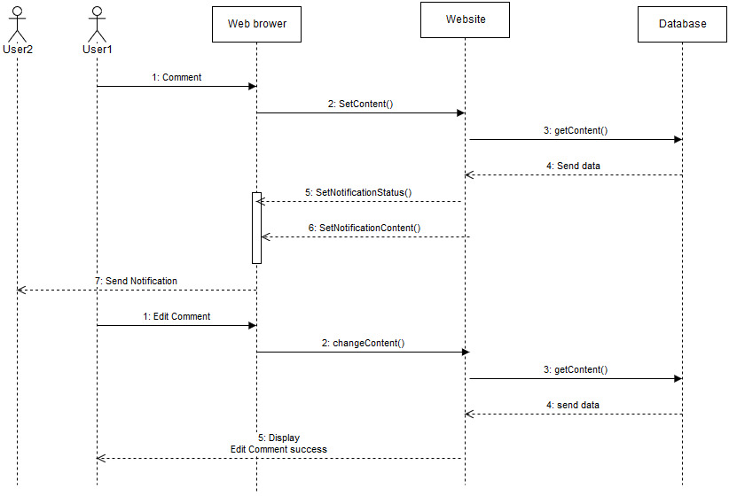

Figure 8: Comment

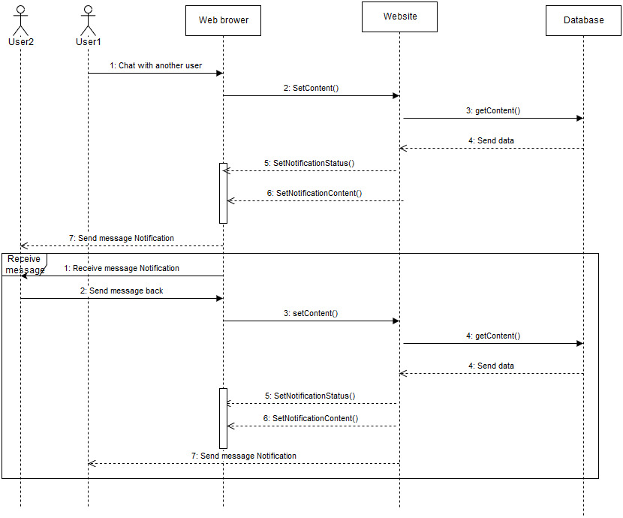

Figure 9: Chat

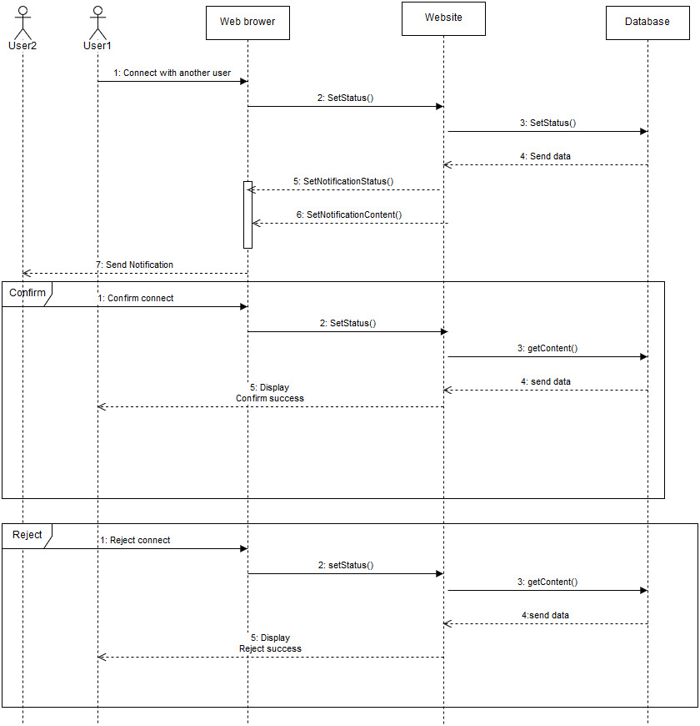

Figure 10: Connect with another User

## ER Diagram

Figure 11: ER diagram