GIT
STEP 1:
Write the Automation Code in Any of the IDE
Project [Main Folder] Sub Folder class[methods,object,variable etc..,] [ .java or .js] [file]
Folder and files
Tester A [Reg] – 5hrs
FaceBook
Registeration
1. To verifyRegWithValidCredentials.java
2. To verifyRegWithinValidCredentials.java
3. To verifyRegWithExistingEmailAddress.java

Tester B [Login ] – [3hrs + import the testerA code]
FaceBook
Login
1.ToVerifyTheLoginWithValidUsernameAndPassword.Java
2. ToVerifyTheLoginWithInValidUsernameAndPassword.Java
3. ToVerifyTheLoginWithValidUsernameAndInvalidPassword.Java

Tester C [HomePage – ProfileEdit]

Tester D

Team Lead [ A – B - C -D] [Automation for login Failed] 2 or 3 files missing
[File Send
File received ]

Tracking System - GIT [Version Control System]
GITHUB Web Hosting device
Working Directory[Copy with in my local Machine] -- [git add filename.format] [git add .] Staging [Selective files To Save] ---- git commit -m “message” Local Repository configure it[git push] - Remote Repository [Repo URL] [Reg +Log]

Move the code from one phase to other with help of git comments

WhenEvery we start to write the code get the latest copy from the remote repo to your Working Directory
[git pull]

To perform this operation:
Working Directory[Copy with in my local Machine] -- [git add filename.format] [git add .] Staging [Selective files To Save] ---- git commit -m “message” Local Repository

We need “GIT” to be installed in your machine

To perform this operation:
Remote Repository [Repo URL] [Reg +Log]
We need to have “gitHub” account [Reg and login]

Go To google Search GIT Download
Step 1:
Create a local Repository for your current Project [Note: Only Project File]
Go to Project folder path:
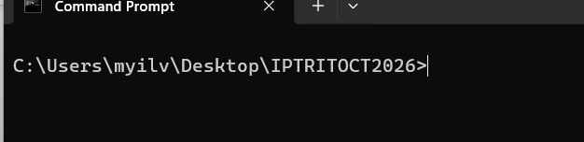
Step 2: Create a local repository
comment: git init

