

[Dynamic Websites]
Assignment Title:
[Home Gym Equipment (HGE)]

Submitted To:
[Kyaw Swar Thant]

Submitted By:
[Myint Myat]
[Student ID -00185397]

NCC L5 DBIT: Strategy First University



NCC Education
Level 5 Diploma in Computing with Business Management
Dynamic Website

Centre Name : Strategy First University
Assignment Title : Home Gym Equipment(HGE)
Exam Cycle : Spring-Winter 2022
Candidate Name : Myint Myat
NCC Education ID No. : 00185397
Submission Date : 17.2.2022
Marker’s Comment :
Moderator’s Comment :

Mark: Moderated Mark : Final Mark :
Statement and Confirmation of Own Work

Strategy First University
A signed copy of this form must be submitted with every assignment.
If the statement is missing your work may not be marked.

Student Declaration
I confirm the following details:

Candidate Name: | Myint Myat
Candidate ID Number: | 00185397
Unit: | Dynamic Websites
Centre: | Strategy First University
Qualification: | Level 5 Diploma in Business Information Technology
I have read and understood NCC Education’s Academic Misconduct Policy.
I confirm that this is my own work and that I have not colluded or plagiarized any part of it.
Candidate Signature: | MM
Date: | 17.2.2022

Task 1
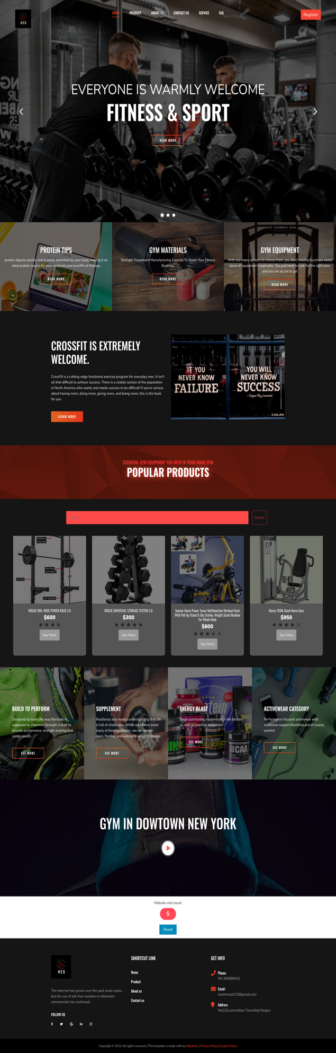
Fig 1.1 -Home Page
Page

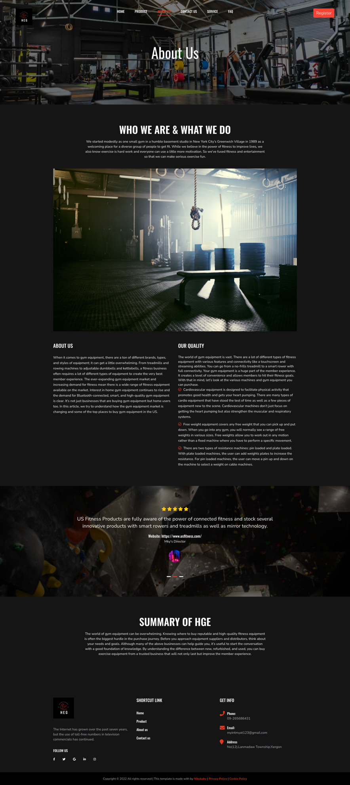
Fig 1.2 -Cookie Policy Page

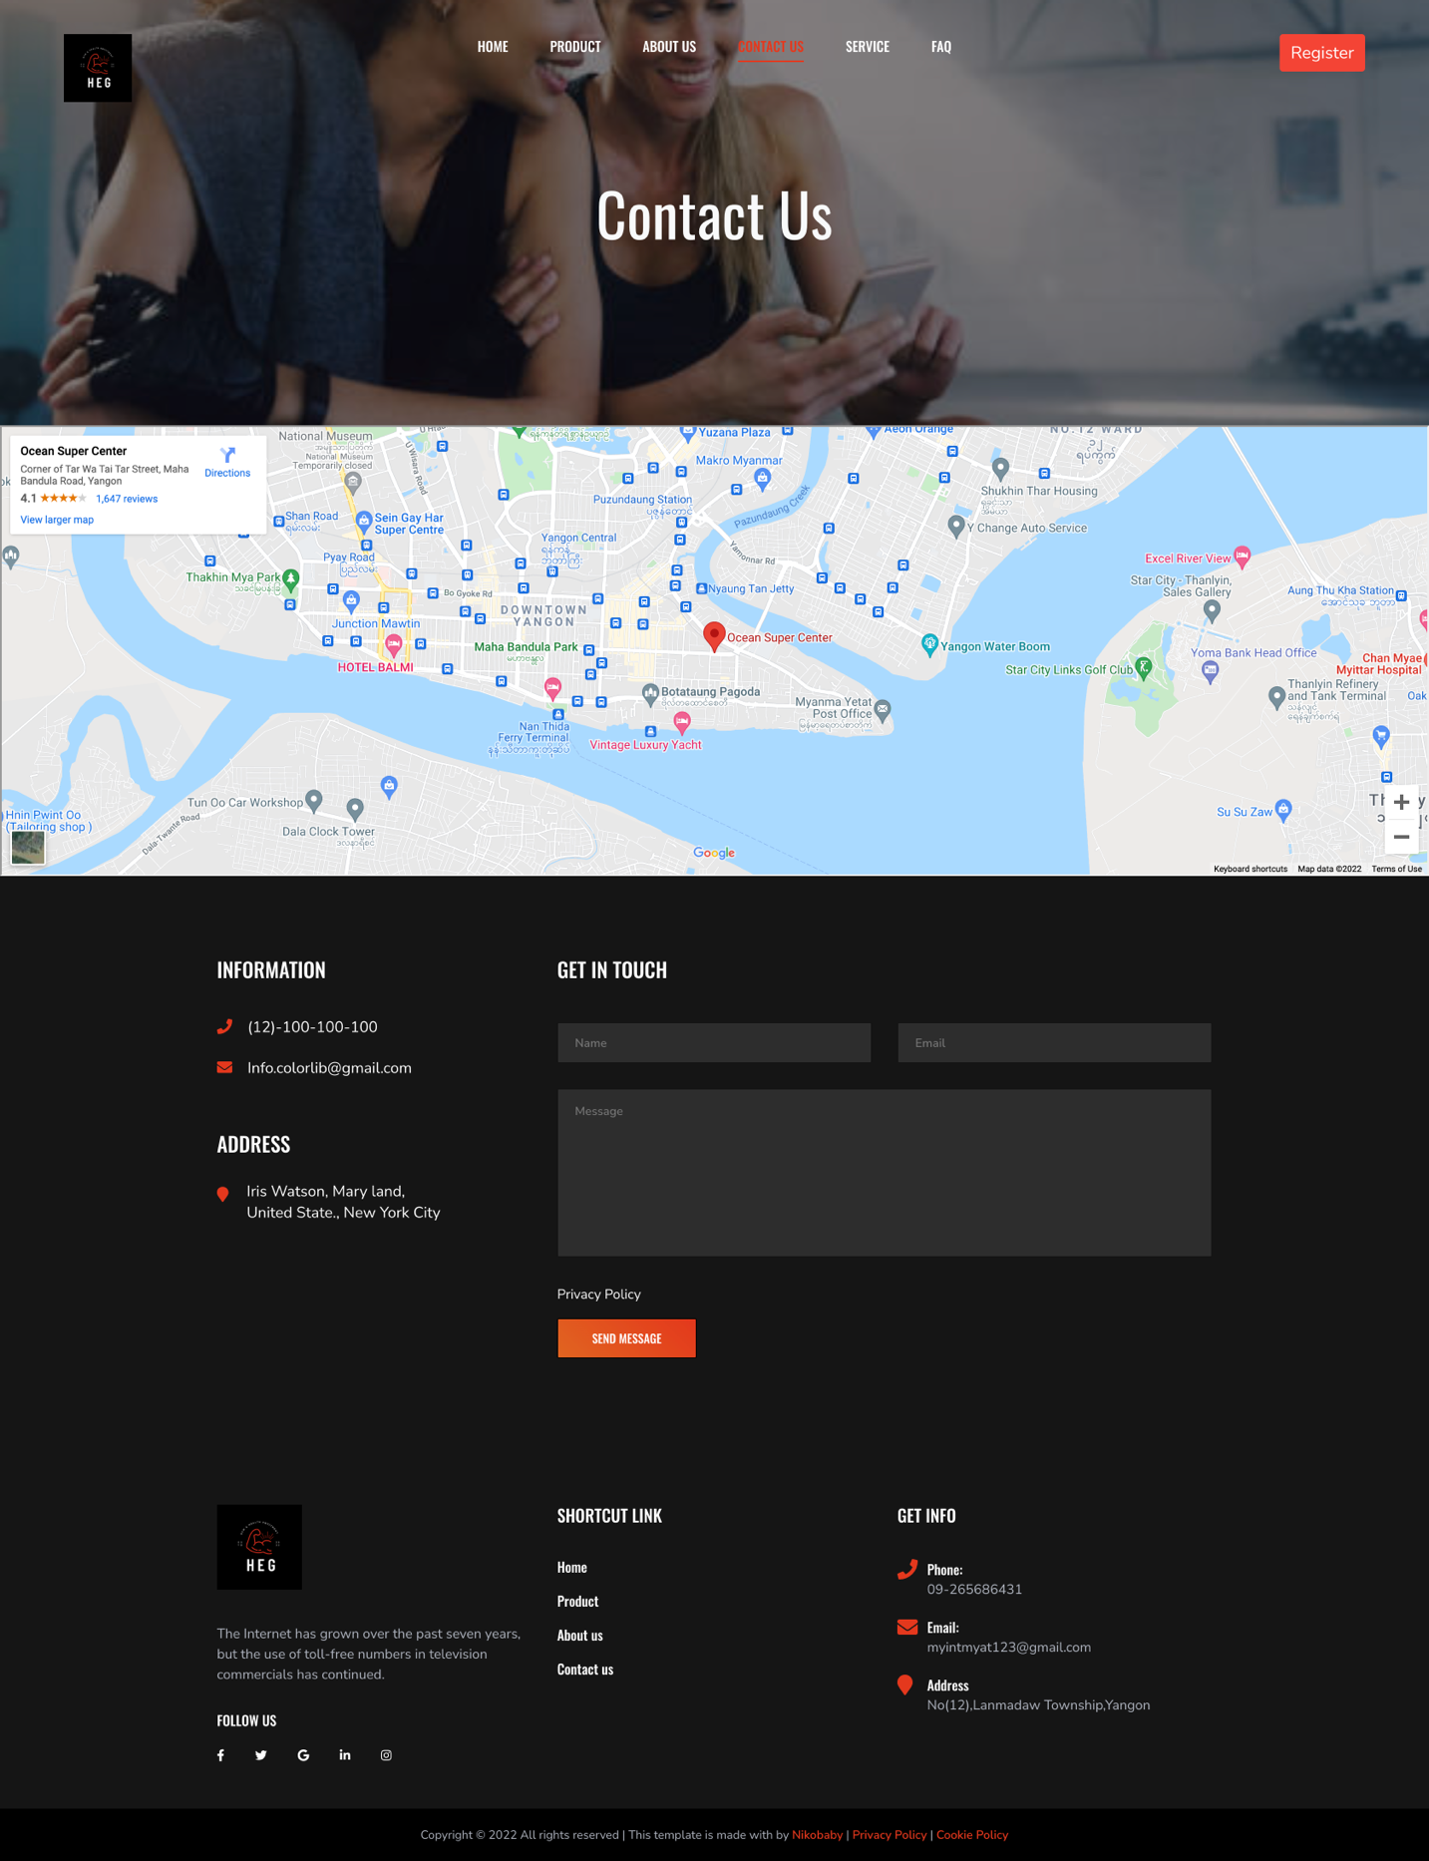
Fig 1.3- Contact Us Page

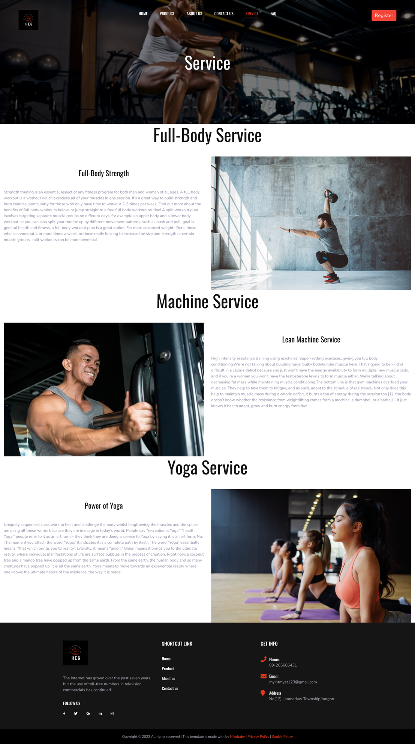
Fig 1.4-Service Page

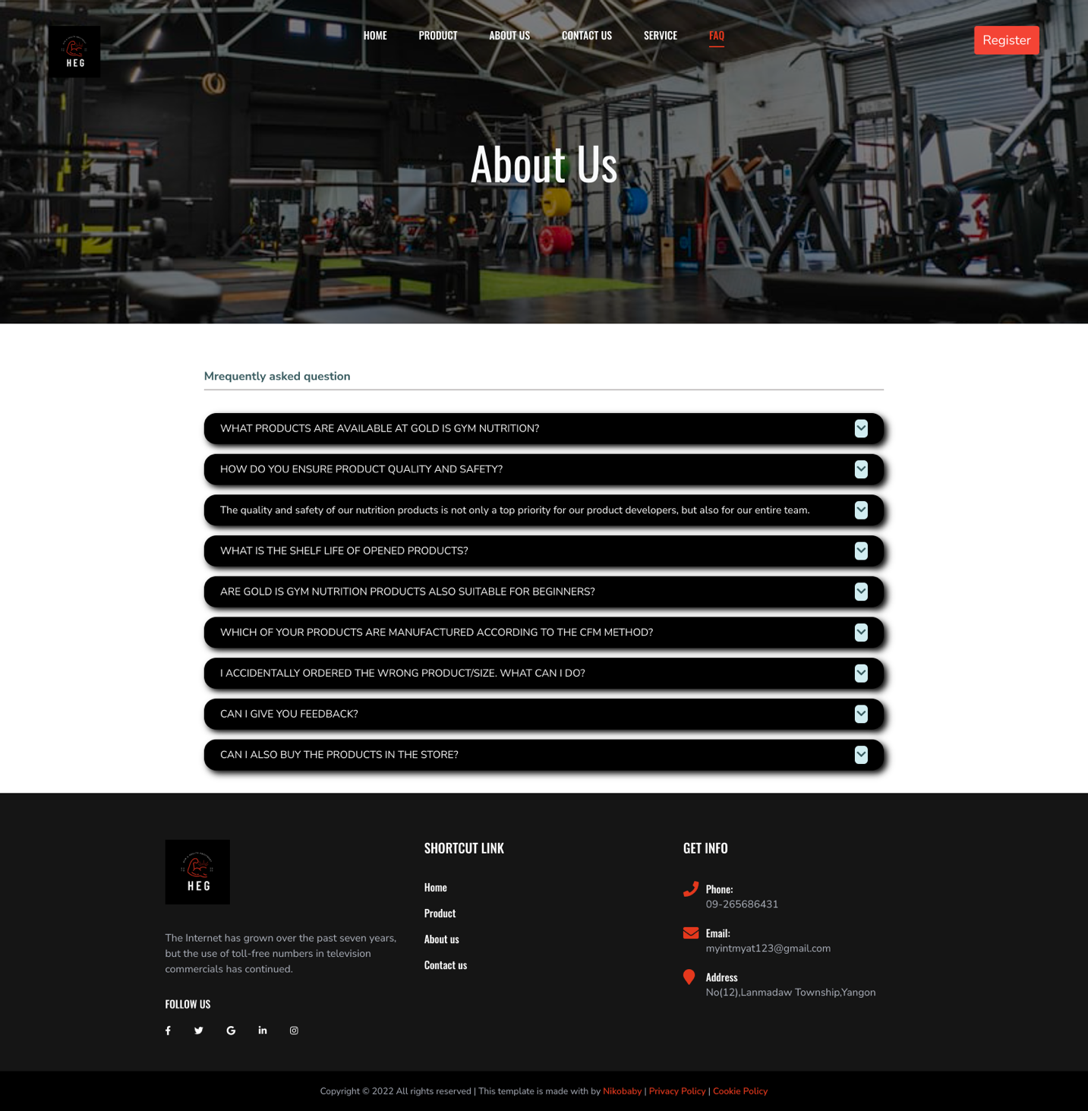
Fig 1.5-FAQ Page

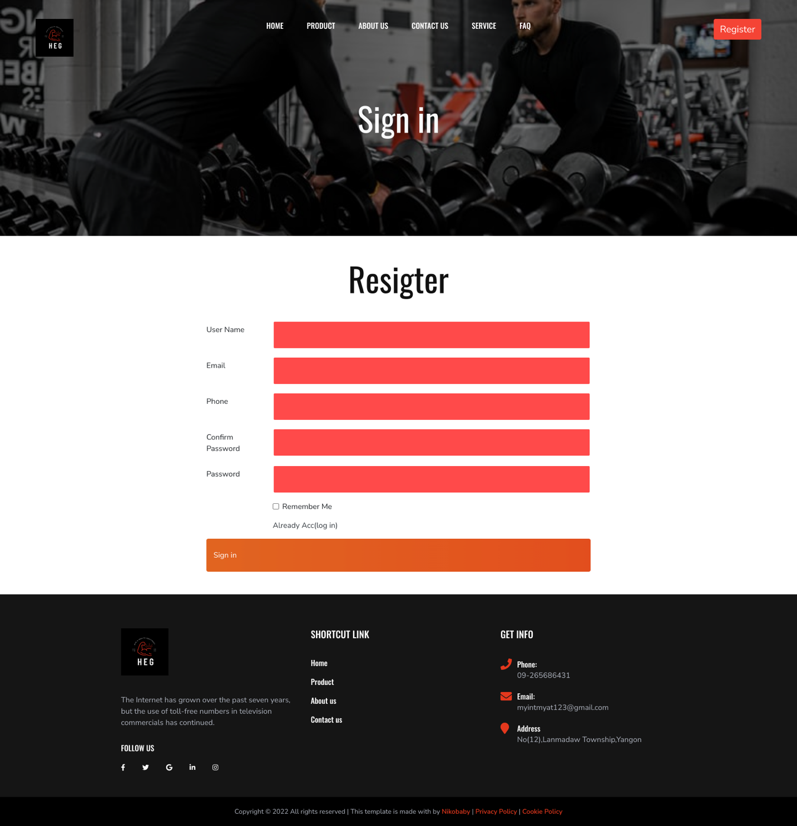
Fig 1.6-Register Page

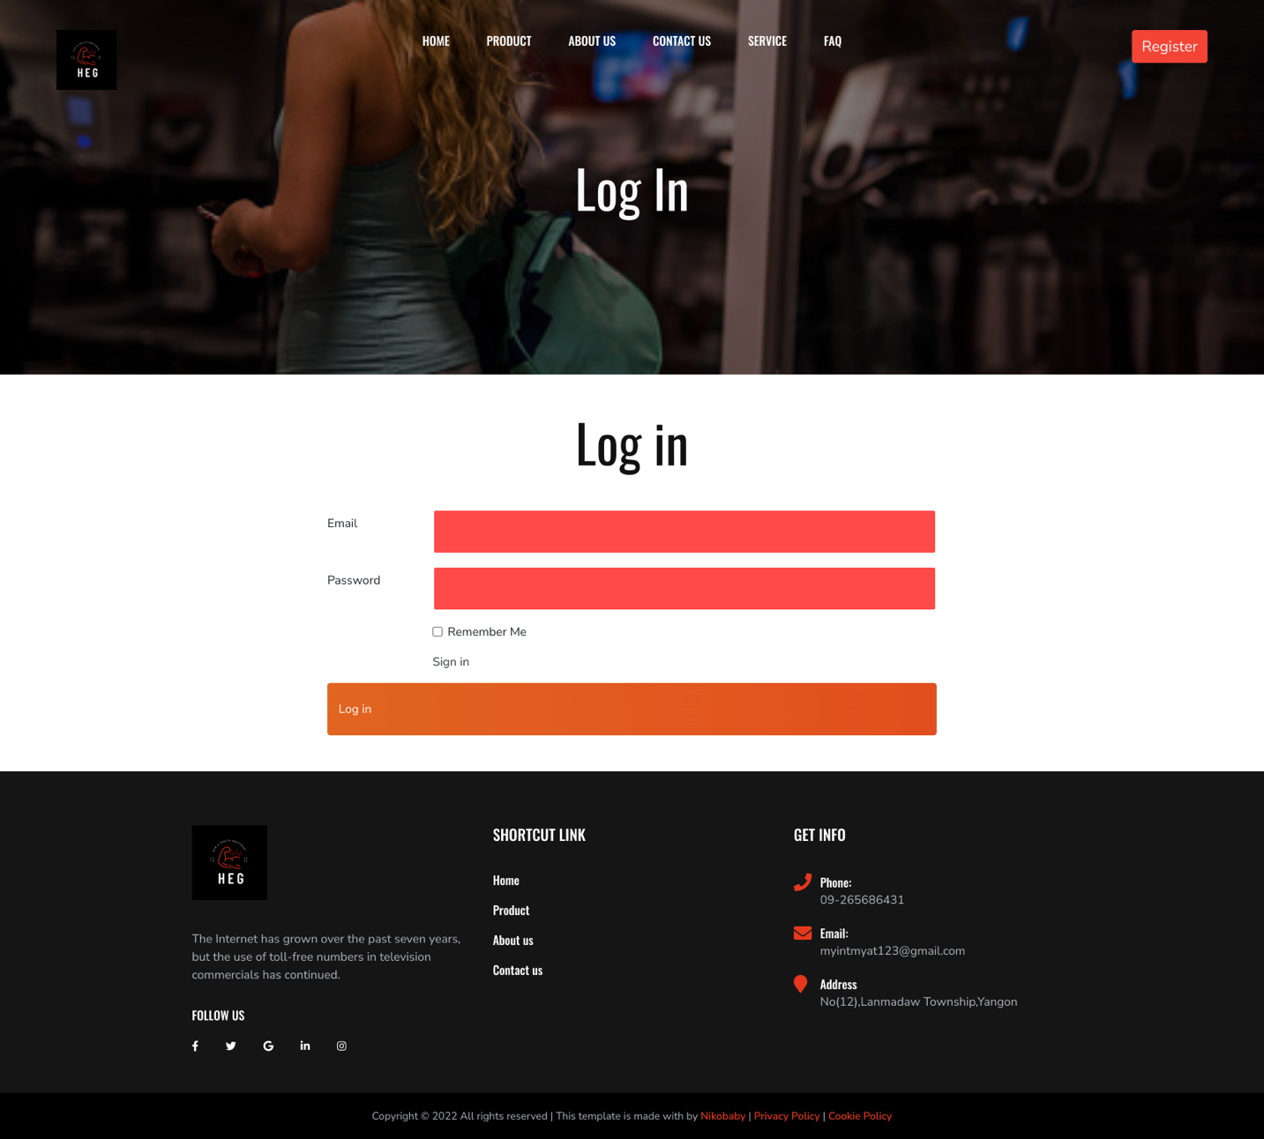
Fig 1.7-Login Page

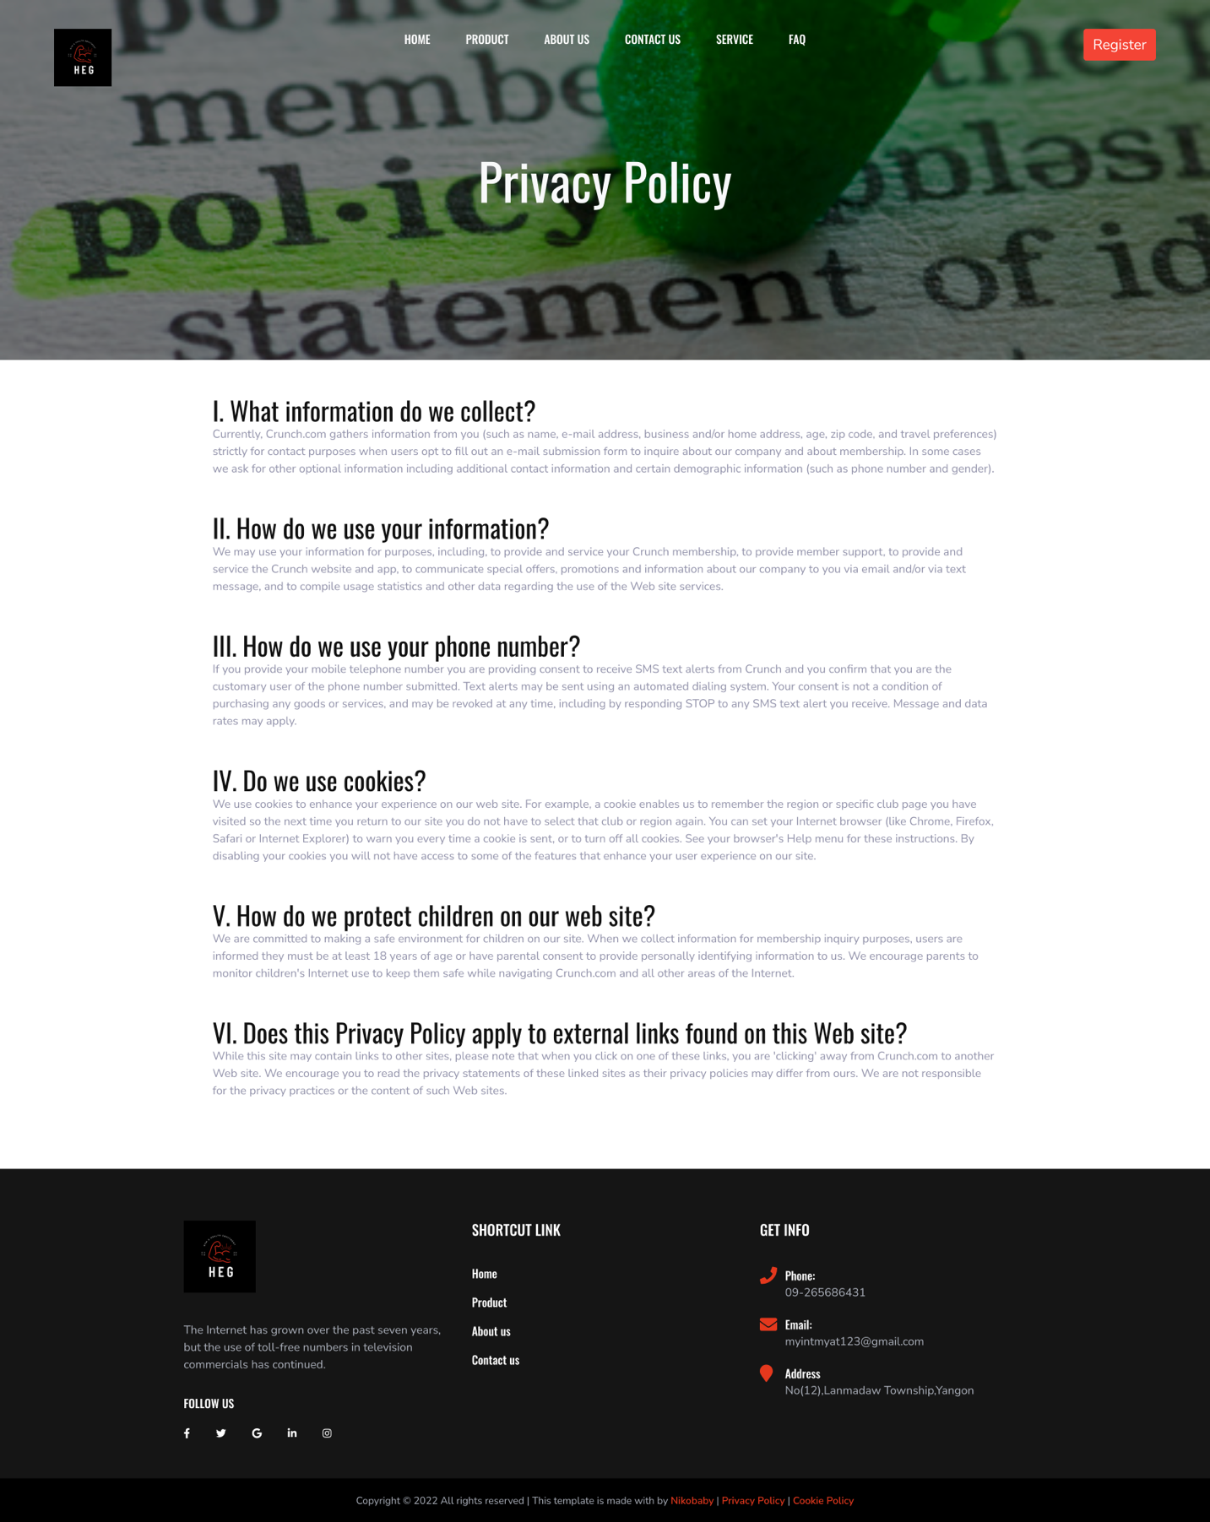
Fig 1.8-Privacy Page

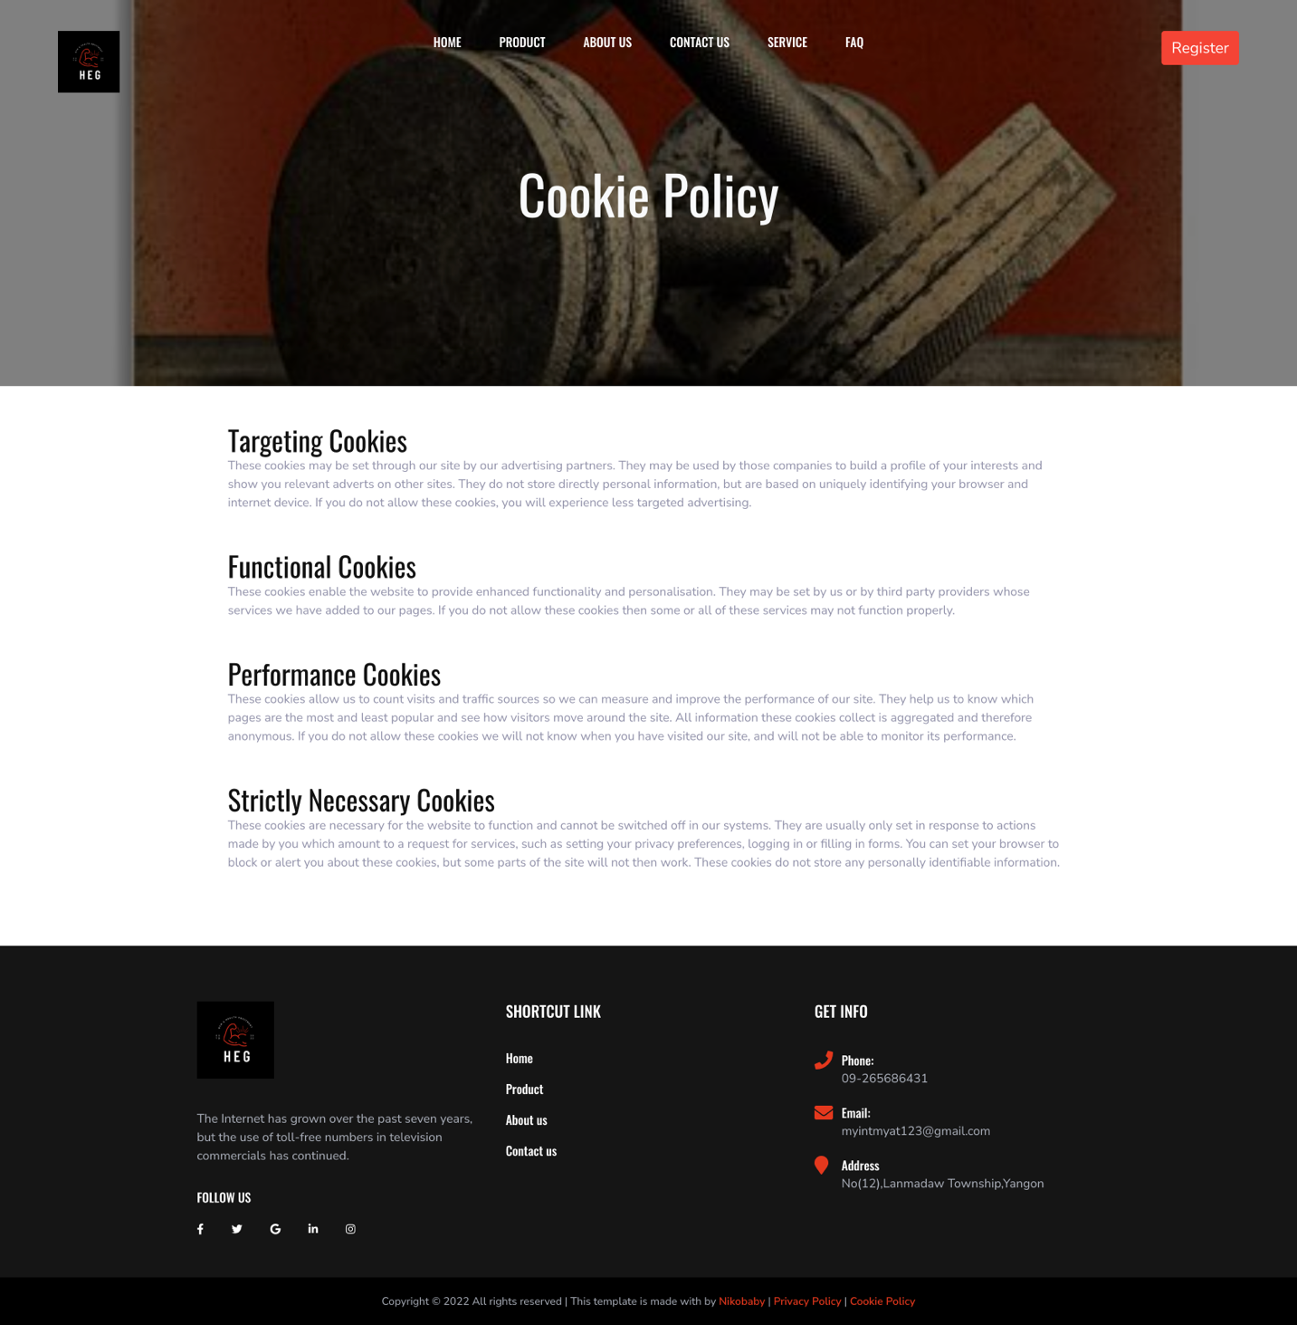
Fig 1.9-Cookie Page

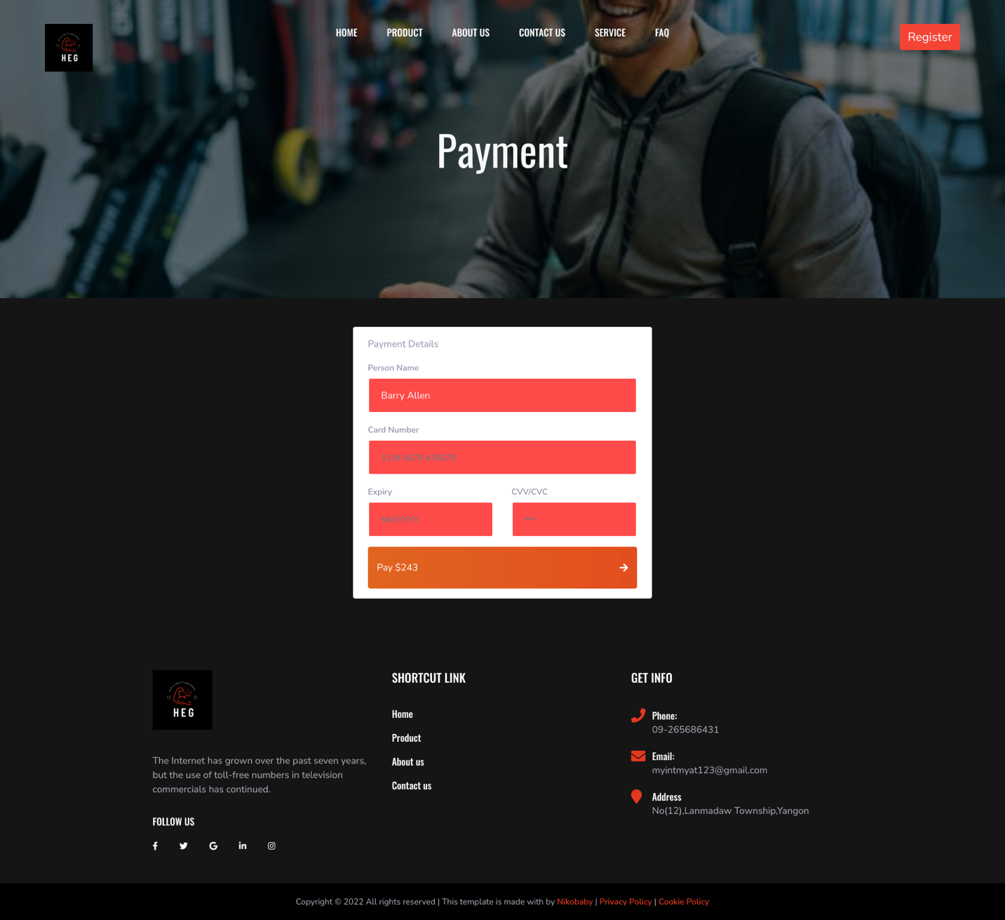
Fig 1.10-Payment Page

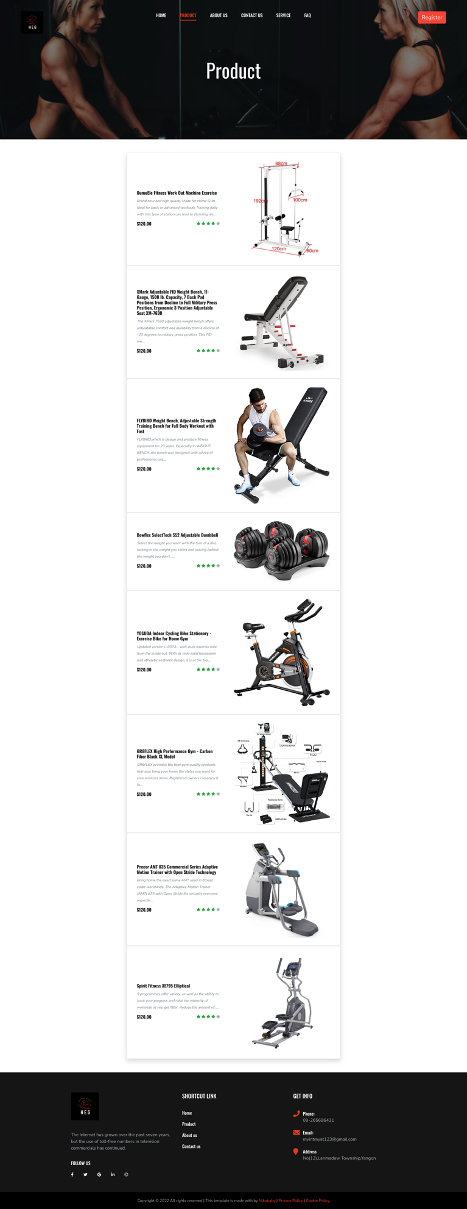
Fig 1.11-Payment Page

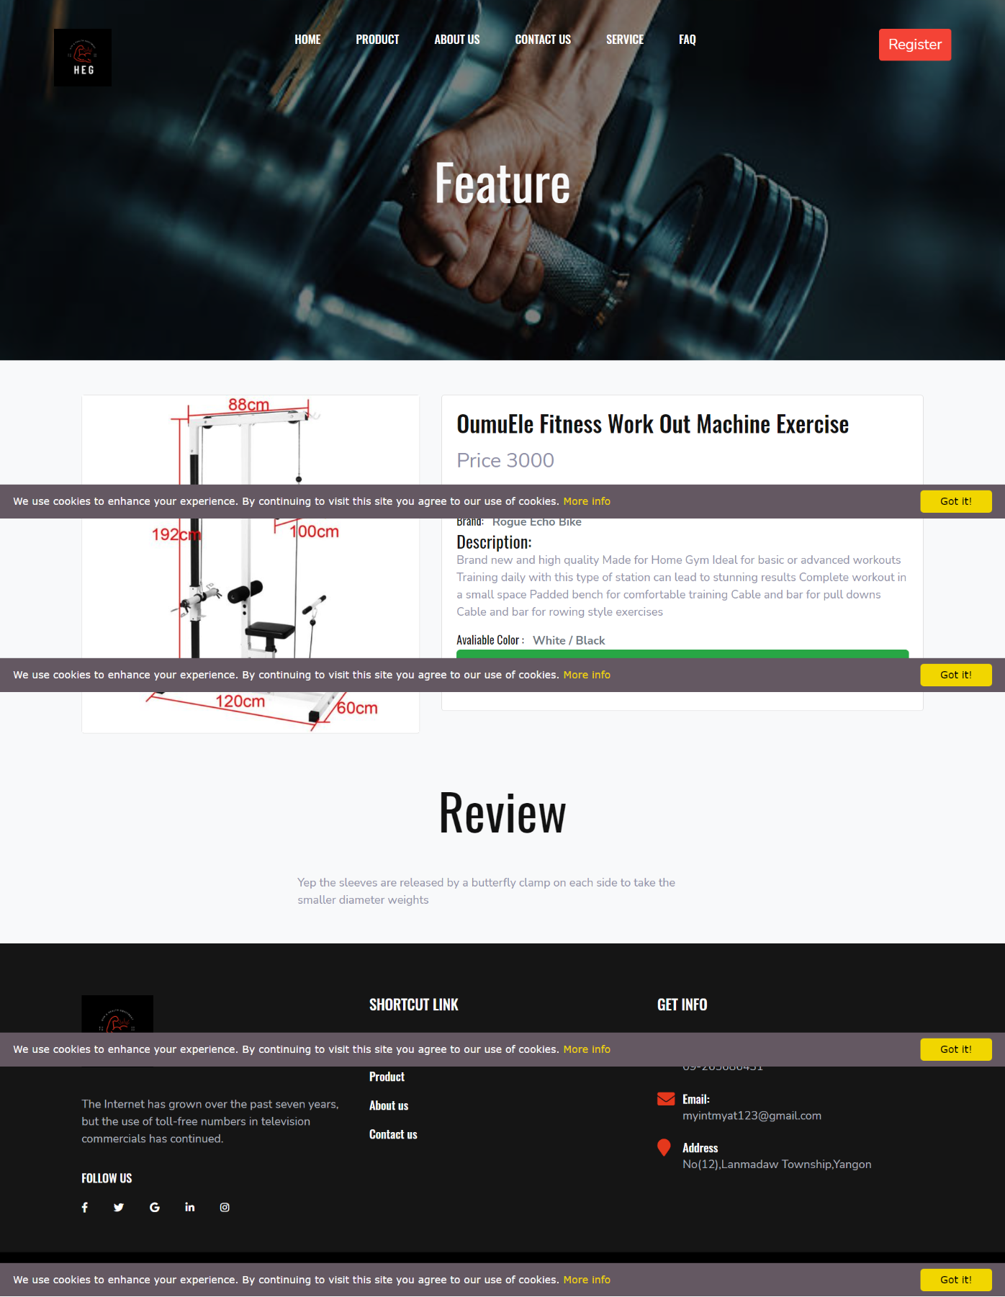
Fig 1.12-Feature Page

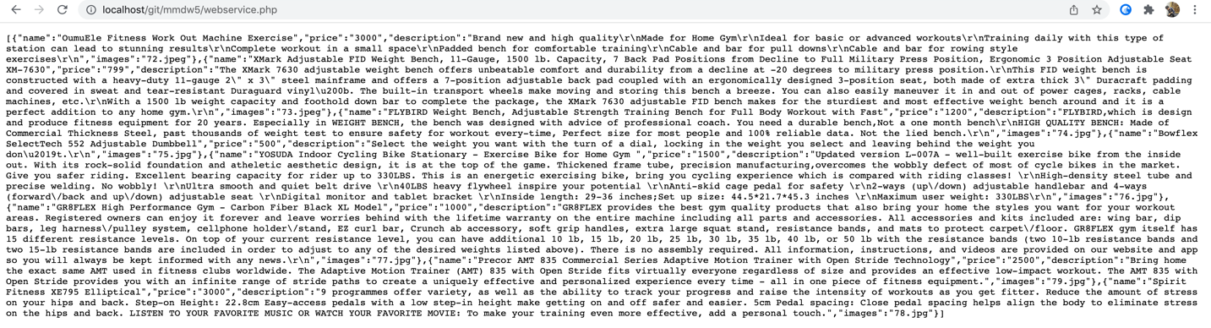
Fig 1.13-Payment Page

Code for index
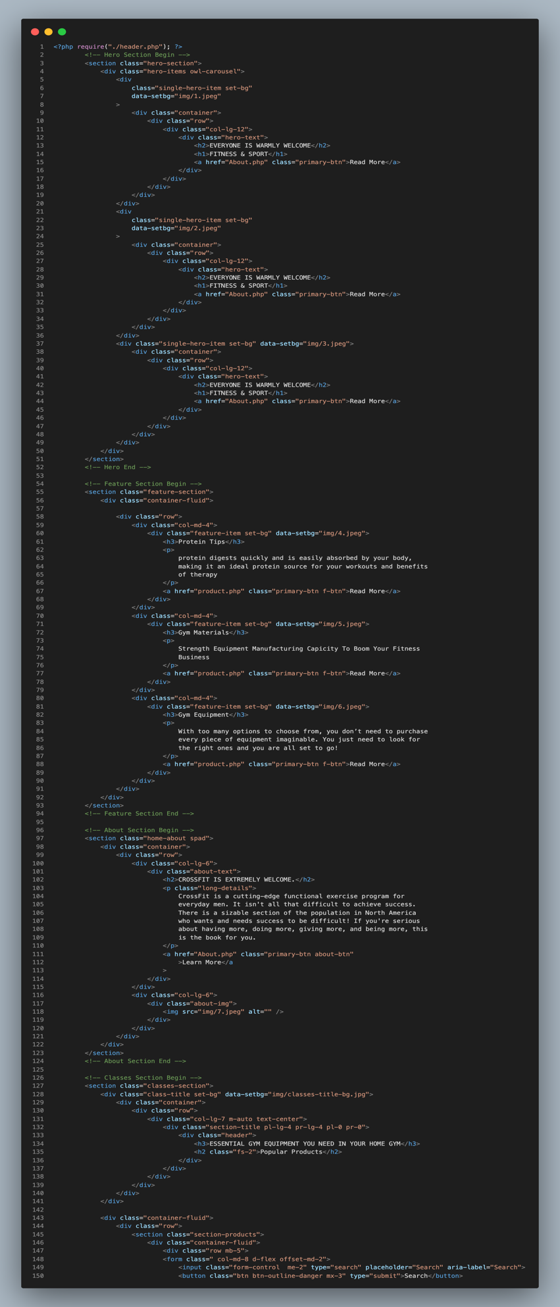

Code For index

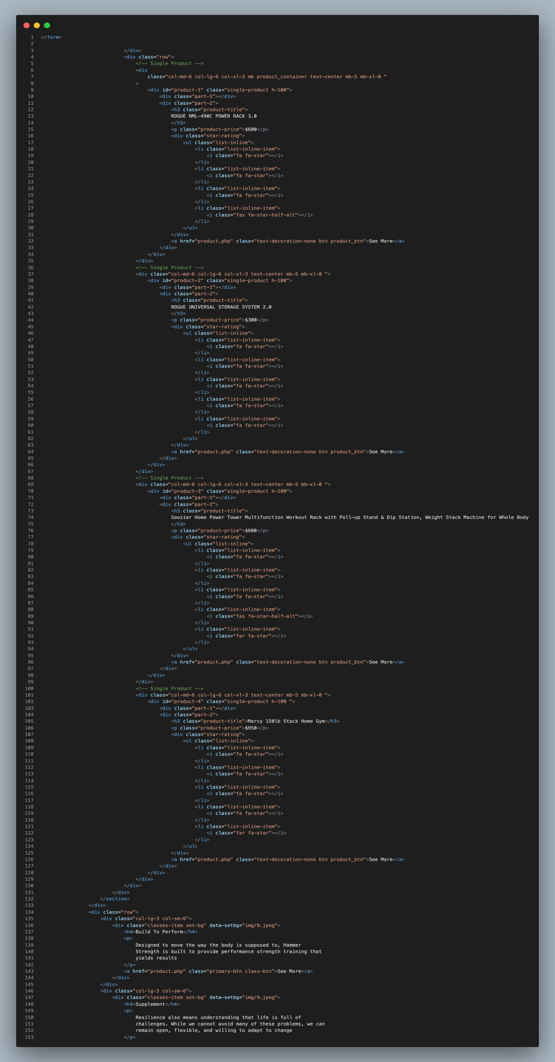

Code For Index

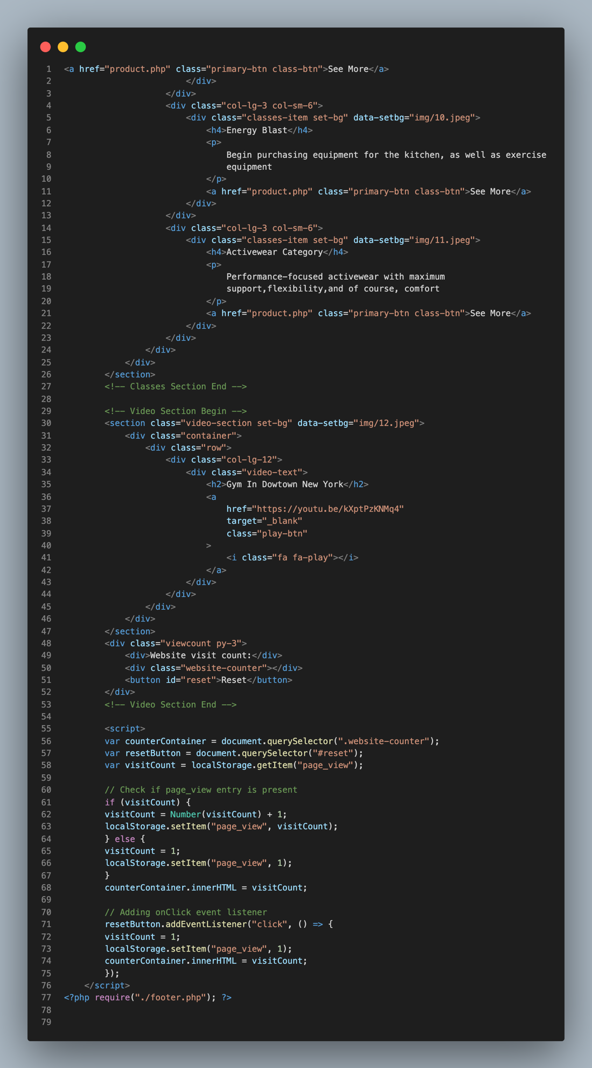

Code for login

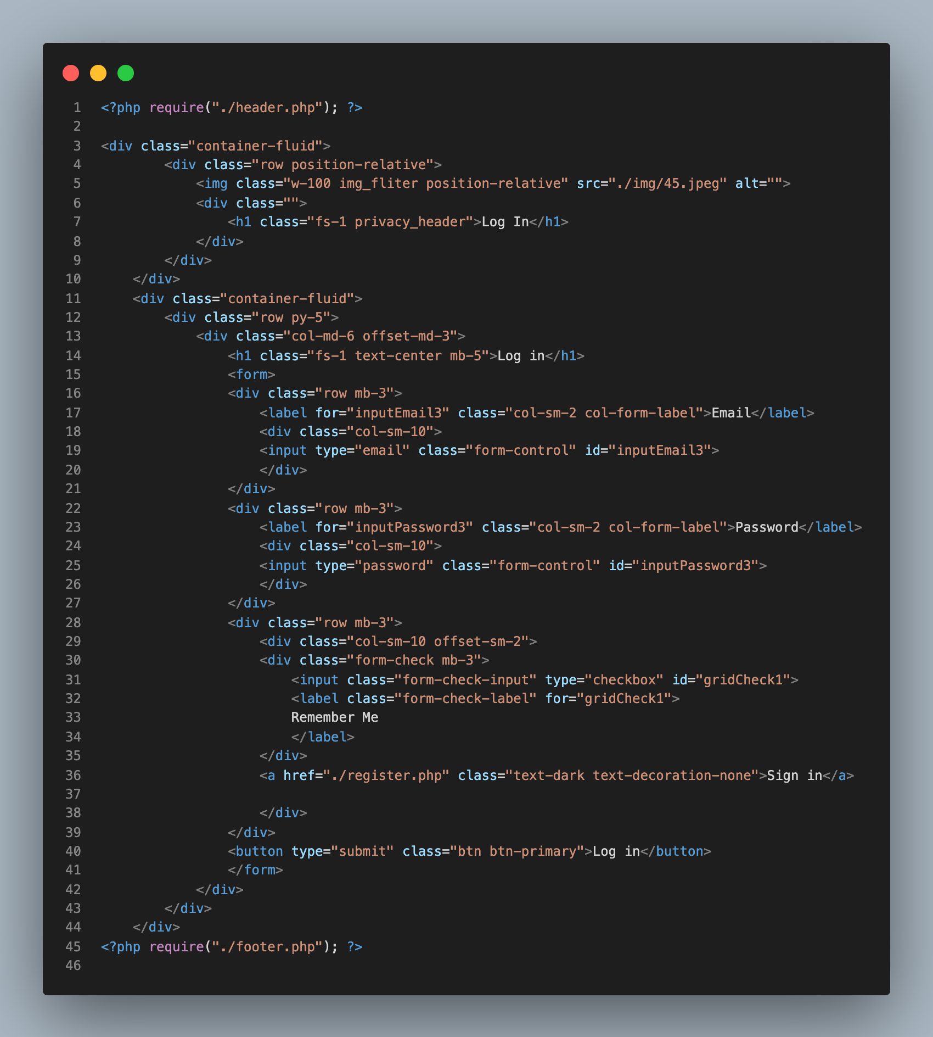

Code for header

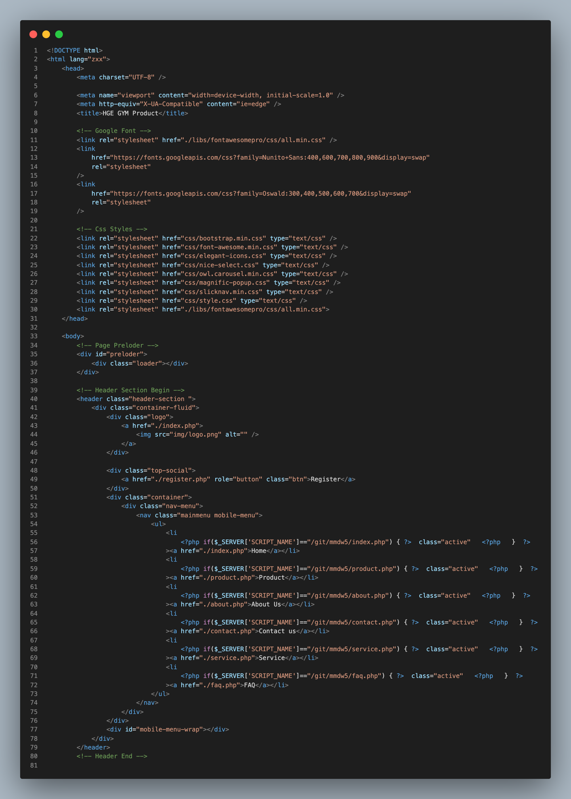

Code for Footer

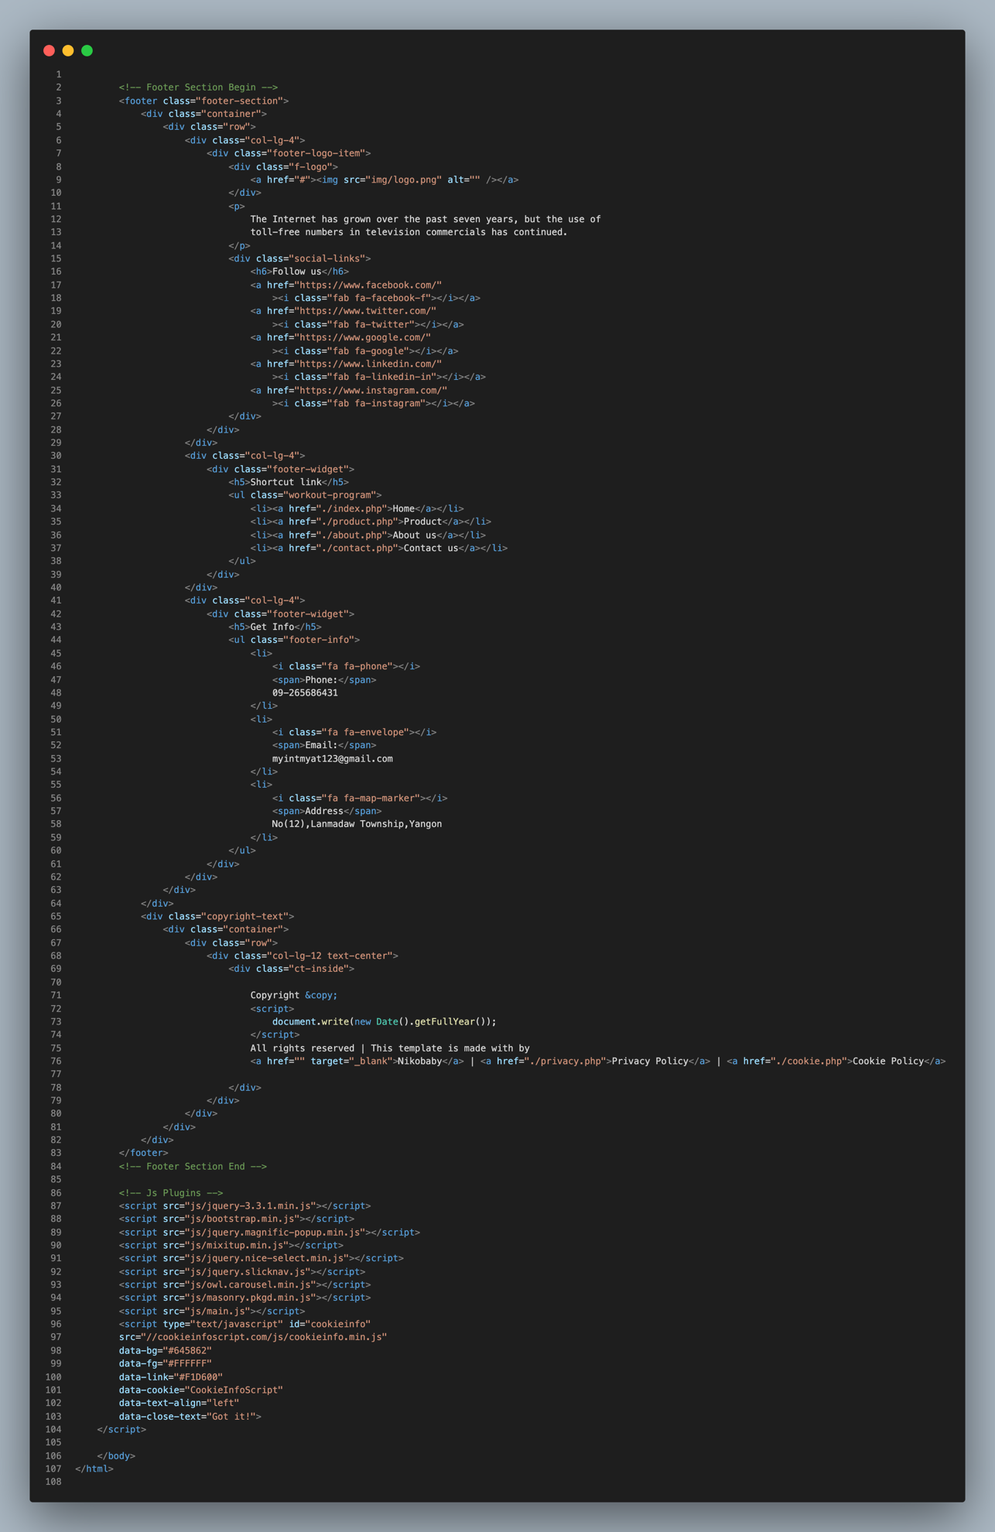

Code For Feature

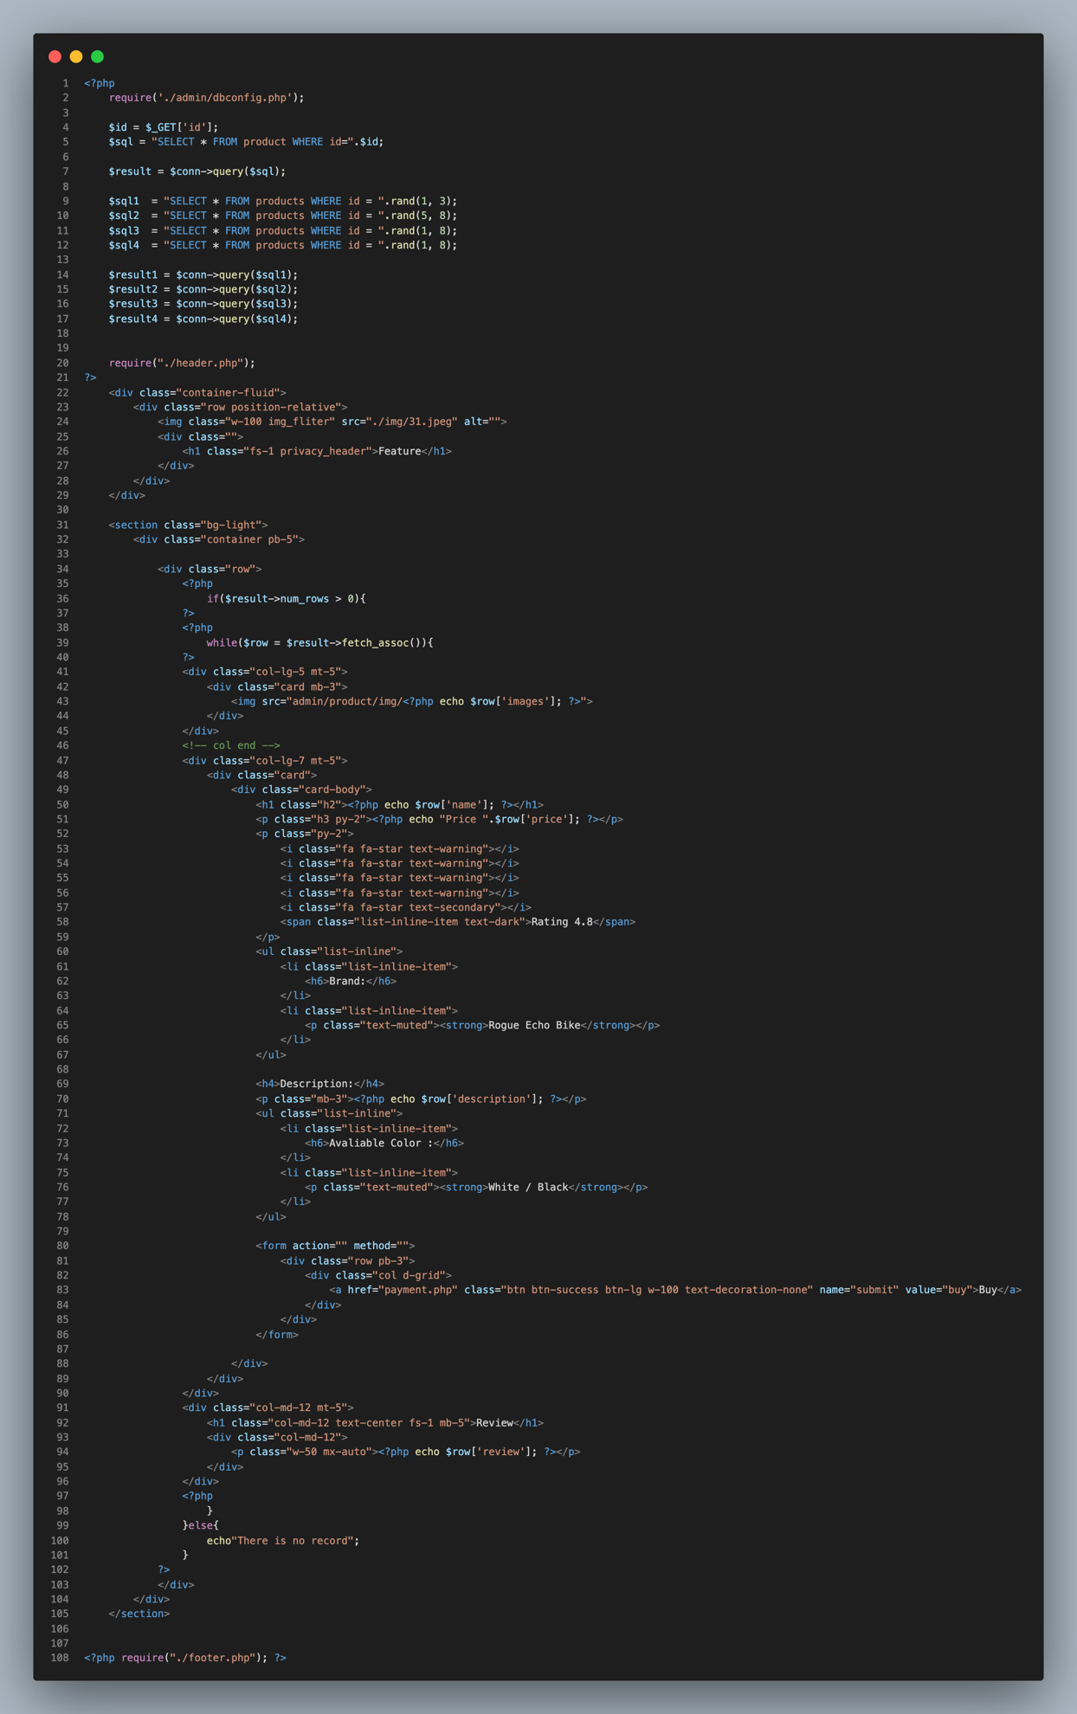

Code For FAQ

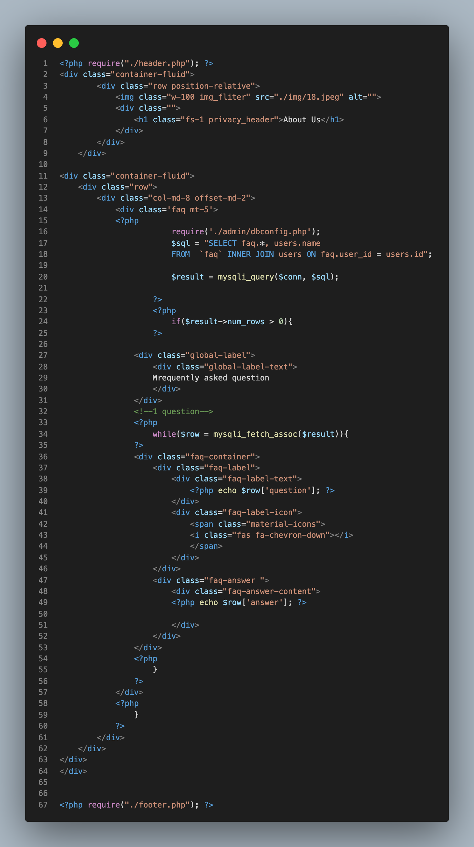

Code For Cookies

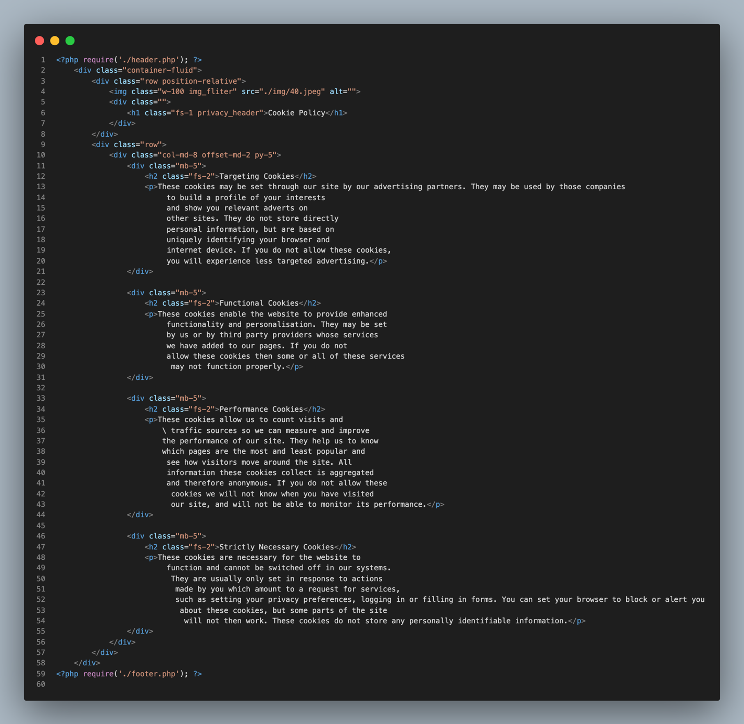

Code For Contact
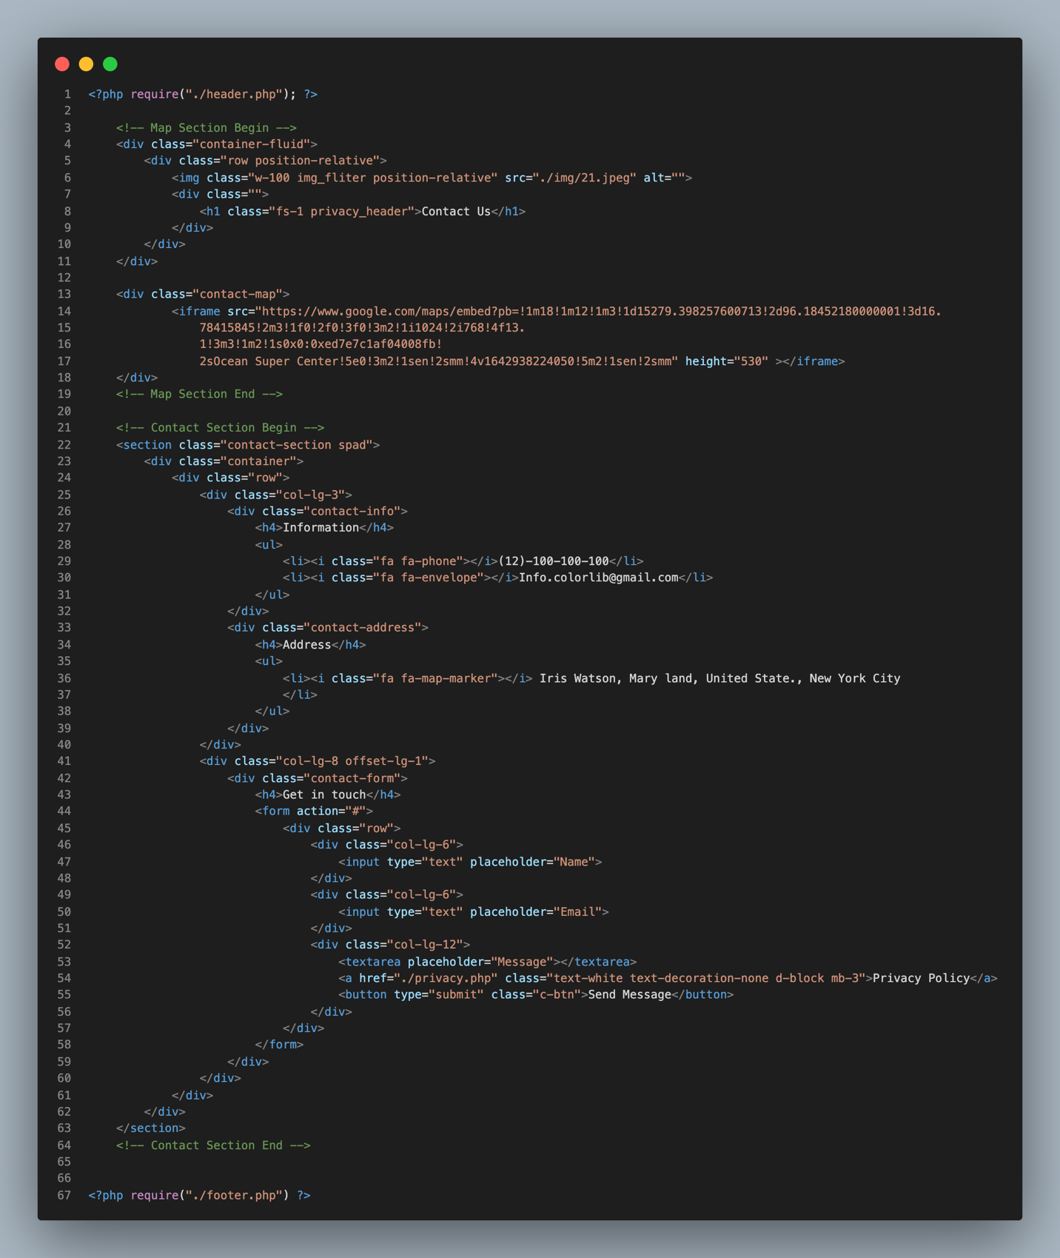

Code For About

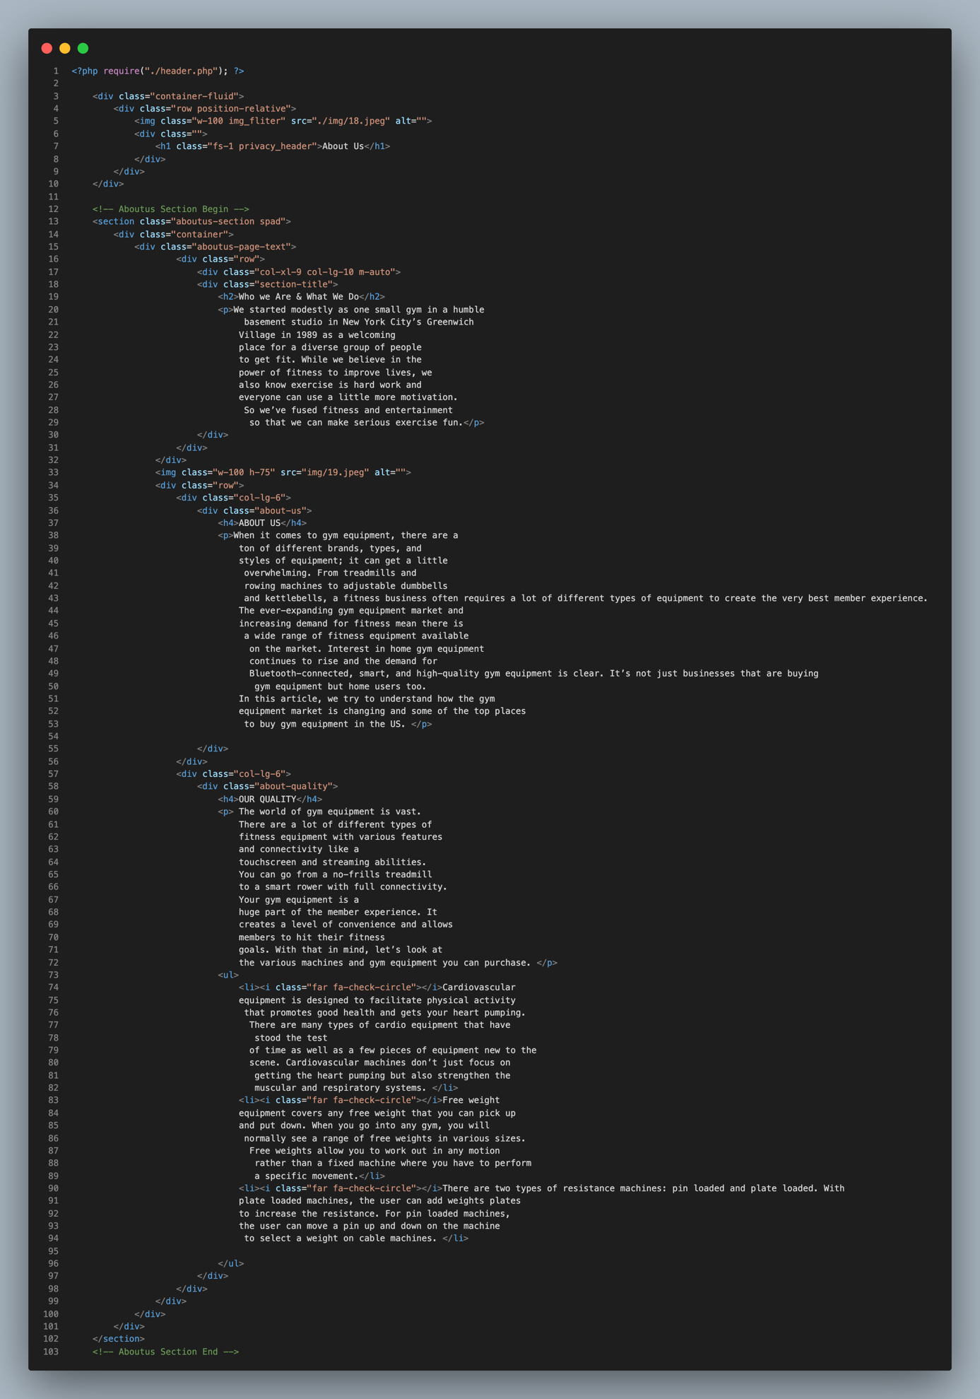

Code For About

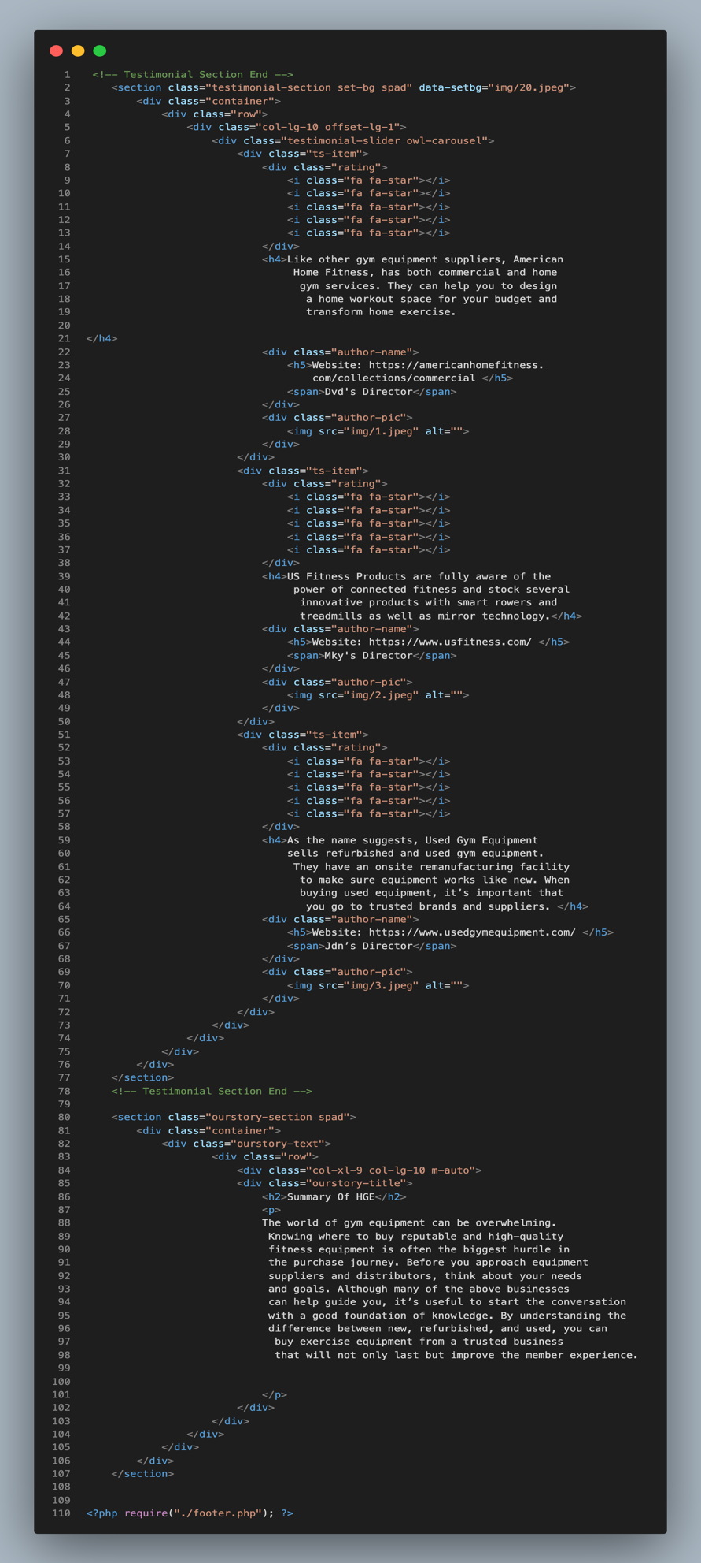

Code For Payment

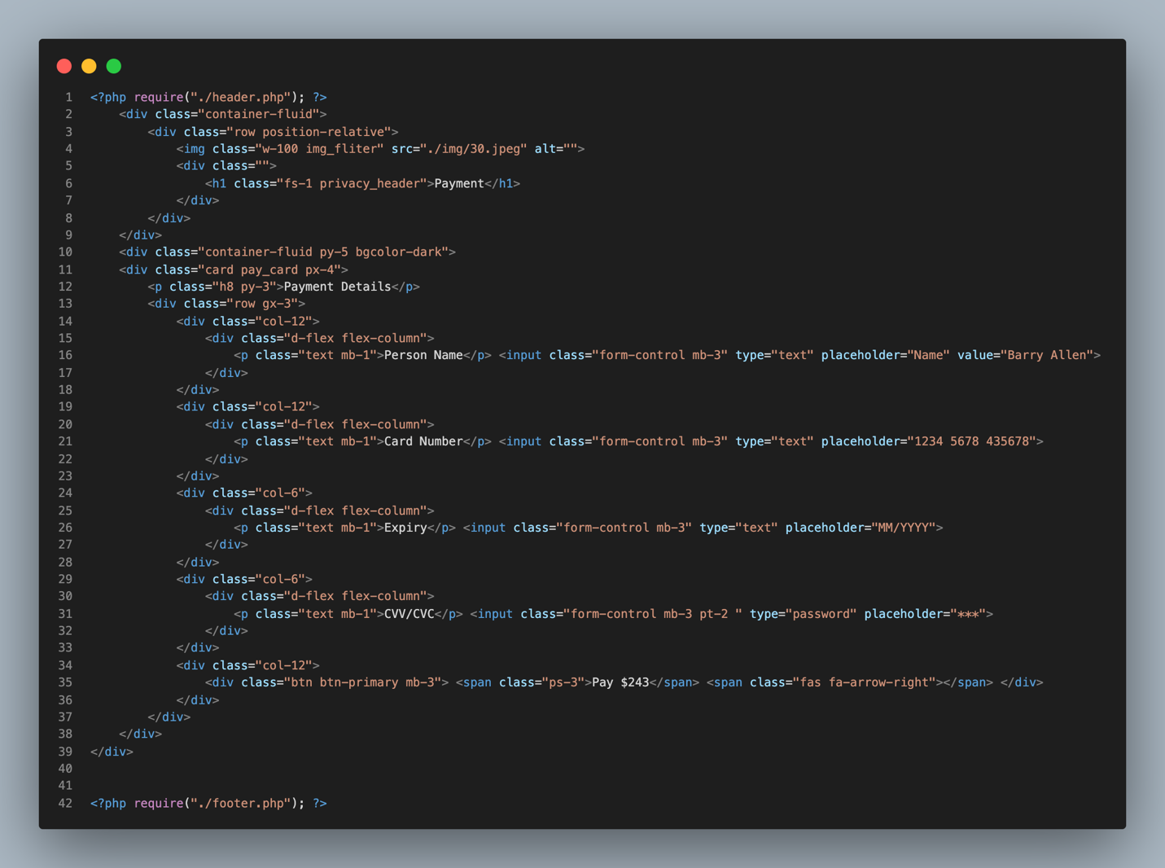

Code For Privacy

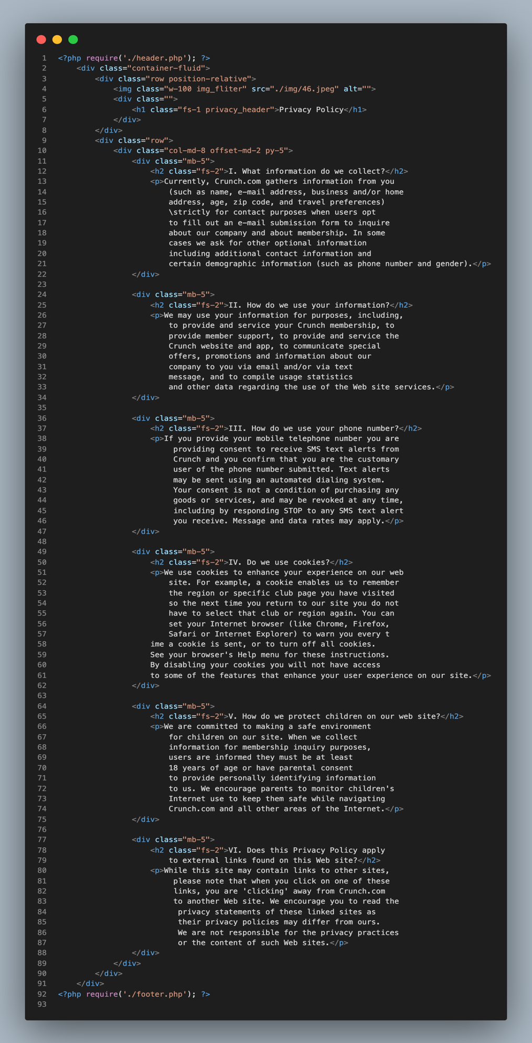

Code For Product

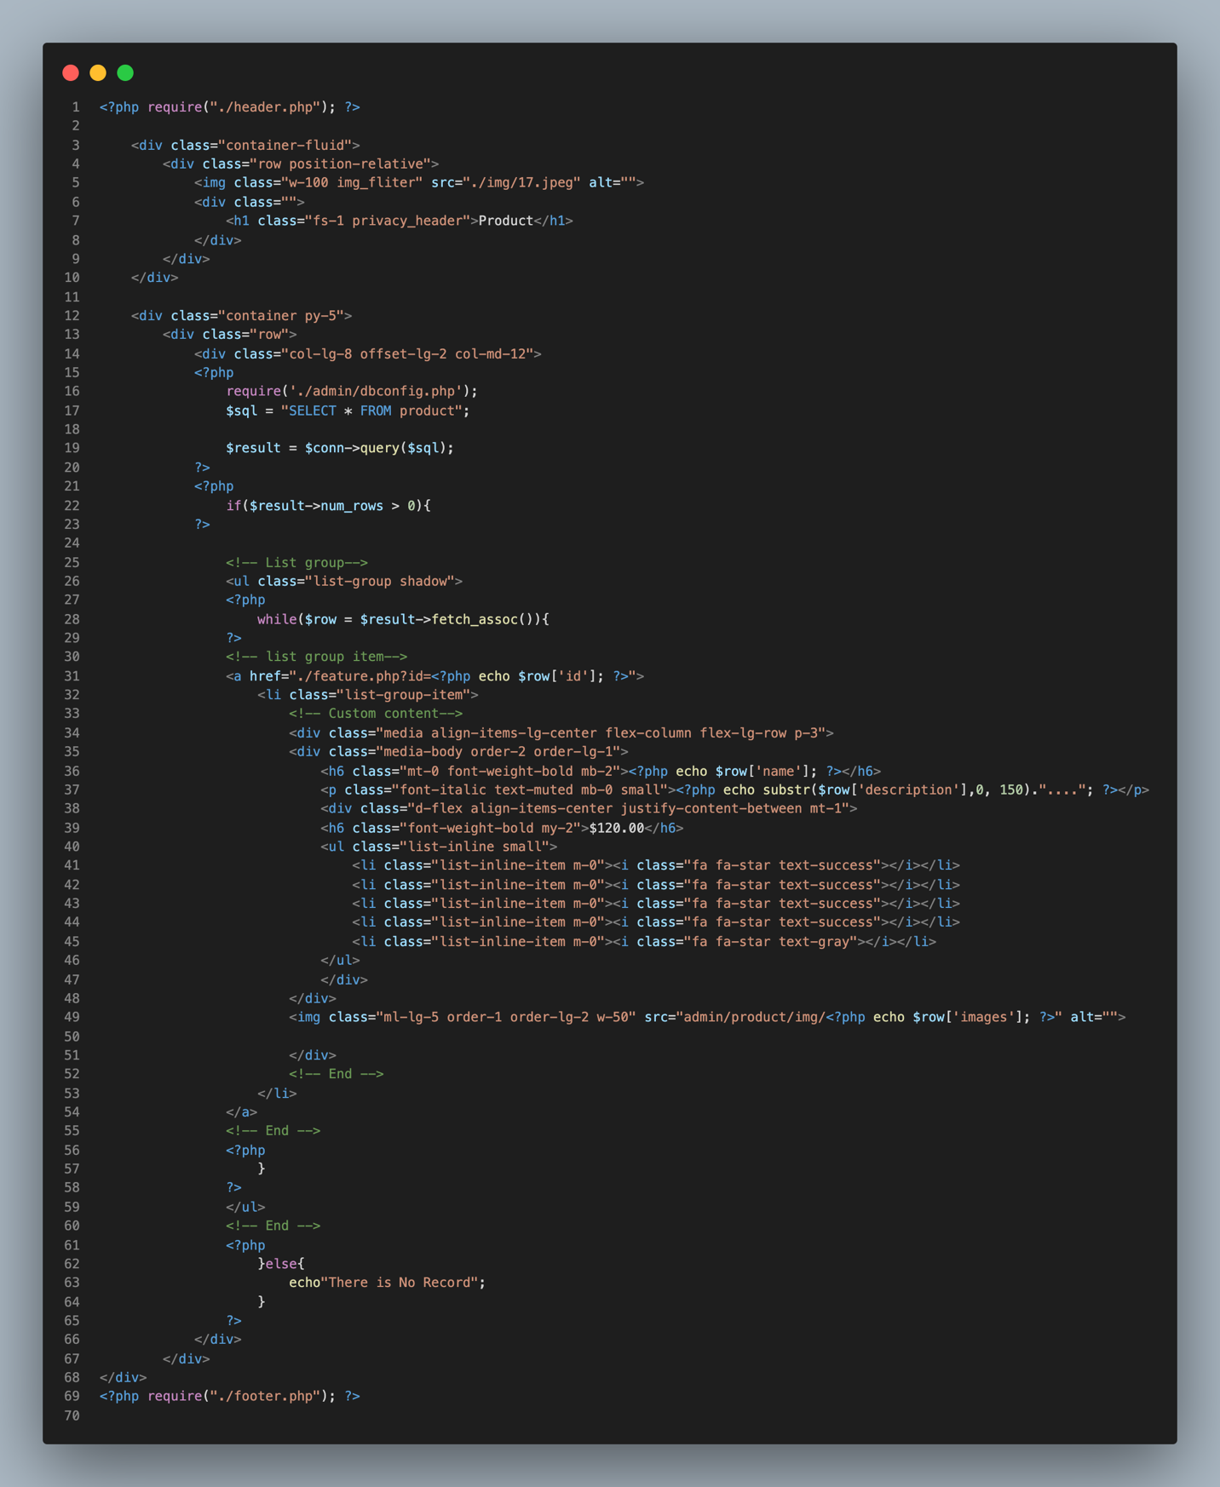

Code For Register

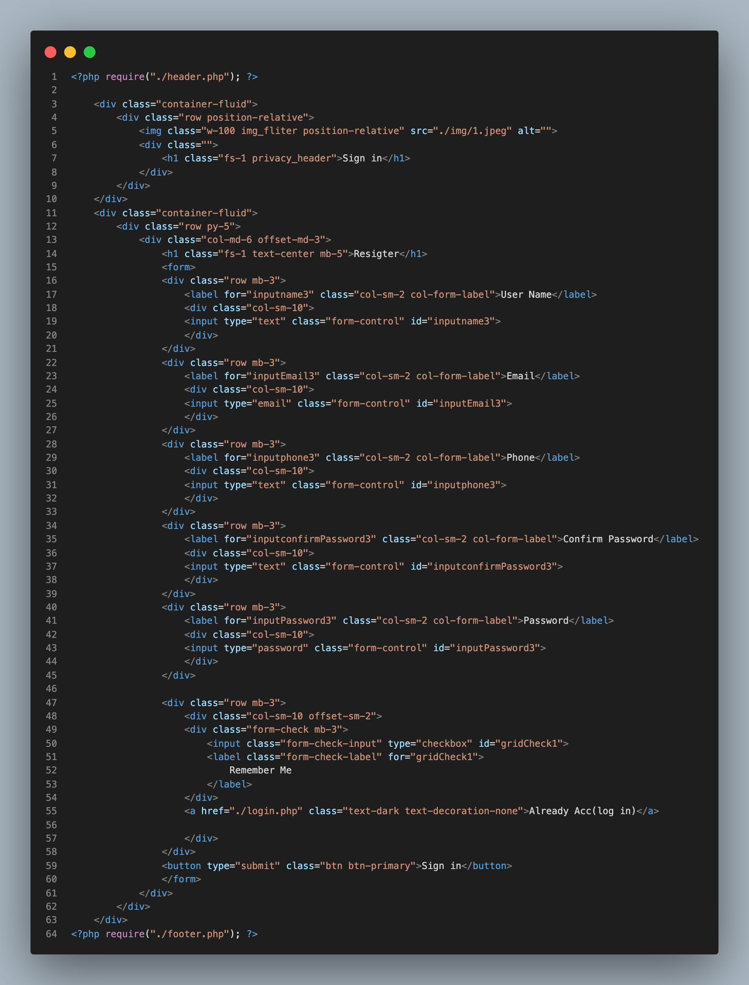

Code For Services

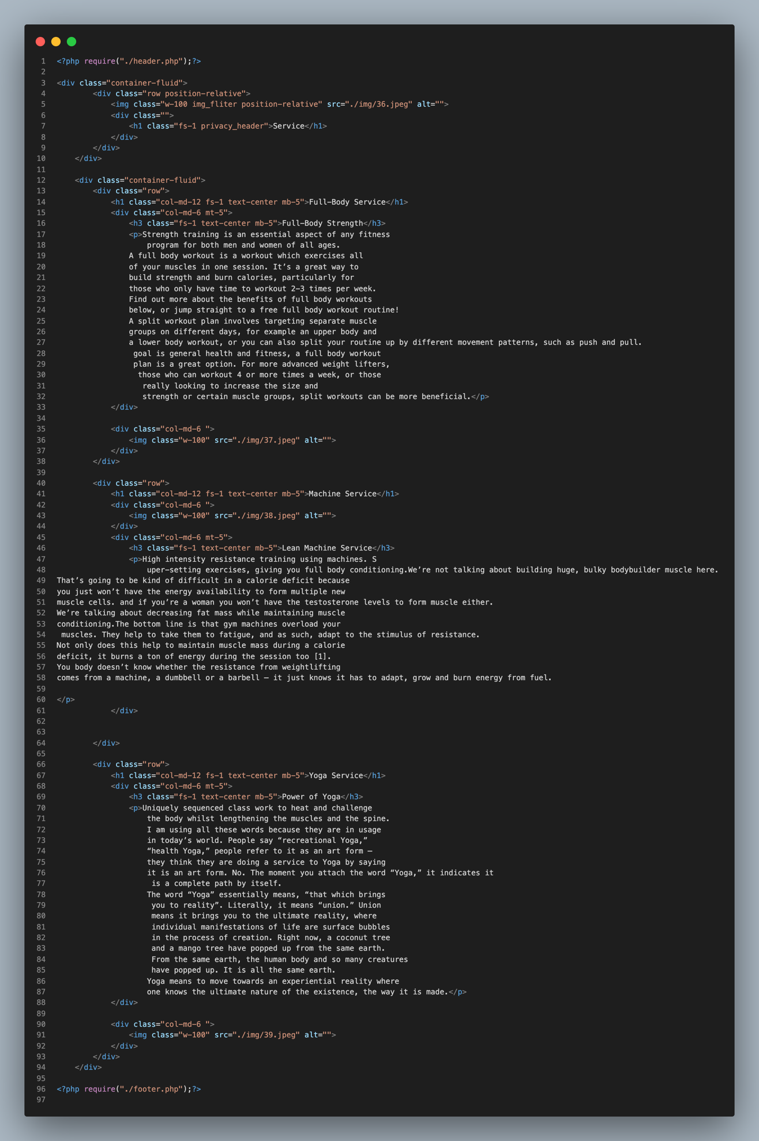

Code For webservice

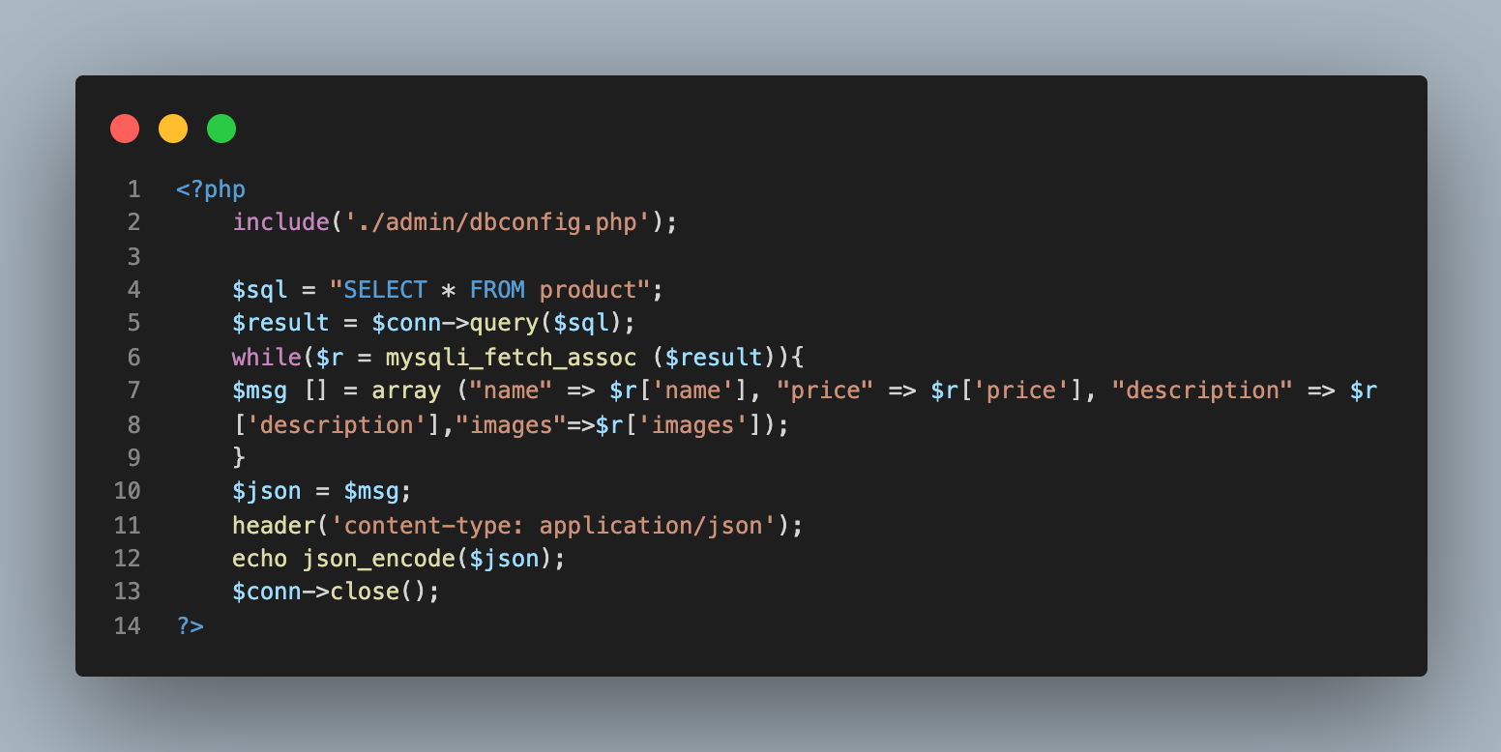

Task 2
Style.css
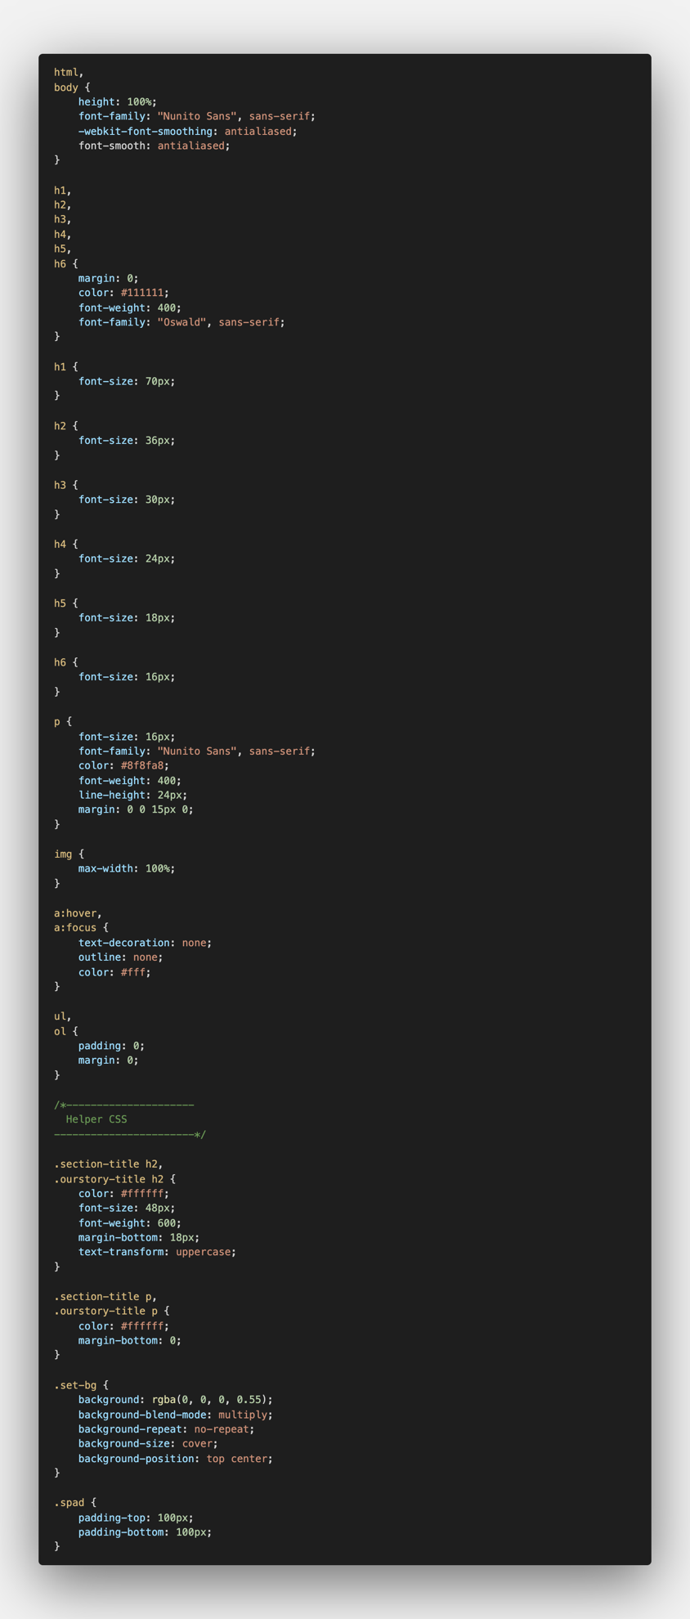
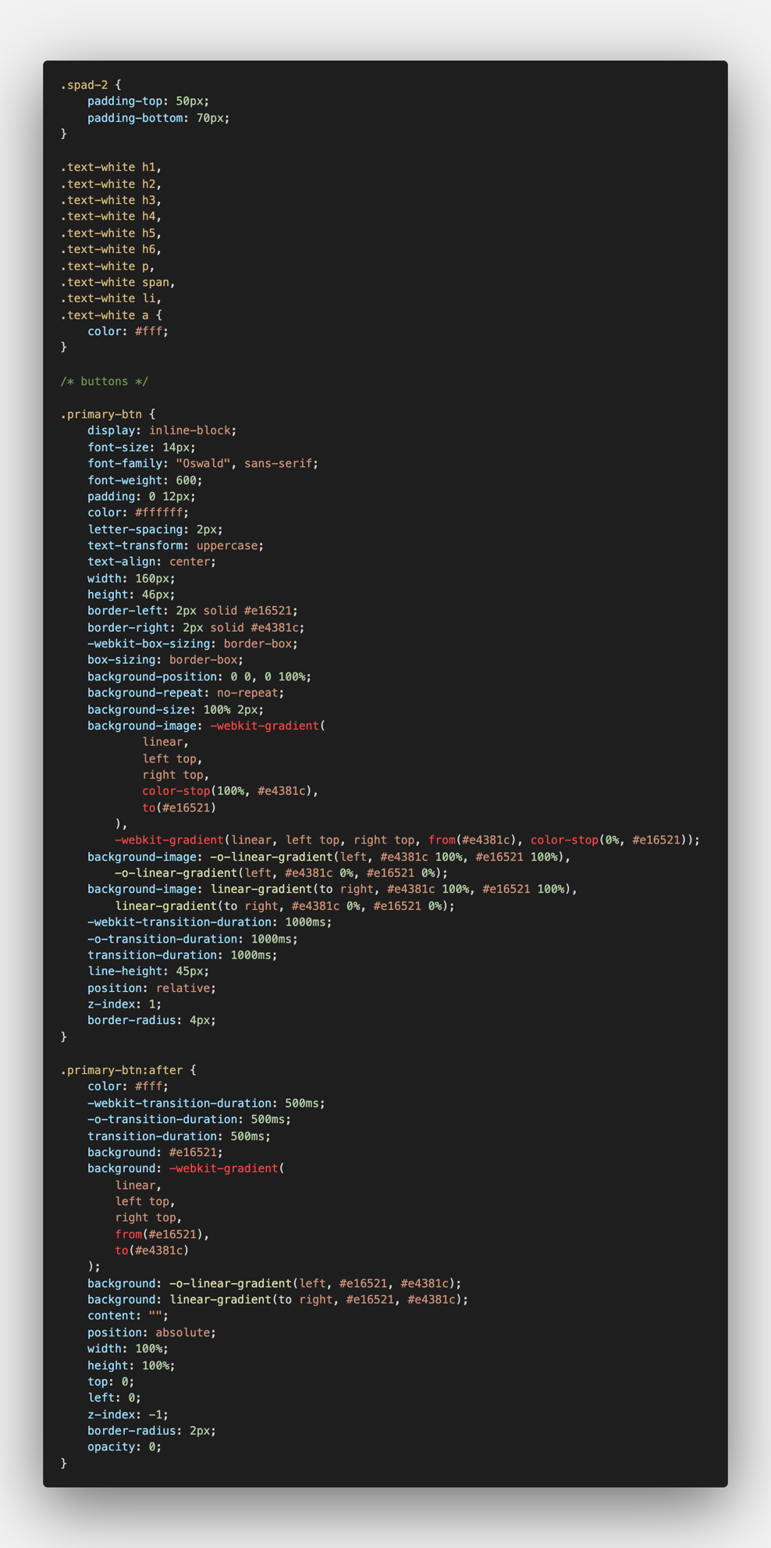
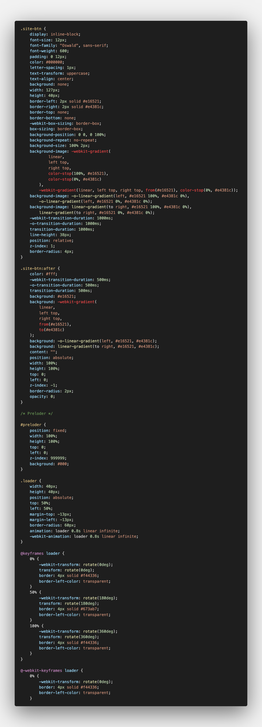
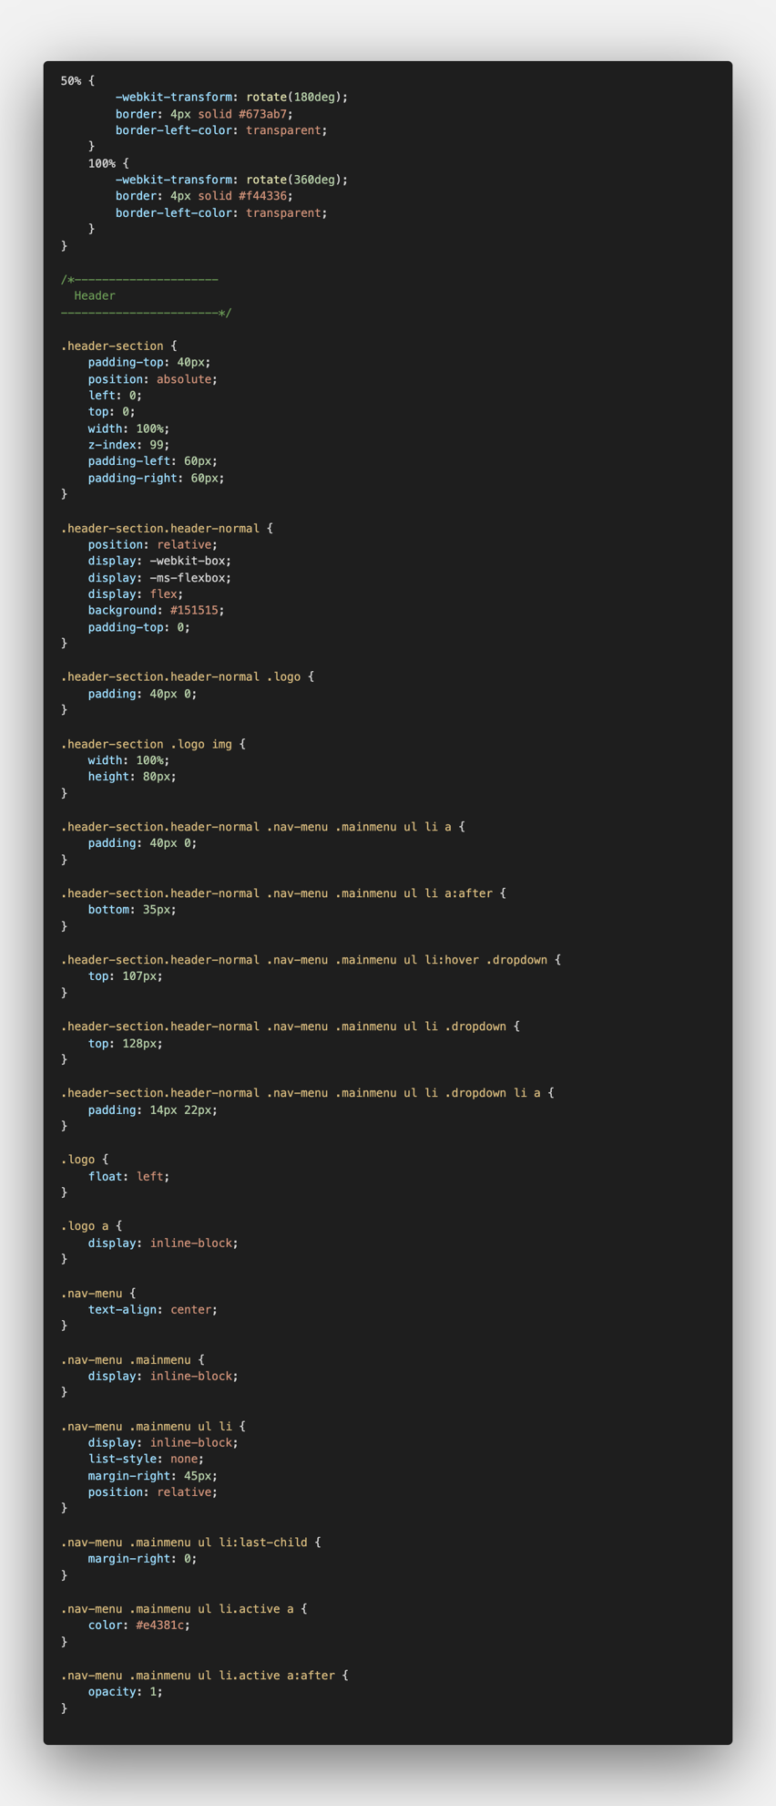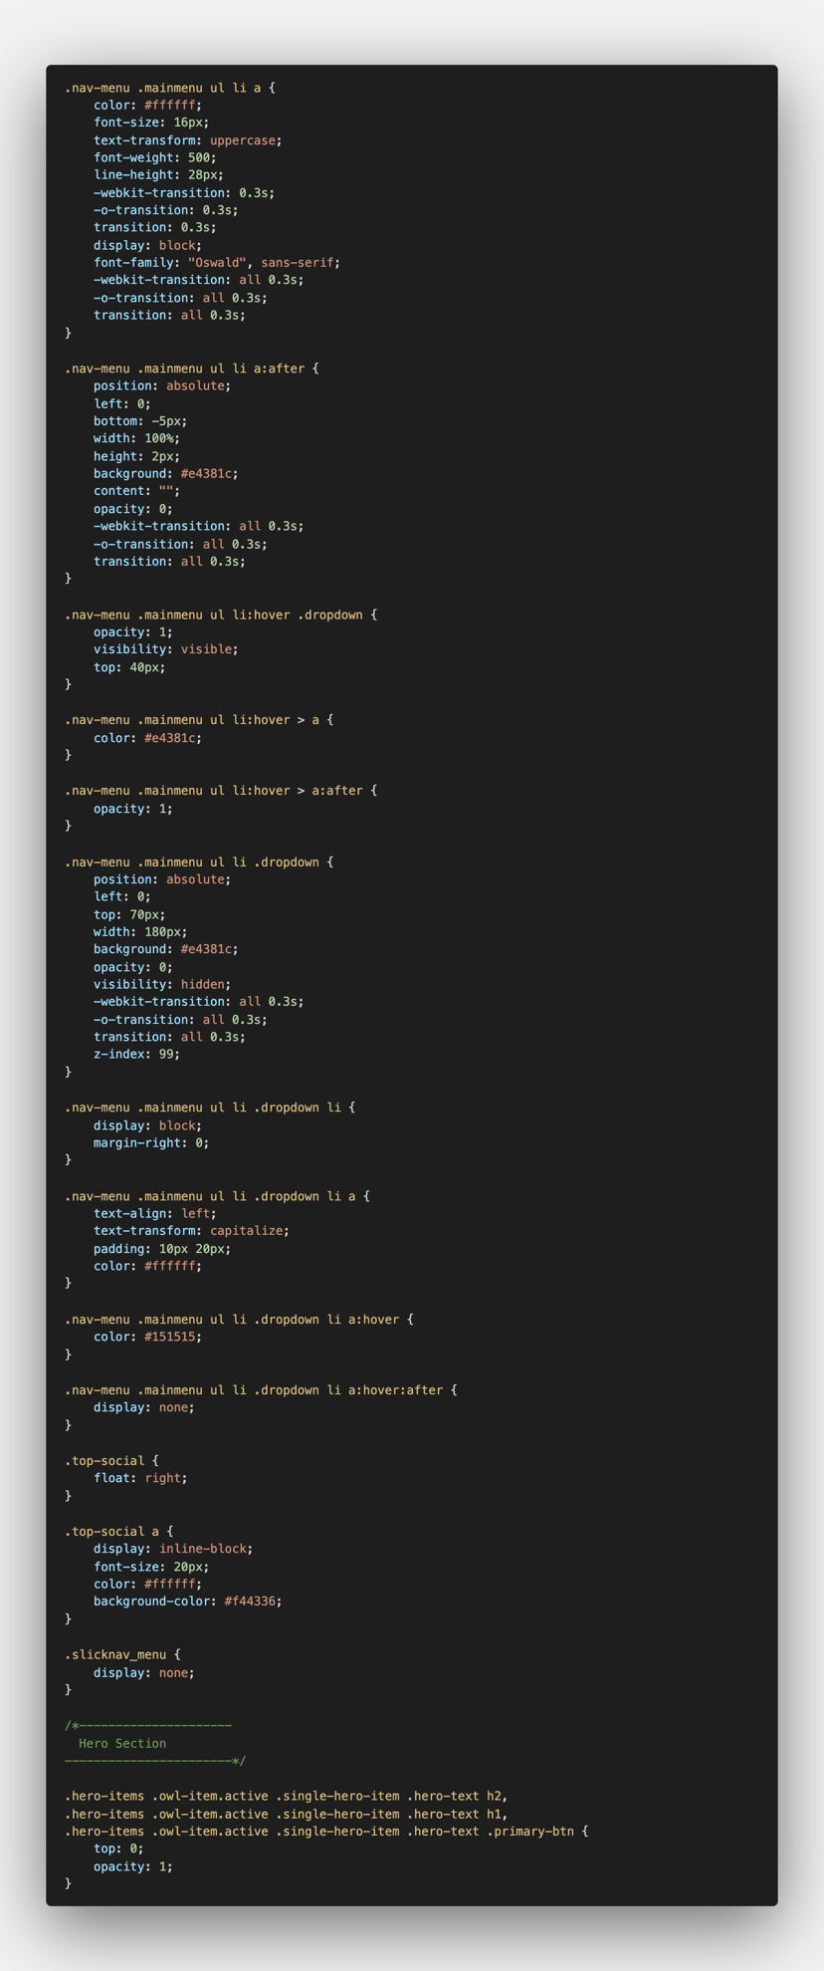
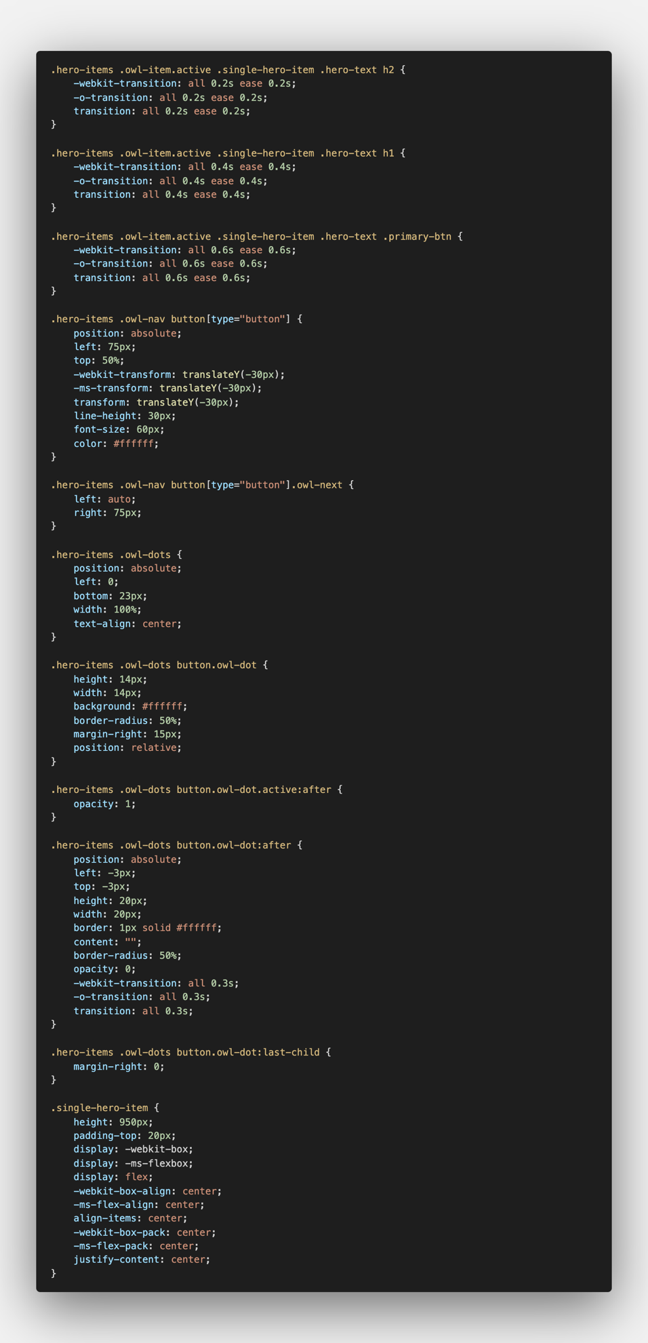
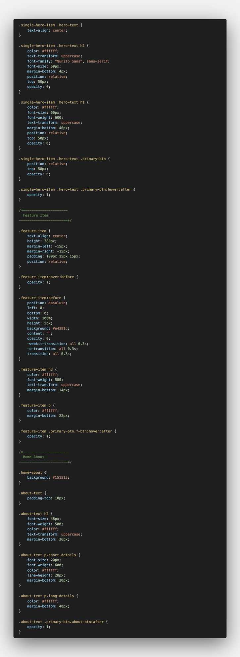
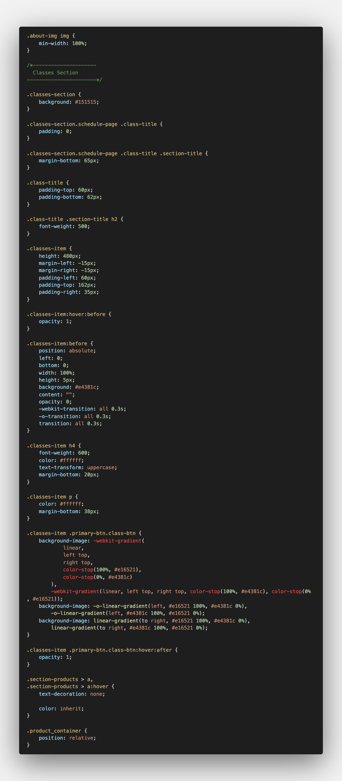
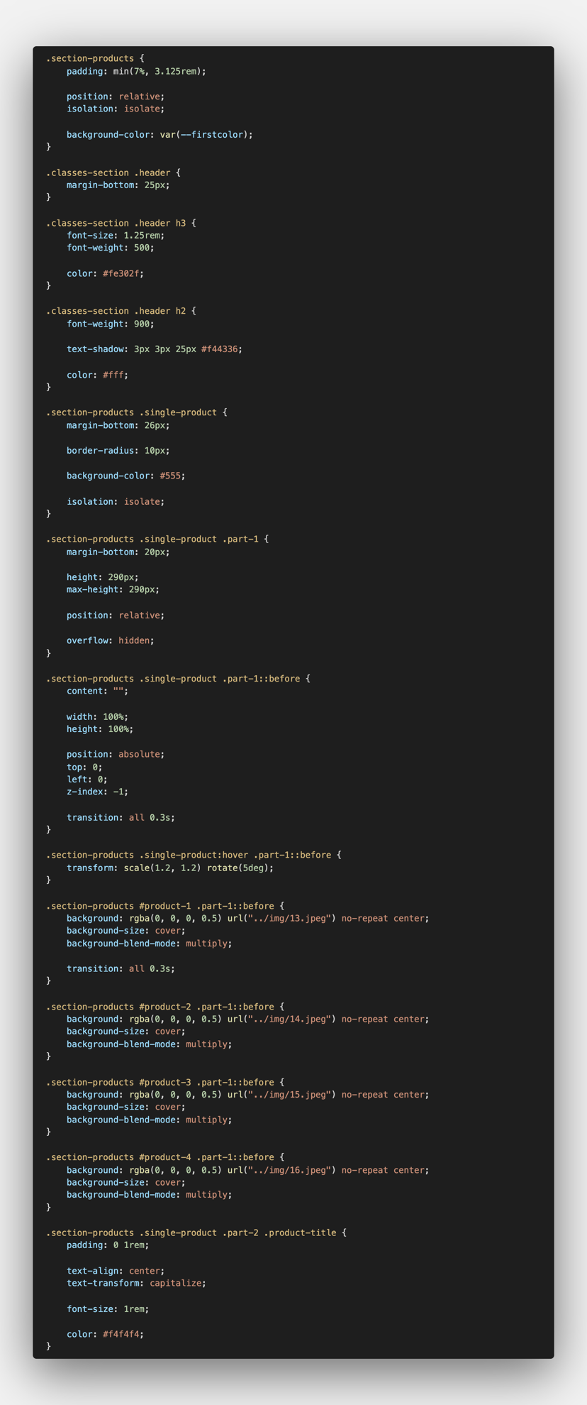
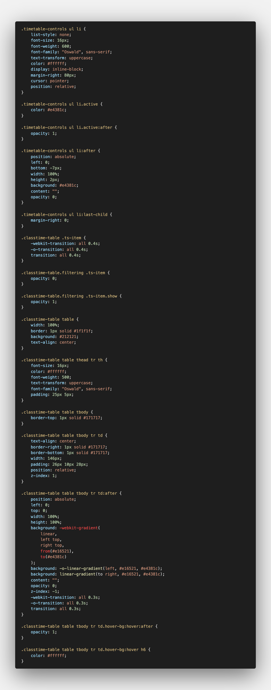
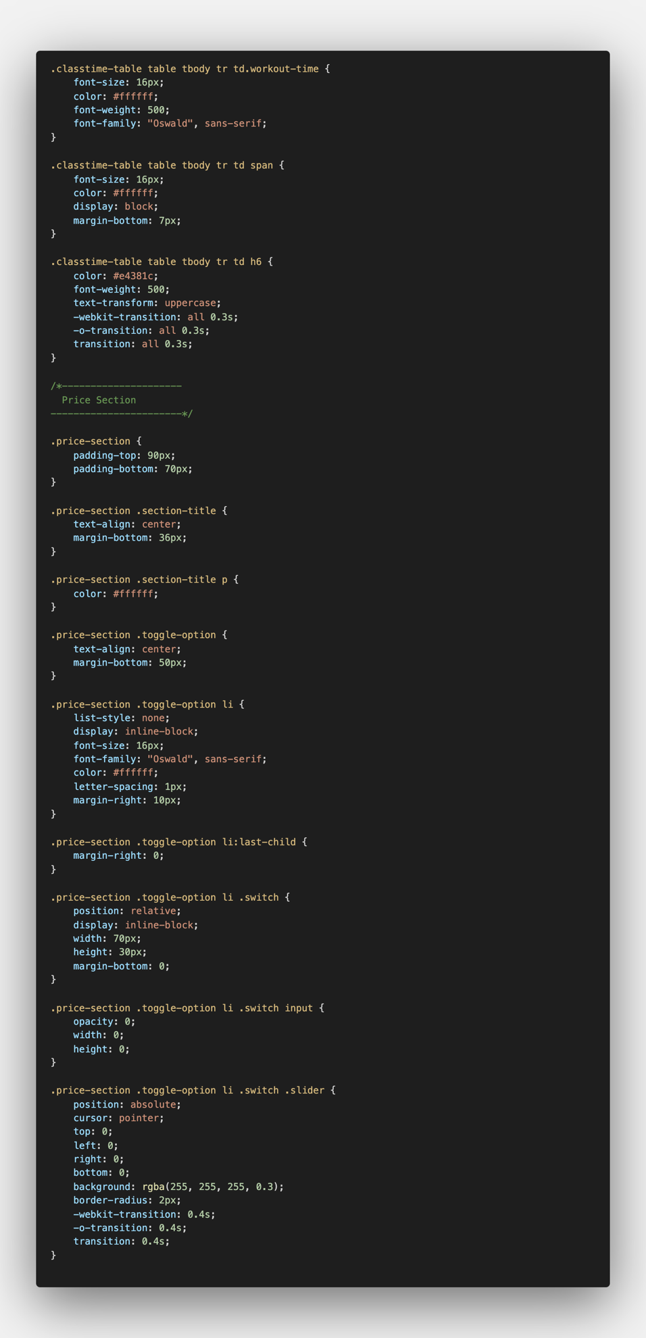
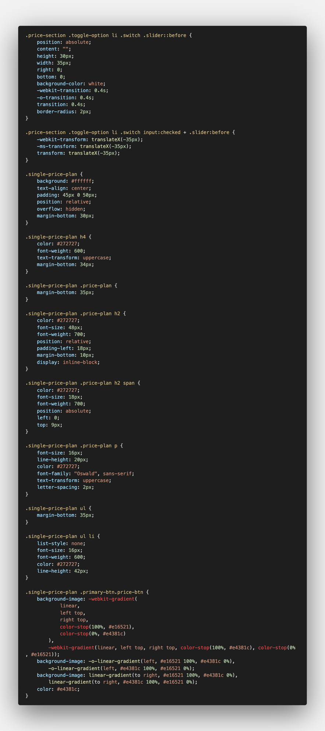
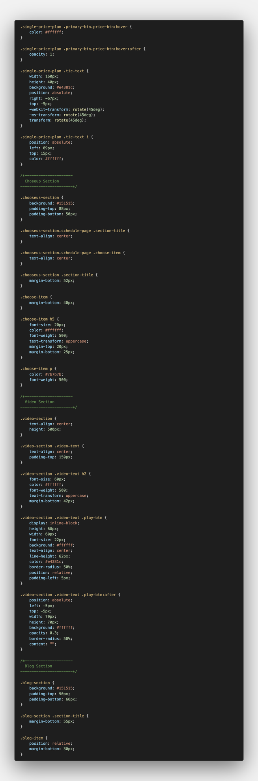
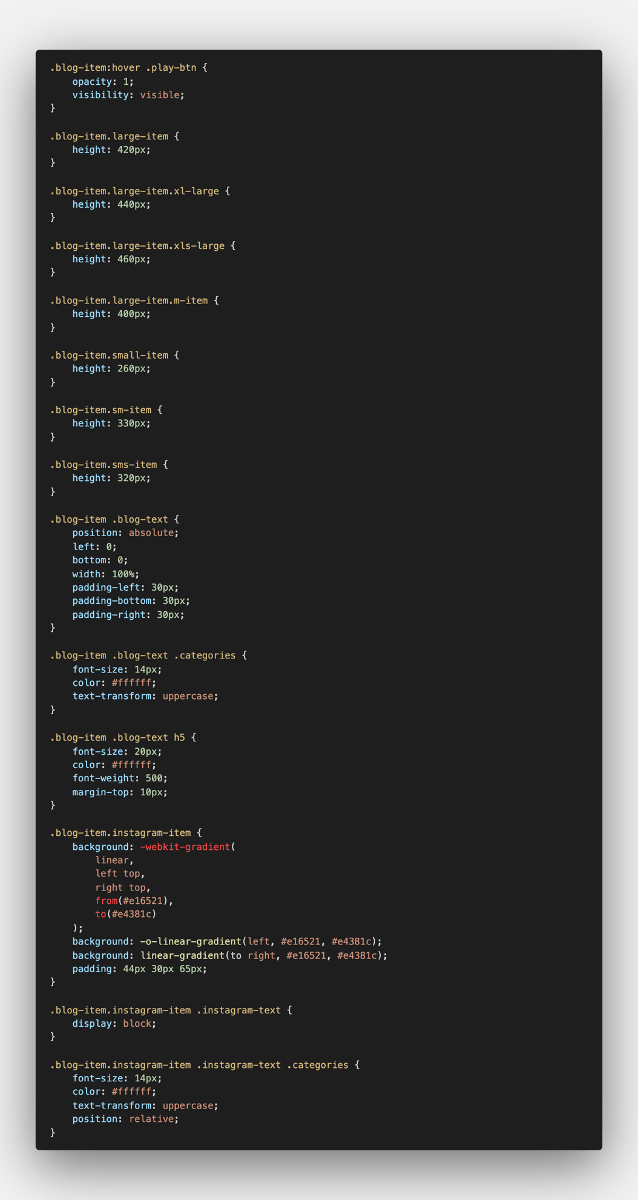
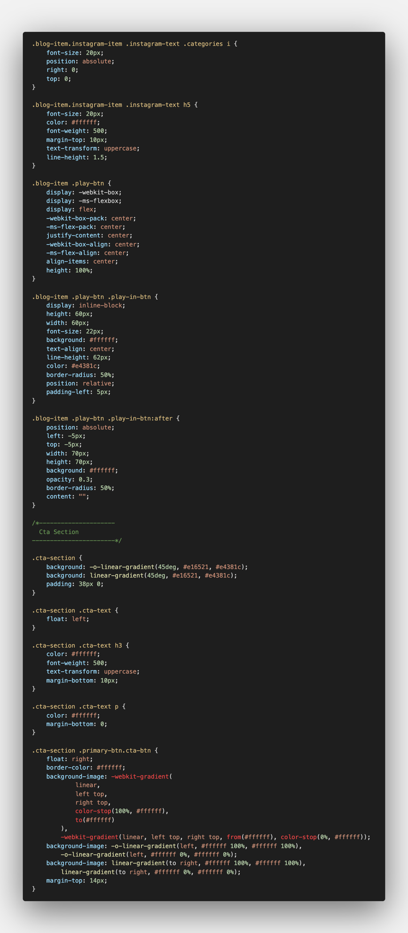
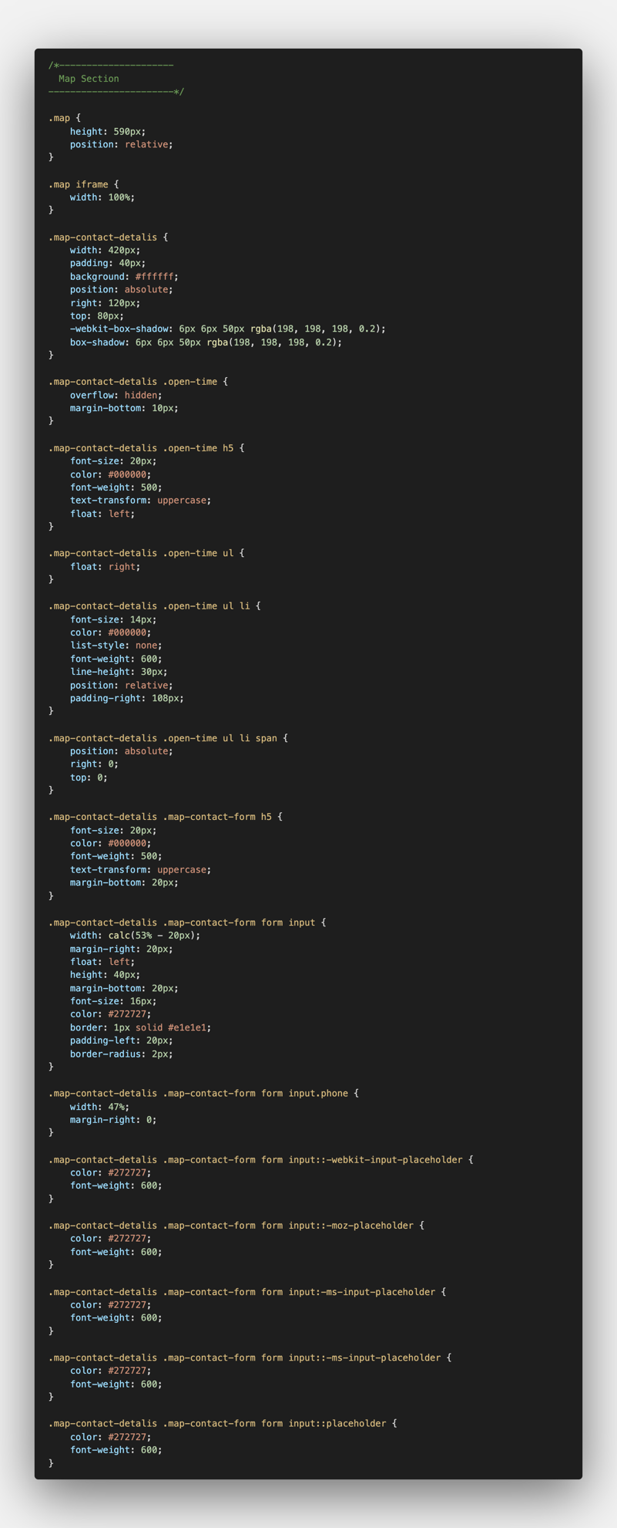
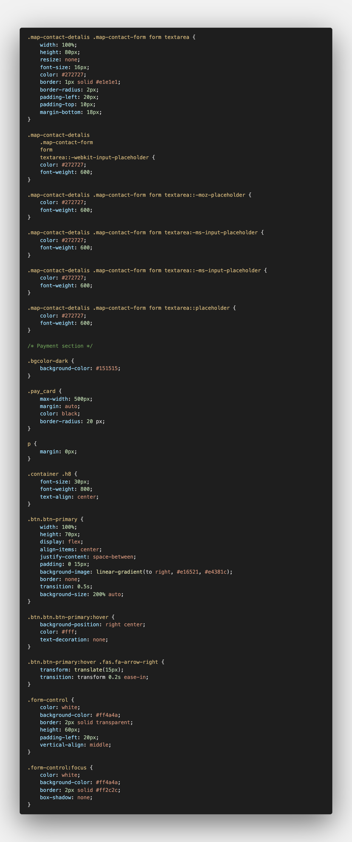
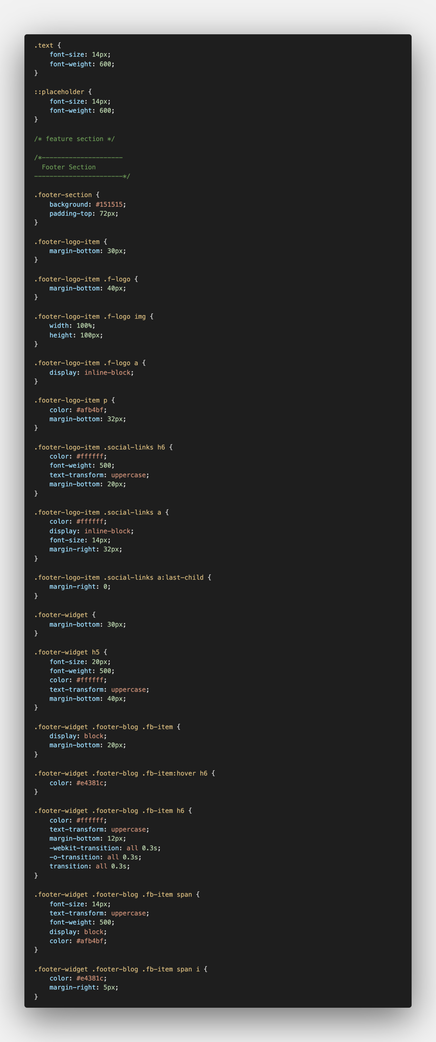
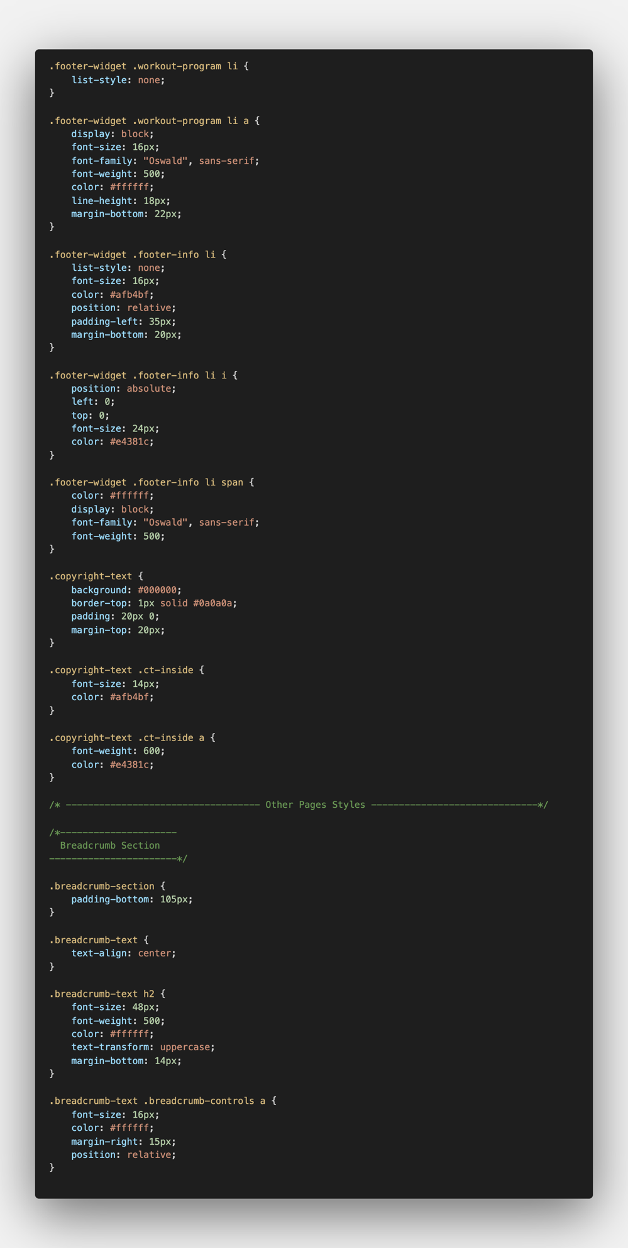
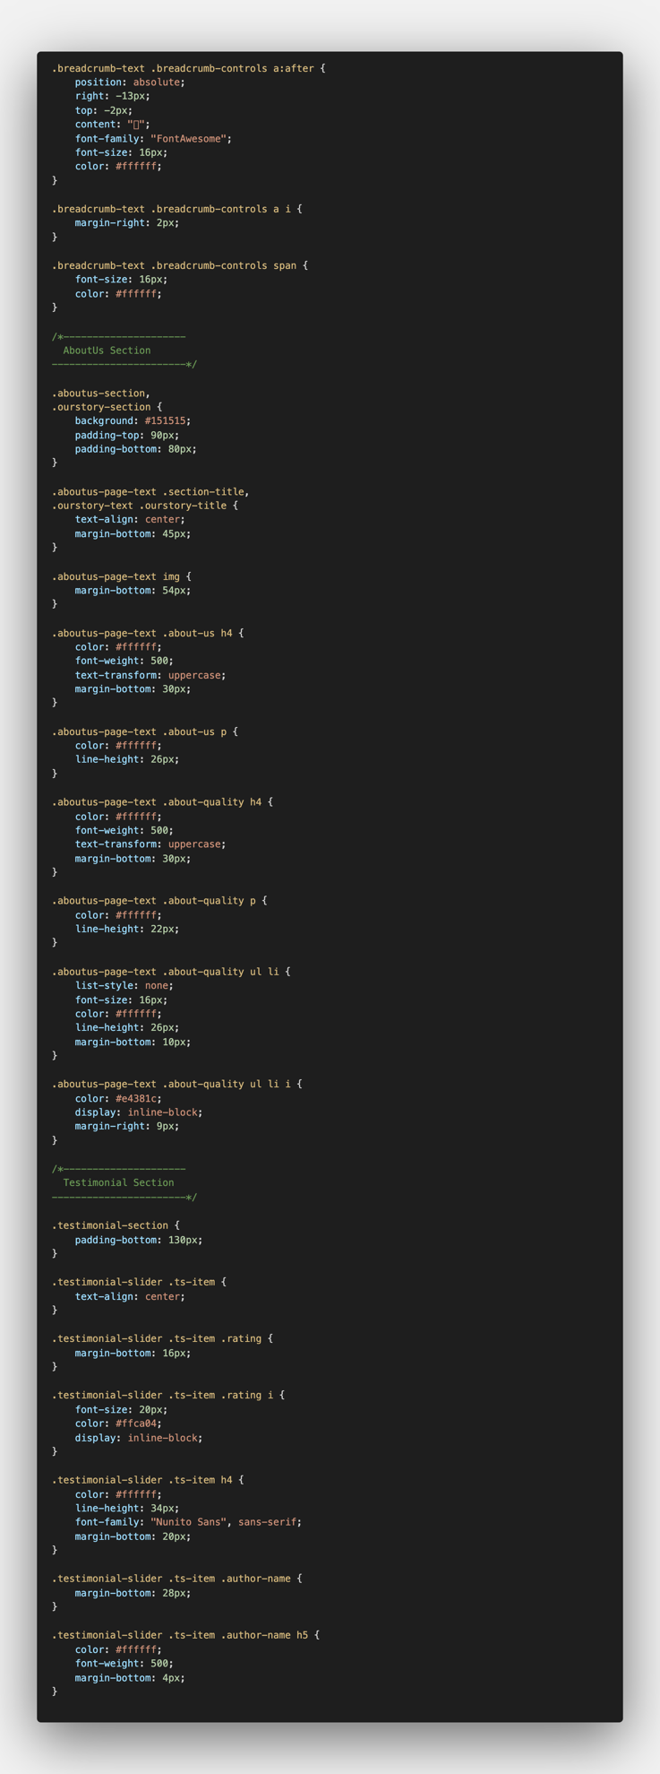
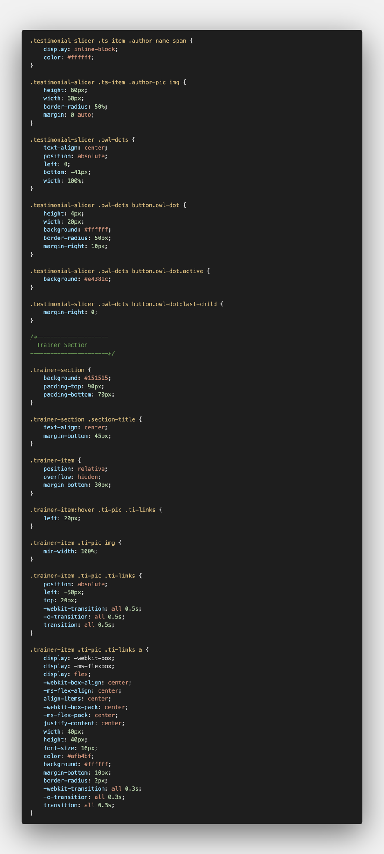
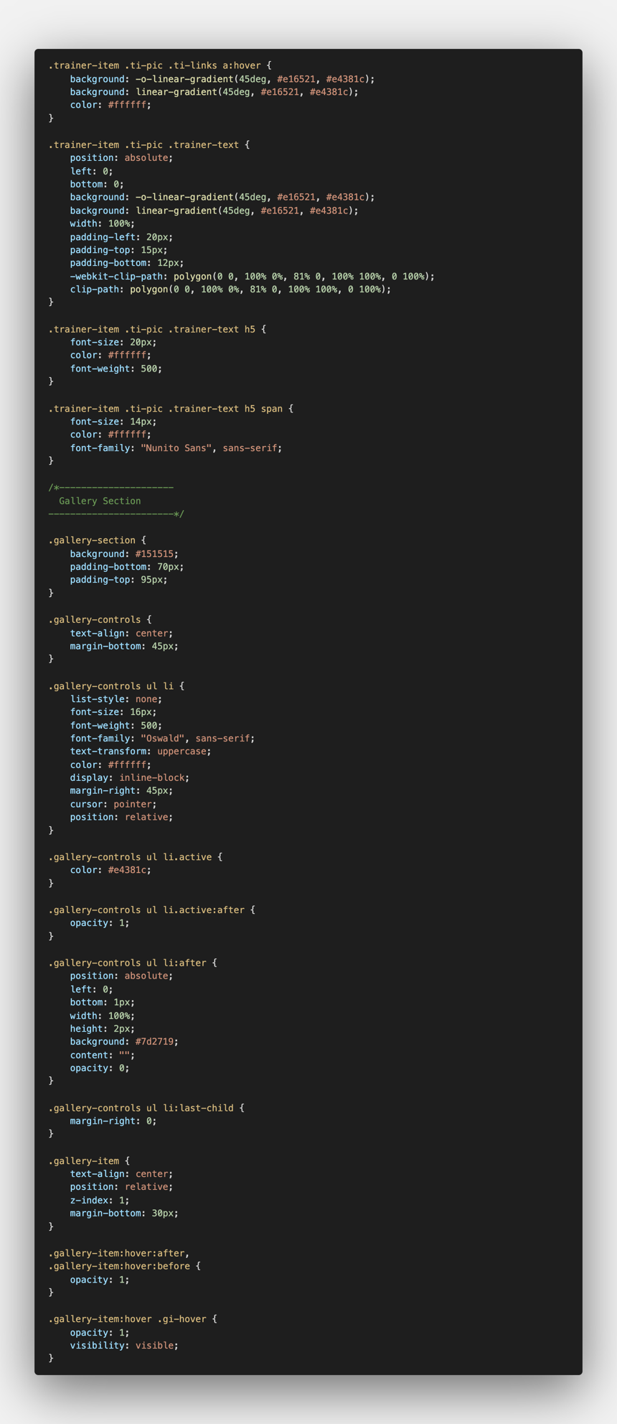
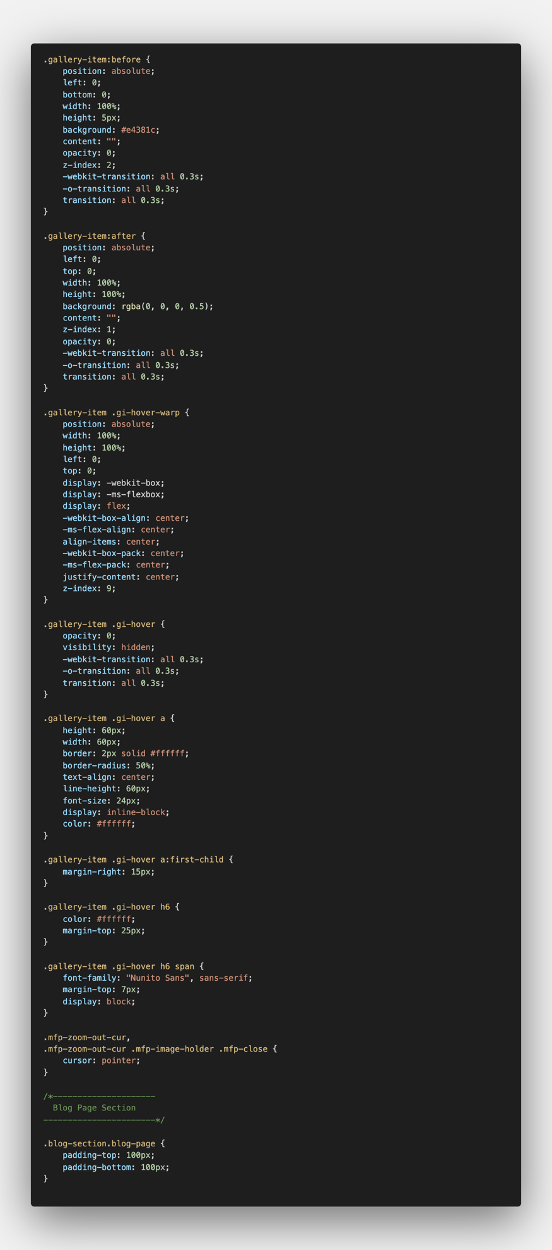
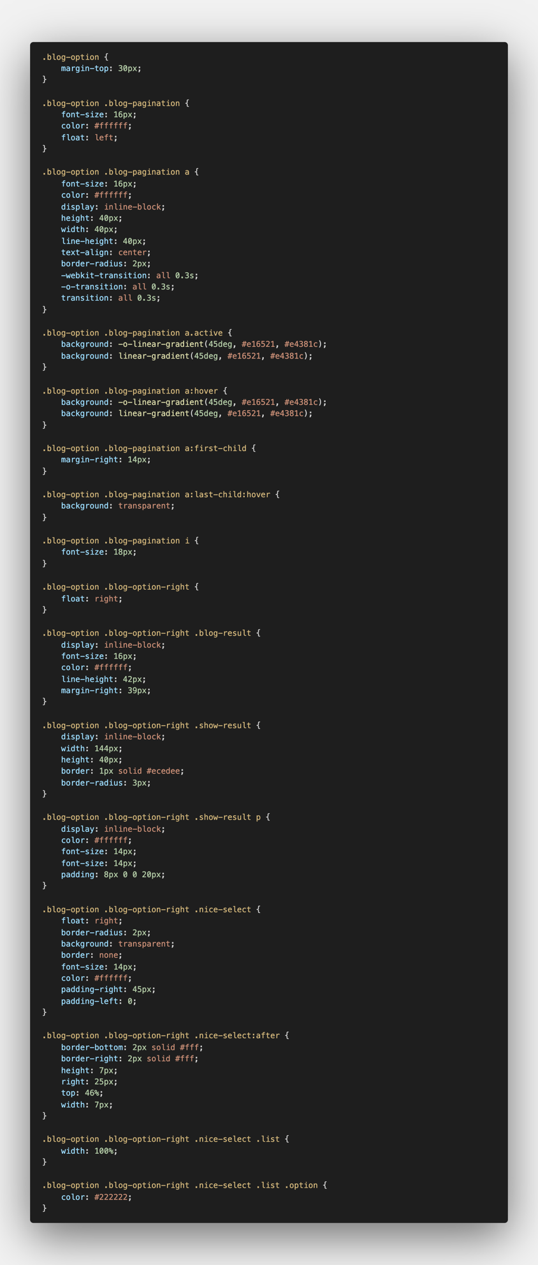
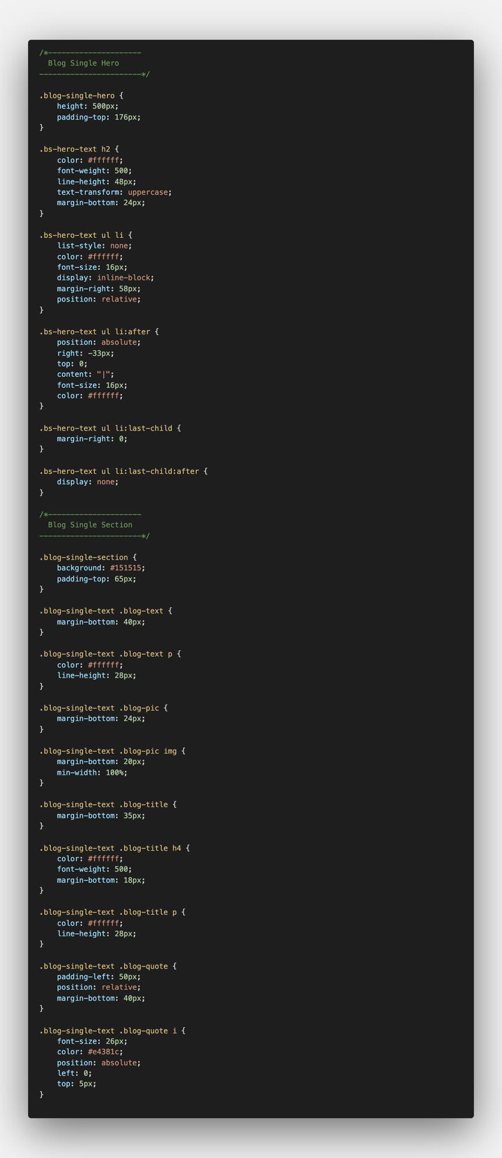
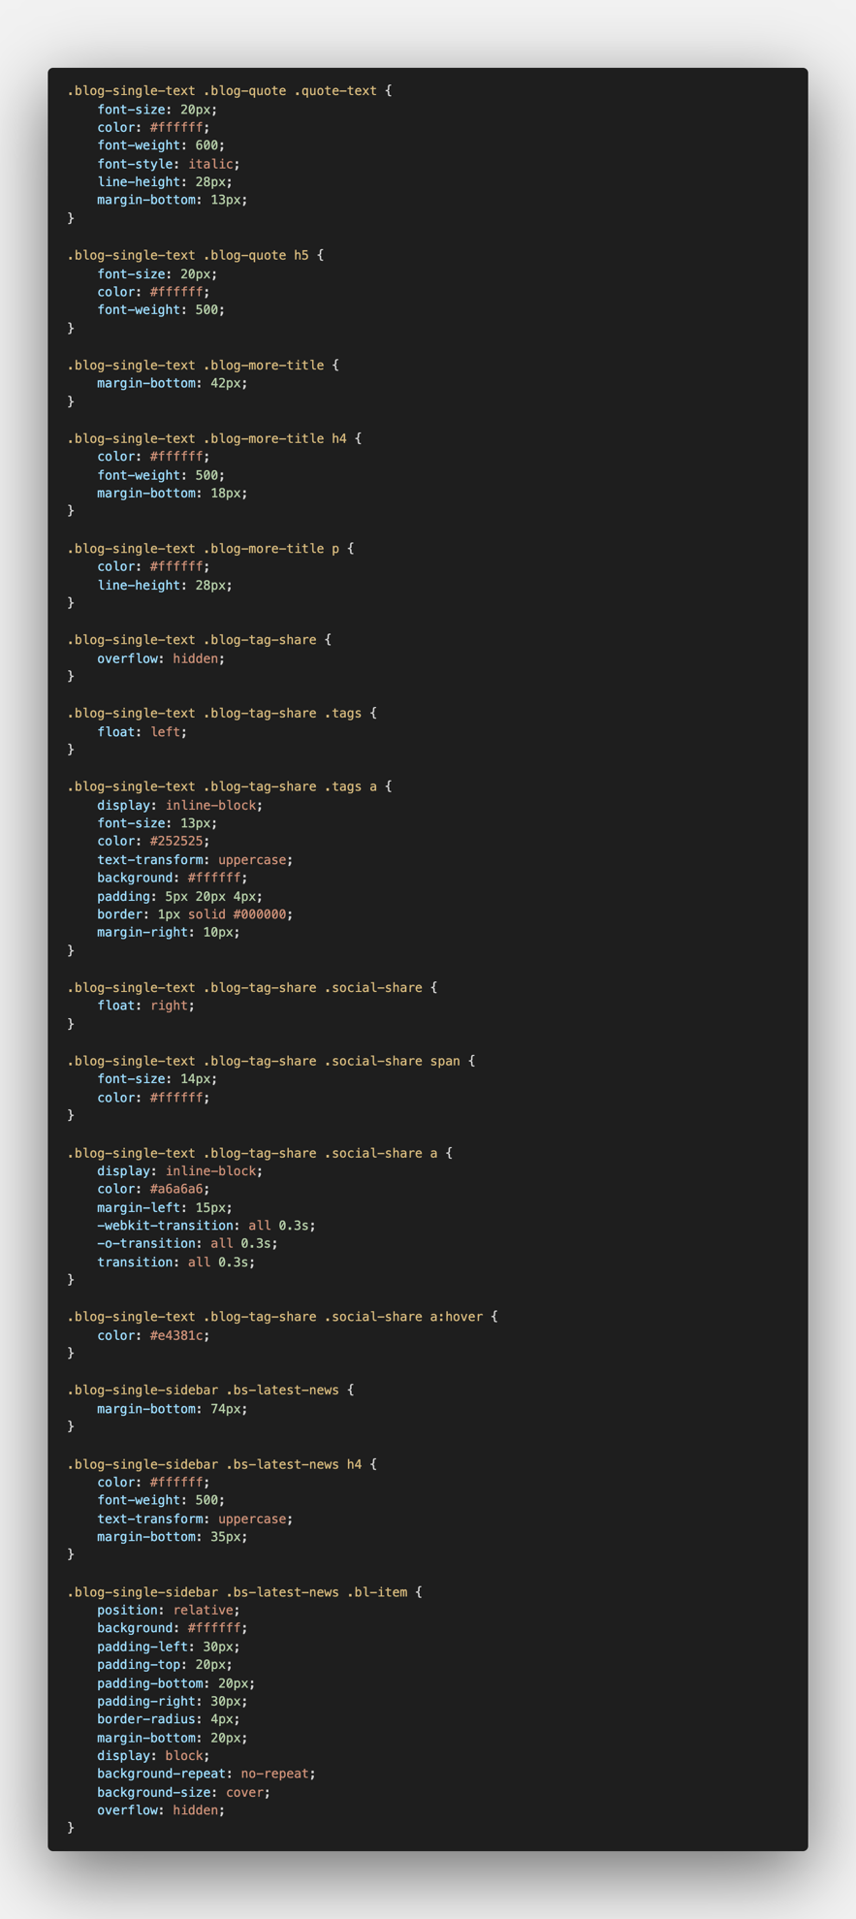
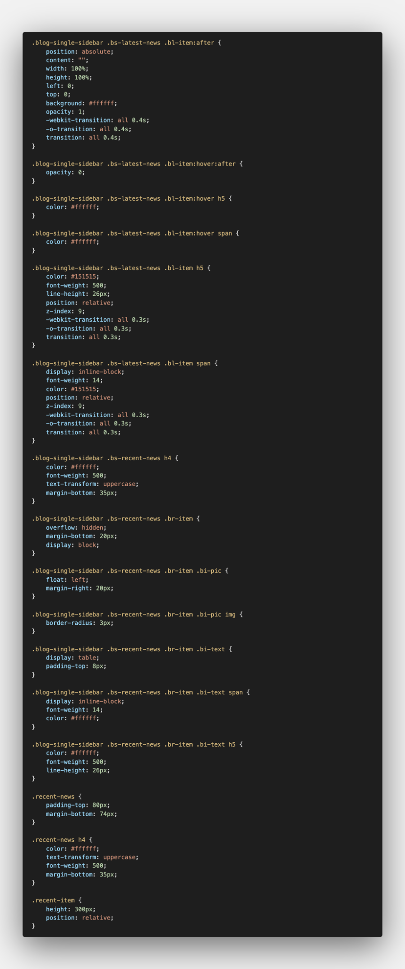

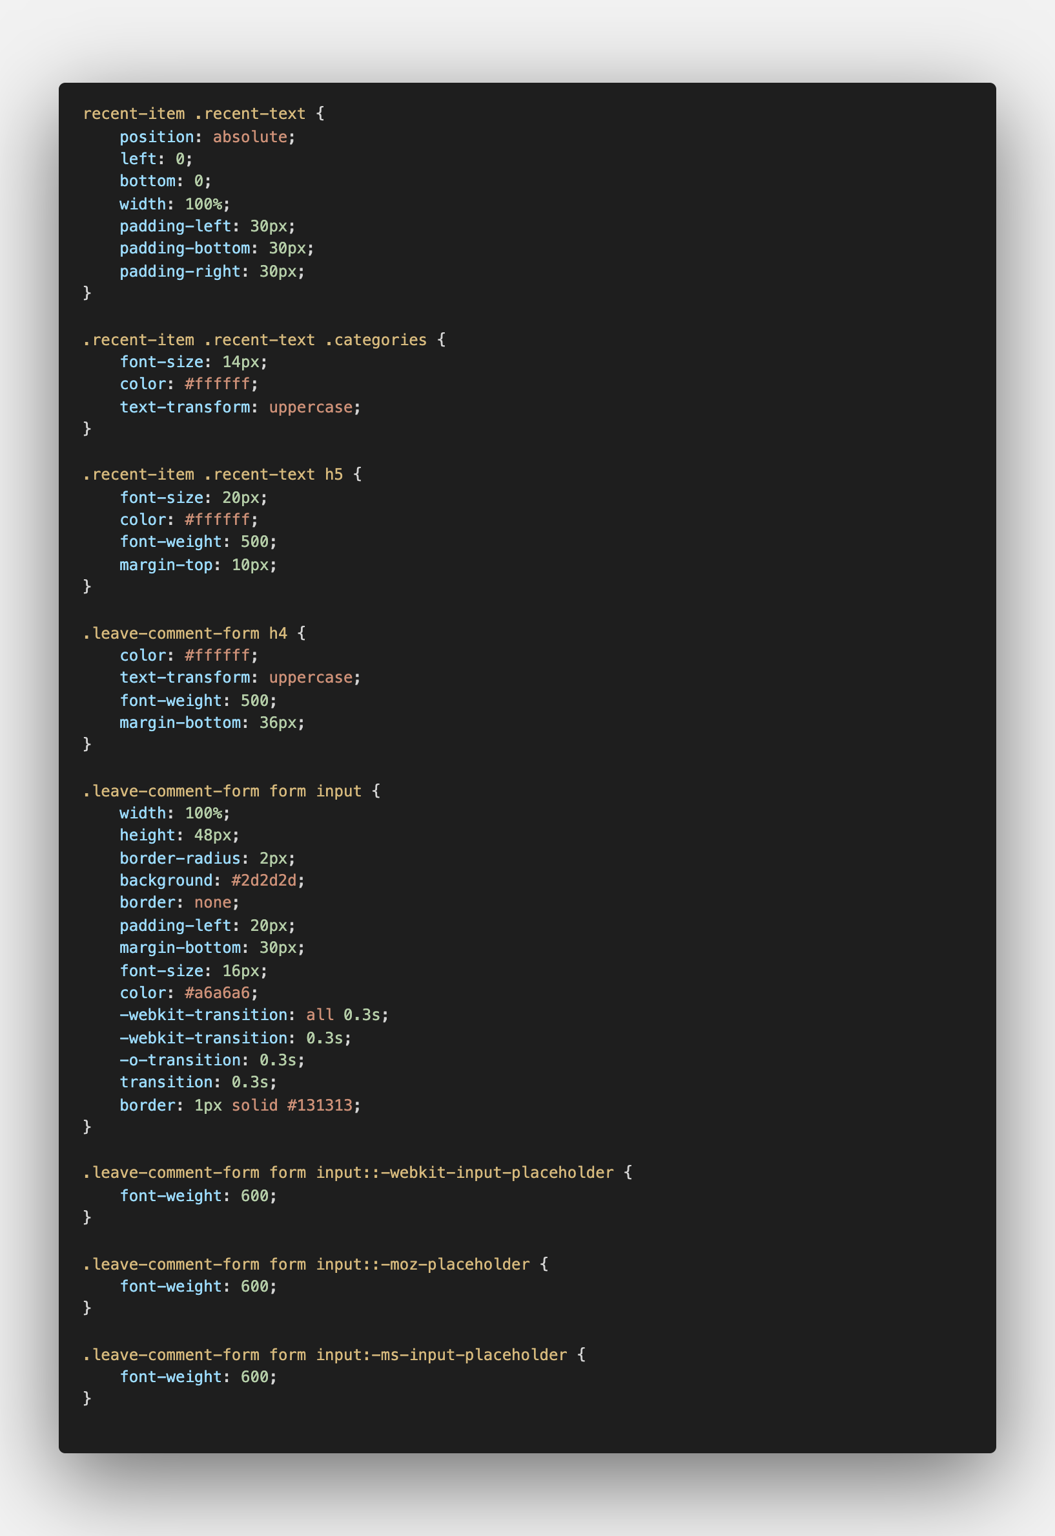
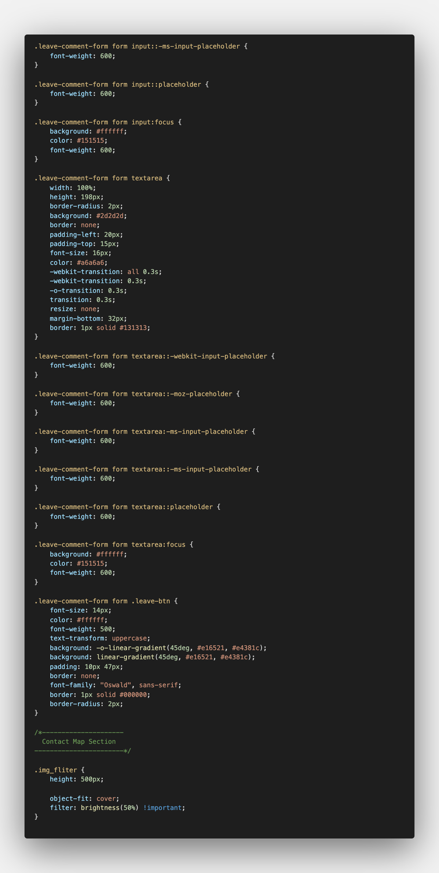
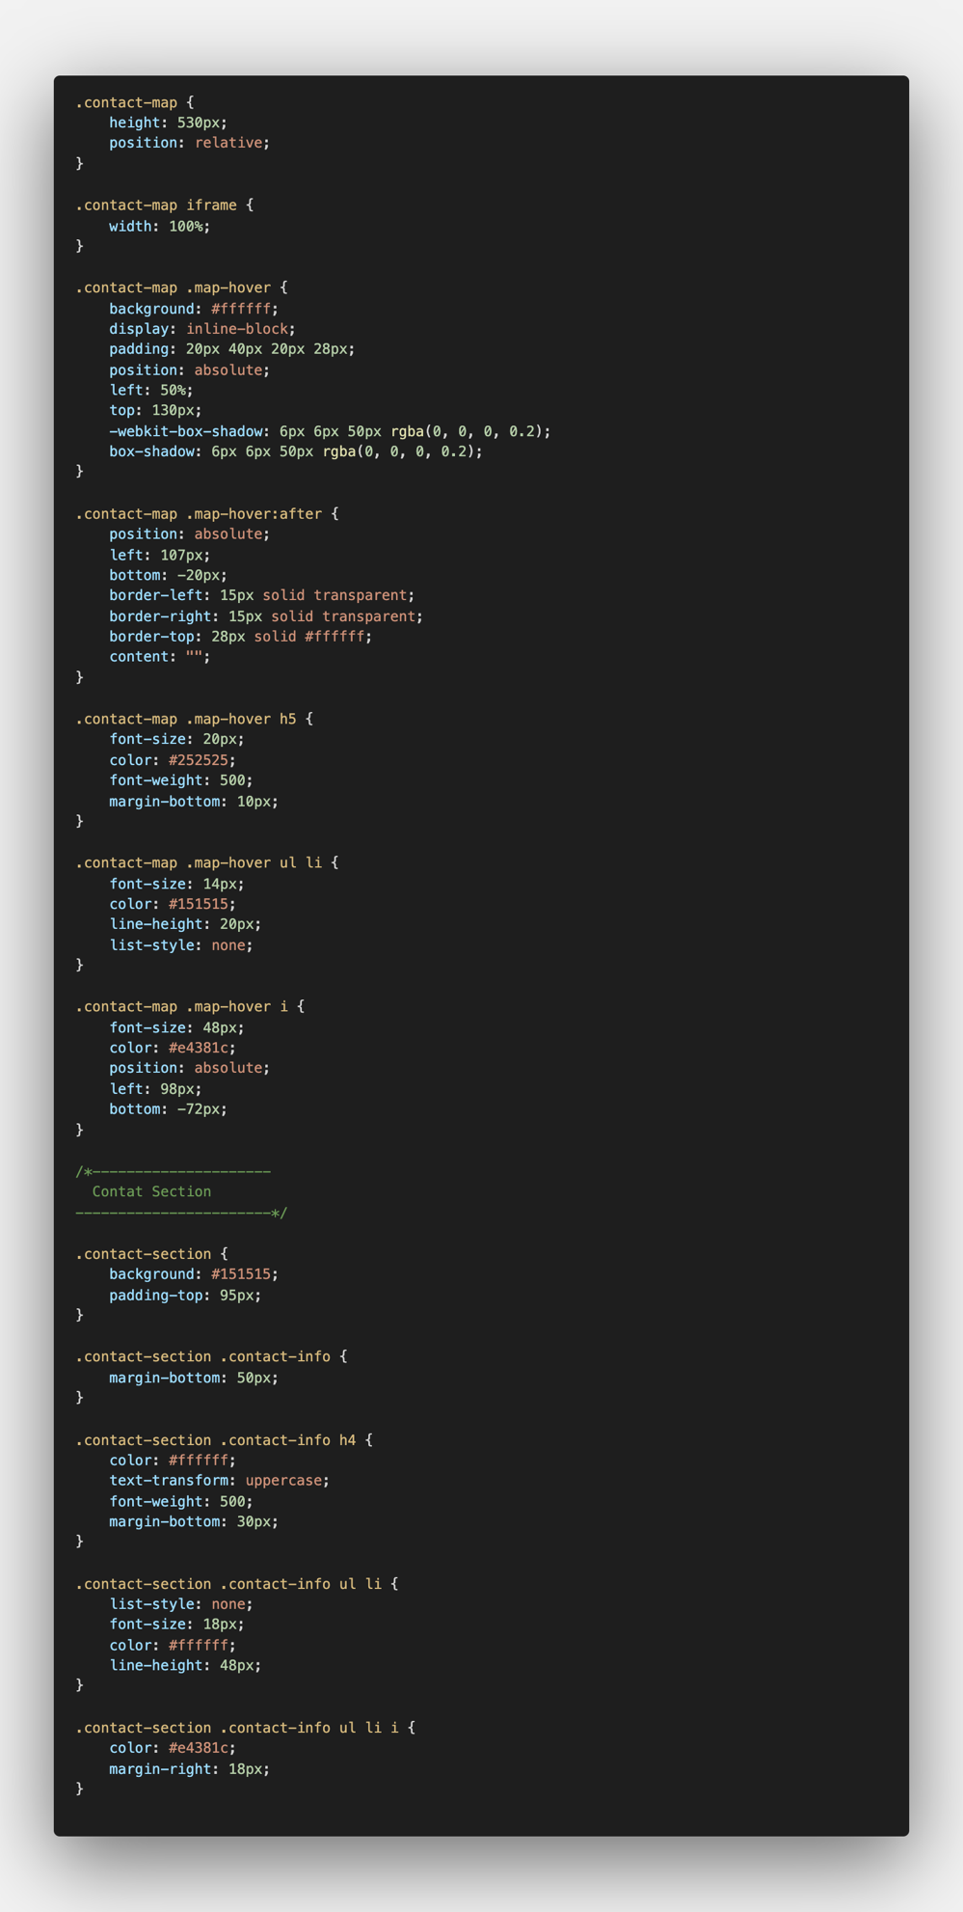

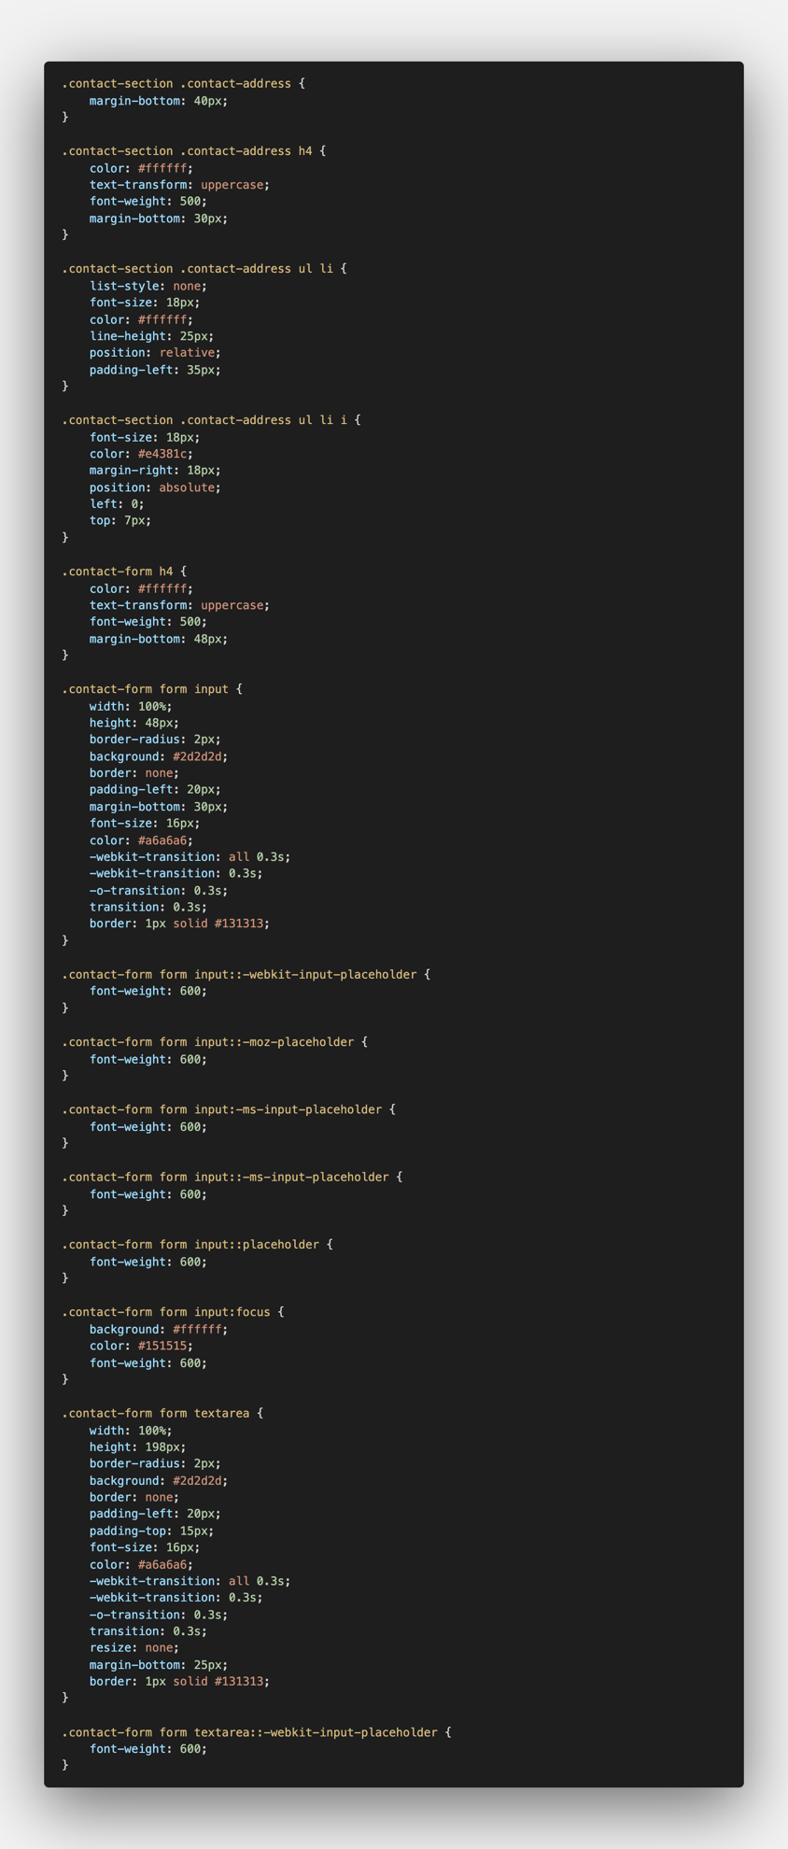

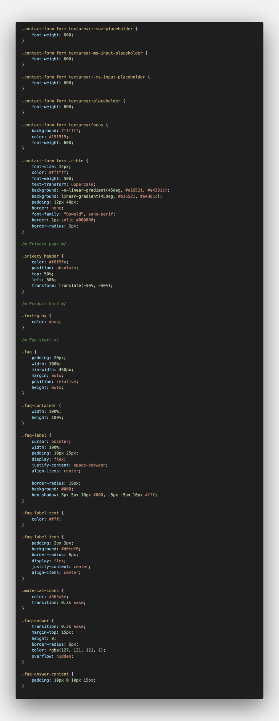
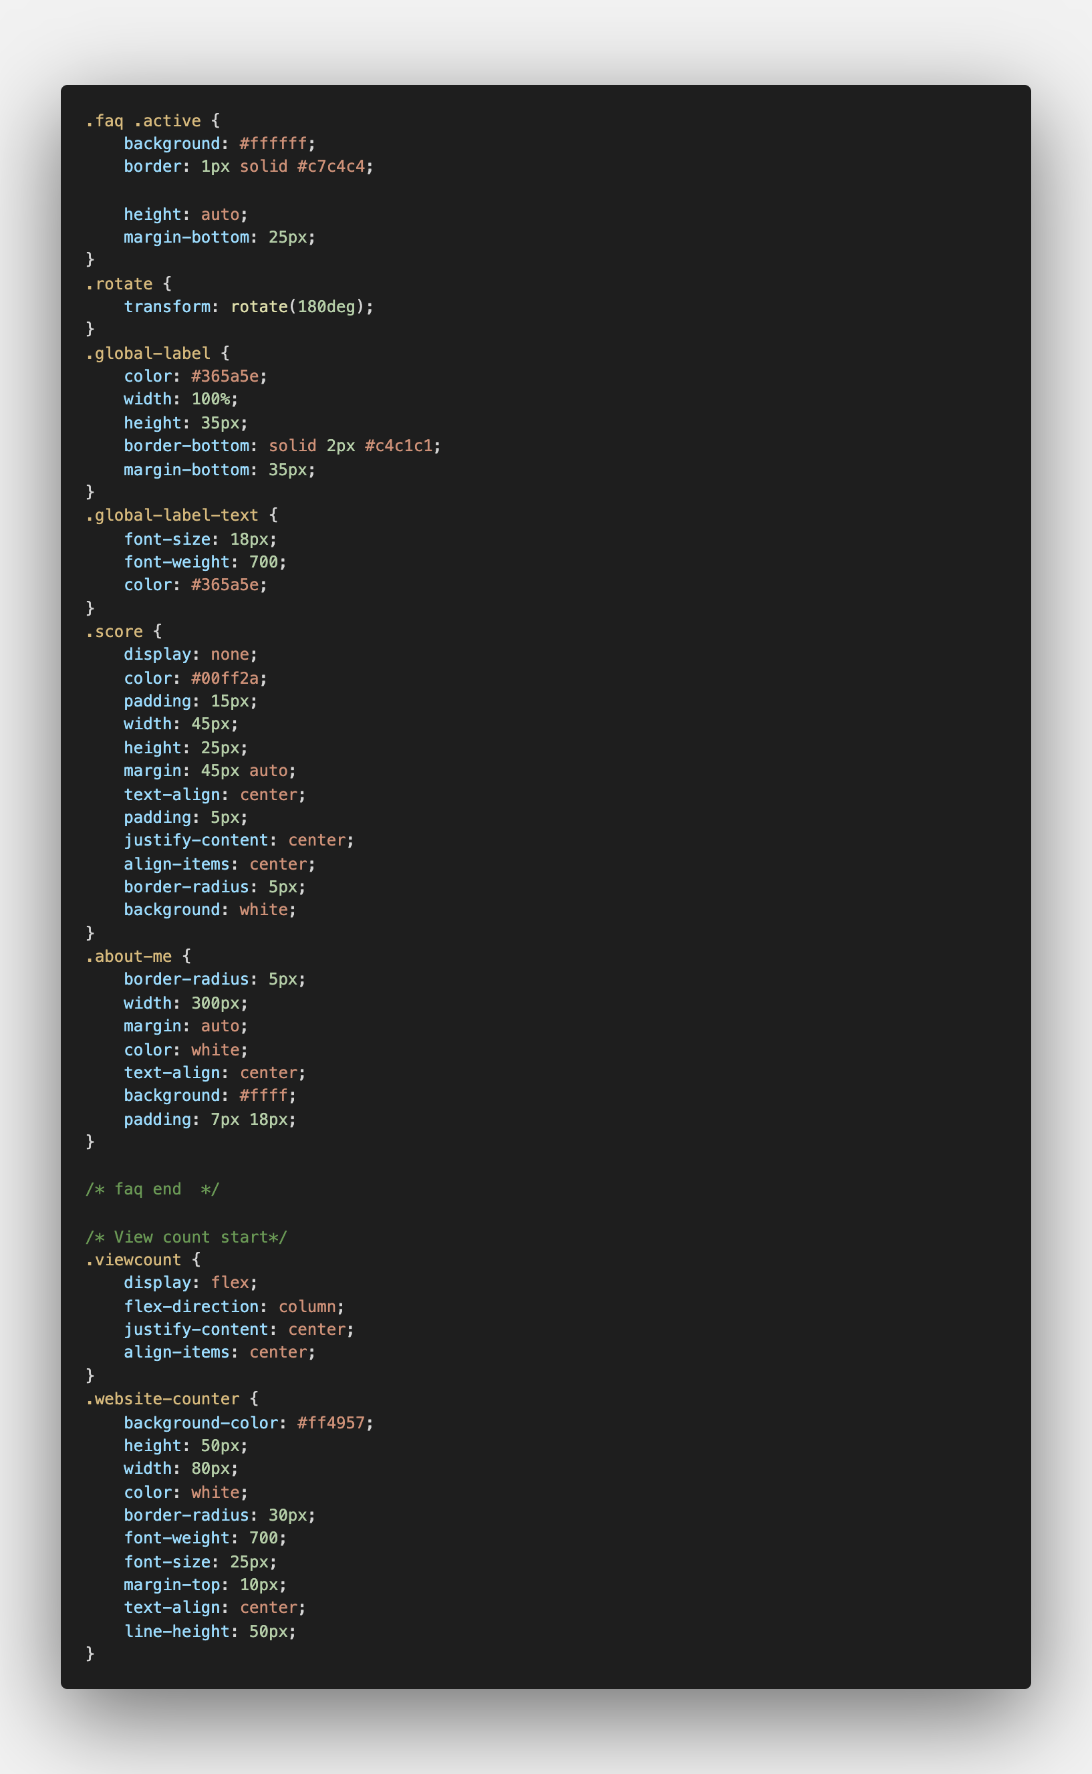
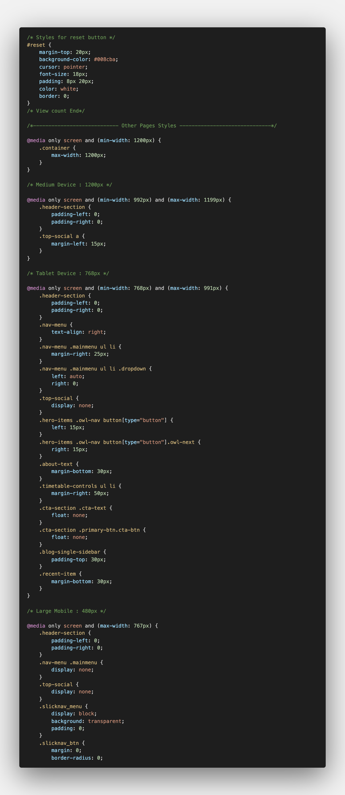
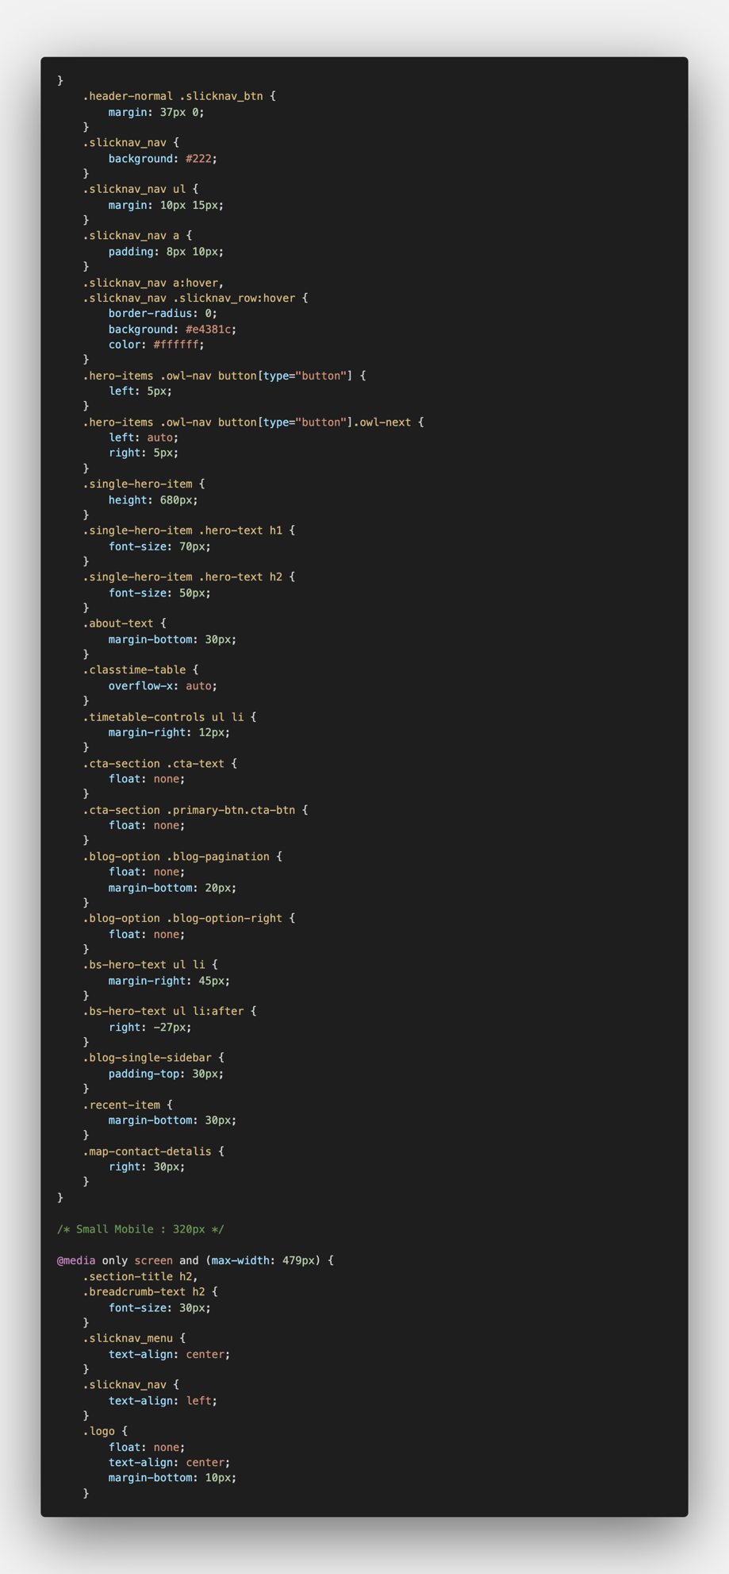

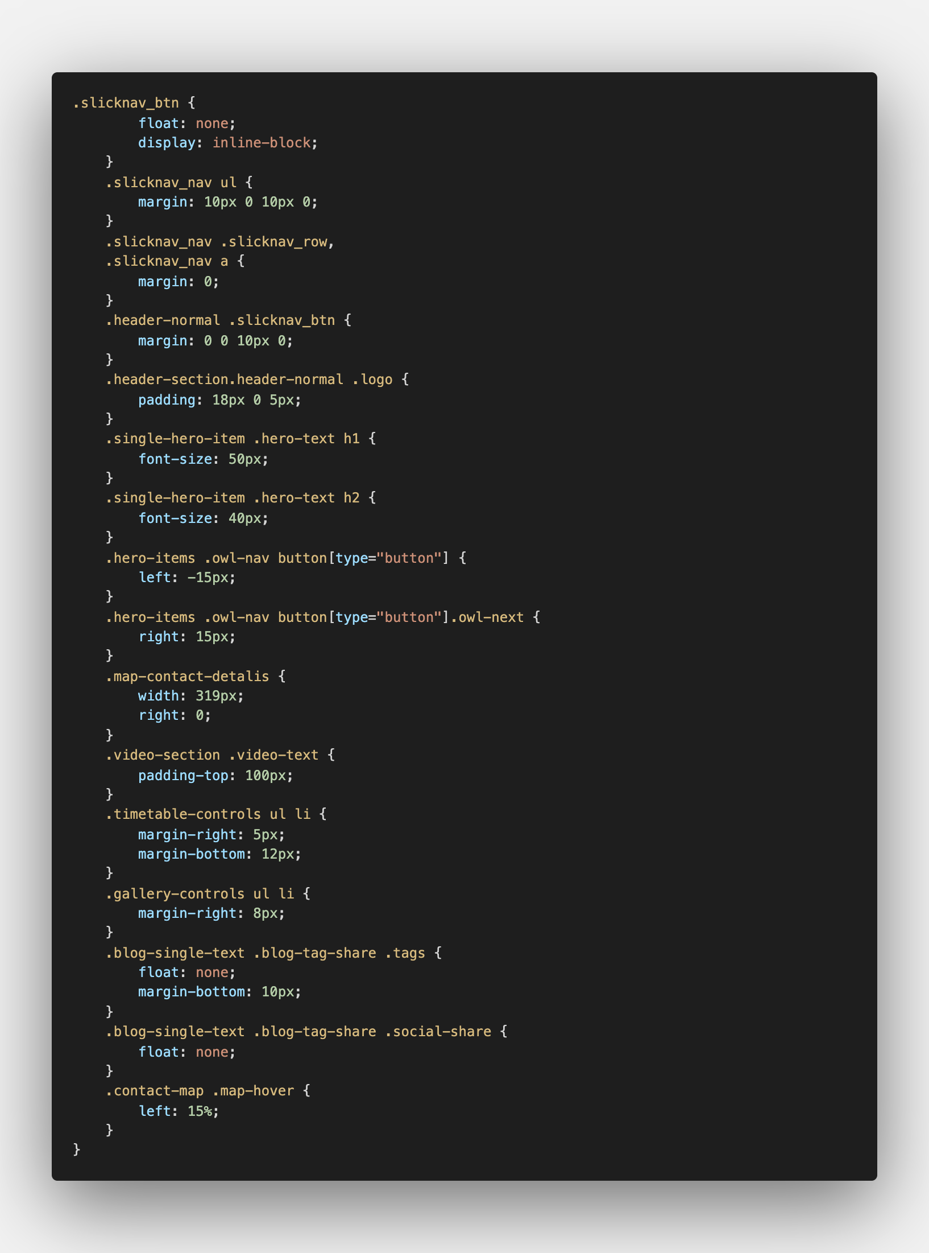
Task 4

Web applications are extremely important when developing HGE websites since they allow the website to operate more methodically and smoothly. A web application is a program that is cached on a remote server and served via the Internet on a web server, as opposed to computer-based software programs that are run locally on the device's operating system, such as Microsoft Windows (OS). The fact that web applications are accessed through a network means that they do not require downloading to be used. Accessing a Web application can be accomplished through the use of a browser such as Chrome, Firefox, or Safari. In order for a web application to work, it must be hosted on a Web server, run on an application server, and be stored in a database. Web servers are responsible for responding to user queries, whereas the application server is responsible for carrying out the essential tasks. In order to store any information that may be required, a database could be used. The majority of Web apps are written in HTML5, CSS, JavaScript, and a variety of other languages. These programming languages are frequently used in client-side programming to assist in the development of an application's front-end. Server-side programming is frequently employed in the development of scripts that would be used by a Web-based application. Languages like phpMyAdmin, which are utilized extensively in server-side programming, are widely used. Other social media web applications such as webmail and other similar web applications are linked to and added to the Inferno HEG website. Webmail facilitates communication between administrators and users by allowing them to receive emails or messages. Social media are also included in the web application of Inferno HEG since it facilitates connecting, communicating, and engaging between the end-user and the organization, among other things. Because the user is not required to install webmail or other web applications on the hard drive, there is no impact on available hard drive space. These programs are capable of running on a variety of platforms, regardless of the operating system, device, or browser used. When developing the HGE website, it is necessary to make use of web-based apps. This facilitates communication between businesses and their customers via the internet. Because of the increased use of the internet, the company will have to adapt the way they do business and will require more web-based apps. There are three components required for a web application to perform properly: a webserver to receive client requests, an application server to execute the tasks requested, and a database to store the information. A web application is a client-server program that performs a specific function on both the client-side and the server-side of the computer. The term "client" refers to the program that a person uses to access and use a web application. It is the server-side that contains PHP and ASP.net, which are responsible for the storage and retrieval of information. In order to provide information to users, the client script (CSS, HTML, and JavaScript) is used. The usage of shopping carts and content management systems in web applications allows the user to connect with the business more effectively. Web applications include email services such as Yahoo and Gmail, instant messaging services, word processors, and spreadsheets, to name a few examples. There are three components required for a web application to perform properly: a webserver to receive client requests, an application server to execute the tasks requested, and a database to store the information.

I wrote 15 pages linked to a database using HTML and CSS. The background image is used on the home page. In the css, the.single-hero-item has padding-top, display, align-items, etc….Below the background image are three headings:<h3> with protein tips, gym materials, gym equipment , and a <p> caption. In Css,. feature-item p{} is written in color, margin-bottom. In a href, a read more pattern is attached to each link. The read more pattern is also linked to the product page. The learn more pattern on the home page is also linked to the about page.
The search bar pattern is also written in <In put> and in the css with. form-control. Click the search bar to return to the home page. Four gym products and type, price, Ratings are also
Starred. More detail can be viewed on the product page by clicking see more pattern. The HGE gym equipment, uniform are linked to see more pattern. Click on more pattern to return to the product page. In css write the desired format in classes-item primary-btn.class-btn{}.Attached with you tube link and background photo added. Click play patterns to go to you tube and watch it. In css it is written as video-section video-text play btn{}.The footer also contains online template design ideas. It is also linked to Instagram, twitter, facebook, Gmail. In css it is written as footer-widget h5 {}.The product page also lists procucts and prices, and the footer looks like a home page.Click on a product item to go to the feature page and click on the buy pattern to order the item. The about us page also includes gym motivation messages and background images. The footer page is included on all 12 pages. The contact page also has a background image and google map and information and addresses. The service page explains full body strength, machine service and yoga with pictures. The FAQ page also has questions and answers. The register page also has a user name, email, phone confirm password and sign in pattern. We can also sign in by ckicking on the email and password on the login in page. The privacy policy page has questions and answers, and cookies policy page also has questions and answers.

Task5
Writing 15 pages is very difficult. Each page takes a lot of time to think about writing another page. To write a page, you have to copy other online template ideas. The xampp folder builder is also a mac book so it's unique from other laptops. I can not install xampp, so I have to watch YouTube videos. I have to ask the teacher when I can not get it at all. It is very busy to link a product with a link on the home page. An error occurred because the product page contains s in the product page. When I clicked read more patterns, I tried very hard to link to each other. The error was resolved after asking the teachers. When adding photos, I had to save the image file to another file, so it did not appear when I ran the page. Some pages have a lot of trouble writing cookies with style.css in some pages. I found a way to write color fonts online, so it worked. Some pages have a lot of trouble writing cookies with style.css in some pages. I found a way to write color fonts online, so it worked. There are also many errors when uploading to GitHub. We can only update on the git hub after restarting your laptop. There are many other errors. However, the whole project was designed to be the best it could be.

