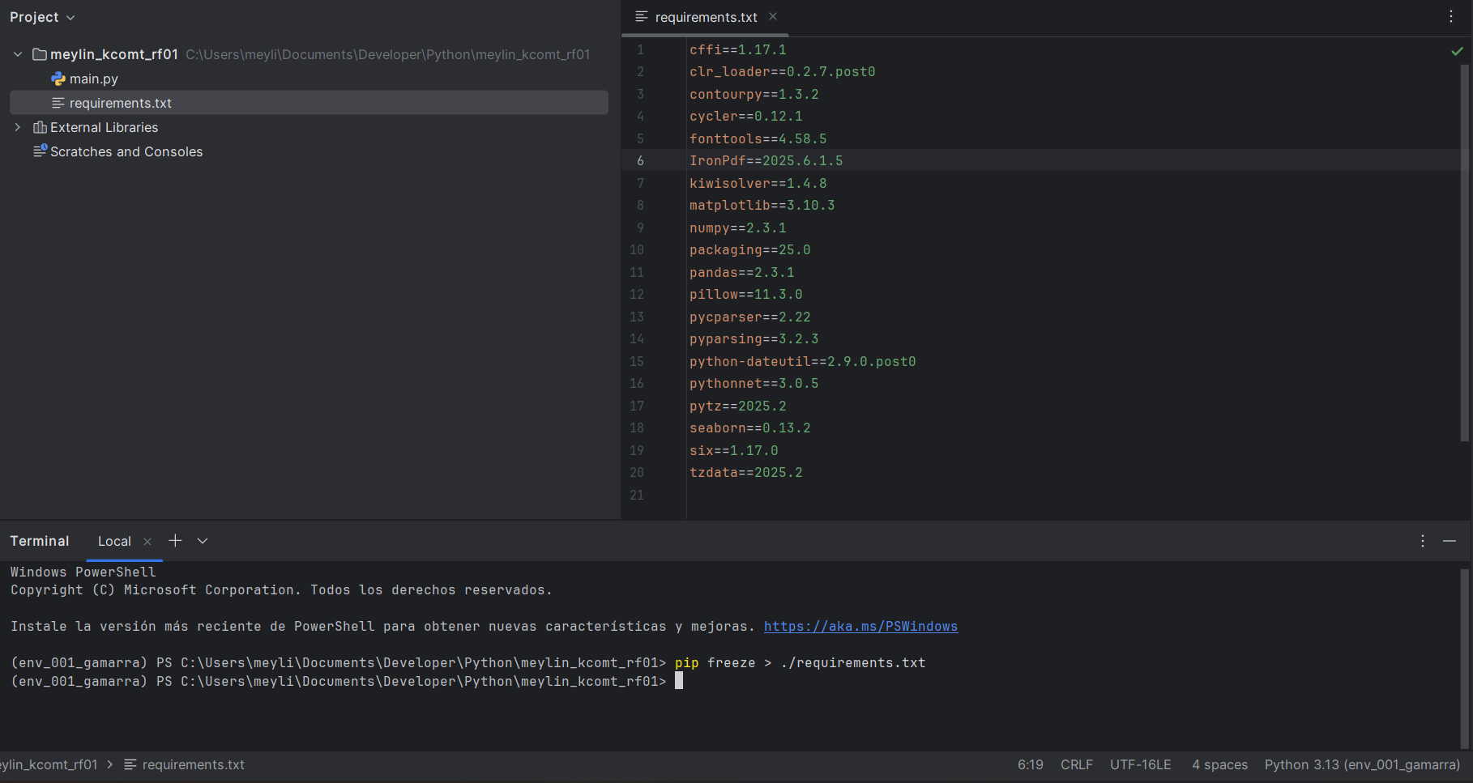**env_001_gamarra**

**env_002_gamarra**

**env_003_gamarra**

**env_003_gamarra**

**env_004_gamarra**

