**Team project report**

* **Task**

The software designed for working with two-dimansional polygons. Using our product, user is able to:

* To add two-dimensional polygons, with a result of the new polygon. (in further updates)
* To subtract two-dimensional polygons, with a result of the new polygon. (in further updates)
* To clone two-dimensional polygons, with a result of the new polygon.
* To scale two-dimensional polygons, with a result of the initial scaled polygon.
* To scale two-dimensional polygons with cloning, with a result of the new polygon.
* To move two-dimensional polygons, with a result of the initial polygon moved on the coordinate system.
* To move two-dimensional polygons, with a resut of the new polygon.
* **Way of implementation, features**

The Point class, which contains point coordinates, is implemented.  
The Vertex structure contains an object point, and a link to the next and previous point  
The polygon is implemented through a twin-list, whose element is vertex type, which does not impose any restrictions on the number of vertices that it contains. The peaks in it are given clockwise

* Results

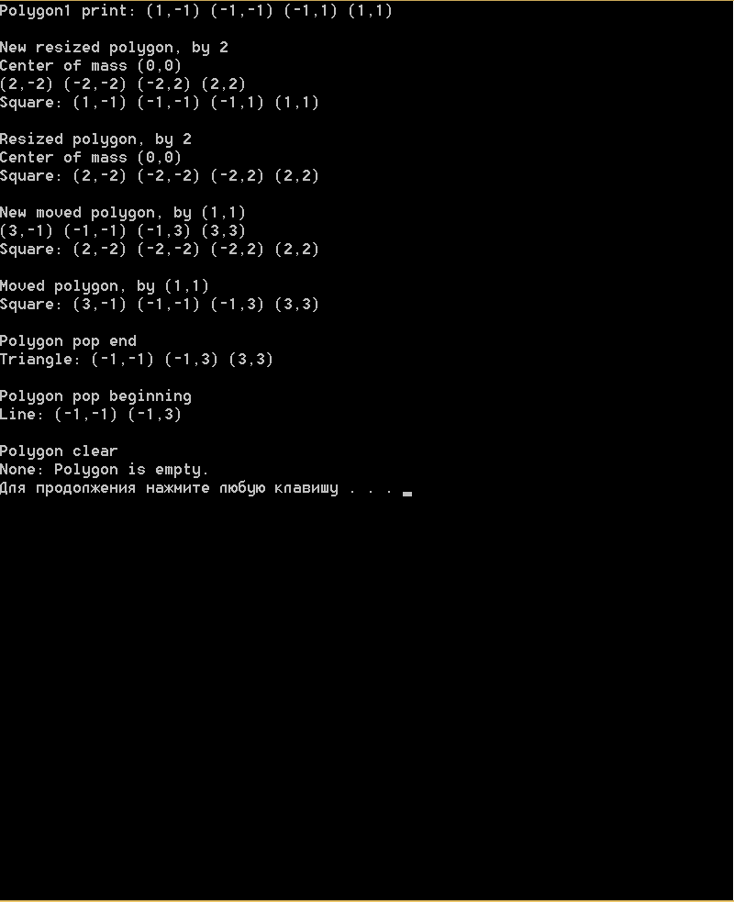

* Problems encountered in the project

There are couple of problems related to merging all parts of code , written by our team+ Input and Output from streams+interaction of classes+connection between classes+construction the scheme of the project......... -_-

But we fixed most of bags and hope evrything works well

* Team cotributions

1. Mykola Krainyk
2. Orest Gorak
3. Victor Hanyk
4. Vadym Pyshnyak
5. Kiral Lukiana



**COUT<< «THANK YOU FOR YOUR ATTENTION «<<ENDL;**

**HOPE YOU LIKED OUR PRODUCT))**