**AZURE**

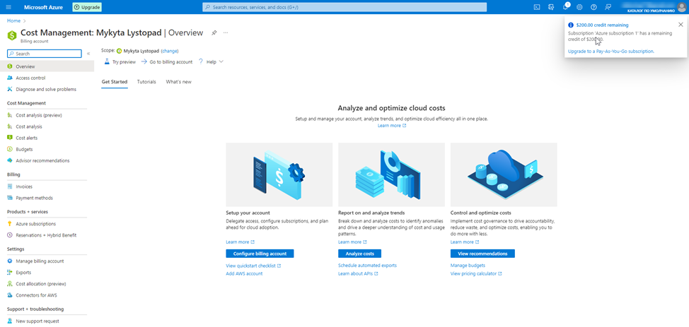

**First of all you need to switch subscription in default directory for apply free billing 200 dollars !!!!!!!!!!**

# **Prerequisites**

**Create azure subscription**

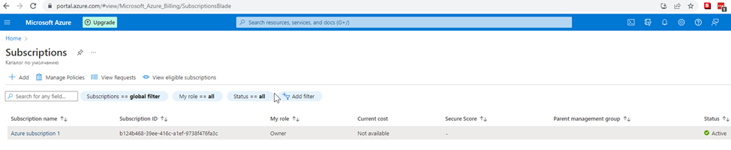

**Create azure devops organization**



**Installing Terraform and Azure Cli**

**1 Download to any directory**

**2 Add path in system env this folder**

**C:\Users\Nik>terraform version**

**Terraform v1.3.4**

**on windows_amd64**

**3 Download and install Azure CLI**

**C:\Users\Nik>az version**

**{**

**"azure-cli": "2.42.0",**

**"azure-cli-core": "2.42.0",**

**"azure-cli-telemetry": "1.0.8",**

**"extensions": {}**

**}**

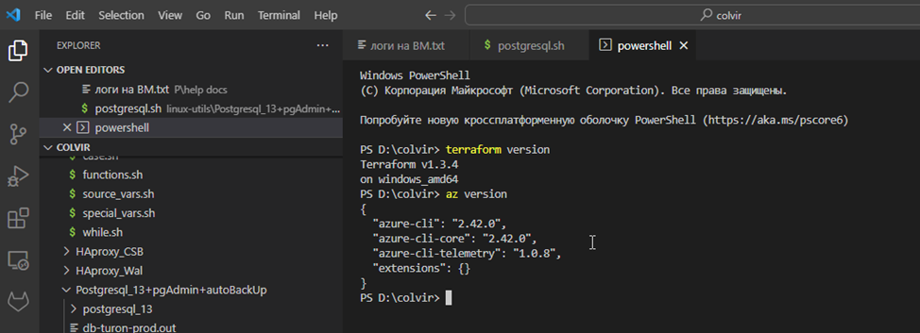

# **Homework**

## **Part 1 – Configure application**

1. Create a service connection in a Azure DevOps project to your subscription -<https://learn.microsoft.com/en-us/azure/devops/pipelines/library/service-endpoints?view=azure-devops&tabs=yaml>

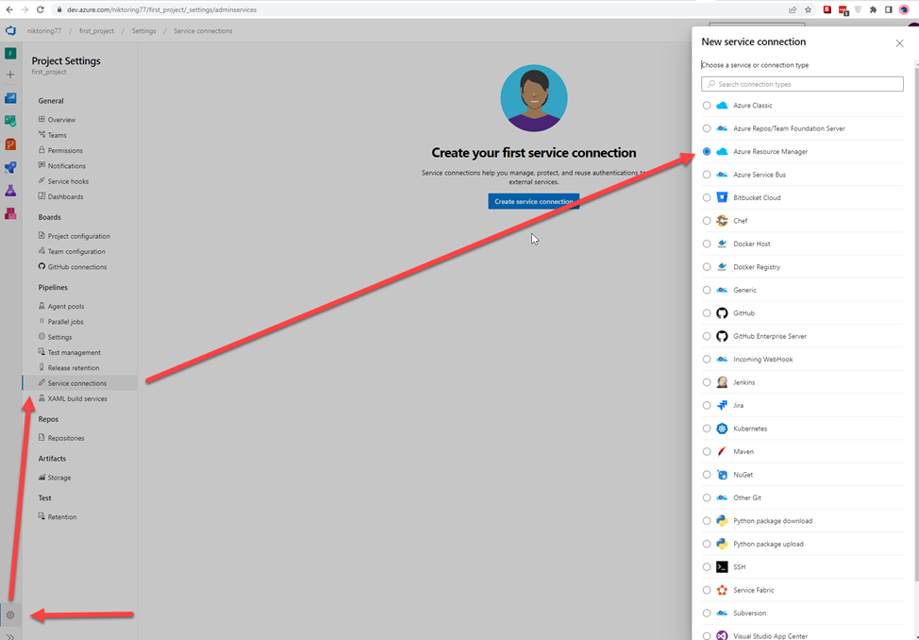

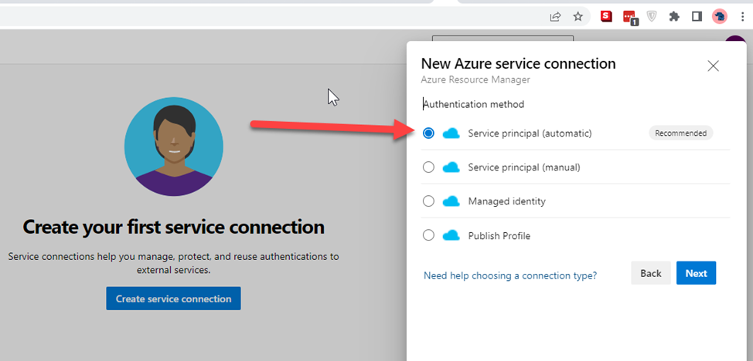

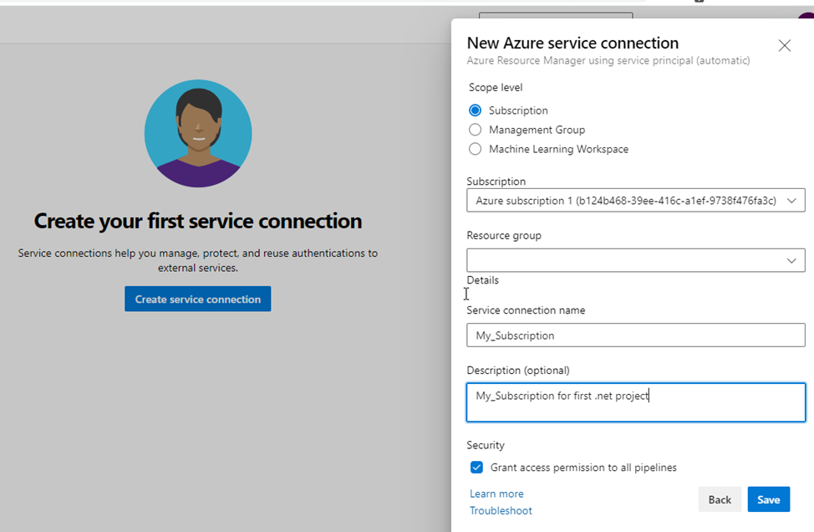

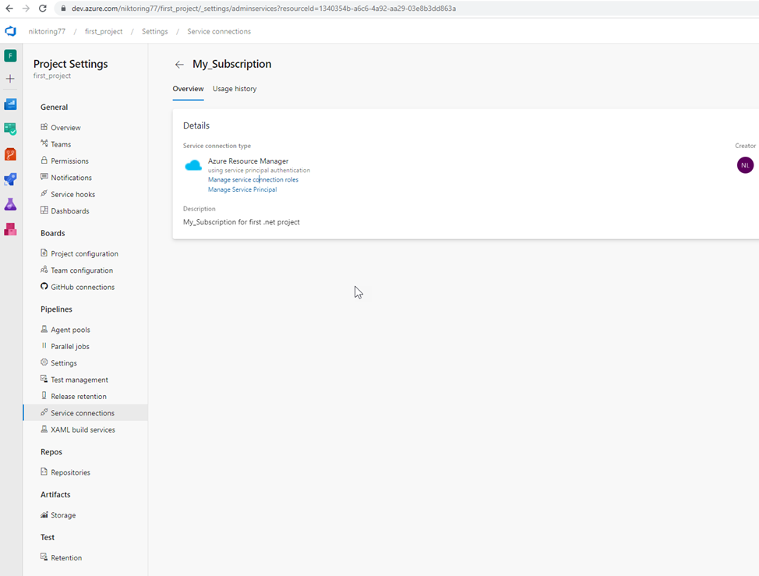

**4** **Create an Azure DevOps repo -** [**https://learn.microsoft.com/en-us/azure/devops/repos/git/create-new-repo?view=azure-devops**](https://learn.microsoft.com/en-us/azure/devops/repos/git/create-new-repo?view=azure-devops) **You can use import repository to import from existing source control version like github**

**Add to Azure repo my project**

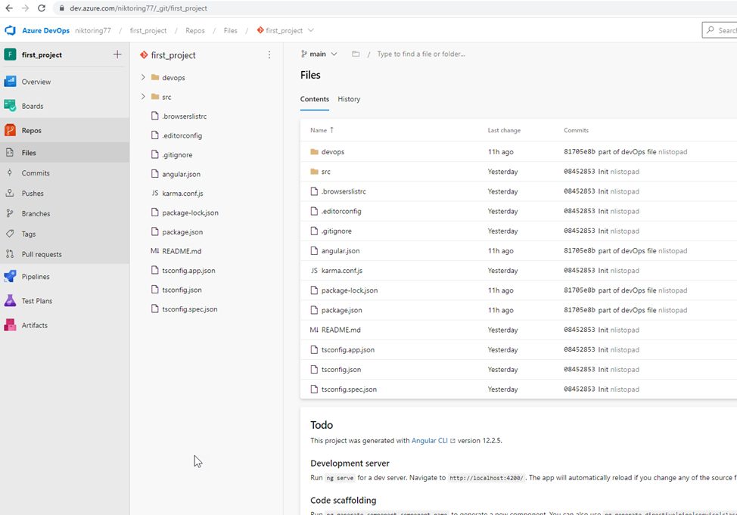

**2)** **Find a .net pet project for the experiments. I find my Angular project**

**Create pipeline**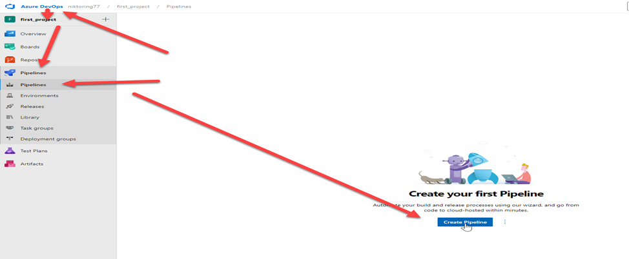

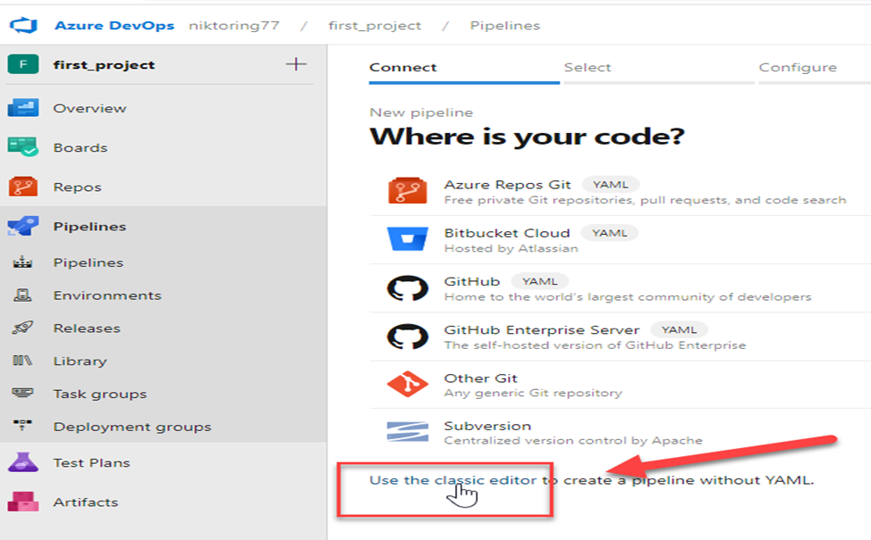 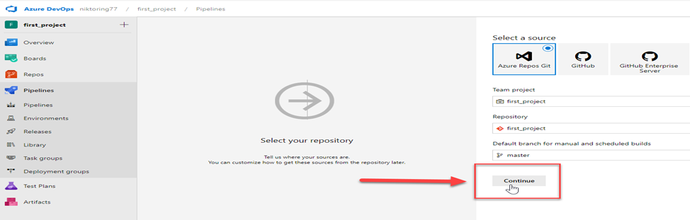

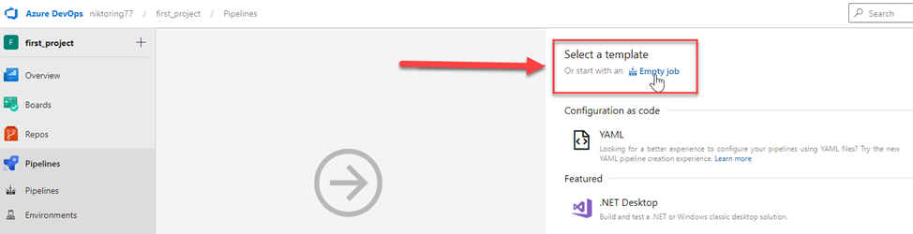

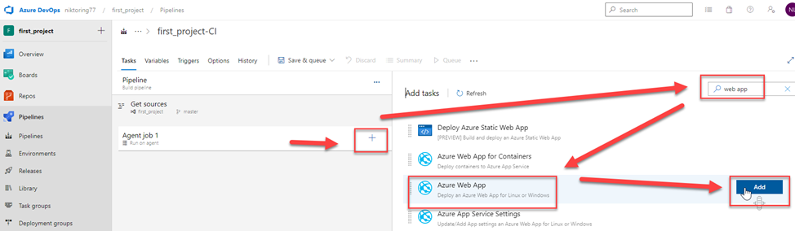

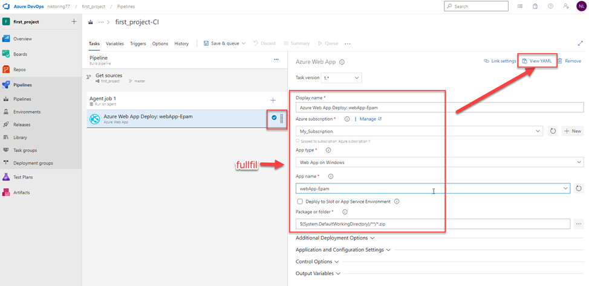

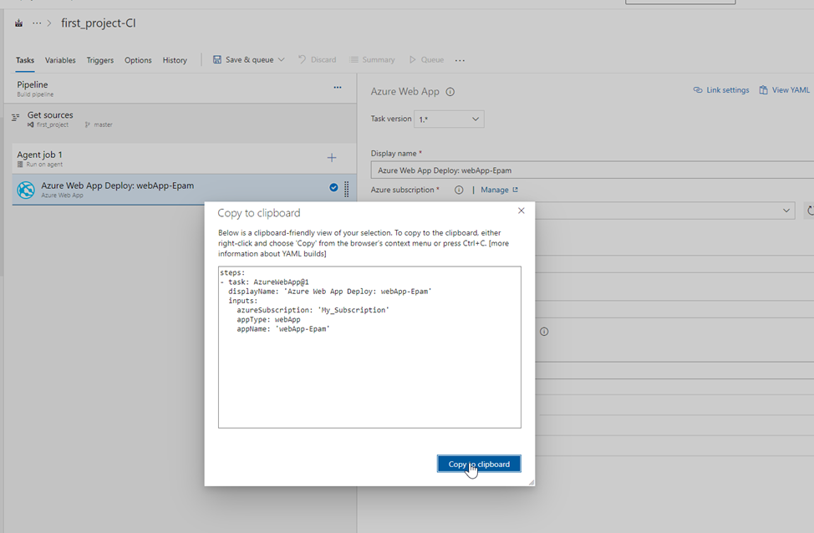

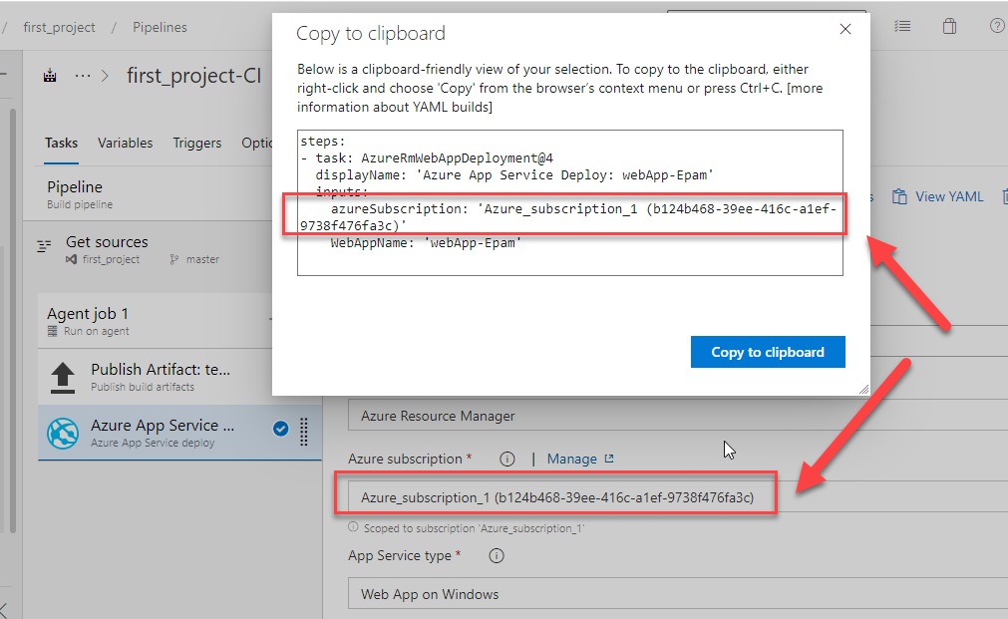

**CREATE or APPROVE your subscribe !!!!!!**

**Add part of code to project**

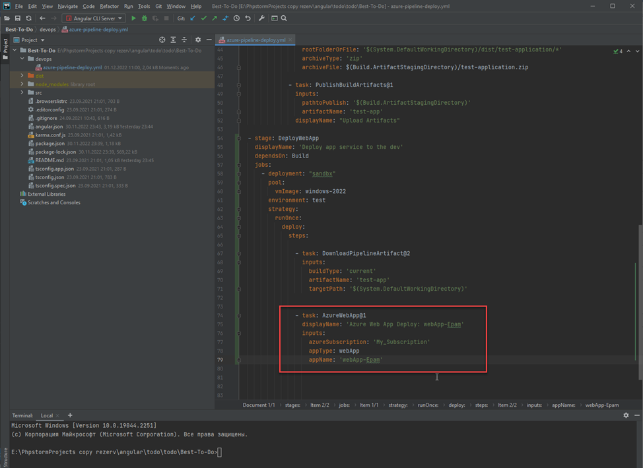

**+ We need to add some parameters**

**Read in manual**

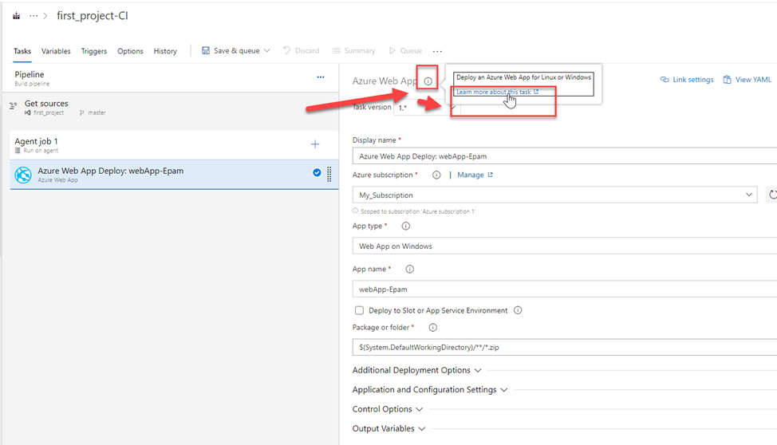

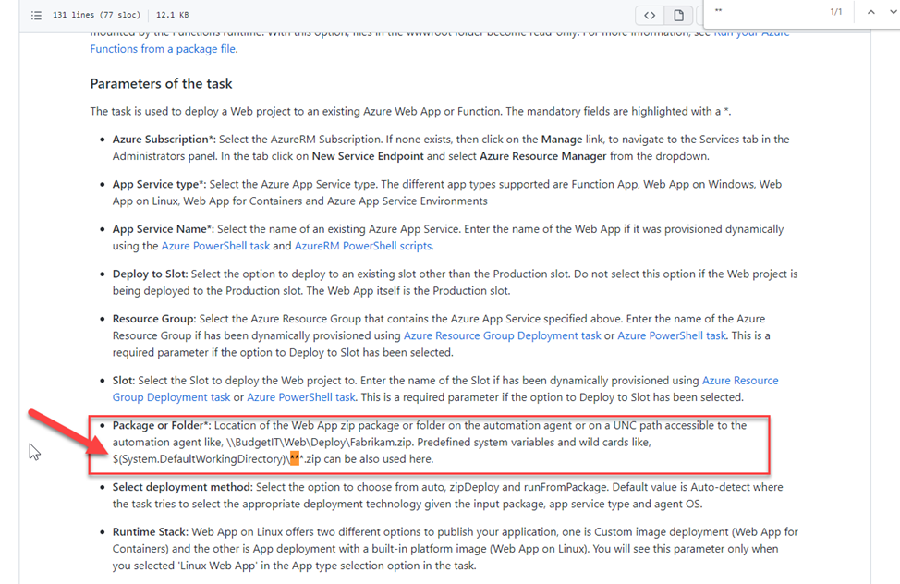

**We need to add:**

package: '$(System.DefaultWorkingDirectory)/**/*.zip'

resourceGroupName: test

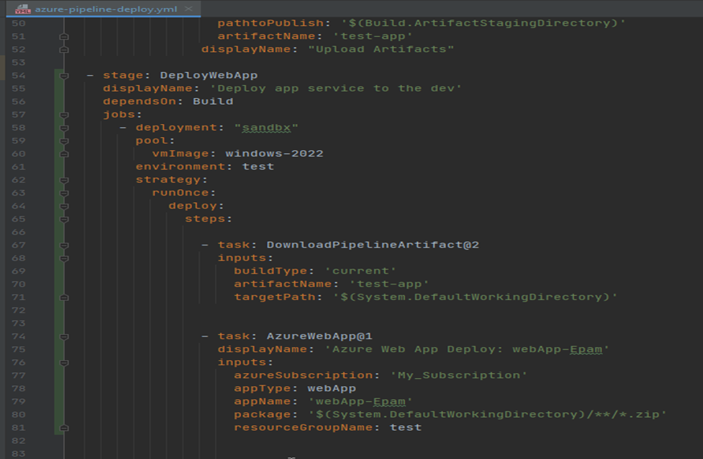

**Push changes to Azure repo**

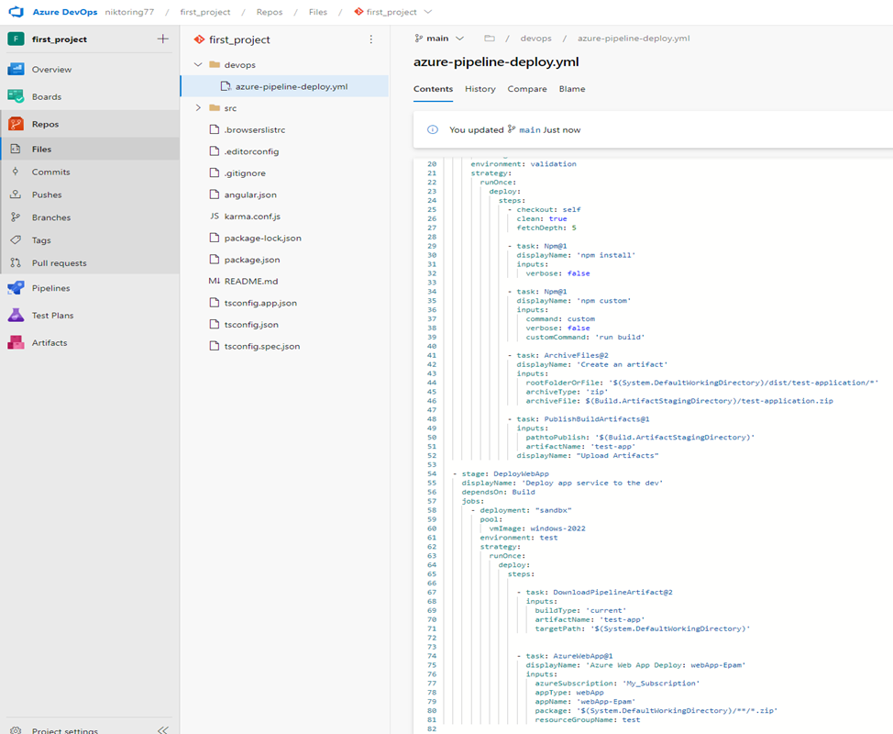

**Do pipeline**

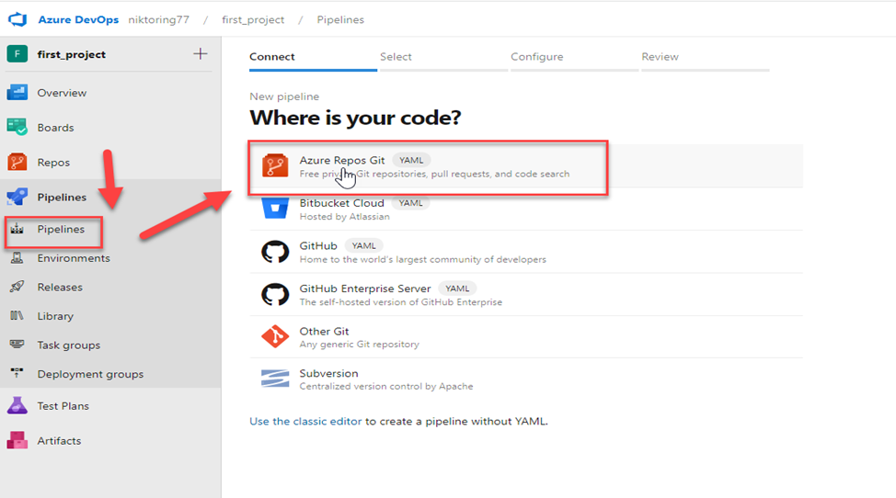

**Choose our app**

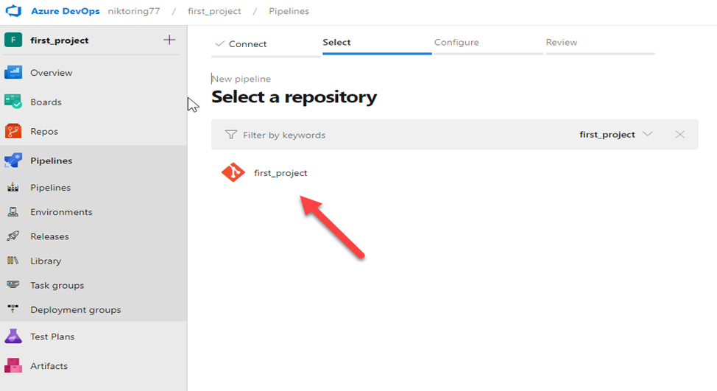

**I pushed to main branch. I need create merge request to DEFAULT branch. in my case it is Master**

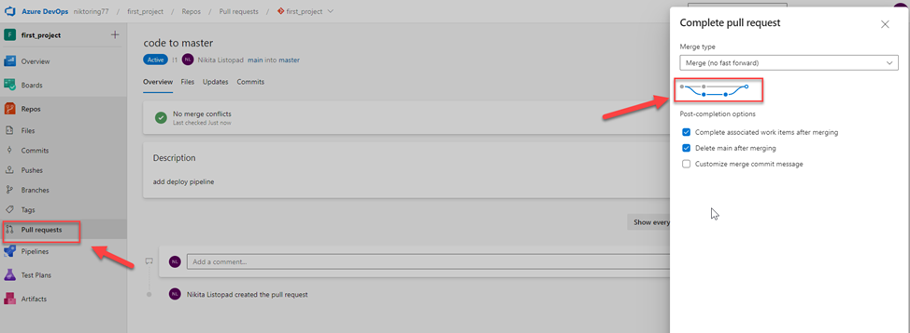

**Then**

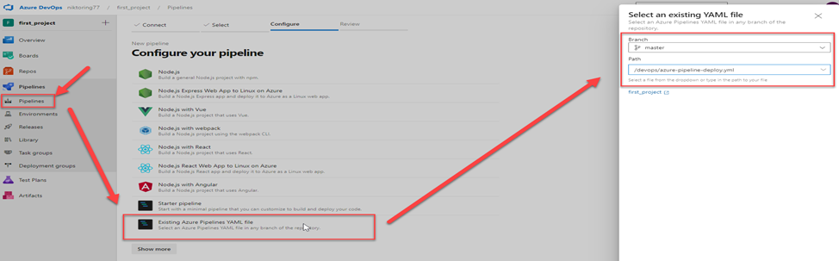

**Continue**

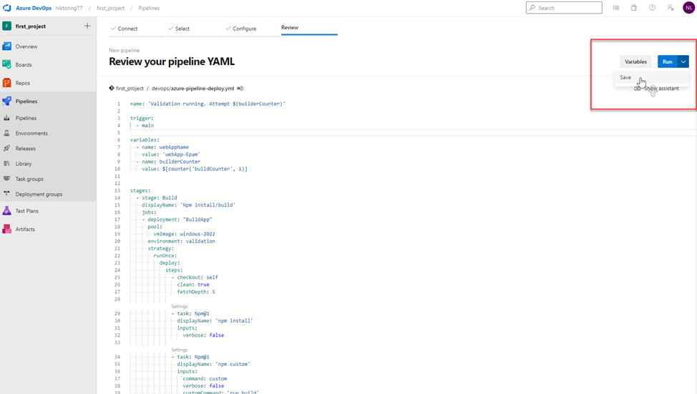

**We have useful options**

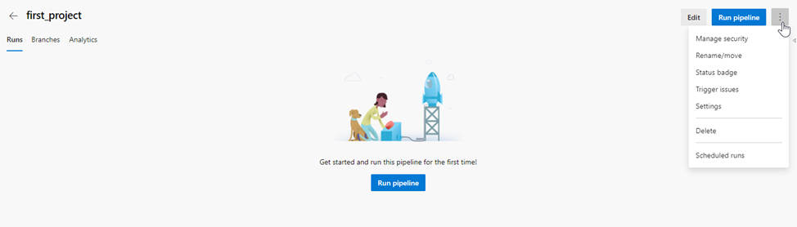

**Edit**

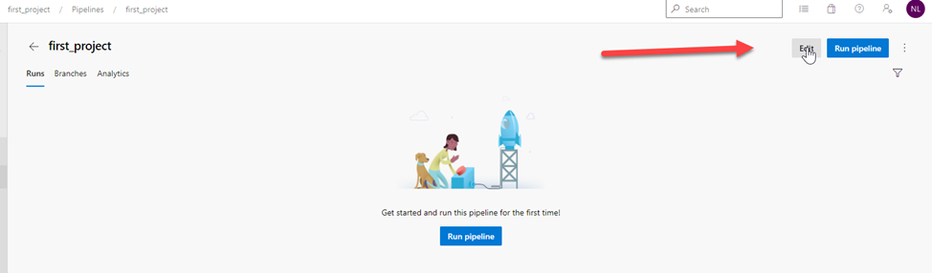

**Check valid our file .yml**

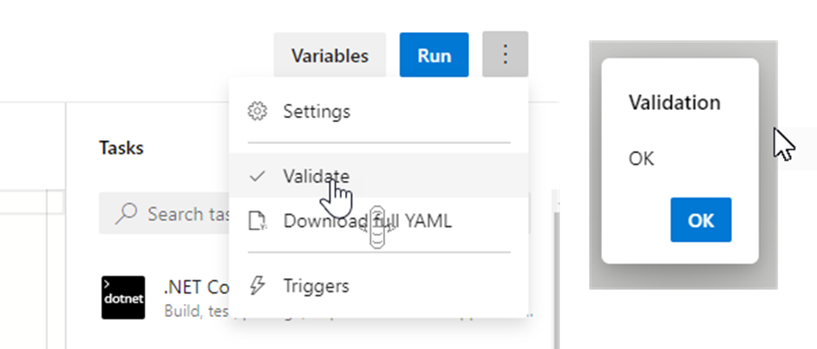

**Run pipeline**

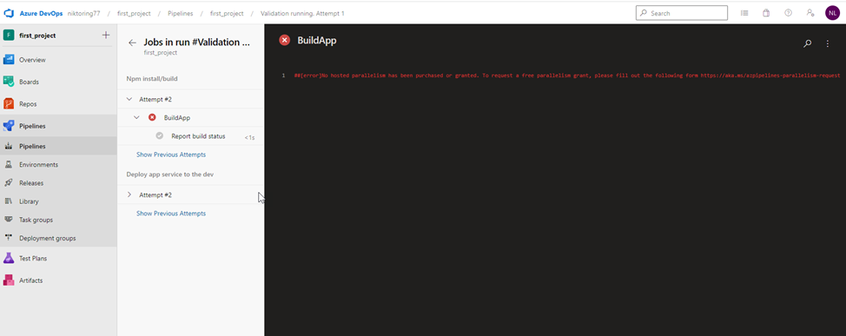

**Send request**

**https://forms.office.com/pages/responsepage.aspx?id=v4j5cvGGr0GRqy180BHbR63mUWPlq7NEsFZhkyH8jChUMlM3QzdDMFZOMkVBWU5BWFM3SDI2QlRBSC4u**

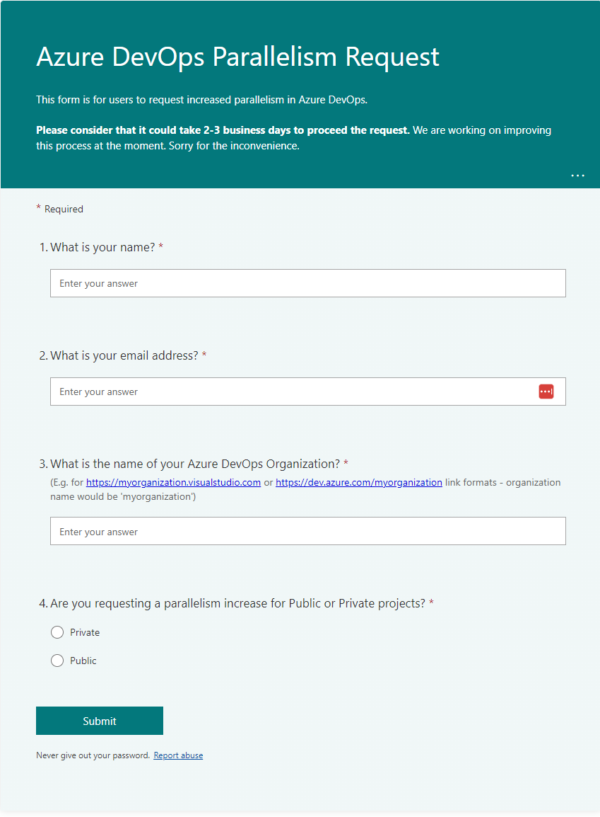

Approval

Where is code on VM in Web-App

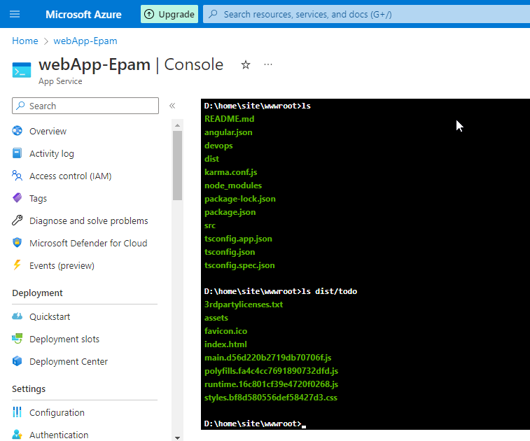

Successful pipeline after error bind with:

rootFolderOrFile: '$(System.DefaultWorkingDirectory)/dist/todo/*'

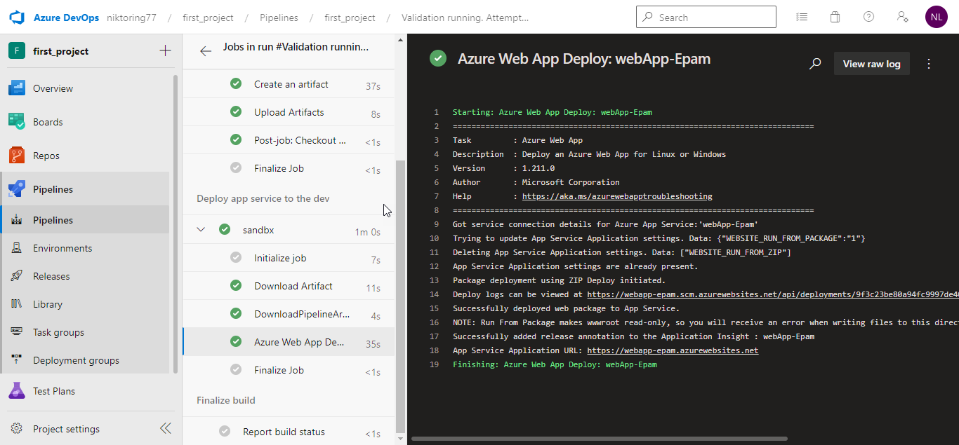

Show result

