BEE U-1,2&3 Diagrams and Circuits

# write notes on classification of semiconductors

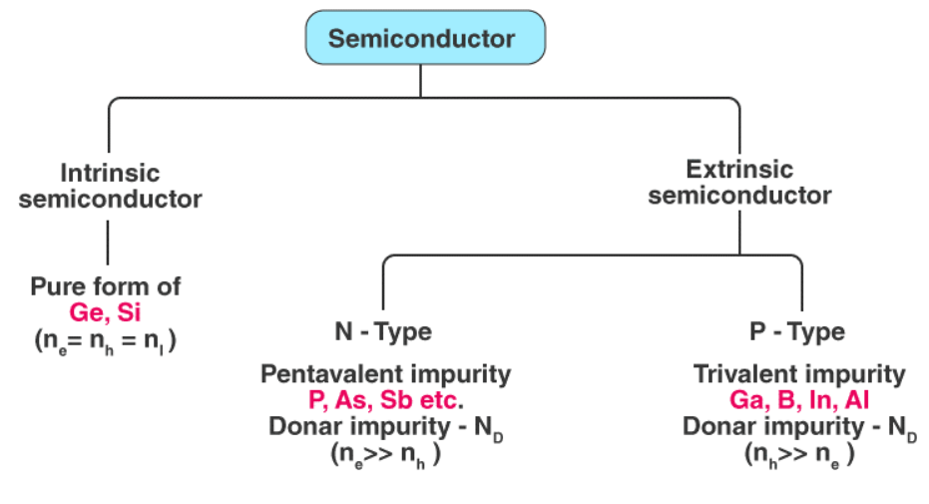

# With neat Sketch compose the construction Its operations of PN Junction diode and also explain VI characteristics of P-N Junction diode:

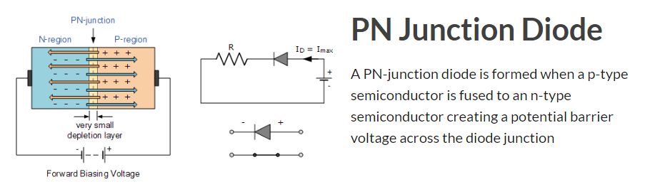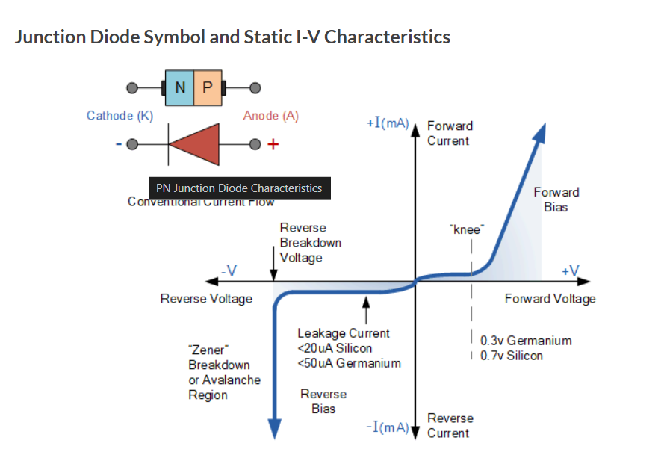

## Explain with neat diagram and waveforms, working of the half-way rectifier?

## 

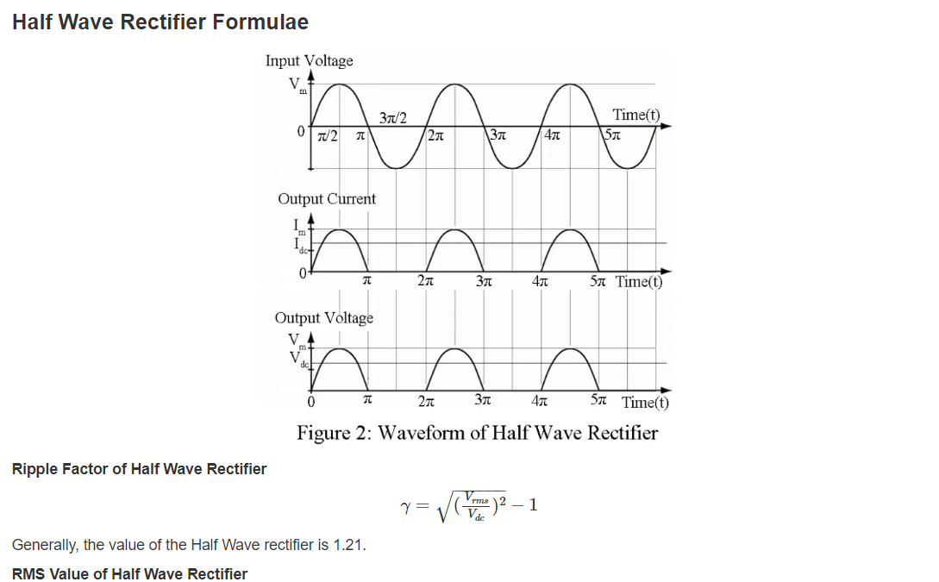

# Explain with need diagram and waveforms, working of full wave rectifier?

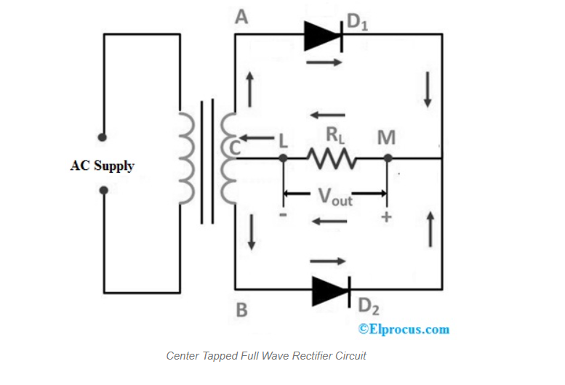

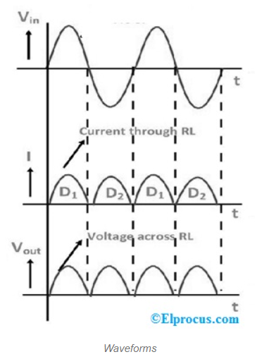

# Explain with neat diagram and waveforms, working on bridge rectifier?

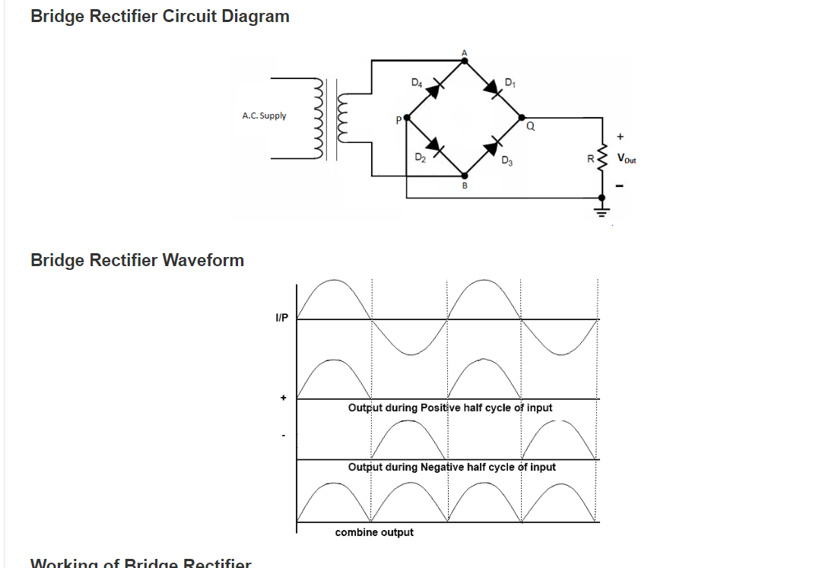

# Zener Diode with neat diagram and VI characteristics

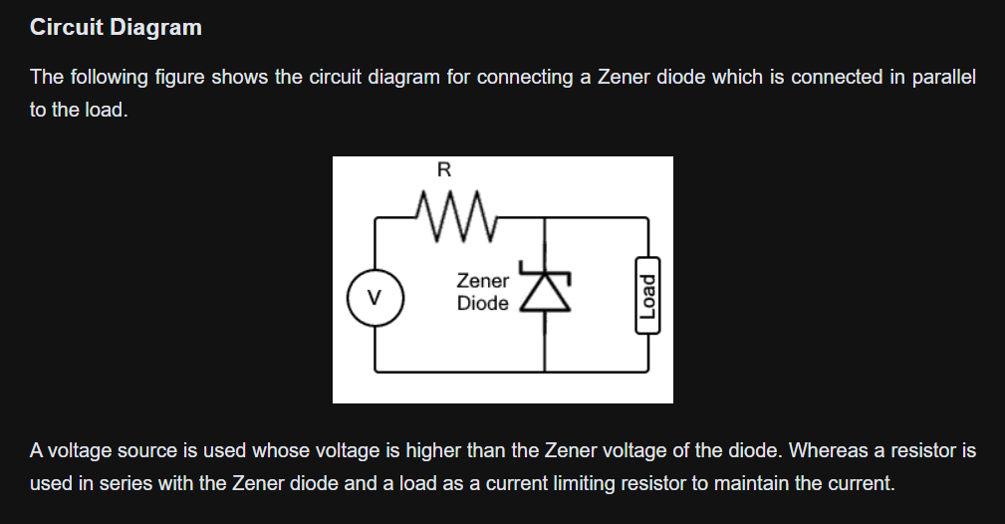

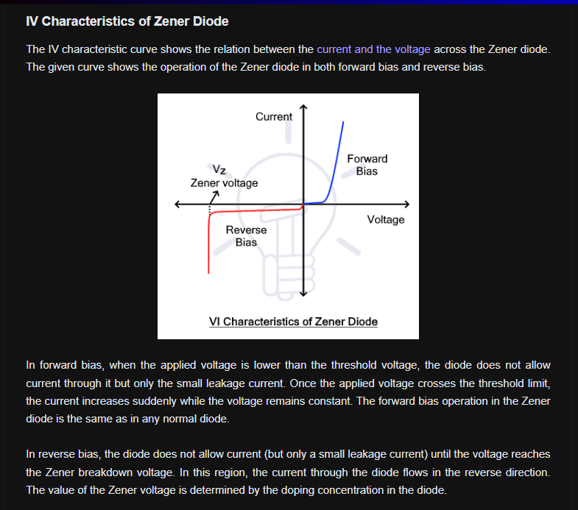

# Explain how Zener Diode can be used as voltage regulator?

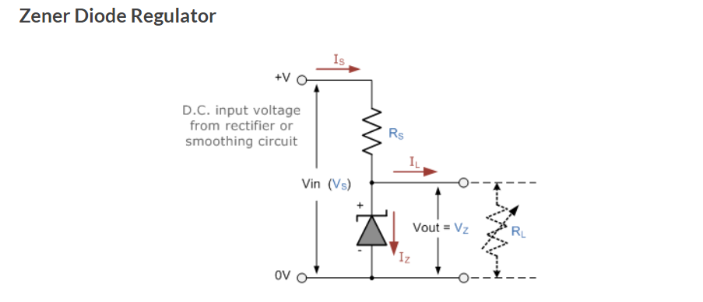

# differentiate between Zener and avalanche breakdown?

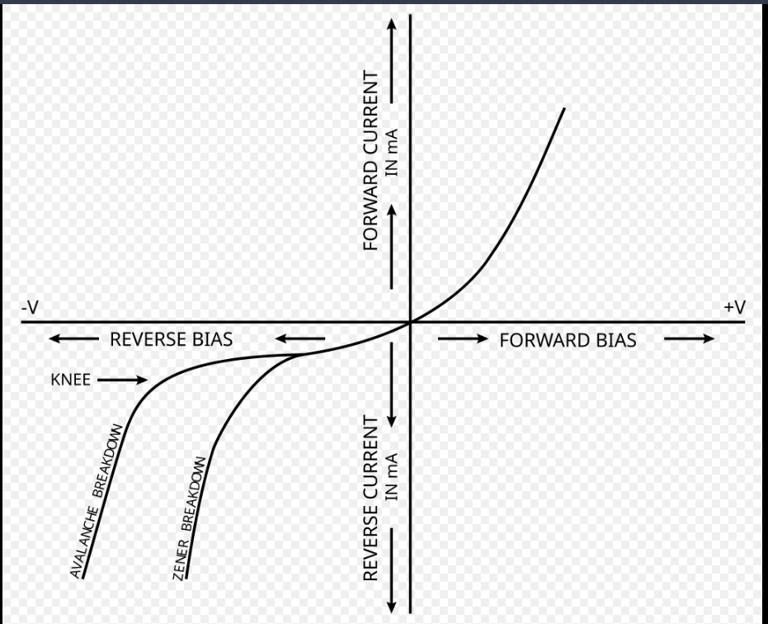

# differentiate between PN Junction diode and zener diode?