

**Software Requirements Specification**

**for**

PantryFinder: Online Community Pantry Finder and Donation Management System Utilizing GPS

**Version 1.0 approved**

**Prepared by Mylene Sanchez, Erika Joy Macalindong & Ma Vianca Tumbaga**

**Team I.TRIO**

**July 09, 2021**

**Table of Contents**

**Table of Contents ii**

**Revision History ii**

**1. Introduction 1**

1.1 Purpose 1

1.2 Document Conventions 1

1.3 Intended Audience and Reading Suggestions 1

1.4 Project Scope 1

1.5 References 1

**2. Overall Description 2**

2.1 Product Perspective 2

2.2 Product Features 2

2.3 User Classes and Characteristics 2

2.4 Operating Environment 2

2.5 Design and Implementation Constraints 2

2.6 User Documentation 2

2.7 Assumptions and Dependencies 3

**3. System Features 3**

3.1 System Feature 1 3

3.2 System Feature 2 (and so on) 4

**4. External Interface Requirements 4**

4.1 User Interfaces 4

4.2 Hardware Interfaces 4

4.3 Software Interfaces 4

4.4 Communications Interfaces 4

**5. Other Nonfunctional Requirements 5**

5.1 Performance Requirements 5

5.2 Safety Requirements 5

5.3 Security Requirements 5

5.4 Software Quality Attributes 5

**6. Other Requirements 5**

**Appendix A: Glossary 5**

**Appendix B: Analysis Models 6**

**Appendix C: Issues List 6**

**Revision History**

|  |  |  |  |
| --- | --- | --- | --- |
| **Name** | **Date** | **Reason For Changes** | **Version** |
| Mylene Sanchez | 07/09/21 |  |  |
| Erika Joy Macalimdong | 07/09/21 |  |  |
| Ma Vianca Tumbaga | 07/09/21 |  |  |

# Introduction

## Purpose

The purpose of this study is to develop a system for the people to have an easiest way of finding different community pantries within the area and donate some essentials. The system focused on online mapping and donation for community pantries and intended for the use of different places that will facilitate the communication between the citizens and for those who are willing to donate. It will provide an online method for finding different community pantries within an area.

In our software requirements, we have Logo for PantryFinder and Homepage, it shows the protocols of social distancing and then it will continue to show you some reminders and guidelines on how to go safe on community pantries. The Login and Create Account for PantryFinder, the community pantry owner will create an account and login to post the details of their community pantry. The Create Post for PantryFinder, the community pantry owner can create a post about the details of their community pantries, the address, the name of the owner, the contact number, and also the essentials or goods that the community pantry has. And the Posts for PantryFinder, the users, the community pantry owner or the donor can view all different posts about community pantries, they just need to scroll it down to see all community pantries that are available around their areas.

## Document Conventions

Throughout this document, to make it more readable and effective, we use texts font of Times New Roman and Arial black. All main headings are size 18, for the sub headings are size 14 and size 11 for the rest of the document font size. And also bold text for the important headings and titles for better readability.

## Intended Audience and Reading Suggestions

The project is a prototype for the online community pantry that will handle the different information regarding the community pantries around their areas, such as the name of community pantry, the name of the owner, contact number, the exact location, the hour that their pantry is open and other information that they like to add. They can filter the location and the essentials that the pantry has. This online community pantry is also applicable for the people who want to donate some food and clothes for every community pantries available.

## Project Scope

The scope of the proposed project is as follows:

* The system has a homepage that contains the social distancing protocol to inform the citizens on what they need to do if they want to go to that community pantry.
* The community pantry owner can create a post regarding the details of their community pantry.
* The community pantry owner can create a post about the details of their community pantries, the address, the name of the owner, the contact number, and also the essentials or goods that the community pantry has.
* The community pantry owner or the donor can view all different posts about community pantries, they just need to scroll it down to see all community pantries that are available around their areas.

## References

* <https://www.slideshare.net/Axphey/the-complete-srs-documentation-of-our-developed-game>
* <https://krazytech.com/projects/sample-software-requirements-specificationsrs-report-airline-database>

# Overall Description

## Product Perspective

The website is created to help citizens or people to easily find different community pantries around their areas. The specific environment that the system will be deployed in will focus on the communities of Lian, Batangas. It aims to give easier access for the users, owners, and donors by simply providing more enhanced features such as Global positioning system (GPS) and creating unique features for encouraging donors to donate.

## Product Features

The proposed system had a web view and application for phone for the citizens and it has four users:

* The community pantry owner who will create the post about their community pantry.
* The user who only just wants to find the different community pantry and the administrator that will monitor all the users.
* For those people who want to donate, it has an interface where they can fill up the details regarding the donation.
* The administrator will be the one who fixes all the updates of the system.

## User Classes and Characteristics

There are various kinds of users for this proposed project. The users include:

* DSWD that will act as the administrator of the system. They will have the privileges to access all the information of the community pantry owner and donor.
* Community Pantry Owner that will post all the information of the community pantry that they will establish. They can update the information and change the status of it
* Donor that will donate essential goods from the community to help those who are in need.
* Citizens that will browse on the application to locate the different community pantries.

## Operating Environment

The system is compatible with android operating systems. Internet connection is a must to view all different functionalities of the system and for the application to be available. Operating environment for the online community pantry system is as listed below.

* PHP
* CSS
* Bootstrap
* SQL
* Maps JavaScript API
* Visual Studio
* Android Studio

## Design and Implementation Constraints

The issue that we have is that the system can’t accommodate the online community pantry anytime, the system needs to have a status if the online community pantry is available. For the safety of our citizens we also add the protocols of social distancing and it will show you some reminders and guidelines on how to go safe on community pantries.

## User Documentation

A user manual would be created to accompany the software product to help users understand the working methods and operation of the prototype system. It would be designed for the people to have an easiest way of finding different community pantries within the area and donate some essentials with a different level of material and language.

## Assumptions and Dependencies

* Assumptions
* The user has an active internet connection to access the application or the system.
* The community pantry owner, donor and the citizen must install the application to access the system or just browse it on the internet.
* Dependencies
* Web interface must be friendly and easy-to-use.
* The search mechanism should be simple and fast.

# System Features

Features of the system:

* Logo for PantryFinder and Homepage, it shows the protocols of social distancing and then it will continue to show you some reminders and guidelines on how to go safe on community pantries.
* Login and Create Account, the community pantry owner will create an account and login to post the details of their community pantry.
* Create Post, the community pantry owner can create a post about the details of their community pantries, the address, the name of the owner, the contact number, and also the essentials or goods that the community pantry has.
* Posts for PantryFinder, the users, the community pantry owner or the donor can view all different posts about community pantries, they just need to scroll it down to see all community pantries that are available around their areas.

* 1. **Pantry Finder**

3.1.1 Description and Priority

The representation of the user's interaction to the system that has mobile view and web system. It also shows the relationship of different users to the different use cases.

3.1.2 Stimulus/Response Sequences

The systemcan also access the different posts of the different community pantry owners and for the user who only needs to know the different community pantries around their area or other places, they will just browse on it and they don't need to register an account. The community pantry owner can create a post regarding the details of their community pantry.The community pantry owner can create a post about the details of their community pantries, the address, the name of the owner, the contact number, and also the essentials or goods that the community pantry has.The community pantry owner or the donor can view all different posts about community pantries, they just need to scroll it down to see all community pantries that are available around their areas.

3.1.3 Functional Requirements

The user, especially the community pantry owner will register an account and login, then they can create a post regarding their community pantry and the donor which they can donate based on what the community pantry needs. They can also access the different posts of the different community pantry owners and for the user who only needs to know the different community pantries around their area or other places, they will just browse on it and they don't need to register an account. The user can access the map that shows the locations of community pantries in the area represented by pins. By clicking on each pin, it shows the name of the pantries and the details. The admin can view and manage all the information of the users and they will be the one who will update the system.

REQ-1: Logo for PantryFinder and Homepage, it shows the protocols of social distancing and then it will continue to show you some reminders and guidelines on how to go safe on community pantries.

REQ-2: Login and Create Account, the community pantry owner will create an account and login to post the details of their community pantry.

REQ-3: Create Post, the community pantry owner can create a post about the details of their community pantries.

REQ-4: Posts for PantryFinder, the users, the community pantry owner or the donor can view all different posts about community pantries.

# External Interface Requirements

## User Interfaces

This section shows the logical characteristics of each intended software interface. In terms of user interface design, common GUI standards will be followed like the message box, screen layouts, designs and so on, as well as standard buttons and controls.

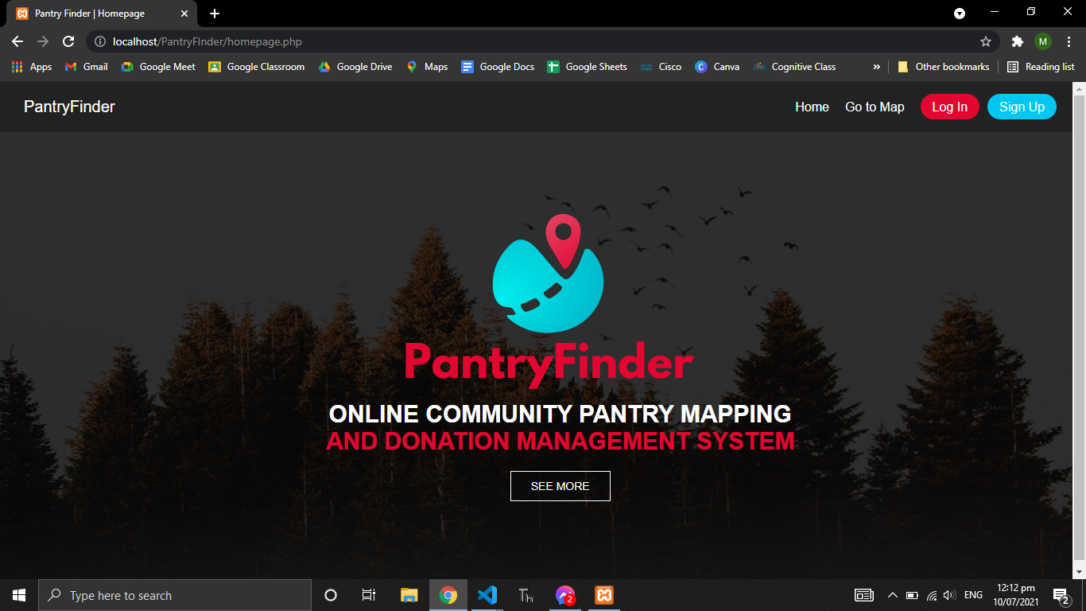

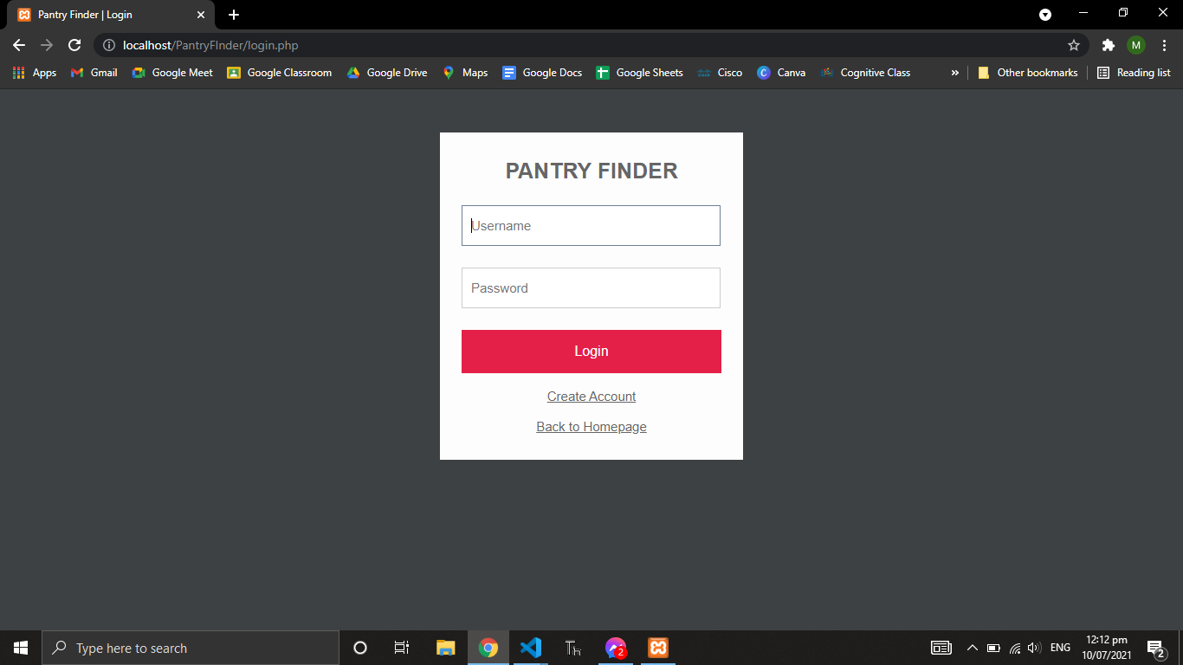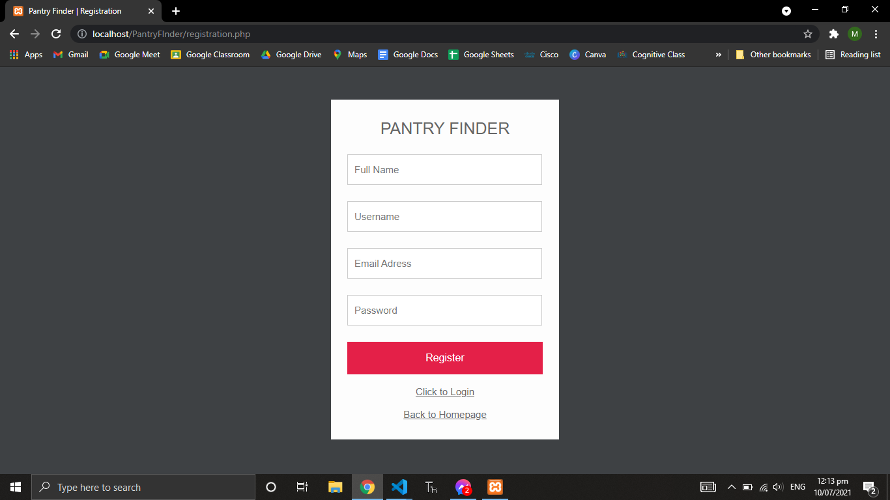

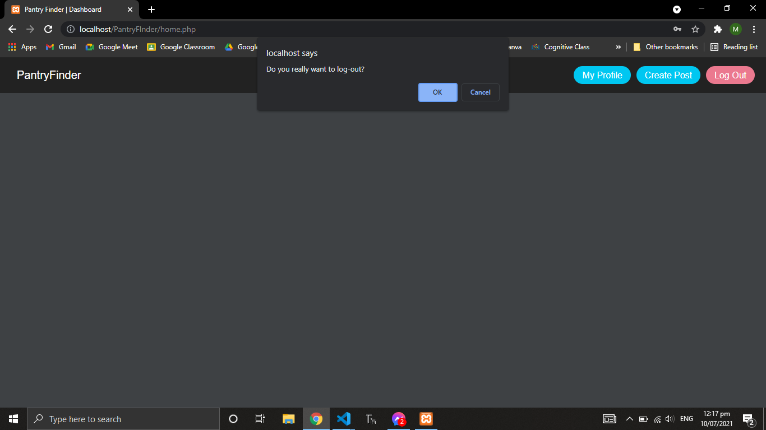

## Hardware Interfaces

* Mobile phones, it helps the citizens and donors to easily access the online community pantry in their barangay.
* GPS to help the citizens and donors to find the easiest way of mapping different community pantries around their areas or even in further places.
* Location Information, In our system we need to trace and record the data of the citizens and donors.
* Laptop, it will help to access the applications of the Pantry Finder.

## Software Interfaces

* **MySql** is an open and free source relational database management system that can be used for a variety of different applications, which is commonly used on web servers and uses Structured Query Language (SQL).
* **Windows Operating System** will be used for the operating system of the web application. We are also planning to include MAC OS for creating the application.
* **Mobile Phone Operating System** such as android jelly bean to nougat.
* **PHP** can be used in a variety of database languages, including MySQL and it supports most web servers today. In web creation, PHP is also a widely used language that other programmers choose because of its ease of deployment and ease of creating static and dynamic web-based applications.

## Communications Interfaces

The requirements that we need in our system is the SMS notification, SMS Notifications are text messages delivered outside of the network in reaction to events or transactions that occur elsewhere.SMS alerts are frequently used as a marketing technique to improve the proportion of repeat visitors, they are also highly beneficial for organization and public safety.

# Other Nonfunctional Requirements

## Performance Requirements

The steps involved to perform the implementation of online community pantry database are as listed below:

**A) E-R DIAGRAM**

The E-R Diagram is a method for visually displaying the logical structure of a database. After that, this analysis is utilized to arrange data as a relation, normalize the relation, and create a relational database.

* **ENTITIES:** Which specify distinct real-world items in an application.
* **PROPERTIES/ATTRIBUTES:** Which specify properties of an entity and relationships.
* **RELATIONSHIPS:** Which connect entities and represent meaningful dependencies between them.

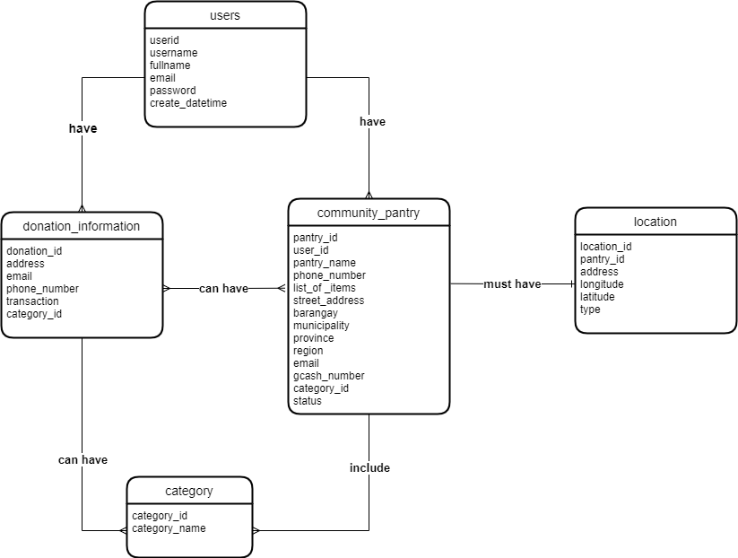

## Safety Requirements

The system has an interface that shows the protocols of social distancing, it will inform the users to prevent contact. And the system will utilize the database to administer the online community pantry's registration, query, retain, and store data. This database will ensure that data is preserved and managed to minimize data loss and damage. When data is lost, which produces incorrect details anytime the forms are generated or accessed.

## Security Requirements

The system will provide a verification code for the creation of an account, to determine if the owner and donor are not creating the wrong account to avoid spreading false information for the users. The system has the authentication for password management for the creation account. The information of the user will be confidential, all the information will preserve the access control and disclosure restrictions of the users.

## Software Quality Attributes

* Reliability - the system can be used by multiple users concurrently. Any user can access the system through phone, pc or laptop.
* Availability - the system is available during 24 hours of the day.
* Portability - users can access the system at any time.
* Interoperability - the database of the users can be accessed by the admin and they are interconnected so that it can track and exchange data easily.
* Usability - it’s easy to use for those people with an easy to understand interface.
* Efficiency - able to handle an increased usage of data.

# Other Requirements

**Appendix A: Glossary**

|  |  |
| --- | --- |
| **Community Pantry** | Refers to a food bank where people can get the essentials for free. |
| **Donor** | Refers to a person who is willing and able to donate something, particularly money to fund charities or other things to help people. |
| **Donation** | Refers to the essential goods that will be given on community pantry |
| **DSWD** | Department of Social Welfare and Development |
| **GPS** | Global Positioning System |
| **GUI** | Graphical User Interface |
| **Laptop** | It is a portable personal computer. |
| **Mobile Phone** | a phone that is accessible to all different platforms and applications. |

**Appendix B: Analysis Models**

**Use Case Diagram**

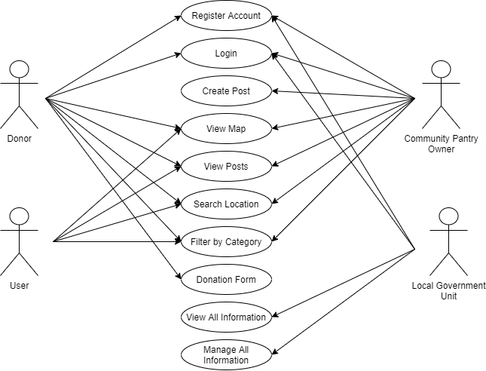

**Data Flow Diagram**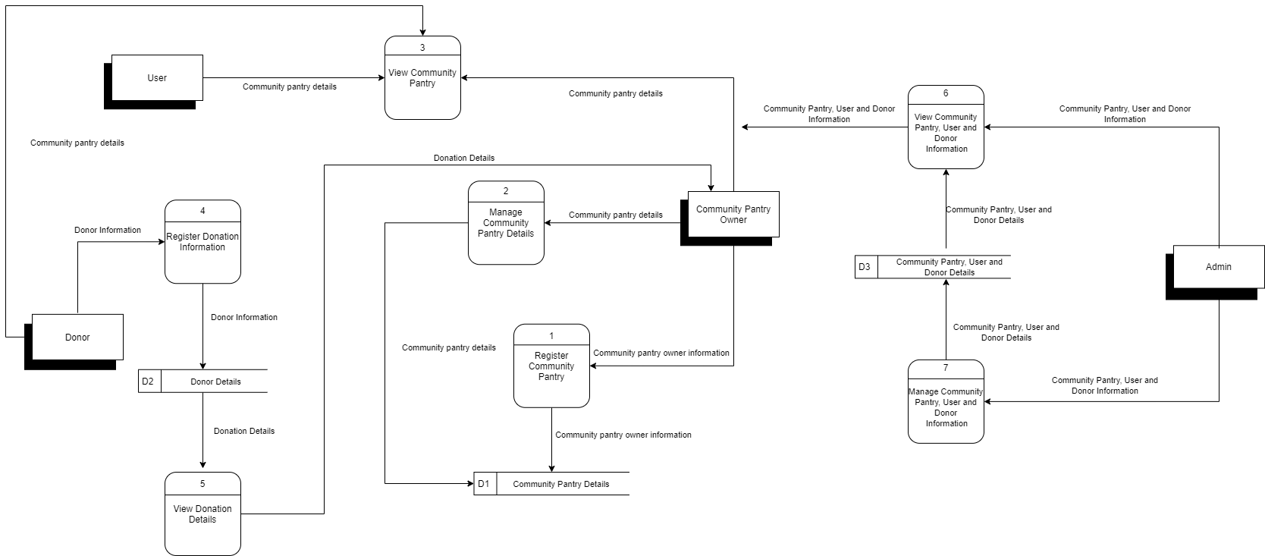

**Entity Relationship Diagram**

**Appendix C: Issues List**

Some issues we might encounter when implementing the application system PantryFinder:

* Creating accounts.
* Creating posts about community pantries.
* Posting places and pin it on the map.
* Can’t validate if the donor is accurate.
* Internet connection