Rclass

Myles

2018뀈 9썡 3씪

## R Markdown

This is an R Markdown document. Markdown is a simple formatting syntax for authoring HTML, PDF, and MS Word documents. For more details on using R Markdown see <http://rmarkdown.rstudio.com>.

When you click the **Knit** button a document will be generated that includes both content as well as the output of any embedded R code chunks within the document. You can embed an R code chunk like this:

summary(cars)

## speed dist   
## Min. : 4.0 Min. : 2.00   
## 1st Qu.:12.0 1st Qu.: 26.00   
## Median :15.0 Median : 36.00   
## Mean :15.4 Mean : 42.98   
## 3rd Qu.:19.0 3rd Qu.: 56.00   
## Max. :25.0 Max. :120.00

## Including Plots

You can also embed plots, for example:

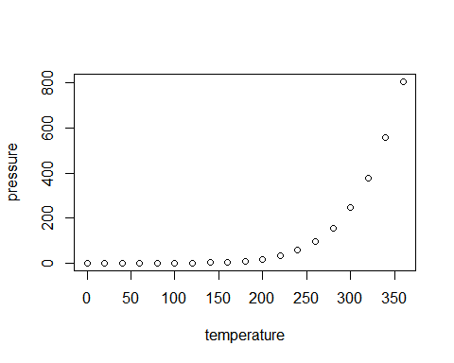

Note that the echo = FALSE parameter was added to the code chunk to prevent printing of the R code that generated the plot.

## mpg cyl disp hp drat wt qsec vs am gear carb  
## Mazda RX4 21.0 6 160 110 3.90 2.620 16.46 0 1 4 4  
## Mazda RX4 Wag 21.0 6 160 110 3.90 2.875 17.02 0 1 4 4  
## Datsun 710 22.8 4 108 93 3.85 2.320 18.61 1 1 4 1  
## Hornet 4 Drive 21.4 6 258 110 3.08 3.215 19.44 1 0 3 1  
## Hornet Sportabout 18.7 8 360 175 3.15 3.440 17.02 0 0 3 2  
## Valiant 18.1 6 225 105 2.76 3.460 20.22 1 0 3 1

## mpg cyl disp hp drat wt  
## mpg 1.0000000 -0.8521620 -0.8475514 -0.7761684 0.68117191 -0.8676594  
## cyl -0.8521620 1.0000000 0.9020329 0.8324475 -0.69993811 0.7824958  
## disp -0.8475514 0.9020329 1.0000000 0.7909486 -0.71021393 0.8879799  
## hp -0.7761684 0.8324475 0.7909486 1.0000000 -0.44875912 0.6587479  
## drat 0.6811719 -0.6999381 -0.7102139 -0.4487591 1.00000000 -0.7124406  
## wt -0.8676594 0.7824958 0.8879799 0.6587479 -0.71244065 1.0000000  
## qsec 0.4186840 -0.5912421 -0.4336979 -0.7082234 0.09120476 -0.1747159  
## vs 0.6640389 -0.8108118 -0.7104159 -0.7230967 0.44027846 -0.5549157  
## am 0.5998324 -0.5226070 -0.5912270 -0.2432043 0.71271113 -0.6924953  
## gear 0.4802848 -0.4926866 -0.5555692 -0.1257043 0.69961013 -0.5832870  
## carb -0.5509251 0.5269883 0.3949769 0.7498125 -0.09078980 0.4276059  
## qsec vs am gear carb  
## mpg 0.41868403 0.6640389 0.59983243 0.4802848 -0.55092507  
## cyl -0.59124207 -0.8108118 -0.52260705 -0.4926866 0.52698829  
## disp -0.43369788 -0.7104159 -0.59122704 -0.5555692 0.39497686  
## hp -0.70822339 -0.7230967 -0.24320426 -0.1257043 0.74981247  
## drat 0.09120476 0.4402785 0.71271113 0.6996101 -0.09078980  
## wt -0.17471588 -0.5549157 -0.69249526 -0.5832870 0.42760594  
## qsec 1.00000000 0.7445354 -0.22986086 -0.2126822 -0.65624923  
## vs 0.74453544 1.0000000 0.16834512 0.2060233 -0.56960714  
## am -0.22986086 0.1683451 1.00000000 0.7940588 0.05753435  
## gear -0.21268223 0.2060233 0.79405876 1.0000000 0.27407284  
## carb -0.65624923 -0.5696071 0.05753435 0.2740728 1.00000000

## mpg cyl disp hp drat wt qsec vs am gear carb  
## mpg 1.00 -0.85 -0.85 -0.78 0.68 -0.87 0.42 0.66 0.60 0.48 -0.55  
## cyl -0.85 1.00 0.90 0.83 -0.70 0.78 -0.59 -0.81 -0.52 -0.49 0.53  
## disp -0.85 0.90 1.00 0.79 -0.71 0.89 -0.43 -0.71 -0.59 -0.56 0.39  
## hp -0.78 0.83 0.79 1.00 -0.45 0.66 -0.71 -0.72 -0.24 -0.13 0.75  
## drat 0.68 -0.70 -0.71 -0.45 1.00 -0.71 0.09 0.44 0.71 0.70 -0.09  
## wt -0.87 0.78 0.89 0.66 -0.71 1.00 -0.17 -0.55 -0.69 -0.58 0.43  
## qsec 0.42 -0.59 -0.43 -0.71 0.09 -0.17 1.00 0.74 -0.23 -0.21 -0.66  
## vs 0.66 -0.81 -0.71 -0.72 0.44 -0.55 0.74 1.00 0.17 0.21 -0.57  
## am 0.60 -0.52 -0.59 -0.24 0.71 -0.69 -0.23 0.17 1.00 0.79 0.06  
## gear 0.48 -0.49 -0.56 -0.13 0.70 -0.58 -0.21 0.21 0.79 1.00 0.27  
## carb -0.55 0.53 0.39 0.75 -0.09 0.43 -0.66 -0.57 0.06 0.27 1.00

## corrplot 0.84 loaded

