# Introduction

This device makes it easier to open canned jars by breaking the seal.

# Research

|  |  |  |  |
| --- | --- | --- | --- |
| Commercial | | | |
| Name | Image | Price | Link |
| Jar Opener for Weak Hands |  | $17.95 | [Link](https://www.amazon.ca/Jar-Opener-Weak-Hands-Tool/dp/B07G84SDW9) |
| Jar Opener 5 in 1 |  | $19.99 | [Link](https://www.amazon.ca/Function-Non-Slip-Seniors-Arthritis-Black-Red/dp/B0936R39DC/ref=sr_1_8?ascsubtag=5663865%7Cn8006bfa253bc46d292f8da511114443d19%7CB08G4G6J4Z&keywords=JAPI+Jar+Opener%2C+5-in-1&linkCode=gs3&qid=1673637246&sr=8-8) |
| DIY | | | |
| Name | Image | Price | Link |
| Jar Opener V2 |  | N/A | [Link](https://www.thingiverse.com/thing:1962792) |
| Jar Opener |  | <$1 filament | [Link](https://www.printables.com/en/model/214950-jar-opener) |

# Requirements

## Goals

|  |  |
| --- | --- |
| G01 | Allow the lid of a jar to be easily removed |

## Functional Requirements

|  |  |
| --- | --- |
| F01 | Be usable by people with limited hand function |
| F02 | Require minimal amount of force to use |

## Constraints

|  |  |
| --- | --- |
| C01 | Must be entirely 3D printed |

# Jar Lid Opener Design V1.0

## Testing

After the print was finished, it was used to remove several stuck jar lids, as well as a jar lid that was held in place to test the breaking point of the print.

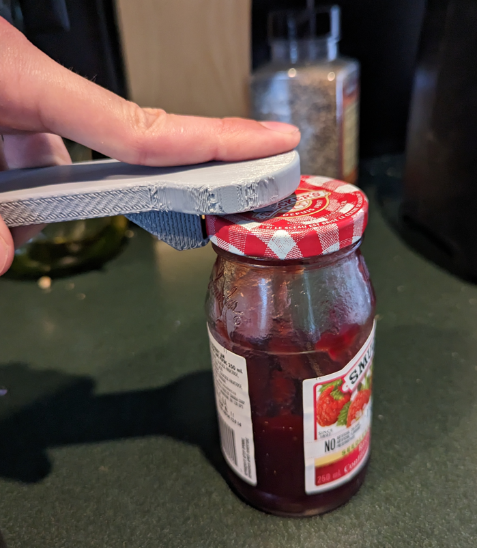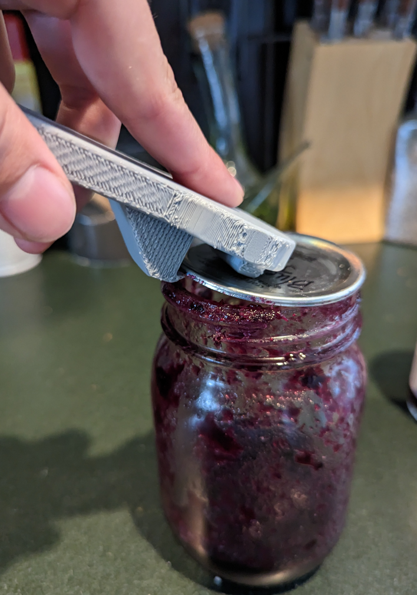

## Opportunities for Improvement

The file could be redesigned to print flat against the printer bed with no supports.