Made By: Myles Crockem

Gun Runner

**About:**

Gun Runner is a 2-player game where one player controls a runner and the other controls a stationary gun. The first player’s objective is to get a bomb and get it in range of the gun without getting shot. The second player’s objective is to control and protect the gun by shooting the runner controlled by the first player. The game ends when either the runner gets shot or the bomb is close enough to the bomb to go off.

**Future Development:**

If I were to continue to work on this project some things I would add:

* Add self-drawn sprites and overall improve the look of the game
* Add random generation of levels and obstacles
* Add different types of guns and characters for the players to pick from with different abilities
* Add power ups for the character to grab and interactable around the level for the gunner

**This is the initial Design idea:**

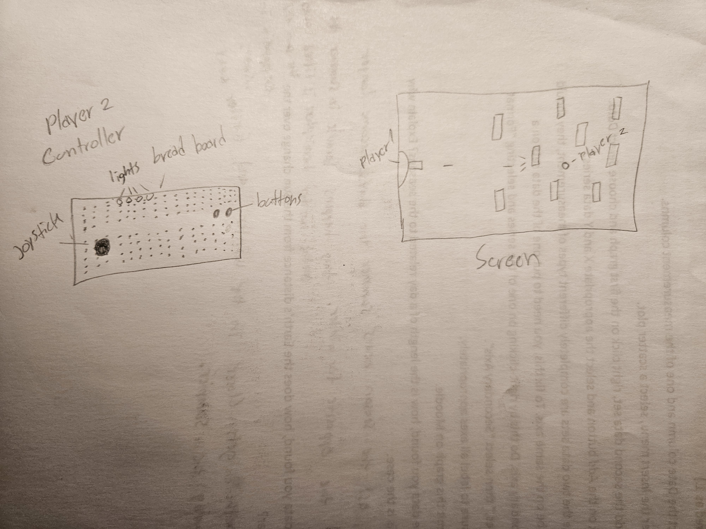

**This is the final product:**

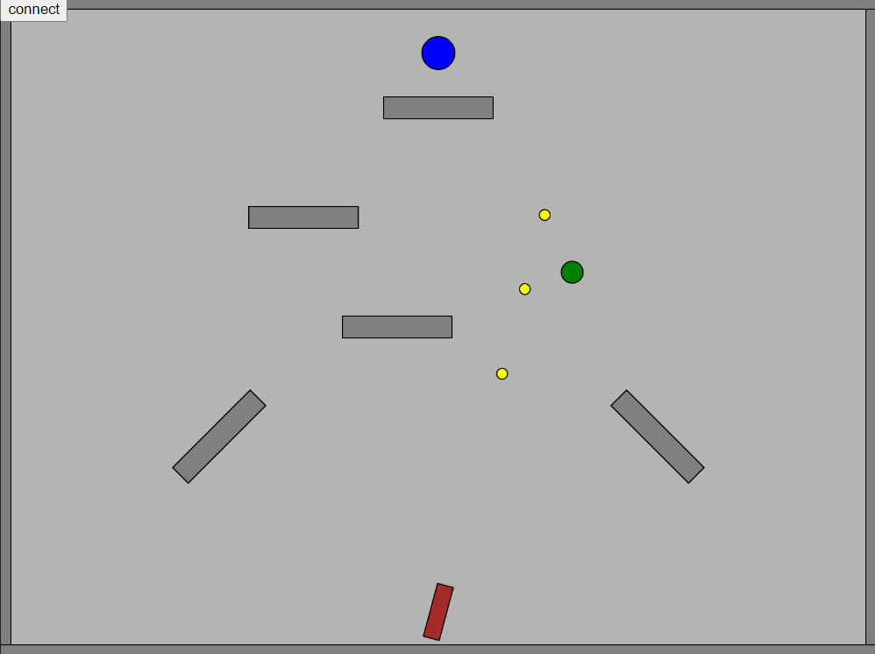

**Gameplay:**

https://youtu.be/11KinTrfFCs