Social Media Comments Categorization, Prioritization and Sentiment Analysis
Mylie Mudaliyar¹, Sweta Chandrasekhar¹, Kirthika V¹ and Priya G¹
¹Vellore Institute of Technology, Vellore, Tamil Nadu, Indıa
Abstract. The proliferation of customer comments on social media platforms presents an engagement challenge for content creators and organizations. Manual re-view methods are inefficient for systematically extracting, analyzing, and responding to large volumes of feedback. This paper proposes a methodology integrating web scraping and K-means clustering to systematically categorize and prioritize responses. Custom web scrapers extract comments from YouTube videos, overcoming limitations of traditional screen scraping. Sentiment analysis using TextBlob and HuggingFace provides insight into overall video sentiment. The unsupervised K-means algorithm clusters comments based on certain factors, enabling data-driven prioritization. This research highlights the potential of integrating web scraping, machine learning, and clustering techniques to elevate customer satisfaction via prompt, tailored responses to feedback at scale. This methodology can be integrated with an us-er interface, with the content creators uploading the desired video ids and getting relevant comment categories or overall user sentiment. This integrated methodology promises to optimize understanding and response to diverse customer feedback at scale.

Keywords: Web scraping, sentiment analysis, K-means clustering.

Introduction

Managing a burgeoning YouTube channel or any social media platform becomes a formidable challenge when inundated with an overwhelming volume of comments and reviews, many of which include numerous questions. The current manual process of sifting through this deluge is inefficient, hindering the ability to identify and respond promptly to customer queries. To address this, the proposed project aims to revolutionize review and comment management through the integration of a web scraping bot and the application of the K-Means clustering method. This dynamic duo will not only streamline the extraction of valuable information from website content but also categorize feedback based on the number of questions posed. The goal is to enhance the efficiency of response prioritization. The broader problem is the lack of an effective system to analyse and prioritize customer feedback across e-commerce and video streaming platforms. By incorporating sentiment analysis, organizations can make informed, data-driven decisions to bolster customer satisfaction. The challenge lies in seamlessly integrating these technologies into various platforms for real-time analysis, thus improving outreach to audiences and customers.

Furthermore, there is a need for comprehensive research to gauge the effectiveness of sentiment analysis across diverse industries. Exploring the impact of sentiment analysis on decision-making processes will contribute valuable insights for organizations seeking to optimize customer engagement strategies. The overarching problem statement revolves around devising a solution that not only addresses the current inefficiencies in handling customer feedback but also explores the untapped potential of sentiment analysis in driving strategic decision-making. Crafted for swift response to reviews and comments, a web scraping bot accelerates engagement by swiftly extracting content and data from websites. Diverging from screen scraping, which merely captures on-screen pixels, web scraping delves into the website's underlying HTML code and database, enabling the replication of entire website content elsewhere. Beyond web scraping, the project harnesses the power of the K-Means clustering method to cluster and categorize comments and reviews. This method prioritizes responses by evaluating the number of questions in each feedback. K-Means Clustering, an unsupervised learning algorithm, organizes unlabeled datasets into distinct clusters. The parameter "K" dictates the number of pre-defined clusters, shaping the clustering process K=2 yields two clusters, K=3 results in three clusters, and so forth.

2 Related Works

[1] This paper focuses on the analysis and prioritization of app reviews. It employs various techniques such as text preprocessing, frequency analysis, word cloud visualization, association mining, and sentiment analysis using Multinomial Naive Bayes to prioritize reviews. The aim is to help app developers understand crucial feedback and make their applications more efficient based on user reviews. However, the paper acknowledges limitations like subjectivity in reviews, biased feedback, privacy concerns, and a narrow focus on single app reviews, suggesting potential applicability to other domains. In [2] an online review-driven method for prioritizing improvements in hotel services is introduced. It utilizes Penalty Reward Contrast Analysis, sentimental analysis, and LDA to compute prioritization. The paper addresses the impact of consumer expectations on satisfaction, aiming to enhance service improvement strategies. However, it notes limitations in the superficial screening of internet reviews and emphasizes the need to consider various customer types and market resources in future research. [3] presents a survey on machine learning-based requirement prioritization techniques, evaluating methods like Priogov, CBRank, and GDRank. The goal is to identify and analyse existing machine learning-based techniques for requirement prioritization in software development. The paper highlights drawbacks of machine learning, such as time consumption and data handling issues, emphasizing the need for additional features to improve reliability. [4] discusses the analysis and implementation of sentiment analysis on user YouTube comments. It covers data acquisition, preprocessing, tool development, prediction, and classification. The focus is on understanding sentiment in YouTube comments, given the platform's popularity. Challenges include issues with sentiment dictionaries, informal language, and the need for proper event labelling. The paper achieves an accuracy of 89.3% in sentiment analysis. In [5] an intelligent code review system using deep learning called DeepCodeReviewer was introduced. It aims to automatically review code for common issues and improve the code review process. The paper acknowledges limitations such as the system not working continuously during pull requests and the lack of highlighting information related to code semantics or long-range context. [6] explores sentiment analysis on Amazon product reviews using a Recurrent Neural Network (RNN). It employs various deep learning models and an Arabic dataset to achieve sentiment analysis. The paper acknowledges limitations in relying solely on an Arabic dataset and the need for a large dataset for accurate analysis. The model achieves an accuracy of 96%, outperforming other deep learning models. [7] focuses on N-Grams assisted YouTube spam comment detection. It identifies spam comments using machine learning algorithms like Random Forest, Support Vector Machine, and Naive Bayes, along with custom heuristics. The goal is to enhance spam comment detection using deep learning models, specifically GRU and bi-directional models. The average detection accuracy is reported as 96%. In [8] sentiment analysis of consumer reviews using deep learning is discussed. It employs various methodologies, including data preprocessing, tokenization, vectorization, and feature encoding. The focus is on sentiment analysis of consumer reviews from different platforms. The proposed model achieves performance comparable to or better than previous approaches, with an accuracy of 83% to 85%. [9] introduces a recommendation algorithm combining ratings and comments using the Local-Global Awareness Attention Model (LGAA). It aims to analyze the efficiency of recommendation systems using LGAA based on text views and deep learning algorithms. The paper proposes improvements to existing deep learning models, achieving a 0.6% to 5.7% improvement using the LGAA model.

3 Methodology

The proposed methodology for the project involves the following steps:

• Identifying the target websites and data to be collected: The first step is to identify the websites from which data needs to be collected. In this case, the target website is YouTube. The data to be collected includes comments from YouTube videos.

• Developing web scrapers: Web scrapers are developed using web drivers and the Google API for YouTube. The web scrapers are designed to navigate through each element of a given page, extract comments of a particular video, and save them as a CSV file.

• Analyzing sentiment: To analyze the sentiment of the comments, two different tools are used - TextBlob analyzer and HuggingFace analyzer. The comments are pre-processed using techniques such as vectorization, tokenization, and punctuation removal.

• Identifying clusters of related words: The elbow method is used to determine the optimal number of clusters for K-means clustering. The words are then clustered into the identified number of clusters, and the cluster with the greatest number of questions is prioritized.
• Interpretation and reporting: The final step is to interpret the results and report on the findings. The results can be used to gain insights into customer opinions and preferences, as well as inform marketing and business decisions.

In summary, the methodology as shown in Fig 1 involves collecting data from YouTube using web scrapers, analyzing sentiment using natural language processing tools, identifying clusters of related words using K-means clustering, and interpreting and reporting on the findings.
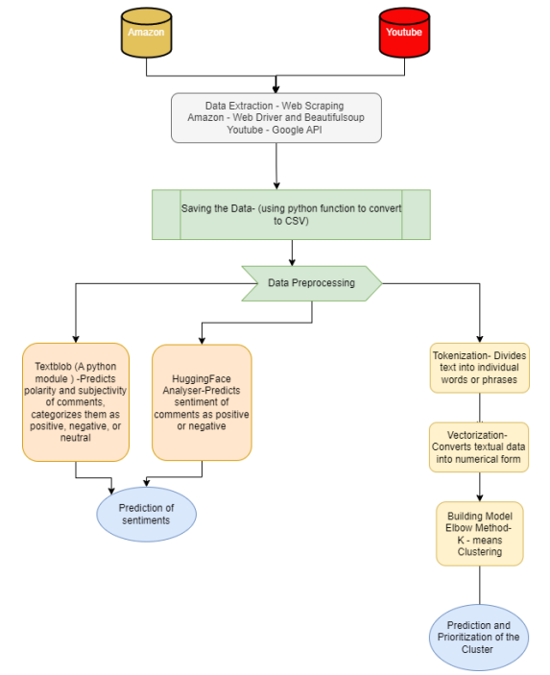
Fig. 1. Architecture diagram of proposed system

- Results and Discussion
The implementation of a web scraping bot coupled with the K-Means clustering method has demonstrated noteworthy outcomes in enhancing the management of reviews and comments. The web scraping bot has proven its efficacy by swiftly and effectively extracting data from websites, surpassing the limitations of screen scraping, which merely captures on-screen pixels. This advanced method allows for the comprehensive extraction of valuable data stored in a website's underlying HTML code and database, facilitating the replication of entire website content elsewhere.
The incorporation of the K-Means clustering method further refines the management process by categorizing comments and reviews based on the number of questions they contain. This strategic approach streamlines the handling of customer feedback, providing a more organized framework for response prioritization. The unsupervised nature of K-Means clustering, grouping unlabeled datasets into clusters based on a pre-defined number, makes it an optimal solution for efficiently categorizing and prioritizing the diverse spectrum of customer feedback.
In summary, this integration of using real time data through web scraping and K-Means clustering for comment categorization along with sentiment analysis has emerged as a highly effective method for managing customer reviews and comments. The streamlined process of categorization and prioritization enables businesses to respond more promptly and efficiently to customer concerns, ultimately contributing to an enhanced level of overall customer satisfaction. This approach not only saves time but also empowers businesses to make data-driven decisions for continuous improvement.

- Conclusion
In conclusion, the integration of a web scraping bot and the K-Means clustering method has revolutionized the landscape of review and comment management. The web scraping bot's efficiency in extracting comprehensive data, surpassing the limitations of screen scraping, offers a rapid and superior approach to replicating website content. Complementing this, the K-Means clustering method categorizes feedback based on question count, enhancing the systematic handling of customer input. As an unsupervised learning algorithm, K-Means clustering excels in organizing unlabeled datasets, providing an optimal solution for prioritizing, and addressing diverse customer concerns. This combined approach not only streamlines the management process but also enables businesses to respond promptly and effectively to customer feedback, ultimately elevating overall customer satisfaction. The synergy between web scraping and K-Means clustering emerges as a potent strategy for businesses seeking to enhance their engagement and responsiveness in the dynamic digital landscape.

References
- Hirave, T., Malgaonkar, S., Alwash, M., Cheriyan, J. and Surve, S., 2019, December. Analysis and Prioritization of App Reviews. In 2019 International Conference on Advances in Computing, Communication and Control (ICAC3) (pp. 1-8). IEEE.
- Zhang, C., Xu, Z., Gou, X. and Chen, S., 2021. An online reviews-driven method for the prioritization of improvements in hotel services. Tourism Management, 87, p.104382.
- Qayyum, S. and Qureshi, A., 2018, November. A survey on machine learning based requirement prioritization techniques. In Proceedings of the 2018 International Conference on Computational Intelligence and Intelligent Systems (pp. 51-55).
- Wadhwani, S., Richhariya, P. and Soni, A., 2022. Analysis and implementation of sentiment analysis of user YouTube comments (No. 7703). EasyChair.
- Gupta, A. and Sundaresan, N., 2018, August. Intelligent code reviews using deep learning. In Proceedings of the 24th ACM SIGKDD International Conference on Knowledge Discovery and Data Mining (KDD’18) Deep Learning Day.
- Alroobaea, R., 2022. Sentiment analysis on amazon product reviews using the recurrent neural network (rnn). International Journal of Advanced Computer Science and Applications, 13(4).
- Aiyar, S. and Shetty, N.P., 2018. N-gram assisted youtube spam comment detection. Procedia computer science, 132, pp.174-182.
- Iqbal, A., Amin, R., Iqbal, J., Alroobaea, R., Binmahfoudh, A. and Hussain, M., 2022. Sentiment analysis of consumer reviews using deep learning. Sustainability, 14(17), p.10844.
- Fang, X., Wang, J., Seng, D., Li, B., Lai, C. and Chen, X., 2021. Recommendation algorithm combining ratings and comments. Alexandria Engineering Journal, 60(6), pp.5009-5018.

