Khoi Duong

Prof. Yang

CE450L

12/16/2022

LAB#9

GitHub link: <https://github.com/MynameisKoi/CE450L/tree/main/Lab%239>



Breadboard setup:

Since my LCD1602A has 4 wires, I will connect GND to pin 6, VCC to pin 2, and SDA and SCL to pins 3 and 5 respectively.

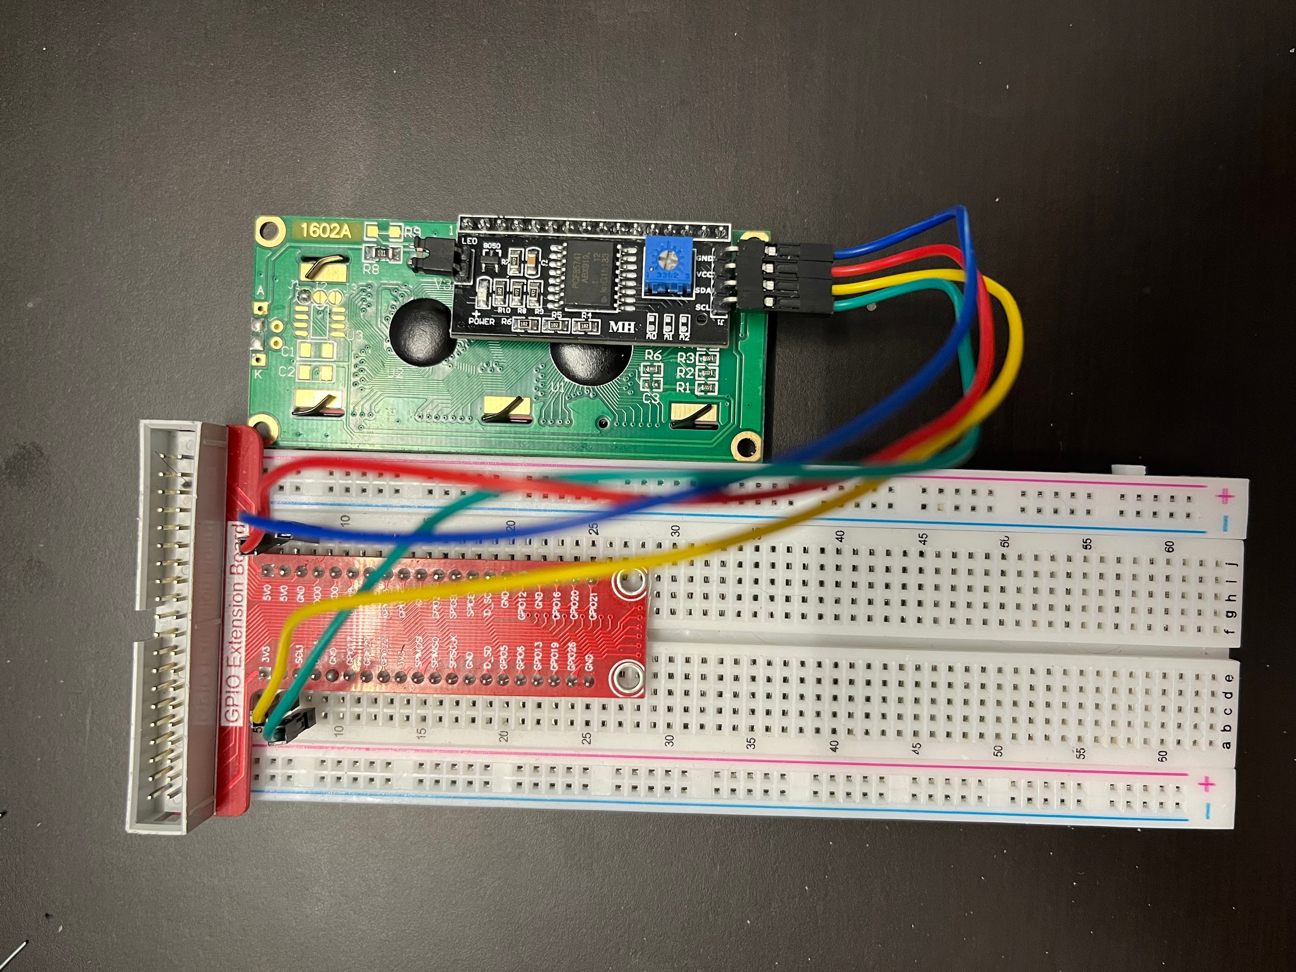

Source code: <https://github.com/MynameisKoi/CE450L/blob/main/Lab%239/I2C_1602A.py>

#!/usr/bin/env python3

from signal import signal, SIGTERM, SIGHUP, pause

from rpi_lcd import LCD

from sys import version_info

import time

if version_info.major == 3:

raw_input = input

def print_msg():

print ("========================================")

print ("| LCD1602 |")

print ("| ------------------------------ |")

print ("| GND connect to PIN 6 |")

print ("| VCC connect to PIN 2 |")

print ("| SDA connect to PIN 3 |")

print ("| SCL connect to PIN 5 |")

print ("| |")

print ("| Control LCD1602 |")

print ("| |")

print ("| Khoi Duong|")

print ("========================================\n")

print ("Program is running...")

print ("Please press Ctrl+C to end the program...")

raw_input ("Press Enter to begin\n")

lcd = LCD()

def safe_exit(*signum*, *frame*):

exit(1)

signal(SIGTERM, safe_exit)

signal(SIGHUP, safe_exit)

def main():

print_msg()

txt = "Welcome to ---> sunfounder.com"

txt2 = "---SUNFOUNDER---"

a = 0

while True:

lcd.text(txt2, 2)

if a + 16 < len(txt):

lcd.text(txt[a:a+16],1)

if a + 16 >= len(txt):

b = txt[a:len(txt)]

c = 16 - len(b)

lcd.text(b + ' ' + txt[0:c], 1)

if a == len(txt):

a = -1

a += 1

time.sleep(0.5)

if __name__ == '__main__':

try:

main()

except KeyboardInterrupt:

lcd.clear()

Run program & demonstration:

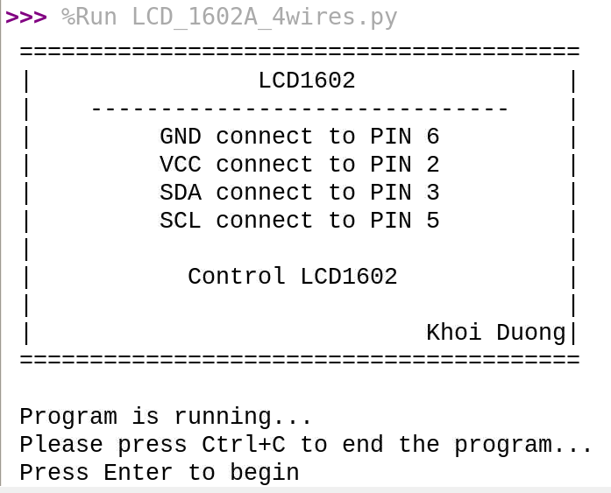

Video link: <https://youtu.be/_5Vxnq9x7xY>



The breadboard setup is the same as the first exercise.

Source code:

<https://github.com/MynameisKoi/CE450L/blob/main/Lab%239/LCD_display_message.py>

#!/usr/bin/env python3

from signal import signal, SIGTERM, SIGHUP, pause

from rpi_lcd import LCD

from sys import version_info

import time

if version_info.major == 3:

raw_input = input

def print_msg():

print ("========================================")

print ("| LCD1602 |")

print ("| ------------------------------ |")

print ("| GND connect to PIN 6 |")

print ("| VCC connect to PIN 2 |")

print ("| SDA connect to PIN 3 |")

print ("| SCL connect to PIN 5 |")

print ("| |")

print ("| Control LCD1602 |")

print ("| |")

print ("| Khoi Duong|")

print ("========================================\n")

print ("Program is running...")

print ("Please press Ctrl+C to end the program...")

raw_input ("Press Enter to begin\n")

lcd = LCD()

def safe_exit(*signum*, *frame*):

exit(1)

signal(SIGTERM, safe_exit)

signal(SIGHUP, safe_exit)

def main():

print_msg()

txt = "you did good job"

txt2 = "--Khoi D 19610--"

a = 0

while True:

lcd.text(txt2, 2)

if a + 16 < len(txt):

lcd.text(txt[a:a+16],1)

if a + 16 >= len(txt):

b = txt[a:len(txt)]

c = 16 - len(b)

lcd.text(b + ' ' + txt[0:c], 1)

if a == len(txt):

a = -1

a += 1

time.sleep(0.5)

if __name__ == '__main__':

try:

main()

except KeyboardInterrupt:

lcd.clear()

Run program & demonstration:



Video link: <https://youtu.be/mSOKQnCp6gs>