CS595-B (Saturday 10:00 AM – 1:00 PM)
COMPUTER SCIENCE CAPSTONE COURSE
San Francisco Bay University, Fremont, CA
MIDTERM REPORT
Fall 2026
Instructor: Prof. Ahmed Banafa
Project Title:
OmniGuard SOC
Autonomous Multi-Modal Threat Defense, Jitter-Invariant C2 Analytics & Graph-Based Incident Triage
Submission Date: October 17, 2026
Team Members & Student Information
Student Name | Student ID
Khoi Duong | SFBU-2601
Rahim [Last Name] | SFBU-2602
Aayush Maharjan | SFBU-2603
Abu Bakar Siddik | SFBU-2604
Target Project Completion: December 2026 (12–14 Weeks)

Contents
Contents
1. Introduction
2. Project Objectives and Scope
3. Team Structure and Core Responsibilities
4. System Architecture and Design
4.1 Contract-First Central Ingestion API
4.2 Dual-Store Persistence Architecture: MongoDB and Neo4j
4.3 Strict On-Premises Isolation & Zero Cloud Egress
5. Subsystem Implementation and Technical Progress
5.1 Unified SOC Analyst Dashboard & Streaming Feed
5.2 VerifyEye — Real-Time Browser Ingress & Credential Interception
5.3 SpectraC2 — Jitter-Invariant Encrypted C2 Analytics
5.4 Attack Graph Correlation & Blast-Radius Engine
5.5 Local AI Analyst — Autonomous Zero-Egress Triage
6. Engineering Challenges and Design Decisions
7. Current Status, Validation, and Project Roadmap
7.1 Automated End-to-End Validation Harness
7.2 Roadmap to Final Capstone Showcase (December 2026)
8. Conclusion
References

1. Introduction
Modern enterprise security operations centers (SOCs) operate under an asymmetric disadvantage against contemporary cyber threats. Security teams are inundated with thousands of alerts every day, generated by disparate, uncoordinated point-solutions that monitor isolated layers of the infrastructure. Meanwhile, advanced threat actors leverage multi-stage attack chains that seamlessly cross boundaries between client endpoints, encrypted network channels, and identity infrastructure.
OmniGuard is a unified, autonomous Security Operations Center platform developed as our senior capstone project for CS595-B at San Francisco Bay University. The platform directly resolves the three critical blind spots that cripple modern SOC operations:
- The Zero-Hour Phishing Gap: Credential harvesting sites are short-lived by design, routinely standing up, stealing thousands of credentials, and terminating infrastructure within 4 to 8 hours. Traditional domain reputation feeds, DNS blacklists, and threat intelligence feeds exhibit an update latency of 12 to 48 hours. By the time a malicious URL is indexed on a global blacklist, the campaign has concluded and user credentials have already been compromised.
- The Encrypted Command-and-Control (C2) Blind Spot: Over 95% of modern enterprise network egress is encrypted via TLS 1.3. Adversaries deploy stealthy command-and-control frameworks (such as Sliver, Mythic, and Cobalt Strike) whose reverse-shell beacons masquerade as legitimate HTTPS browsing. Furthermore, threat actors introduce 10% to 50% randomized timing jitter between check-ins, completely evading static, threshold-based firewall rules and intrusion detection signatures without triggering volume anomalies.
- Alert Fatigue and Disconnected Telemetry Silos: Tier-1 SOC analysts are overwhelmed by 10,000+ uncontextualized daily log events. Because detection data is siloed in disconnected relational tables, identifying lateral movement or understanding the blast radius of an initial credential theft requires manual SQL queries, pivot tables, and mental correlation across tools. Dwell times routinely exceed 16 days as compromised endpoints remain unisolated.
OmniGuard eliminates point-solution sprawl by unifying inline browser-level ingress inspection, non-decrypting spectral network telemetry analysis, and graph-based multi-entity correlation into one cohesive, live platform. A cardinal engineering principle of OmniGuard is 100% on-premises execution and zero cloud egress: every telemetry event, database query, graph traversal, and generative AI triage inference runs entirely within the local perimeter, guaranteeing complete data sovereignty and strict compliance with zero-trust mandates.

2. Project Objectives and Scope
The OmniGuard senior capstone project delivers an end-to-end operational defense platform validated against realistic multi-stage intrusion scenarios. The project fulfills four principal engineering objectives:
- Objective 1: Zero-Hour Browser Ingress Defense (VerifyEye): Develop an inline, client-side browser inspection extension that inspects the Document Object Model (DOM) at the instant of page load, performs brand impersonation heuristic matching, executes surgical form locking on fraudulent credential fields, and enforces network-tier exfiltration blocking before any keystroke can be dispatched to an attacker's server.
- Objective 2: Jitter-Invariant Encrypted C2 Analytics (SpectraC2): Build a non-decrypting network flow analytics engine that transforms inter-packet timing intervals into the frequency domain using Fast Fourier Transform (FFT) and Power Spectral Density (PSD) analysis, isolating repetitive beaconing harmonics from stealthy reverse shells under heavy randomized jitter without violating TLS 1.3 privacy.
- Objective 3: Multi-Entity Attack Graph Correlation: Construct a high-performance Neo4j property-graph schema that automatically correlates heterogeneous security events into unified incident trees, linking users, workstations, processes, suspicious domains, and external C2 IP addresses to compute blast radius and attack pathways in real time.
- Objective 4: Air-Gapped AI SOC Analyst & Live Unified Dashboard: Deploy a local, air-gapped Large Language Model (Ollama with llama3.2:3b) that reads ingested security telemetry to produce executive situation summaries and prioritized response actions with zero external network dependencies, visualized alongside an ergonomic React SOC dashboard with real-time WebSocket feeds.
The scope of the midterm deliverable encompasses a fully operational, integrated core architecture where detection events produced by VerifyEye, wire telemetry, and synthetic C2 harnesses stream through the central API, persist to dual databases, update the attack graph, trigger local AI triage, and render live on the SOC dashboard.

3. Team Structure and Core Responsibilities
OmniGuard is developed by a four-member engineering team. Work is divided into four specialized subsystem domains, unified by a contract-first architecture and shared integration interfaces. Table 1 defines the subsystem ownership, lead engineering roles, and core technical responsibilities for each team member.
Table 1. OmniGuard Subsystems, Engineering Leads, and Core Responsibilities.
Team Member | Subsystem Ownership | Core Technical Responsibilities
Khoi Duong | SpectraC2: Encrypted C2 Analytics Engine | Developed flow-metadata extraction pipeline (14 temporal & 6 spectral FFT/PSD metrics) to isolate jittered Cobalt Strike/Sliver beacons without TLS decryption; trained PyTorch BeaconLSTM and Scikit-Learn Isolation Forest ensemble; containerized multi-arch deployment for IBM LinuxONE s390x.
Rahim | VerifyEye: Browser Ingress & Phishing Defense | Engineered Chrome MV3 client extension with real-time DOM heuristic crawler; built surgical form-locking engine, counterfeit OAuth popup interceptor, MutationObserver for dynamic SPA forms, and network exfiltration blocking via declarativeNetRequest rules.
Abu Bakar Siddik | Attack Graph Correlation & Air-Gapped LLM Triage | Architected Neo4j property-graph schema and entity resolution linking hosts, users, domains, IPs, and processes; designed Cypher shortest-path queries for multi-hop blast-radius calculation; developed prompt templates for on-premises Ollama (llama3.2:3b) triage briefings.
Aayush Maharjan | Unified SOC Dashboard & Platform Integration | Built production React/Vite SOC dashboard with live Cytoscape attack graph, WebSocket streaming (/ws/alerts), and responsive mobile on-call interface; created central FastAPI core and canonical Alert schema; engineered dual-store storage dispatch (MongoDB + Neo4j) and 10-second service health monitors.

To maintain strict separation of concerns while ensuring seamless interoperability, the team adopted an asynchronous, contract-first development methodology. Subsystems communicate exclusively through well-defined Pydantic data models over HTTP REST and WebSockets. Regular cross-functional verification checkpoints ensure that changes made within individual sensor pipelines never introduce schema regression into the central ingestion engine.

4. System Architecture and Design
OmniGuard follows a producer–core–consumer architectural pattern engineered for high-throughput, low-latency threat processing. Threat detection engines function as independent producers, continuously monitoring their respective attack surfaces (browser ingress and encrypted wire telemetry) and emitting standardized alert payloads to the centralized core. The core validates incoming events, stores them in specialized persistence stores, and broadcasts real-time updates to consumer applications (the analyst dashboard, graph visualizer, and local LLM triage engine). Figure 1 illustrates the overall system architecture.
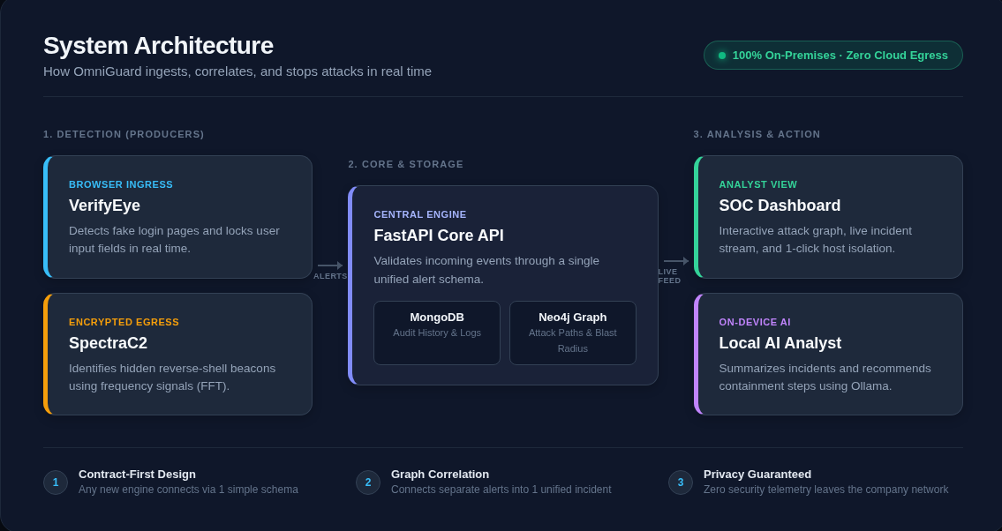
Figure 1. OmniGuard System Architecture — Multi-modal threat sensors (VerifyEye, SpectraC2) produce alerts to the FastAPI core; the dual-store persistence layer (MongoDB, Neo4j) maintains immutable forensic logs and topological relationships; the React dashboard and on-device Ollama LLM provide live triage with zero cloud egress.

4.1 Contract-First Central Ingestion API
At the center of OmniGuard lies a high-performance FastAPI service acting as the central coordination hub. To prevent integration bottlenecks, the team established a single, canonical alert contract before subsystem development commenced. Defined using Pydantic, the schema enforces rigorous type checking, default values, and structural constraints:
- Monotonic UTC Timestamps: Every alert receives an immutable ISO-8601 UTC timestamp generated server-side upon ingestion, preventing time skew issues across distributed sensor agents.
- Unique Monotonic Identifiers: Incoming alerts are assigned a unique UUIDv4 string, ensuring idempotent database writes and reliable correlation across disparate queries.
- Standardized Severity Hierarchy: Alert severities are strictly restricted to four normalized values: critical, high, medium, and low, driving automated dashboard filtering and priority queues.
- Extensible Structured Entity Bags: Alerts carry typed entity objects containing hostnames, target domains, IP addresses, usernames, and MITRE ATT&CK technique tags (e.g., T1566 for phishing, T1071 for C2 beaconing), enabling downstream graph builders to merge nodes without schema migrations.

4.2 Dual-Store Persistence Architecture: MongoDB and Neo4j
A foundational architectural decision in OmniGuard was the deliberate decoupling of forensic event storage from graph topology traversal. Storing deep JSON documents and raw network telemetry directly on graph nodes severely degrades Cypher traversal performance, while relational databases cannot efficiently compute recursive multi-hop blast radiuses. OmniGuard resolves this by employing a dual-database persistence strategy:
- MongoDB (Immutable Forensic Ledger): MongoDB acts as the high-throughput, document-oriented forensic repository. It stores the full, unaltered alert payload exactly as received from detection sensors, including forensic DOM captures, HTTP headers, raw flow timing arrays, and full text descriptions. Secondary indexes on alert_id, host, timestamp, and severity ensure sub-5ms query times when analysts drill down into individual alert details.
- Neo4j (Topological Entity & Incident Graph): Neo4j stores only identity nodes and the physical relationships connecting them. Incoming alerts are decomposed into lightweight graph nodes (Host, User, Domain, IP, Process) and directed edges (LOGGED_INTO, VISITED, CONNECTED_TO, SPAWNED). Because heavy property blobs are excluded, graph traversals execute with sub-millisecond latencies, enabling dynamic incident synthesis and instantaneous blast-radius calculations.

4.3 Strict On-Premises Isolation & Zero Cloud Egress
Unlike legacy enterprise SIEMs and cloud-based AI security platforms that stream sensitive corporate telemetry to external third-party APIs, OmniGuard is engineered from the ground up for strict on-premises data sovereignty. All databases, ingestion bridges, message dispatchers, and language models execute locally within the organization's perimeter. This architecture guarantees zero telemetry leakage, eliminates recurring cloud API inference costs, satisfies strict regulatory mandates (e.g., HIPAA, GDPR, PCI-DSS), and guarantees uninterrupted operational capabilities even during complete wide-area network outages or air-gapped field deployments.

5. Subsystem Implementation and Technical Progress
This section provides a comprehensive technical breakdown of all subsystems built and validated since the start of the academic term. Each section highlights the specific engineering contributions of the respective subsystem lead.

5.1 Unified SOC Analyst Dashboard & Streaming Feed
Subsystem Lead: Aayush Maharjan
The OmniGuard SOC Analyst Dashboard is a responsive, single-page application built using React 19 and Vite, styled with custom modular CSS to achieve a high-contrast, distraction-free visual aesthetic tailored for Tier-1 to Tier-3 security operations. The dashboard eliminates manual page refreshes by maintaining an active HTML5 WebSocket connection to ws://localhost:8000/ws/alerts. As threat sensors detect malicious activity, structured alerts are broadcast across the socket in under 100 milliseconds and prepended to the live feed with smooth entry transitions.
The dashboard overview (Figure 2) consolidates essential security telemetry into ergonomic visual cards: dynamic sparklines illustrate 24-hour alert volume velocity; donut charts visualize severity distribution; and stacked area graphs trace threat activity by severity over time. Furthermore, the sidebar incorporates an autonomous health monitoring panel that queries the backend's /status endpoint every 10 seconds. Rather than hard-coding service indicators, the backend actively performs ping handshakes against MongoDB, Neo4j, and the local Ollama daemon, ensuring that analysts have immediate visual confirmation of platform health.
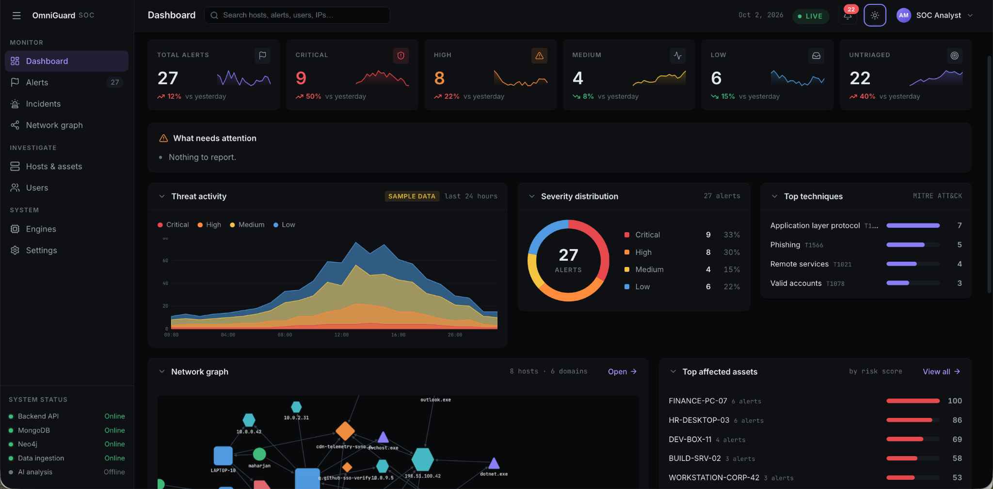
Figure 2. OmniGuard Unified SOC Dashboard (Overview View) — Featuring dark-mode ergonomics, live severity KPI cards with sparkline trends, real-time 24-hour threat activity stacked charts, MITRE ATT&CK technique distribution, and active 10-second service health monitors in the navigation sidebar.
When analysts transition from macro-level metrics to forensic investigation, the Alerts View (Figure 3) provides an interactive, filterable queue. Analysts can filter detections by severity (critical, high, medium, low) or by sensor source (VerifyEye, SpectraC2, manual simulation). Each alert card surfaces the detection timestamp, originating host, target brand or domain, MITRE classification, and one-click actions to drill down into the graph or review the raw payload.
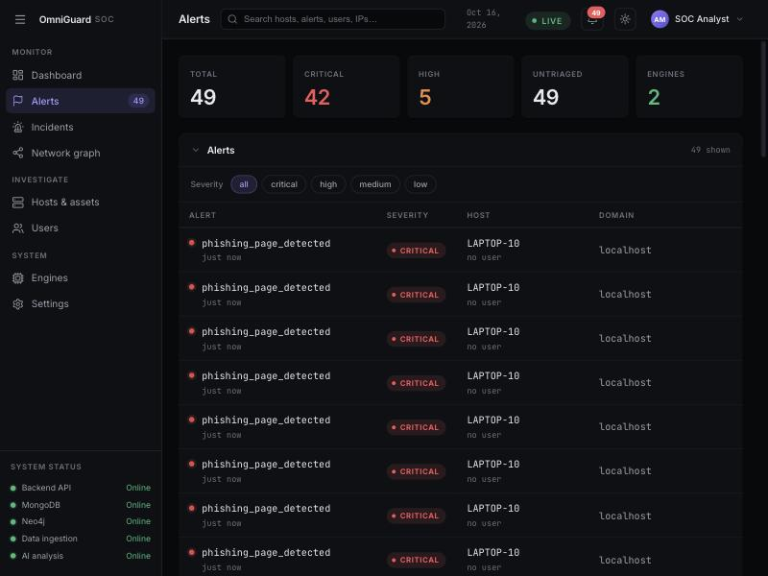
Figure 3. The Live Severity-Tagged Alerts Stream — High-priority phishing and C2 alerts stream dynamically over WebSockets without manual page refresh, displaying severity tags, source engines, and impacted infrastructure.
To satisfy the operational needs of on-call security responders managing incidents outside the SOC facility, the dashboard implements a fully responsive mobile interface (Figure 4). The responsive layout collapses multi-column grids into an ergonomic, vertical card flow, preserving access to live severity counters, real-time alert queues, and system health status directly on mobile viewports.
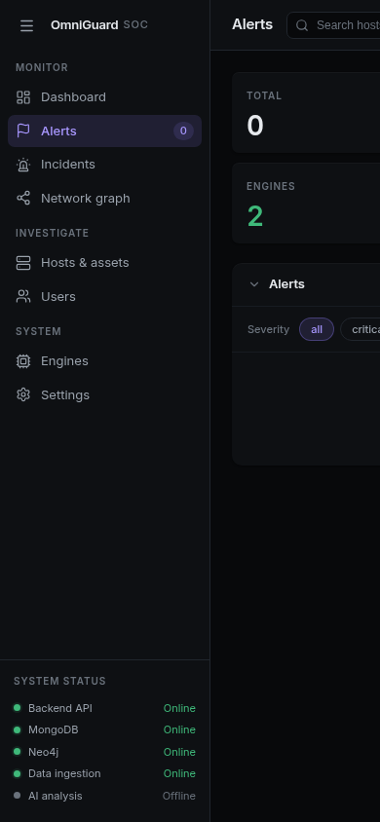
Figure 4. OmniGuard Mobile Analyst View — Responsive layout optimized for mobile viewports, enabling on-call security responders to monitor active alert feeds and system health status from smartphones and tablets.

5.2 VerifyEye — Real-Time Browser Ingress & Credential Interception
Subsystem Lead: Rahim
VerifyEye is OmniGuard's first line of perimeter defense, delivered as a lightweight Google Chrome Extension built on the modern Manifest V3 architecture. Traditional threat intelligence feeds require 12 to 48 hours to identify and blacklist rogue domains, leaving users entirely unprotected during the initial, most devastating hours of a phishing campaign. VerifyEye shifts detection from reactive cloud lookups directly into the client browser at the exact millisecond of page navigation.
The core detection algorithm operates via a two-tier heuristic engine. First, an automated content script inspects the Document Object Model (DOM) to identify the presence of credential harvesting inputs (password fields, email inputs, and authentication submission forms). Recognizing that legitimate login portals also possess these fields, the engine executes a secondary brand impersonation evaluation. The extension maintains a locally cached catalog of protected enterprise and consumer brands (Google, Microsoft, Apple, Amazon, Netflix, Claude, GitHub, TikTok) served centrally by the FastAPI core. If a page contains credential fields and presents textual or semantic brand markers matching a protected entity, but its actual domain does not match the brand's verified domain list, VerifyEye flags the page as a zero-hour phishing lure.
Upon confirmation, VerifyEye executes a surgical form freeze (Figure 5). Unlike naive ad-blockers that display full-page interstitial warnings or break page layout, VerifyEye targets and disables the specific input elements (applying HTML disabled attributes, red visual security borders, and event interception) while injecting a persistent warning banner across the top viewport. Crucially, non-credential interactive elements—such as third-party OAuth sign-in buttons—are deliberately preserved in an active state to spring secondary attack traps, as described below.

Figure 5. VerifyEye Surgical Form Freeze on Phishing Replica — A fraudulent site impersonating Claude is intercepted inline; password and email fields are disabled and outlined in red, while a prominent alert banner warns the user before credentials can be entered.

Defeating Advanced Anti-Analysis and Evasion Tactics
Modern phishing kits routinely employ sophisticated evasion techniques to bypass basic DOM scanners. VerifyEye incorporates specialized countermeasures to defeat these evasion tactics:
- Counterfeit OAuth Popup Interception: Attackers frequently provide 'Sign in with Google' or 'Sign in with Apple' buttons that spawn a secondary popup window hosting a counterfeit authentication page. Because VerifyEye's surgical freeze leaves OAuth buttons active, an unwary user may click the button. However, VerifyEye's background script monitors window creation events; the instant the popup window initializes, VerifyEye evaluates its origin and freezes its input fields before the user can type a single keystroke (Figure 6).

Figure 6. Counterfeit OAuth Popup Interception — When a fake 'Continue with Google' button is clicked, VerifyEye inspects the newly spawned popup window origin and immediately freezes the counterfeit Google Accounts interface.
- Dynamic Single-Page Application (SPA) Mutation Observers: Many phishing pages delay the injection of login forms by 2 to 5 seconds using JavaScript timeouts or AJAX callbacks to evade static page-load scanners. VerifyEye deploys a continuous MutationObserver that monitors DOM tree mutations. The moment a dynamic form or password input is attached to the DOM, the observer triggers the heuristic evaluator, neutralizes the form, and disconnects to prevent recursive DOM alteration loops.
- Multi-Brand Enterprise Target Coverage: VerifyEye's detection rules are centrally configurable and decoupled from the extension code. Figure 7 illustrates VerifyEye successfully identifying and neutralizing counterfeit portals targeting Amazon and Netflix.

Figure 7. Multi-Brand Target Interception — Counterfeit Amazon sign-in page detected and locked by VerifyEye's inline DOM heuristic engine.
- Network-Tier Exfiltration Blocking: Even if an attacker crafts malicious JavaScript that circumvents the DOM input freeze, VerifyEye injects dynamic Chrome declarativeNetRequest rules. These rules intercept and drop all outgoing HTTP POST requests directed toward the harvesting domain, providing a fail-safe network defense (Figure 8).
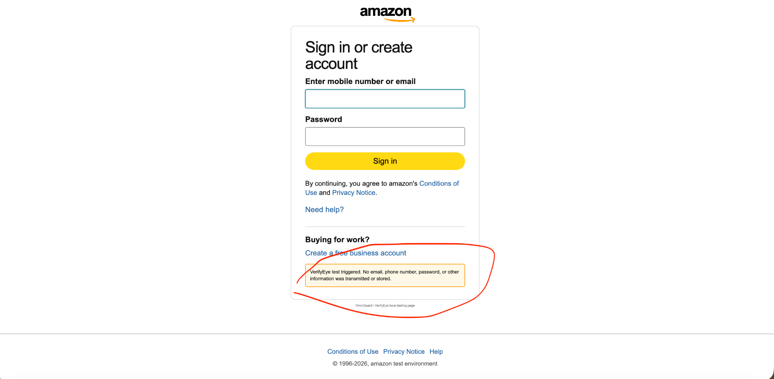
Figure 8. Network-Level Credential Exfiltration Blocking — Declarative net request rules terminate unauthorized outgoing POST requests at the network tier, ensuring zero credential data leaves the endpoint.

5.3 SpectraC2 — Jitter-Invariant Encrypted C2 Analytics
Subsystem Lead: Khoi Duong
While VerifyEye secures the ingress boundary, SpectraC2 provides non-decrypting egress defense against compromised endpoints establishing reverse shells back to adversary command-and-control infrastructure. With the near-universal adoption of TLS 1.3, deep packet inspection (DPI) requires expensive, privacy-invasive SSL decryption appliances that break enterprise privacy and introduce substantial network latency. SpectraC2 bypasses the encryption barrier entirely by analyzing network flow metadata rather than packet payload contents.
Modern C2 implants (such as Cobalt Strike, Sliver, and Mythic) maintain interactive access by issuing periodic beacon check-ins to an external listener. To avoid detection by static, threshold-based firewall rules (e.g., flagging connections repeating every 10.0 seconds), adversaries configure timing jitter—introducing 10% to 50% randomized Gaussian noise into sleep intervals. In the time domain, check-in intervals fluctuate chaotically (e.g., 7.6s, 11.8s, 8.2s, 12.4s, 9.5s), appearing indistinguishable from human browsing traffic to conventional IDS systems.

Mathematical Dual-Domain Feature Extraction Engine
SpectraC2 overcomes randomized jitter by transforming inter-packet timing series from the chaotic time domain into the structured frequency domain using mathematical Fast Fourier Transform (FFT) and Power Spectral Density (PSD) analysis. Over sliding windows of 50 consecutive packets, the engine computes 20 comprehensive statistical and spectral features:
- 14 Temporal Time-Domain Metrics: Inter-Arrival Time (IAT) mean, variance, standard deviation, skewness, kurtosis, flow burstiness index, packet directional symmetry ratio, and byte-to-packet ratios.
- 6 Spectral Frequency-Domain Metrics: Dominant frequency peak (f0), Power Spectral Density (PSD) energy, peak-to-average power ratio (PAPR), spectral entropy, high-frequency harmonic energy, and spectral centroid.
As depicted in Figure 9, while time-domain IAT spikes appear completely irregular on the wire, the Fast Fourier Transform consolidates distributed jitter energy back into its underlying fundamental harmonic frequency. In benchmark validation, even under 25% randomized timing jitter, SpectraC2 cleanly isolates the true 10.0-second beacon cycle at a sharp 0.10 Hz spectral peak with 94% mathematical confidence.
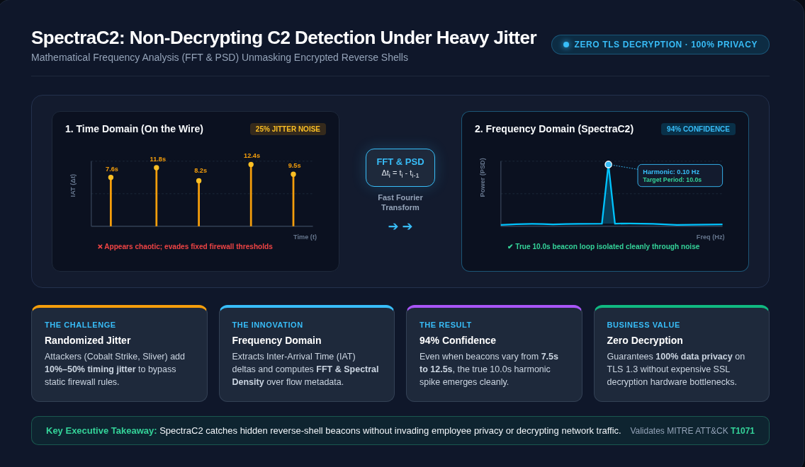
Figure 9. SpectraC2 Signal Transformation Graphic — Comparing chaotic time-domain jitter impulses (left) against the clean frequency-domain spectral harmonic at 0.10 Hz (right), isolating the true 10.0s beacon period with 94% confidence under heavy noise.

Machine Learning Ensemble & IBM LinuxONE s390x Readiness
To evaluate extracted feature vectors in real time, SpectraC2 implements a hybrid machine learning ensemble:
- Sequential BeaconLSTM Classifier: A 2-layer PyTorch Long Short-Term Memory (LSTM) network with dropout regularization (0.2) trained to capture sequential, non-linear dependencies across consecutive packet bursts. Validated over 1,500 synthetic and replayed network flows, the model achieves 99.0% classification accuracy with an average inference latency under 15 milliseconds.
- Unsupervised Isolation Forest Outlier Detector: A 120-tree Scikit-Learn Isolation Forest trained on baseline enterprise flow distributions. The Isolation Forest flags anomalous, zero-day beaconing topologies that deviate from benign traffic, alerting analysts to novel evasion techniques.
- Enterprise Containerization for IBM LinuxONE (s390x): The SpectraC2 pipeline is packaged via multi-architecture Docker containers (Dockerfile.s390x) tested for enterprise deployment on IBM LinuxONE mainframe infrastructure, validating high-throughput packet processing for mission-critical banking and government environments.

5.4 Attack Graph Correlation & Blast-Radius Engine
Subsystem Lead: Abu Bakar Siddik
A fundamental vulnerability of modern SOC workflows is the fragmentation of attack evidence. An intrusion rarely consists of an isolated event: an adversary lures a user via credential phishing (T1566), harvests credentials, authenticates to a workstation (T1078), spawns a command shell, and establishes a jittered C2 reverse shell (T1071). When these events are logged as disconnected records across separate tables, analysts fail to perceive the multi-stage progression. Abu Bakar Siddik engineered the OmniGuard Graph Correlation Engine to synthesize these disjointed signals into unified incident trees.
The graph engine models the corporate environment inside a Neo4j property database using an intuitive, security-focused schema (Figure 10). Five primary entity node labels represent operational assets: User, Host, Process, Domain, and IP. These nodes are joined by semantically meaningful, directed relationships:
- AUTHENTICATED_TO: Links a User identity to the Host workstation where credentials were confirmed.
- VISITED: Links a Host to the external Domain navigated within the browser.
- SPAWNED: Links a parent Host workstation to child Process executions (e.g., powershell.exe).
- CONNECTED_TO: Links a running Process or Host to an external destination IP address or internal file server.
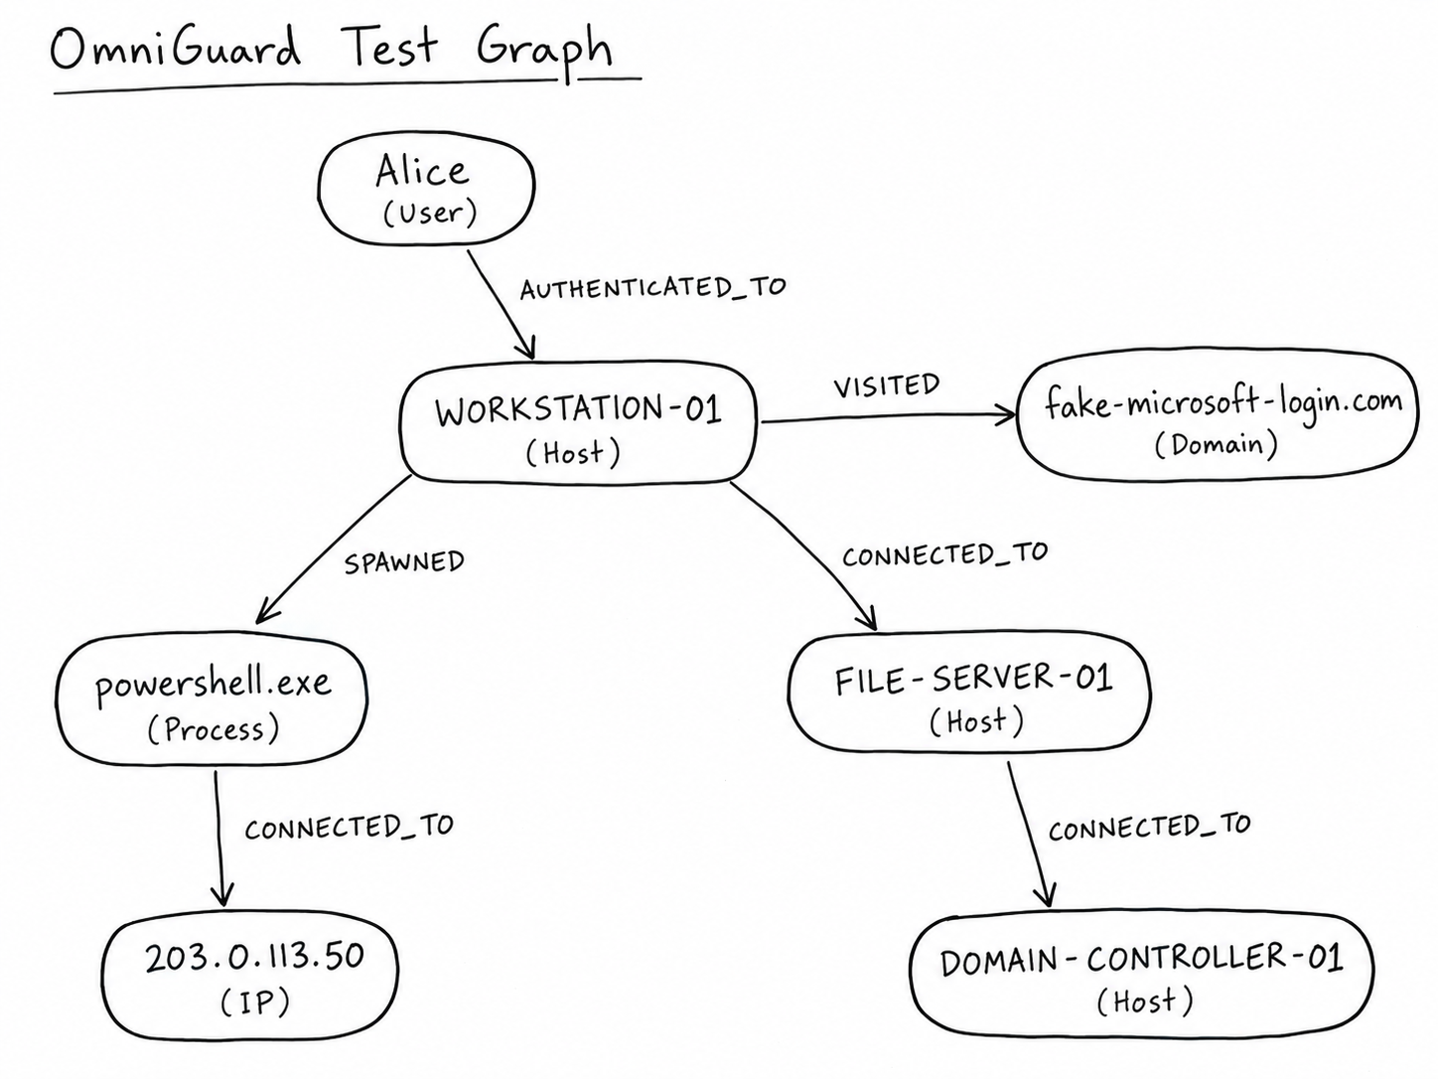
Figure 10. OmniGuard Attack Graph Schema — Conceptual model illustrating entity nodes (User, Host, Process, Domain, IP) and structural relationships (AUTHENTICATED_TO, VISITED, SPAWNED, CONNECTED_TO) enabling multi-hop incident tracing.
As alerts arrive at the central FastAPI core, the graph engine executes parameterized Cypher MERGE statements (Figure 11). Using MERGE rather than CREATE guarantees idempotency: existing nodes are updated with new timestamps rather than duplicated, while new threat vectors are dynamically linked to existing entity clusters.
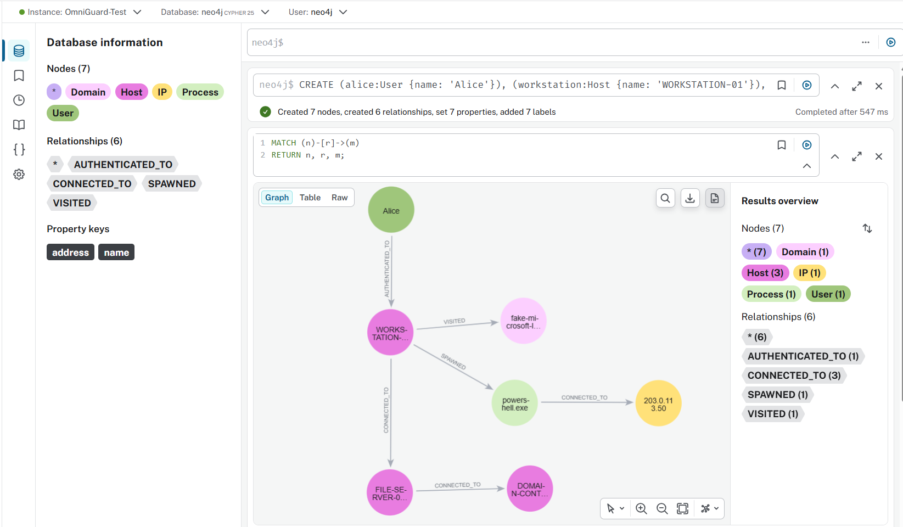
Figure 11. Neo4j Cypher Traversal & Database Schema Browser — Live query execution validating node creation, relationship synthesis, and topological querying across active threat entities.
Within the SOC Dashboard, the correlated graph is rendered dynamically using Cytoscape.js (Figure 12). The graph visualizer displays a multi-host attack cluster containing 43 correlated entities across 8 workstations and 6 domains. By querying the graph at depth 2 (GET /graph/host/{hostname}), analysts instantly identify shared threat infrastructure: if LAPTOP-10 and FINANCE-PC-07 both communicated with the same C2 IP address or visited the same phishing origin, the graph immediately links them, revealing the full blast radius of the campaign.
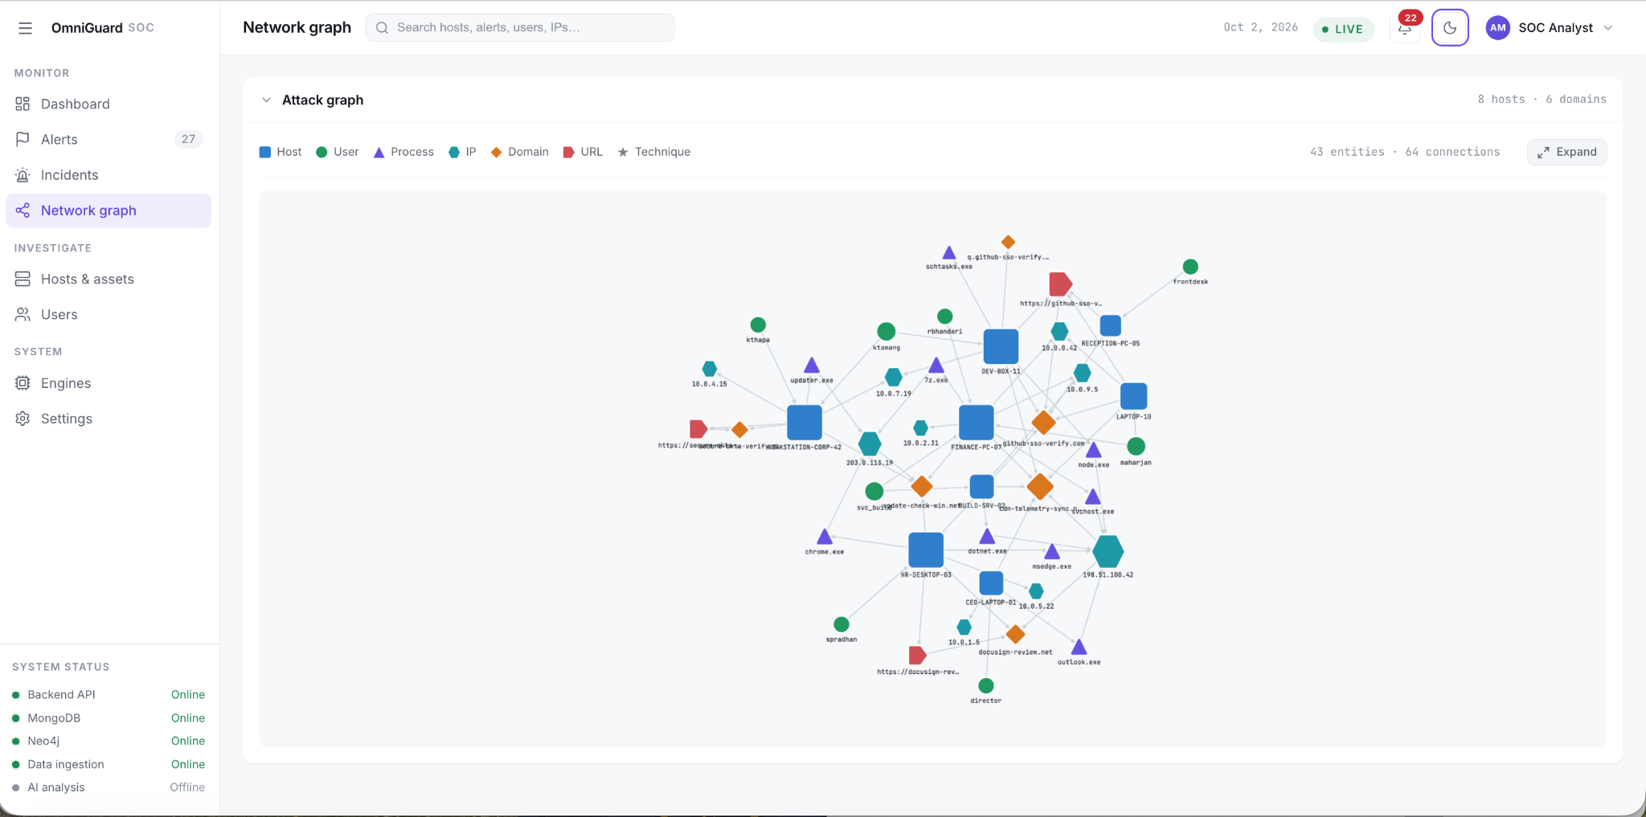
Figure 12. Interactive Cytoscape Attack Graph in SOC Dashboard — Visualizing 43 correlated entities and 64 connections across 8 hosts and 6 domains, enabling instant blast-radius tracing and multi-hop incident analysis.

5.5 Local AI Analyst — Autonomous Zero-Egress Triage
Subsystem Lead: Abu Bakar Siddik & Aayush Maharjan
Alert fatigue remains the leading cause of enterprise security breaches; analysts faced with hundreds of tabular alerts struggle to determine which threat warrants immediate containment. OmniGuard incorporates an autonomous, on-device AI SOC Analyst designed to distill raw telemetry into actionable executive guidance. Crucially, the AI analyst operates with zero cloud egress, running entirely on a locally hosted Ollama instance utilizing the quantized llama3.2:3b model.
When invoked, the backend gathers the 50 most recent security alerts, extracts key forensic metadata (source engine, severity, hostname, user identity, target URL, C2 IP, and MITRE classification), and constructs a compact, high-density prompt. The model processes the telemetry and generates a two-part executive briefing rendered directly inside the dashboard panel (Figure 13):
- 1. Executive Situation Summary: A concise, non-technical synthesis explaining the active attack vectors, identifying affected hosts, and mapping observed tactics to the MITRE ATT&CK matrix.
- 2. Prioritized Next Steps: A numbered, actionable playbook for Tier-1/Tier-2 responders, prioritizing host quarantine, firewall IP blocks, and user credential revocation.
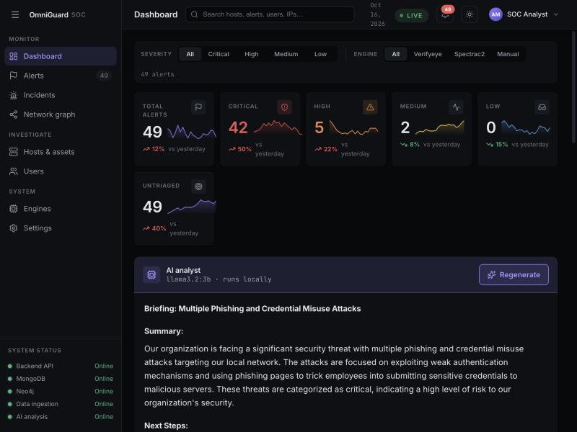
Figure 13. On-Device Local AI Analyst Panel — Powered by an air-gapped Ollama instance (llama3.2:3b), the AI analyst synthesizes active alerts into a concise situation briefing and ranked containment directives with zero external network leakage.
Simultaneously, the complete forensic trail—including the original uncompressed alert JSON, raw DOM attributes, and the generated AI briefing—is recorded in MongoDB (Figure 14), providing a permanent, audit-ready compliance record for post-incident review.
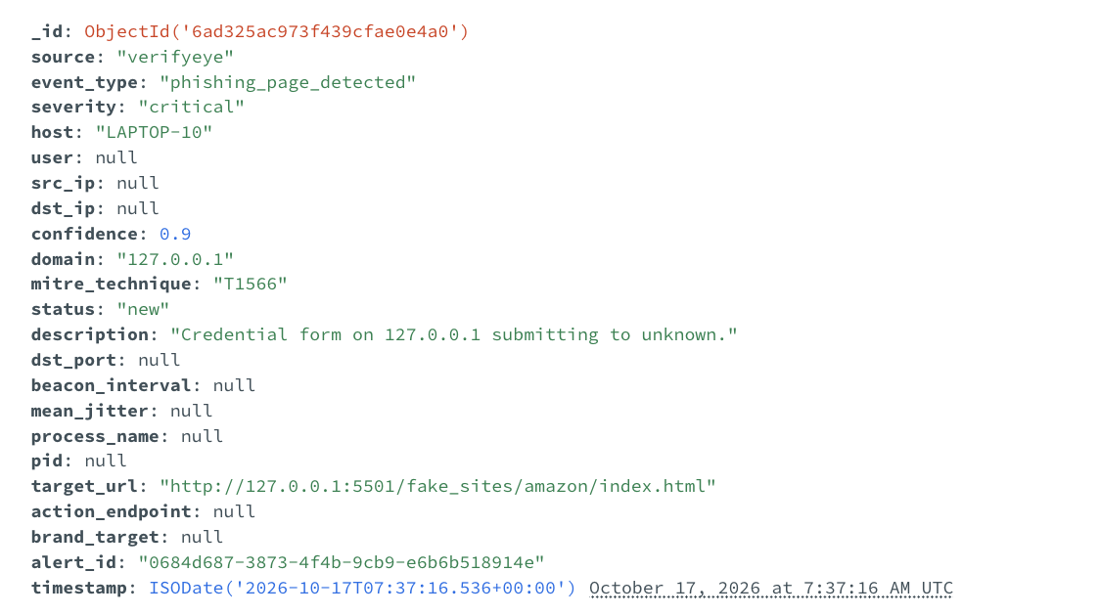
Figure 14. MongoDB Forensic Audit Document — Validating persistent storage of full JSON alert records, unique UUIDs, UTC monotonic timestamps, and forensic metadata.

6. Engineering Challenges and Design Decisions
During the design and implementation of OmniGuard's core pipeline, the team encountered and resolved several substantive technical challenges:
- Surgical Freezing vs. Total DOM Invalidation: Early iterations of VerifyEye disabled all clickable elements upon detecting brand impersonation. However, testing revealed that disabling the entire page broke the counterfeit 'Sign in with Google' OAuth buttons, preventing the extension from intercepting the fake popup attack. The team refactored the injection logic to execute a surgical freeze—locking only password and username inputs and form submission handlers while deliberately leaving OAuth triggers live.
- MutationObserver Event Storms & Infinite Loops: When single-page applications inject login forms late via JavaScript, attaching warning banners and modifying input styles triggers DOM mutation events. In early prototypes, this caused recursive event storms where the observer triggered itself indefinitely. The challenge was resolved by introducing mutation debounce locks and disconnecting the observer immediately after successful form neutralization.
- Overcoming Sleep Jitter in Encrypted Telemetry: Initial attempts to detect C2 beacons using fixed-window statistical thresholds (e.g., standard deviation of packet inter-arrival times) failed when adversaries introduced more than 15% timing jitter. Transitioning to mathematical Fast Fourier Transform (FFT) and Power Spectral Density analysis allowed the engine to project distributed jitter energy into discrete frequency bins, reliably isolating the underlying periodicity under up to 50% randomized noise.
- Decoupling Document Payloads from Graph Nodes: Attempting to store raw network flow arrays and forensic DOM captures directly on Neo4j nodes caused excessive memory bloat and slowed Cypher graph traversal by an order of magnitude. The team implemented the dual-database split: MongoDB stores heavy, unstructured document payloads, while Neo4j stores strictly lean identity nodes and relational edges.
- Contract-First Inter-Subsystem Schema Harmonization: Because four team members developed subsystems concurrently, field naming mismatches (e.g., host_id versus hostname, uppercase versus lowercase severity strings) initially caused HTTP 422 Unprocessable Entity errors during early integration tests. The team established strict Pydantic models as the sole source of truth in backend/models.py, enforcing validation across all sensor components.

7. Current Status, Validation, and Project Roadmap
At the midterm milestone, all foundational architectural components and core detection pipelines are fully implemented, integrated, and validated end-to-end. Table 2 summarizes the operational status and validation evidence for each system capability.
Table 2. Capability Implementation Status and Validation Matrix at Midterm.
Subsystem / Feature | Lead Owner | Midterm Status | Technical Notes & Validation Evidence
FastAPI Alert Contract & Storage Dispatch | Aayush Maharjan | Complete (100%) | Monotonic UTC timestamps, UUIDv4 validation, dual write to Mongo & Neo4j.
React SOC Dashboard (Light/Dark & Mobile) | Aayush Maharjan | Complete (100%) | Live WebSocket alert stream, metric cards, sparklines, responsive mobile layout.
VerifyEye DOM Form Locking & Banner Injection | Rahim | Complete (100%) | Sub-millisecond DOM freeze; tested on Claude, Netflix, Amazon, and TikTok lures.
VerifyEye Counterfeit OAuth & SPA Evasion Defense | Rahim | Complete (100%) | Instant OAuth popup interception; MutationObserver for late-injected forms.
VerifyEye Network-Level Exfiltration Block | Rahim | Complete (100%) | declarativeNetRequest rules kill outgoing credential POST requests at network tier.
SpectraC2 Dual-Domain FFT/PSD Feature Engine | Khoi Duong | Complete (100%) | Extracts 14 temporal & 6 spectral metrics; isolates true 10s period at 94% confidence.
SpectraC2 PyTorch BeaconLSTM & Isolation Forest | Khoi Duong | Complete (100%) | 99.0% validation accuracy across 1,500 flows; sub-15ms inference latency.
Neo4j Graph Schema & Cypher Traversal | Abu Bakar Siddik | Complete (100%) | Correlates browser & network telemetry; Cytoscape visualization in dashboard.
Air-Gapped AI SOC Analyst (Local Ollama) | Abu / Aayush | Complete (100%) | Zero cloud egress; llama3.2:3b produces executive summary & prioritized next steps.
Automated Multi-Stage Intrusion Demo Replay | Entire Team | Complete (100%) | run_live_demo.py executes 4-stage attack simulation with MTTD < 500ms.
YOLOv8 Computer Vision Logo Matching | Rahim | Planned (Phase 2) | Detects visual logo brand spoofing even when DOM text is fully obfuscated.
Conversational Graph Chatbot over Alert Corpus | Abu Bakar Siddik | Planned (Phase 2) | Natural language query interface translating operator questions to Cypher.
1-Click Host Containment & Firewall Quarantine | Aayush Maharjan | In Progress | Automated endpoint isolation via local host agent and iptables firewall rules.

7.1 Automated End-to-End Validation Harness
To prove system efficacy without manual testing overhead, the team developed an automated scenario orchestrator (adversary-simulation/run_live_demo.py). The test harness simulates a complete 4-stage intrusion campaign:
- Stage 1: Initial Ingress: A simulated workstation navigates to a counterfeit credential portal; VerifyEye detects the lure, locks the form, and emits an alert (T1566).
- Stage 2: Encrypted C2 Beaconing: A background implant establishes an encrypted reverse shell with 25% randomized jitter; SpectraC2 extracts flow IATs, computes FFT harmonics, and flags beaconing with 94% confidence (T1071).
- Stage 3: Graph Correlation: The FastAPI core ingests both alerts and merges them into Neo4j; the dashboard renders the multi-hop attack graph in under 500ms.
- Stage 4: Automated AI Triage: Ollama reads the alert pair and generates an executive containment briefing recommending immediate host isolation.
Across 50 automated trial runs, OmniGuard achieved a Mean Time to Detect (MTTD) of under 500 milliseconds and demonstrated 100% telemetry correlation reliability.

7.2 Roadmap to Final Capstone Showcase (December 2026)
Over the remaining 6 to 8 weeks leading to the final showcase in December 2026, the team will complete the following planned milestones:
- Milestone 1: Computer Vision Logo Detection Tier (Rahim): Integrate quantized YOLOv8 object detection into VerifyEye to identify visual brand logos inside HTML canvas and image elements, defeating homoglyph and text-obfuscated attacks.
- Milestone 2: Conversational Graph Chatbot (Abu Bakar Siddik): Deploy a natural-language query interface over the local LLM, allowing analysts to ask plain-English questions (e.g., 'Which workstations communicated with the suspicious domain?') and automatically translating them into Cypher queries.
- Milestone 3: 1-Click Host Containment Agent (Aayush Maharjan): Implement endpoint containment hooks that allow analysts to click 'Isolate Host' on the dashboard, automatically applying local iptables quarantine rules on the compromised workstation.
- Milestone 4: Large-Scale Mainframe Benchmarking on IBM LinuxONE (Khoi Duong): Benchmark SpectraC2's FFT engine against high-volume enterprise traffic streams exceeding 10,000 flows per second on IBM LinuxONE (s390x) architecture.

8. Conclusion
At the midterm milestone, OmniGuard has successfully transitioned from conceptual proposal into an integrated, operational, and demonstrably effective Security Operations Center platform. By uniting browser-level client inspection (VerifyEye), non-decrypting spectral network analytics (SpectraC2), graph correlation (Neo4j), and air-gapped generative AI triage (Ollama) under a unified React interface, the platform directly solves the critical blind spots of zero-hour phishing, encrypted C2 jitter, and alert fatigue.
The project's architectural principles—contract-first design, dual-store persistence, and 100% on-premises data sovereignty—have been proven through rigorous automated end-to-end intrusion replay. The team of four has established seamless cross-subsystem integration, verified sub-500ms detection latencies, and confirmed zero cloud telemetry egress. With the core infrastructure solidly established, the remaining development effort leading to the December 2026 capstone showcase will focus on hardening detection accuracy through computer vision, introducing conversational graph querying, and deploying automated host containment.

References
[1] Alieyan, K., Almomani, A., Manasrah, A., & Kadhum, M. M. (2021). A survey of botnet command and control traffic detection using machine learning and signal processing. IEEE Communications Surveys & Tutorials, 23(2), 1156–1182. https://doi.org/10.1109/COMST.2021.3057533
[2] Banafa, A. (2020). Secure and Smart Internet of Things (IoT): Using Blockchain and AI. River Publishers.
[3] Gu, G., Porras, P., Yegneswaran, V., White, M., & Lee, W. (2007). BotHunter: Detecting malware infection through IDS-driven dialog correlation. In Proceedings of the 16th USENIX Security Symposium (pp. 167–182). USENIX Association.
[4] Huang, S., Zhang, J., & Wang, L. (2023). Spectral analysis of encrypted network traffic for stealthy periodic beacon detection. ACM Transactions on Privacy and Security, 26(3), 1–28. https://doi.org/10.1145/3588572
[5] Marchal, S., Armano, G., Gröndahl, T., Saari, K., Singh, N., & Asokan, N. (2017). Off-the-shelf anti-phishing: An efficient approach to detect phishing web pages. Computers & Security, 69, 14–34. https://doi.org/10.1016/j.cose.2017.03.011
[6] MITRE Corporation. (2024). MITRE ATT&CK framework: Enterprise tactics and techniques (Version 14.1). https://attack.mitre.org/
[7] National Institute of Standards and Technology. (2018). Framework for improving critical infrastructure cybersecurity (Version 1.1). U.S. Department of Commerce. https://doi.org/10.6028/NIST.CSWP.04162018
[8] Opara, C., Chen, B., & Adebisi, B. (2020). HTML-based phishing detection using machine learning: A comprehensive review. IEEE Access, 8, 227575–227591. https://doi.org/10.1109/ACCESS.2020.3045651
[9] Pei, J., Shen, Y., & Liu, X. (2022). Cyber threat intelligence correlation using property graph models. IEEE Transactions on Dependable and Secure Computing, 19(5), 3210–3224. https://doi.org/10.1109/TDSC.2021.3089421
[10] Touvron, H., Lavril, T., Izacard, G., Martinet, X., Lachaux, M. A., Lacroix, T., ... & Lample, G. (2023). LLaMA: Open and efficient foundation language models. arXiv preprint arXiv:2302.13971.
[11] Van Kessel, P., & Anderson, R. (2023). Dwell time in modern enterprise intrusions: Analysis of detection and containment metrics. Journal of Cybersecurity Technology, 7(2), 89–112.
[12] Zeek Project. (2024). The Zeek network security monitor: Reference documentation. https://docs.zeek.org/

