ICT285 Databases 2020: Lab 01

**Introduction to Oracle and SQL**

# ABOUT THE LABS

There are 12 labs for you to complete during this unit. They are all designed to be self-paced, so you should be able to complete them with little or no assistance. If you do find yourself having trouble with the work, make sure you ask your tutor or the Unit Coordinator before the next lab so that you don’t fall behind. To get the most out of the labs you should be up to date with the reading and lecture material.

The lab exercises aren’t directly assessable; however, completing them will assist you with both the practical and theoretical aspects of the unit, in particular with the assignments and weekly quizzes. Both assignments in this unit assume that you have attempted and completed the lab exercises.

# AIMS OF THIS LAB

In today’s lab you will practice logging on to the Oracle database server that we will use throughout these labs, using both a command-line interface and the GUI SQL Developer interface. The main thing is to become comfortable with logging on and using Oracle, so that you are ready to commence learning SQL in the next lab.

**After completing this lab you should be able to:**

* Log into the database server using both the SSH and SQL Developer interfaces
* Enter and execute simple SQL commands
* View a table structure using DESCRIBE TABLE
* Explain the main characteristics of the VARCHAR2, CHAR, NUMBER and DATE data types as they are implemented in Oracle

This lab addresses the following learning outcome of the unit:

LO 3. Demonstrate practical skills in using SQL

# REFERENCE MATERIAL

Some background to Oracle SQL Developer can be found in Chapter 10B of the text which is available online from <http://wps.prenhall.com/bp_kroenke_database_13/> or via <http://www.pearsonglobaleditions.com/Sitemap/Kroenke/> .

We will be using the View Ridge Gallery Database tables in the first few labs. For background, see Chapters 6 and 7 of the textbook, section ‘The View Ridge Gallery Database’ in each.

# QUIZ

Quiz 1 includes several questions that will test your understanding of the concepts addressed in this lab.

**Please, please, please – before you send me an email telling me you cannot log in to Oracle, make sure you have followed the instructions below.**

# 1. Logging into Oracle SQLPlus using SSH

Oracle is located on the linux server **arion.murdoch.edu.au**, and to use Oracle you need to log in to arion first then to the Oracle database.

The first time you log into Oracle SQLplus, you **MUST** do so using an SSH client such as PuTTY or using the SSH command in a terminal session in Linux or MacOS[1].

PuTTY can be downloaded from <http://www.chiark.greenend.org.uk/~sgtatham/putty/> . Please note that **ANY SSH client[2]** can be used, though it is useful if the client used has some way of either logging the session or piping output to a file.

* **Start PuTTY and enter arion.murdoch.edu.au into the hostname. Make sure you select SSH as the protocol.**

Type arion.murdoch.edu.au here

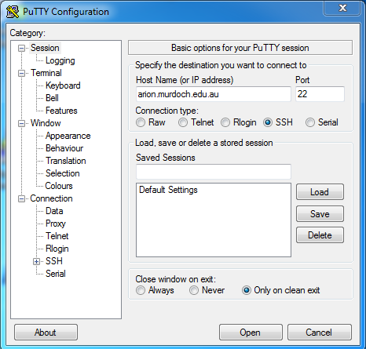

Select **SSH** as the protocol

There may be several security warnings appear – you are quite safe to answer ‘Yes’. The session window should now open and you will see the login prompt for arion:

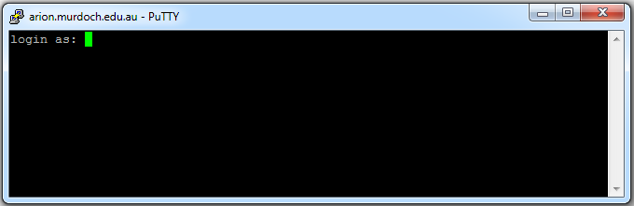

* **To log into arion, enter your usual student number and password.** This is the same username and password that you use for other Murdoch systems.

You are now logged in to arion and see the arion prompt:

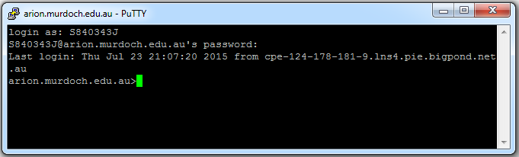

The Oracle component we are using is called SQLPlus.

* **To log in to Oracle SQLPlus, type sqlplus at the arion prompt:**

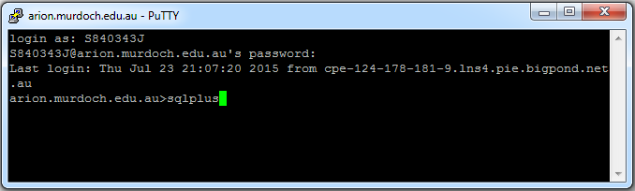

SQLPlus starts and you will be prompted for your Oracle username and password:

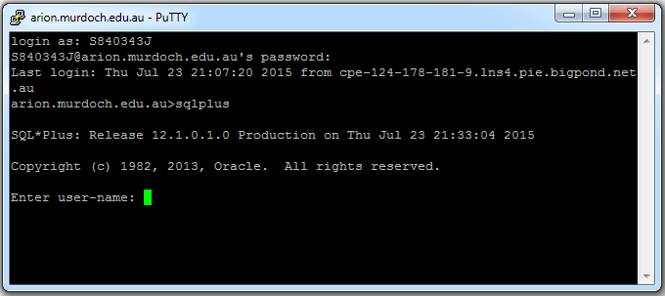

*(read the next bit before doing anything!!)*

* Your **ORACLE username** is an **uppercase V followed by your student number.** For example, if your student number was **20012001**, your username would be **V20012001.**
* **Your ORACLE password is initially the same as your Oracle username** (you can change it later)

Your Oracle username and password are case-sensitive and must not contain special characters such as @.

* **Type in your Oracle username and type in the same again for your Oracle password:**

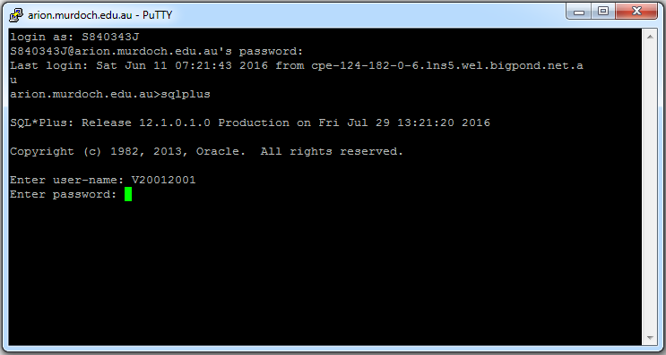

The first time you log on you will be prompted to change your password. You will see a message stating that the account has expired and you need to change your password.

Your password must be at least 6 characters and contain alphabetical and numerical characters, e.g. h3lpm3. The password is case-sensitive.It should not contain special characters such as @

* **At the prompts enter your old password (the one you just entered), then your new password, then your new password again.**

**Make sure you remember what your new password is – if you forget and enter the wrong password 3 times you will be locked out. If you do forget your password, you will need to send an email to** [**d.toohey@murdoch.edu.au**](mailto:d.toohey@murdoch.edu.au) **asking very nicely to have your password reset.**

## Changing your password again

If you want to change your password at any other time, at the SQL prompt, enter **password;** and follow the instructions.

## Entering SQL commands in SSH

You are now logged in to Oracle and should see the SQLPlus prompt **SQL>**. This means you can enter SQL commands.

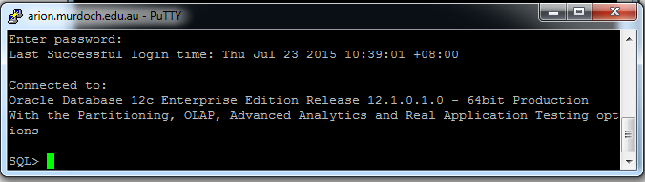

1. Enter the fo**l**lowing command and press Enter:

**select * from dtoohey.customer;**

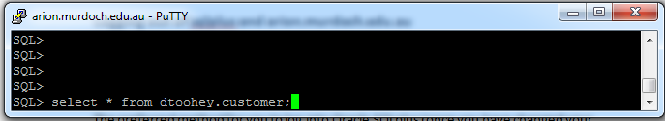

The query runs and 11 rows are selected from the Customer table:

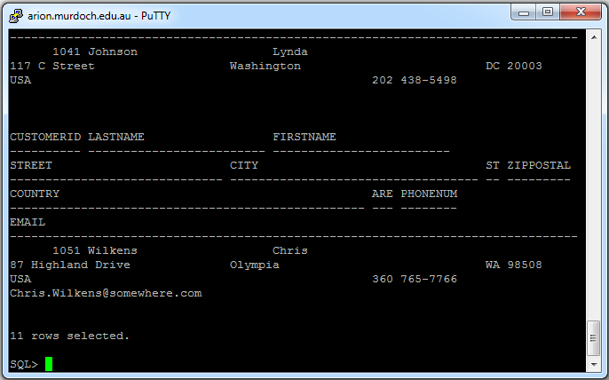

Notice a couple of things from this simple example. Firstly, in the SSH client, the command has to be terminated with a semicolon (;) before it will be executed. If you wish you can enter a command over several lines, and it won’t execute until the semicolon is added.

Notice also that you have prefixed the name of the table (customer) with the name of the user who owns it – **dtoohey**. Unless you are the owner of the table, you must always prefix the table name with the account name.

**Logging out of SQLPlus and arion.murdoch.edu.au:**

* **To exit from Oracle, type exit at the SQL> prompt**
* **And then to exit from arion.murdoch.edu.au type exit**

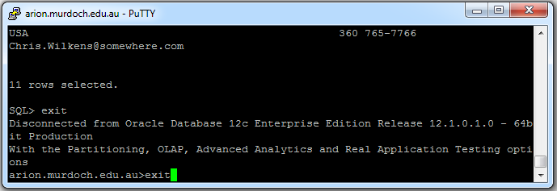

The PuTTY window will close and you will be exited from arion.

The preferred method for you to log into Oracle SQLPlus (once you have changed your password) is to use the Oracle SQL Developer GUI Client. We will do this next.

# 2. Logging into Oracle SQLPlus using the SQL Developer GUI Client

SQL Developer is a GUI client that allows the user to interact with the Oracle database in a more friendly way than via a simple command line. It is available in the ICT285 labs and we will use it for most of the labs.

**It is important to note that you must still log in to Oracle using the SSH client the FIRST TIME you log in to Oracle in order to unlock your account (or any time that your password has been reset). This cannot be done using Oracle SQL Developer.**

SQL Developer is available free from Oracle and can be downloaded from: <http://www.oracle.com/technology/products/database/sql_developer/index.html> .  
It available for several different platforms and the installation is fairly straightforward. (Note that you need to register on the Oracle site before you can download. **The login and password you create on the Oracle site are nothing to do with this unit.**)

**Starting SQL Developer**

* Log on to your computer in the usual way.
* In the on-campus computer labs, Choose Start-Programs, then Oracle SQL Developer.
* If you have installed SQL Developer at home, start it by selecting the SQL Developer executable.

**Connecting to the database**

The database connection we are using for these labs is called STUDENT. In order to connect to the database, you need to create a new Database Connection:

* Click the New Connection button 

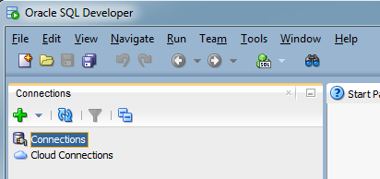

New Connection

* Enter the following details into the New/Select Database Connection dialogue

|  |  |
| --- | --- |
| Connection Name: | **STUDENT** |
| Username: | Your **Oracle username** (e.g. V20012001: see section 1) |
| Password: | Your **Oracle password** (see section 1) |
| Connection Type: | Select “**Basic**” |
| Role: | Select “**default**” |
| Hostname: | **arion.murdoch.edu.au** |
| Port: | **1580** |
| SID: | **student** |

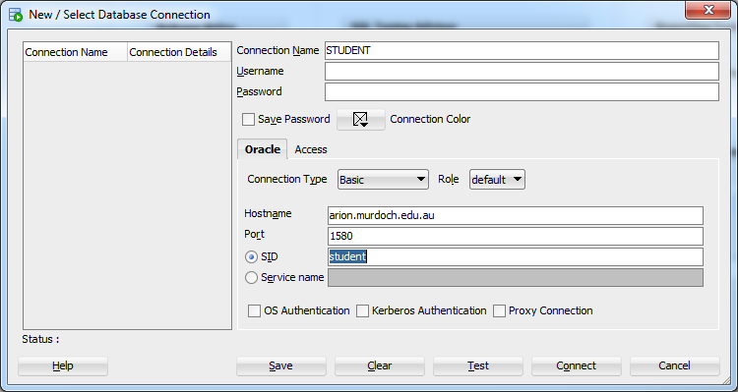

* Click Save so that you don’t have to re-enter the information on subsequent logins. NB: Your password will not be saved and you will need to enter it for future logins.
* Click Connect.

# The STUDENT database connection should now be visible in your connections:

# 

# Entering SQL commands in SQL Developer

Now that you are connected to the database you can enter a command. There are several tables to which you have limited access at this stage. These tables have been created by dtoohey (another user account).

**To enter an SQL command in SQL Developer:**

* Make sure you are connected.
* Right mouse click on the STUDENT connection and select **Open SQL worksheet** from the menu:

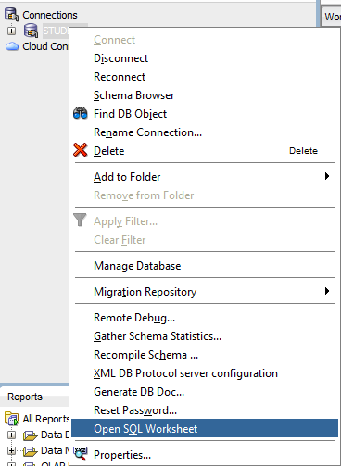

* Now, on the right hand side of the screen, you should see the SQL Worksheet, which is where you will enter your SQL commands.

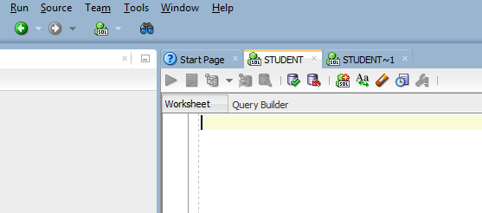

SQL Worksheet

* In the SQL Worksheet type **SELECT * FROM dtoohey.CUSTOMER;**
* To execute the query in the SQL worksheet, you can click on the large green arrow  (Run Statement; ctrl-Enter), or the smaller one next to it  (Run Script, F5). Try both:

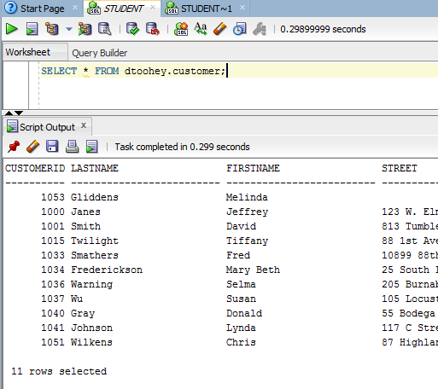

Regardless of how you entered and executed the query, you should see a table of 11 rows, the same set as you did in the ssh interface. Use the scrollbar to view the top of the table if necessary.

* Now try entering the same command over two lines:

**SELECT \***

**FROM dtoohey.CUSTOMER;**

Notice that you can enter commands on a single line or over several lines. The command won’t execute until you actually run it by pressing F5 (or similar).

Notice also that again you have prefixed the name of the table with the name of the user who owns it – **dtoohey**. Unless you are the owner of the table, you must always prefix the table name with the account name.

* Enter **SELECT * FROM ARTIST;**

This time you will get an error message, because you did not use the prefix **dtoohey** and you do not have any tables of your own called artist. It is worth noting what types of errors produce which error messages, as it is not always obvious until you understand what is happening.

**Are the commands case-sensitive?** Experiment with upper and lower case for the SQL commands (select, from), the table name (customer) and the table owner (dtoohey).

# 3. Sharing tables and privileges in databases

A database is a shared resource, and the database that we are using in the labs is shared by everyone in the unit. Before we go on, it is worth reviewing some important concepts about shared data resources.

# Sharing tables

Sharing tables and other objects in Oracle is done through a system of granting privileges. When a user creates an object such as a table, he or she has all privileges on that object, such as selecting, inserting, deleting, or updating data. Other users cannot access the object unless the owner of the object has explicitly granted them permission. In these labs you will sometimes access objects that have already been created by another account, and at other times you will create and manipulate your own.

# Privileges

User accounts in Oracle (and in most DBMSs) are created with different levels of **privileges** granted to them by the system administrator, according to the tasks they need to accomplish and the level of security required. To simplify things, groups of similar users are often assigned to **roles,** and privileges are granted to the role rather than the individuals. You belong to the role STUDENT, which allows you to create (and drop) tables, views, triggers, procedures and sessions, but does not give you any administrative privileges.

# 4. Listing the Definitions of a Table

You have now had some practice in listing the *contents* of the practice tables (the actual records they contain). To view the *structure* of the tables, rather than their contents, enter:

* **DESCRIBE dtoohey.CUSTOMER;**

The result shows the field names, whether nulls are allowed, and the data type of each field:

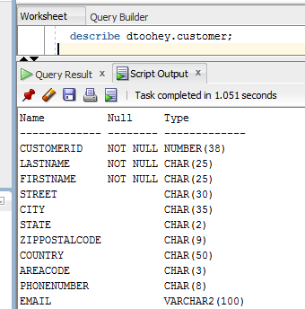

# 5. Oracle Data Types

Oracle has several data types which have properties as described below. Data types can differ between DBMSs, but there will be some commonality. **It is important to be familiar with these broad data types in order to design efficient data storage.**

* **VARCHAR2** is variable-length character data type. A character field of 10 characters would be defined as VARCHAR2(10). Variable length means that only the number of characters entered is stored.
* **CHAR** is fixed-length character data type, e.g. CHAR(10). Fixed length means that if the value entered for the field is less than the length defined (10 here), the remainder of the string is padded with blanks.
* The **NUMBER** data type is used for all numeric data. There are three NUMBER types: integer, fixed point and floating point.
* You specify the number of digits in an **integer** number by for example NUMBER(2) – this stores two-digit numbers such as 23, 99, etc.
* **Fixed point** numbers such as 123.45 or 888.22 would be defined as NUMBER(5,2), where the first number in the brackets is the total number of digits and the second is the number of digits after the decimal point.
* If NUMBER is used on its own, this defines a **floating point** number with no fixed precision after the decimal.
* The **DATE** type stores century, year, month, day, hour, minute and second. The default format is DD-MON-YY. **NOTE:** if you do not specify a century, Oracle assumes you mean the current century i.e., 01-APR-98 is taken to be 01-APR-2098
* Oracle also has the **LONG** data type, which is used to store up to 2GB of variable-length character data, such as a letter or report; and the **RAW** and **LONG** **RAW** types, which store binary data such as digitised sound and images.

# 6. Editing and saving SQL commands in SQL Developer

If you have written a query that you wish to re-use, there are a couple of ways in which you can save it.

## Using a script file

Saving to a script file can be a useful method of saving statements to create and populate several tables, without having to type in each command separately.

List the contents of one of the tables, e.g. Artist :

* Enter **SELECT * from dtoohey.ARTIST;**

Again you should see a list of records. Suppose this is a query that you want to reuse. The query is currently in the buffer so you just need to save the contents of the buffer:

* Choose **File: Save:** from the menu and give the file a name, e.g. selectArtist. Oracle adds an **.sql** extension and the file is saved as **selectArtist.sql**. Save the file to your own area on the network or to a flash drive.
* To retrieve the file choose **File: Open** and select the file. It is retrieved into the worksheet (you may be asked to confirm the connection as STUDENT).
* Run the command as usual.

## Using Notepad

You can also save SQL statements to a text file using Notepad, and copy and paste it to the worksheet as required.

# 7. Editing and saving SQL commands in SSH

If you are not using SQL Developer, you can simply copy and paste between the PuTTY window (or your ssh client) and a text editor such as Notepad.

**To copy and paste from PuTTY to Notepad** you need to highlight the command in the PuTTY window and press Ctrl-V in the Notepad window.

**To copy and paste from Notepad to PuTTY** you need to highlight the command in the Notepad window and press Ctrl-C to copy it, then right mouse click in the PuTTY window.

You can scroll back through your commands using the scroll bars.

* In the PuTTY window, enter **select * from dtoohey.ARTIST;**
* Now use Notepad to edit your previous statement to read **select * from dtoohey.CUSTOMER;** and paste it back into the PuTTY window.
* Press the enter key to run the command as usual.

Explore both the SSH and SQL Developer interfaces further as you need, until you are confident with both methods of interacting with Oracle. We’ll continue next week with learning various types of SQL queries.

# REVIEW: WHAT SHOULD I NOW BE ABLE TO DO?

* Log into the database server using both the SSH and SQL Developer interfaces
* Enter and execute simple SQL commands
* View a table structure using DESCRIBE TABLE
* Explain the main characteristics of the VARCHAR2, CHAR, NUMBER and DATE data types as they are implemented in Oracle

# WHAT’S NEXT?

In the next lab, you’ll start exploring SQL in more detail, looking at retrieving data from database tables using the SELECT statement.

1. If you are going to access the server in this way, you would use the command – “ssh –l YOUR_STUDENT_NUMBER arion.murdoch.edu.au” in a terminal session
2. For a fuller list of SSH clients, see: <http://en.wikipedia.org/wiki/Comparison_of_SSH_clients>