**ICT285 Assignment2 Submission**  
Student Name: Arkar Phyo Aung  
Student No: 32957613  
Email:32957613@student.murdoch.edu.au

**Part1: Revised ERD**

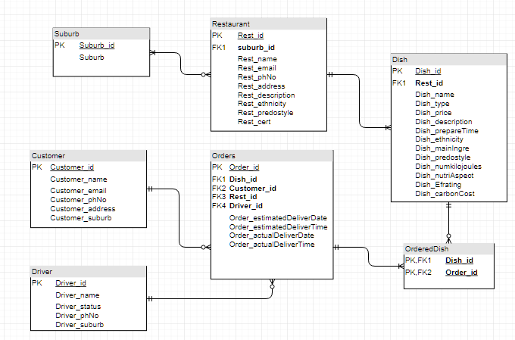

LEGEND: Underlined: Primary Key  
 : Bold: Foreign Key  
I have created the lookup table which is Suburb, to include only the attribute. Suburb_id is the Primary key of the lookup table and suburb in RESTAURANT is defined as foreign key referencing it.  
Assumption: Particular Restaurant may have outlets in one or many suburbs. In one suburb, may have zero or many of that particular Restaurant Outlets.

CUSTOMER (Customer_id, Customer_name, Customer_email, Customer_phNo, Customer_address, Customer_suburb)

RESTAURANT (Rest_id, **Suburb_id**, Rest_name, Rest_email, Rest_phNo, Rest_address, Rest_description, Rest_ethnicity, Rest_predostyle, Rest_cert)

DISH (Dish_id, **Rest_id**, Dish_name, Dish_type, Dish_price, Dish_description, Dish_prepareTime,   
Dish_ethnicity, Dish_mainIngre, Dish_predostyle, Dish_numkilojoules, Dish_nutriAspect, Dish_Efrating, Dish_carbonCost)

DRIVER (Driver_id, Driver_name, Driver_status, Driver_phNo, Driver_suburb)

ORDERS (Order_id, **Dish_id**, **Customer_id**, **Rest_id**, **Driver_id**, Order_estimatedDeliverDate, Order_estimatedDeliverTime, Order_actualDeliverDate, Order_actualDeliverTime)

SUBURB (Suburb_id, Suburb)

ORDEREDDISH ( **Dish_id, Order_id**)  
 **Part 2: Data Dictionary**

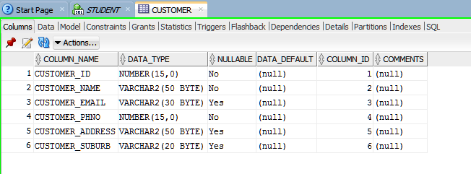

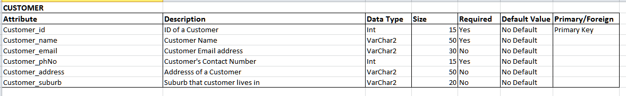

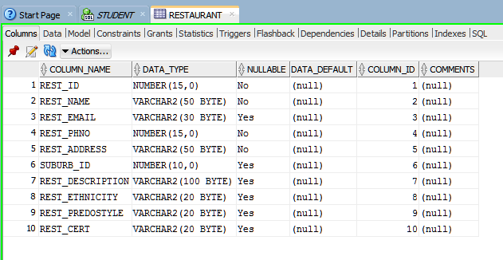

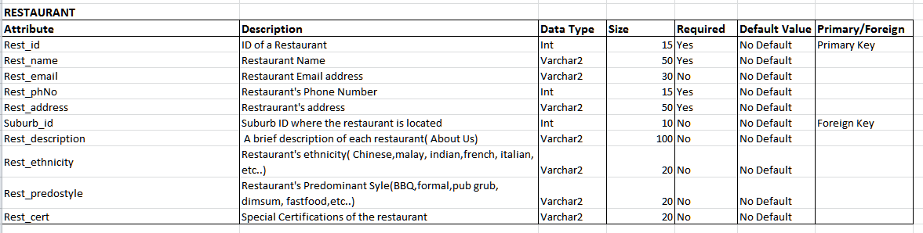

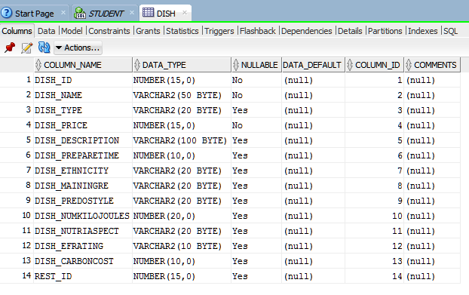

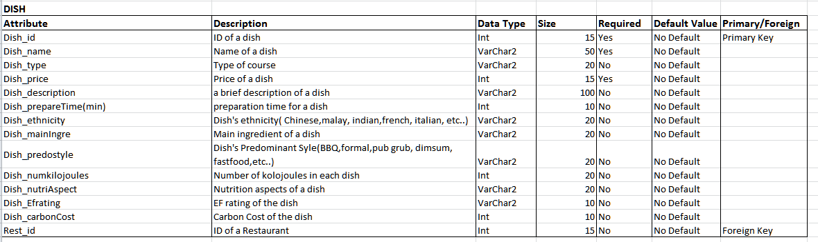

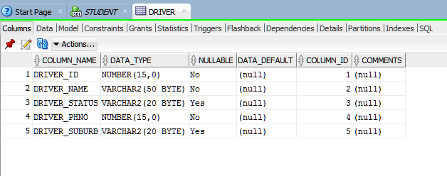

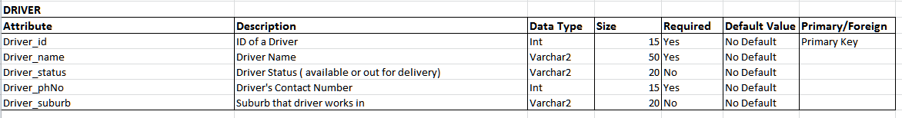

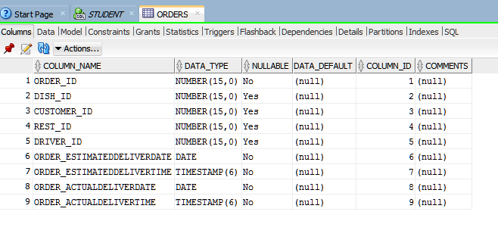

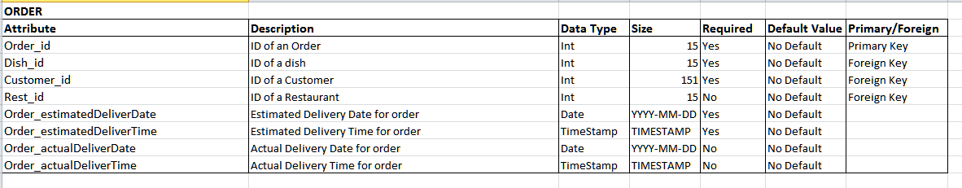

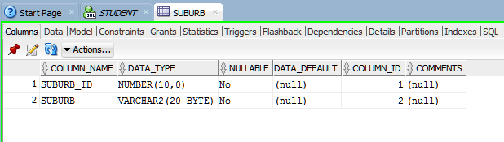

 **Part 3: Implementation** I have used V account. ***Creating Tables***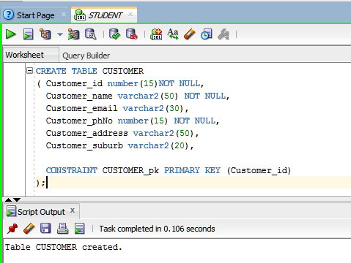

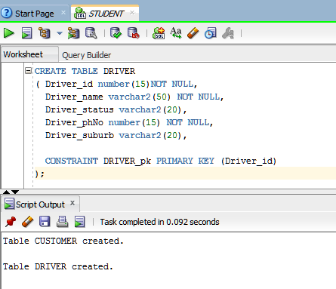

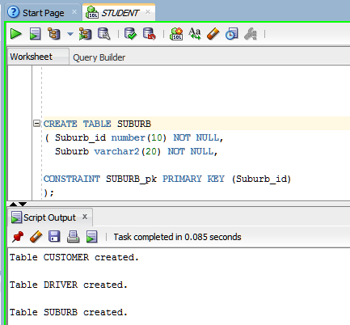

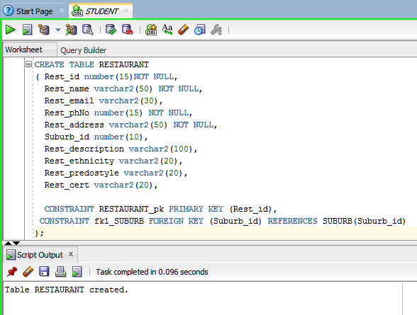

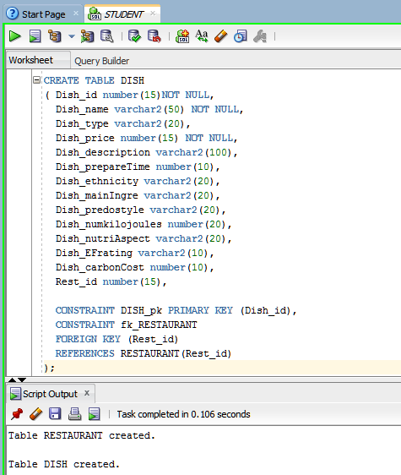

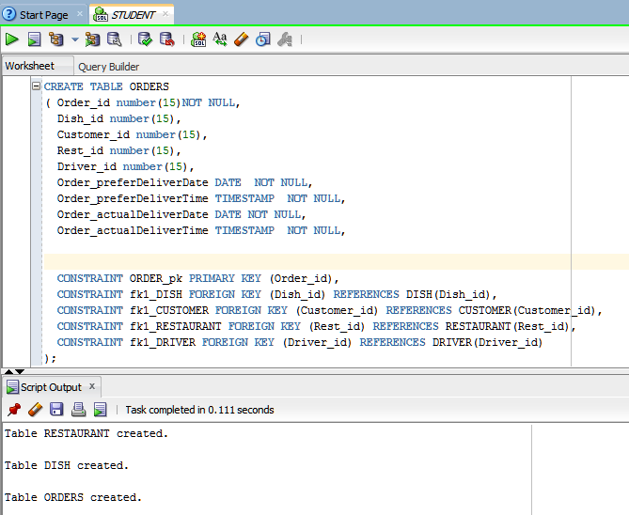

***INSERTING VALUES INTO TABLES***

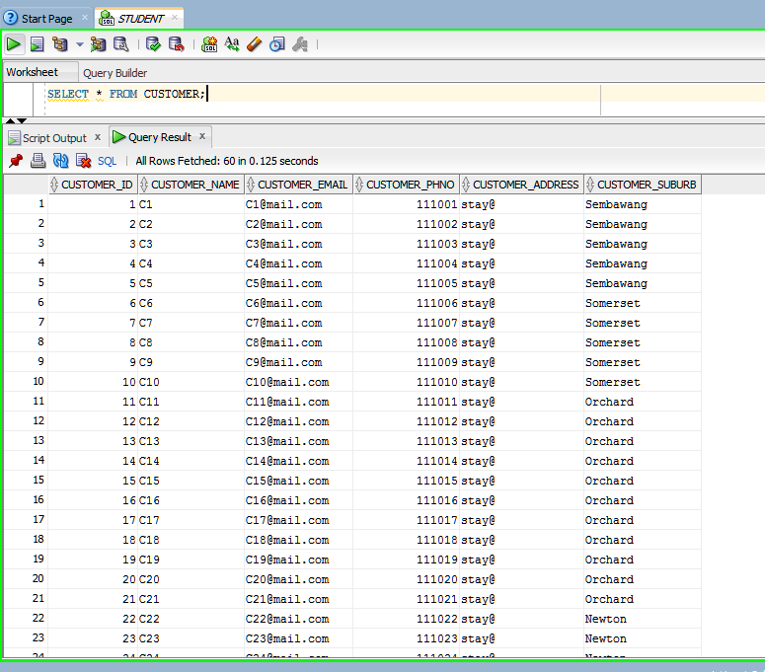

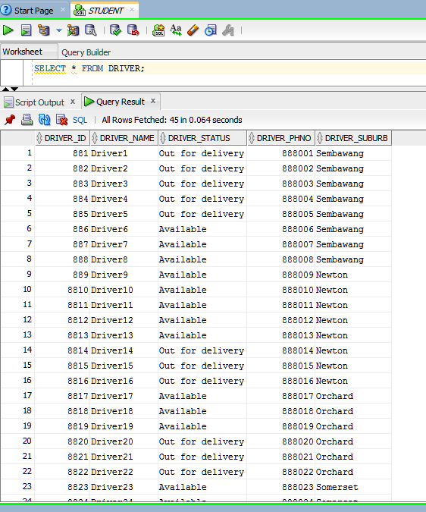

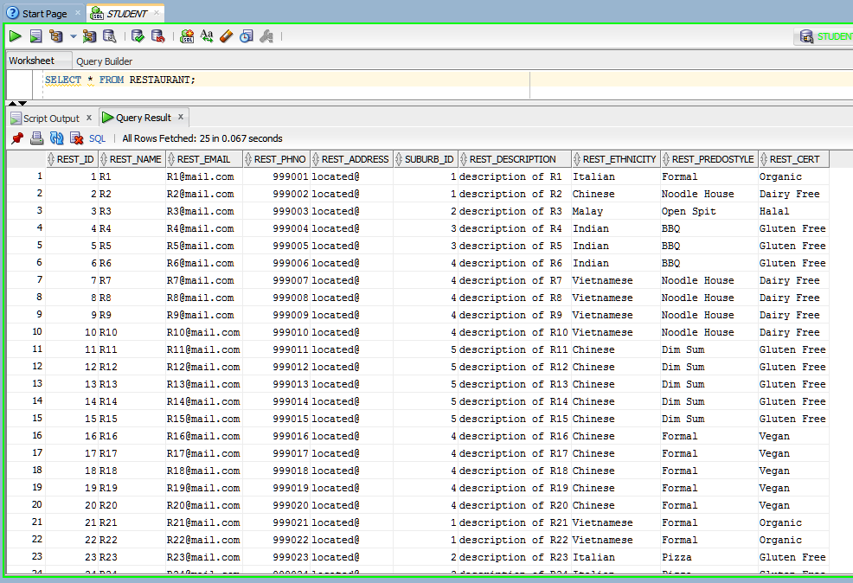

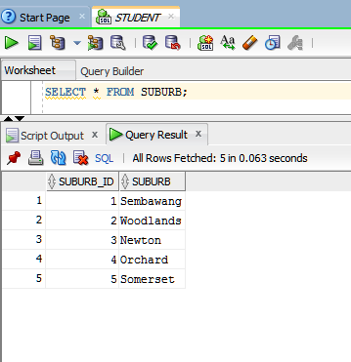

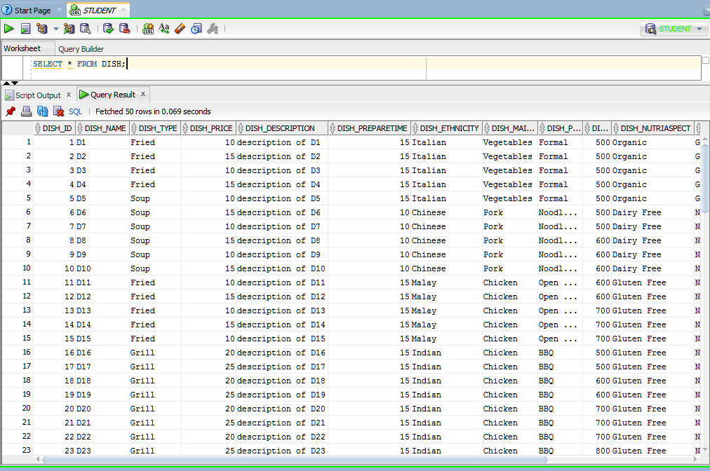

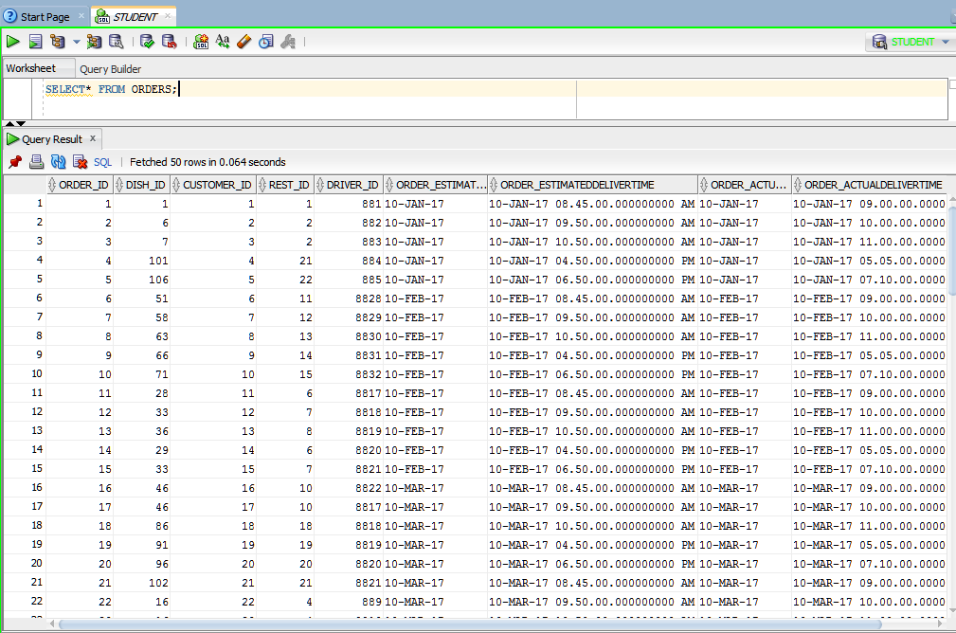

***Granting access to MARKERTL***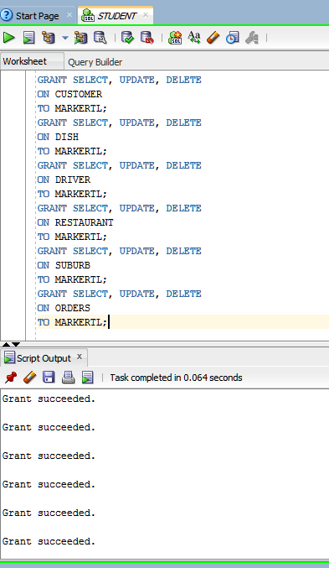 **Part 4: Views**

View: A

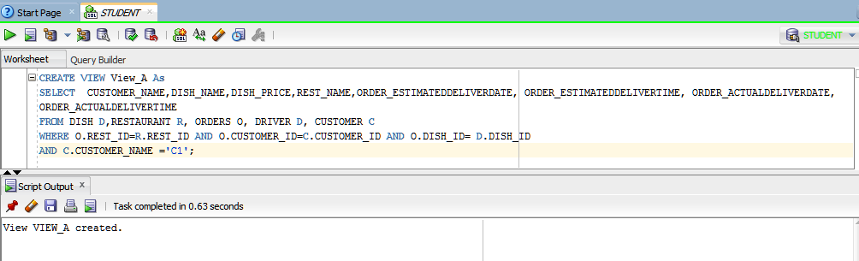

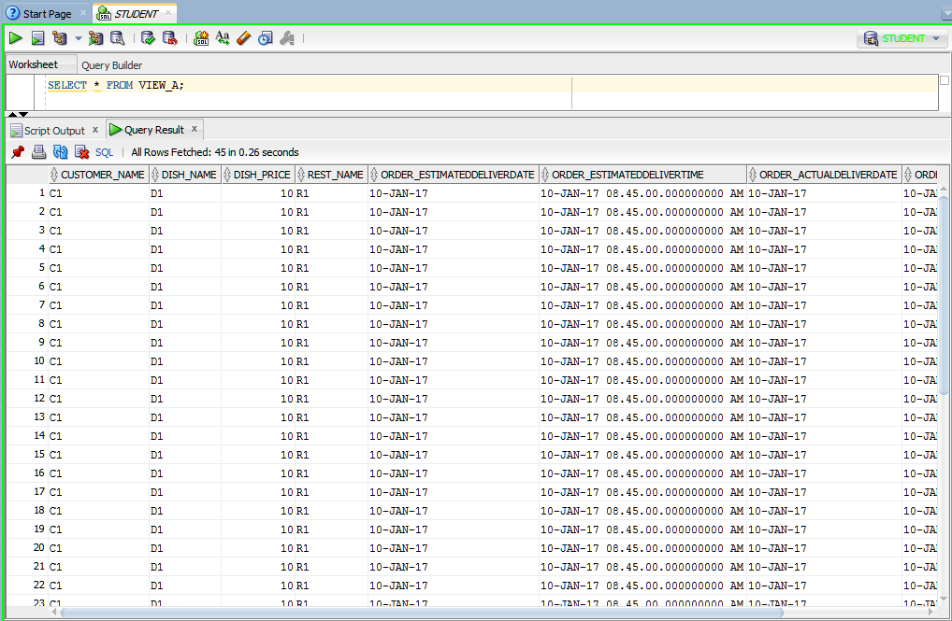

View: B  
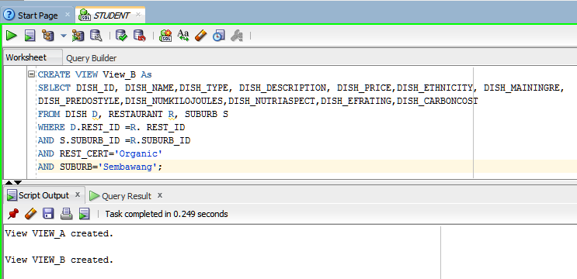

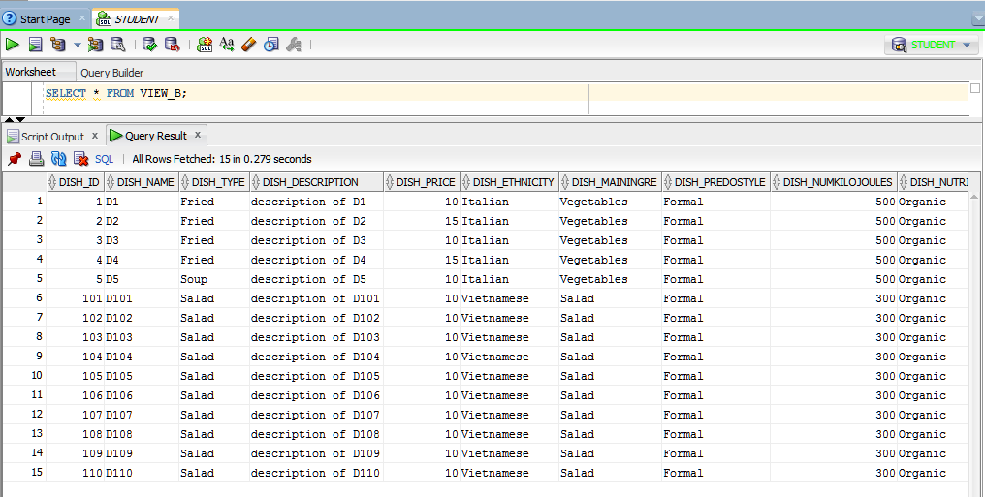

View: C  
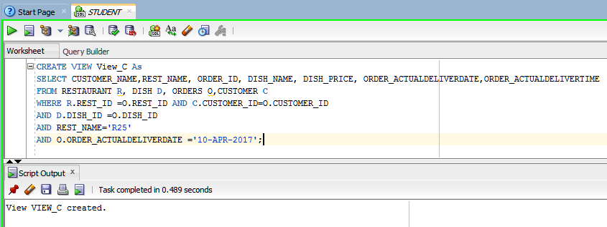

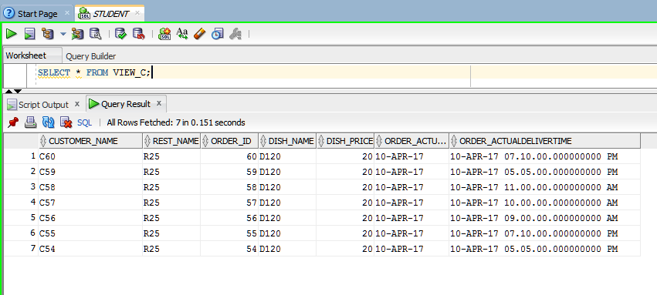  
View: D  
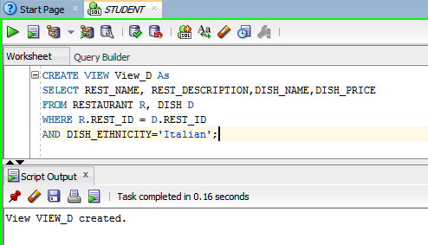

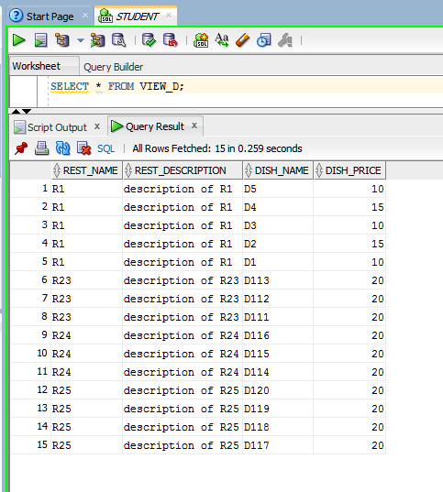

View: E

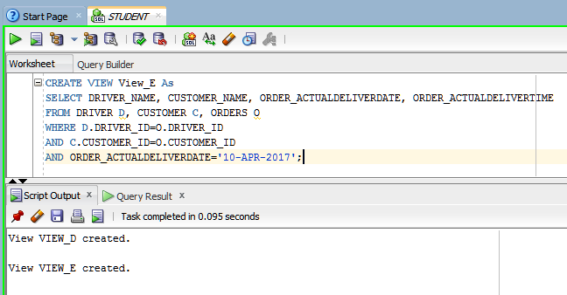

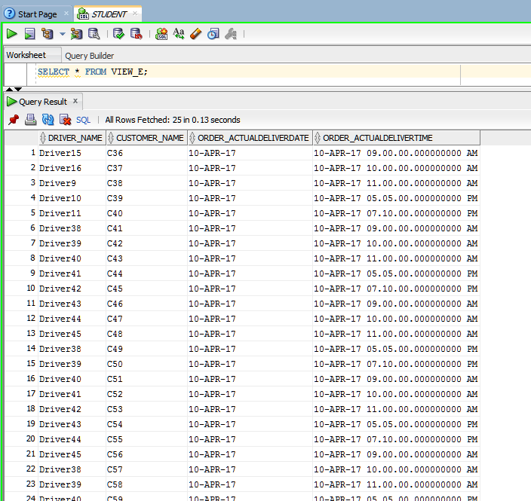

View: F  
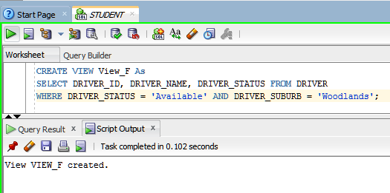

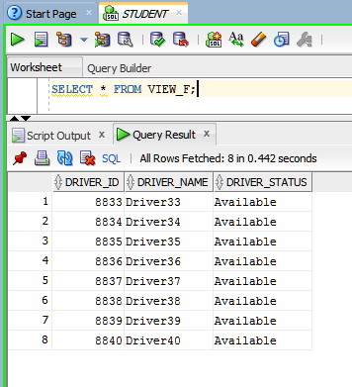  
View: G  
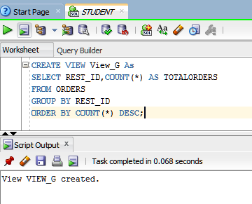

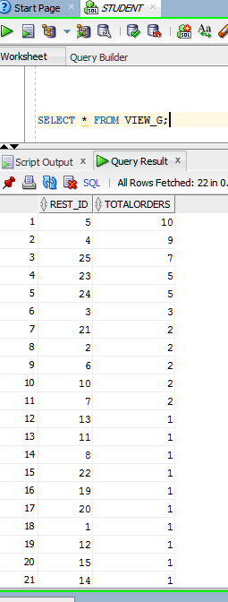  
View: H  
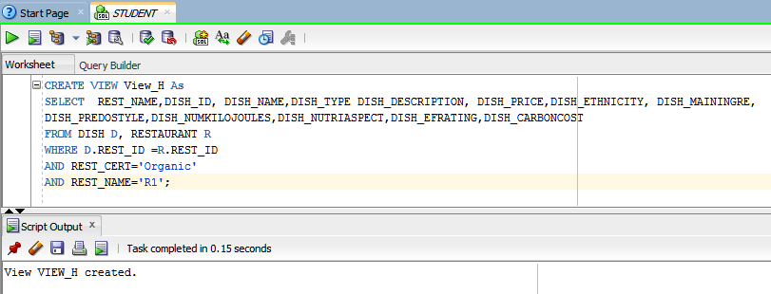

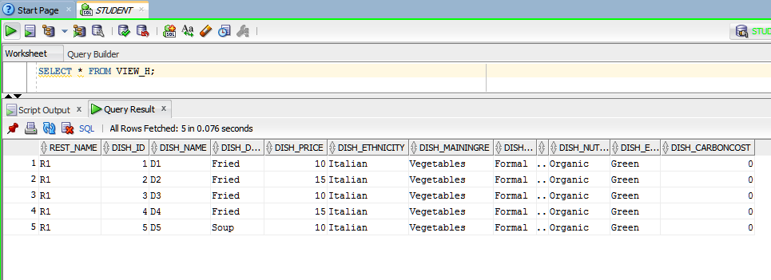  
View: I  
  
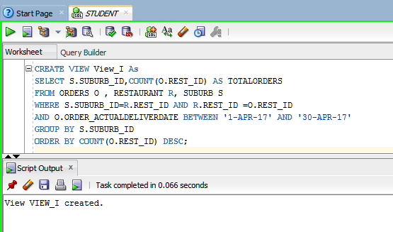

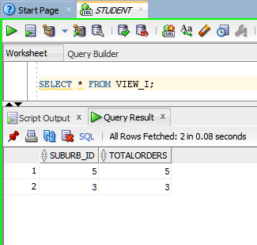

View: J  
  
CREATE VIEW View_J As

SELECT * FROM VIEW_J;