# 1 Tagged Templates?

Tagged template basically transforms template strings by placing function name before it.

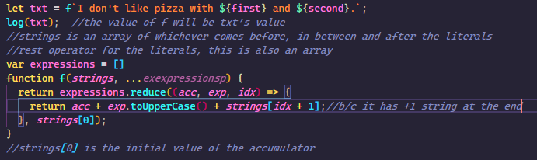

# 2. First Class Functions

If functions in a language are treated like any other variables for example, being passed as an argument to other functions and being assigned to a variable, the language is said to have first class functions.

Functions we pass as an argument are called callback functions.

Passing function as an argument

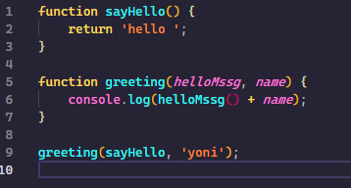

Function returning a function

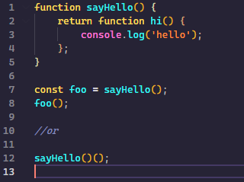

Both ways work when invoking.

# 3. Closures

When for example a variable we declared and initialized outside a function is called inside a function and work, that’s what closure is.

In Js every scope has access to everything outside of its scope.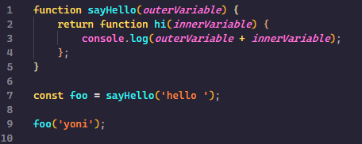

# 4. Reflect API

All methods in the Reflect object is static.

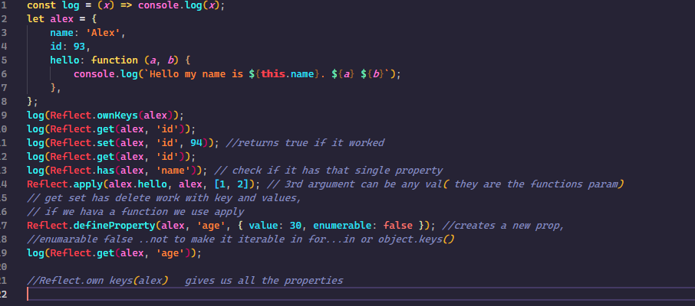

Construct

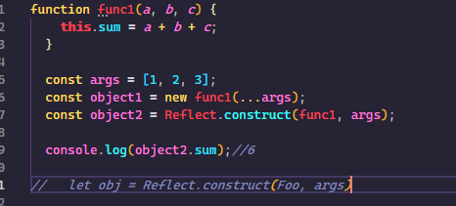

Proto

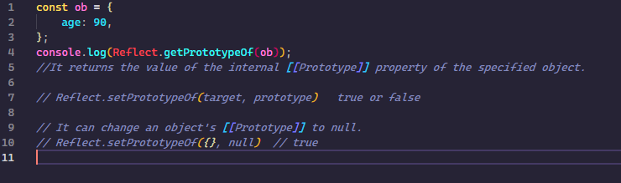

# 5. Export Default

The export statement is used when creating JavaScript modules to export functions, objects, or primitive values from the module so they can be used by other programs with the import statement.