- GAZE ESTIMATION
The primary task of gaze trackers is to determine gaze. Gaze should in this context be understood as either the gaze direction or the point of regard (PoR).² Gaze modeling consequently focuses on the relations between the image data and the point of regard/gaze direction.
Basic categorizations of eye movements include saccades and fixations. A fixation occurs when the gaze rests for some minimum amount of time on a small predefined area, usually within 2-5 degrees of central vision, usually for at least 80-100 ms. Saccades are fast, jump-like rotations of the eye between two fixated areas, bringing objects of interest into the central few degrees of the visual field. Smooth pursuit movements are a further categorization that de- scribe the eye following a moving object. Saccadic eye movements have been extensively investigated for a wide range of applications including the detection of fatigue/ drowsiness, human vision studies, diagnosing neurological disorders, and sleep studies [28]. Fixations are often analyzed in vision science, neuroscience, and psychological studies to determine a person’s focus and level of attention. Properties of saccades and fixations may provide diagnostic data for the identification of neurological, vision or sleep disorders. Eye positions are restricted to a subset of anatomically possible positions described in Listing’s and Donder’s laws [140]. According to Donder’s law, gaze direction determines the eye orientation uniquely and the orientation is furthermore independent of the previous

2. Keep in mind that gaze information does not necessarily mean that the person is in an attentive state nor that the estimated point of regard is coincident with the monitor.

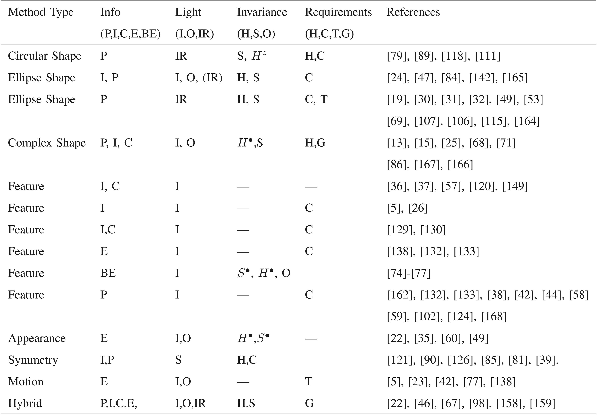

Fig. 6. Eye Detection models: The “Method Type” column corresponds to the method category. The “Info” column refers to the information that can be obtained directly from the model: Pupil (P), Iris (I), Corners (C), Entire Eye (E), Between-the-Eyes (BE). The “Light” column indicates under which light conditions the method operates: Indoor(I), Outdoor (O), or under IR light (IR). The “Invariance” column considers the robustness to scale (S), head pose (H) changes, and to occlusion (O) due to the eye blinks or closed eyes. The “requirements” column includes high-resolution (H) eye images, High contrast (C), Temporal (T) dependencies, Good Initialization (G). Superscript ● indicates robustness to some degree and ○ indicates robustness to a minor degree. Methods may consequently possess properties not reported here (e.g., capable of using IR in both indoor and outdoor conditions). Values given in parentheses are optional.

positions of the eye. Listing’s law describes the valid subset of eye positions as those which can be reached from the so- called primary position through a single rotation about an axis perpendicular to the gaze direction.
When light falls on the curved cornea of the eye (see Fig. 7), some of it is reflected back in a narrow ray pointing directly toward the light source. Several reflections occur on the boundary between the lens and the cornea, producing the so- called Purkinje images [28]. The first Purkinje image or corneal reflection is often referred to as the glint.
To exemplify the importance of light sources for gaze estimation, consider looking directly at a light source. The distance between the glint and the center of the pupil is small. However, looking away increases this distance. This implies that if the sole purpose of the gaze tracker is to determine whether a person is looking at a specific light source, all that is needed is to make a simple classification (threshold) on the length of the pupil-glint vector. This also illustrates that high-accuracy gaze estimation may not be necessary for all applications.
People move their heads when using a gaze tracker. A person’s gaze is determined by the head pose (position and orientation) and eyeball orientation. A person can change gaze direction by rotating the eyeball (and consequently also
the pupil) while keeping the head stationary. Similarly, a person can change gaze direction by moving the head while keeping the eye stationary relative to the head. Usually, a person moves the head to a comfortable position before orienting the eye. Head pose, therefore, determines the coarse-scale gaze direction while the eyeball orientation
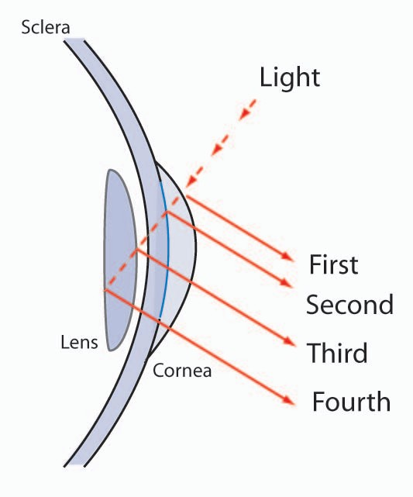
Fig. 7. Light is reflected on the eye and results in various Purkinje images (first, second, etc.).

determines the local and detailed gaze direction. Gaze estimation therefore needs to (either directly or implicitly) model both head pose and pupil/iris position. The problem of ensuring head pose invariance in gaze trackers is important and constitutes a challenging research topic. Head pose invariance may be obtained through various hardware configurations and prior knowledge of the geometry and cameras. Information on head pose is rarely used directly in the gaze models. It is more common to incorporate it implicitly either through the mapping function (regression- based method described in Section 3.1) or through the use of reflections on the cornea (3D model-based approaches described in Section 3.2).
All gaze estimation methods need to determine a set of parameters through calibration. We clarify the calibration procedures into the following:

- camera-calibration: determining intrinsic camera parameters;
- geometric-calibration: determining relative locations and orientations of different units in the setup such as camera, light sources, and monitor;
- personal calibration: estimating cornea curvature, angular offset between visual and optical axes; and
- gazing mapping calibration: determining parameters of the eye-gaze mapping functions.
Some parameters may be estimated for each session by letting the user look at a set of predefined points on the monitor; others need only be calculated once (e.g., human specific parameters) and yet other parameters are estimated prior to use (e.g., camera parameters, geometric and physical parameters such as angles and location between camera and monitor). A system where the camera para- meters and geometry are known is termed fully calibrated. This classification will be used to differentiate the assump- tions made in various methods.
Desirable attributes in a gaze tracker include minimal intrusiveness and obstruction, allowing for free head movements while maintaining high accuracy, easy and flexible setup, and low cost. A more detailed description of eye tracker preferences is given by Scott and Findlay [125]. Only a few years ago, the standard eye tracker was intrusive, requiring, for example, a reflective white dot placed directly onto the eye or attaching a number of electrodes around the eye [63]. Use of headrests, bite-bars, or making the eye tracker head mounted were common approaches to accommodate significant head movements. Head movements are typically tracked using either a magnetic head tracker, another camera, or additional illuminators. Head and eye information is fused to produce gaze estimates [122], [151].
Compared to the early systems, video-based gaze trackers have now evolved to the point where the user is allowed much more freedom of head movements while maintaining good accuracy (0.5 degree or better). As reviewed in this section, recent studies show that using specific reflections from the cornea allows gaze trackers to be easily and cheaply produced, and enhances stable and head pose invariant gaze estimation. However, commercial eye trackers remain regrettably expensive.
Current gaze estimation methods are mostly feature- based (described in the subsequent section), but we will later review others such as appearance-based methods.

Feature-Based Gaze Estimation
Gaze estimation methods using extracted local features such as contours, eye corners, and reflections from the eye image are called Feature-based methods. The primary reasons for using feature-based methods are that the pupil and glints (under active light models) are relatively easy to find and that these features can, as indicated above, be formally related to gaze. This encompasses aspects related to the geometry of the system as well as to eye physiology. For these reasons, they have become the most popular approach for gaze estimation.
Two types of feature-based approaches exist: the model- based (geometric) and the interpolation-based (regression- based). The interpolation-based methods [11], [31], [46],
[47], [69], [104], [157] that assume the mapping from image features to gaze coordinates (2D or 3D) have a particular parametric form such as a polynomial [104], [131] or a nonparametric form such as in neural networks [69], [45]. These methods avoid explicitly calculating the intersection between the gaze direction and gazed object. The 3D model- based methods, on the other hand, directly compute the gaze direction from the eye features based on a geometric model of the eye. The point of gaze is estimated by intersecting the gaze direction with the object being viewed [113], [144], [151], [100], [8].
In the following sections, we first describe regression- based methods (Section 3.1), and follow with a review of the 3D model-based approaches in Section 3.2, which are further subdivided based on their hardware requirements. A discussion of gaze estimation methods and a table
summarizing the models are given in Section 3.3.

2D Regression-Based Gaze Estimation
Early gaze tracking systems employed a single IR light source to improve contrast and obtain stable gaze estima- tion results. The erroneous assumption implicitly made by many single-glint methods is that the corneal surface is a perfect mirror, so, if the head is kept fixed even when the cornea surface is rotated, the glint remains stationary. The glint is therefore considered the origin of a glint-centered coordinate system. The difference between the glint and the pupil center is in this view used to estimate gaze direction. A mapping from the pupil-glint difference vector to the screen is often conducted.
As early as 1974, Merchant et al. [99] proposed a real- time video-based eye tracker employing IR light (dark- bright pupil images) using a single camera. A collection of
mirrors and galvanometers allows for head movements. They use the pupil-glint vector and a linear mapping to estimate the point of regard (POS) and notice nonlinearities with large pupil-glint angles. They compensate for these using polynomial regression. Similarly, and much later, Morimoto et al. [103] also used a single camera and utilized one second order polynomial for the x and y directions separately to represent a direct mapping of the glint-pupil difference vector to the point of regard. Unfortunately, the calibration mapping decays as the head moves away from its original position [104]. A similar approach, but without using glint information, is described by Stampe [131]. He additionally proposes polynomial functions to model the correlation between pupil centers.

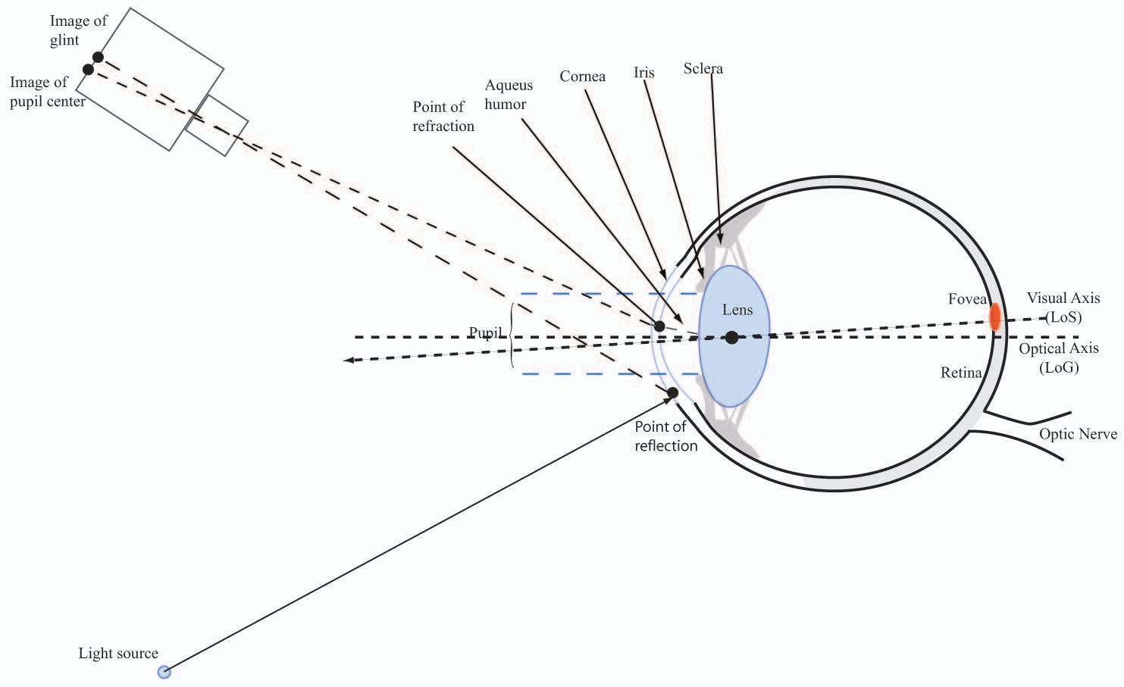

Fig. 8. General model of the structures of the human eye, light, light sources, and projections.

White et al. [156] assume a flat cornea surface and propose a polynomial regression method for PoR estimation in a similar way as Morimoto et al. and Merchant et al. [103], [99]. They additionally propose using a first order linear regression to account for gaze imprecision resulting from lateral head movements. During calibration, a set of four calibration mappings for different head locations is estimated by exploiting spatial symmetry. Head positions are accurately located by creating a second glint using another IR light source. Using two light sources as points of reference and exploiting spatial symmetries, a single static calibration can be adjusted as the head moves. They mention that, in practice, higher order polynomial functions do not provide better calibration and argue that gaze estimation can be done independently of eye rotation and head translation—a fact that was later generalized and proved to be true [43], [128].
Neural networks and their variants are popular tools for regression tasks. Ji and Zhu [70] suggest a generalized regression neural network-based method in which the pupil parameters, pupil-glint displacement, orientation and ratio of the major and minor axes of the pupil ellipse, and glint coordinates are used to map the screen coordinates. The intention and advantage of the method is that no calibration is necessary after initial training. This method only improves head movement moderately. It is reported that the method handles head movements while still producing accuracies of about 5 degree. Zhu et al. [171] suggest the use of Support Vector Machines to describe the mapping from the pupil and single glint to screen coordinates.
Most gaze estimation methods do not offer a way of knowing when the current inputs are no longer compatible with the calibration data. Witzner et al. [45], [46] use Gaussian process interpolation to exploit the covariance of the training data and new inputs as an indicator of when gaze predictions deviate from the inputs of the calibration data (e.g., a head movement) and to make predictions.
Two-dimensional interpolation methods do not handle head pose changes well. Helmets may be of some help, but, contrary to the intentions behind mounting the eye trackers on the head, they may still move after calibration and thus influence accuracy. Kolakowski and Pelz propose a set of heuristic rules for adjusting minor slippage of head mounts [83].
Using a single camera, the 2D regression methods model the optical properties, geometry, and the eye physiology indirectly and may therefore be considered as approximate models, which may not strictly guarantee head pose invariance. They are, however, simple to implement, do not require camera or geometric calibration, and may still provide good results under conditions of small head movements. More recent 2D regression-based methods attempt to improve performance under larger head move- ments through compensation, or by adding additional cameras [171], [170]. Zhu and Ji introduce a 2D regression- based method [170] using two cameras to estimate 3D head position. They use the 3D eye position to modify the regression function to compensate for head movements. However, contrary to other regression methods, the method of Zhu and Ji [170] needs a prior stereo calibration of the cameras.

3D Model-Based Gaze Estimation
Three-dimensinoal model-based approaches model the common physical structures of the human eye geometri- cally so as to calculate a 3D gaze direction vector. By defining the gaze direction vector and integrating it with information about the objects in the scene, the point of regard is computed as the intersection of the gaze direction vector with the nearest object of the scene (e.g., the monitor).
Fig. 8 shows the structures of the eye used in gaze tracking. The eyeball is approximately spherical, with a radius of about 12-13 mm. The parts of the eye that are visible from the outside are the pupil, the iris (colored part), and the sclera (the white part of the eye). The

boundary between the iris and the sclera is called the limbus. The pupil is the aperture located in the center of the iris and it regulates the amount of light entering the eye by continuously expanding and contracting. The cornea is a protective transparent membrane on the surface of the eye in front of the iris with a radius of about
7.8 mm [43]. Behind the iris is the biconvex multilayered structured lens. The shape of the lens changes so as to focus objects at various distances on the retina, which is a layer coating the back of the eye containing photosensitive cells. The fovea is a small region in the center of the retina, in line with the central 5 or so degrees of vision. The fovea contains the majority of color sensitive cells, and these cells are more tightly packed and more differentially connected to the optic nerve than cells in peripheral areas of the retina. The fovea is responsible for the perception of fine details. Gaze direction is either modeled as the optical axis or as the visual axis. The optical axis (a.k.a. line of gaze (LoG)) is the line connecting the pupil center, cornea center, and the eyeball center. The line connecting the fovea and the center of the cornea is known as visual axis (a.k.a. the line of sight (LoS)). The line of sight is assumed to be the true direction of gaze. The visual and optical axes intersect at the cornea center (a.k.a. nodal point of the eye) with subject-dependent angular offsets. In a typical adult, the fovea is located about 4-5 degrees horizontally and about 1.5 degrees below the point of the optic axis and the retina and may vary up to 3 degrees between subjects [12], [43]. Knowledge of the 3D location of the eyeball center or the corneal center is a direct indicator for the head location in 3D space and may obviate explicit head location models. The estimation of these points is therefore the cornerstone of most head pose invariant models.
The parameters used for geometric modeling of the eye can be divided into extrinsic, fixed eye intrinsic, and variable categories [8]. The extrinsic parameters model 3D eye position (center of the eyeball) and optical axis. The fixed eye intrinsic parameters include cornea radii, angles between visual and optical axes, refraction parameters (e.g., in aqueous humor), iris radius, and the distance between the pupil center and cornea center. They remain fixed during a tracking session, but may change slowly over the years. Parameters such as the visual axis, refraction indexes,³ the distance between the cornea center and pupil center, and the angles of the visual axis and optical axis are subject- specific, some of which are difficult to measure directly. The variable parameters change the shape of the eye model and include the pupil radius.
Most 3D model-based (or geometric) approaches [151], [144], [145], [156], [43], [105], [100], [112], [109], [128], [127]
rely on metric information and thus require camera calibration and a global geometric model (external to the eye) of light sources, camera and monitor position, and orientation. Exceptions to this are methods that use projective invariants [164], [20] or simplifying assumptions

- Refraction occurs when light passes from one transparent medium to another; it changes speed and bends. The degree of bending depends on the refractive index of the mediums and the angle between the light ray and the normal to the surface separating the two mediums. The consequences of refraction are a nonlinear displacement of the observed location of features such as the pupil and may, thus, influence the estimation of the 3D location.
[47]. It is out of the scope of this paper to provide mathematical details of these methods, but most follow the same fundamental principles. Euclidean relations such as angles and lengths can be employed through calibrated cameras. The general approach is to estimate the center of the cornea, and thus, the optical axis in 3D. Points on the visual axis are not directly measurable from the image. By showing at least a single point on the screen, the offset to the visual can be estimated. The intersection of the screen (known in fully calibrated setups) and the visual axis yield the point of regard.
Model-based approaches typically estimate gaze direc- tion by assuming spherical eyeball and cornea surfaces. Only a few methods model these structures as ellipsoid [8]. The spherical models of the cornea may not be suitable for modeling the boundary area of the cornea and often lead to greater inaccuracies when the user moves the eye to the extremities of the display (e.g., glints move on a non- spherical surface). Both the optical and visual axes intersect at the cornea center making the cornea center an important parameter to estimate in a geometric approach.
With a known cornea curvature, it is possible to find the cornea center using one camera and two light sources. However, estimation of the cornea center requires at least two light sources and two cameras when the eye-specific parameters are unknown [128]. Instances of applying these results in a fully calibrated setup have been proposed by several authors [105], [127], [43]. Estimation of the angles between the optical and visual axes is also needed to find the direction of gaze, requiring at least a single point of calibration [127]. For simplicity, anthropomorphic averages for the cornea curvature are frequently used [112], [51].
The following sections describe methods and formal relations of point features such as center of pupil with varying geometry and cameras. Starting with one light source and a single camera, each subsequent section reviews models with increasing number of light sources and cameras. Calculating the importance of refraction requires additional work and quantification and will only be quantified when applicable.
B1: Single camera and single light. Due to their simplicity and effectiveness, single camera and single glint approaches were quite common in early gaze tracker implementations. Regression-based methods (Section 3.1) mostly employ a single camera and a single light source; but for the remainder of this section, attention is only given to the geometric approach, i.e., the 3D model-based approach. A few geometric methods use a single light source [115], [43]. Ohno et al. [115] describe a model-based approach using a single calibrated camera and single glint. They use population averages for the cornea curvature, distance between pupil center and the center of cornea, as well as a constant refraction index (1.336) to estimate the optical axis. Later, Ohno argues that personal calibration can be reduced to two fixation points using two light sources and a single camera [114].
Shih et al. [128] prove that the use of a single glint and
the pupil center cannot lead to head pose invariant gaze estimation. Their results explain the need for additional constraints such as additional cameras to compensate for

head pose changes in single glint systems, using population averages or a spherical eyeball model to obtain the optical axis [115].
Guestrin and Eizenman [43] generalize these results for calibrated systems, showing that the gaze direction can be determined by using only a single glint given the distance between the eye and the monitor or keeping the head fixed. Much of the theory behind geometric models using fully calibrated setups has been formalized by Guestrin and Eizenman [43]. Their model covers a variable number of light sources and cameras, human specific parameters, light source positions, and camera parameters. The model, however, is limited by requiring euclidean information (e.g., fully calibrated setups).
The majority of the results of Guestrin and Eizenman [43]
regard point sources such as center of the pupil, center of glint etc. Villanueva and Cabeza [146] show that, in fully calibrated setups, the ellipse information of the pupil (disregarding refraction) can be used to reduce the number of light sources to one and still provide head pose invariance. Consequently, there may be several unrevealed results using pupil or iris contours.
A common misconception of single glint systems is that
the pupil-glint difference vector remains constant when the eye or the head moves. The glint will clearly change location when the head moves, but it is less obvious that the glint shifts position when changing gaze direction. The eye rotates around the eyeball center and not around the cornea center. This means that a change of gaze direction also moves the cornea in space, and thus, the glint will not remain fixed. Second, minor changes of glint position may also be due to a nonspherical cornea. The influence of small head movements on the difference vector is indeed minimal. The technique is used somewhat successfully in gaze trackers, where the camera is fixed relative to the eye to compensate for small amounts of slippage. However, larger head movements cause significant changes in the difference vector.
B2: Single camera and multiple lights. Adding light sources to the setup is a small step from the previous methods, but, as it turns out, a giant leap for obtaining head pose invariance. Shih et al. [128] and Guestrin and Eizen- man [43] show that the cornea center and, in turn, also gaze direction can be estimated in fully calibrated settings using two or more light sources and known cornea curvature. Guestrin and Eizenman’s system⁴ allows for only small head movements, but it appears that their well-founded approach would allow for greater head movements with a higher resolution camera [43]. They also make simplifying assumptions on refraction in the aqueous humor. Several authors follow this approach with minor adjustments to the model [100], [144], [127], [55]. In fact, only one calibration point is needed to estimate the cornea curvature, cornea center, and visual axis (single angle) when using two light sources [146]. These methods are usually accurate, but ongoing collection and maintenance of geometric and camera calibrations usually entails errors.
The gaze tracking systems relying on this approach are
consequently inflexible when attempting to change the geometry of light sources, camera (e.g., zoom), and screen

- A particular instance of their model with a single camera and two light sources.
to particular needs. They may also result in heavy systems. This type of approach seems to be the foundation of several commercial systems.
Contrary to the previous methods, Yoo and Chung [164] describe a method which is capable of determining the point of regard based solely on the availability of light source positions information (e.g., no camera calibration) by exploiting the cross-ratio of four points (light sources) in projective space. Yoo and Chung [164] use two cameras and four IR light sources placed around the screen to project these corners on the corneal surface, but only one camera is needed for gaze estimation. When looking at the screen, the pupil center should ideally be within the four glint areas. A fifth IR light emitter is placed on axis to produce bright pupil images and to be able to account for nonlinear displacements of the glints. In order to account for the nonlinear displacements of the projected glints on the cornea, they learn four α_{i} parameters, initially asking the user to look at the light sources. Coutinho and Morimoto [20] extend the model of Yoo and Chung [164] by using the LoS-LoG offset as an argument for learning a constant on-screen offset. Based on this, they argue that a simpler model can be made by learning a single α value rather than four different values as originally proposed. They show significant accuracy improvements compared to the original paper, provided that the user does not change their distance to the camera and monitor. The method is not robust to depth-scale changes since a constant LoS-LoG offset does not yield a constant offset on the screen when changing the distance of the eye to the screen. The model of cross-ratios is also an approximation since the pupil is located on a different plane from that determined by the (corrected) corneal reflections. The advantage of the method is that it does not require a calibrated camera. It only requires light source position data relative to the screen. One limitation is that the light sources should be placed right on the corners of the screen—a task which is not entirely trivial. In practice, the method is highly sensitive to the individual eye, and formal analysis of the method is presented by Kang et al. [72].
The intersection of gaze direction vectors from two eyes provides information about the 3D point of gaze and has recently motivated researchers to propose methods remi- niscent of stereo vision for 3D PoR estimation [29],[56]. Methods for 3D PoR seem to obtain fairly reliable results, but are still in an early stage of development.
In general, multiple light sources are faced with increased chance that one of the glints might disappear. There may therefore need to be physical restraints on the actual head locations in order to ensure that all glints appear in the image.
B3: Multiple cameras and multiple lights. Fixed single camera systems are faced with the dilemma of trading head movements against high-resolution eye images. A large field of view is required to allow for free head motion, but a limited field of view is needed to capture sufficiently high- resolution eye images to provide reliable gaze estimates. Multiple cameras are utilized to achieve these goals either through wide-angle lens cameras or a movable narrow-angle lens cameras. Multiple cameras also allow for 3D eye modeling. The first remote eye tracking systems appearing in the literature that use multiple cameras, either have separate cameras for each eye or use one camera for head

location tracking to compensate for head pose changes and another camera for close-up images of the eye [70], [171], [151]. Whenever the eye moves outside the range of the narrow field of view camera, some systems mechanically reorient the narrow field of view camera toward the new eye position using a pan and tilt head [135], [113]. Acquisition time of pan and tilt cameras can be improved by replacing them with mirrors [112]. Only recently have the geometric constraints known from stereo been used effectively [8], [11], [113], [128].

- Head pose compensation using multiple cameras. Regres- sion-based gaze estimation methods are sensitive to head pose changes. A direct solution to compensate for minor head movement is to use one camera for observing the head orientation and another camera for eye images and then combine the information [70], [73], [171]. The methods are more complex due to the need for additional geometric calibrations and it is not obvious how to fuse observed head orientations and regression parameters into gaze coordinates. Applying multiple cameras in this way does not use the available stereo constraints effec- tively, since eye information is only coarsely defined in one of the cameras. In the following section, we describe methods where multiple cameras are used in a more common stereo setup.
- Stereo and Active Cameras: Stereo makes 3D eye modeling directly applicable [8], [11], [80], [113], [127]. In fact, it can be shown that information of the optical axis can be estimated in fully calibrated stereo systems without any session calibration [128] and only one calibration point is needed when also modeling the visual axis (one angle) [127]. A recent implementation of this is suggested by Zhu and Ji [170]. Differently from Shih’s method, their method can estimate gaze when the optical axis of the eye intersects or is close to the line connecting the nodal points of the two cameras.
Tomono et al. [139] discuss a setup consisting of three cameras and two light sources and mirrors. Even though stereo is used, they employ a simplified face model (rather than modeling the center of the eye) together with an eye model to estimate LoS.
Beymer and Flickner present an elaborate system model- ing the eye in 3D and estimate LoS with four cameras: two stereo wide-angle cameras and two stereo narrow field of view cameras [8]. A separate stereo system is used to detect the face in 3D and to direct galvanometer motors to orient the narrow field of view cameras. They use dark-bright pupil principle, but do not exploit information about the light sources. Inspired by Beymer and Flickner, Brolly and Mulligan [11] use a mirror galvanometer system for rapid head movement tracking, but only using a single narrow field camera. Rather than explicitly modeling the eye and the mappings from the stereo and the galvo-coordinates, they propose learning the polynomial regression model. In spite of a lower resolution of the eye images as well as a simpler modeling problem, they obtain accuracies similar to those obtained by Beymer and Flickner [8].
Combinations of stereo systems with pan-tilt have been suggested [135], [113]. Talmi and Liu [135] suggest combin- ing a stereo system for face modeling with a pan-tilt for
detailed eye images [135]. Ohno and Mukawa utilize three cameras, two fixed stereo wide-angle cameras and a narrow-angled camera mounted on a pan-tilt unit [113]. Their main result, however, is that two calibration points are necessary in order to estimate the visual axis.
Noureddin et al. [112] suggest a two-camera solution, where a fixed wide-angle camera uses a rotating mirror to direct the orientation of the narrow-angled camera. They show that the rotating mirror speeds up acquisition in comparison to a pan-tilt setup.
Multiple camera solutions have also been successfully applied with head mounts, where one or more cameras are oriented toward the user and one pointing away. The camera that is pointing away is synchronized with the gaze direction [9]. The use of multiple cameras seems to produce robust results, but requires stereo calibration. They are faced with the usual problems of stereo (e.g., point matching, occlusion, and more data to process).

Other Methods
IR light and feature extraction are important for most current gaze estimation methods. This section reviews methods that follow another path. These alternative approaches include use of visible light [15], [150], [157],
[45], the appearance-based approaches [6], [160], [157], and methods that only use the reflections from the layers of the eye avoiding extraction of pupil and iris features (dual- purkinje methods [21], [108]).

Appearance-Based Methods
Feature-based methods require detection of pupils and glints, but the extracted features may be prone to errors. Besides, there may be latent features conveying information about gaze that is not modeled by the chosen features. Similarly to the appearance models of the eyes, appearance- based models for gaze estimation do not explicitly extract features, but rather use the image contents as input with the intention of mapping these directly to screen coordinates (PoR). Consequently, the hope is that the underlying function for estimating the point of regard, relevant features, and personal variation can be extracted implicitly, without requirements of scene geometry and camera calibration. One such approach employs cropped images of eyes to train regression functions, as seen in multilayer network [6], [133],
[160] or Gaussian processes [157] or manifold learning [136]. Images are high-dimensional representations of data, which are defined on a lower dimensional manifold. Tan et al. employ Locally Linear Embedding to learn the eye image manifold [136]. They use a significantly lower number of calibration points while improving accuracy as compared to Baluja and Pomerleau [6]. Williams et al. [157] use a sparse Gaussian process interpolation method on filtered visible spectrum images, and consequently, obtain gaze predictions and associated error measurements.
Appearance-based methods typically do not require calibration of cameras and geometry data since the mapping is made directly on the image contents. Thus, they resemble the interpolation-based methods described in Section 3.1. The appearance models have to infer both the geometry and the relevant features from the images, and therefore, tend to require a significant number of calibration points. The relatively high number of calibration points are for some applications less of a problem. It may be more

relevant to avoid processing the image (e.g., in the case of a low-resolution eye region) or not requiring glints (e.g., for outdoor use). While appearance methods intend to model the geometry implicitly, no method has reported head pose invariance. The reason is that the appearance of the eye region may look the same under different poses and gaze directions. In addition, given the same pose, change in illumination will also alter the eye appearance and possibly lead to less accuracy. Future methods may reveal how to place geometric priors on appearance models.

Natural Light Methods
Natural light methods are a natural alternative to the use of IR. Natural light approaches face several new challenges such as light changes in the visible spectrum, lower contrast images, but are not as sensitive to the IR light in the environment, and may thus, be potentially better suited when used outdoor [109], [89], [15], [47], [46], [157], [151].
Colombo and Del Bimbo [15] model the visible portions of the user’s eyeball as planar surface and regard any gaze shift due to an eyeball rotation as a translation of the pupil in the face plane. Knowing the existence of a one-to-one mapping of the hemisphere and the projective plane, Witzner and Pece [47] model the point of regard as a homographic mapping from the iris center to the monitor. This is only an approximation as the nonlinear one-to-one mapping is not considered. These methods are not head pose invariant. Newman et al. [109] and Wang and Sung [150], [151] propose two separate systems employing stereo and face models to estimate gaze direction. Newman et al. [109] model the eyes as spheres and estimate the point of regard by intersecting the two estimates of line of gaze for each eye. The eyeball center is estimated from a head pose model. Personal calibration is also employed. Wang and Sung [150], [151] also combine a face pose estimation system with a narrow field of view camera to compute the line of gaze through the two irises [150] and one iris [151], respectively. They assume that the iris contour is a circle to estimate its normal direction in 3D through novel eye models.
Gaze estimation methods using rigid facial features have also been proposed [54], [67], [161]. The location of the iris and the eye corners are tracked with a single camera, and by imposing structure-from-motion-like algorithms, the visual axis is estimated. To estimate the point-of-gaze, Matsumoto et al. [97] propose the use of stereo cameras.
These methods work without IR lights, but accuracy is low (about 5 degrees); however, they are in an early stage of development and thus are nonetheless promising for use in a wide range of scenarios. Single camera models are currently limited by the same degenerate configurations as structure-from-motion algorithms, with the implication being that the scale of the head must remain constant.
Methods using visible may also employ corneal reflec- tions since the results obtained using IR are also applicable to visible light. The difference is that the required image features are less accurately depicted in the images, and that visible light may disturb the user and cause the pupil to contract.

Dual Purkinje
A single light source may produce several glints due to reflections from different layers of the eye [21], [108]. When the eye undergoes translation, both the first and fourth
reflections (see Fig. 7) move together, but, during rotation, the interdistance of the reflections changes. This inter- distance provides a measure of the angular orientation of the eye. Methods using the difference between these reflections (purkinje-images) are called dual-purkinje meth- ods. The accuracy of the Dual-Purkinje-Image technique is generally high, but, since the fourth purkinje image is weak, heavily controlled light conditions are necessary.

Discussion
Several alternative approaches to gaze estimation have been presented of which the feature-based methods encompass the majority. We have reviewed current techniques expres- sing the relationships among gaze, eye features (pupil and glints), hardware choice (light sources and cameras), prior geometry information, and pose. Calibration of cameras and geometry, in-session calibration, and the presence of glints are often needed for these techniques to be effective. Additional human-specific parameters may require further calibration. These methods often obtain head pose invar- iance through the use of glints. Explicit modeling of head pose is most common when glints are not available, e.g., in visible spectrum methods.
Two-dimensional interpolation-based approaches, often used with single camera setups, are relatively simple but are mainly effective when the head remains motionless with reference to the camera(s), either physically restrained or used with head-mounted gaze trackers. Changes in head movements may be compensated for in single glint systems by using additional (explicit) head models, pan-tilt cameras, or by incorporating a rotating mirror. Since the main advantage of a single camera system is low cost and simplicity, these methods seem to complicate matters unnecessarily and disregard the relatively accurate 3D eye models usually obtained by stereo cameras or with additional lights. Methods relying on fully calibrated setups are most common in commercial systems but are limited for public use unless placed in a rigid setup. Any change (e.g., placing the camera differently or changing the zoom of the camera) requires a tedious recalibration. A procedure for effectively performing accurate and automatic system calibration has not yet been reported. Head pose invariance is obtained using at least two light sources in a fully calibrated setup. In the partially calibrated case, a good approximation to the PoR, which is robust to head pose changes, can be obtained with multiple light sources (known position w.r.t. monitor). The 3D model-based approaches, while involving more complex setup and algorithms, can handle head movement robustly and with good accuracy. Stereo approaches obtain 3D measurements only in the overlapping areas of the two visual fields and so the model, and hence, user movement is constrained to this region. Pan-tilt camera solutions allow for greater movement, but have to be reoriented mechanically, which may slow them down. Mirrors have been used to speed up acquisition.
A comparison of the accuracy of different trackers, both research and commercial systems, and a short description of the main characteristics of each system are provided in Fig. 9. Although speed of computation and the number of points necessary for a calibration are important attributes in an eye tracking system, they are not discussed in this review due to both a general lack of formal data and available data being outdated. Note that the numbers reported in the table refer to

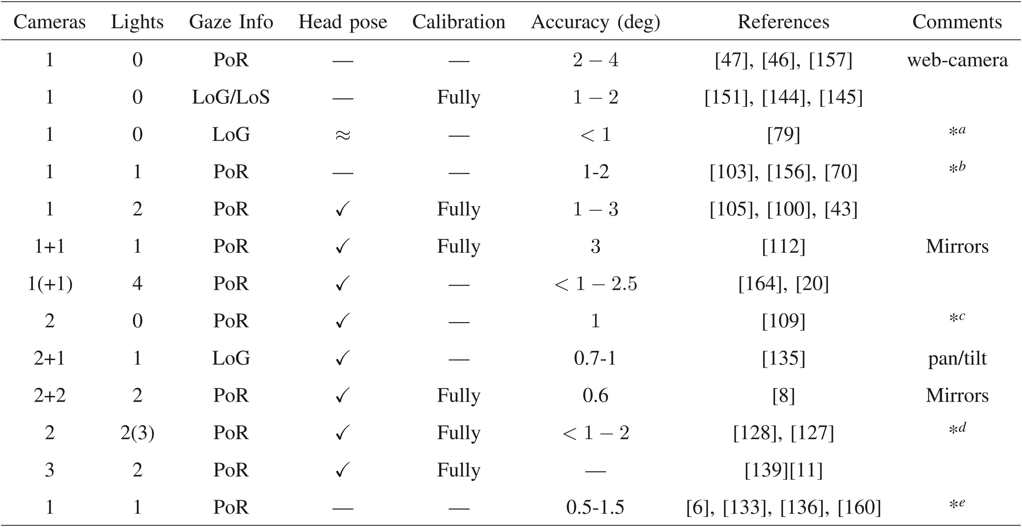

Fig. 9. Comparison of gaze estimation methods with respective prerequisites and reported accuracies (e.g., based on different data and scenarios). The “cameras” column shows the number of cameras necessary for the methods. An additional “+1” means that an extra pan and tilt camera is used. If this is given in parenthesis, the pan and tilt is used in the implementation, but not necessary by the method. The column “Lights” indicates the number of light sources needed and with an additional set of parenthesis to indicate if extra lights have been used in the implementations. “Gaze info” describes the type of gaze information being inferred by the method (PoR), optical (LoG), or visual axes (LoS). When LoG/LoS is used, it is implicitly assumed that an additional 3D scene model is needed to get the point of regard. The column “Head pose” shows if the methods are head pose invariant ( ), if approximate solutions are proposed ( ), or an external head pose unit is needed (—). The “Calibration” column indicates if explicit calibration of scene geometry and cameras are needed prior to use. ªAdditional markers, iris radius, parallel with screen. ^{b}Polynomial approximation. ^{c}3D face model. ^{d}Experiments have been conducted with three glints, but two ought to be sufficient. ^{e}Appearance-based.
p =

the publications and one should be careful when comparing accuracy since these data come from various sources and because gaze estimates might have been temporally regular- ized (i.e., smoothing the output).
Theoretical aspects of feature-based gaze tracking based on point sources in a fully calibrated setup are to a large extent understood [43]. However, the estimated fixation points at the border of the monitor tend to be less accurate than those at the central portion of the monitor. There are several identifiable causes for this inaccuracy.
- The fovea is modeled as a point, but physically, it exists over a small area on the retina.
- The angle between the line of sight and the optical axis may vary from one fixation point to the next, but the angle is usually modeled as a constant.
- A spherical model of the eyeball may be sufficient for the central part of the cornea, but it is not representable enough for its periphery, i.e., tracking accuracy may be degraded if the curvature of the cornea varies greatly between subjects.
- Fixations are used to measure accuracy, but they are, contrary to their name, not stable as the eye jitters due to drift, tremor, and involuntary microsaccades [163].
Refraction and glasses may nonlinearly change the appearance and reflective properties of the eyes as well as the locations of reflections. Refraction causes points pre- sumed to be located on 3D to appear on different lines. The image of the pupil is also altered nonlinearly. Villanueva and Cabeza [146] point out that refraction is an important
parameter when modeling pupil images. The difference in gaze accuracy may differ more than 1 degree depending on whether refraction is accounted for. It would therefore be valuable to compare methods using the iris (which is less influenced by refraction) with similar models for the pupil. The use of glasses may likewise confound the physical assumptions of such models (e.g., reflections come from glasses and not from the cornea). We are not aware of any models that geometrically (explicitly) model glasses. Ap- pearance-based interpolation methods implicitly model these nonlinearities.
Eye tracking hardware can be produced and sold with predefined configurations. In this case, applying models where fixed geometry is assumed may be viable. However, these systems do not allow the tailoring of hardware arrangements to particular needs (e.g., in wheelchairs) and may be costly since 1) time-consuming, precise hardware calibration is needed and 2) rigid, purpose-built frames need to be constructed to keep the hardware fixed. Relaxing the prior assumptions of the systems or using low-grade cameras may decrease gaze accuracy and require more session calibration. Note that even the best methods do not guarantee head pose invariance. However, they may, in practice, produce good results if only under optimal working conditions. Depending on the intended applica- tion, high accuracy may not be needed. For some cases, it may be more important to lower the price by using Web cameras, allowing for easy and flexible hardware config- urations, and avoid IR light and feature detection ( e.g., for outdoor use). For example, high accuracy may be required

when using gaze for analyzing Web pages or in clinical experiments, while a lower accuracy is required in applica- tions such as environmental control or eye typing, where only a few buttons need to be activated. Similarly, it may be that, for some applications, it is acceptable to use multiple session calibration points, while for others, it is necessary to have only a few (e.g., working with children). Uncalibrated or partially calibrated setups allow for more flexibility but lead to a more difficult modeling problem. Future research may reveal the potential of partially calibrated gaze trackers (e.g., unknown position of light sources, but calibrated cameras) or identify other eye features that provide sufficient information to ensure head pose invariance. Several approaches address the uncalibrated scenario by relying on approximations, and the use of multiple glints is an obvious choice for obtaining robust solutions. However, glints may disappear as the eye or head is moving, and thus, using multiple light sources may restrict user move- ments in practice. A combination of geometry-based feature methods and appearance-based methods could potentially benefit from the relative strengths of both types of methods. Both 2D regression-based and appearance-based meth- ods map image data directly to the point of regard. Contrary to the 3D feature-based methods, this method requires multiple in-session calibration points. The gaze estimation problem has an inherent set of parameters associated with it. In fully calibrated settings, the majority of these parameters have been calibrated prior to use, and thus, only a few session calibration points are needed to infer the remaining parameters. Appearance-based models make few assumptions on image features and geometry, and therefore, need to obtain the parameters through session calibration. Comparing methods based on the required number of calibration points should only be done with care. The choice of model depends on multiple factors: required accuracy, hardware cost, image quality/eye region resolution, available information in the image (e.g., glints),
and flexibility of setup.
There are several possible important findings, which could benefit current models. For example, Donder’s and Listing’s laws and recent discoveries about the cognitive or perceptual processes underlying eye movements are rarely used explicitly. Besides this, features such as the iris and pupil contour as well as other facial features provide useful additional information that could be used to reduce the required number of light sources [146].

- EYE DETECTION AND GAZE TRACKING APPLICATIONS
Eye detection and gaze tracking have found numerous applications in multiple fields. Eye detection is often the first and one of the most important steps for many computer vision applications such as facial recognition, facial feature tracking, facial expression analysis, as well as in iris detection and iris recognition. The accuracy of eye detection directly affects the subsequent processing and recognition. In addition, automatic recovery of eye position and eye status (open/close) from image sequences is one of the important topics for model-based coding of videophone sequences and driver fatigue applications.
Gaze tracking offers a powerful empirical tool for the study of real-time cognitive processing and information
transfer. Gaze tracking applications include two main fields of application, namely, diagnostic and interactive [28]. Diagnostic eye trackers provide an objective and quantita- tive method for recording the viewer’s point of regard. This information is useful when examining people watching commercials, using instruments in plane cockpits, and interacting with user interfaces, and in the analysis and understanding of human attention [3], [41], [119], [155].
In contrast, gaze-based interactive user interfaces react to the user’s gaze either as a control input [7], [10], [52], [87],
[154] or as the basis of gaze-contingent change in display. Gaze-contingent means that the system is aware of the user’s gaze and may adapt its behavior based on the visual attention of the user, e.g., for monitoring human vigilance [28], [66], [65], [69], [143]. Thus, the system tends to adapt its behavior according to the gaze input, which, in turn, reflects the person’s desires. This property of eye movements, as well as the fact that eye tracking facilitates hands-free interaction with little muscle strain, makes gaze tracking systems a unique and effective tool for disabled people, where eye movements may be the only available means of communication and interaction with the computer and other people. Specifically, early work on interactive eye tracking applications focused primarily on users with disabilities [62], [88], [137]. Among the first applications were “eye typing” systems, where the user could produce text through gaze inputs (for a review, see [95]). For some applications, eye movements are more natural, fast, and comfortable means of communication, and the tendency now is to develop gaze-based applications for the benefit of all. For example, anyone reading foreign languages could be provided with suggestions for words and sentences based on eye movement patterns as they read [64]. Using eye trackers ubiquitously may require gaze-based application designers to be more conscious of current challenges such as higher noise levels on gaze estimates. A new approach addressing navigation and selections in large information spaces with noisy inputs is suggested by Witzner et al. [51]. Nonintrusive gaze tracking may be used for interaction with computer in a similar way to using the mouse, or in game-like interaction with videos, where the viewer seamlessly interacts and defines the narrative of the video. Eye tracking also seems to be gaining interest in the vehicle industry for driver vigilance and safety. Another important and yet perhaps least investigated application involves using eye movements to gain some insight into the way that people view synthesized images and animations, with the dual purpose of optimizing perceived quality and devel- oping more efficient algorithms.

- SUMMARY AND CONCLUSIONS
We have presented a review categorizing eye tracking systems from numerous angles; from the different methods of detecting and tracking eye images to computational models of eyes for gaze estimation and gaze-based applications. Specifically, for eye detection and tracking, we have discussed various techniques using different properties of the eyes including appearance, shape, motion, or some combination.
While these methods have been successful in improving eye detection and tracking, there remains significant potential for further developments. Reliably detecting and

tracking eyes in conditions of variable face pose and variable ambient lighting remains largely problematic. It appears that an integrated approach exploiting several available attributes is the promising direction for further development. While eyes are nonrigid, their spatial relation to other parts of the face is relatively stable. These relations are of potential interest for eye detection models, for example, through patch-based approaches.
We have reviewed several categories of techniques for gaze estimation. While the regression-based methods using a single glint are simple and fairly accurate, they are only suited to particular applications due to their restrictions with regard to head movements. This restriction can be relaxed by using a wide-angle face camera and a pan-tilt- controlled eye camera. However, this setup increases both the complexity and cost. The 3D model-based eye tracking systems can tolerate natural head movements, but they usually require a one-time system and geometric calibration. In the fully calibrated setup, considering possible light and camera configurations, the one-camera and two-light-source configuration appears to be an interesting choice (especially for commercial systems) since its setup is simple and robust to head pose changes. Adding an additional camera may reduce the number of calibration points since the assump- tion of the known cornea curvature is no longer needed. When only modeling the visual and not the optical axes, the number of calibration points can be reduced from two to one, in addition to the system calibration. A low number of calibration points are preferable, but this requires complete knowledge of the geometric arrangement of system parts and the eye/face. The desire for a simple calibration procedure with few calibration points therefore implies decreased flexibility and increased price. Appearance-based methods, on the other hand, are not based on known parameters of feature extraction, setup, and light conditions, and may therefore be more flexible and simple. Since they must infer more parameters, they require more session calibration and do not ensure head pose invariance.
In summary, future gaze tracking systems should still be
low cost, easy to setup, minimal or no calibration, and good gaze estimation accuracy under varying illumination con- ditions and natural head movements. Some of these requirements are currently conflicting, for example, flex- ibility and a low number of calibration points.
Future directions for the eye and gaze trackers include:
- Limit the use of IR: IR light is useful for eye trackers, mainly because it is not only invisible to the user but also it can be used for controlling light conditions, obtaining higher contrast images, and stabilizing gaze estimation. A practical limitation of systems using IR light is that they are not necessarily reliable when used outdoors. Future eye tracking systems should also be able to function outdoors. Current efforts in this direction employ structure- from-motion methods on facial feature points. These techniques remain in an early stage of development and further research is needed.
- Head mounts: While significant emphasis has been placed on remote gaze tracking, head-mounted gaze trackers could be experiencing a renaissance due to both the challenges facing remote eye trackers, and to the increased interest in mobile eye tracking and
tiny head-mounted displays. In these cases, eye trackers could facilitate hands-free interaction and improve the quality of the displays. Head-mounted eye trackers may also be more accurate since they are less affected by external changes (head pose, lights, etc.) and the simplified geometry may allow for more constraints to be applied. For example, the use of glints may become unnecessary.
- Flexible setup: Many current gaze trackers require calibration of the camera(s) and the geometric arrangement. In some situations, it would be convenient for the light sources, cameras, and monitor to be as needed, but without requiring explicit calibration of geometry and cameras. For example, this would benefit eye trackers intended for mobility and the mass market, as the rigid frames can be avoided, resulting in more compact, light- weight, adaptable, and cheap eye trackers.
- Limit calibration: Current gaze models either use a strong prior model (hardware calibration) with little session calibration or weak prior model, but more calibration points. Another future direction will be to develop methods that do not require any calibration. This does not seem to be possible given the current eye and gaze models. New eye models and theories need to be developed to achieve calibration-free gaze tracking.
- Costs: The costs of current eye tracking systems remain too high for general public use. The main reason for this is the cost of parts, especially high- quality cameras and lenses, the cost of development, and the relatively small market. Alternatively, systems may opt for standard or even off-the-shelf components such as digital video and Web cameras and exploit the fast development in this area [46], [47], [89]. While advances in new camera and sensor technology may add to the continuing progress in the fields, new theoretical developments are needed in order to perform accurate gaze tracking with low- quality images.
- Higher degree of tolerance: Tolerance toward glasses and contact lenses is a practical problem that has been solved only partially. The use of several light sources, synchronized according to the users’ head movement relative to the camera and light source, may remove some of the associated problems. However, more detailed modeling such as modeling glass themselves may be needed if eye trackers are to be used outdoors, where light conditions are less controllable.
The tendency to produce mobile and low-cost
systems may increase the ways in which eye tracking technology can be applied to mainstream applica- tions, but may also lead to less accurate gaze tracking. While high accuracy may not be needed for such applications, mobile systems must be able to cope with higher noise levels than eye trackers indoor use.
- Interpretation of gaze: Besides the technical issues of localizing the eye and determining gaze, the interpretation that the cognitive and affective states underlying gaze behavior is also important. The analysis of eye movement behavior involves

understanding human visual perception and cog- nition, as well as the emotional and cognitive states associated with the task. Development of applications that exploit a combination of gaze with other gestures and known neuropsychological correlates of human eye movements certainly provides sufficient material for long-term research.
While the techniques surveyed in this paper focus on eye detection and gaze tracking, many of the same techniques can be useful for detection and tracking of other objects (e.g., faces). Despite the fact that describing the structure of the eye is relatively simple, the complexities in its appearance make the eye a challenging research topic.
Eye and gaze tracking and their applications involve
unique and clearly defined problems, which have already spawned new models, influencing research beyond eye tracking [157], [166], but eyes could also be seen as a primary case for future models in image analysis, geometry, and machine learning due to the inherent challenging properties of the eye as a trackable subject. For this reason, research in the area of eye tracker development is of increasing interest to a wide variety of research fields.

ACKNOWLEDGMENTS
This paper is partially funded by the European network of Excellence, COGAIN, supported by the European Commis- sion’s IST 6th Framework Program. Qiang Ji is partially funded by the US Air Force Office of Sceintific Research (F49620-03-1-0160) and the US Defense Advanced Research Projects Agency (DARPA) (N00014-03-01-1003). The authors would like to thank Arantxa Villanueva, Fiona Mulvey, Martin Bo¨ hme, and Javier San Agustin for fruitful comments and discussions.

