Conference Management System (CMS)

**Students Conference**

Many colleges and universities realize the benefit of hosting students’ research conference. Students present their research as if in a regular academic conference. Students’ conference offers an opportunity to showcase students performing outstanding research, as well as an opportunity for all students to learn about the research process, including presenting their results with posters or in person.

Because of the substantial amount of logistic details and requirements involved in such a conference, it’s best to use computer software to run the conference. Furthermore during the covid19 pandemic when in-person meetings are not practical or possible, using a conference management software is a must in order to hold an online conference. Conference management software complements other computer tools for holding meetings, such as Zoom, Tencents Meeting, Gather, Ding Talk, etc.

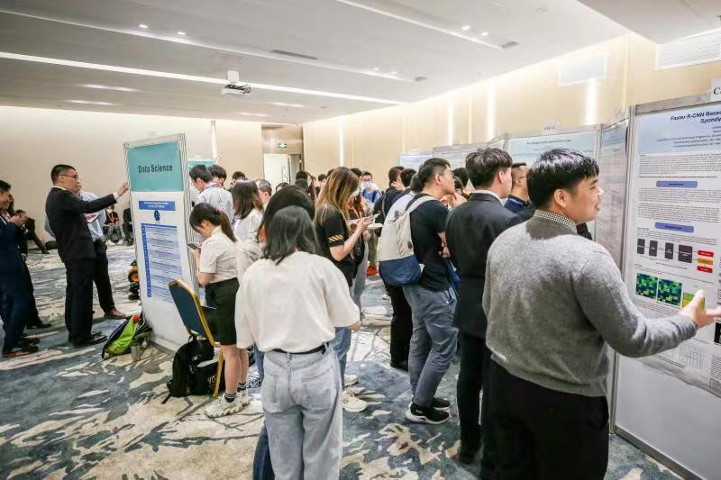

Figure 1 UIC Posters Conference April 2021

**The Need for Special Software in UIC’s Posters’ Conference**

Commercial software are not adequate for hosting a students’ conference in a college such as United International College (UIC). First of all, the college is responsible for any material posted in the UIC website viewable by the public. Contents in the college’s website must undergo a review process before they are posted for outside viewing. Reviewing all the students’ posters is not practical due to the lack of time and domain knowledge of the reviewers. So the posters information must be placed in the college’s intranet.

Using commercial conference management software inside the intranet poses a problem because these software are black boxes. Certifying these software to be free of any malware is difficult if not impossible. Using open source software is theoretically possible, but few commercial software are open source.

Furthermore UIC’s posters conference require many features that are not available in commercial conference management software. For example judges’ online score, voting by attendees and lucky draw tools are generally not available in commercial software, at least not in the way we use them in UIC. In regular academic conference registration, an attendee enters the name and organization and pay the registration fee. That person is then given a badge which uniquely identify that person in the conference. In UIC’s students’ conference, an attendee can be anyone in the college. He or she can walk in and out of the venue during the conference, without making any payment. There needs to be a mechanism to register the attendees and make sure each attendee does not register more than once.

So with all these problems in using commercial software, we decided to create our own software for our students’ posters conference.

**Procedure of UIC’s Posters Conference**

The procedure for UIC posters conference is as follows. On the day of the conference, judging starts at 1:30 pm, and the winners are declared at around 4:30 pm. We hold concurrent sessions for each of our 7 programmes in DST, with a separate session for each programme. Each programme has a winning poster, as determined by the judges. From these winners, the best overall DST poster is chosen. Figure 2 shows the number of posters in each programme over the past 3 years.

|  |  |  |  |
| --- | --- | --- | --- |
| **Programme** | **2019** | **2020** | **2021** |
| APSY | 12 | 12 | 11 |
| CST | 8 | 10 | 16 |
| DS | 2 | 2 | 12 |
| ENVS | 12 | 14 | 15 |
| FM | 10 | 10 | 12 |
| FST | 15 | 14 | 13 |
| STAT | 12 | 12 | 17 |

Figure 2 Number of posters in each programme

**Judging in each programme**

(Regular) judges choose the best of programme posters.

Each session has two judges to evaluate the posters for that programme and select the best poster for that programme. The judges are chosen by the programme director for that programme. Before the event, different account names and passwords are created and sent to the judges. During the conference, the judges can login to their account.

It’s worth noting that the role of the judges is not only to pick the winners, but also to give feedback to all posters. The posters conference is not only a competition, but the conference also serves as a valuable learning experience for all participating students. A great majority of the presentations are made by undergraduates, so performing research and presenting it in a conference is a brand new experience for most students.

**Head judges**

From among the best of programme posters chosen by the regular judges, the head judges choose the best of division (i.e. best of the best) poster. The dean chooses the two head judges, different from the regular judges. The head judges follow the same criteria to evaluate the posters as the regular judges, but head judges only see the winning posters from each programme in their scoring list. Head judges are given accounts and passwords as head judges in CMS.

So CMS requires a tool for the regular judges to record the scores online, viewable to the head judges when a winner is declared for that programme. The head judges can then evaluate the winning poster for that programme. Figure 3 shows an example of the judges’ tool to record the scores, along with the criteria for judging. ASP1 is the code for that particular poster listed.

[Note – your user interface should look better than this. For one thing, the font size is too small.]

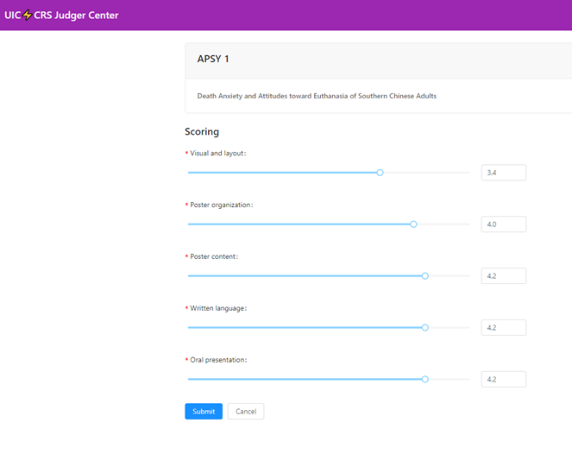

Title of poster

ASP programme, poster 1

Figure 3 Judges tool to record score

**Attendee’s registration, voting for most popular poster and lucky draw**

Attendees vote for the most popular poster.

All registered attendees can vote for their favorite poster during the conference. To encourage good attendance, everyone who voted is eligible for lucky draw prizes.

In order to maintain fairness in voting and lucky draw, we need a mechanism to ensure each attendee can register and vote only once. After an attendee scans the conference QR code posted in the conference venue, a webpage opens in which the attendee can enter his or her UIC email address. Only UIC email addresses are accepted. We assume each attendee has only one UIC email address.

CMS maintains a database of the UIC email addresses registered for the conference. This ensures each college email address can only be used once. If the email address is registered properly, a link is sent to the attendee’s UIC email. The attendee can click on that link to vote and to view information related to the conference. This way, CMS ensures each attendee can register and vote only once. For the lucky draw, CMS randomly choose winners from the database of people who have voted. This ensures everyone has an equal chance of winning at the lucky draw.

CMS also stores the relevant information for the posters conference, such as posters’ titles, authors and abstracts, event schedule, announcements, etc. Then this information are readily available to the judges, participants and attendees.

A few years ago before CMS was used, judging, registration and voting were done manually. There were not enough time for the head judges to perform a second round of judging to choose the overall winner. Students could leave the venue, came back and register again. This allowed them to vote multiple times and unfairly increase their chances to win at the lucky draw. Using CMS eliminates these drawback, allowing a fairer and more efficient conference.

**Technology and Tools Used in CMS**

These are some possible frameworks to use in CMS. There are other possible frameworks.

* Django – an open source web application framework written in Python. It adapts the Model-Template-View (MVT) framework pattern. The advantage of using Django is that programmers can quickly create high quality, easy to maintain, database driven applications.
* An alternative to Django is Flask, which is a lightweight customizable framework. Flask is easier to learn and use, but does not have as many plug-ins as Django. Django has been around longer than Flask, so Django has a more active community from where a programmer can find solutions to implementing functions.
* Bootstrap – a front end framework for rapid development of web applications and websites, based on HTML, CSS and JavaScript.
* jQuerry – a lightweight extension to JavaScript, providing an abstract layer for web programming, making it compatible with any browser.
* React – a JavaScript library for building user interfaces, useful for building large applications with data that change with time.

You may also consider using:

* Websocket – keep long connection between client and server, provide a seamless experience for users.
* CKEditor – enable rich-text content displaying and editing.
* MySQL – database management. More widely used than alternatives such as SQLite and Django’s ORM.

**Features of CMS**

* During the conference, CMS is stored in a UIC server accessible inside UIC’s intranet. A user can access CMS in UIC’s WiFi by entering the given IP address with a web browser. (You can use a placeholder CMS IP address in the class project.)
* A real time tool for judges to record scores online. When a winner is declared in a programme, head judges in the next round of judging are notified immediately so they can commence their work. Currently judges are given tablets to access the judging tool in CMS. They can type in the CMS IP address in a browser. Before the conference, account names and passwords are created for the judges.
* A secure way to register attendees. When an attendee scan the QR code posted in the venue site, a webpages opens. The attendee can enter his or her UIC email address. Only UIC email addresses are accepted. If the address is valid and had not been registered already, CMS sends a password-less link to that email address. Only that person should be able to access the password-less link. Each attendee can register only once, assuming each attendee has only one UIC email address.
* Using the password-less link, a register attendee can vote for the most popular poster, one vote per person.
* The CMS homepage displays the current scoreboard of the voting during the conference.
* Everyone who voted is eligible for lucky draw. During the lucky draw, the dean or the chairman of the posters conference can use CMS to randomly select winners from people who voted. Everyone voted has an equal chance of winning.
* Abstracts, including authors and titles, are stored in CMS so judges and attendees can search for individual posters.
* Conference information, such as conference schedule, venue, announcements, winners, etc. are stored in CMS, viewable by judges and attendees.
* CMS should be scalable. The number of posters and attendees in posters conference has been increasing in the past few years. More programmes in DST will be included in the future.
* CMS should be adaptable to changes as demanded by unforeseen situations. For example in the beginning of the 2020 Spring Semester, covid19 forced the posters conference to be held online. That version of CMS was adapted to handle an online conference in a just few weeks. A well written CMS code should be able to handle requirement changes better than a poorly written code.

Note: The version of CMS used in the previous posters conference has some drawbacks. I expect you to write a better version using all the tools and techniques you've learned in the Software Engineering class.