TeamJuan
Members: Trajuan Smith
Driver: Trajuan Smith
Navigator: Trajuan Smith
Live URL: https://codd.cs.gsu.edu/~tsmith413/WebDev/inClass/act5/css-arcade-teamjuan/index.html
GitHub: https://github.com/Myriad21/Activity05-TeamJuan

LAYOUT PREDICTION BLITZ — TEAM FINDINGS REPORT
Team Name: TeamJuan

SCENARIO 1 / 6 — Cookie Menu Row: We predicted "NO RESPONSE (time expired)" — INCORRECT (actual: 🅱 One row; outer cards touch the edges, equal space between)
SCENARIO 2 / 6 — Tic-Tac-Toe Board: We predicted "🅰 A 3 × 3 board" — CORRECT (actual: 🅰 A 3 × 3 board)
SCENARIO 3 / 6 — Axis Flip: We predicted "🅰 Vertically (top-to-bottom)" — INCORRECT (actual: 🅲 Horizontally (left-to-right))
SCENARIO 4 / 6 — Fraction Launch: We predicted "🅲 Time between repeats" — INCORRECT (actual: 🅰 Delay before the animation starts)
SCENARIO 5 / 6 — The Snap-Back: We predicted "🅱 It snaps back to its starting position" — CORRECT (actual: 🅱 It snaps back to its starting position)
SCENARIO 6 / 6 — The Missing Heart: We predicted "🅰 On top of the shirt at 140px / 110px" — INCORRECT (actual: 🅲 In normal flow, with top/left/z-index ignored)

Final Score: 2 / 6

Bug 1
The flex-direction property sets the direction of the main axis. Since it is set to column, the main axis runs vertically, causing the three recipe cards to stack on top of each other instead of appearing in a horizontal row.
Bug 2
There are only two column tracks defined, so the browser places two cells in each row. The remaining cells automatically flow into new rows, creating five rows with the ninth cell alone in the last row.
Bug 3
The answer should use the first keyframe styles during the delay, then keep the final keyframe styles after the animation ends. The animation-fill-mode property controls this, and both applies the keyframe styles both before and after the animation.
Bug 4
The heart is using position: static, so top and left do not position it, and z-index does not affect its stacking as intended. Changing the heart to position: absolute allows those properties to work and positions it relative to its positioned parent.

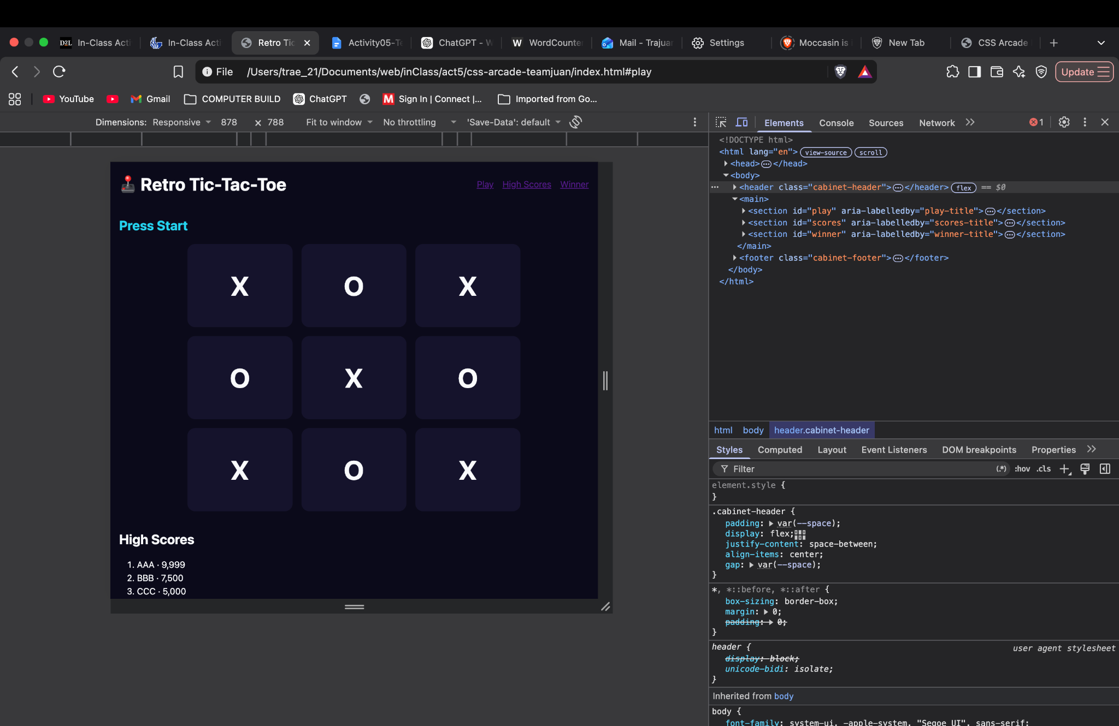
Checkpoint 1 — Flexbox Layout
Selector: .cabinet-header
The header uses display: flex with justify-content: space-between, align-items: center, and gap to position the title and navigation.

Checkpoint 2 — CSS Grid Board
Selector: .game-grid
The game board uses display: grid with grid-template-columns: repeat(3, 1fr) to create three equal-width columns for the 3×3 Tic-Tac-Toe board.
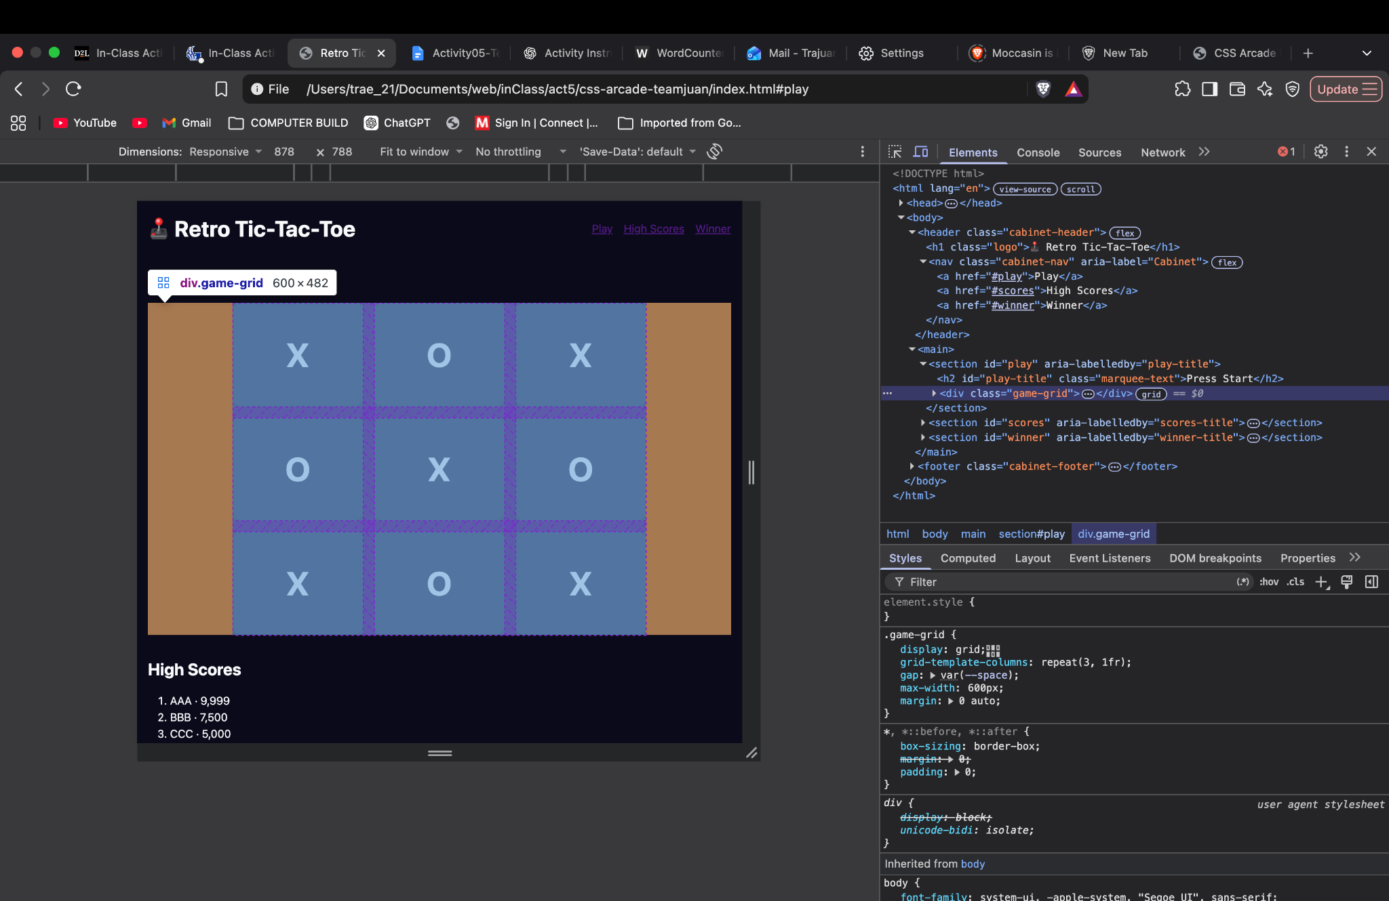

Checkpoint 3 — Keyframe Animation
Selector: .marquee-text / @keyframes press-start
The Press Start text uses an animation with 0%, 50%, and 100% keyframes that changes its position with transform and changes its color. The animation also uses a delay and the both fill mode.

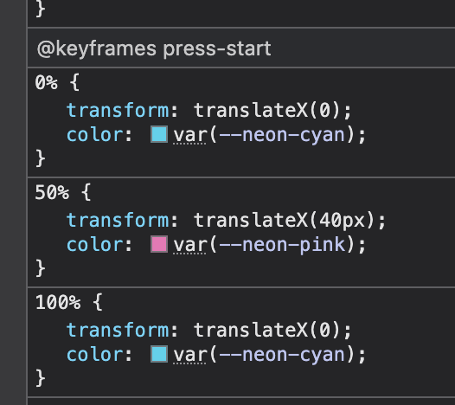
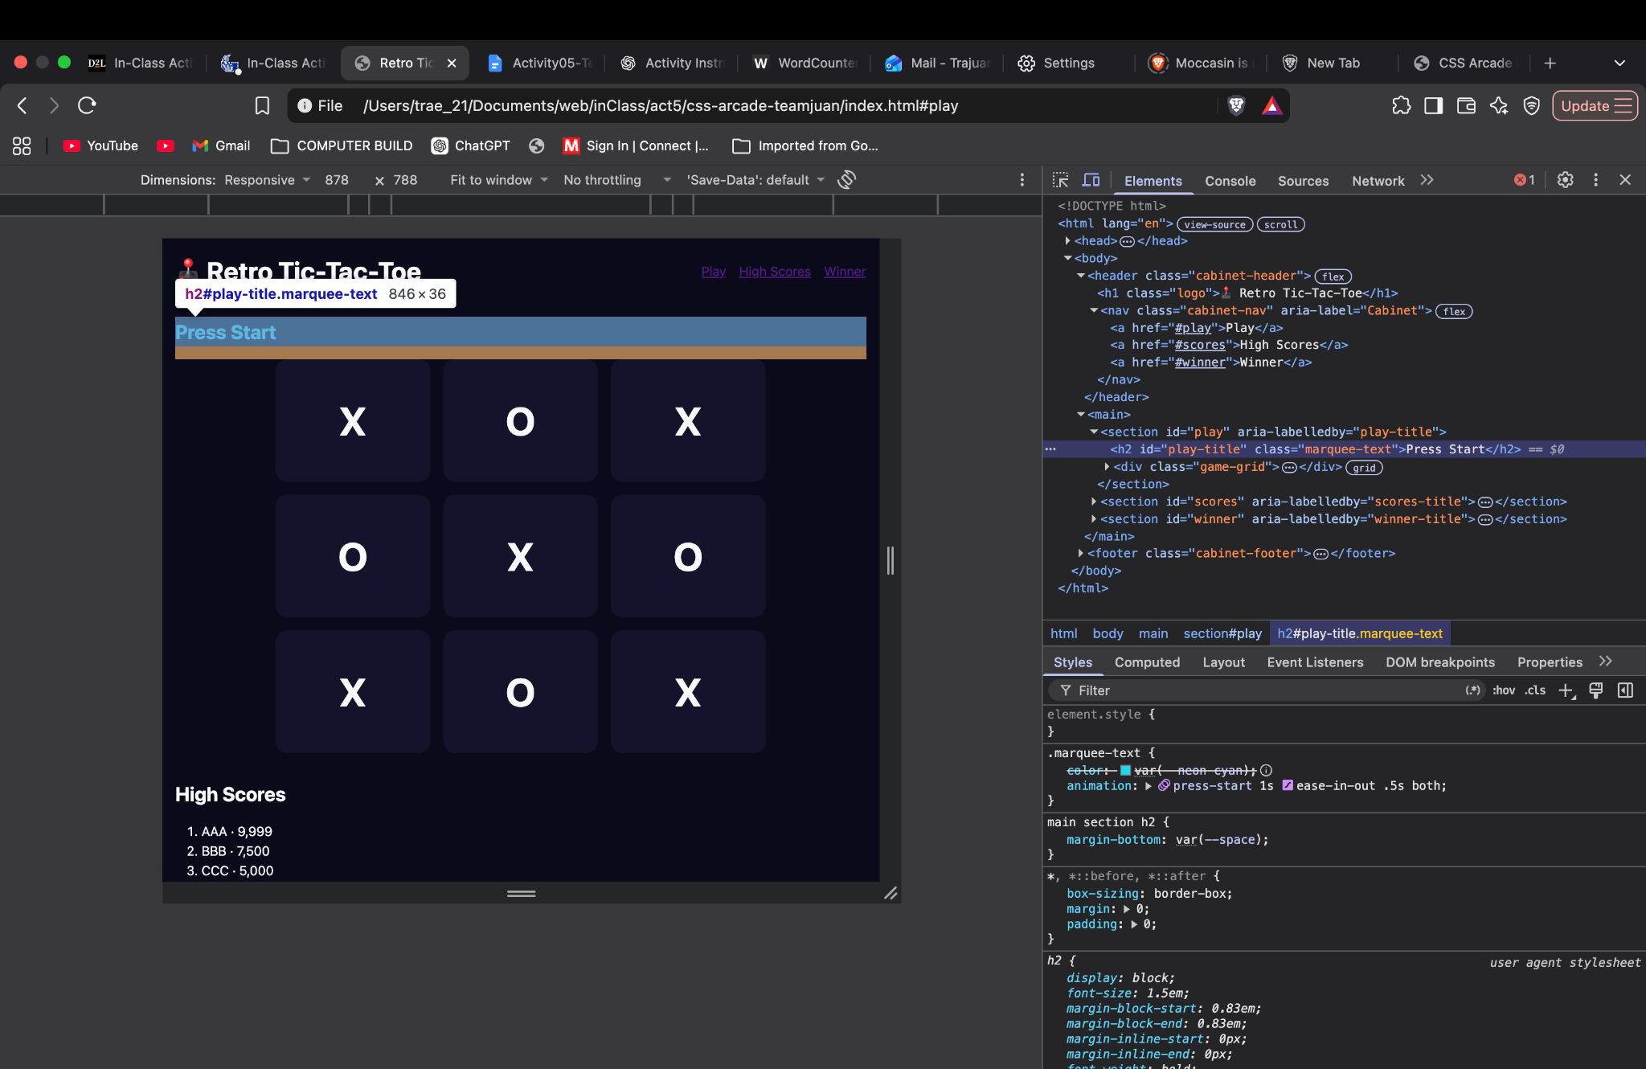

Checkpoint 4 — Layered Composition
Selectors: .layer-stack and .layer
.layer-stack uses position: relative as the positioning parent. The child layers use position: absolute with different z-index values to stack the background X, PLAYER 1 text, and WINS! text.
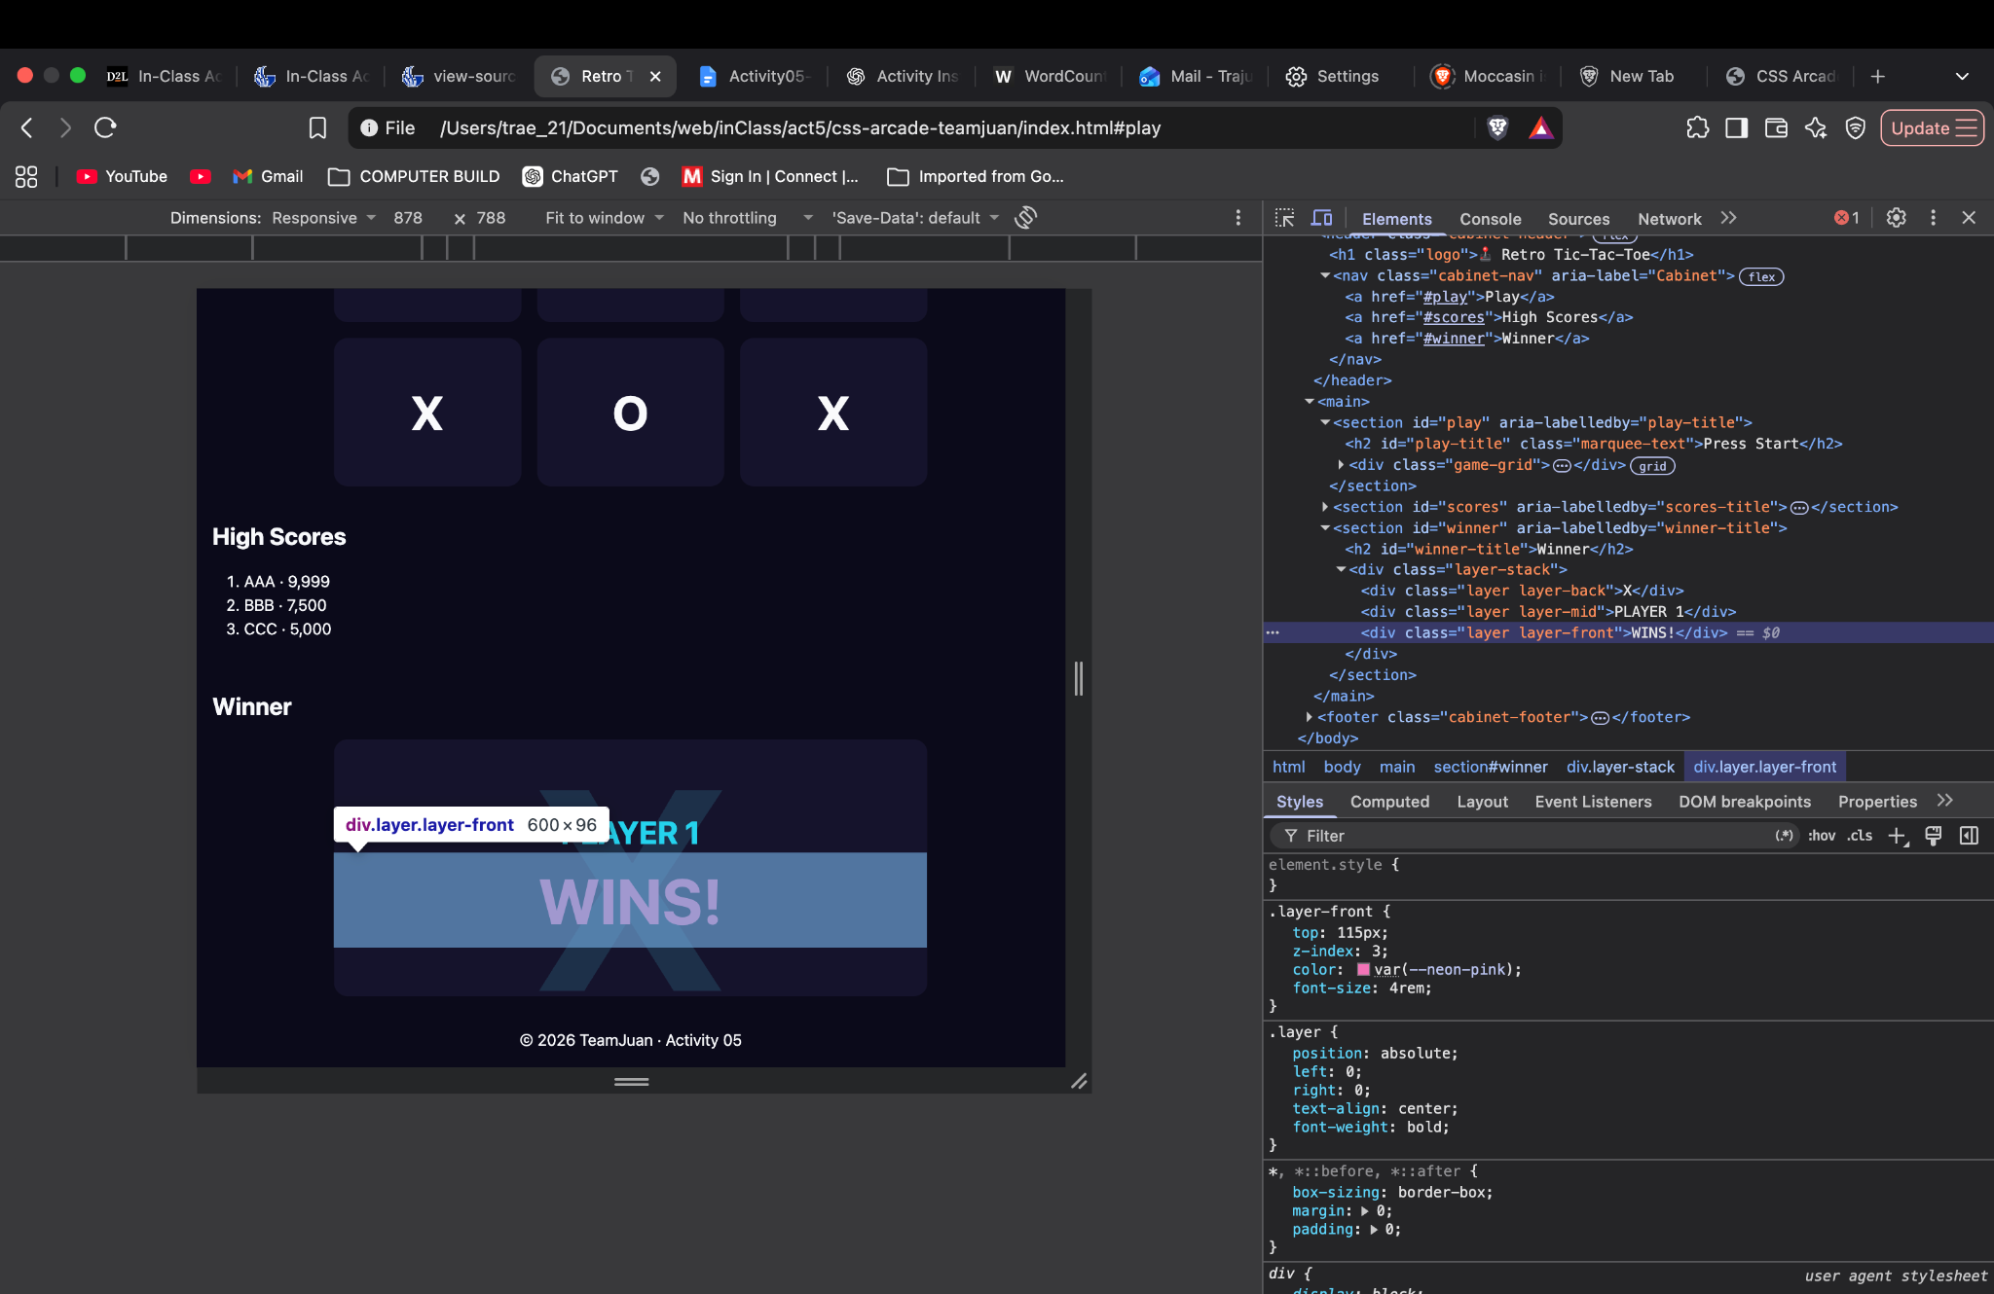

Checkpoint 5 — Micro-Interaction
Selectors: .tile:hover and .tile:focus-visible
The Tic-Tac-Toe tiles use transitions on transform and box-shadow. Hovering or keyboard-focusing a tile enlarges it and adds a neon glow.

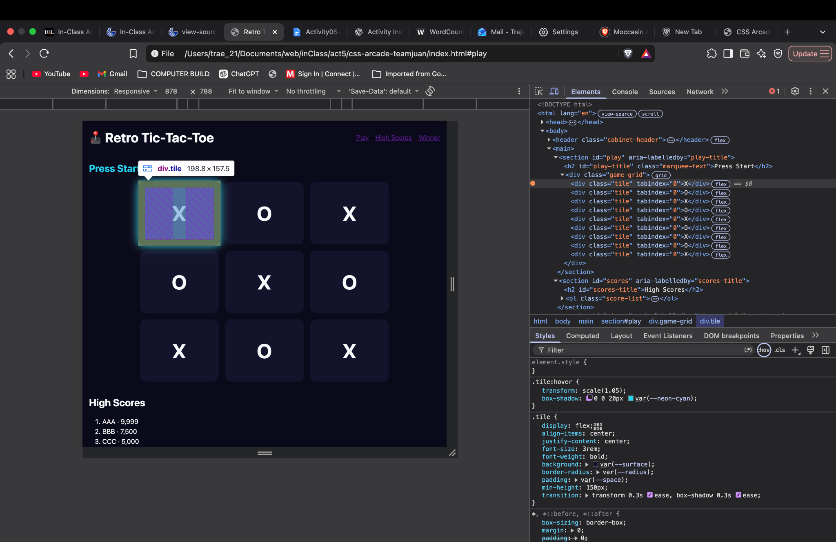

Checkpoint 6 — Professional & Responsive
Selector: @media (max-width: 768px)
At screen widths of 768px or less, .cabinet-header changes to flex-direction: column, stacking the title and navigation for smaller screens. The Tic-Tac-Toe tiles also become smaller to better fit the viewport.
