**Museum**

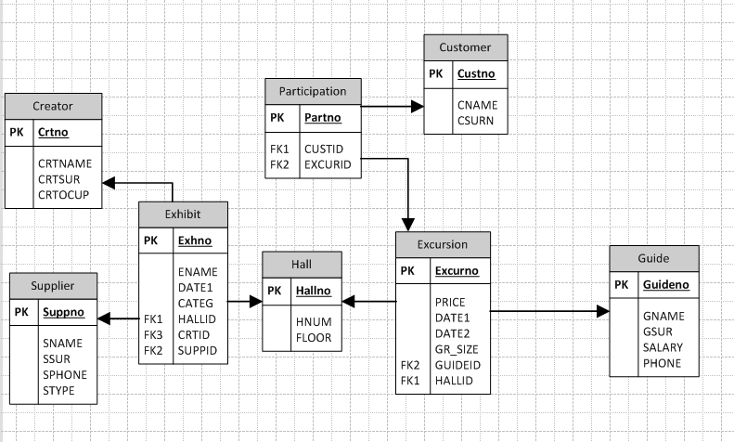

Functions:

1. Generates id for each new customer(trigger NEW_CUST_ID) ;
2. Generates id for each new guide(trigger NEW_GUIDE_ID);
3. Generates id for each new supplier(trigger NEW_SUPP_ID);
4. Generates id for each new creator(trigger NEW_CRT_ID);
5. Generates id for each new hall(trigger NEW_HALL_ID);
6. Generates id for each new exhibit(trigger NEW_EXH_ID);
7. Generates id for each new excursion(trigger NEW_EXCUR_ID);
8. Generates date1 for each new excursion(trigger NEW_EXCUR_DATE1);
9. Generates date2 for each new excursion(trigger NEW EXCUR_DATE2);
10. Generates id for each new participation record(trigger NEW_PART_ID);
11. Informs about deletion of customer record(trigger DEL_INFO);
12. Informs about update of customer record(trigger UPDATE_INFO);
13. Limits halls to have only 3 floors available(trigger LIM_FLOOR);
14. Searches and shows customers by their id;
15. Shows number of customers in the database;
16. Shows all guides that has higher salary than 2200;
17. Shows highest salary earned by guides;
18. Shows annual salary;
19. Shows all suppliers that donated;
20. Shows everyone registered in database;
21. Shows all customers who are signed up for excursion;
22. Shows oldest exhibit.