**CHAPTER 1**

**ABSTRACT**

Fake Currency has always been an issue which has created a lot of problems in the market. The increasing technological advancements have made the possibility for creating more counterfeit currency which are circulated in the market which reduces the overall economy of the country. There are machines present at banks and other commercial areas to check the authenticity of the currencies. But a common man does not have access to such systems and hence a need for a software to detect fake currency arises, which can be used by common people. This proposed system uses Image Processing to detect whether the currency is genuine or counterfeit. The system is designed completely using MATLAB programming language. It consists of the steps such as grayscale conversion, edge detection, segmentation, etc. which are performed using suitable methods. The first order and second order statistical features are extracted initially from the input. The effective feature vectors are given to the SVM classifier unit for classification. The proposed method produced classification accuracy of 95.8%. The experimental results are compared with state of-the methods and produced reliable results.

.

**CHAPTER 2**

**INTRODUCTION**

**2.1 Introduction**

Today, the technology is very fast growing in the word. This increasing of technology the every year government or bank sector faces the problem of fake currency. This problem is very serious issue in India now a day. Similarly the government is also improving day to day but using high printing technology counterfeit circulates the fake banknote in the Indian market. The Reserve Bank of India (RBI) in its latest annual report said that the during 2017-2018, 17,929 pieces of Rs 2,000 notes were detected in 2017-2018 while only 638 counterfeit notes of the same denomination had been detected the year before. In the past, people detecting of counterfeit banknote only manual or a hardware machine which is not easy available in market. The technology of currency detection system basically used for identification and extraction the features of bank note. The main objective of this paper is to get familiar with the new security feature which is provided by the government of India so that they can differentiate between the fake and real note. Detecting of fake note some module including image acquisition, Image per-processing, Image adjusting, Grayscale conversion, Edge detection, Segmentation, Feature extraction classification every step required algorithm for which using OpenCV library ( open source computer vision library). Acquisition of image is process of capture a digital image from camera such that all features are highlighted. In the project we proposed a novel approach for the detection and classification of duplication in currency note using ORB (Oriented FAST and Rotated BRIEF) and Brute-Force matcher in OpenCV.

Different countries around the world use different types of currencies for the monetary exchange of some kinds of goods. One common problem faced by many countries related to currency, is the inclusion of fake currency in the system. India is one of the countries that face a lot of problems and huge losses due to the fake currencies. Due to this there are losses in the overall economy of the country‘s currency value. The technological advancements have made a pathway for currencies to be duplicated such that it cannot be normally recognized. Advanced printers and new editing computer software’s are used to create counterfeit currencies. Fake currencies can just be slipped into bundles of genuine currency which is how they are usually circulated in the market. Commercial areas like the banks, malls, jewelry stores, etc have huge amount of transactions on a daily basis. Such places may be able to afford and find it feasible to buy machines that use UV light and other techniques to detect the authenticity of the currency. But for common people it is very difficult to just detect whether the currency is fake or genuine and they may face losses especially during bank deposits or transactions. This system is designed such that any person can use it easily and detect the authenticity of the currency he has by using the visual features of the currency. This system can further be converted into an app so that it is accessible to all the people. Furthermore, this system can be designed to detect currencies of other countries as well.

Digital image processing is the use of computer algorithms to perform image processing on digital images. As a subcategory or field of digital signal processing, digital image processing has many advantages over analog image processing. It allows a much wider range of algorithms to be applied to the input data and can avoid problems such as the build-up of noise and signal distortion during processing. Since images are defined over two dimensions (perhaps more) digital image processing may be modeled in the form of multidimensional systems. Digital image processing allows the use of much more complex algorithms, and hence, can offer both more sophisticated performance at simple tasks, and the implementation of methods which would be impossible by analog means.

Image segmentation is the process of partitioning a digital image into multiple segments (sets of pixels, also known as super pixels). The goal of segmentation is to simplify and/or change the representation of an image into something that is more meaningful and easier to analyze. Image segmentation is typically used to locate objects and boundaries (lines, curves, etc.) in images. More precisely, image segmentation is the process of assigning a label to every pixel in an image such that pixels with the same label share certain characteristics. Image restoration is different from image enhancement in that the latter is designed to emphasize features of the image that make the image more pleasing to the observer, but not necessarily to produce realistic data from a scientific point of view. Image enhancement techniques (like contrast stretching or de-blurring by a nearest neighbor procedure) provided by "Imaging packages" use no a priori model of the process that created the image. With image enhancement noise can effectively be removed by sacrificing some resolution, but this is not acceptable in many applications. In a Fluorescence Microscope resolution in the z-direction is bad as it is. More advanced image processing techniques must be applied to recover the object.

**Indian Currency**

Money is any object or record that is typically time-honored for the payment of items and services and the repayment of money owed in a particular socio-economic context or country. The currency of India is the Indian Rupee (INR). The word “rupee” originates from the Sanskrit word rup or rupa meaning silver. Sher Shah Suri (1486-1545) introduced the very first rupee, which has a ratio of 40 copper pieces (Paisa) per rupee. The name derived from Sanskrit word raupyakam, which means silver. In the 18th century private banks such as the Bank of Bengal, the Bank of Bombay and the Bank of Madras began the process of issuing paper currency. The Indian government was provided the monopoly on printing currency after the paper currency act of 1861. India's government (GOI) printed currency until RBI was established in 1935, assuming that accountability. In 1938 only Rs 10, Rs 100, Rs 1000 and Rs 10000 were issued. RBI currently issued notes Rs 5, Rs 10, Rs 20, Rs 50, Rs 100, Rs 500 and Rs 2000, also known as banknotes. The printing of notes in Rs 5 demonetization was also stopped.

**Legal Provisions against Counterfeiting**

Printing and circulation of forged notes are offences under section 489A to 489 E of Indian Penal Code (IPC) and are punishable by fine or imprisonment or both in the courts of law. The currency has great significance in everyday life. Therefore, many researchers have become interested in the recognition of currencies and have proposed various approaches. According to literature, image processing is the most efficient method in currency recognition area. A banknote has safety features mainly in the design and printing of paper. The physical dimension of the note depends on its cutting size, length, width, thickness and grammage. The paper on which currency note is printed has a high level of security. Watermark and Security thread are the most important components of currency note paper security.

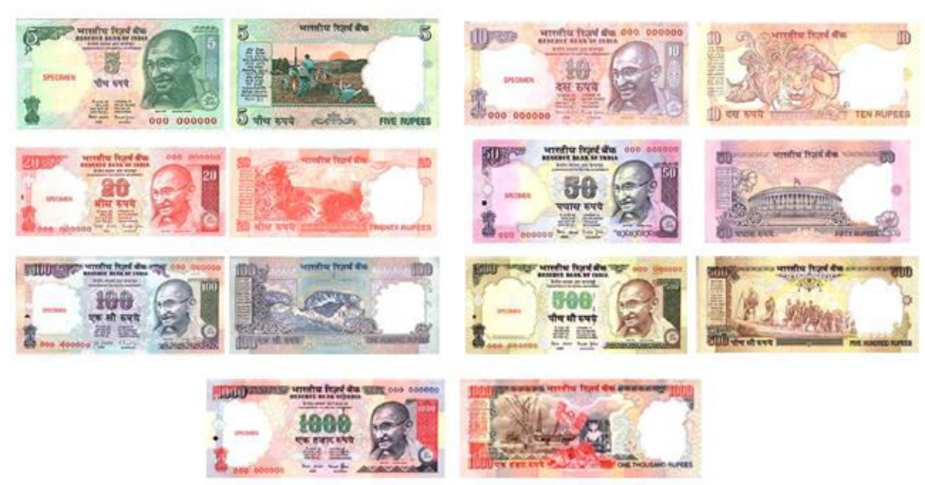

Fig. 1. Indian Rupees

**Storage of image of currency**

A rupee 2000 real note first scanned by scanner and outlook of notes are represented in the figures 2 and 3, thereafter, the scanned image is the input in MATLAB.

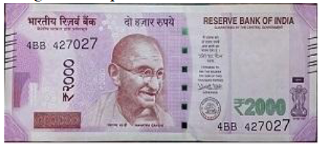

Fig.2. Image of Real Currency

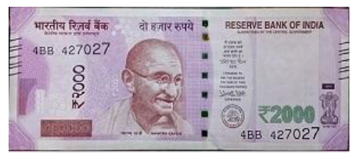

Fig.3. Image of Fake Currency

**The reasons for selecting the feature**

Micro-printing is widely used for a robust feature of Indian banknotes. The advantage of micro-printing is that they cannot be visible without a magnifying glass or appropriate focus of the camera, this feature is very tough to replicate in fake notes by the normal printing process and actually require a very high cost and the other reason is Optically Variable Ink (OVI), which is very costlier ink and is impossible to forge through printer or ordinary printing machines. In real notes, the printing quality of watermark is very good, perfect and unmutilated. That is the reason why it is very hard to knock off for the counterfeits. The stitching technique of the security threads and the pattern around the security thread are clearly identifiable. A new dimension in stopping counterfeit notes is created by the presence of ultraviolet lines in the banknotes. Therefore, these features are used to perform forgery detection.

**Security feature of Indian currency**

The Fake currency detection system varies depending on specific features of banknotes of country. For Indian Banknotes, features are considered. For testing purpose Rs 2000 note. There are some important security features of Indian currency: -

* See through Register
* Bleed Line
* Watermark
* Optically Variable Ink
* Florescence
* Security thread
* Latent Image
* Micro lettering,
* Identification Mark

**SEE THROUGH REGISTER**

The small floral design printed both on the observer side (hollow) and reverser side (filled up) with note color. The denomination numeral of note is written horizontally along bottom the motif on the right side (reverse side) and above the latent image on the lift side (observer side). The design looks like a single floral design when seen against the light.

**BLEED LINE:**

The bleed line printed on the obverse in both, the upper left and the right hand edge of the notes to aid the visually impaired. The bleed line is printed only 2000,500,200,100 notes.

**WATER MARKING**

The mahatma Gandhi watermark is present on the bank notes. The mahatma Gandhi watermark is with a shade effect and multidirectional lines in watermark.

**OPTICALLY VARIABLE INK**

Optically variable ink is used for security feature; this type of feature is in the Rs.1000 and Rs.500 bank note. Optically variable ink as security feature for bank note is introduced in Nov.2000. The denomination value is printed with the help of optical variable ink. The colour of numerical 1000 or 500 appear green, when note is flat but change the colour to blue when is held in an angle.

**FLUORESCENCE**

Fluorescent ink is used to print number panels of the notes. The note also contains optical fiber. The number panel in fluorescent ink and optical fiber can be seen when exposed to UV light.

**SECURITY THREAD**

The security thread is in 1000 and 500 note, which appears on the left of the Mahatma Gandhi’s portrait. In security thread the visible feature of “RBI” and “BHARAT”. When note is held against the light, the security thread can be seen as one continuous line.

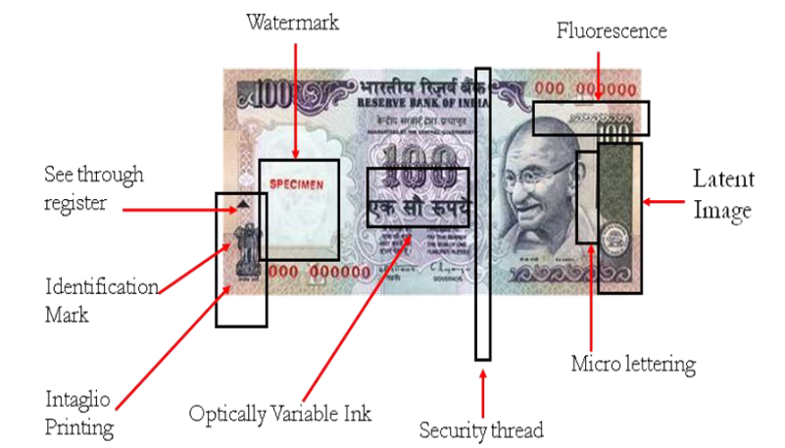

Fig. 4 Security features of Indian Currency notes

**LATENT IMAGE**

The latent image shows the respective denomination value in numerical. On the observe side of notes, the latent image is present on the right side of Mahatma Gandhi portrait on vertical band. When the note is held horizontally at eye level then the latent image is visible.

**MICRO LETTERING**

The micro letter’s appears in between the portrait of Mahatma Gandhi and vertical band. Micro letter’s contains the denomination value of bank note in micro letters. The denomination value can be seen well under magnifying glass.

**IDENTIFICATION MARK**

Each note has its special identification mark. There are different shapes of identification mark for different denomination (Rs.100-Triangle, Rs.500-circle and Rs.1000-Diamond). The identification mark is present on the left of water mark

**2.2 Objectives of the project**

The main objective of the project is to identify the fake Indian currency notes automatically using machine learning. Although there were many methods in existence, this method was designed to overcome the drawbacks of the previous methods. This method gives a faster and more accurate output when compared to the other techniques.

**CHAPTER 3**

**EXISTING SYSTEM**

**3.1 LITERATURE SURVEY**

**A) Automatic Cash Deposite Machine With Currency Detection Using Fluorescent And UV Light**

Author: Dhiraj Vasant Kapare

**Year of publishing:** 2015

**Description**

Cash Deposit Machines (CDM) has altered the relationship between banks and their depositors, as well as the competitive relationships among banks. In this paper, I survey the literature to describe the ways have influenced these aspects of banking markets. The project is designed to provide fully automatic cash deposit machine. It is combination of Embedded, DIP & Automation. In Mat lab every data image of note is compared with ideal stored image of every appropriate type of note. Every note is passed through UV light to detect the originality of note which consequently results in acceptance and rejection of faulty notes. Automated cash deposit machines can offer significant benefits to both banks and their depositors. The machines can enable depositors to deposit cash at more convenient times and places than during banking hours at branches. At the same time, by automating services that were previously completed manually, CDMs can reduce the costs of servicing some depositor demands. These potential benefits are multiplied when banks share their CDMs, allowing depositors of other banks to access their accounts through a bank’s CDM.

# Disadvantages of existing system

* Less accuracy to recognize the fake note
* Ineffective feature extraction technique
* Complex and Low performance speed

**CHAPTER 4**

**SYSTEM CONFIGURATION**

**4.1 System Requirement**

**4.1.1 Hardware Requirements**

Processor : Intel Pentium D

Mother Board : Intel 945G Express Chipset

Bus Speed : 2.80 GHZ

RAM : 2 GB

Hard disk : 20 GB or more

Monitor : 17 “inch CRT (IBM)

Keyboard : 104 Keys

Mouse : Lenovo PS/2 3 buttons

CD-ROM : LITE-ON CD-ROM

**4.1.2 Software Requirements**

Operating System : Windows 7

Tool Used : MATLABR2013A

**Language Description**

**MATLAB**

The environment in which we build our simulation model was MATLAB. The name MATLAB stands for matrix laboratory. MATLAB, developed by MathWorks Inc., is a software package for high performance numerical computation and visualization. The combination of analysis capabilities, flexibility, reliability, and powerful graphics makes MATLAB the premier software package for scientific researchers. MATLAB provides an interactive environment with hundreds of reliable and accurate built-in mathematical functions. These functions provide solutions to a broad range of mathematical problems including matrix algebra, complex arithmetic, linear systems, differential equations, signal processing, optimization, nonlinear systems, and many other types of scientific computations. The most important feature of MATLAB is its programming capability, which is very easy to learn and to use, and which allows user-developed functions. It also allows access to Fortran algorithms and C codes by means of external interfaces. There are several optional toolboxes written for special applications such as signal processing, control systems design, system identification, statistics, neural networks, fuzzy logic, symbolic computations, and others. MATLAB has been enhanced by the very powerful Simulink program.

Simulink is a software package for modeling, simulating, and analyzing dynamical systems. It supports linear and nonlinear systems, modeled in continuous time, sampled time, or a hybrid of the two. Systems can also be multi-rate, i.e., have different parts that are sampled or updated at different rates. For modeling, Simulink provides a graphical user interface (GUI) for building models as block diagrams, using click-and-drag mouse operations. With this interface, you can draw the models just as you would with pencil and work (or as most textbooks depict them). Simulink includes a comprehensive block library of sinks, sources, linear and nonlinear components, and connectors. You can also customize and create your own blocks Models are hierarchical. This approach provides insight into how a model is organized and how its parts interact. After you define a model, you can simulate it, using a choice of integration methods, either from the Simulink menus or by entering commands in MATLAB's command window. The menus are particularly convenient for interactive work, while the command-line approach is very useful for running a batch of simulations (for example, if you are doing Monte Carlo simulations or want to sweep a parameter across a range of values). Using scopes and other display blocks, you can see the simulation results while the simulation is running. In addition, you can change parameters and immediately see what happens, for "what if" exploration. The simulation results can be put in the MATLAB workspace for post processing and visualization. And because MATLAB and Simulink are integrated, you can simulate, analyze, and revise your models in either environment at any point.

**FEATURES**

A family of add-on application-specific solutions called toolboxes. Very important to most users of MATLAB, toolboxes allow you to learn and apply specialized technology. Toolboxes are comprehensive collections of MATLAB functions (M-files) that extend the MATLAB environment to solve particular classes of problems. Areas in which toolboxes are available include signal processing, control systems, neural networks, fuzzy logic, wavelets, simulation, and many others.

**MAIN PARTS OF MATLAB**

**Development Environment**

This is the set of tools and facilities that help you use MATLAB functions and files. Many of these tools are graphical user interfaces. It includes the MATLAB desktop and Command Window, a command history, an editor and debugger, and browsers for viewing help, the workspace, files, and the search path.

The MATLAB Mathematical Function Library

This is a vast collection of computational algorithms ranging from elementary functions like sum, sine, cosine, and complex arithmetic, to more sophisticated functions like matrix inverse, matrix eigen values, Bessel functions, and fast Fourier transforms.

**The MATLAB Language**

This is a high-level matrix/array language with control flow statements, functions, data structures, input/output, and object-oriented programming features.It allows both "programming in the small" to rapidly create quick and dirty throw-away programs, and "programming in the large" to create complete large and complex application programs.

**Graphics**

MATLAB has extensive facilities for displaying vectors and matrices as graphs, as well as annotating and printing these graphs. It includes high-level functions for two-dimensional and three-dimensional data visualization, image processing, animation, and proposedation graphics.

It also includes low-level functions that allow you to fully customize the appearance of graphics as well as to build complete graphical user interfaces on your MATLAB applications.

**The MATLAB application program interface (API)**

This is a library that allows you to write C and FORTRAN programs that interact with MATLAB. It includes facilities for calling routines from MATLAB (dynamic linking), calling MATLAB as a computational engine, and for reading and writing MAT-files.

**FUNCTIONS**

Displaying images with ‘IMSHOW’

In MATLAB, the primary way to display images is by using the image function. This function creates a Handle Graphics image object, and it includes syntax for setting the various properties of the object. MATLAB also includes the ‘imagesc’ function, which is similar to image but which automatically scales the input data.

The Image Processing Toolbox includes an additional display routine called ‘imshow’. Like image and ‘imagesc’, this function creates a Handle Graphics image object. However, ‘imshow’ also automatically sets various Handle Graphics properties and attributes of the image to optimize the display.

In general, using ‘imshow’ for image processing applications is preferable to using image and ‘imagesc’. It is easier to use and in most cases, displays an image using one image pixel per screen pixel.

**SUBPLOT**

Create and control multiple axes.

Syntax

Subplot(m,n,p)

Subplot (m,n,p,’replace’)

Subplot (m,n,p,’align’)

Subplot(h)

Subplot (‘Position’, [left bottom width height])

h=subplot(…)

**Description**

Subplot divides the current figure into rectangular panes that are numbered row wise. Each pane contains an axes. Subsequent plots are output to the current pane. ‘Subplot (m,n,p)’ creates an axes in the pth pane of a figure divided into an m-by-n matrix of rectangular panes. The new axes becomes the current axes. If p is a vector, it specifies and axes having a position that covers all the subplot positions listed in p.

**FIGURE**

Create figure window.

‘FIGURE’, by itself, creates a new figure window, and returns its handle. Figure creates figure graphics objects. Figure objects are the individual windows on the screen in which MATLAB displays graphical output. Figure creates a new figure object using default property values.

**IMREAD**

Read image from graphics file.

A = ‘IMREAD (FILENAME, FMT)’ reads a grayscale or color image from the file specified by the string FILENAME, where the string FMT specifies the format of the file. See the reference page, or the output of the function ‘IMFORMATS’, for a list of supported formats. If the file is not in the current directory or in a directory in the MATLAB path, specify the full pathname of the location on your system. If ‘IMREAD’ cannot find a file name FILENAME, it looks for a file named FILENAME.FMT.

‘IMREAD’ returns the image data in the array A. If the file contains array scale image, A is a two-dimensional (M-by-N) array. If the file contains a color image, A is a three-dimensional (M-by-N-by-e) array. The class of the returned array depends on the data type used by the file format.

For most file formats, the color image data returned uses the RGBcolor space. For TIFF files, however, ‘IMREAD’ can return color data that uses the RGB, CIELAB, ICCLAB, or CYMK color spaces. If the color image uses the CYMK color space, A is an M-by-N-by-4 array.

[X,MAP] = IMREAD (FILENAME,FMT) reads the indexed image in FILENAME into X and its associated colormap into MAP. Colormap values in the image file are automatically rescaled into the range [0,1].

**IMAGE PROCESSING**

The field of image processing continues, as it has since the early '70s, on a path of dynamic growth in terms of popular and scientific interest and number of commercial applications. Considerable advances have been made over the past 30 years resulting in routine application of image processing to problems in medicine, manufacturing, entertainment, law enforcement, and many others. Examples include mapping internal organs in medicine using various scanning technologies (image reconstruction from projections), automatic fingerprint recognition (pattern recognition and image coding), and HDTV (video coding), to name a few.

The discipline of image processing covers a vast area of scientific and engineering knowledge. It is built on a foundation of one- and two-dimensional signal processing theory and overlaps with such disciplines as artificial intelligence (scene understanding), information theory (image coding), statistical pattern recognition (image classification), communication theory (image coding and transmission), and microelectronics (image sensors, image processing hardware). Broadly, image processing may be subdivided into the following categories: enhancement, restoration, coding, and understanding. The goal in the first three categories is to improve the pictorial information either in quality (for purposes of human interpretation) or in transmission efficiency. In the last category, the objective is to obtain a symbolic description of the scene, leading to autonomous machine reasoning and perception.

Image Processing and Analysis can be defined as the "act of examining images for the purpose of identifying objects and judging their significance". A major attraction of digital imaging is the ability to manipulate image and video information with the computer. Digital image processing is now a very important component in many industrial and commercial applications and a core component of computer vision applications. Image processing techniques also provide the basic functional support for document image analysis and many other medical applications. The field of digital image processing is continually evolving. Transform theory plays a key role in image processing. Image and signal compression is one of the most important applications of wavelets. A key idea for wavelets is the concept of “scale” The discrete wavelet transforms decomposes an image into “approximation” and “detail”.

Image

The term image, refers to a two-dimensional light intensity function f(x,y), where x and y denote spatial coordinates and value at any point (x, y) is proportional to the brightness of the image at that point.

Digital Image

A digital image can be considered as a matrix whose row and column indices identify a point in the image and the corresponding matrix element values identifies the gray level at that point.

In a most generalized way, a digital image is an array of numbers depicting spatial distribution of a certain field of parameters. Digital image consists of discrete picture elements called pixels.

Based on the way that image data is saved, images can be split into 3 different types:

1. **bitmap**
2. **vector**
3. **metafile**

**BITMAP**

Bitmaps images are exactly what their name says they are: a collection of bits that form an image. The image consists of a matrix of individual dots (or pixels) that all have their own color described using bits. Bitmap graphics are also called **raster images.** A picture saved using the Paint program is likely to have the .bmp file extension, for bit map. The data in .bmp files is not compressed; therefore bitmap files tend to be very large. Bitmap graphics can be saved in any of these formats: GIF, JPEG, TIFF, BMP, PICT, PNG and PCX.

**VECTOR**

In vector graphics, the co-ordinates of images (lines and curves) are saved as mathematical data. You can imagine the co-ordinates as being all the points through which lines or curves pass. It's a little like drawing a square on a piece of graph work and describing it, using the co-ordinates of all 4 corners. Computer Aided Design (CAD) is based on vector graphics. Images produced using vector graphics are ideal for many purposes because they're so much smaller than bitmaps - it is not necessary to store information about every pixel, just about the lines and curves, their co-ordinates, width and color.

The format of your vector graphic could be draw or one of many others depending on the software used. Examples of commercial software that uses vector graphics are Corel Draw, Macromedia Flash and Adobe Illustrator. Scalable Vector Graphics, or SVG, is a new graphics format that allows Web designers to include very realistic interactive vector graphics and animation to Web pages using only plain text commands based on XML (extensible Markup Language).

## DIGITAL IMAGE PROCESSING

Image processing deals with the processing and display of images of real objects. Their emphasis is on the modification of the image, which takes in a digital image and produces some other information, decision etc.

A digital image is an array of real or complex processing of any two dimensional data.

1. Each point (x, y) has an intensity value, or color
2. Not All Images Are Equal
3. Images can be manipulated to extract desired information
4. Best end result a matter of taste.

The elements of the general-purpose system capable of performing the image processing operations are

1. Image Acquisition
2. Image Storage
3. Processing the image
4. Communication
5. Display

Storage of digital processing elements falls in the following three categories. They are

1. Short-term storage - used during processing
2. Online storage - for relatively fast recall
3. Archival storage - characterized by infrequent access

Processing of digital image involves procedures that are usually expressed in algorithmic form. The exception of image acquisition and display, most image processing functions implemented in software.

Communication in digital image primarily involves local communication between image processing systems and remote processing systems and remote communication from one point to another, typically in connection with the transmission of image hardware. Communication across vast distances proposeds a more serious challenge if the intent is to communicate image data rather than abstracted results.

Monochrome and color TV monitors are the principle display devices used in modern digital processing systems. Printing image display devices are useful primarily for low-resolution image processing work.

**STEPS IN IMAGE PROCESSING**

There are seven steps involved in the digital image processing.

Comparison

Pre-processing

Image Restoration

Image Enhancement

Image Acquisition

Multi resolution Wavelet Transformation

Morphological Processing

Segmentater

Representater&

Descriptor

Recognizer

&

Interpreter

Knowledge

Base

Steps involved in Image processing

Image acquisition is the process of acquiring a digital image. To acquire an image we require an imaging sensor and the capability to digitize the signal produced by the sensor.

The key function of preprocessing is to improve the image in ways that increase the chances of the other process.

(i) Image enhancement

1. To provide more effective display of data for visual interpretation human eye can distinguish up to 40 grey shades
2. Increase the visual distinction between features in a scene.
3. "Digital darkroom" techniques

(ii) Image rectification and restoration

1. Correction of geometric distortions,
2. Calibration of data,
3. Elimination of noise
4. Correction of blurring,

Segmentation partitions the input image into its constitute parts or objects. In general, autonomous segmentation is one of the most difficult tasks in digital image processing.

Description, also called feature selection, deals with extracting features that result in some quantitative information of interest or features that are basic foe differentiating one class of objects from another.

Recognition is the process that assigns a label to an object based on the information provided by its descriptors. Interpretation involves assigning meaning to an ensemble of recognized objects.

Knowledge about a problem domain is coded into an image processing system in the form of a knowledge database. This knowledge may be as simple as detailing regions of an image where the information of interest is known to be located, thus limiting the search that has to be conducted in seeking the information. The knowledge base can be quite complex such as an interrelated list of all major possible defects in a materials inspection problem or an image database containing high-resolution satellite images of a region in connection with change-detection applications.

In addition to guiding the operation of each processing module, the knowledge base also controls the interaction between modules. The knowledge base guides not only the operation of each module, but it also aids in feedback operations between modules through the knowledge bas

**CHAPTER 5**

**PROPOSED SYSTEM**

* 1. **INTRODUCTION**

The system proposed here work here on the image of currency note under ultraviolet light acquired by a digital camera. The algorithm which is applied here is as follows a) Acquisition of image of currency note under ultraviolet light by simple digital camera or scanner. b) Image acquired is RGB image and now is converted to grayscale image. c) Edge detection of whole gray scale image. d) Now characteristics features of the paper currency will be cropped and segmented. e) After segmentation, characteristics of currency note are extracted. f) Intensity of each feature is calculated. g) If the condition is satisfied using SVM classifier, then the currency is normal.

**Advantages of proposed system**

* High accurate.
* Very simple
* Requires less hardware
* sLow processing time
* Consumes low power

**5.3 Modules**

* Image Acquisition
* Pre-Processing
* RGB to Gray-Scale Conversion
* Edge Detection
* Image Segmentation
* Feature Extraction

## 1) Statistical Features

## 2) Edge Features

* Classification

**Image Acquisition**

The image of the currency that has to be checked or verified as a genuine currency is taken as an input for the system. The input image can be acquired using techniques like scanning the image or clicking a picture with the phone and then uploading it to the system

**Pre-Processing**

The Median Filter is commonly used as a robust approach for noise reduction. This filter is particularly efficient against 'salt-and-pepper' noise. In other words, it is robust to the presence of gray-level outliers. Median Filter computes the value of each output pixel as the statistical median of the neighborhood of values around the corresponding input pixel.

**RGB to Gray-Scale Conversion**

Conversion of a color image to a grayscale image requires more knowledge about the color image. A pixel color in an image is a combination of three colors Red, Green, and Blue (RGB).Similarly, A Grayscale image can be viewed as a single layered image. Different techniques can be used to convert a coloured image to grayscale image

**Edge Detection**

Edge detection is an image processing technique for finding the boundaries of objects within images. It works by detecting discontinuities in brightness. Edge detection is used for image segmentation and data extraction in areas such as image processing, computer vision, and machine vision. The purpose of detecting sharp changes in image brightness is to capture important events and changes in properties of the world. Edge detection helps to detect all the edges of the necessary ROI to perform various operations in the latter stages

**Image Segmentation**

The image segmentation is the process which is divided a digital image into multiple segments, set of pixel. It is also called the image thresholding which threshold is decided and if value of given pixel is above threshold then is converted into white pixel otherwise converted into black pixel.

**Feature Extraction**

Feature extraction describes the process of converting the input images into unique set of useful feature sets. In other words, it is a way of reducing the dimensionality of raw images into a concise set of desirable features. A good set of extracted features make the task of formal classification technique easy in classifying the images. However, the extraction of useful distinctive features is a complex and tedious task. There are several well-known techniques for feature extraction including local binary patterns, transform features, principal component analysis, decision boundary feature extraction and statistical features. Characterization of currency images require careful extraction of useful image features which are given as an input for the image classification methods.

## 1) Statistical Features

Statistical can be thought as a recurrent pattern of information or structure in raw data. There are different ways to extract the statistical features such as, structural, statistical, and transform based methods. In this paper statistical based feature extraction methods are used, specifically it focused on first order histogram based features and second order co-occurrence matrix features from MR images. Histogram provides First order statistical information for the images. Probability density (𝑃) can be used as a measure of the occurrence of the intensity level. This can be calculated by.



Where I refers to intensity level histogram values, N refers to the total number pixels which is product of the horizontal spatial domain resolution cells (H) and the vertical spatial domain resolution cells (V). g (k) is the intensity level for a given gray scale level k; M is the maximum number of gray levels in an input image.

From probability density of gray scale intensity levels (P) several useful quantitative first order statistical features can be obtained. These features include mean (𝐹1), kurtosis (𝐹2), skewness (𝐹3), variance (𝐹4), entropy (𝐹5) and energy (𝐹6). The first simple feature mean represents the average of the MRI intensity, while variance measures the intensity changes around the mean. The degree of asymmetry around the mean of the histogram is measured by the skewness. The degree of outliers in the histogram are measured by the kurtosis, uniformity of histogram is measured by the energy, and the randomness of distribution is measured by entropy. The mathematical formulas of these first order statistical features using probability distribution of intensity levels

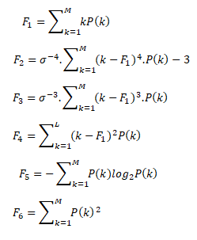

Where, 𝑃 (𝑖) is the probability density obtained in (1) and k = 1, 2, … . ,M. 𝜎 is standard deviation which is F21/2. The first order statistical features based on Histogram are considered local features. They do not take into account the spatial information that can be obtained from the image. Therefore, a second level of feature extraction utilizes the gray-level spatial co-occurrence matrix [G(k, 𝑛)]. These features have been defined as the second order histogram based features, and are calculated using the joint probability distribution of pixel pairs. The joint probability distribution between pixels uses the distance (d) and angle (Ɵ) within a given neighborhood as a basis for the calculation. It is the practice to use d=1, 2 and 𝜃 = 0°, 45°, 90°,135° for calculation of the joint probability distribution between pixels. Statistical features derived from the matrix are Correlation (𝐹7), Homogeneity (𝐹8), Angular Second Moment Energy (𝐹9), Entropy (𝐹10), Maximum Probability (𝐹11) and Inverse Difference (𝐹12) can be calculated

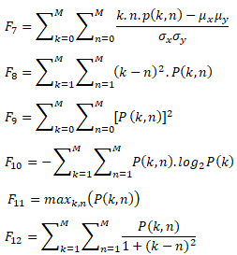

A total of twelve first and second order statistical features are extracted.

## 2) Edge Features

Since tumors are small and they appear as round structures with a diameter less dimension, the following shape-based features are extracted for tumor region:

* Area (SArea): area of tumor region specified by the actual number of pixels
* Convex area (SConA): area of tumor convex region specified by the actual number of pixels
* Solidity (SSol): ratio of the area of tumor (SArea) over the convex area (SConA).
* Extent (SExt): ratio of SArea to the pixels in the bounding box
* Circularity (SCirD): diameter of a circle with the same area as the region which is equal to (4SArea/π)1/2
* Ellipticity (SAxiA, SAxiB): lengths of the major and minor axes of the ellipse that has the same normalized second central moments as the tumor region.
* Eccentricity (SEcc): ratio of distance between the foci and the major axis length (SAxiA) of the ellipse with a same 2nd moment as the region

**Classification**

Support vector machines are supervised learning models with associated learning algorithms that analysis data used for classification and regression analysis. Given a set of training examples, each marked as belonging to one or the other of two categories, an SVM training algorithm builds a model that assigns new examples to one category or the other, making it a non- probabilistic binary linear classifier (although methods such as Platt scaling exist to use SVM in a probabilistic classification setting).

A compact set of features is identified for each category (statistical and edge). For a given fake currency image, our system computes these selected features for each category and passes them into SVM classifiers to distinguish the fake and normal

notes

**CHAPTER 6**

**SYSTEM DESIGN AND DEVELOPMENT**

**6.1 System Design**

Paper fake currency recognition is one of the applications of pattern recognition. There are some similar recognition systems, such as face recognition system, fingerprint recognition system. However the theories they use are similar but the techniques and approaches are different. Noise removal, preprocessing, In order to make the system more comprehensive, we need to create a small database for storing the features of the currency. The system will be programmed based on MATLAB and include a user-friendly interface. The main steps in the   
system are:

* Read image, reading the image we get from the scanner as well as the format of the image is JPEG
* Preprocessing, removing noise
* Feature extraction
* Classification
* Result

The approach consists of a number of steps including image acquisition, gray scale conversion, edge detection, feature extraction, image segmentation and comparison of images. Image acquisition is the creation of digital images, typically from a physical scene. In the proposed work, the image will be acquired by using simple digital camera by providing some backlighting so that all the features of the currency can appear on the image properly. The image is then stored in the computer or further processing. Edge detection and image segmentation are the most important tasks performed on the images.

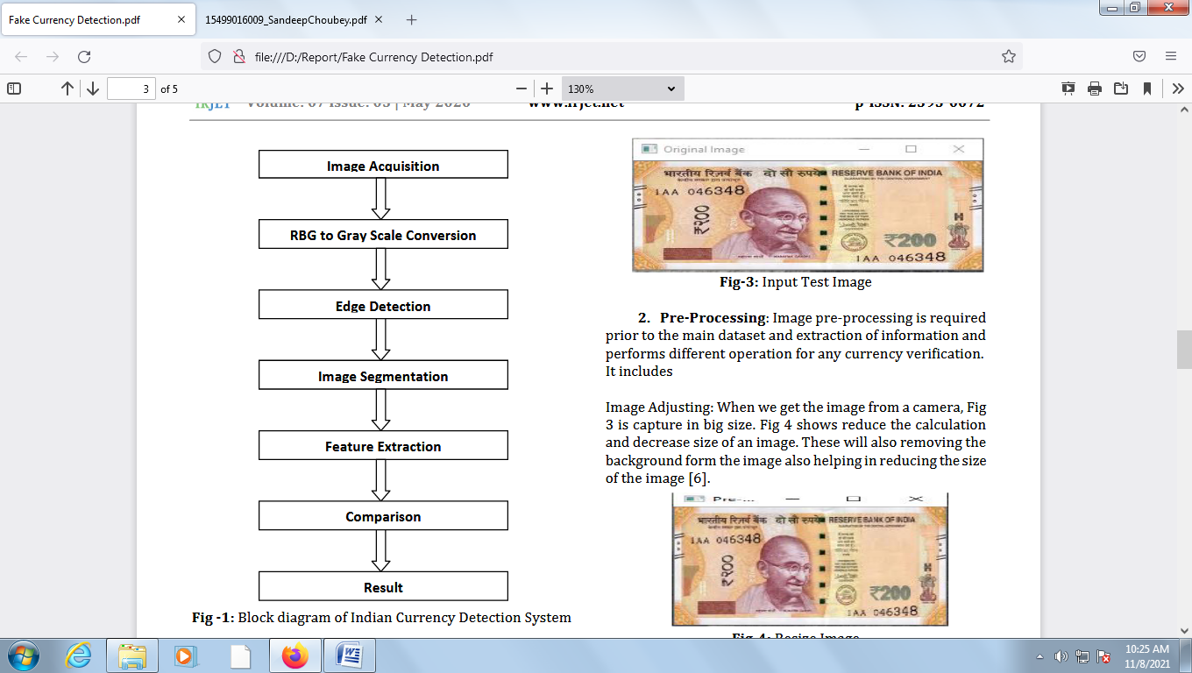

**MAT FILE**

A MAT file is a Microsoft Access file. The purpose of using the MAT file here is to save the features of training images which we had extracted. The features will be used during classification. The features of test image will be matched with the features stored in MAT file. If features of the test image match with the features in MAT file the currency type will be displayed.

**EDGE DETECTION**

Edge detection is a fundamental tool in image processing and computer vision, particularly in the areas of feature detection and feature extraction, which aim at identifying points in a digital image at which the image brightness changes sharply or, more formally, has   
discontinuities. Edge detection is one of the fundamental steps in image processing, image analysis, image pattern recognition, and computer vision techniques.

**IMAGE SEGMENTATION**

Image segmentation sub divides the image into its constituent regions or objects. The level to which sub division is carried depends on the problem being solved. Segmentation algorithm for monochrome images generally are based on one of the two basic properties of image intensity values-

* Discontinuity
* Similarity In the first category, the approach is to partition an image based on abrupt changes in intensity such as edges in an image.

The approach in the second category is based on partitioning an image into regions that are similar according to a set of predefined criteria. Processing speed and recognition accuracy are generally two important targets in such systems.

A Digital Image processing is an area characterized by the need for   
extensive experimental work to establish the validity of proposed solutions to a given problem. It encompasses processes whose inputs and outputs are images encompasses processes that extract attributes from images up to and including the recognition of individual objects. MATLAB is the computational tool of choice for research, development and analysis. The image formats supported by MATLAB are BMP, HDF, JPEG, PCX, TIFF, XWB, PNG etc. Characteristic extraction of images is challenging work in digital image processing. It involves extraction of visible and some invisible features of Indian currency notes. A good characteristic extraction scheme should maintain and enhance those characteristics of the input data which make distinct pattern classes separate from each other.

**CLASSIFICATION**

The classification is the process to classify the fake currency note into its correct class. The software will extract the features of the test images. Once statistical features will be extracted they will be matched with the features stored in MAT file using SVM Classifier. The features in MAT file are features of train images. If the features of test image will be matched with the features in MAT file the software will return the class of that currency note. If the test image features don’t match with any of the features in Mat file the software will display that it is doesn’t belong to any class.

The proposed system will work on two images, one is original image of the paper currency and other is the test image on which verification is to be performed. The proposed algorithm for the discussed paper currency verification system is presented as follows-

* Image of paper currency will be acquired by simple scanner or digital camera.
* The image acquired is RGB image and then it will be converted into gray scale.
* Edge detection of the whole gray scale image will be performed.
* After detecting edges, the four characteristics of the paper currency will be cropped and segmented.
* After segmentation, the characteristics of the paper currency will be extracted.
* The characteristics of test image are compared with the original pre-stored image in the system.
* If it matches then the currency is genuine otherwise counterfeit.

The technique uses four characteristics of paper currency including identification mark, security thread, latent image and watermark. The system may extract the hidden features i.e. latent image and watermark of the paper currency.

In the proposed method characteristics of paper currencies are employed that are used by people for differentiating different banknote denominations. Basically, at first instance, people may not pay attention to the details and exact characteristics of banknotes for their recognition, rather they consider the common characteristics of banknotes such as the size, the background color (the basic color), and texture present on the banknotes.

In this method, these characteristics will be used to differentiate between different banknote denominations. Identification of fake note paper currency identification system is useful in banking systems and in other fields of financial applications. Automatic currency note identification invariably depends on the currency note characteristics of a particular country and the extraction of features directly affects the recognition ability.

**CHAPTER 7**

**RESULTS AND DISCUSSION**

**7.1 RESULT**

**Input Image**

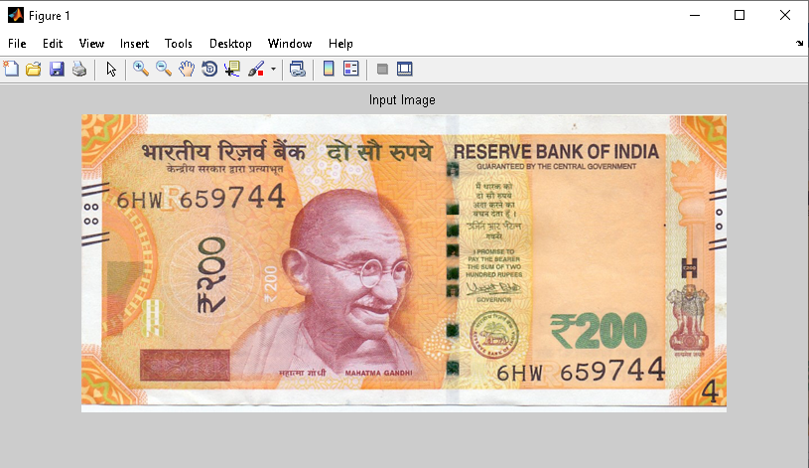

**Denoised Image**

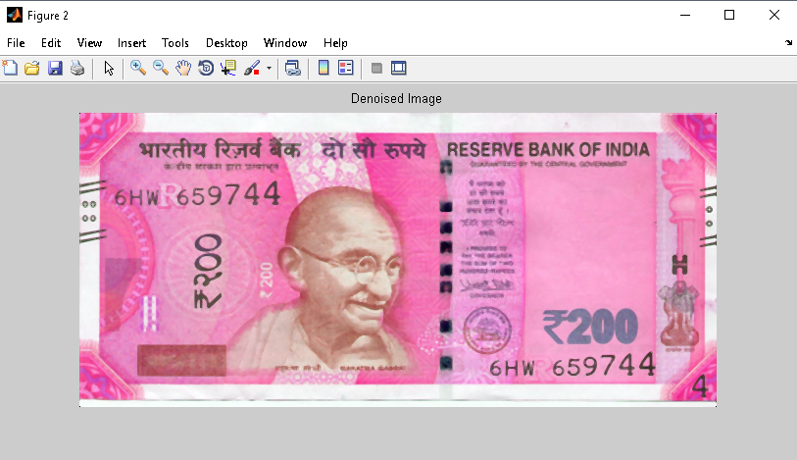

**Gray Scale Image**

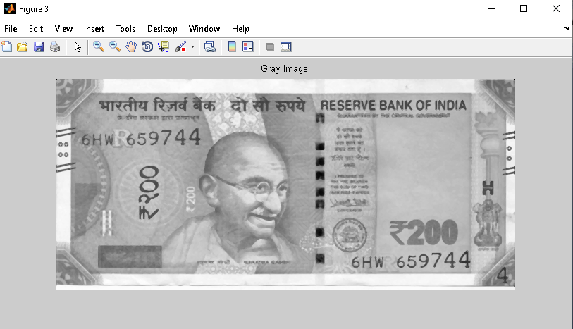

**Edge Detection**

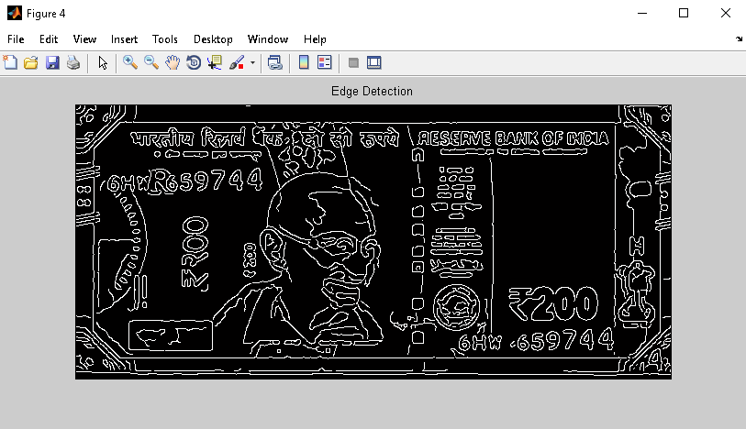

**ROI Extraction-Texture and Statistical Features**

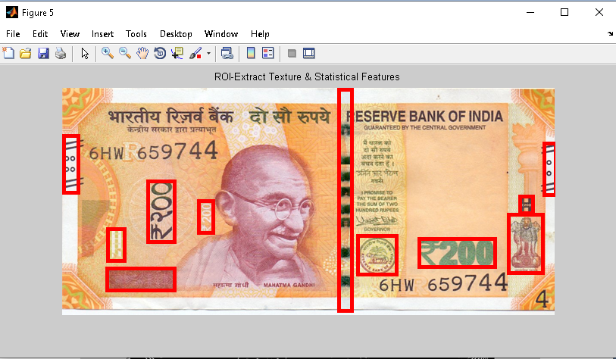

**ROI Extraction-Edge and Shape Features**

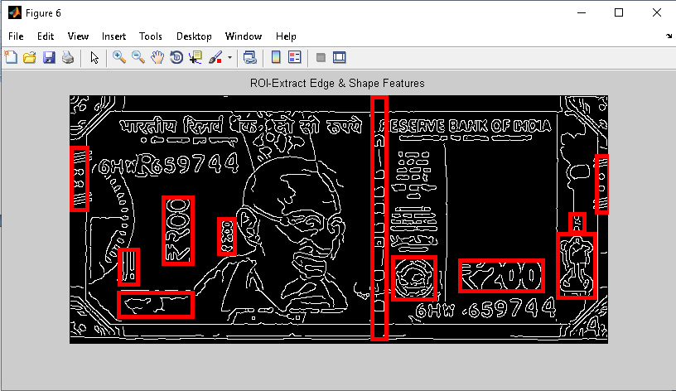

**Detection Result**

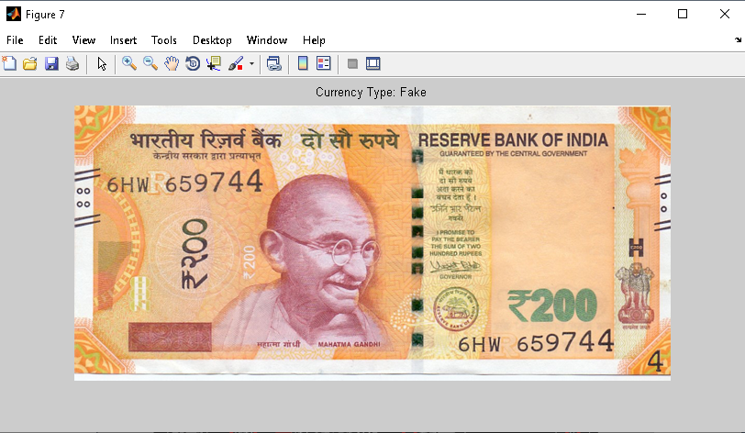

**7.2 PERFORMANCE ANALYSIS**

Calculating the performance measures described above, we were able to gain an understanding of how every algorithm performed. Below are the accuracy, precision, and f-scores for each algorithm. As can be seen from the above results, proposed performs with the most consistency. It has the lowest accuracy of 99.2%., however, 80% of the time it gave a result with 100% accuracy. Comparing the other two algorithms, it can be seen that GBC was the closest to the performance of proposed with an accuracy of 99.4% while SVC had the lowest result of 97.5%. However, it can be noted that all three algorithms had an accuracy above 97% which is quite impressive. Similar results can be derived by comparing the results for precision and f-score. Moreover, taking a look at the confusion matrices, it can be noticed that proposed gave only 2 wrong predictions whereas GBC gave 6 and SVC predicted 26 samples incorrectly. This consolidates the fact that proposed outperforms the rest of the algorithms for this case. As such a project needs to have high accuracy as predicting even some notes as false positives or negatives can cause major faults, it will not be possible to use the model build by using SVC as it produces 26 faulty predictions. Looking at these results it can be seen that for the given data set the most accurate algorithm to use is proposed. Moreover, it can be noted that proposed predicted all genuine notes correctly, which is essential in the real world as predicting counterfeit as an authentic currency will be more detrimental.

Table.1 Algorithm Comparison accuracy

|  |  |  |  |
| --- | --- | --- | --- |
| **Algorithm** | **Accuracy** | **Precision** | **F-Score** |
| **Proposed(SVM)** | 99.9 | 99.9 | 99.9 |
| **SVC** | 97.5 | 99.7 | 98.6 |
| **GBC** | 99.4 | 99.9 | 99.7 |

**CHAPTER 8**

**CONCLUSION**

Currency use is a necessity for survival and hence it is always necessary to keep in track of its originality. Paper currencies are used much more in India and hence a system to detect the fake currency is needed. As the new currencies are used in the market, the proposed system seems to be useful to detect the currency to be genuine or not. This system compares more features for feature extraction than other proposed systems. It also shows where the differences are in the currencies instead of simply displaying the result. At present we are having new MG series Indian currency note Rs. 200 and can also experiment of notes Rs. 2000, Rs. 500, Rs. 100, Rs.50, Rs.20 and Rs.10. This experiment shows that this is the low cost system to detection the Indian banknote. and the result is 95.0% which means that the system is working efficiently.

**CHAPTER 9**

**FUTURE WORK**

In future, we will develop android app for detection Indian currency. This system can be further implemented for foreign currencies like Dollars, Euros, Taka, etc. as a future scope.

.

**CHAPTER 10**

**APPENDIX**

**10.1 Coding**

clc;

clear all;

close all

%------------ Image Reading ------------------------------------------

[FILENAME,PATHNAME]=uigetfile('*.jpg','Select the Image');

FilePath=strcat(PATHNAME,FILENAME);

disp('The Image File Location is');

disp(FilePath);

[DataArray,map]=imresize(imread(FilePath),[300,650]);

figure,imshow(DataArray,map);

title('Input Image');

% Seperate Channel

r_channel=DataArray(:,:,1);

b_channel=DataArray(:,:,2);

g_channel=DataArray(:,:,3);

% Noise Removal

r_channel=medfilt2(r_channel);

g_channel=medfilt2(g_channel);

b_channel=medfilt2(b_channel);

%restore channels

rgbim(:,:,1)=r_channel;

rgbim(:,:,2)=g_channel;

rgbim(:,:,3)=b_channel;

figure,imshow(uint8(rgbim));

title('Denoised Image');

% RGB to Gray

Igray = 0.30*r_channel + 0.59*g_channel + 0.11*b_channel;

figure,imshow(uint8(Igray));

title('Gray Image');

% Edge Detection

y=double(Igray);

f1 = zeros(3,3,5);

f1(:,:,1) = [1 2 1;0 0 0;-1 -2 -1]; %vertical

f1(:,:,2) = [-1 0 1;-2 0 2;-1 0 1]; %horizontal

f1(:,:,3) = [2 2 -1;2 -1 -1; -1 -1 -1];% 45 diagonal

f1(:,:,4) = [-1 2 2; -1 -1 2; -1 -1 -1];%135 diagonal

f1(:,:,5) = [-1 0 1;0 0 0;1 0 -1]; % non directional

for i = 1:5

g_im(:,:,i) = filter2(f1(:,:,i),y);

end

[m, p] = max(g_im,[],3);

edim = edge(y, 'canny');

im2 =(p.*edim);

edhist=im2;

figure, imshow(edhist)

title('Edge Detection');

Avg=mean2(Igray);

if(Avg>202 && Avg<207)

load 100.mat

elseif(Avg>175 && Avg<180)

load 200.mat

elseif(Avg>190 && Avg<195)

load 500.mat

elseif(Avg>209 && Avg<214)

load 2000.mat

end

figure,imshow(uint8(DataArray));

title('ROI-Extract Texture & Statistical Features');

hold on

for n=1:size(A,1)

rectangle('Position',A(n,:),'EdgeColor','r','LineWidth',4)

end

pause(1)

figure,imshow(edhist);

title('ROI-Extract Edge & Shape Features');

hold on

for n=1:size(A,1)

rectangle('Position',A(n,:),'EdgeColor','r','LineWidth',4)

end

pause(1)

SFL_Data=zeros(size(A,1),6);

SSL_Data=zeros(size(A,1),12);

for n=1:size(A,1)

imcropgray = imcrop(Igray,A(n,:));

Img_data=imcropgray;

% STATISTICAL FEATURES

% First Level Feature

Mean = mean2(Img_data);

Variance = mean2(var(double(Img_data)));

Kurtosis = kurtosis(double(Img_data(:)));

stats = graycoprops(Img_data,'Contrast Correlation Energy Homogeneity');

Energy = stats.Energy;

Contrast = stats.Contrast;

Entropy = entropy(Img_data);

FL_Feat=[Mean Variance Kurtosis Energy Contrast Entropy];

FL_Feat(isnan(FL_Feat))=0;

% disp('First Level Feature');

% disp(FL_Feat)

SFL_Data(n,:)=FL_Feat;

% Second Level Feature

offsets = [0 1; -1 1; -1 0; -1 -1]; %0°, 45°, 90°, 135°

GLCM1 = graycomatrix(Img_data,'NumLevels',8,'Offset',offsets);

GLCM2 = graycomatrix(Img_data,'NumLevels',32,'Offset',offsets);

stats = graycoprops(GLCM1,'Contrast Correlation Energy Homogeneity');

stats1 = graycoprops(GLCM2,'Contrast Correlation Energy Homogeneity');

Correlation=[mean(stats.Correlation) mean(stats1.Correlation)];

ASM=[mean(stats.Energy) mean(stats1.Energy)];

Homogeneity=[mean(stats.Homogeneity) mean(stats1.Homogeneity)];

IDM=[Inverse_Diff(GLCM1) Inverse_Diff(GLCM2)];

Max_prob=[Maximium_Prob(GLCM1) Maximium_Prob(GLCM2)];

Entropy = [entropy(GLCM1) entropy(GLCM2)];

SL_Feat=[ASM Correlation Homogeneity IDM Max_prob Entropy];

SL_Feat(isnan(SL_Feat))=0;

SSL_Data(n,:)=SL_Feat;

end

ST_feat=[mean(SFL_Data) mean(SSL_Data)];

disp('Statistical Features')

disp(ST_feat);

EF_Data=zeros(size(A,1),7);

for n=1:size(A,1)

imcropedge = imcrop(edhist,A(n,:));

% Edge Features

results=regionprops(imcropedge,'Area','EulerNumber','Orientation','BoundingBox','Extent',...

'Perimeter','Centroid','Extrema','PixelIdxList','ConvexArea',...

'FilledArea','PixelList','ConvexHull','FilledImage','Solidity',...

'ConvexImage','Image','SubarrayIdx','Eccentricity','MajorAxisLength',...

'EquivDiameter','MinorAxisLength','EulerNumber');

NR=vertcat(results.BoundingBox);

Circularity=zeros(size(NR,1));

Eccentricity=zeros(size(NR,1));

Convexity=zeros(size(NR,1));

Area=zeros(size(NR,1));

Compactness=zeros(size(NR,1));

Extent=zeros(size(NR,1));

Solidity=zeros(size(NR,1));

for ii=1:size(NR,1)

Circularity(ii) = ((results(ii).Perimeter) .^2 )./ (4*(pi*(results(ii).Area)));

Circularity(isnan(Circularity))=0;

Circularity(isinf(Circularity)) = 0;

Compactness(ii)=(4*results(ii).Area*pi)/(results(ii).Perimeter).^2;

Compactness(isnan(Compactness))=0;

Compactness(isinf(Compactness)) = 0;

Convexity(ii)=results(ii).ConvexArea;

Convexity(isnan(Convexity))=0;

Convexity(isinf(Convexity)) = 0;

Area(ii)=results(ii).Area;

Area(isnan(Area))=0;

Area(isinf(Area)) = 0;

Eccentricity(ii)=results(ii).Eccentricity;

Eccentricity(isnan(Eccentricity))=0;

Eccentricity(isinf(Eccentricity)) = 0;

Extent(ii)=results(ii).Extent;

Extent(isnan(Extent))=0;

Extent(isinf(Extent)) = 0;

Solidity(ii)=results(ii).Solidity;

Solidity(isnan(Solidity))=0;

Solidity(isinf(Solidity)) = 0;

end

SF=[mean2(Area) mean2(Solidity) mean2(Convexity) mean2(Circularity) mean2(Eccentricity) mean2(Compactness) mean2(Extent)];

EF_Data(n,:)=SF;

end

EDF_feat=mean(EF_Data);

disp('Edge Features')

Tfeat=[ST_feat EDF_feat];

load Pdata.mat

load Ndata.mat

xdata = [Train_dataP;Train_dataN];

group = [Train_LabP;Train_LabN];

svmTrain = svmtrain(xdata,group,'kernel_function','rbf');

Classfy_Result = svmclassify(svmTrain,Tfeat);

if(Classfy_Result==1)

figure,imshow(DataArray,map);

title('Currency Type: Real');

msgbox('Currency Type: Real');

else

figure,imshow(DataArray,map);

title('Currency Type: Fake');

msgbox('Currency Type: Fake');

end

**REFERENCES**

[1] P. D. Deshpande and A. Shrivastava,“ Indian Currency Recognition and Authentication using Image Processing,” IJARSE, Vol. 07, No. 7, pp. 1107-1119, 2018.

[2] Y. Neeraja, B. Divija and M. Nithish Kumar, “Fake Currency Detection Using K-nn Technique,” IJREITSS, Vol. 09, No. 1, pp. 201-205, 2019.

[3] K. Sawant and C. More, “Currency Recognition Using Image Processing and Minimum Distance Classifier Technique,” IJAERS, Vol. 3, No. 3, pp. 1-8, 2016.

[4] K. B. Zende, B. Kokare, S. Pise and P. S. Togrikar, “Fake Note Detection System,” IJIRT, Vol. 4, No. 1, pp. 46-49, 2017.

[5] Li Liu and Yue Lu, “An Image-Based Approach to Detection of Fake Coins,” TIS, June 2017. [12] Tsiapa I, Tsilimbaris MK, Papadaki E, Bouziotis P, Pallikaris IG, Karantanas AH, et al. High resolution MR eye protocol optimization: comparison between 3D-CISS, 3D-PSIF and 3D-VIBE sequences. Physica Med 2015;31:774–80.

[6] A. Ali, M. Manzoor, “Recognition System for Pakistani Paper Currency,” RJASET, Vol. 6, No. 16, pp. 3078-3085, 2013.

[7] S. P. Bhagat, S. B. Patil, “Indian Currency Recognition Based on ORB,” IJIRCCE, Vol. 4, No. 8, pp. 14984-14989, 2016.

[8] Yanyan Qin, Hongke Xu , Huiru Chen, “Image Feature Points Matching via Improved ORB”, ICPIC, Vol. 14, pp. 204-208, 2014.

[9] I. A. Doush and S. AL-Btousha, “Currency recognition using a smartphone: Comparison between color SIFT and gray scale SIFT algorithms”, JKSU-CIS, Vol. 29, PP. 484-492, 2017. [10] Z. Ahmed, S. Yasmin, Md. N Islam and R. U. Ahmed, “Image Processing Based Feature Extraction of Bangladesh Banknotes,” IEEE, 2014.

[11] H. Hassanpour, A. Yaseri and G. Ardeshir, “Feature Extraction For Paper Currency Recognition,” ISSPA, IEEE, 2007.

[12] R. C. Gonz and R. E. Woods, “Texture Features For Browsing And Retrieval Of Image Data,” IEEE Trans.Pattern Anal and Mach. Inte, Vol. 18, No. 8, pp. 837-842, 1996.

[13] M. Gogoi, S. E. Ali and S. Mukherjee “Automatic Indian Currency Denomination Recognition System Based on Artificial Neural Network”, IEEE, pp. 553-558, 2015.

[14] E. Hariri, M. Hariri and M. Afzali, “Banknote Detection Methods And Identifying Its Imperfection,” pp. 912-918, 2015.

[15] N. Sharma, and K. Narang, “A Review Paper on Currency Recognition System,” IJRASET, Vol. 5, No. 5, pp. 1748-1751, 2017.

[16] S. Mahajan and K. P. Rane, “A Survey on Counterfeit Paper Currency Recognition and Detection,” ICIAC, pp. 54-61, 2015.

[17] N. Rathee, A. Kadian, and R. Sachdeva, “Feature Fusion for Fake Indian Currency Detection,” Computing for Sustainable Global Development (INDIACom), 2016 3rd International Conference on IEEE, 2016.

[18] Anjana, Manoj Diwakar and Anand Sharma, "An Automated Recognition of Fake or Destroyed Indian Currency Notes In Machine Vision", IJCSMS, Vol. 12, April 2012.

[19] A. Ali and M. Manzoor, “Recognition System for Pakistani Paper Currency,” World Appl Sci J, pp. 3078-3085, 2013.