**Software Requirements Specification Document**

|  | Virtual Recipe Analyzer, Team 10  B. Sri Varshitha, T. Hemasri, V. Swetha Reddy |
| --- | --- |

# **Brief problem statement**

*The problem we are addressing is the lack of a comprehensive recipe analysis tool that enables home cooks and health-conscious individuals to experiment with different ingredients and analyze their recipes. Existing recipe platforms primarily focus on recipe discovery and storage, but they do not offer real-time analysis of recipe feasibility and nutritional details based on the user’s chosen ingredients. Our project seeks to fill this gap by providing users with a solution that not only allows them to craft unique recipes but also ensures these recipes align with their dietary preferences and health goals.*

# **System requirements**

*Front-end: React.js*

*Back-end: Node.js with Express.js*

*Database: MongoDB*

# **Users profile**

*Home Cooks: Users who enjoy cooking at home and want to create recipes with ingredients they have on hand.*

*People with Dietary Restrictions: Users following specific diets (e.g., vegan, gluten-free) seeking recipes that comply with their dietary restrictions.*

*Health-Conscious Individuals: Users interested in understanding the nutritional value of their meals.*

*Beginner Cooks: Users with limited cooking experience who need guidance on creating balanced and feasible recipes.*

# Feature requirements (described using use cases)

| **No.** | **User Case Name** | **Description** | **Release** |
| --- | --- | --- | --- |
|  | User Registration | Allows users to create an account. | R1 |
|  | User Login | Allows registered users to log in. | R1 |
|  | Ingredient Selection | Enables users to input ingredients and quantities for a recipe. | R1 |
|  | Analyze Recipe | Analyzes a user's recipe for feasibility and provides health details. | R1 |
|  | Save Recipe | Allows users to save their created recipes. | R2 |
|  | View Saved Recipes | Lets users view their saved recipes. | R2 |
|  | Modify Recipe | Allows users to edit and update their saved recipes. | R2 |
|  | Delete Recipe | Allows users to delete their saved recipes. | R2 |
|  | User Logout | Allows logged in users to log out. | R1 |

**Use case diagram**

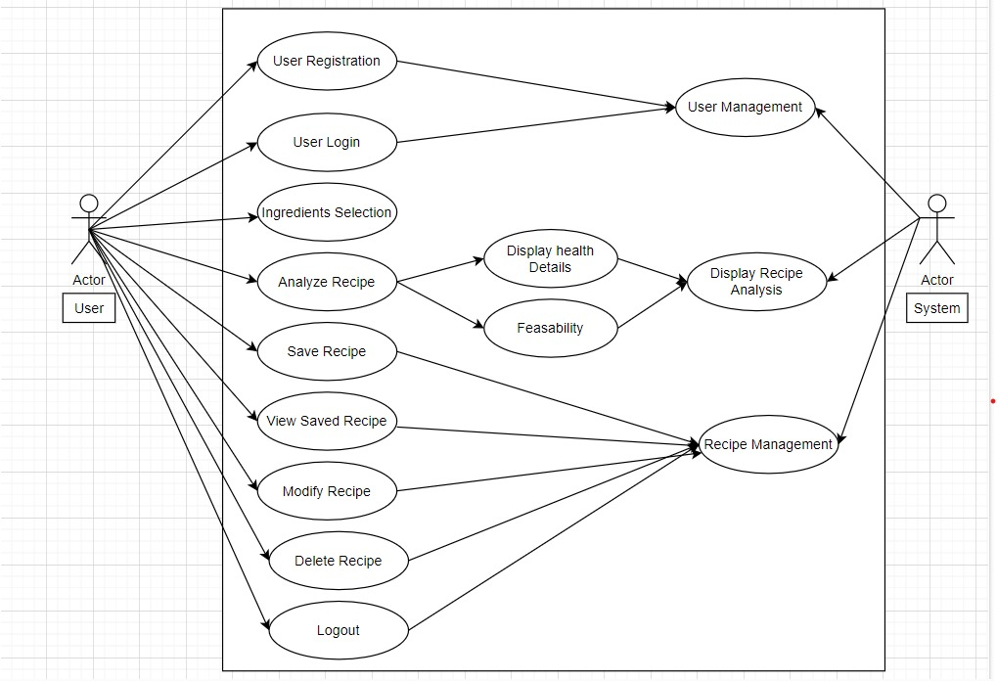

**Use case description**

| **Use Case Number:** | UC-01 |
| --- | --- |
| **Use Case Name:** | User Registration |
| **Overview:** | This use case allows new users to create an account on the Recipe Analyzer Web App. |
| **Actors:** | Unregistered User |
| **Pre condition:** | None |
| **Flow:** | 1. User selects the "Sign Up" option. 2. User enters their desired username, email, and password. 3. User submits the registration form. 4. The system validates the information. 5. If validation is successful, the system creates a new user account. 6. The system redirects the user to the login page with a success message. |
|  | * If the provided email is already registered, the system displays an error message. * If any validation fails, the system displays error messages and prompts the user to correct the information. |
| **Post Condition:** | If successful, the user has a registered account and can log in. |

| **Use Case Number:** | UC-02 |
| --- | --- |
| **Use Case Name:** | User Login |
| **Overview:** | This use case enables registered users to log in to the Recipe Analyzer Web App. |
| **Actors:** | Registered User |
| **Pre condition:** | None |
| **Flow:** | 1. User navigates to the login page and selects the "Log In" option. 2. User enters their registered email and password. 3. User submits the login form. 4. The system verifies the user's credentials. 5. If the credentials are correct, the system grants access to the user's account and redirects them to the app's dashboard. |
|  | * If the provided credentials are incorrect, the system displays an error message. * If any validation or authentication fails, the system displays error messages and prompts the user to correct their information. |
| **Post Condition:** | If successful, the user gains access to their account and can utilize the web app’s features. |

| **Use Case Number:** | UC-03 |
| --- | --- |
| **Use Case Name:** | Ingredients Selection |
| **Overview:** | This use case allows users to create a recipe by selecting ingredients from a list of images and specifying their respective weights or quantities. |
| **Actors:** | Registered User |
| **Pre condition:** | The user must be logged in to access this feature |
| **Flow:** | 1. User logs in to the Recipe Analyzer Web App. 2. User navigates to the "Create Recipe" section. 3. User selects ingredients by clicking on images from a list of available ingredients. 4. For each selected ingredient, the system displays a blank box next to it for the user to input the weight or quantity. 5. User inputs the weight or quantity for each selected ingredient. 6. User repeats steps 4-6 to add additional ingredients as needed. |
|  |  |
| **Post Condition:** | If successful, the user has selected ingredients. |

| **Use Case Number:** | UC-04 |
| --- | --- |
| **Use Case Name:** | Analyze recipe |
| **Overview:** | This use case enables users to analyze the feasibility and health details of a recipe they have created by clicking the "Analyze Recipe" button. |
| **Actors:** | Registered User |
| **Pre condition:** | The user must have created a recipe by choosing ingredients and being logged in. |
| **Flow:** | 1. User logs in to the Recipe Analyzer Web App. 2. User navigates to the "Create Recipe" section. 3. User selects ingredients by clicking on images from a list of available ingredients. 4. User clicks the "Analyze Recipe" button. 5. The system validates the input data. 6. If validation is successful, the system creates the new recipe, associates it with the user's account, and saves it to the database. 7. The system provides a confirmation message to the user and redirects them to the recipe details page. 8. The system performs an analysis of the selected recipe, considering ingredient compatibility and nutritional information. 9. The system presents the analysis results to the user, including any feasibility or health-related details. |
|  | * If any validation fails (e.g., missing weights, invalid weights), the system displays error messages and prompts the user to correct the information. * If there are issues with the analysis process (e.g., data retrieval errors), the system displays an error message and suggests the user try again later. |
| **Post Condition:** | The user receives an analysis report for their recipe, helping them make informed cooking choices based on the recipe's composition. |

| **Use Case Number:** | UC-05 |
| --- | --- |
| **Use Case Name:** | Save Recipe |
| **Overview:** | This use case allows users to save the recipes they have created within the Recipe Analyzer Web App. |
| **Actors:** | Registered User |
| **Pre condition:** | The user must be logged in to access the recipe saving feature. Additionally, the user must have chosen ingredients to create a recipe that they want to save. |
| **Flow:** | 1. User logs in to the Recipe Analyzer Web App. 2. User navigates to the "Create Recipe" or "My Recipes" section. 3. User selects a recipe they have created or are in the process of creating. 4. User clicks the "Save Recipe" button. 5. The system saves the selected recipe to the user's account, associating it with their profile. 6. The system confirms the successful saving of the recipe and provides a message to the user. |
|  | * If there are issues with saving the recipe to the database (e.g., database connection error), the system displays an error message and suggests the user try again later. |
| **Post Condition:** | If successful, the user's created recipe is saved to their account, and they can access it in the "My Recipes" section for future reference and analysis. |

| **Use Case Number:** | UC-06 |
| --- | --- |
| **Use Case Name:** | View Saved Recipes |
| **Overview:** | This use case enables users to access and view the recipes they have saved within the Recipe Analyzer Web App. |
| **Actors:** | Registered User |
| **Pre condition:** | The user must be logged in to access the view saved recipes feature. |
| **Flow:** | 1. User logs in to the Recipe Analyzer Web App. 2. User navigates to the "My Recipes" section 3. The system retrieves and displays a list of recipes associated with the user's account. 4. User can select a specific recipe from the list to view its details and analysis. |
|  | * If the user has not saved any recipes yet, the system displays a message indicating that there are no saved recipes to view. |
| **Post Condition:** | The user can access and view their saved recipes, allowing them to review, modify, or analyze these recipes as needed. |

| **Use Case Number:** | UC-07 |
| --- | --- |
| **Use Case Name:** | Modify Recipe |
| **Overview:** | This use case permits users to edit and update the recipes they have previously saved within the Recipe Analyzer Web App. |
| **Actors:** | Registered User |
| **Pre condition:** | The user must be logged in to access the recipe modification feature, and they should have at least one saved recipe. |
| **Flow:** | 1. User logs in to the Recipe Analyzer Web App. 2. User navigates to the "My Recipes" section. 3. The system retrieves and displays a list of recipes associated with the user's account. 4. User selects a specific recipe they want to modify from the list. 5. User is provided with the option to edit the selected recipe's title, ingredients, quantities and measurements. 6. User makes the desired changes to the recipe. 7. User submits the modified recipe. 8. The system validates the changes. 9. If validation is successful, the system updates the recipe with the user's modifications and saves the updated recipe to the database. 10. The system provides a confirmation message to the user indicating that the recipe has been successfully modified. |
|  | * If there are issues with saving the modified recipe to the database (e.g., database connection error), the system displays an error message and suggests the user try again later. |
| **Post Condition:** | If successful, the user's selected recipe is updated with the modifications, and the updated recipe is saved to their account for future reference and analysis. |

| **Use Case Number:** | UC-08 |
| --- | --- |
| **Use Case Name:** | Delete Recipe |
| **Overview:** | This use case grants users the ability to remove recipes they have previously saved within the Recipe Analyzer Web App. |
| **Actors:** | Registered User |
| **Pre condition:** | The user must be logged in to access the recipe deletion feature, and they should have at least one saved recipe. |
| **Flow:** | 1. User logs in to the Recipe Analyzer Web App. 2. User navigates to the "My Recipes" section. 3. The system retrieves and displays a list of recipes associated with the user's account. 4. User selects a specific recipe they want to delete from the list. 5. User confirms the deletion action by clicking "Delete" button. 6. The system prompts the user to confirm the deletion. 7. User confirms the deletion by confirming the prompt. 8. The system deletes the selected recipe from the user's account and removes it from the database. 9. The system provides a confirmation message to the user, confirming the successful deletion of the recipe. |
|  | * If the user cancels the deletion at the confirmation prompt, the system cancels the deletion process, and the recipe remains in the user's account. |
| **Post Condition:** | If successful, the user's selected recipe is permanently deleted from their account, and it is no longer accessible within the Recipe Analyzer Web App. |

| **Use Case Number:** | UC-09 |
| --- | --- |
| **Use Case Name:** | User Logout |
| **Overview:** | This use case enables users to log out of their account within the Recipe Analyzer Web App, ending their current session. |
| **Actors:** | Registered User |
| **Pre condition:** | The user must be logged in to access the logout feature. |
| **Flow:** | 1. User is currently logged in to the Recipe Analyzer Web App. 2. User navigates to the "Log Out" option within the app. 3. The system ends the user's session, logs them out of their account, and redirects them to the app's home page. 4. The system provides a confirmation message, confirming the successful log out. |
|  |  |
| **Post Condition:** | If successful, the user's current session is terminated, and they are logged out of their account. |