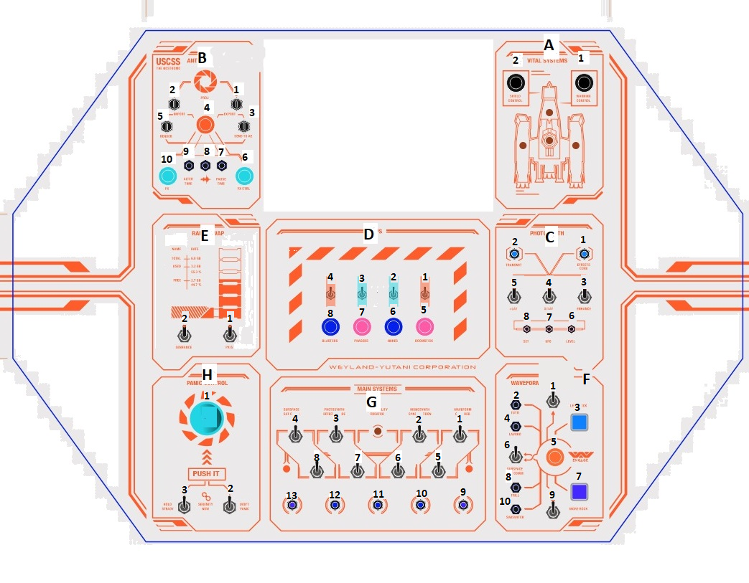
A:
1,2: NO-(C), 12V LED

B:
1,2,3,5: NO-C,NC-O, 5VLED; 4: NO-(C), 12VLED; 6: NO-(C),12VLED; 7,8,9: NO-C,NC-O,5VLED.

C:
1,2: 5VLED; 3,4,5: NO-C; 6,7,8: NO-(C)5VLED.

D:
1,2,3,4: NO-C; 5,6,7,8: NO-(C)12VLED.

E:
1,2: NO-C.

F:
1:NO-C; 2,4: NO-C,NC-O,5VLED; 3: NO-C, 5VLED; 5: NO-(C), 12VLED; 6:NO-C; 7:NO-C,5VLED; 8,10: NO-C,NC-O,5VLED; 9:NO-C.

G:
1…8: NO-C; 9…13: 5VLED.

H:
1: NO-(C), 12VLED; 2,3: NO-C

