***Sanyam Agrawal SE21UCSE192 CSE3***

***CNS - Assignment 3***

**Bandit War Game**

**Level 0-1**: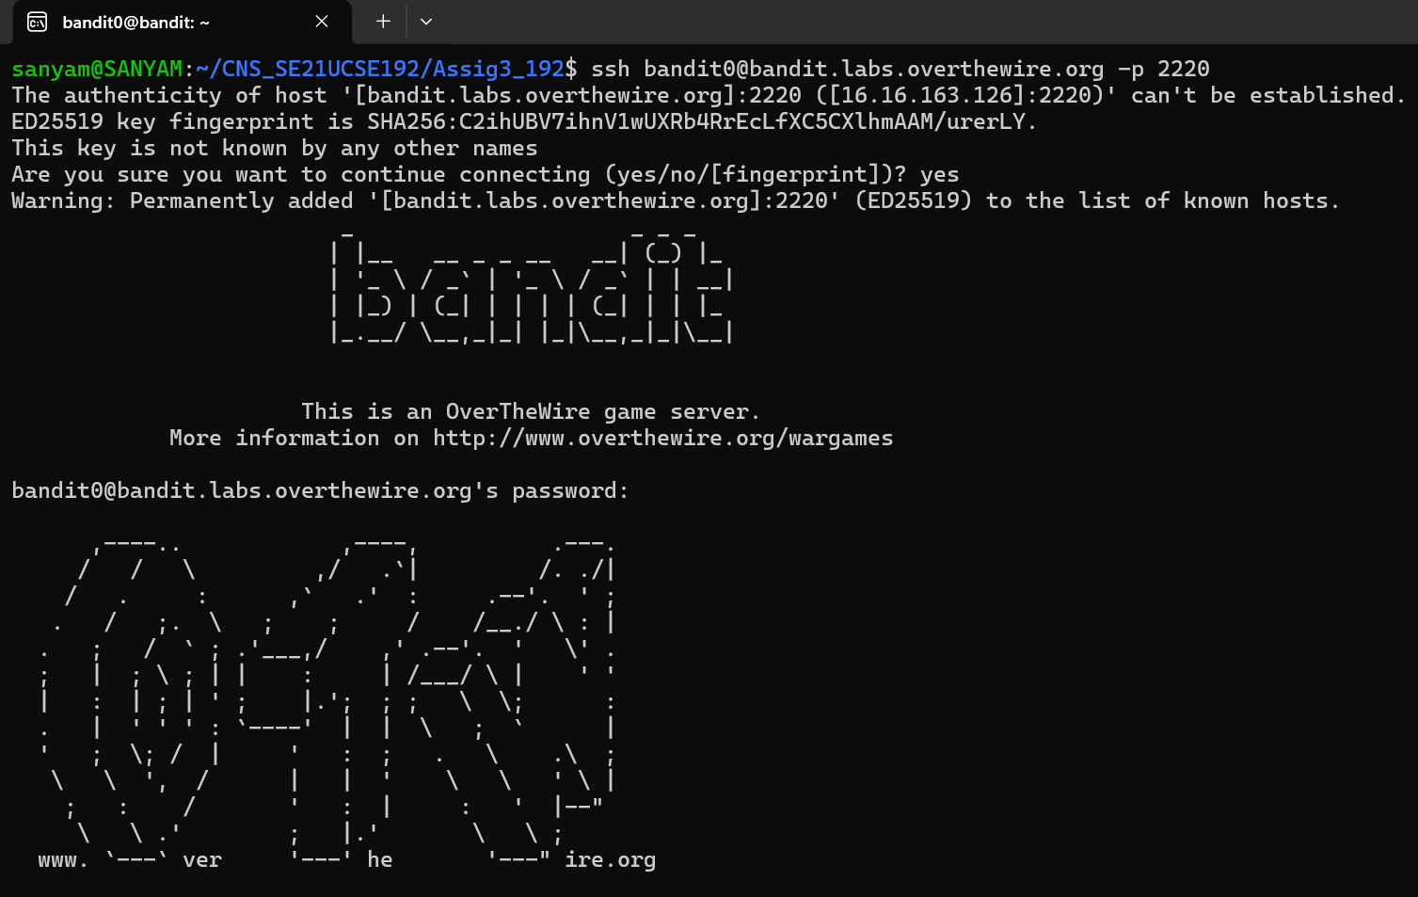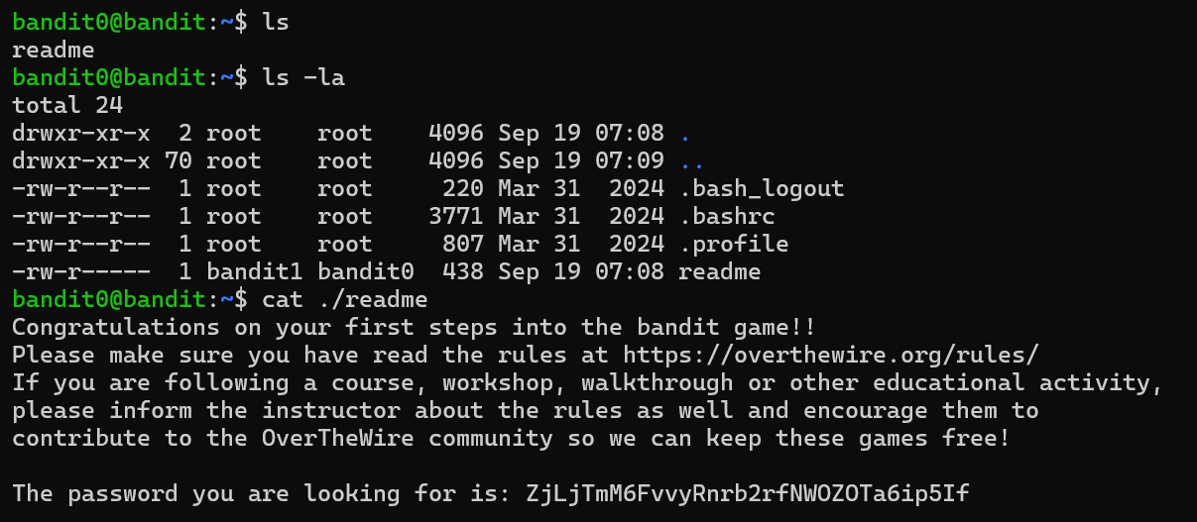**-----------------------------------------------------------------------------------------------------------------**

**Level 1-2:**

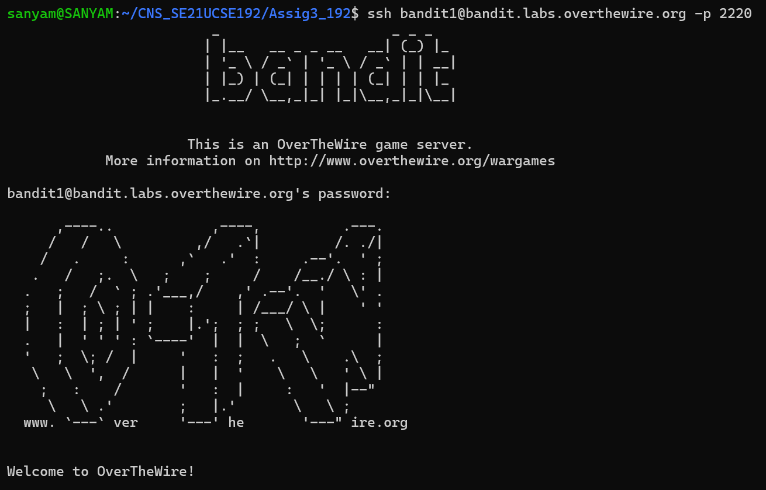

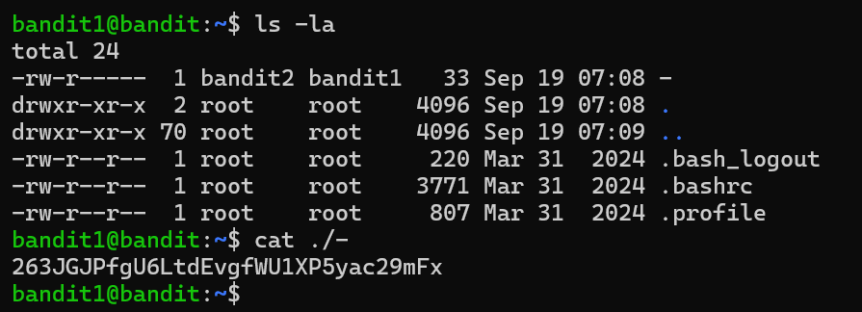**-----------------------------------------------------------------------------------------------------------------**

**Level 2-3:**

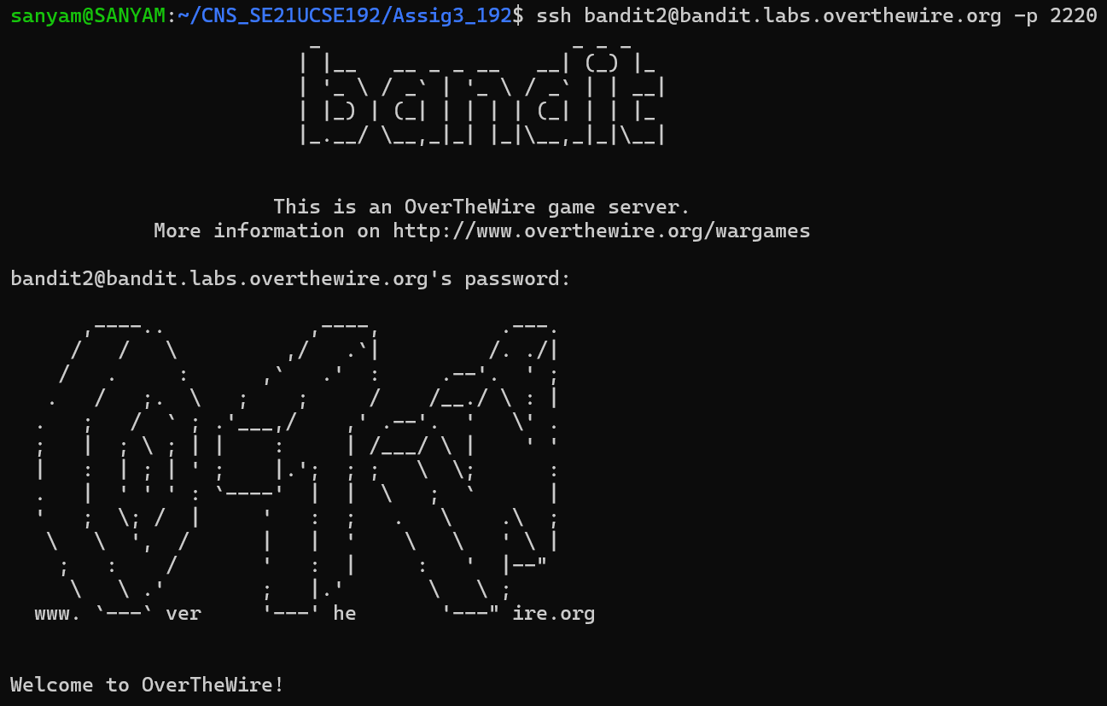

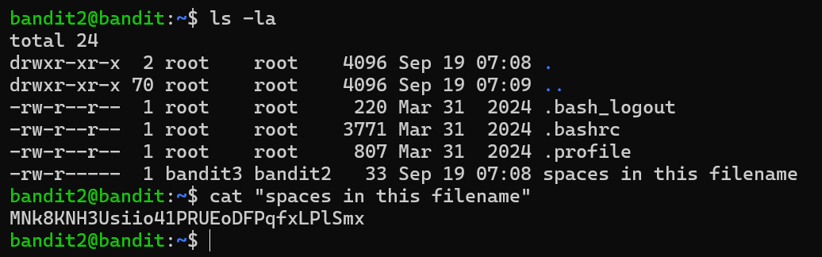**-----------------------------------------------------------------------------------------------------------------**

**Level 3-4:**

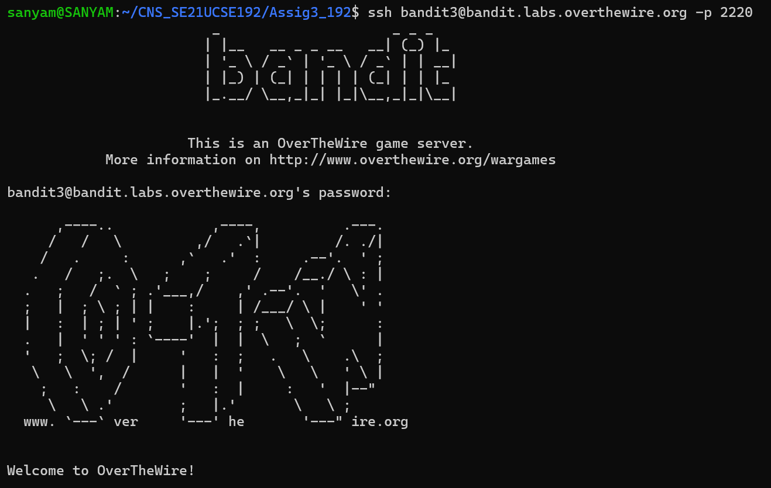

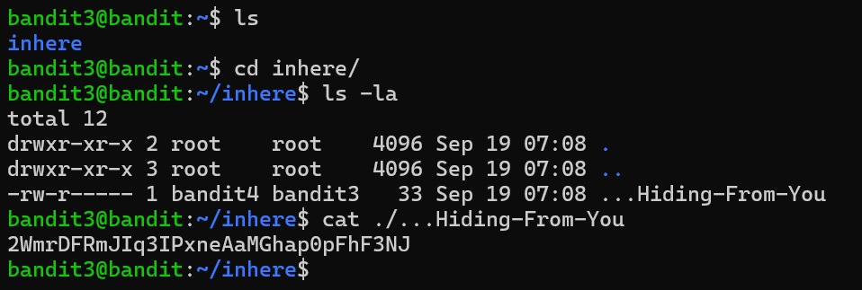**-----------------------------------------------------------------------------------------------------------------**

**Level 4-5:**

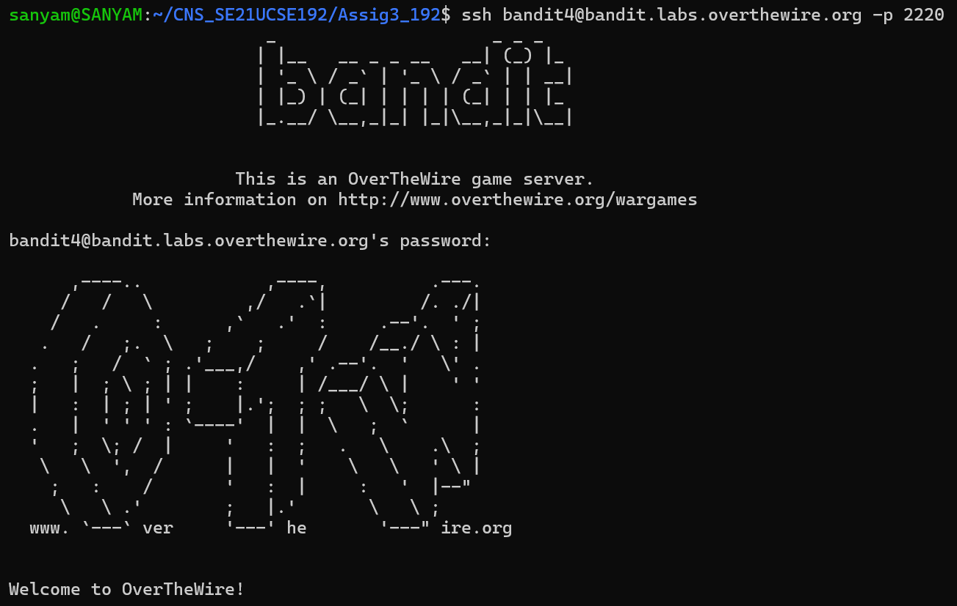

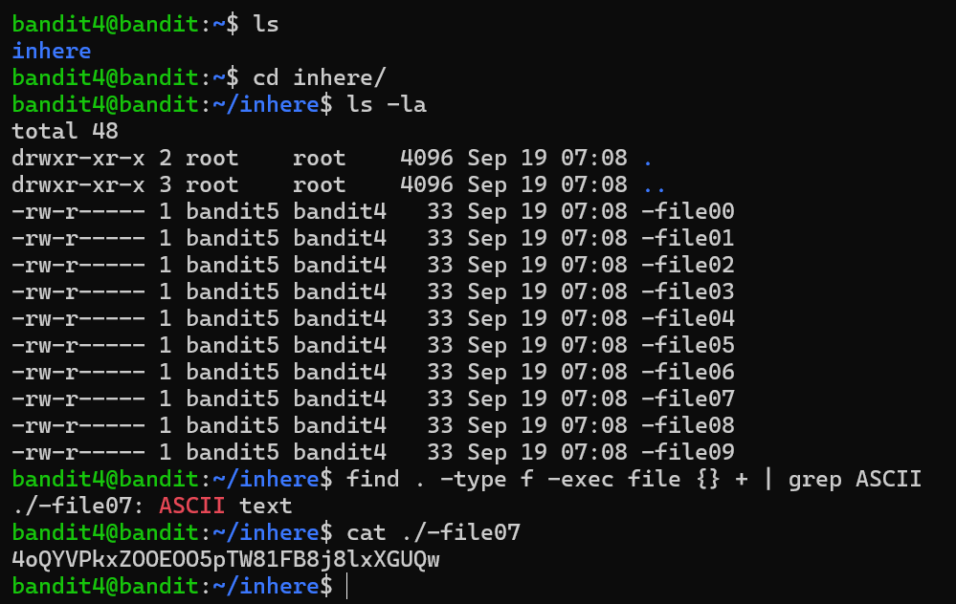**-----------------------------------------------------------------------------------------------------------------**

**Level 5-6:**

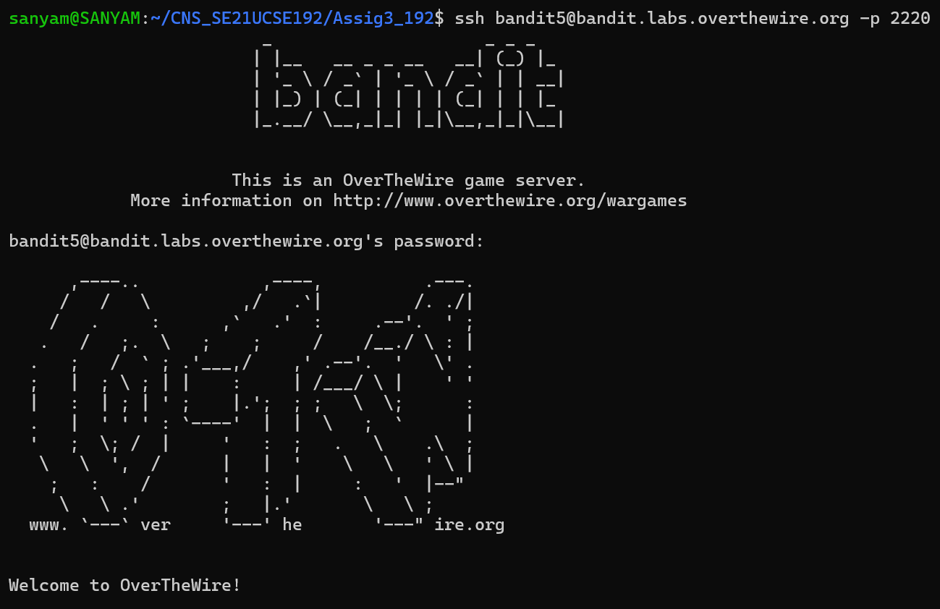

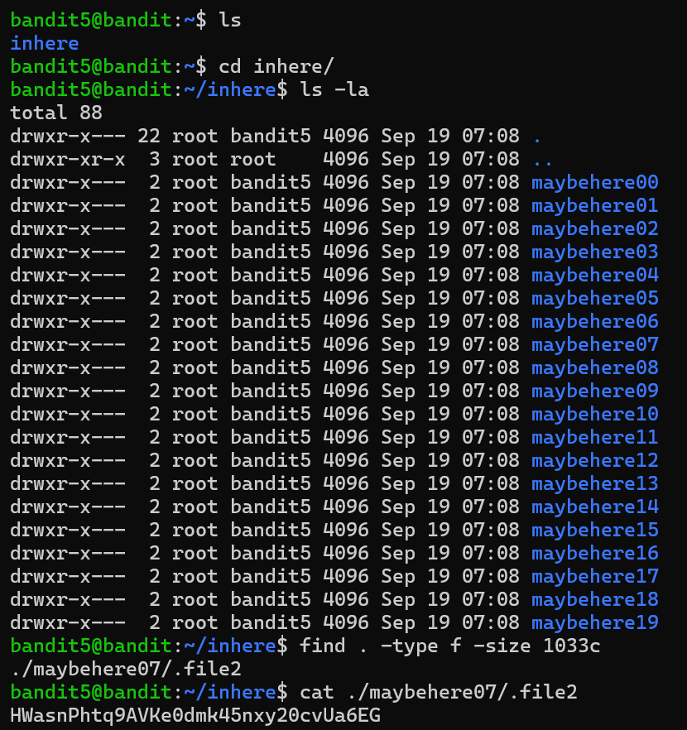

**-----------------------------------------------------------------------------------------------------------------**

**Level 6-7:**

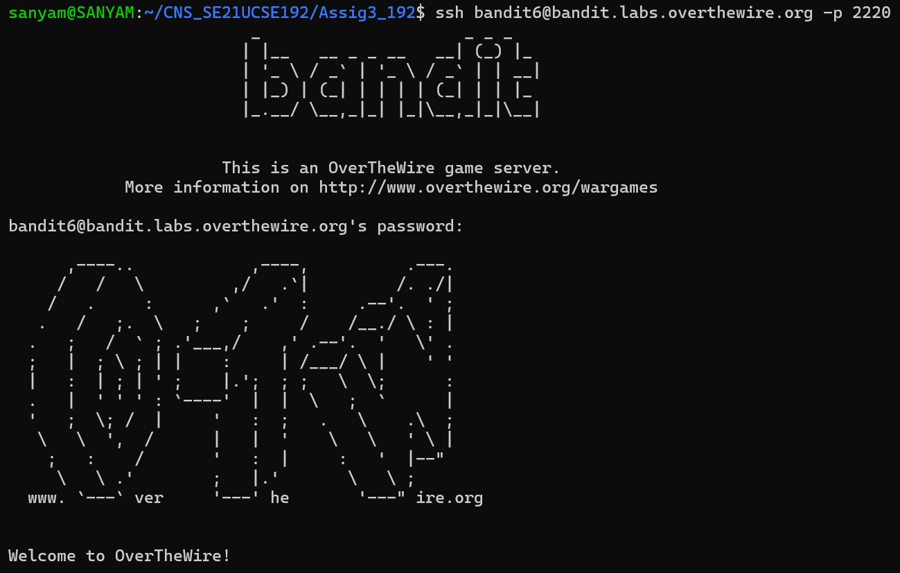

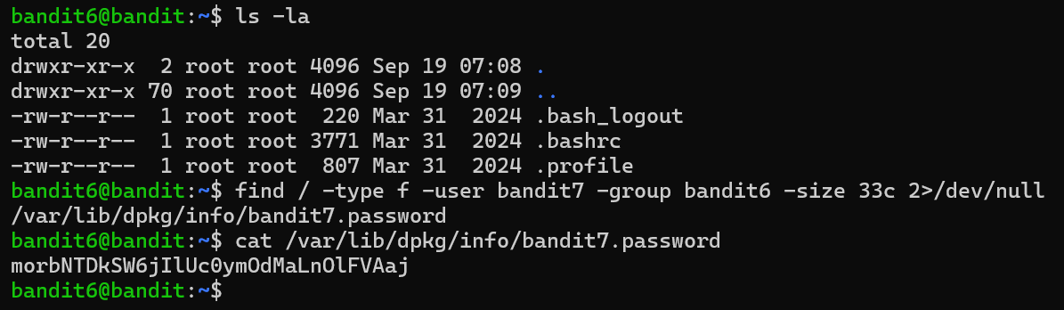**-----------------------------------------------------------------------------------------------------------------**

**Level 7-8:**

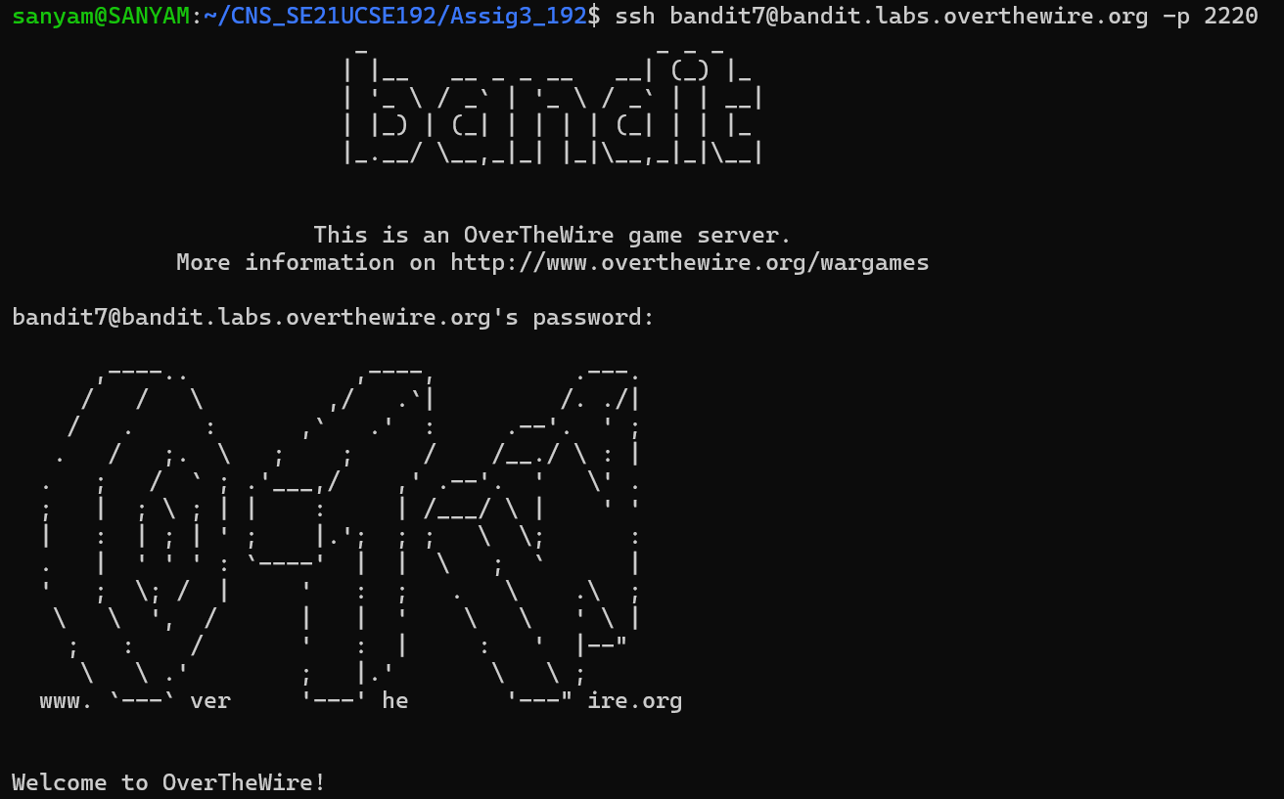

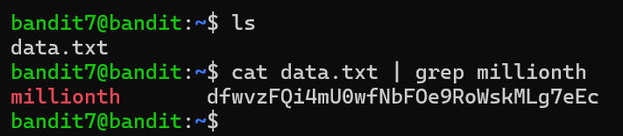**-----------------------------------------------------------------------------------------------------------------**

**Level 8-9:**

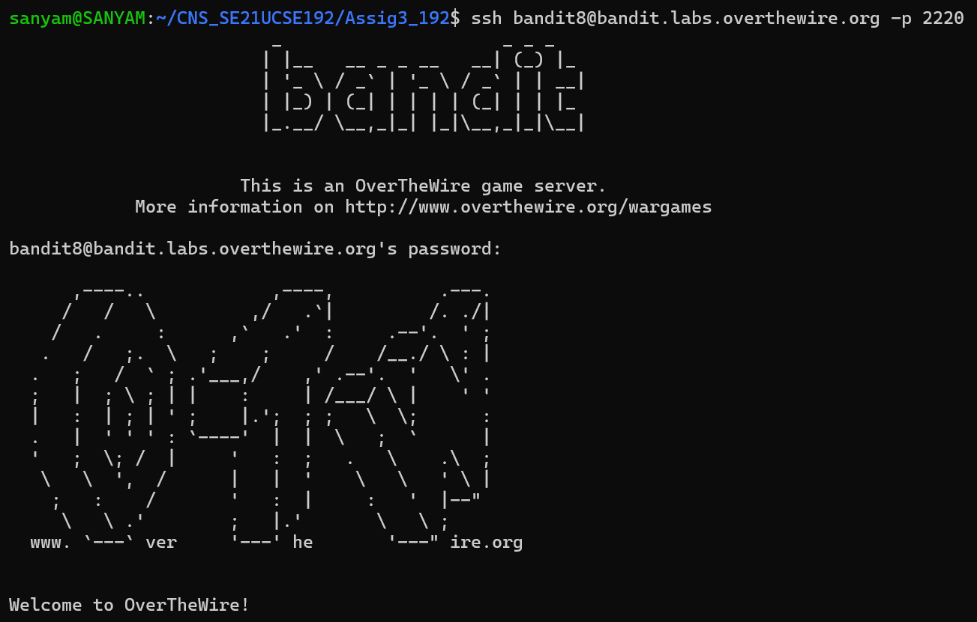

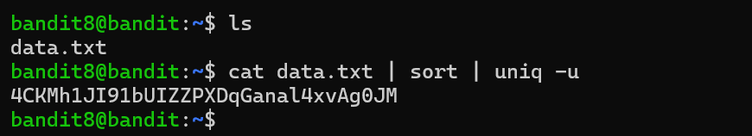**-----------------------------------------------------------------------------------------------------------------**

**Level 9-10:**

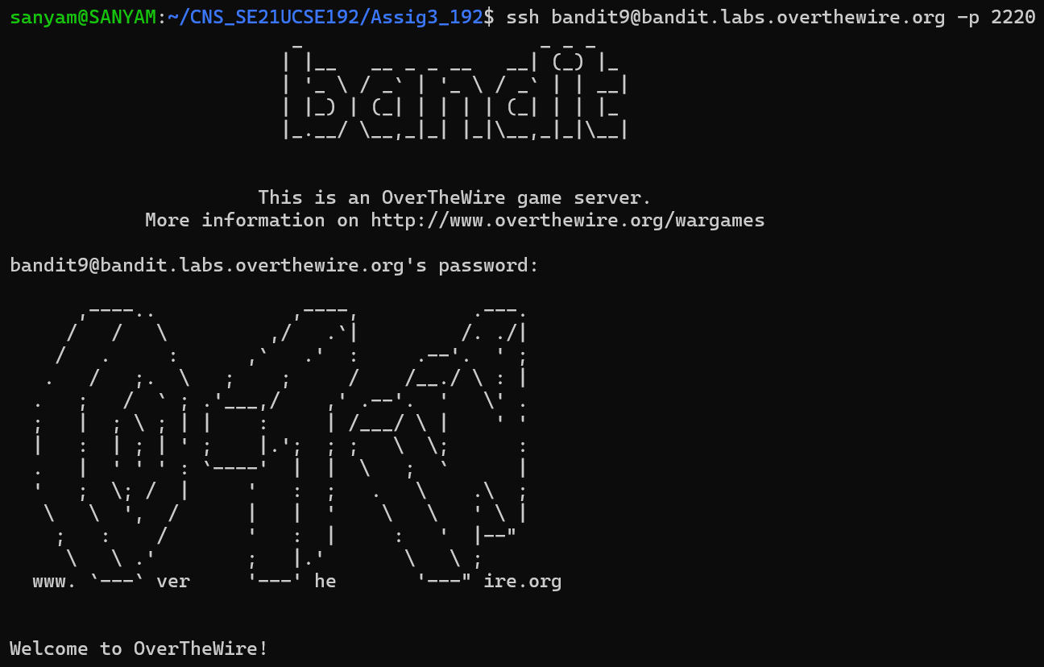

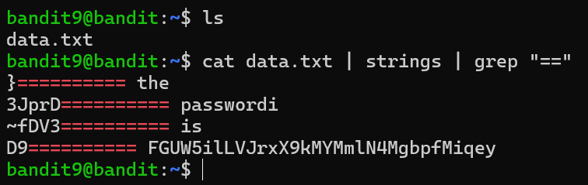**-----------------------------------------------------------------------------------------------------------------**

**Level 10-11:**

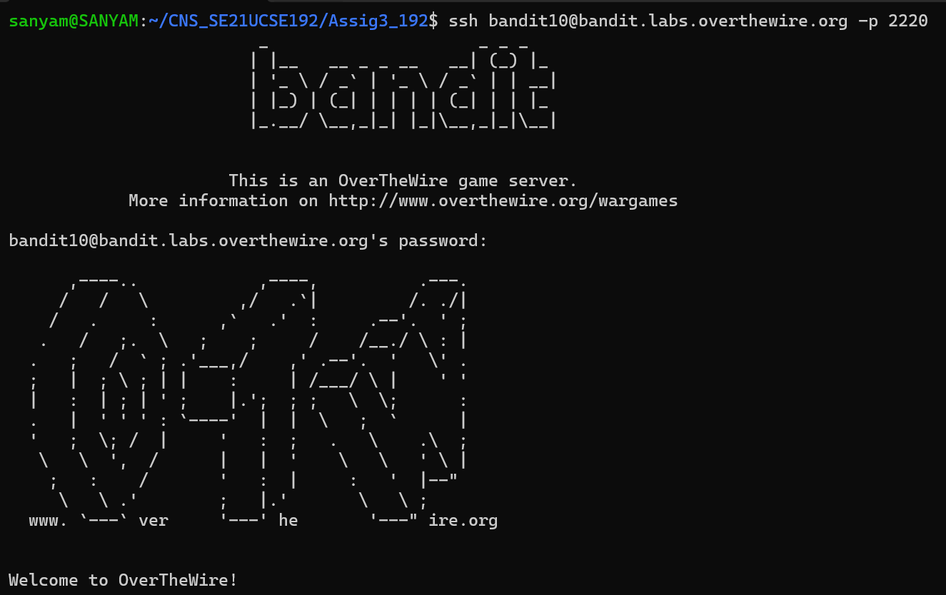

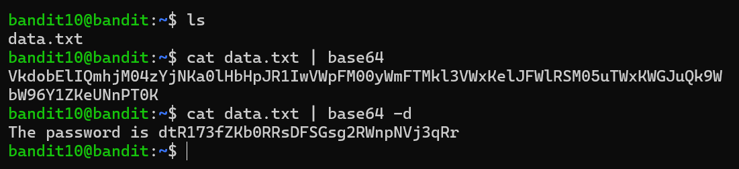

**-----------------------------------------------------------------------------------------------------------------**

**Level 11-12:**

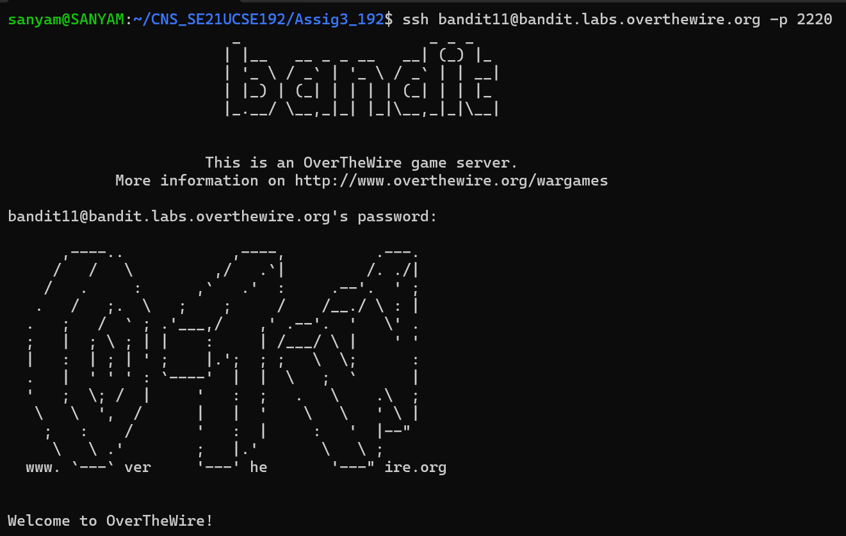

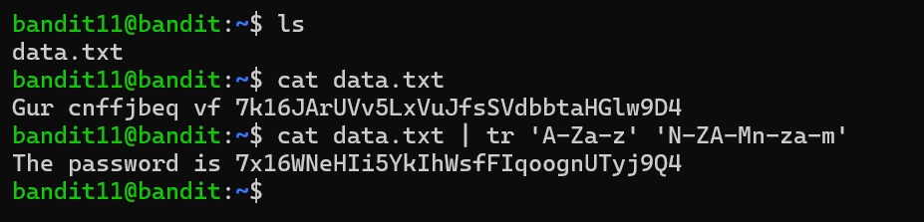

**-------------------------------------------------------------------------------------**

**Level 12-13:**

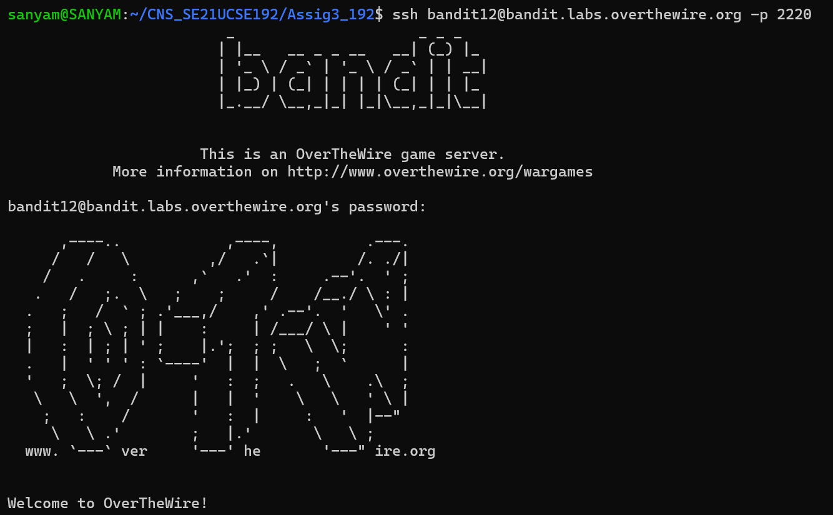

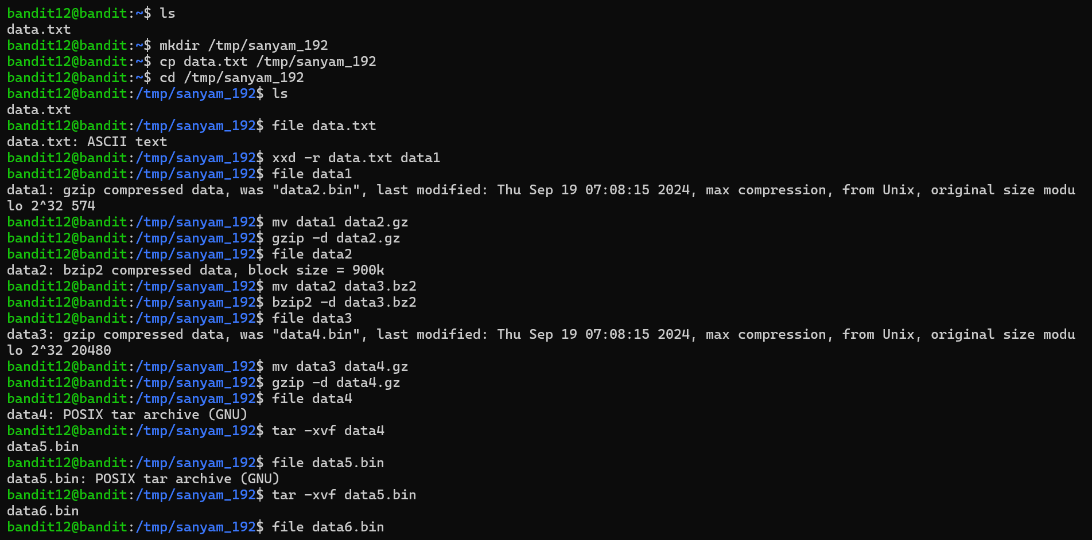

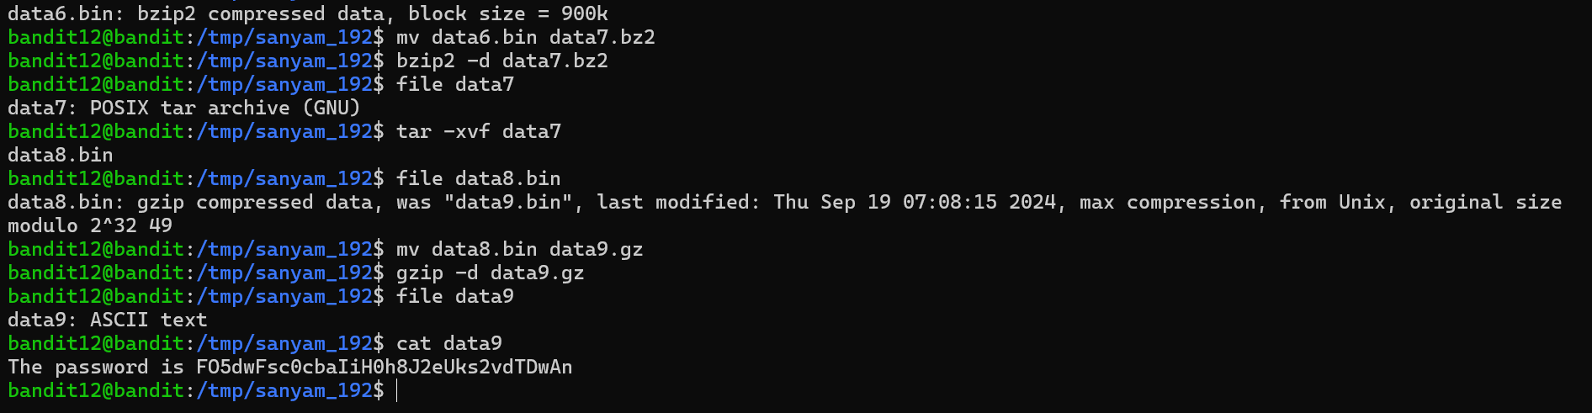**-------------------------------------------------------------------------------------**

**Level 13-14:**

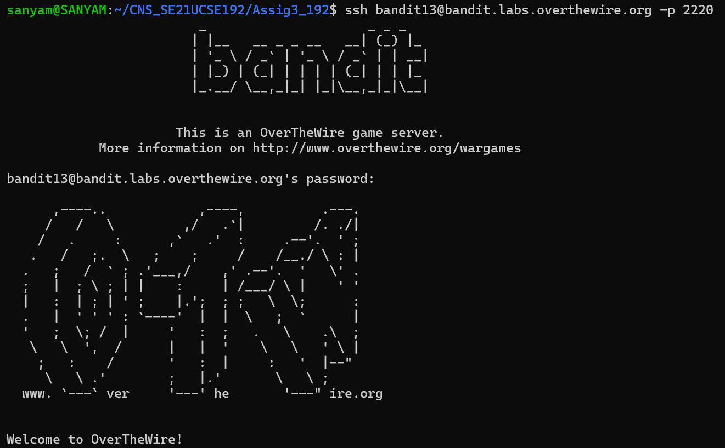

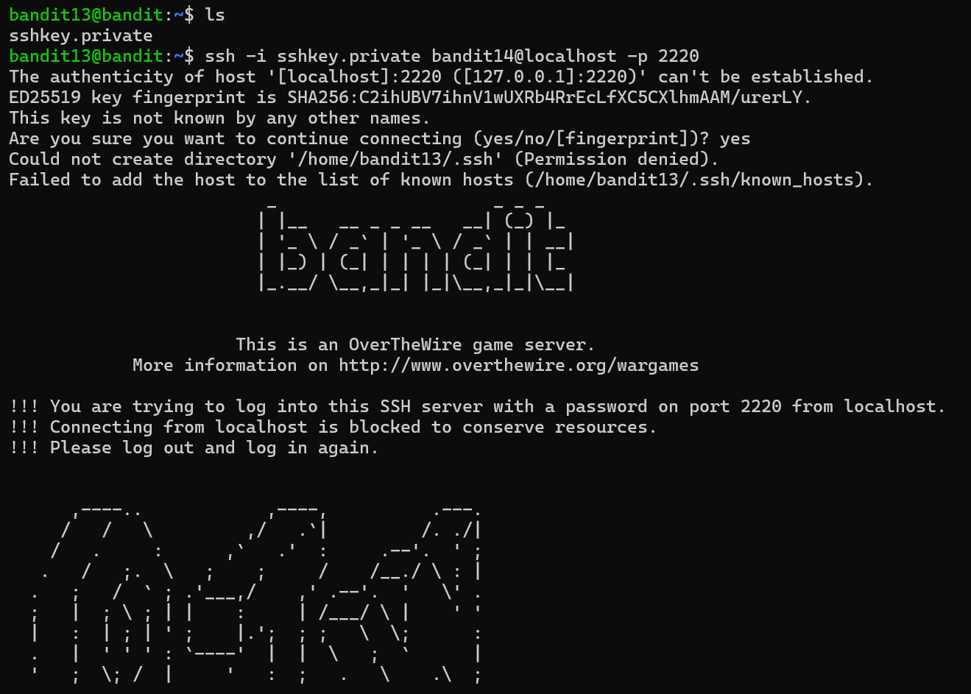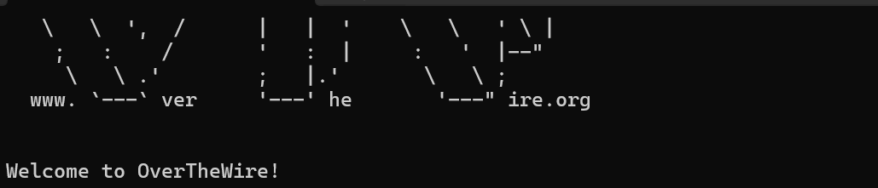**-----------------------------------------------------------------------------------------------------------------**

**Level 14-15:**

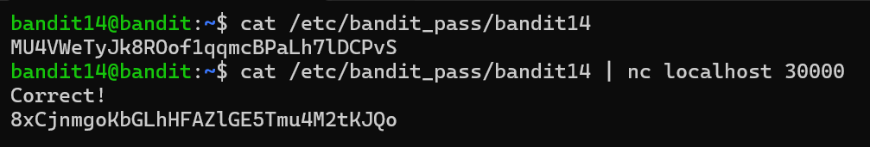**-------------------------------------------------------------------------------------**

**Level 15-16:**

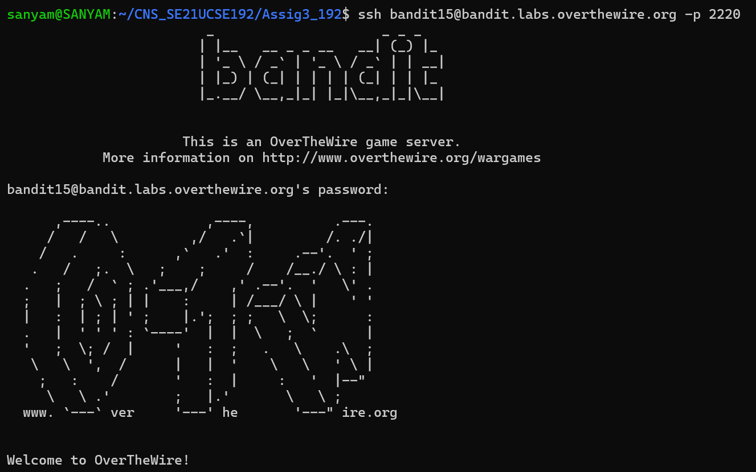

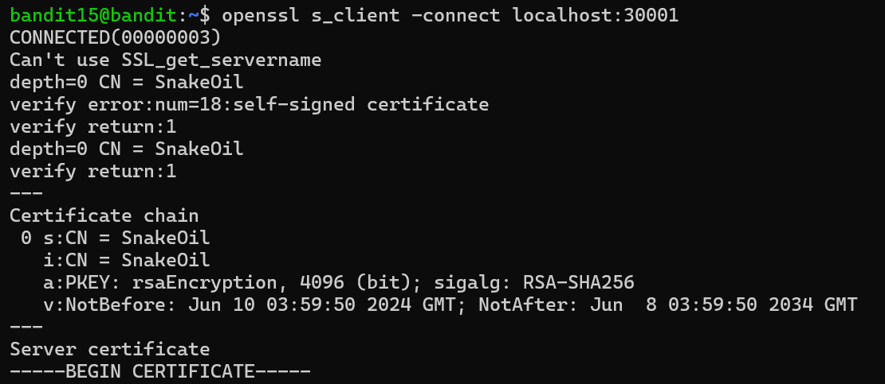 **..................**

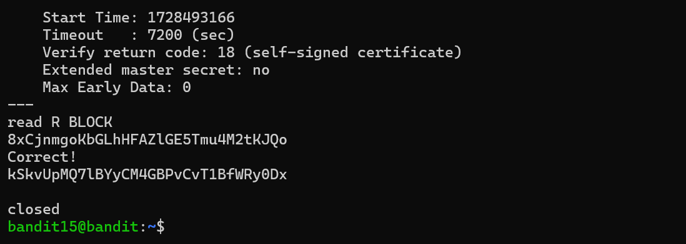

* **Login Verification:** My unique identifier **SE21UCSE192** is visible during each new SSH connection from **bandit0@bandit** to **bandit15@bandit**, confirming that I personally initiated and completed each level.
* **Bandit Level 13 → Level 14:**  
  The password for the next level is not provided. Instead, a **private SSH key** was used to log into **bandit14@localhost**. This allowed me to connect directly to Level 14 without needing a password, as per the level's goal.

**______________________END________________________**