PROJECT TIMBANG
A Verified Daily Vegetable Price Board and Produce Marketplace
for Nueva Vizcaya
Alamin ang presyo bago magbenta. · Know the price before you sell.
A Final Project
Presented to the Faculty of the College of Arts and Sciences
Nueva Vizcaya State University, Bayombong, Nueva Vizcaya
In Partial Fulfillment of the Requirements in
IT ECC 6 – Application Development and
CS PC 7 – Information Assurance and Technology
AARON ANTHONY A. GANO II
BS Computer Science (Robotics)
November 2026

TABLE OF CONTENTS
1. What is TIMBANG?
2. Why it is needed
3. Who it is for
4. Screenshots
5. How a price earns its trust label
6. Features in this build
7. Design
8. Security and privacy
9. Testing
10. Tech stack
11. Repository layout
12. Getting started
13. Documentation
14. Status
15. About
Appendices
Appendix A. Code Snippets
Appendix B. Approved Letter
Appendix C. Copy of Assessment Form
Appendix D. Copy of System Evaluation Form
Appendix E. Documentation

1. What is TIMBANG?
Timbang is Filipino for "to weigh." Before selling, a farmer weighs the price, the buyer and their options. TIMBANG gives them what they need to do that:
• A daily price bulletin for the whole province. Opening the app shows every vegetable across all markets in Nueva Vizcaya: the typical price, the range between markets, the change since yesterday in pesos, when it was last updated, and how much the price can be trusted (High / Medium / Low).
• Switch to any municipality. The header works like the town switcher in One Vizcaya: tap Prices in · All of Nueva Vizcaya and pick one of the 15 towns to see its own market(s). The choice is remembered on the phone, and the produce listings follow it.
• Market comparison: the same vegetable across nearby markets, so a farmer can see where it sells best.
• Produce listings: farmers post what they are harvesting, and buyers contact them directly.
• Price alerts: a notification when the price crosses a level the user chose.
• SMS price check: PRESYO KAMATIS BAYOMBONG returns the latest median price, even on a basic phone.
• Works offline: the last price board stays readable without signal, and listings posted offline are sent when the phone reconnects.

2. Why it is needed
Small farmers often sell without knowing the current market price, so the price is often set by whoever is buying. The existing sources fall short:
Source | Gap
DA Bantay Presyo | Retail and consumer focused; reported to be Metro Manila centered
PSA Farm Price Survey | Periodic statistics, not daily
Facebook groups | Unverified and hard to search

TIMBANG adds local, daily prices with a trust label, and a direct route to buyers.
Design principles. Every feature has to be:
1. Timely: updated daily and always showing its age.
2. Local: the user's own market and nearby ones first.
3. Trusted: every price shows its source and a confidence label.
4. Actionable: a price comes with a way to reach a buyer.
5. Accessible: works offline and by SMS, and on low-end Android phones.
6. Complementary: traders are buyers too. TIMBANG does not work against middlemen, who also provide transport and credit.
TIMBANG only reports observed prices. It never sets or enforces prices.

3. Who it is for
Role | Who | What they can do
Magsasaka (farmer) | Vegetable, rice, corn and fruit growers | Check and compare prices, post produce, answer buyer inquiries, set alerts, report prices
Mamimili (buyer) | Traders, vendors, restaurants, households, institutions | Check prices, search produce, ask farmers, set alerts
Tagapag-ulat (reporter) | Cooperative officers, LGU market monitors, approved by an admin | Submit verified price reports that carry more weight
Admin | Provincial / municipal agriculture office staff | Manage the commodity and market lists, import official prices, approve reporters, moderate content, view pilot metrics

People sign up with their phone number (one-time SMS code) and choose farmer or buyer. Reporter and admin roles are granted only by an admin.

4. Screenshots
Mobile app: first-launch language choice, the province-wide bulletin (the default), the municipality switcher, and one town's bulletin
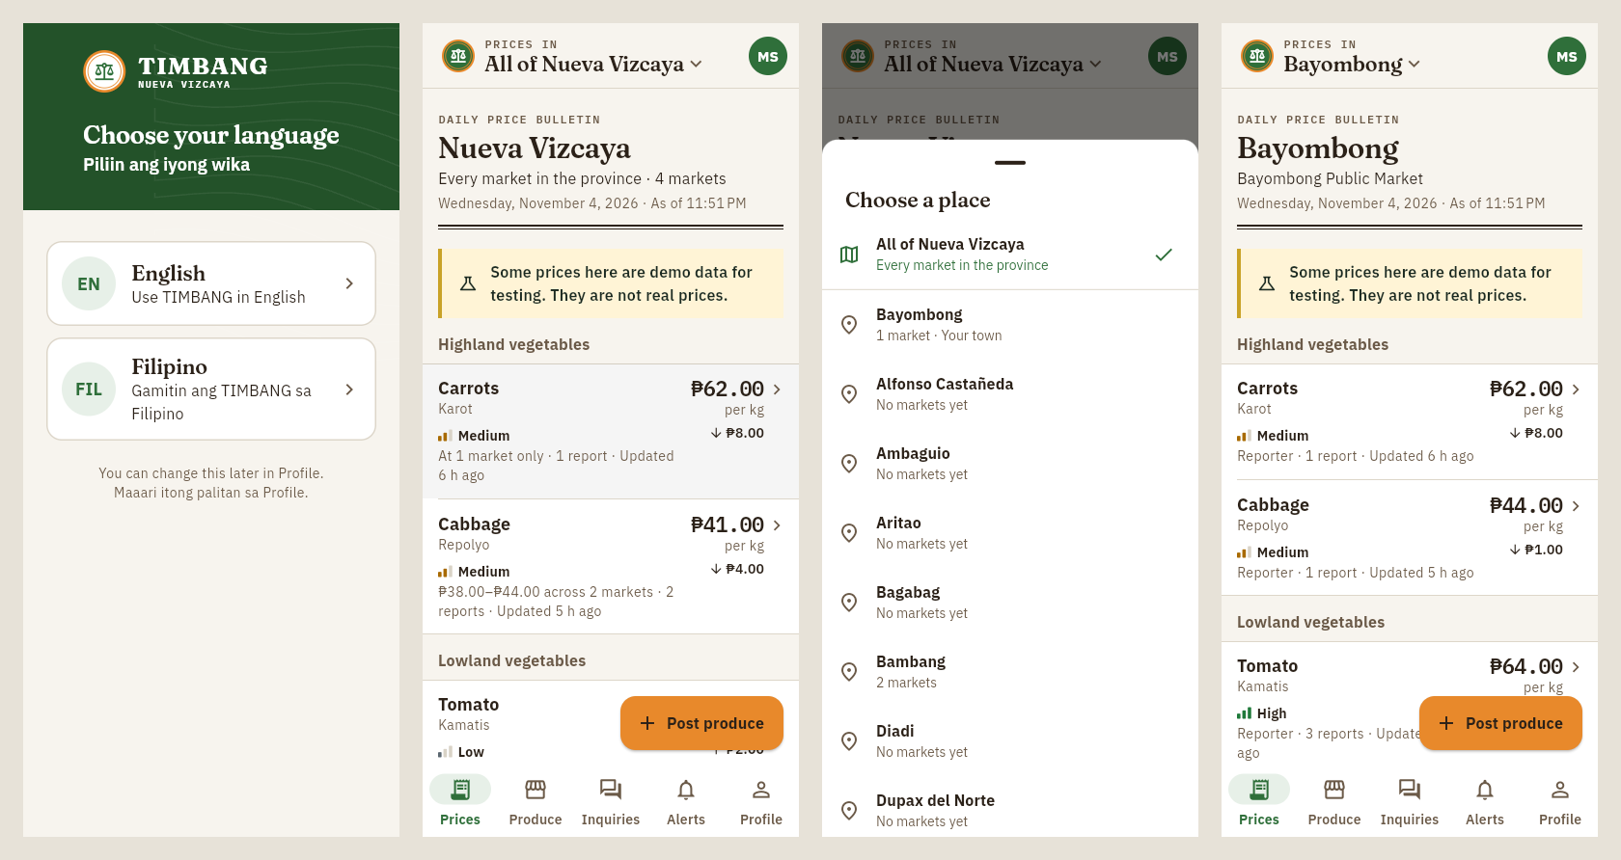
Figure 1. Province bulletin and municipality switcher
Services, market comparison for one vegetable, and an admin's Profile (the admin dashboard button comes first)
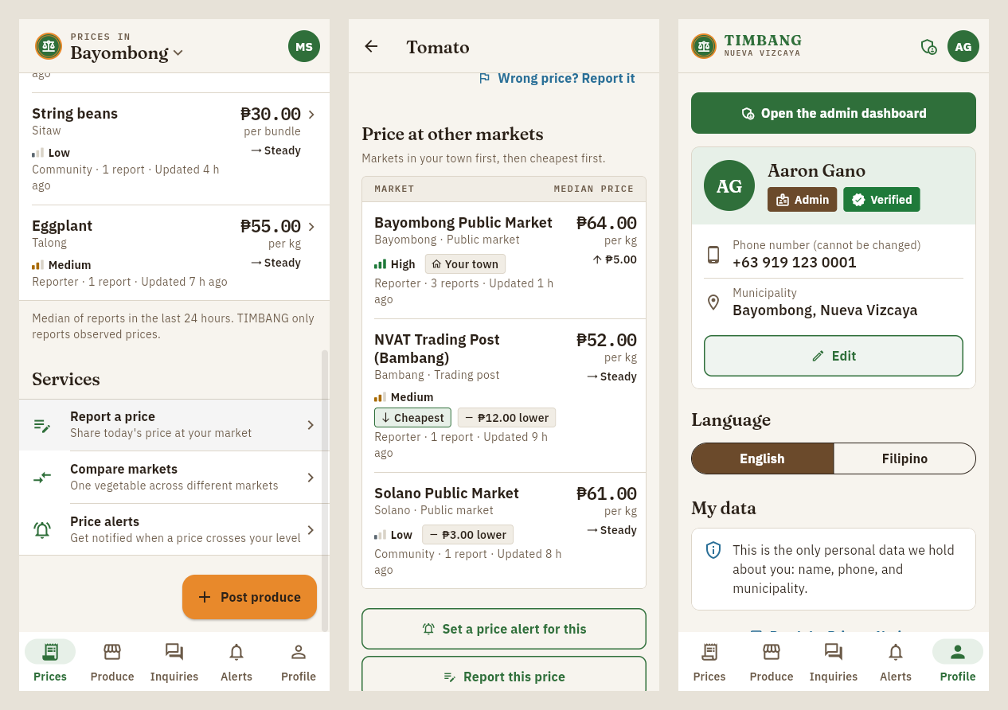
Figure 2. Services, comparison and admin profile
Website: public landing page
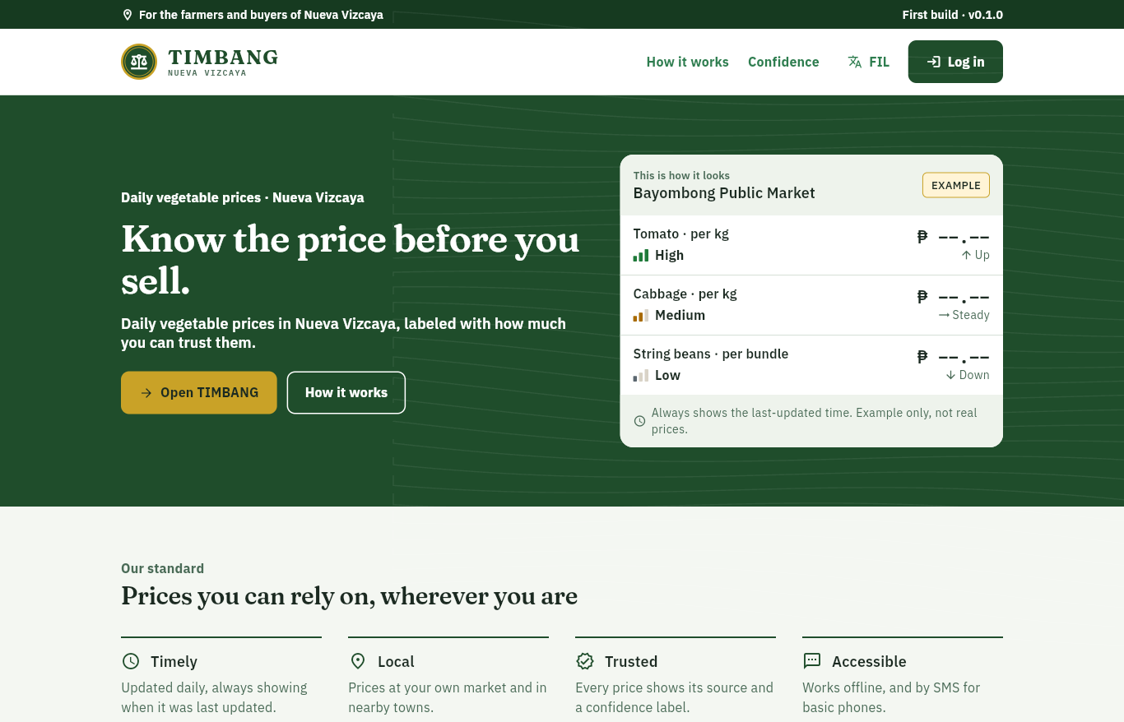
Figure 3. TIMBANG website
Admin dashboard: overview and pilot metrics, the commodity list (Excel or CSV import), and the SMS simulator
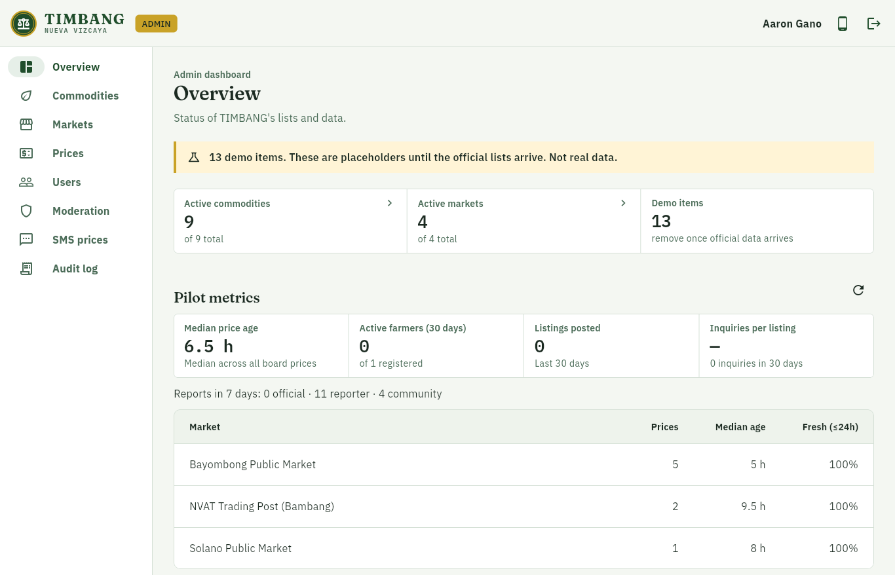
Figure 4. Admin overview and pilot metrics
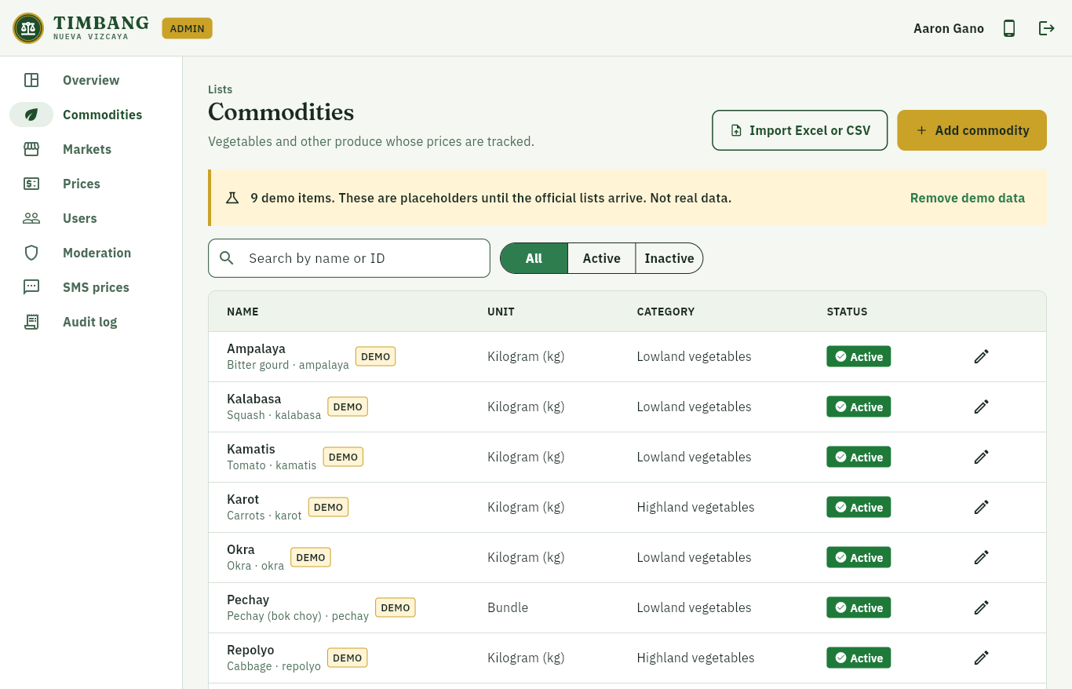
Figure 5. Admin commodities
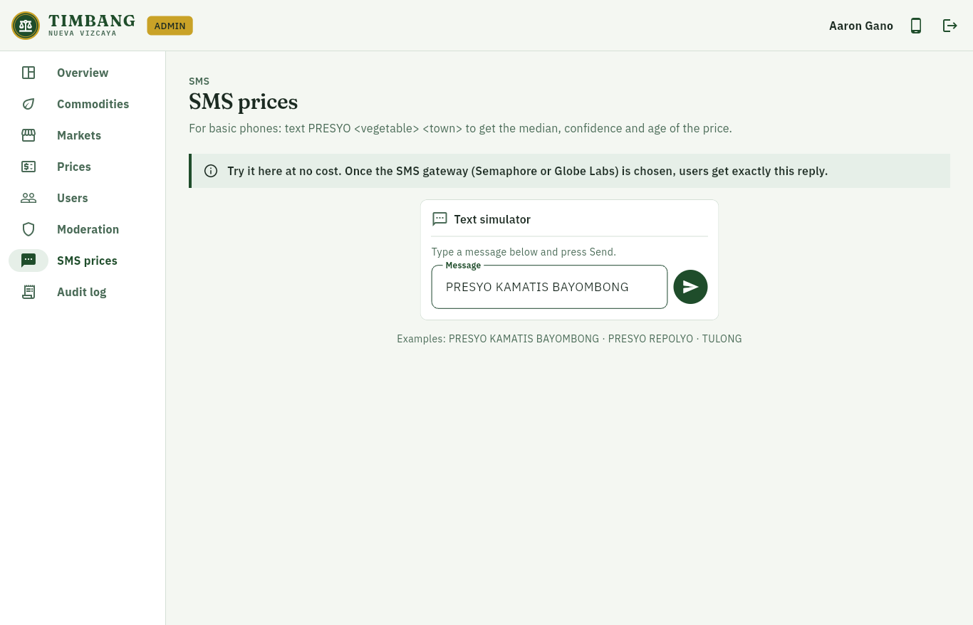
Figure 6. Admin SMS simulator
The screenshots use demo data (marked DEMO in the app). They are not real prices.

5. How a price earns its trust label
Each price on the board is computed by a Cloud Function every time a new report arrives (functions/src/confidence.ts, fully unit-tested):
1. It takes the median of the last 24 hours of reports, never the average or the latest single report.
2. Reports more than 30% away from the median are set aside as outliers and queued for admin review. Official reports are never set aside.
3. It assigns a confidence label:
Label | When
Mataas (High) | An official price (DA / DAR / NVAT), or 3+ agreeing reports including a verified reporter
Katamtaman (Medium) | Reports from verified reporters
Mababa (Low) | Community reports only, until they are confirmed

4. The trend compares the median with the previous day's (within ±3% counts as no change).
5. With no new report in 24 hours, the price stays visible, marked "Luma na" (stale), and its age is always shown.
The source of each price is shown as Opisyal (official), Tagapag-ulat (reporter) or Komunidad (community).
Province view (the default home screen). Each vegetable is summarised across the markets that have a price for it today:
• Price: the median of the markets' medians, so one market cannot pull it alone.
• Range: lowest to highest market price, and how many markets reported.
• Confidence: the lowest among those markets, so the province view never overstates trust.
• Change: the same median, compared with yesterday's.
Tap a vegetable to see each market separately.

6. Features in this build
Area | Included
Accounts | Phone OTP login, farmer/buyer self sign-up, profile, RA 10173 consent, view or copy my data, delete account
Prices | Province-wide bulletin by default; municipality switcher in the header (remembered on the phone); per-market board, market comparison, change since yesterday, confidence, source, age, stale label, offline cache
Reporting | Anyone can report a price; reporters count as verified; rate limits; outlier handling
Listings | Post produce (quantity, price, harvest date, town, photos), browse, filter, sort, mark sold, renew, automatic 14-day expiry
Inquiries | One message to the farmer, push notification, call/text buttons, inbox with unread badge
Alerts | Notification when the median crosses the user's price (once per crossing)
Admin | Works on the website and inside the mobile app (Profile → Open the admin dashboard, or the shield icon in the header). Commodities and markets (forms, Excel or CSV import), official price import (file or one price at a time), users and roles, reporter market assignment, moderation and user flags, audit log, pilot metrics, SMS simulator
SMS | PRESYO <gulay> <bayan> query behind a swappable gateway (mock for now; Semaphore or Globe Labs later)
Language | English by default; English or Filipino chosen on first launch, changeable in Profile

7. Design
The look is a mix of an official printed price bulletin and a civic service app:
• Bulletin layout: each screen opens with a masthead (place, date, "as of" time) over a double rule, and prices sit in full-width ruled lists grouped by category, without cards.
• Light header: the header sits on the page with a thin rule, not a solid green bar. It holds the seal, the municipality switcher and the profile.
• Trust meter: confidence is a 3-bar meter plus the word (▮▮▮ High, ▮▮▯ Medium, ▮▯▯ Low), so it never depends on color alone.
• Services list: plain rows (report a price, compare markets, price alerts), each with one sentence saying what it does. Farmers also get one Post produce button.
• Type: Fraunces (headlines and wordmark), IBM Plex Sans (text) and IBM Plex Mono (prices and data labels, like the readout of a weighing scale). All three include the peso sign and Filipino letters.
• Accessible: text contrast at least 4.5:1 (checked in tests), touch targets at least 48 dp, screen-reader labels on prices, trends and trust meters.
• Language: English by default. English or Filipino is chosen on first launch and can be changed in Profile or with the EN/FIL button on the website.
Not part of TIMBANG (by design): online payments or wallets, delivery and hauling, bookings, ratings, open chat, shopping carts, and any price setting.

8. Security and privacy
Security is graded for CS PC 7, so it is built in from the start:
• Deny-by-default Firestore and Storage rules, with tests for every collection (100+ rules tests).
• Roles live in Firebase custom claims set only by an admin-only function, never by the app itself. Typing role: admin into a Firestore document does nothing; the first admin is set with npm run seed:admin (see below). Reporters and admins are approved by an admin, which is what the Verified tag means. In this prototype the first admin is verified immediately. A fuller ID and endorsement check is planned for the pilot.
• Prices are only written by the server. It sets each report's trust tier and rate-limits submissions.
• Every admin action is recorded in an audit log.
• App Check, a signed SMS webhook, phone numbers hashed and masked in logs, and no analytics.
• Data Privacy Act of 2012 (RA 10173): only name, phone and town are collected. The privacy notice opens as its own full screen; I agree only unlocks after reading to the end. Users can view, copy and delete their data.
See docs/threat-model.md (STRIDE) and docs/security-checklist.md (OWASP MASVS).

9. Testing
Every part of the system has automated tests, run against the Firebase Local Emulator Suite. Last full run: November 11, 2026, 393 tests, all passed.
Test suite | What it checks | Tests
App (flutter_test) | Screens, price board, imports, accessibility (text contrast, touch target size, labels), language | 106
Cloud Functions (Jest) | Price confidence, roles, reports, imports, listings, inquiries, alerts, SMS, account deletion | 166
Security rules (@firebase/rules-unit-testing) | Allowed and denied reads and writes for every collection and for Storage | 103
Integration (Node test runner) | End-to-end function calls on the emulators: prices, roles, catalog, inquiries, SMS, admin | 18
Total |  | 393

10. Tech stack
Layer | Technology
App and website | Flutter (Android + web), Material 3, Riverpod, go_router; two themes from one token file: Harvest Earth (app) and Forest and Gold (website)
Auth | Firebase Authentication (phone OTP) + custom claims
Database | Cloud Firestore with offline persistence
Server logic | Cloud Functions for Firebase (TypeScript, asia-southeast1)
Files | Cloud Storage (compressed listing photos)
Notifications | Firebase Cloud Messaging
Integrity | Firebase App Check
SMS | SmsGateway interface (mock now; Semaphore or Globe Labs later)
Fonts | Fraunces, IBM Plex Sans, IBM Plex Mono (SIL OFL), bundled so they work offline
Tests and CI | flutter_test, Jest, @firebase/rules-unit-testing, emulator integration tests, GitHub Actions

Phone / browser ──► Firebase Auth (phone OTP)
│
├──► Firestore (rules-protected) ◄── Cloud Functions ──► FCM push
│ ▲ ▲
└──► Callable functions (reports, inquiries, admin)
│
Basic phone ──SMS──► gateway ──► smsWebhook ────┘

11. Repository layout
Path | Contents
app/ | Flutter app. lib/main_app.dart is the mobile app, lib/main_web.dart the website + admin
functions/ | Cloud Functions: price board, alerts, inquiries, roles, moderation, SMS
firestore.rules, storage.rules | Security rules (deny by default)
tests/rules/, tests/integration/ | Rules tests and emulator integration tests
scripts/ | Local tools: first admin, demo data, emulators on your Wi-Fi
docs/ | Guides and design notes (see below)

12. Getting started
Requirements: Flutter 3.47+, Node 22, Java 21, npm i -g firebase-tools.
npm install && npm --prefix functions install
npm run emulators # local Firebase: Auth, Firestore, Functions, Storage (UI at :4000)

# in another terminal
FIRESTORE_EMULATOR_HOST=127.0.0.1:8080 npm run seed:demo # demo data (marked DEMO)

cd app && flutter pub get
flutter run -t lib/main_app.dart # mobile app
flutter run -d chrome -t lib/main_web.dart # website + admin

Debug builds connect to the local emulators automatically. Login codes are shown in the Emulator UI (Authentication tab); no SMS is sent. To make yourself admin, sign in once, then run the command below, sign out and sign in again. The app then shows Open the admin dashboard at the top of Profile.
FIREBASE_AUTH_EMULATOR_HOST=127.0.0.1:9099 FIRESTORE_EMULATOR_HOST=127.0.0.1:8080 \
npm run seed:admin -- +639171234567

Demo logins on the real Firebase project (no SMS cost): Firebase console → Authentication → Sign-in method → Phone → Phone numbers for testing, e.g. +63 917 000 0001 with code 123456. Remove them, or keep them private, before the pilot.
Lists and prices after the build, from a phone: the commodity, market and price lists live in the database, not in the code, so no rebuild is needed. Admins add or edit them in the app (Profile → Open the admin dashboard) or on the website, one at a time or by importing the office's Excel (.xlsx) or CSV file as it is:
• names are enough (IDs are made from them), in Filipino or English;
• title rows above the header and section headings (e.g. HIGHLAND VEGETABLES) are skipped, and a heading becomes the category of the rows under it;
• units such as per kilo, tali or pcs are understood;
• price sheets can have one row per price, or one column per market.
Order: import the markets, then the commodities, then the prices. Editing needs an internet connection (each change is checked and logged by the server); reading the price board works offline. An empty list shows an Add the list button for admins.
Tests
npm run test:rules # Firestore + Storage rules
npm --prefix functions test # Cloud Functions unit tests
npm run test:integration # functions against the emulators
cd app && flutter analyze && flutter test

Building and deploying: docs/BUILD.md (Firebase project, deploy, website) and docs/APK_BUILD.md (Android APK checklist and troubleshooting).

13. Documentation
Document | What it covers
docs/SETUP_CHECKLIST.txt | One-page checklist (Notepad): PC setup → test on your phone → real Firebase project → pilot
docs/BUILD.md | Firebase project setup, deploy, website, first admin
docs/APK_BUILD.md | Building and installing the Android APK
docs/data-model.md | Firestore collections, fields and rules
docs/sms.md | SMS price query and adding a real gateway
docs/threat-model.md | STRIDE threat model
docs/security-checklist.md | OWASP MASVS checklist
docs/pilot-metrics.md | What the pilot measures
docs/usability-sus.md | Usability test tasks and SUS questionnaire (Filipino/English)
docs/templates/ | CSV templates for commodities and markets

14. Status
First build (v0.1.1): working prototype. All MVP features are built and tested against the Firebase emulators.
• Data: the commodity, market and price lists shown are demo data. The official lists from DA, DAR and NVAT have been requested through the Office of the Governor; when they arrive, admins import them from Excel or CSV, or type them in, with no code changes.
• SMS: the gateway (Semaphore or Globe Labs) has not been chosen yet. SMS works through the mock gateway and the admin simulator.
• Pilot plan: one public market (likely Bayombong) and one farmer group for about 4 weeks.
TIMBANG is an independent student project. It is not yet affiliated with or endorsed by the Provincial Government of Nueva Vizcaya, DA, DAR or NVAT.

15. About
Developed by Aaron Anthony A. Gano II, BS Computer Science (Robotics), Nueva Vizcaya State University, Bayombong, as a joint requirement of IT ECC 6 – Application Development and CS PC 7 – Information Assurance and Technology.
Typefaces, all under the SIL Open Font License and bundled in app/assets/fonts: Fraunces for headlines and the wordmark, IBM Plex Sans for text, and IBM Plex Mono for prices and data labels (like the readout of a weighing scale).

APPENDIX A
CODE SNIPPETS

Appendix A. Code Snippets
This appendix presents selected source code of Project TIMBANG. The snippets were chosen because they implement the core of the system: how a daily price and its confidence label are computed, how data and roles are protected, how prices are submitted and imported, and how the province-wide price bulletin is produced. The mobile application and website are written in Dart (Flutter); the server logic is written in TypeScript (Cloud Functions for Firebase); access control is written in the Firestore Security Rules language. The complete source code is available in the project repository (github.com/MysteriousAlarm/Timbang).
Snippet A.1. Median price, outlier handling and confidence label
Source file: functions/src/confidence.ts
The price shown on the board is the median of the last 24 hours of reports, never the average or the latest single report. Reports more than 30% away from the median are set aside as outliers (official prices are never set aside), and the confidence label is assigned from the sources that remain.
export function median(values: number[]): number {
if (values.length === 0) throw new Error('median of empty list');
const s = [...values].sort((a, b) => a - b);
const mid = Math.floor(s.length / 2);
const m = s.length % 2 ? s[mid] : (s[mid - 1] + s[mid]) / 2;
return Math.round(m * 100) / 100;
}

const deviation = (price: number, m: number) => Math.abs(price - m) / m;

/**
* Splits reports into valid and outlier around the median.
* - Rejected reports are ignored entirely (an admin decision).
* - Official reports are never outliers: they are the reference.
* - If every non-official report would be an outlier, none are marked
* (e.g. two disagreeing reports): there is no majority to trust.
*/
export function markOutliers(reports: CalcReport[]): {
valid: CalcReport[];
outliers: CalcReport[];
median: number;
} {
const candidates = reports.filter((r) => r.status !== 'rejected');
if (candidates.length === 0) return { valid: [], outliers: [], median: NaN };
const first = median(candidates.map((r) => r.price));
const outliers = candidates.filter(
(r) => r.source !== 'official' && deviation(r.price, first) > OUTLIER_THRESHOLD,
);
if (outliers.length === candidates.length) {
return { valid: candidates, outliers: [], median: first };
}
const valid = candidates.filter((r) => !outliers.includes(r));
return { valid, outliers, median: median(valid.map((r) => r.price)) };
}

export function classifyConfidence(valid: CalcReport[], m: number): Confidence {
if (valid.some((r) => r.source === 'official')) return 'high';
const agreeing = valid.filter((r) => deviation(r.price, m) <= AGREEMENT_THRESHOLD);
if (agreeing.length >= 3 && agreeing.some((r) => r.source === 'reporter')) return 'high';
if (valid.some((r) => r.source === 'reporter')) return 'medium';
return 'low';
}

Snippet A.2. Deny-by-default security rules and self sign-up validation
Source file: firestore.rules
Roles are read only from verified custom claims on the login token, never from data the app writes. A new user may only create their own profile as a farmer or buyer, with the phone number that was verified by SMS, and only the fields allowed under data minimization (RA 10173).
rules_version = '2';

// Project TIMBANG Firestore rules.
// Deny by default. Roles come ONLY from custom claims (request.auth.token.role),
// which are set by the admin-only `setUserRole` Cloud Function.
// The `role` field in users/{uid} is a display mirror and is never trusted here.
service cloud.firestore {
match /databases/{database}/documents {

// ---------- helpers ----------
function signedIn() {
return request.auth != null;
}
function claimRole() {
return signedIn() && ('role' in request.auth.token) ? request.auth.token.role : null;
}
function isAdmin() {
return claimRole() == 'admin';
}
function isOwner(uid) {
return signedIn() && request.auth.uid == uid;
}

// The 15 municipalities of Nueva Vizcaya (keep in sync with app core/config and functions config.ts).
function municipalities() {
return ['Alfonso Castañeda', 'Ambaguio', 'Aritao', 'Bagabag', 'Bambang',
'Bayombong', 'Diadi', 'Dupax del Norte', 'Dupax del Sur', 'Kasibu',
'Kayapa', 'Quezon', 'Santa Fe', 'Solano', 'Villaverde'];
}
function validName(v) {
return v is string && v.trim().size() >= 2 && v.size() <= 80;
}
function validMunicipality(v) {
return v is string && v in municipalities();
}
function validFcmTokens(v) {
return v is list && v.size() <= 10;
}

// ---------- users ----------
// Data minimization (RA 10173): only name, phone, municipality are personal data.
match /users/{uid} {
allow read: if isOwner(uid) || isAdmin();

// Self-signup: only farmer or buyer, unverified, active. Phone must match the
// verified phone on the auth token, so nobody can claim another number.
allow create: if isOwner(uid)
&& request.resource.data.keys().hasOnly(
['name', 'phone', 'municipality', 'role', 'verified', 'status',
'createdAt', 'consentAt', 'fcmTokens'])
&& request.resource.data.keys().hasAll(
['name', 'phone', 'municipality', 'role', 'verified', 'status',
'createdAt', 'consentAt'])
&& validName(request.resource.data.name)
&& request.resource.data.phone is string
&& request.resource.data.phone == request.auth.token.phone_number
&& validMunicipality(request.resource.data.municipality)
&& request.resource.data.role in ['farmer', 'buyer']
&& request.resource.data.verified == false
&& request.resource.data.status == 'active'
&& request.resource.data.createdAt == request.time
&& request.resource.data.consentAt == request.time
&& (!('fcmTokens' in request.resource.data) || validFcmTokens(request.resource.data.fcmTokens));

Snippet A.3. Admin-only role assignment with audit logging
Source file: functions/src/roles.ts
Only an administrator can grant a role. Every change is written to the audit log, and an administrator cannot accidentally remove their own admin role.
/**
* Admin-only: set a user's role custom claim.
* Clients can never set their own role; this is the only path that writes the claim.
*/
export async function setUserRoleHandler(
caller: Caller | undefined,
data: unknown,
deps: RoleDeps,
): Promise<{ uid: string; role: Role }> {
if (!caller) throw new HttpsError('unauthenticated', 'Sign in first.');
if (caller.role !== 'admin') throw new HttpsError('permission-denied', 'Admins only.');

const { uid, role } = parseSetUserRoleInput(data);
if (uid === caller.uid && role !== 'admin') {
// Prevents an admin from locking the province out by accident.
throw new HttpsError('failed-precondition', 'Admins cannot remove their own admin role.');
}

const existing = await deps.getClaims(uid);
if (existing === null) throw new HttpsError('not-found', 'User not found.');

const previous = typeof existing.role === 'string' ? existing.role : 'none';
await deps.setClaims(uid, { ...existing, role });
// reporter/admin are vetted by an admin, so they are marked verified.
await deps.mirrorRole(uid, role, role === 'reporter' || role === 'admin');
await deps.audit({
actorId: caller.uid,
action: 'set_user_role',
targetPath: `users/${uid}`,
detail: `${previous} -> ${role}`,
});
return { uid, role };
}

Snippet A.4. Server-side price report validation and rate limiting
Source file: functions/src/priceReports.ts
The trust tier of a report (reporter or community) is decided by the server from the user's role, so it cannot be faked by the app. Each user is limited to 20 reports per hour, and repeated reports of the same item and market within 10 minutes are refused.
/** Source tier comes from the verified role claim, never from the client. */
export function sourceFor(role: unknown): Source {
return role === 'reporter' || role === 'admin' ? 'reporter' : 'community';
}

/** Any signed-in user may report; reporters/admins count as verified, others as community. */
export async function submitPriceReportHandler(
caller: Caller,
data: unknown,
store: PriceStore,
): Promise<{ id: string; source: Source }> {
if (!caller) throw new HttpsError('unauthenticated', 'Sign in first.');
const d = (typeof data === 'object' && data !== null ? data : {}) as Record<string, unknown>;
const extra = Object.keys(d).filter((k) => !['commodityId', 'marketId', 'price'].includes(k));
if (extra.length) throw new HttpsError('invalid-argument', 'Unexpected fields.');
const { commodityId, marketId, price } = d;
if (typeof commodityId !== 'string' || !ID.test(commodityId)) {
throw new HttpsError('invalid-argument', 'Invalid commodityId.');
}
if (typeof marketId !== 'string' || !ID.test(marketId)) {
throw new HttpsError('invalid-argument', 'Invalid marketId.');
}
if (!validPrice(price)) {
throw new HttpsError(
'invalid-argument',
`price must be ${PRICE_MIN}-${PRICE_MAX}, 2 decimals.`,
);
}

const user = await store.getUser(caller.uid);
if (!user) throw new HttpsError('failed-precondition', 'Create your profile first.');
if (user.status !== 'active') throw new HttpsError('permission-denied', 'Account suspended.');

const [commodity, market] = await Promise.all([
store.getCommodity(commodityId),
store.getMarket(marketId),
]);
if (!commodity?.active) throw new HttpsError('not-found', 'Unknown or inactive commodity.');
if (!market?.active) throw new HttpsError('not-found', 'Unknown or inactive market.');

const source = sourceFor(caller.role);
const assigned = user.assignedMarketIds ?? [];
if (caller.role === 'reporter' && assigned.length > 0 && !assigned.includes(marketId)) {
throw new HttpsError('permission-denied', 'You are not assigned to this market.');
}

// Rate limits (Section 10): per hour, and no repeats of the same pair within a few minutes.
const now = store.now();
const recent = await store.reportsByUserSince(caller.uid, now - 60 * 60 * 1000);
if (recent.length >= REPORTS_PER_HOUR) {
throw new HttpsError('resource-exhausted', 'Too many reports. Try again later.');
}
const dupSince = now - DUPLICATE_REPORT_MINUTES * 60 * 1000;
if (
recent.some(
(r) => r.commodityId === commodityId && r.marketId === marketId && r.timestamp > dupSince,
)
) {
throw new HttpsError('already-exists', 'You just reported this. Try again later.');
}

const [id] = await store.addReports([
{
commodityId,
marketId,
price,
unit: commodity.unit,
reporterId: caller.uid,
reporterRole: typeof caller.role === 'string' ? caller.role : 'member',
source,
timestamp: now,
status: 'valid',
isDemo: false,
},
]);
return { id, source };
}

Snippet A.5. SMS webhook signature verification and number masking
Source file: functions/src/sms/gateway.ts
Incoming SMS messages are accepted only when their HMAC-SHA256 signature is valid, checked in constant time. Phone numbers are masked before anything is written to the logs.
export function hmacHex(secret: string, body: Buffer | string): string {
return createHmac('sha256', secret).update(body).digest('hex');
}

/** Constant-time HMAC check of `x-timbang-signature` over the raw body. Fails closed. */
export function verifyHmac(secret: string, body: Buffer | string, signature: unknown): boolean {
if (!secret || typeof signature !== 'string' || !/^[0-9a-f]{64}$/i.test(signature)) return false;
const expected = Buffer.from(hmacHex(secret, body), 'hex');
const got = Buffer.from(signature, 'hex');
return expected.length === got.length && timingSafeEqual(expected, got);
}

/** "+639171234567" -> "+63917***4567" for logs. Never log full numbers. */
export function maskNumber(n: string): string {
return n.length > 7 ? `${n.slice(0, 6)}***${n.slice(-4)}` : '***';
}

Snippet A.6. Province-wide price summary
Source file: app/lib/features/price_board/application/board_providers.dart
The home screen shows the whole province by default. Each vegetable is summarised across all markets: the median of the markets' medians, the price range, and the lowest confidence among those markets, so the province view never overstates how much a price can be trusted.
/// Summarises each commodity across active markets:
/// - price: the median of the markets' medians (one market cannot pull it alone);
/// - confidence: the LOWEST among those markets (never overstates trust);
/// - age: the newest report; counts and source tiers: summed;
/// - change: median of today vs median of yesterday where known (±3% = steady).
/// Only entries in the commodity's most common unit are combined, so kg and bundle never mix.
List<ProvinceRow> provinceRows(
List<BoardEntry> entries,
List<Commodity> commodities,
List<Market> markets,
) {
final activeMarkets = {
for (final m in markets)
if (m.active) m.id,
};
final byCommodity = <String, List<BoardEntry>>{};
for (final e in entries) {
if (activeMarkets.contains(e.marketId)) {
byCommodity.putIfAbsent(e.commodityId, () => []).add(e);
}
}
final rows = <ProvinceRow>[];
for (final c in commodities.where((c) => c.active)) {
final list = byCommodity[c.id];
if (list == null || list.isEmpty) continue;
final unitCount = <String, int>{};
for (final e in list) {
unitCount[e.unit] = (unitCount[e.unit] ?? 0) + 1;
}
final unit = unitCount.entries.reduce((a, b) => a.value >= b.value ? a : b).key;
final same = list.where((e) => e.unit == unit).toList();
final prices = [for (final e in same) e.medianPrice];
final median = _median(prices);
final prevs = [for (final e in same) ?e.previousMedian];
final prev = prevs.isEmpty ? null : _median(prevs);
final trend = prev == null || prev == 0
? Trend.flat
: (median - prev) / prev > 0.03
? Trend.up
: (median - prev) / prev < -0.03
? Trend.down
: Trend.flat;
final lowest = same.map((e) => e.confidence).reduce((a, b) => a.index >= b.index ? a : b);
rows.add((
commodity: c,
markets: same.length,
low: prices.reduce((a, b) => a < b ? a : b),
high: prices.reduce((a, b) => a > b ? a : b),
entry: BoardEntry(
commodityId: c.id,
marketId: '',
unit: unit,
medianPrice: median,
confidence: lowest,
reportCount: same.fold(0, (n, e) => n + e.reportCount),
trend: trend,
latestReportAt: same.map((e) => e.latestReportAt).reduce((a, b) => a.isAfter(b) ? a : b),
previousMedian: prev,
official: same.fold(0, (n, e) => n + e.official),
reporter: same.fold(0, (n, e) => n + e.reporter),
community: same.fold(0, (n, e) => n + e.community),
isDemo: same.any((e) => e.isDemo),
),
));
}
rows.sort(
(a, b) => a.commodity.nameFil.toLowerCase().compareTo(b.commodity.nameFil.toLowerCase()),
);
return rows;
}

Snippet A.7. Reading official price sheets as the office prepares them
Source file: app/lib/features/reports/domain/official_csv.dart
Administrators can import the Excel or CSV file from the provincial agriculture office without reformatting it: vegetables and markets may be written by name, title rows are skipped, and both the "one row per price" and the "one column per market" layouts are accepted.
/// Reads an official price sheet as it comes from the office, in either layout:
/// - long: one row per price, with commodity, market and price columns (date optional);
/// - wide: one row per commodity and one column per market, each cell a price.
/// Commodities and markets may be written as their catalog ID or their name
/// ([commodityNames] / [marketNames] map [normKey] of a name to an ID).
/// Title rows above the header and sub-heading rows without prices are skipped.
OfficialImport parseOfficialTable(
List<List<String>> table, {
required Set<String> commodityIds,
required Set<String> marketIds,
Map<String, String> commodityNames = const {},
Map<String, String> marketNames = const {},
}) {
if (table.isEmpty) return const OfficialImport([]);
String? resolve(String raw, Set<String> ids, Map<String, String> names) {
final v = raw.trim().toLowerCase();
if (ids.contains(v)) return v;
final byName = names[normKey(raw)];
return byName != null && ids.contains(byName) ? byName : null;
}

int? findCol(List<String> keys, List<String> names) {
final i = keys.indexWhere(names.contains);
return i < 0 ? null : i;
}

bool looksLikeHeader(List<String> keys) =>
findCol(keys, _aliases['commodityId']!) != null &&
(keys.any(_isPrice) || keys.any((k) => resolve(k, marketIds, marketNames) != null));

final h = findHeaderRow(table, looksLikeHeader);
final keys = [for (final c in table[h]) normKey(c)];
final cCol = findCol(keys, _aliases['commodityId']!);
final mCol = findCol(keys, _aliases['marketId']!);
final dCol = findCol(keys, _aliases['date']!);
final pIdx = keys.indexWhere(_isPrice);
final pCol = pIdx < 0 ? null : pIdx;
// Wide layout: headers that are markets.
final marketCols = <int, String>{
for (var i = 0; i < keys.length; i++)
if (i != cCol && i != dCol && resolve(table[h][i], marketIds, marketNames) != null)
i: resolve(table[h][i], marketIds, marketNames)!,
};
final wide = mCol == null && marketCols.isNotEmpty;
final missing = [
if (cCol == null) 'commodityId',
if (!wide && mCol == null) 'marketId',
if (!wide && pCol == null) 'price',
];
if (missing.isNotEmpty) return OfficialImport(const [], headerIssues: missing);

Snippet A.8. Remembering the chosen municipality
Source file: app/lib/features/price_board/application/price_scope.dart
The place selected in the header (the whole province or one of the 15 municipalities) is saved on the device so the app opens to the same place the next time.
class PriceScopeController extends Notifier<String?> {
@override
String? build() {
final saved = ref.watch(savedPriceScopeProvider);
return AppConfig.municipalities.contains(saved) ? saved : null;
}

/// null = all of Nueva Vizcaya.
Future<void> choose(String? municipality) async {
state = AppConfig.municipalities.contains(municipality) ? municipality : null;
try {
final prefs = await SharedPreferences.getInstance();
await prefs.setString(_prefsKey, state ?? '');
} catch (_) {
// Not saved (private browser window): the choice still applies for this session.
}
}
}

final priceScopeProvider = NotifierProvider<PriceScopeController, String?>(
PriceScopeController.new,
);

APPENDIX B
APPROVED LETTER

Appendix B. Approved Letter
The signed and approved letter is attached on the following page.

Insert the scanned copy of the signed and approved letter here.
(In Word: delete this box, then Insert > Pictures and set the width to 6 inches.)

APPENDIX C
COPY OF ASSESSMENT FORM

PROJECT TIMBANG
Usability Assessment Form (System Usability Scale)
Talatanungan sa Paggamit ng Sistema
Instructions / Panuto: This form is answered after you try TIMBANG. Your answers are used only for this study and are kept confidential under the Data Privacy Act of 2012 (RA 10173). You may stop at any time. / Sagutan ito pagkatapos subukan ang TIMBANG. Gagamitin lamang ang iyong sagot para sa pag-aaral na ito at mananatiling kumpidensiyal.
Part I. Respondent Profile / Impormasyon ng Sumasagot
Name (optional) / Pangalan: | Date / Petsa:
Municipality / Bayan: | Age / Edad: ☐ below 25 ☐ 25–40 ☐ 41–60 ☐ above 60
Role / Tungkulin: ☐ Farmer / Magsasaka ☐ Buyer / Mamimili ☐ Agriculture staff | Phone used / Telepono: ☐ Smartphone ☐ Basic phone
Times you sell or buy produce per week: | Evaluator / Tagasuri:

Part II. Test Tasks / Mga Gawain (to be filled in by the evaluator)
No. | Task / Gawain | Done without help | Done with help | Not done | Time (min)
1 | Log in with your mobile number. / Mag-log in gamit ang iyong numero. | ☐ | ☐ | ☐
2 | Find today's price of tomato (kamatis). How old is it? / Hanapin ang presyo ng kamatis ngayon. Gaano ito katagal na? | ☐ | ☐ | ☐
3 | Switch to your municipality and compare the price with other markets. / Pumili ng iyong bayan at ihambing ang presyo sa ibang palengke. | ☐ | ☐ | ☐
4 | Farmer: post your produce. Buyer: send a question about a listing. / Magsasaka: mag-post ng ani. Mamimili: magtanong tungkol sa isang ani. | ☐ | ☐ | ☐
5 | Set a price alert. / Mag-set ng alerto sa presyo. | ☐ | ☐ | ☐
6 | Basic phone: text PRESYO KAMATIS BAYOMBONG. / I-text ang PRESYO KAMATIS BAYOMBONG. | ☐ | ☐ | ☐

Part III. System Usability Scale / Antas ng Kadalian ng Paggamit
Put a check (✓) on the number that shows how much you agree. / Lagyan ng tsek (✓) ang numerong tumutugma sa iyong pagsang-ayon. 1 – Strongly disagree / Lubos na hindi sang-ayon 2 – Disagree / Hindi sang-ayon 3 – Neutral / Walang kinikilingan 4 – Agree / Sang-ayon 5 – Strongly agree / Lubos na sang-ayon
No. | Statement / Pahayag | 1 | 2 | 3 | 4 | 5
1 | I would like to use TIMBANG frequently.  Gusto kong gamitin ang TIMBANG nang madalas. | ☐ | ☐ | ☐ | ☐ | ☐
2 | I found TIMBANG unnecessarily complex.  Masyadong komplikado ang TIMBANG. | ☐ | ☐ | ☐ | ☐ | ☐
3 | I thought TIMBANG was easy to use.  Madaling gamitin ang TIMBANG. | ☐ | ☐ | ☐ | ☐ | ☐
4 | I would need the help of a technical person to be able to use TIMBANG.  Kakailanganin ko ng tulong ng ibang tao para magamit ito. | ☐ | ☐ | ☐ | ☐ | ☐
5 | I found the various functions in TIMBANG were well integrated.  Magkakaugnay nang maayos ang mga bahagi nito. | ☐ | ☐ | ☐ | ☐ | ☐
6 | I thought there was too much inconsistency in TIMBANG.  Masyadong maraming hindi pagkakatugma sa app. | ☐ | ☐ | ☐ | ☐ | ☐
7 | I would imagine that most people would learn to use TIMBANG very quickly.  Mabilis itong matututunan ng karamihan. | ☐ | ☐ | ☐ | ☐ | ☐
8 | I found TIMBANG very cumbersome to use.  Mabigat o mahirap itong gamitin. | ☐ | ☐ | ☐ | ☐ | ☐
9 | I felt very confident using TIMBANG.  Kumpiyansa ako habang ginagamit ito. | ☐ | ☐ | ☐ | ☐ | ☐
10 | I needed to learn a lot of things before I could get going with TIMBANG.  Marami akong kailangang matutunan bago ito magamit. | ☐ | ☐ | ☐ | ☐ | ☐

Part IV. Comments and Suggestions / Puna at Mungkahi
What did you like most? / Ano ang pinakanagustuhan mo?
______________________________________________________________________
______________________________________________________________________
What was difficult or confusing? / Ano ang mahirap o nakalilito?
______________________________________________________________________
______________________________________________________________________
What should be added or changed? / Ano ang dapat idagdag o baguhin?
______________________________________________________________________
______________________________________________________________________

______________________________  Signature of respondent / Lagda ng sumasagot | ______________________________  Signature of evaluator / Lagda ng tagasuri

Scoring Guide (for the researcher)
The System Usability Scale (Brooke, 1996) gives one score from 0 to 100 per respondent. Compute it as follows:
1. For each odd-numbered item (1, 3, 5, 7, 9): subtract 1 from the answer.
2. For each even-numbered item (2, 4, 6, 8, 10): subtract the answer from 5.
3. Add the ten results and multiply the sum by 2.5.
SUS score | Interpretation
above 80.3 | Excellent (grade A)
68 to 80.3 | Good, above average
68 | Average
51 to 67 | Below average, needs improvement
below 51 | Poor

Report the mean, median and range of the SUS scores per group (farmers, buyers, agriculture staff), the task completion rate (done without help ÷ respondents), the average time per task, and a summary of the comments. The target for the pilot is a mean SUS score of at least 70.
Reference: Brooke, J. (1996). SUS: A "quick and dirty" usability scale. In P. W. Jordan, B. Thomas, B. A. Weerdmeester, & I. L. McClelland (Eds.), Usability evaluation in industry (pp. 189–194). Taylor & Francis.

APPENDIX D
COPY OF SYSTEM EVALUATION FORM

Appendix D. Copy of System Evaluation Form
The system evaluation form used in this study is attached on the following page.

Insert the copy of the system evaluation form here.
(In Word: delete this box, then Insert > Pictures, or paste the form's pages.)

APPENDIX E
DOCUMENTATION

Appendix E. Documentation
This appendix contains the user manual of Project TIMBANG (E.1), its technical documentation (E.2), and the photo documentation of the study (E.3). The screenshots were taken from the first build (version 0.1.1) using demonstration data, which the application labels as "DEMO"; the prices shown are not real prices.

E.1 User Manual

About TIMBANG
TIMBANG ("to weigh") is a daily vegetable price board and produce marketplace for the farmers and buyers of Nueva Vizcaya. It shows the typical (median) price of each vegetable per market, how much that price can be trusted, and when it was last updated. Farmers can post what they are harvesting and buyers can contact them directly. TIMBANG runs as an Android application, as a website, and through SMS for basic phones. It only reports observed prices and never sets prices.
User | What they can do
Farmer (Magsasaka) | Check and compare prices, post produce, answer buyer inquiries, set price alerts, report prices
Buyer (Mamimili) | Check and compare prices, browse produce, send inquiries to farmers, set price alerts
Price reporter (Tagapag-ulat) | Submit price reports that carry more weight; approved by an administrator
Administrator | Manage the vegetable and market lists, import official prices, manage users, moderate content, view pilot metrics

1. Getting started
1.1 Choose a language. On first opening, choose English or Filipino. The choice can be changed later in Profile.
1.2 Log in with your mobile number. Enter your number (e.g. 0917 123 4567) and tap Send code. A 6-digit code is sent by SMS. Enter it and tap Verify. No password is needed.
 | 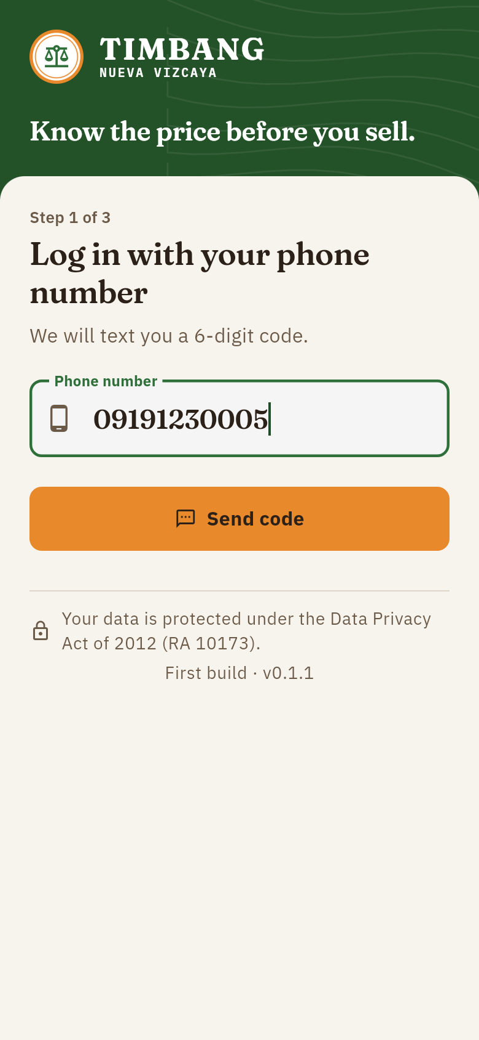 | 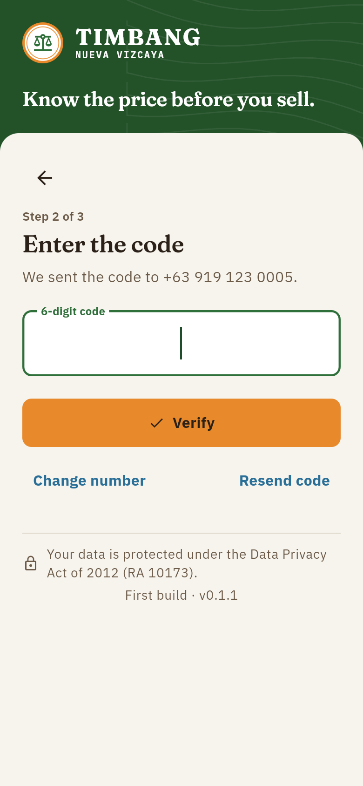
Figure E-1. Language selection | Figure E-2. Phone number login | Figure E-3. Entering the SMS code

1.3 Create your profile. New users enter their full name, choose their municipality, and choose whether they are a farmer or a buyer. Reporter and administrator roles are given only by an administrator.
1.4 Read and agree to the Privacy Notice. Tap Read and agree. The Data Privacy Act notice opens on its own screen. The checkbox at the bottom becomes available only after scrolling to the end; tick it and tap I agree, then tap Save profile.
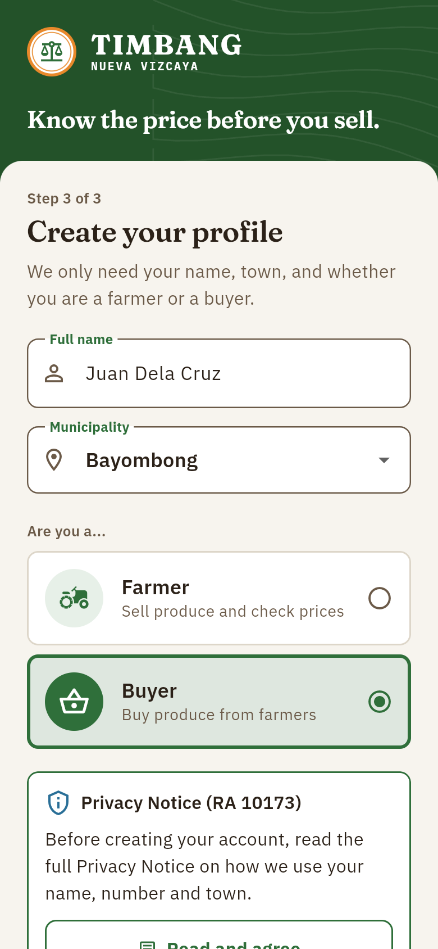 | 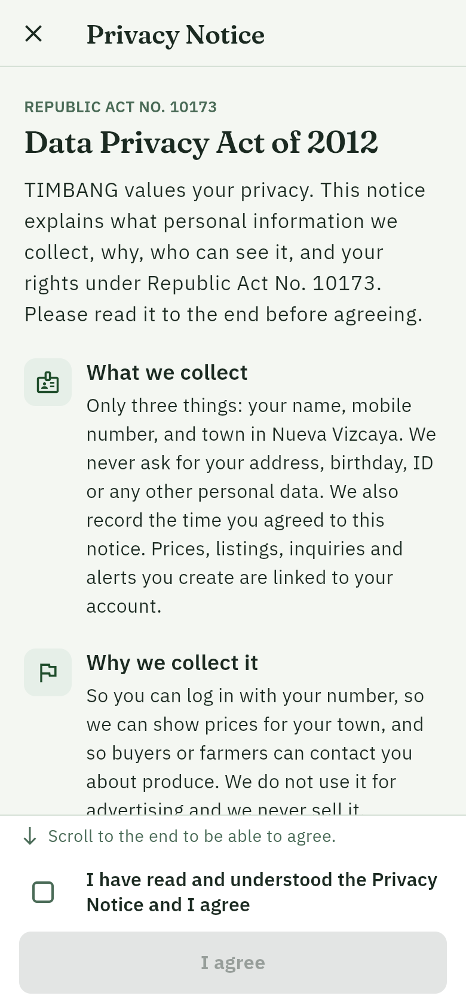 | 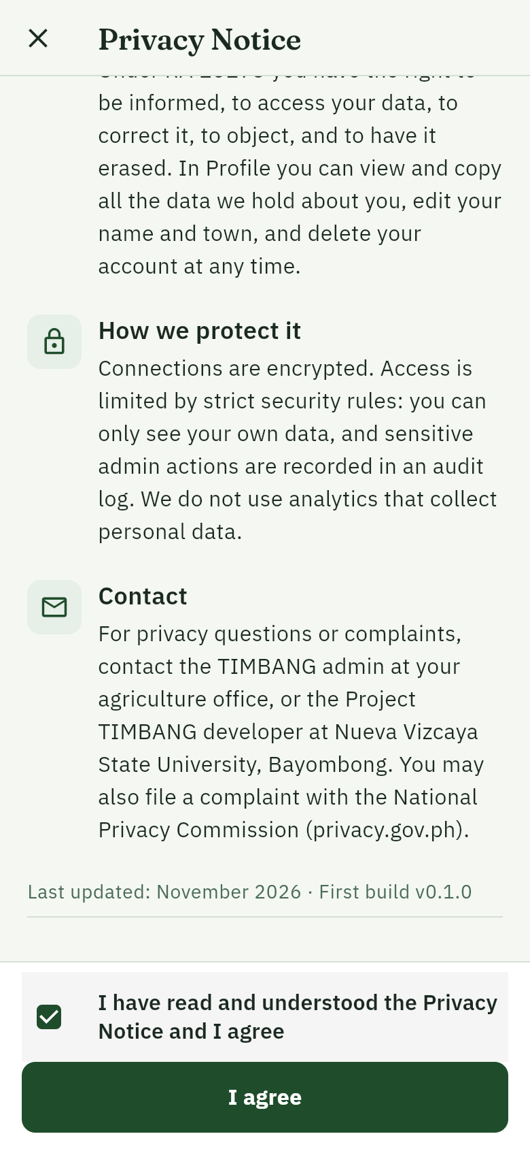
Figure E-4. Profile setup | Figure E-5. Privacy Notice (top) | Figure E-6. Agreeing at the end of the notice

2. Checking prices
2.1 The daily price bulletin. The home screen (Prices tab) shows every vegetable across all markets in Nueva Vizcaya, grouped by category. Each row shows the median price per unit, the change since yesterday, the trust meter, the price range across markets, the number of reports and when it was last updated. A price with no report in 24 hours is still shown, marked Stale.
Trust meter | Meaning
███ High | An official price (DA, DAR, NVAT), or three or more agreeing reports including a verified reporter
██░ Medium | Reports from verified price reporters
█░░ Low | Community reports only, until they are confirmed

2.2 Choose a place. Tap Prices in · All of Nueva Vizcaya at the top and pick one of the 15 municipalities to see the prices at its market(s). The choice is remembered on the phone, and the produce listings follow the same town.
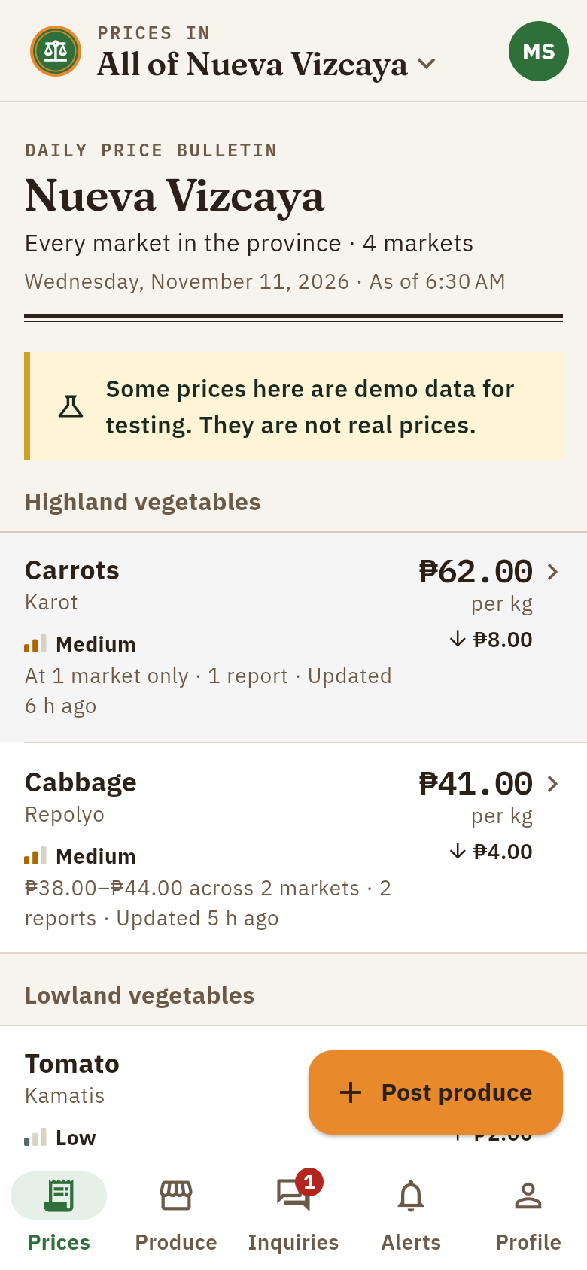 | 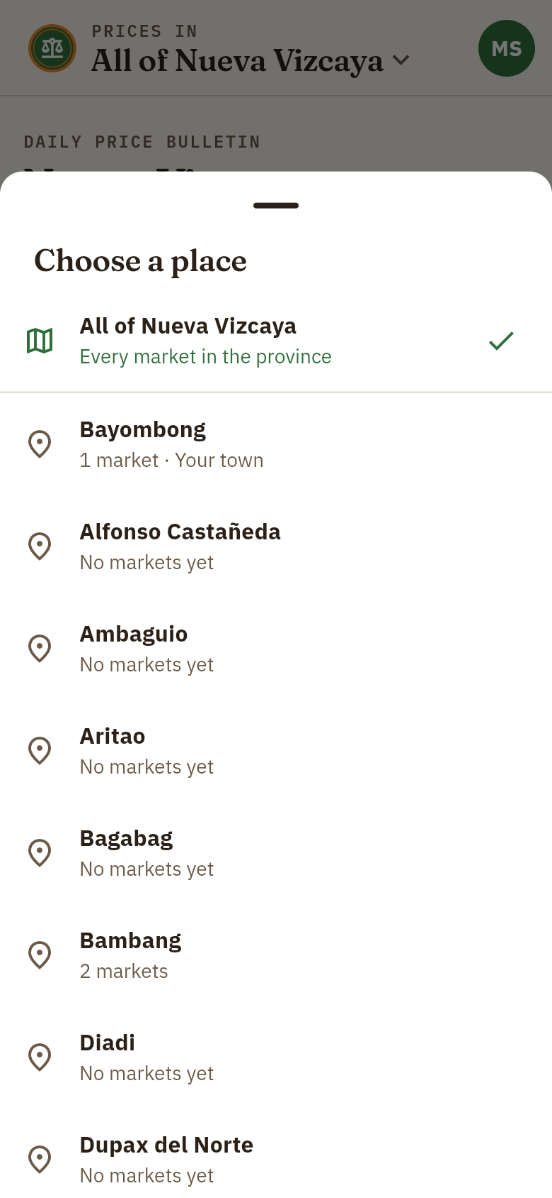 | 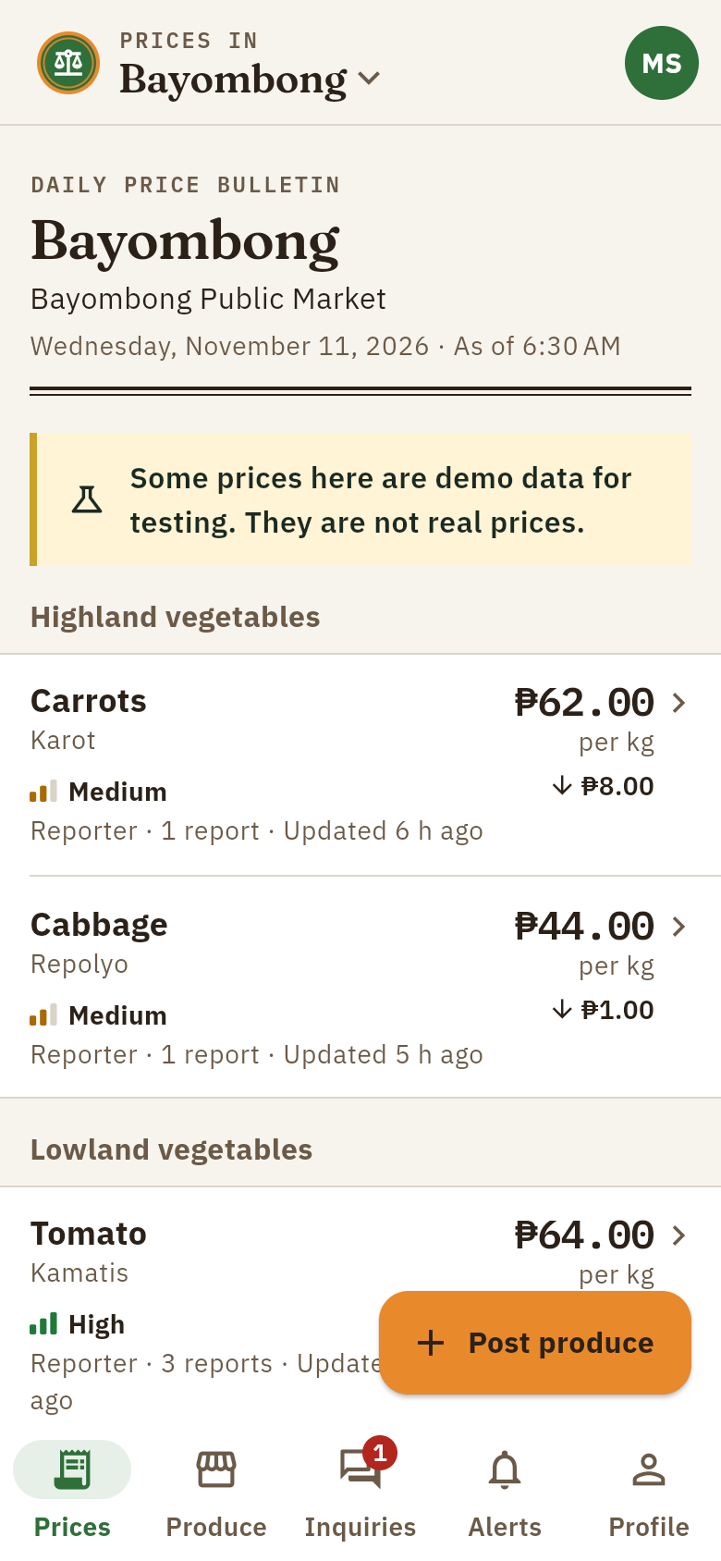
Figure E-7. Province-wide price bulletin | Figure E-8. Choosing a municipality | Figure E-9. Prices in one town

2.3 Compare markets. Tap a vegetable to see its price at your market, yesterday's price, and its price at every other market, with your town first and the cheapest market marked.
2.4 Report a price. Under Services, tap Report a price, choose the vegetable and market, enter the price you saw, and tap Send report. Community reports count as low confidence until a verified report matches them.
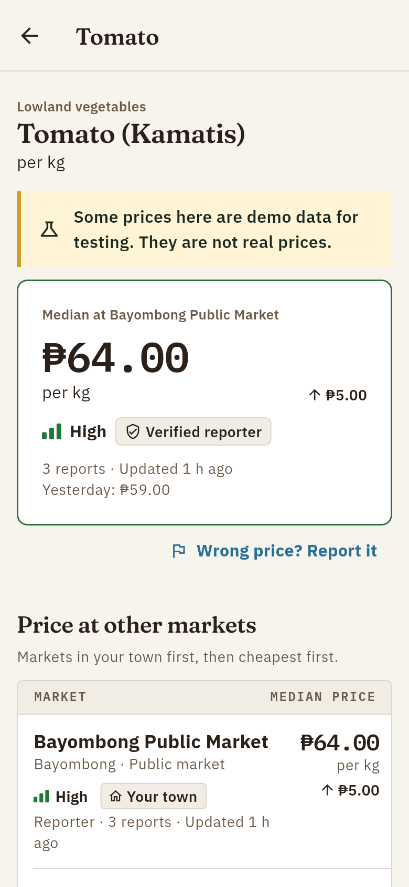 | 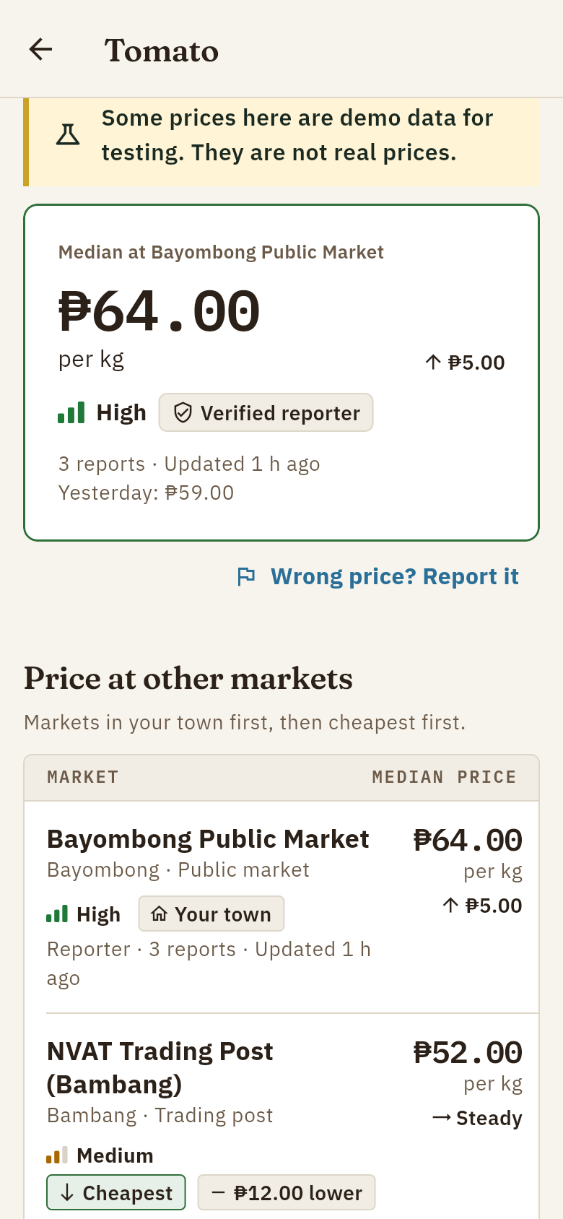 | 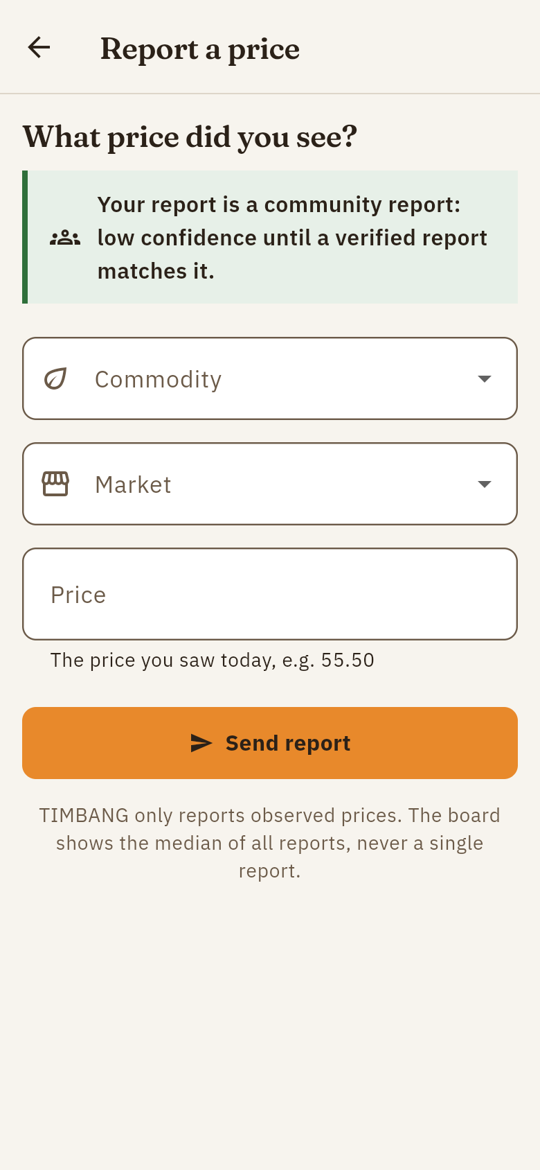
Figure E-10. Price of one vegetable | Figure E-11. Comparison across markets | Figure E-12. Reporting a price

3. Produce listings
3.1 Browse produce. The Produce tab lists what farmers are selling, filtered by vegetable and municipality and sorted by newest or cheapest.
3.2 Post produce (farmers). Tap Post produce, choose the vegetable, enter the quantity, asking price, municipality and harvest date, optionally add a note and up to three photos, and tap Post produce. A listing stays active for 14 days and can be marked sold or renewed.
3.3 Contact the farmer (buyers). Open a listing to see its details, how its price compares with the market median, and the farmer's number. Call, text, or send one inquiry through the app.
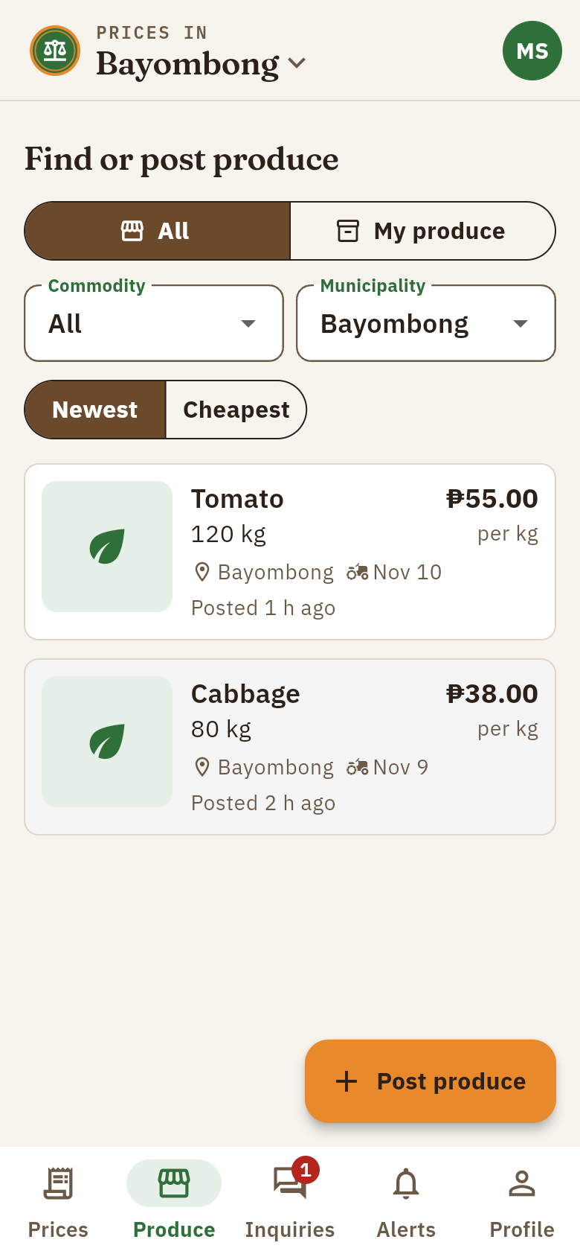 | 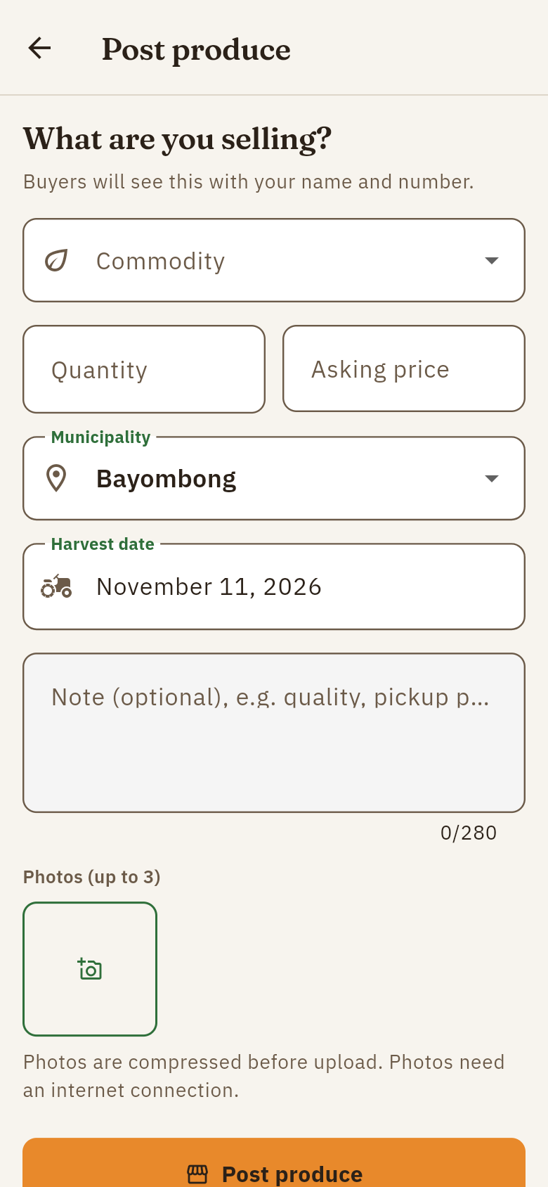 | 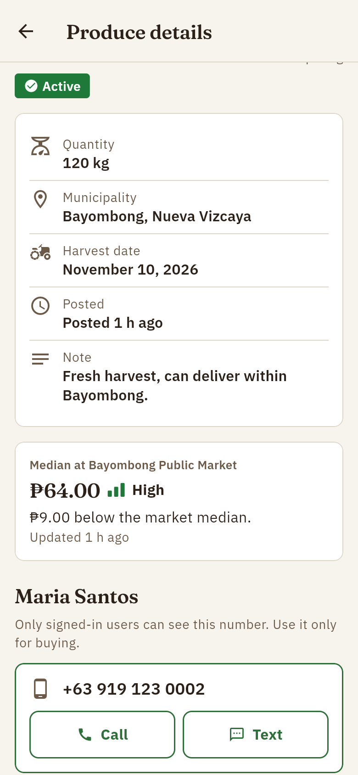
Figure E-13. Produce listings | Figure E-14. Posting produce | Figure E-15. Listing details and contact

4. Inquiries, alerts and profile
4.1 Inquiries. Farmers see buyers' messages in the Inquiries tab, with buttons to call or text back, mark as read, or close. A red badge shows new inquiries.
4.2 Price alerts. In Alerts, tap Add alert, choose a vegetable and market, choose Rises to or Falls to, and enter the price. A notification is sent once each time the median crosses that price.
4.3 Profile. Profile shows your name, number and municipality, lets you change the language, read the Privacy Notice again, view or copy all your data, sign out, or delete your account.
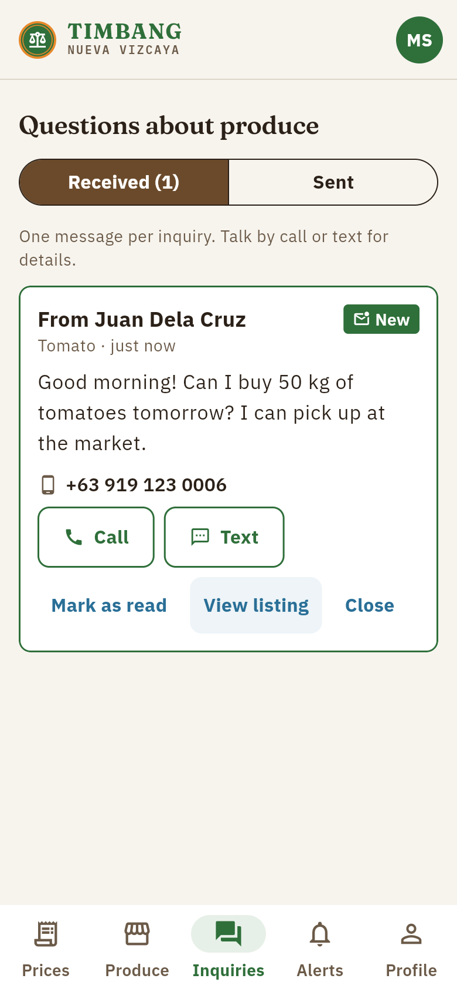 | 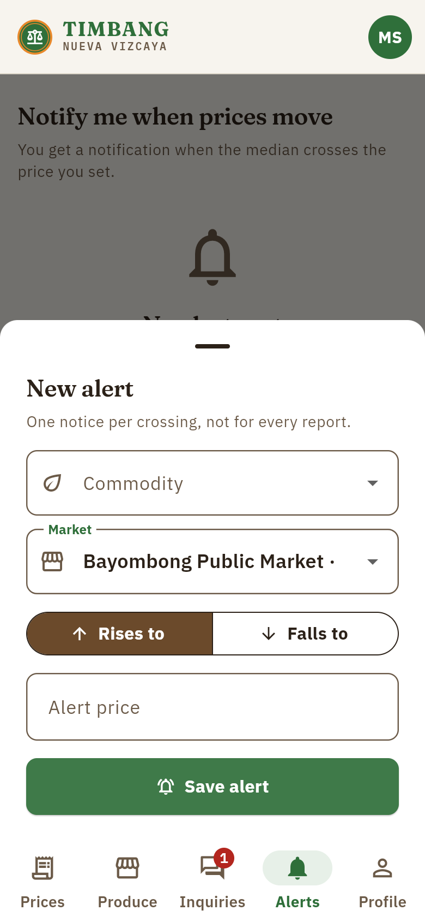 | 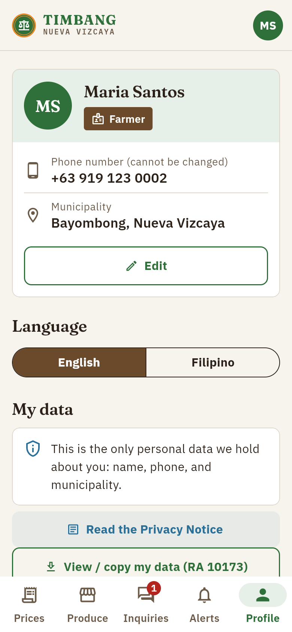
Figure E-16. Inquiry inbox | Figure E-17. Creating a price alert | Figure E-18. Profile and my data

5. Administrator dashboard
Administrators open the dashboard from Profile (Open the admin dashboard) on the phone, or directly after logging in on the website. The dashboard has these pages:
- Overview: counts of active vegetables and markets, demo items, and the pilot metrics (median price age, active farmers, listings, inquiries per listing, freshness per market).
- Commodities and Markets: add or edit items one at a time, or import the office's Excel or CSV file as it is. Items are never deleted, only set inactive.
- Prices: import official prices from a file (one row per price, or one column per market), add a single official price, and monitor incoming reports.
- Users: approve price reporters, assign their markets, change roles, suspend accounts.
- Moderation: review user reports and prices far from the median.
- SMS prices: try the SMS price query exactly as a basic-phone user would.
- Audit log: a record of every sensitive administrator action.
Import order for official data: first the markets, then the vegetables (commodities), then the prices. Every row is checked before anything is saved; rows with errors are listed with their line numbers.
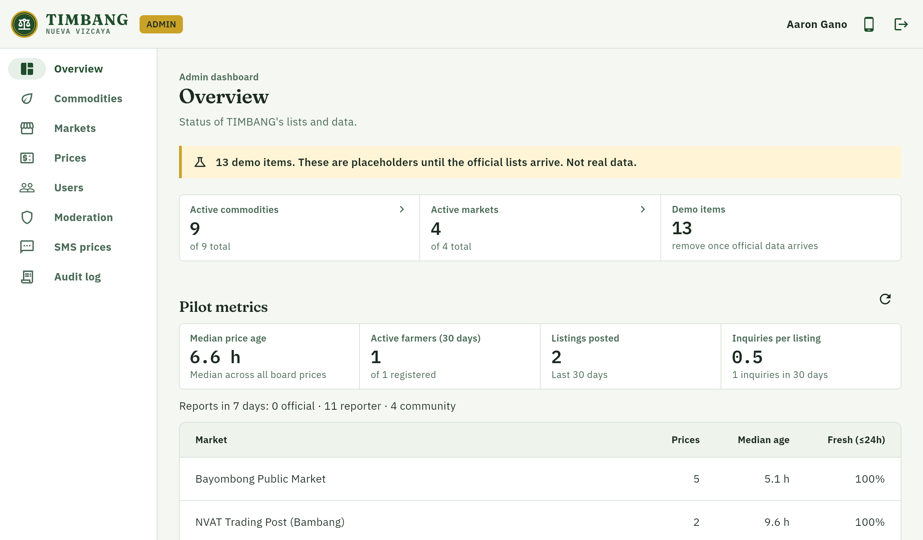
Figure E-19. Administrator overview and pilot metrics
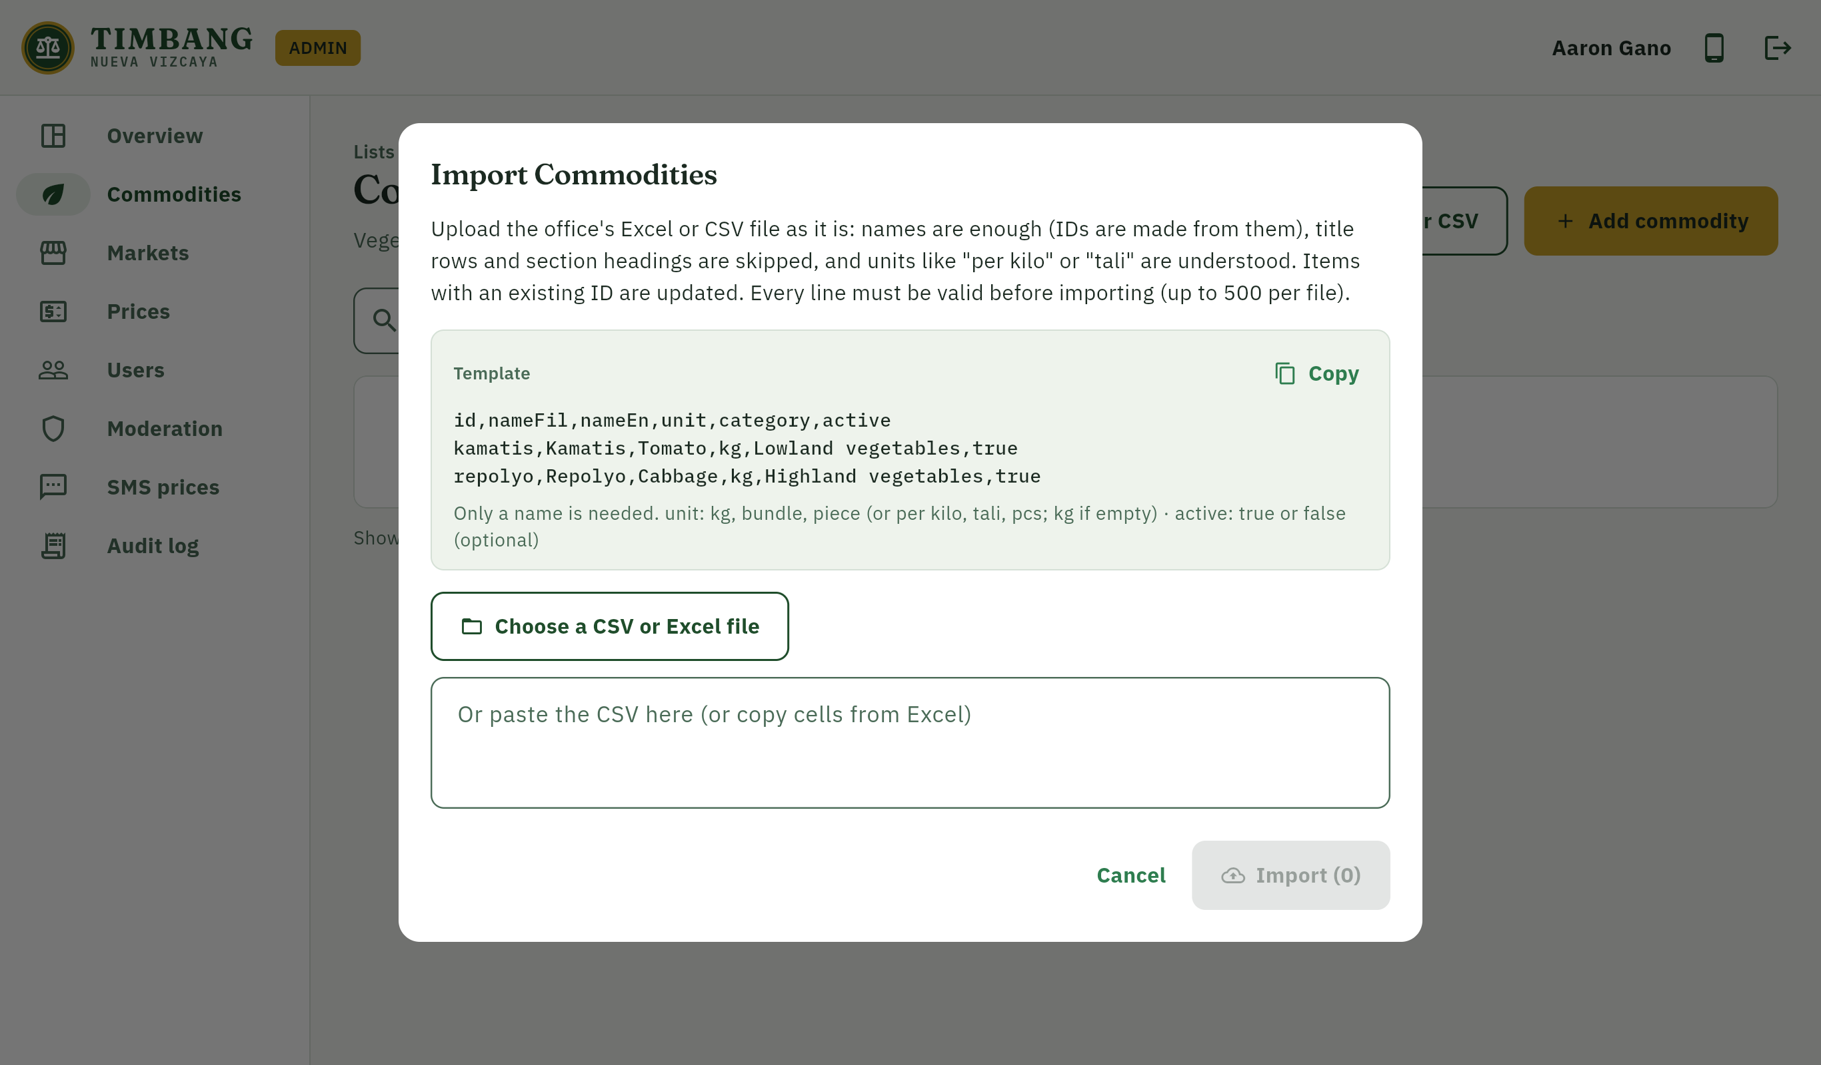
Figure E-20. Importing the vegetable list from Excel or CSV
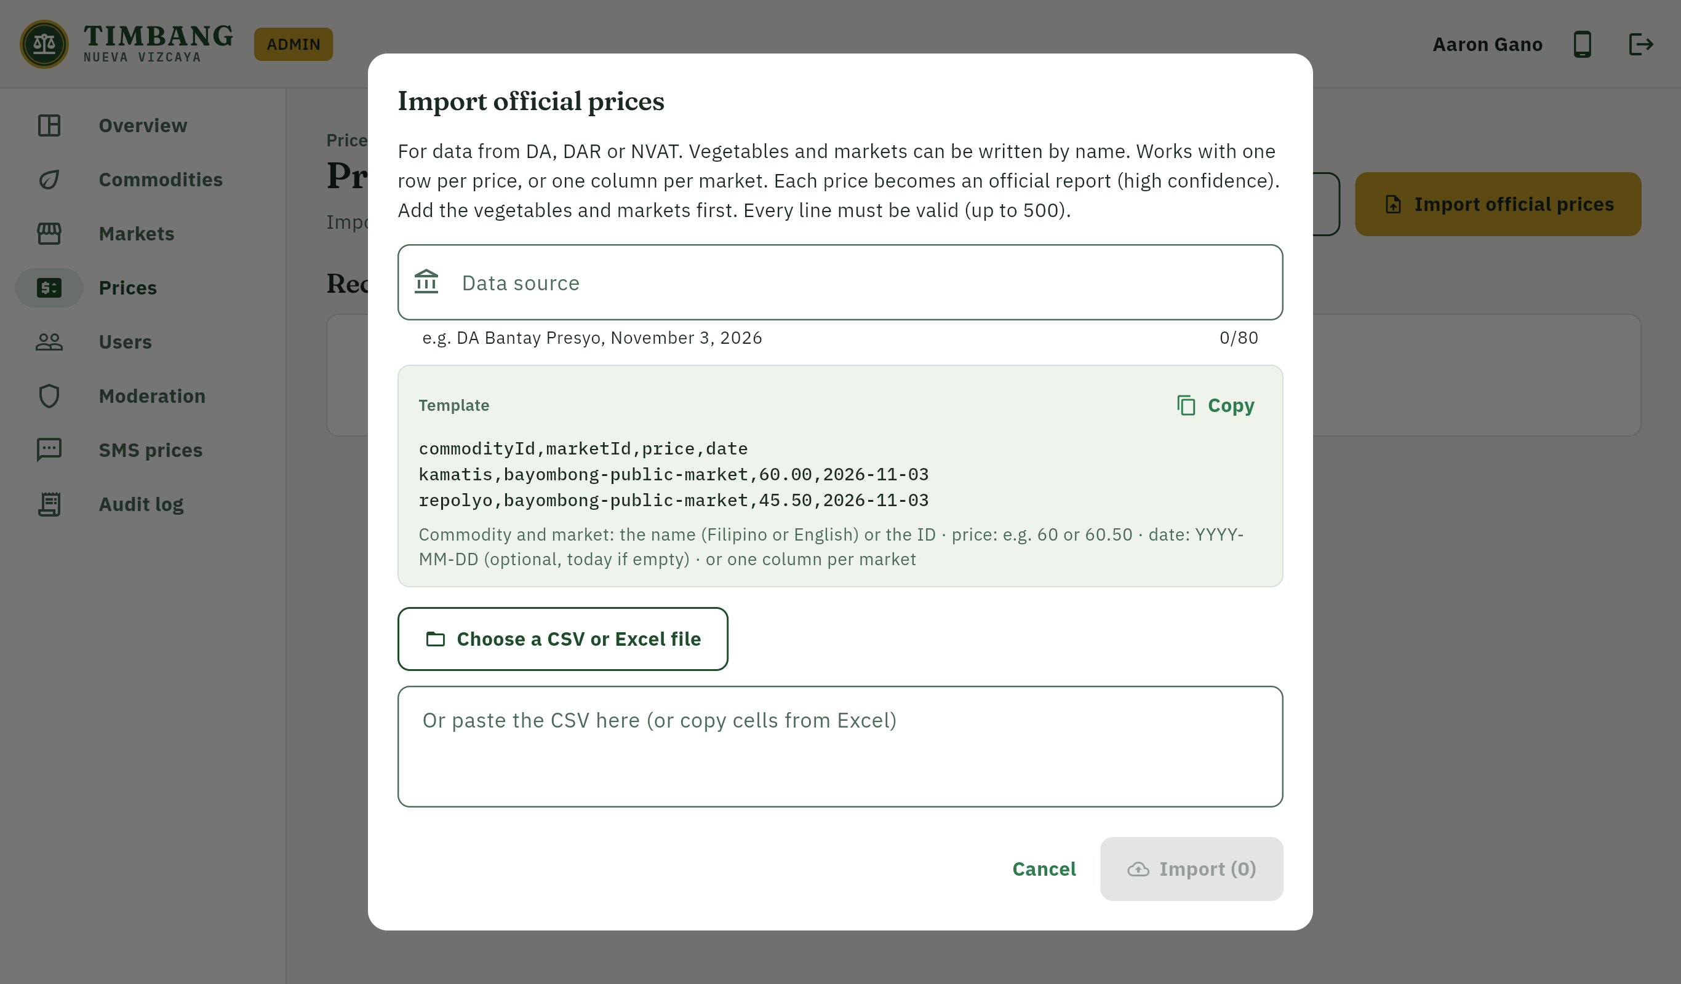
Figure E-21. Importing official prices
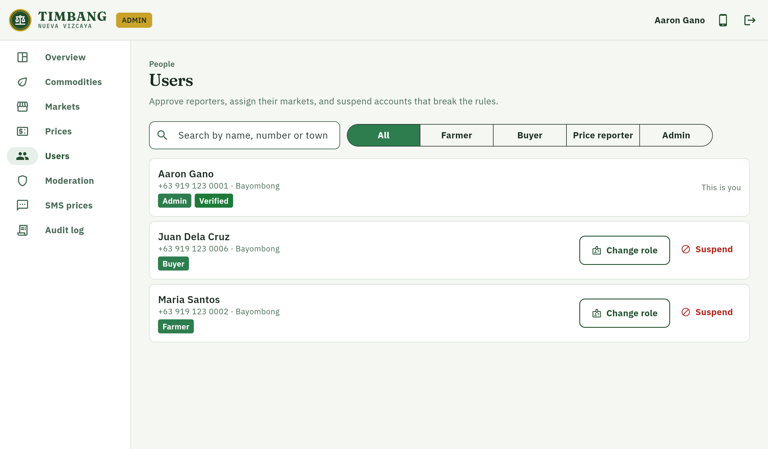
Figure E-22. User and role management
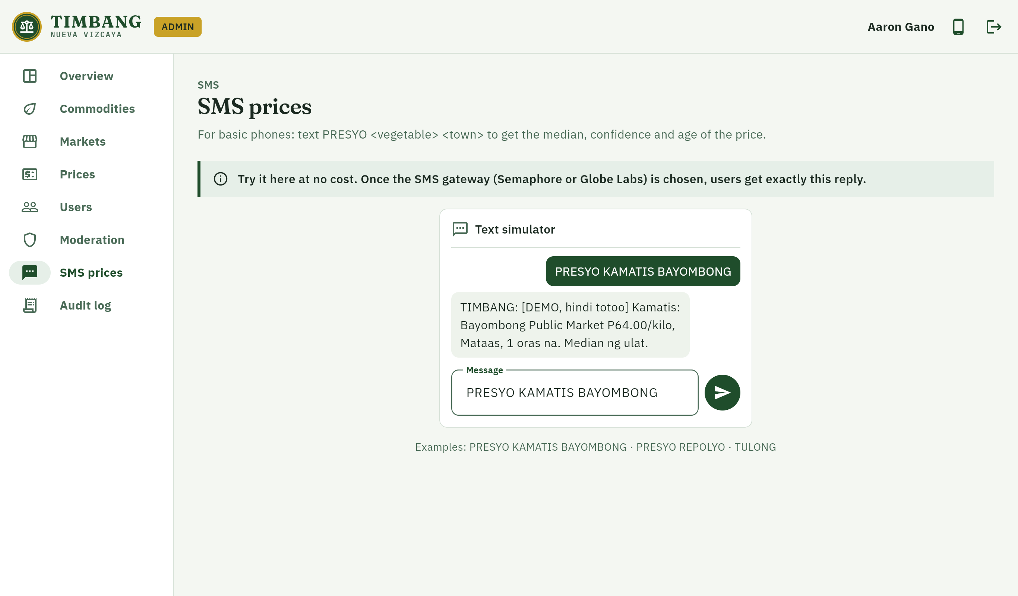
Figure E-23. SMS price query simulator

6. Website
The public website (timbang-nv.web.app) explains TIMBANG and its confidence labels, and lets users log in to the same features as the app from a browser.
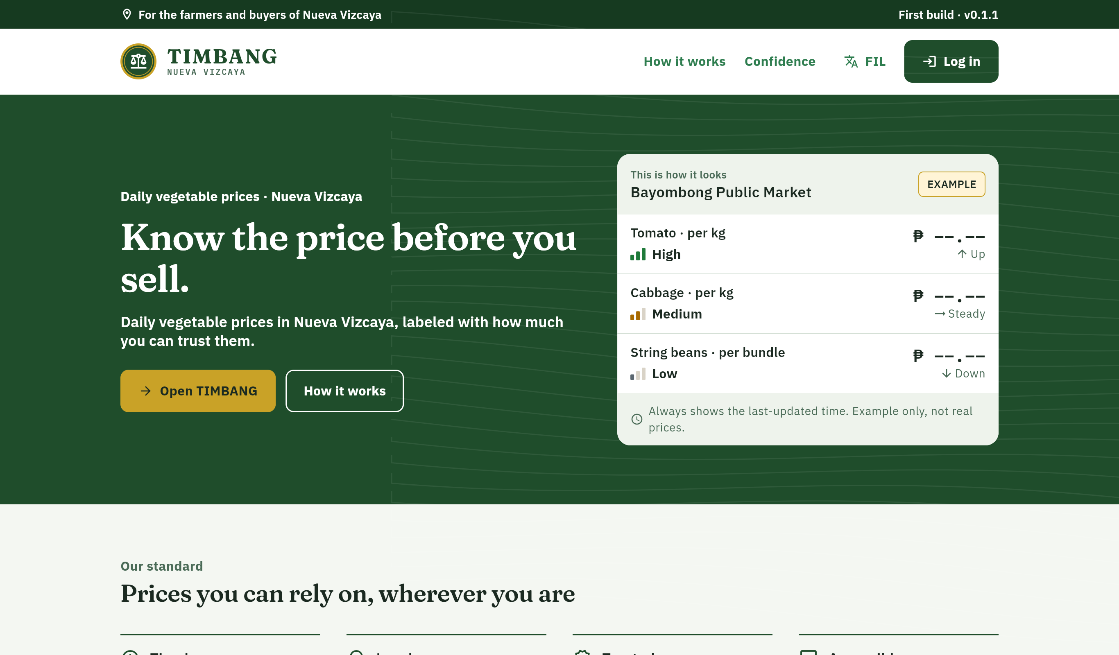
Figure E-24. Public website

E.2 Technical Documentation

1. System overview
TIMBANG consists of a Flutter application built for Android and the web from one code base, a set of Cloud Functions that hold all trusted logic, a Cloud Firestore database protected by security rules, Cloud Storage for listing photos, and an SMS interface for basic phones. Prices and roles are written only by the server; the application can only read them.
Component | Technology | Responsibility
Mobile app | Flutter (Dart), Material 3, Riverpod, go_router | Price board, listings, inquiries, alerts, profile; offline cache
Website and admin dashboard | Flutter web, Firebase Hosting | Public landing page, same user features, administrator dashboard
Authentication | Firebase Authentication (phone OTP), custom claims | Login by SMS code; roles stored as verified claims
Database | Cloud Firestore (asia-southeast1), offline persistence | Users, lists, price reports, price board, listings, inquiries, alerts, audit log
Server logic | Cloud Functions for Firebase (TypeScript, Node.js 22) | Price computation, imports, roles, inquiries, alerts, SMS, data export and erasure
Files | Cloud Storage | Compressed listing photos (max 1 MB, images only)
Notifications | Firebase Cloud Messaging | Inquiry and price-alert notifications
Integrity | Firebase App Check | Blocks requests that do not come from the genuine app (switchable)
SMS | SmsGateway interface (mock; Semaphore or Globe Labs later) | PRESYO <vegetable> <town> price query

2. Data model
Collection | Contents | Who may write
users | Name, phone, municipality, role (display only), verified, status, consent time | Owner (limited fields); server
commodities, markets | Official lists of vegetables and markets | Server (admin functions) only
price_reports | Each submitted or imported price with its source tier and status | Server only
price_board | Computed median, confidence, trend and age per vegetable and market | Server only
listings | Produce posted by farmers; 14-day expiry | Owner farmer (validated)
inquiries | Buyer messages to farmers | Server creates; farmer and buyer update status
alerts | User price alerts | Owner (validated)
abuse_reports | User reports of wrong prices or listings | Any user creates; admin resolves
audit_logs | Every sensitive administrator action | Server only

3. Price confidence method
1. Take all reports for one vegetable at one market from the last 24 hours, excluding reports rejected by an administrator.
2. Compute the median price, never the mean or the latest single report.
3. Set aside reports more than 30% from the median as outliers and recompute the median. Official reports are never set aside; if every report would be an outlier, none are set aside.
4. Assign confidence: High for an official price or three or more reports within 15% of the median including a verified reporter; Medium for verified reporter reports; Low for community reports only.
5. Compute the trend against the previous 24-hour median; a change within ±3% is shown as steady.
6. Keep showing a price with no new report in 24 hours, marked stale with its age.
7. Province view: the median of the market medians, with the range across markets and the lowest confidence among those markets.

4. Security and privacy measures
- Deny-by-default Firestore and Storage rules, with a test for every collection.
- Roles in verified custom claims, set only by an admin-only function; role changes are audited.
- All prices, imports and role changes are performed by Cloud Functions that re-validate input.
- Rate limits: 20 price reports per user per hour, 10 inquiries per hour, 10 SMS replies per number per hour.
- SMS webhook authenticated with HMAC-SHA256 in constant time; phone numbers hashed or masked in logs.
- Firebase App Check support, HTTPS only, and security headers on the website.
- Data Privacy Act of 2012 (RA 10173): only name, phone and municipality are collected; consent is recorded; the full privacy notice must be read before agreeing; users can view, copy and delete their data.
- Threat model (STRIDE) and OWASP MASVS checklist in the project documentation.

5. Testing results
All automated tests were run on November 11, 2026 against the Firebase Local Emulator Suite. All tests passed.
Test suite | What it checks | Tests | Result
Application (flutter_test) | Screens, price board, imports, accessibility (text contrast, touch target size, labels), language | 106 | All passed
Cloud Functions (Jest) | Price confidence, roles, reports, imports, listings, inquiries, alerts, SMS, account deletion | 166 | All passed
Security rules (rules-unit-testing) | Allowed and denied reads and writes for every collection and for Storage | 103 | All passed
Integration (Node test runner) | End-to-end function calls on the emulators: prices, roles, catalog, inquiries, SMS, admin | 18 | All passed
Total |  | 393 | All passed

6. System requirements
User | Requirement
Mobile app | Android 7.0 or newer; mobile data or Wi-Fi to log in and update (the price board stays readable offline)
Website | A current browser (Chrome, Edge, Firefox, Safari)
SMS | Any mobile phone that can send and receive text messages
Administrator | Phone or computer with a browser; official lists as Excel (.xlsx) or CSV files

7. Build and deployment
1. Create the Firebase project (Blaze plan), enable phone sign-in, Firestore (asia-southeast1) and Storage.
2. Connect the app with flutterfire configure and register the Android signing fingerprints (SHA-1, SHA-256).
3. Deploy rules, indexes and functions: firebase deploy --only firestore,storage,functions.
4. Build the Android app: flutter build apk --release -t lib/main_app.dart.
5. Build and publish the website: flutter build web --release -t lib/main_web.dart, then firebase deploy --only hosting.
6. Grant the first administrator role with npm run seed:admin, then import the official lists from the dashboard.

8. Limitations of the first build
- The demonstration lists and prices are placeholders until the official lists from the DA, DAR and NVAT are imported.
- The SMS gateway (Semaphore or Globe Labs) is not yet chosen; SMS works through the mock gateway and the simulator.
- Release builds are signed with a development key; a dedicated release key is needed before wider distribution.
- TIMBANG is an independent student project and is not yet affiliated with or endorsed by the Provincial Government of Nueva Vizcaya, DA, DAR or NVAT.

E.3 Photo Documentation
The following photos document the conduct of the study.

Insert photo here
Photo E-1. Consultation with the Office of the Provincial Agriculturist / Office of the Governor
Date: ____________________ Place: ______________________________

Insert photo here
Photo E-2. Data gathering: collection of the official vegetable price lists
Date: ____________________ Place: ______________________________

Insert photo here
Photo E-3. System testing with farmers
Date: ____________________ Place: ______________________________

Insert photo here
Photo E-4. System testing with buyers
Date: ____________________ Place: ______________________________

Insert photo here
Photo E-5. Usability assessment (System Usability Scale) with respondents
Date: ____________________ Place: ______________________________

Insert photo here
Photo E-6. Presentation of the system
Date: ____________________ Place: ______________________________

