VERRA
Platform Architecture Plan

Verra Agent Orchestrator
A production-grade, guardrailed, multi-layer orchestration service behind every module
Document | Agent Orchestrator — Architecture & Implementation Plan
Product | Verra (working name)
Version | 0.1 — Draft for review
Date | 16 June 2026
Scope | Common orchestration service · all modules
Themes | Multi-layer · guardrails · fallbacks · cost & token management

Table of Contents

1. Purpose & Scope
This document specifies the Verra Agent Orchestrator: a single, production-grade, guardrailed service that manages every AI agent behind every module (Tax, Books & Close, Audit, Compliance, Assistant). Instead of each module wiring its own prompts, models and tools, all agentic work flows through one common orchestration service that enforces policy, manages cost and tokens, provides fallbacks, and writes an immutable audit trail.
Why a common service. Centralizing orchestration gives one place to enforce guardrails and human-in-the-loop gates, one cost/token control plane, consistent observability, reusable agents/tools, and a single point to add model fallbacks — rather than duplicating (and drifting) this logic across modules.

2. Goals & Non-Goals

2.1 Goals
- One orchestration API used by all modules; agents/tools are reusable and versioned.
- Guardrails and human-approval gates enforced centrally on every request and response.
- Resilient by design: model/agent/tool fallbacks, retries, circuit breakers, graceful degradation.
- First-class cost and token management with per-tenant budgets, caps, caching and attribution.
- Full observability: tracing, metrics, logs, evals, replay; clear SLOs.

2.2 Non-goals
- Not a module's business logic — the orchestrator runs agents; domain rules live in agents/tools.
- Not a model trainer — it routes to providers; fine-tuning is a separate pipeline.
- Not a replacement for the system of record — it reads/writes via tools and the audit store.

3. Design Principles
- Guardrailed by default: no agent runs without passing input/output guardrails and policy checks.
- Human-in-the-loop for consequence: send/file/post and low-confidence actions require explicit approval.
- Deterministic where it matters: money, brackets and thresholds use calculators/tools, not free-form generation.
- Everything is observable & replayable: every step is traced; runs can be replayed for debugging and evals.
- Fail safe, not silent: degrade to cached/rules-only/human-queue rather than return an unverified answer.
- Budget-aware: cost and tokens are first-class inputs to routing, not an afterthought.
- Multi-tenant & zero-retention: strict tenant isolation; no training on customer data; provider zero-retention contracts.

4. Architecture Overview
Modules call the orchestration service through a single gateway. Requests pass through guardrails, then the multi-layer orchestrator core (Planner → Router → Executor → Critic) under a supervisor, drawing on shared platform services (agent registry, tool registry, model gateway, memory/RAG, state & audit). A cost/token manager and observability stack wrap every request. Model providers are arranged in a health- and budget-aware fallback chain.
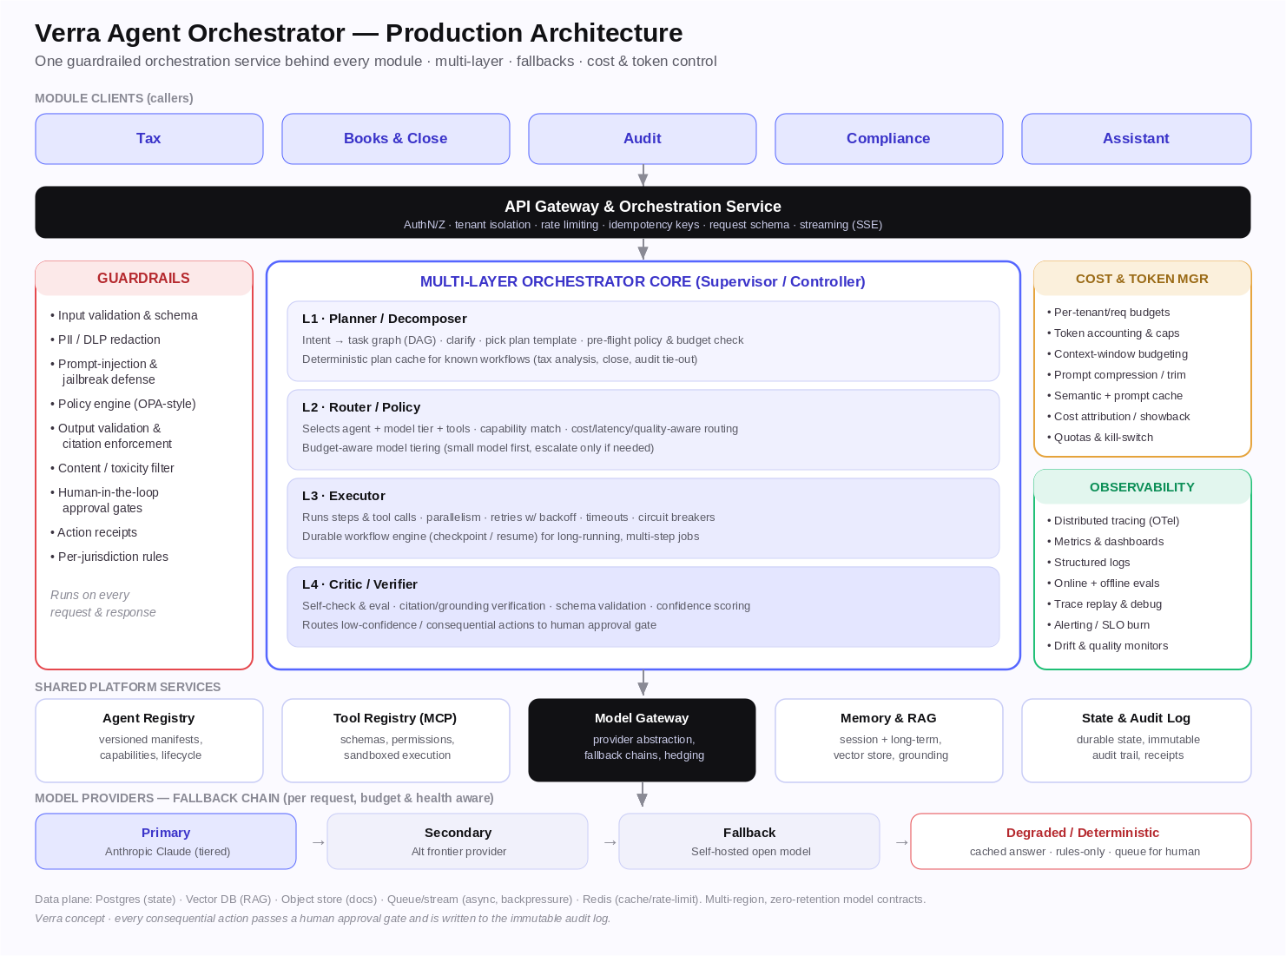
Figure 1 — Verra Agent Orchestrator (logical architecture).

5. Multi-Layer Orchestration Core
A supervisor/controller owns each run's lifecycle (state machine: planned → routed → executing → verifying → awaiting-approval → done/failed) and coordinates four layers:

5.1 L1 — Planner / Decomposer
- Turns the module request + context into a typed task graph (DAG of steps).
- Uses deterministic plan templates for known workflows (tax analysis, month-end close, audit tie-out) and an LLM planner for open-ended asks.
- Runs pre-flight checks: policy, permissions, and budget feasibility before any spend.

5.2 L2 — Router / Policy
- Selects the agent(s), model tier, and tools per step using capability matching plus a cost/latency/quality policy.
- Budget-aware model tiering: start with the smallest sufficient model; escalate only on low confidence or complexity.
- Emits a routing decision record (why this agent/model/tool) for observability and audit.

5.3 L3 — Executor
- Executes steps and tool calls with controlled parallelism; enforces per-step timeouts.
- Retries with exponential backoff + jitter; circuit breakers per provider/tool; bulkheads to isolate failures.
- Backed by a durable workflow engine: long-running, multi-step jobs checkpoint and resume safely (idempotent steps).

5.4 L4 — Critic / Verifier
- Verifies outputs: grounding/citation checks, schema validation, numeric cross-checks, confidence scoring.
- Triggers self-correction or re-route on failure; routes consequential/low-confidence results to the human approval gate.
- Writes the action receipt and audit entry on completion.

5.5 Orchestration patterns supported
- Single-agent tool use; planner-executor; supervisor with specialist sub-agents; map-reduce/parallel fan-out; debate/critic loops — selected by plan template.

6. Agent Registry & Lifecycle
Agents are declarative, versioned artifacts — not hardcoded in modules.
Aspect | Detail
Manifest | id, version, description, capabilities/skills, allowed tools, model policy, guardrail profile, eval set
Versioning | semver; immutable published versions; pinning per tenant/module
Lifecycle | draft → eval-gated → canary → GA → deprecated; rollback supported
Isolation | agents declare least-privilege tool + data scopes; enforced at runtime
Discovery | modules request a capability; registry resolves the best agent version

7. Tool Layer & Registry (MCP)
- Tools (including MCP servers) are registered with typed JSON schemas, descriptions, and permission scopes.
- Execution is sandboxed and rate-limited; side-effecting tools (send/file/post) are gated and audited.
- Deterministic calculators (tax brackets, thresholds, reconciliations) are first-class tools — preferred over LLM math.
- Tool results are validated against schema before re-entering the model context.

8. Model Gateway & Fallback Strategy
A single model gateway abstracts all providers behind one interface, so agents are provider-agnostic and fallbacks are centralized.

8.1 Routing strategies
- Capability/tier routing (small → frontier) based on task class and required quality.
- Cost- and latency-aware selection within the allowed tier; optional latency hedging (race a backup, take first valid).
- Sticky routing per run for consistency; deterministic seeds where supported.

8.2 Fallback chain
Order | Tier | Trigger to fall through
1 | Primary frontier model (Anthropic Claude, tiered) | Error, timeout, rate-limit, budget exceeded, low-confidence
2 | Secondary frontier provider | Primary unhealthy or over budget
3 | Self-hosted open model | Both providers unavailable / cost ceiling
4 | Degraded / deterministic | All models unavailable → cached answer, rules-only output, or queue for human
- Circuit breakers per provider with health checks; automatic recovery (half-open probes).
- Idempotency keys prevent duplicate side effects across retries/fallbacks.
- Every fallback hop is recorded (provider, reason, cost) in the trace and audit log.

9. Cost Management
Control | How it works
Budgets & quotas | Per-tenant, per-module, per-run and monthly budgets; soft-warn then hard-cap
Model tiering | Cheapest sufficient model first; escalate only on need — biggest lever
Caching | Prompt cache + semantic cache for repeat/similar requests; provider prompt-caching
Batching | Batch non-interactive jobs (bulk parsing, overnight analysis) at lower cost
Attribution | Cost tagged by tenant/module/agent/run for showback & chargeback
Kill-switch | Per-tenant and global circuit breaker if spend spikes; alerts on burn rate
Forecasting | Pre-flight cost estimate per plan; block/queue if over budget

10. Token Management
Control | How it works
Context budgeting | Each step gets a token budget; orchestrator assembles context to fit the window
Retrieval over stuffing | RAG selects only relevant chunks instead of whole documents
Compression/summarization | Rolling summaries of long histories; map-reduce for large corpora
Truncation policy | Deterministic, priority-ordered trimming (system > task > evidence > history)
Token accounting | Per-request input/output token metering; surfaced in traces and budgets
Rate limiting | Per-tenant token-per-minute limits with queue/backpressure
Output bounds | max_tokens per task class; structured outputs to avoid verbosity

11. Guardrails (defense in depth)
Stage | Guardrail
Input | Schema/format validation; auth & tenant scope; PII/DLP detection & redaction; prompt-injection/jailbreak detection; policy (allow/deny) checks
In-flight | Tool permission enforcement; sandboxing; budget/token caps; loop & step-count limits; timeout
Output | Grounding & citation enforcement; schema validation; numeric cross-checks; toxicity/PII scan; confidence threshold
Action | Human-in-the-loop approval gates for send/file/post & low-confidence; action receipts; immutable audit log
Policy engine | Centralized, declarative rules (OPA-style) versioned per jurisdiction & tenant
Guardrails run on every request and response; a failure can block, redact, re-route, or escalate to a human — never silently pass.

12. Reliability & Resilience
- Retries with exponential backoff + jitter; per-call and per-run timeouts.
- Circuit breakers and bulkheads per provider/tool to contain failures.
- Idempotency keys and exactly-once side effects for tools that mutate state.
- Durable workflows (checkpoint/resume) so long jobs survive restarts and partial failures.
- Backpressure via queues; load shedding and graceful degradation under peak (tax/audit season).
- Multi-region, redundant deployment; documented DR with RTO/RPO targets.

13. State, Memory & Audit
- Run state: durable, queryable; supports pause/resume and approval waits.
- Memory: session (short-term), long-term per client/engagement, and vector store for RAG grounding.
- Audit log: append-only, tamper-evident; records actor, action, inputs, sources, model/provider, cost/tokens, approval, and rollback handle.
- Action receipts: every side-effecting action emits a receipt linked to its sources and approver.

14. Observability & Evaluation
- OpenTelemetry traces spanning gateway → layers → tools → providers; one trace per run.
- Metrics: latency, success/error, retries, fallbacks, tokens, cost, queue depth, approval rates.
- Structured logs with correlation IDs; PII-safe.
- Evals: offline regression suites per agent/jurisdiction gate releases; online evals + canary on live traffic.
- Replay: deterministic re-run of any trace for debugging and eval authoring.
- Alerting on SLO burn, cost spikes, guardrail-block rates, and quality drift.

15. Security & Multi-Tenancy
- AuthN/Z (OIDC, service-to-service mTLS); RBAC and strict tenant isolation end-to-end.
- Secrets in a managed vault; least-privilege tool credentials; no secrets in prompts/logs.
- Sandboxed tool execution; egress controls; data-residency routing per jurisdiction (GDPR/DPDP).
- Zero-retention provider contracts; no customer data used for training; encryption in transit & at rest.
- SOC 2 Type II / ISO 27001 controls; pen-tested; supply-chain scanning.

16. Orchestrator API (module contract)
Modules use a small, stable API. A run can stream events and may pause for approval.
POST /v1/runs
{
"tenant_id": "firm_123",
"module": "tax",
"capability": "tax_analysis",
"input": { "client_id": "mehta", "tax_year": 2025 },
"context_refs": ["doc:1040-2025", "ledger:..."],
"budget": { "max_usd": 0.80, "max_tokens": 120000 },
"approval": { "mode": "required", "callback": "https://..." },
"idempotency_key": "..."
}
→ 202 { "run_id": "run_abc", "stream": "/v1/runs/run_abc/events" }
- GET /v1/runs/{id} — status, cost, tokens, citations, receipts.
- POST /v1/runs/{id}/approve | /reject — human gate resolution.
- Event stream (SSE): plan, route, step, tool_call, token/cost deltas, needs_approval, result.

17. Core Data Model
Entity | Key fields
Run | id, tenant, module, capability, status, budget, cost, tokens, trace_id
Plan | run_id, task graph (steps + deps), template, version
Step | id, agent, model, tools, status, retries, tokens, cost, output_ref
RoutingDecision | step_id, chosen agent/model/tool, reason, fallbacks_used
AgentVersion | id, version, manifest, eval status, lifecycle state
ToolDef | id, schema, permissions, sandbox profile
AuditEvent | run_id, actor, action, sources, provider, cost, approval, hash
Budget | scope (tenant/module/run), limits, consumed, period

18. Technology Choices (build vs. buy)
Concern | Recommended approach
Workflow/durability | Durable engine (e.g., Temporal) or managed equiv. for checkpoint/resume
Orchestration graph | Agent graph framework (e.g., LangGraph) or in-house DAG runner
Model gateway | Unified gateway (e.g., LiteLLM/OpenRouter-style) or in-house provider abstraction
Policy engine | OPA / Cedar for declarative, versioned guardrail policy
Guardrails | Layered: in-house validators + DLP/PII + injection classifiers
Vector/RAG | Managed vector DB; chunking + reranking pipeline
Observability | OpenTelemetry + LLM-trace tooling (e.g., Langfuse/Arize-style) + metrics stack
State/data | Postgres (state/audit), Redis (cache/rate-limit), object store, queue/stream
Principle: buy/adopt for undifferentiated heavy lifting (tracing, durability, vector DB); build the routing, guardrail, and cost/token policy that are core to Verra's trust posture.

19. SLOs & Targets (initial)
Metric | Target
Orchestrator availability | ≥ 99.9%
Assistant first-token latency (p95) | < 3 s
Successful run rate (excl. user cancels) | ≥ 99%
Fallback success (when primary fails) | ≥ 99% answered or safely degraded
Guardrail false-block rate | < 1% (monitored)
Cost variance vs. budget | within ±10%

20. Phased Implementation Roadmap
Phase | Timeframe | Deliverables
P0 · Skeleton | Weeks 1–4 | Gateway, model gateway w/ 1 provider + 1 fallback, basic guardrails, audit log, tracing
P1 · Core | Weeks 5–10 | Planner/Router/Executor/Critic, agent + tool registries, token/cost manager, HITL gates
P2 · Resilience | Weeks 11–16 | Durable workflows, circuit breakers, full fallback chain, caching, eval harness
P3 · Scale | Weeks 17–24 | Multi-region, autoscaling for peak, policy engine, dashboards/SLOs, canary + online evals
P4 · Harden | Weeks 25–32 | SOC 2 controls, DR drills, cost optimization, advanced guardrails, chargeback

21. Risks & Mitigations
Risk | Mitigation
Orchestrator becomes a bottleneck/SPOF | Stateless gateway, horizontal scale, bulkheads, multi-region, graceful degradation
Runaway cost / token spend | Budgets, caps, kill-switch, tiering, caching, pre-flight estimates
Guardrail gaps (injection, PII leak) | Defense-in-depth, policy engine, red-team + eval suite, continuous monitoring
Provider outage / rate limits | Multi-provider fallback chain, circuit breakers, self-host backstop
Hidden non-determinism / regressions | Trace replay, eval-gated releases, canary, pinned agent/model versions
Complexity / over-engineering | Phase it; buy undifferentiated pieces; start with one module (Tax)

Disclaimer. Concept architecture for the Verra platform. Specific tools named are illustrative options, not commitments; choices should be validated in a spike before adoption.

