VERRA
SYSTEM DESIGN DOCUMENT

Verra — System Design
Python/FastAPI microservices · Next.js frontend · multi-jurisdiction
Document | System Design
Version | 0.2 — Python/microservices
Date | 16 June 2026
Backend | Python 3.12 · FastAPI · microservices (ADR-0016/0017)
Frontend | Next.js (ADR-0004)
Companion | BRD, PRD, Orchestrator Plan, ADRs

Table of Contents

1. Purpose & Scope
This System Design describes how the Verra platform is built end to end: the services, data model, APIs, key runtime flows, deployment, security and non-functional design. It operationalizes the BRD/PRD and the Agent Orchestrator Plan, grounded in docs/adr. The MVP realizes the Tax slice on this architecture.

2. Architecture Overview
Verra is a multi-tenant SaaS built as Python/FastAPI microservices (ADR-0016/0017) with a separate Next.js frontend (ADR-0004). A public gateway fronts the services; all agentic work goes through the Agent Orchestrator (ADR-0001). Supporting services provide agent/tool registries, a model gateway with fallbacks, ingestion/RAG, guardrails, and a Postgres-based state + immutable audit store. Guardrails, cost/token management and observability wrap every request. Code lives under code/frontend and code/backend.

2.1 Services (containers)
Microservices (ADR-0017): public traffic enters only through the gateway; the orchestrator coordinates the rest.
Service | Responsibility | Stack
frontend (web) | UI; assistant; tax workspace; portals | Next.js + React + Tailwind (TS)
gateway | Public edge: authN/Z, tenant, rate limit, idempotency, SSE | Python · FastAPI
orchestrator | Supervisor + Planner/Router/Executor/Critic; calls other services | Python · FastAPI + Temporal
model_gateway | Provider abstraction, routing, fallback chain, token metering | Python · FastAPI
ingestion | OCR/parse, extraction, embeddings, retrieval (RAG) | Python · FastAPI
guardrails | Input/output validation, PII/DLP, injection, policy | Python · FastAPI
registry | Agent + tool registries (versioned) | Python · FastAPI
audit | Append-only hash-chained audit log + receipts | Python · FastAPI

3. Data Model
Relational core in PostgreSQL with mandatory tenant_id and Row-Level Security (ADR-0009). Audit store is append-only and hash-chained. Embeddings in pgvector (ADR-0007/0013). DDL: code/backend/infra/db/schema.sql.
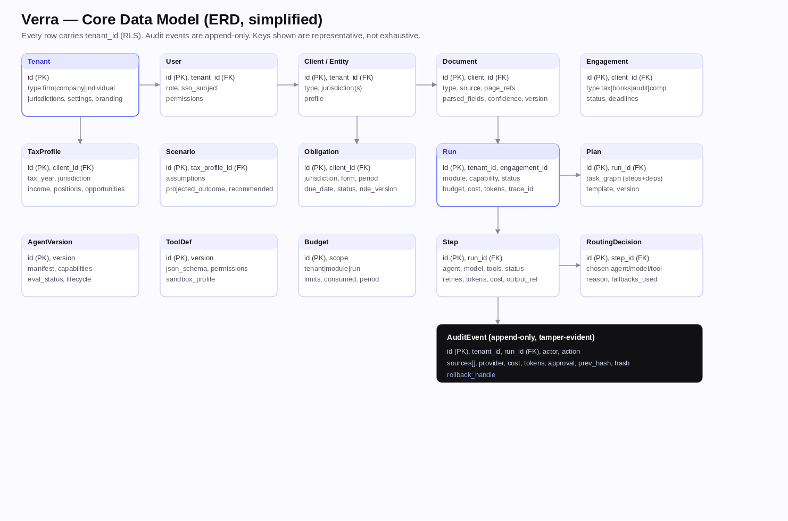
Figure 1 — Core data model (ERD, simplified).

4. API Design
Public surface is the gateway; the stable internal contract is the Orchestrator API. Machine-readable spec: code/backend/api/openapi.yaml. The frontend generates its client from this OpenAPI spec (no shared in-process types across FE/BE).
Method · path | Purpose
POST /v1/runs | Start a run (tenant, module, capability, input, context_refs, budget, idempotency_key)
GET /v1/runs/{id} | Status, cost, tokens, citations, receipts
GET /v1/runs/{id}/events | SSE: plan, route, step, tool_call, token/cost deltas, needs_approval, result
POST /v1/runs/{id}/approve · /reject | Resolve a human approval gate

5. Key Runtime Flow — Tax Analysis Run
End-to-end path of one tax-analysis run across the microservices, with guardrails, layered orchestration, model fallback, human gate and audit.
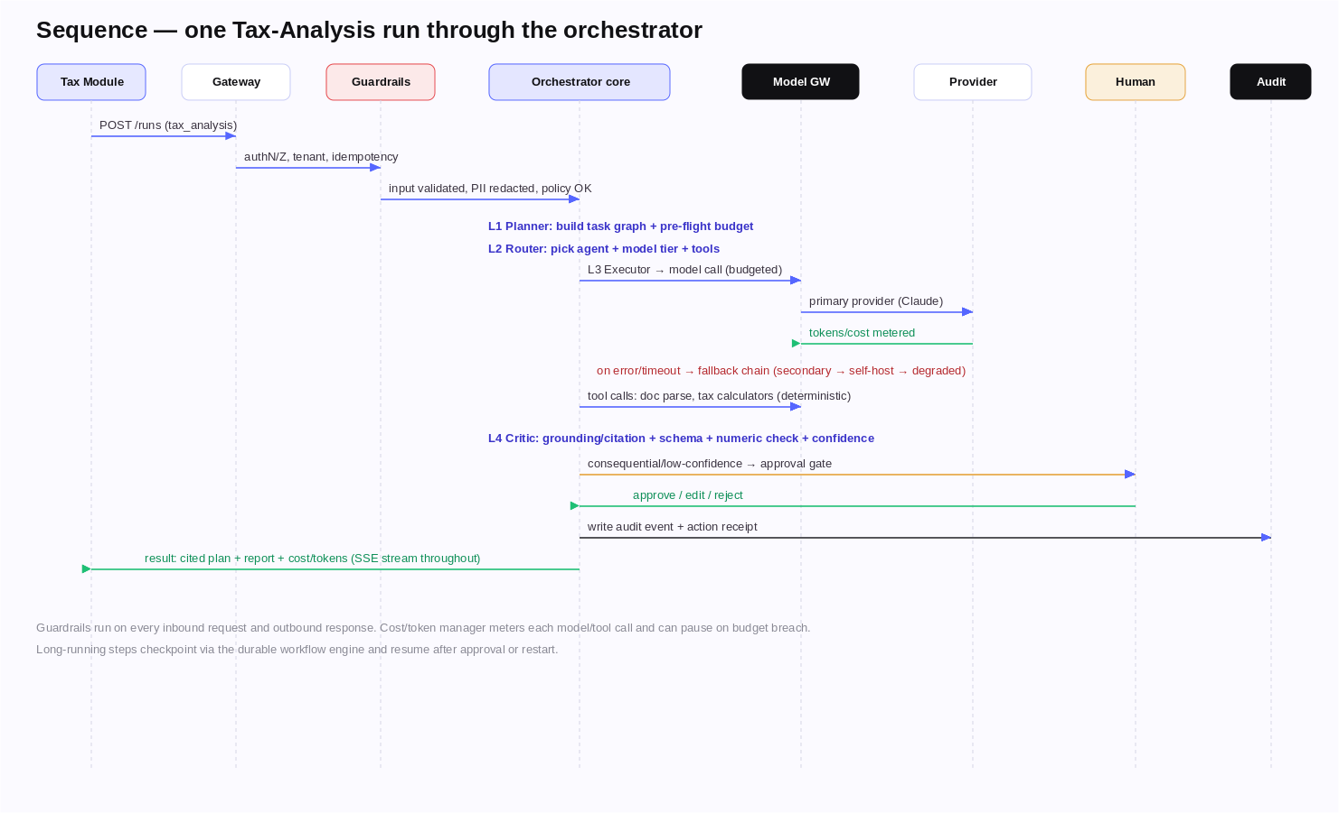
Figure 2 — Sequence of a tax-analysis run.

6. Deployment Topology
Containers run on Kubernetes behind CDN/WAF/LB, with a Postgres+pgvector / Redis / object-store data plane and external providers/integrations. Multi-region active-active for residency + DR (ADR-0014).
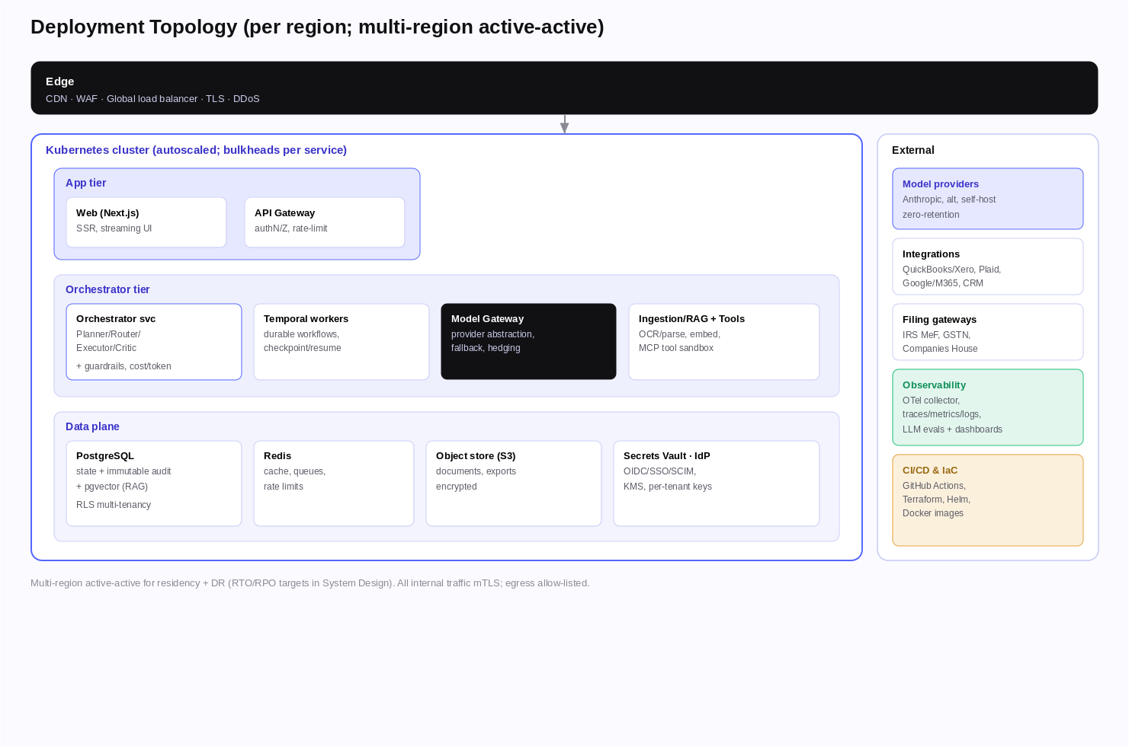
Figure 3 — Deployment topology (per region).

7. Multi-Tenancy & Data Isolation
- Every row carries tenant_id; PostgreSQL RLS enforces isolation; per-service schemas (ADR-0009/0017).
- Per-tenant encryption keys; enterprise/residency tenants can use a dedicated schema/DB/region.
- Tenant context propagates gateway → orchestrator → services and is asserted in queries and tests.

8. Security & Threat Model
Defense in depth; STRIDE summary with primary mitigations.
Threat | Mitigation
Spoofing | OIDC, mTLS service-to-service, signed tokens
Tampering | Hash-chained audit log; signed artifacts; RLS
Repudiation | Per-action audit receipts with actor + approval
Information disclosure | Encryption, PII/DLP redaction, least privilege, zero-retention AI
Denial of service | Rate limits, quotas, autoscaling, bulkheads, WAF
Elevation of privilege | RBAC, tenant RLS, sandboxed tools, vault secrets
Prompt injection / exfiltration | Input guardrails, tool allow-lists, output validation, egress controls
Compliance: SOC 2 Type II / ISO 27001; GDPR & India DPDP; professional-responsibility limits (analysis + drafts; human owns advice/filings).

9. Reliability, Scalability & Performance
- Stateless services scale horizontally; Temporal handles durable, resumable work.
- Circuit breakers + bulkheads per provider/tool; retries with backoff; idempotent side effects.
- Seasonal peaks handled via autoscaling (scale ingestion/orchestrator independently), queues, load shedding.
- Targets: ≥99.9% availability; assistant first-token p95 < 3s; ≥99% successful runs.

10. Observability
- OpenTelemetry trace per run across gateway → services → providers; metrics + structured logs (ADR-0012).
- LLM-trace tooling for prompt/response, evals and replay; dashboards + SLO-burn alerts.
- Eval-gated releases; canary + online evals.

11. Environments & Configuration
Env | Purpose | Notes
local | docker-compose (code/backend) | pg+pgvector, redis, minio, 7 services; mock providers
preview | Per-PR ephemeral | Seeded; CI-deployed
staging | Pre-prod, eval gating | Prod-like; SOC2 dry-run
production | Live, multi-region | Canary deploys

12. Technology Summary
Frontend: TypeScript/Next.js/Tailwind (pnpm+Turbo) [ADR-0002/0004]. Backend: Python 3.12 / FastAPI microservices [ADR-0016/0017] with Temporal; model gateway + fallback chain; PostgreSQL+pgvector; Redis; OIDC/RBAC/mTLS; OPA/Cedar policy; OpenTelemetry; Docker/K8s/Terraform/GitHub Actions.

13. Open Questions
- Dedicated vector DB threshold (when pgvector is outgrown).
- Per-service DB split timing (start shared-DB + schemas).
- gRPC vs HTTP/JSON for internal calls as throughput grows.
Disclaimer. Concept system design; vendor/tool names are starting points to validate in a spike (ADR-0000).

