

Examination Report
Case Information
Case Number | 001
Examiner Name | Harith, Jian Zhen
Description | DF In class asssignment

Evidence

Name | Acquisition MD5 | Verification MD5 | Evidence Number | Examiner Name
Alicia |  |  | E02HD1 | Thomas Chee

Examiner Notes
The following notes were prepared as part of the examination.

Documents of Interest

Documents
The below bookmarks represent documents that are potentially relevant to this case.

Pictures of Interest
Pictures
 | Name | Logical Size | Item Type | Signature Analysis | File Type
1 | i1^cimgpsh_orig.png | 164,629 | Entry

Pictures
The below bookmarks represent pictures that are potentially relevant to this case.
1) i1^cimgpsh_orig.png
Item Path Alicia\Users\Alicia\AppData\Roaming\Skype\live#3aaliciatanhuijing\media_messaging\media_cache_v3\i1^cimgpsh_orig.png
File Created 15/03/17 12:50:00 PM
Last Written 15/03/17 12:50:00 PM
Last Accessed 15/03/17 12:50:00 PM
MD5
Comment Picture of her having $200,000 inside her account even though she is just a student
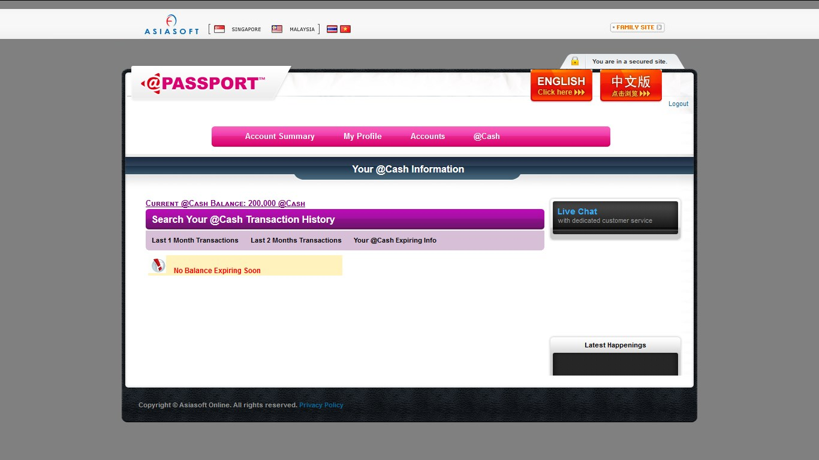

Email of Interest

Email
The below bookmarks represent emails that are potentially relevant to this case.

Internet Artifacts of Interest

Internet Artifacts
The below bookmarks represent Internet artifacts that are potentially relevant to this case.
2) upgrade.js-20170302120751
Item Path Alicia\Users\Alicia\AppData\Roaming\Mozilla\Firefox\Profiles\lx5oaqu6.default\sessionstore-backups\upgrade.js-20170302120751
File Created 15/03/17 10:22:07 AM
Last Written 14/03/17 04:24:02 PM
Last Accessed 15/03/17 10:22:07 AM
MD5
Comment Metasploit meterpreter is a an attack payload using DLL injection
3) 10AFC983E5FF72DF0F3440E4A9033FFB639DF74D
Item Path Alicia\Users\Alicia\AppData\Local\Mozilla\Firefox\Profiles\lx5oaqu6.default\cache2\entries\10AFC983E5FF72DF0F3440E4A9033FFB639DF74D
File Created 15/03/17 12:44:42 PM
Last Written 15/03/17 12:45:54 PM
Last Accessed 15/03/17 12:45:54 PM
MD5
Comment had no money in her acc den suddenly got 200k
4) note.txt
Item Path Alicia\$RECYCLE.BIN\S-1-5-21-4134190322-1791598225-2319710166-1002\note.txt
File Created 15/03/17 10:54:38 AM
Last Written 15/03/17 10:57:15 AM
Last Accessed 15/03/17 10:54:38 AM
MD5
Comment password txt
5) 5F9F7DF72FE37DF48134CC255B4A7DC455C4B2A1
Item Path Alicia\Users\Alicia\AppData\Local\Mozilla\Firefox\Profiles\lx5oaqu6.default\cache2\entries\5F9F7DF72FE37DF48134CC255B4A7DC455C4B2A1
File Created 15/03/17 10:42:38 AM
Last Written 15/03/17 10:42:40 AM
Last Accessed 15/03/17 10:42:38 AM
MD5
Comment meterpreter results
6) 79881C3C06818DD50F2DF9C1D35A4390039C729C
Item Path Alicia\Users\Alicia\AppData\Local\Mozilla\Firefox\Profiles\lx5oaqu6.default\cache2\entries\79881C3C06818DD50F2DF9C1D35A4390039C729C
File Created 15/03/17 10:42:45 AM
Last Written 15/03/17 10:51:50 AM
Last Accessed 15/03/17 10:51:45 AM
MD5
Comment metasploit keylogger
7) ea88e807ceb512dd.dat
Item Path Alicia\Users\Alicia\AppData\Roaming\Skype\live#3aaliciatanhuijing\chatsync\ea\ea88e807ceb512dd.dat
File Created 15/03/17 02:04:17 AM
Last Written 15/03/17 01:07:09 PM
Last Accessed 15/03/17 02:04:17 AM
MD5
Comment motive

Other Findings
The below bookmarks represent other information that is potentially relevant to this case.

Videos
8) 20170315_100927.jpg
Item Path Alicia\$RECYCLE.BIN\S-1-5-21-4134190322-1791598225-2319710166-1002\20170315_100927.jpg
File Created 15/03/17 10:57:44 AM
Last Written 15/03/17 10:09:35 AM
Last Accessed 15/03/17 10:57:44 AM
MD5
Comment shoulder surfing
bc12345

