Example1:
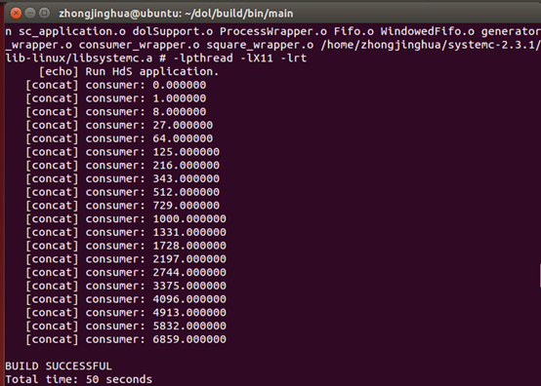
Example2:
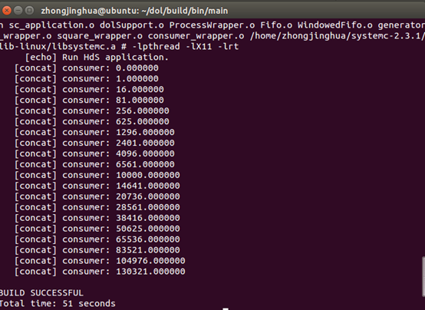

example1:
To update the “i=i*i;” into “i=i*i*i;” in the square.c
example2:
To update the “3” into “2” in the example2.xml

It is a simple but confusing project,whcih in fact I finish it just before it's deadline comes.I am sorry for that,I hope I could finish the homeword with a higher
efficiency.

