|  |  |  |  |  |  |
| --- | --- | --- | --- | --- | --- |
| **Ujian Akhir Praktikum - Semester Pendek2015/2016**  *Practicum Final Exam - Compact Semester Year 2015/2016* | | | | | |
| **Matakuliah**  *Subject* | | **ISYS6123-Introduction to Database Systems** | | |  |
| **Kelas**  *Class* | **: BA11 BB11** | | **Tanggal**  *Date* | **: 8/24/2016** |
| **Dosen**  *Lecturer* | **: D3709 - Novan Zulkarnain.ST., M.Kom** | | **Waktu**  *Time* | **: 11:20-13:00** |

**PERATURAN UJIAN:**

*Exam Regulations:*

* Mahasiswa tidak diperbolehkan membuka **BUKU** atau catatan apapun

*Student is not allowed to open or use any books or notes*

* Mahasiswa tidak diperbolehkan menggunakan disket/flash disk/tempat penyimpanan data apapun di dalam ruangan ujian

*Student is not allowed to use disc/flash disc/or any other storage devices in exam room*

* Mahasiswa tidak diperbolehkan berdiskusi dengan peserta ujian lainnya

*Student is not allowed to discuss with other exam participants*

* Asisten **BERHAK** memberi nilai 0 **(NOL)** bagi peserta ujian yang melakukan segala bentuk kecurangan

*Assistant is able to give 0 (ZERO) score for exam participant who doesany cheating actions*

* Kumpulkan jawaban dan soal tepat pada waktunya

*Submit the case and answer on time*

* Bila Anda tidak membaca peraturan ini, maka Anda dianggap telah membaca dan menyetujuinya

*If you have missed to read these regulations, so you are considered to have read and agreedon it*

**PERHATIAN!**

***Attention!***

* Kerjakan sesuai dengan soal

*Work in accordance with the exam case*

* Bagi yang mengerjakan tidak sesuai dengan soal akan diberikan sanksi sebagai berikut:

*For those who do not work in accordance with the exam case will be punished as follows:*

* + - * **Jikaada** penilaian logika, maka penilaian logika adalah **NOL (0)**

***If there is*** *logic marking, it will be marked as* ***ZERO (0)***

* + - * Untuk penilaian yang lain (selain logika) akan **dikalikan** setengah dari nilai yang diperoleh

*Another marking (beside logic) will be* ***multiplied*** *by half the value obtained*

**Tabel Relasional**

*Relational Table*

**Bluejack Library**

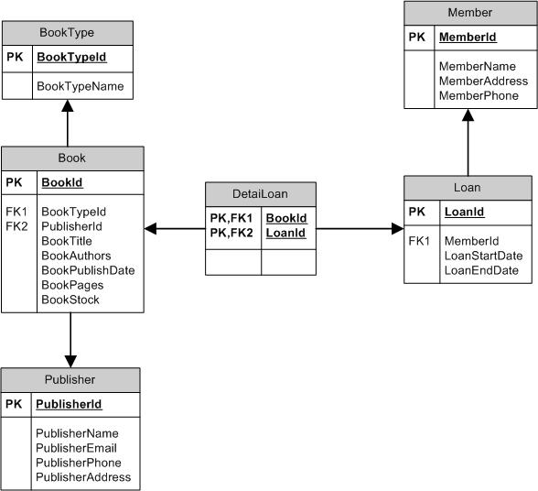

**Soal**

*Case*

1. Display BookId, BookTitle, Book Authors (obtained from BookAuthors in uppercase format), BookPages, and BookStock for every book which stock is greater than 10

(**upper**)

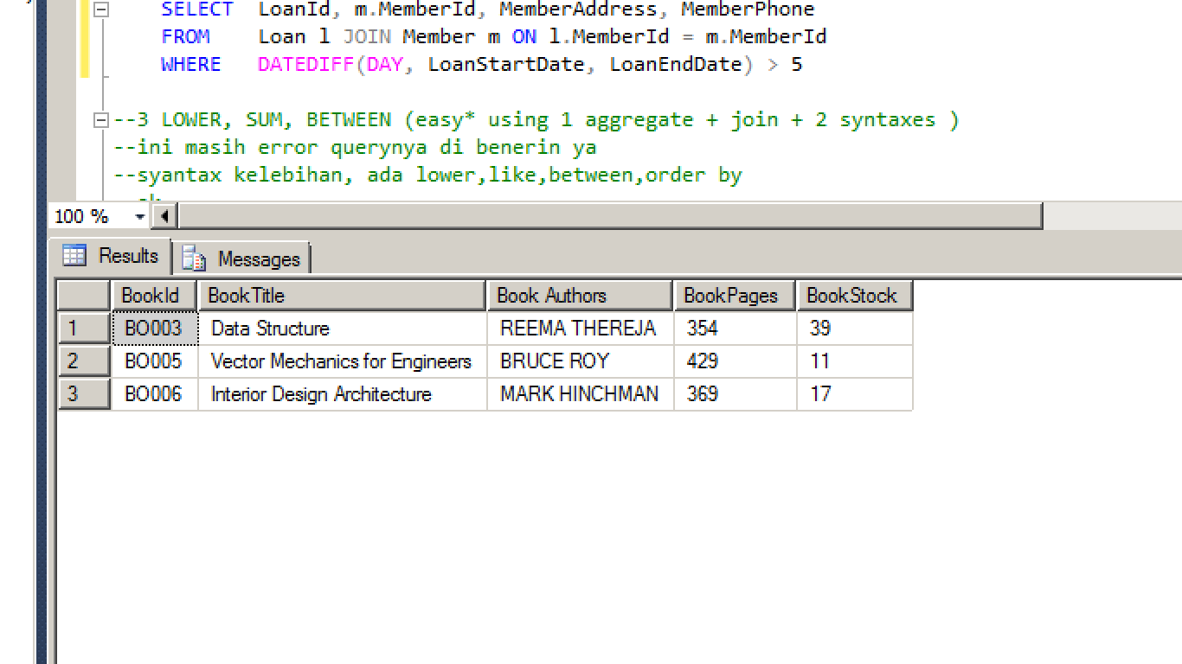

1. Display LoanId, MemberId, MemberAddress, and MemberPhone for every loan which the difference between LoanStartDate and LoanEndDate is greater than 5 days.

(**datediff, day, join**)

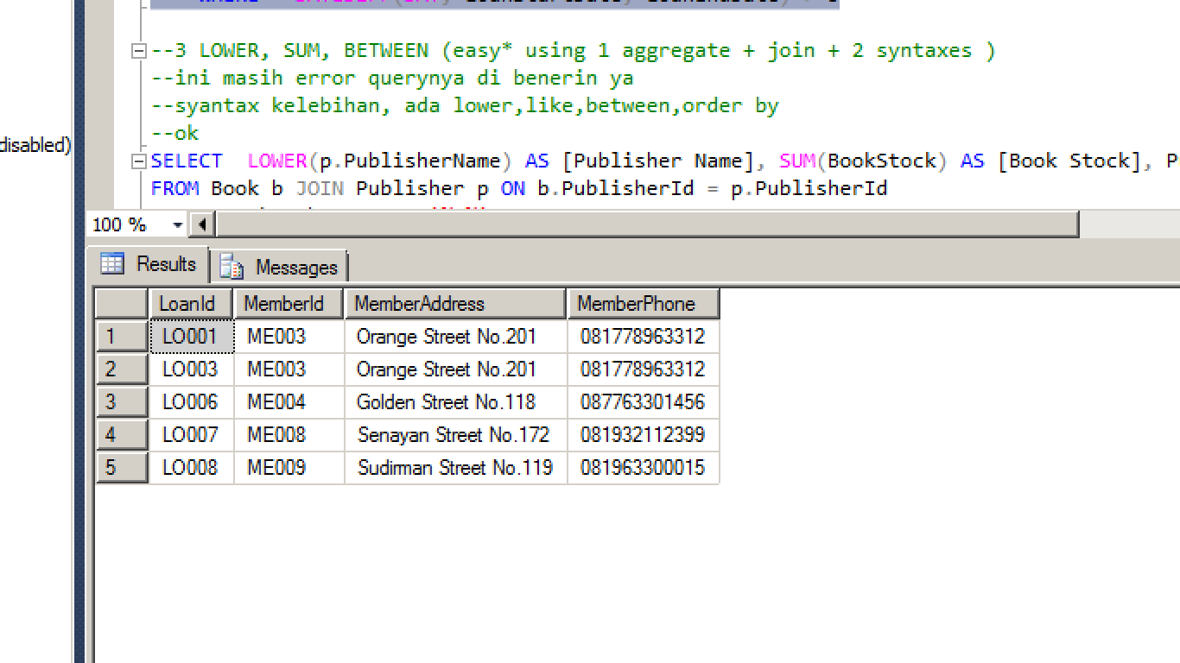

1. Display Publisher Name (obtained from PublisherName in lowercase format), Book Stock (obtained from total amount of book stock), and PublisherEmail for every book authors whose name contains ‘e’ character.

**(lower, sum, like, join, groupby)**

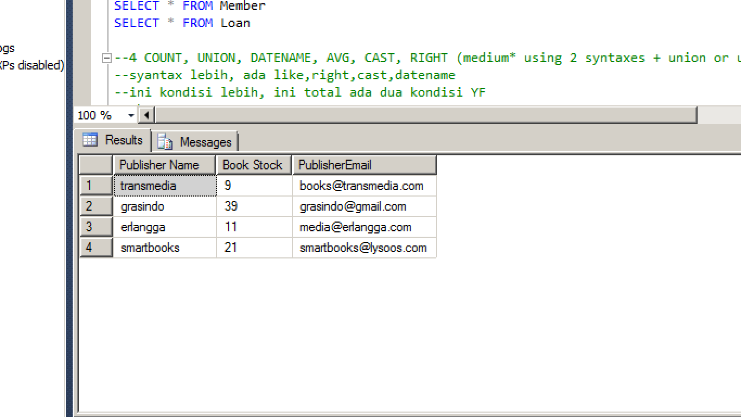

1. Display BookType (obtained by adding ‘Type ’ word in front of the last three digits of BookTypeID), BookTypeName, Pages (obtained by adding ‘Max ’word in front ofthe maximum number of book pages) for every book which type is ‘Academic’ or ‘Engineering’. Then, **combine** itwith BookType (obtained by adding ‘Type ’ word in front of the last three digits of BookTypeID), BookTypeName, Pages (obtained by adding ‘Min ’word in frontof the minimum number of book pages)for every book which type is‘Academic’ or ‘Engineering’.

**(right, max, min, cast, union, groupby)**

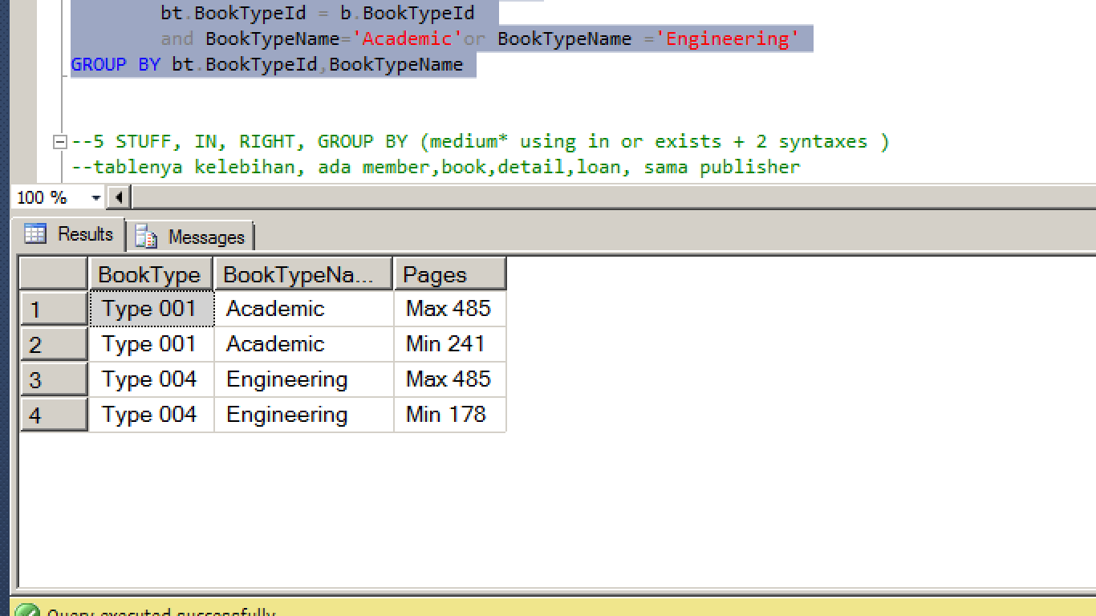

1. Display MemberName, MemberAddress, and Phone (obtained by replacing the first letter of MemberPhone with ‘+62 ’) for every book which title is more than two word and book stock is greater than 15.

**(stuff, in, like)**

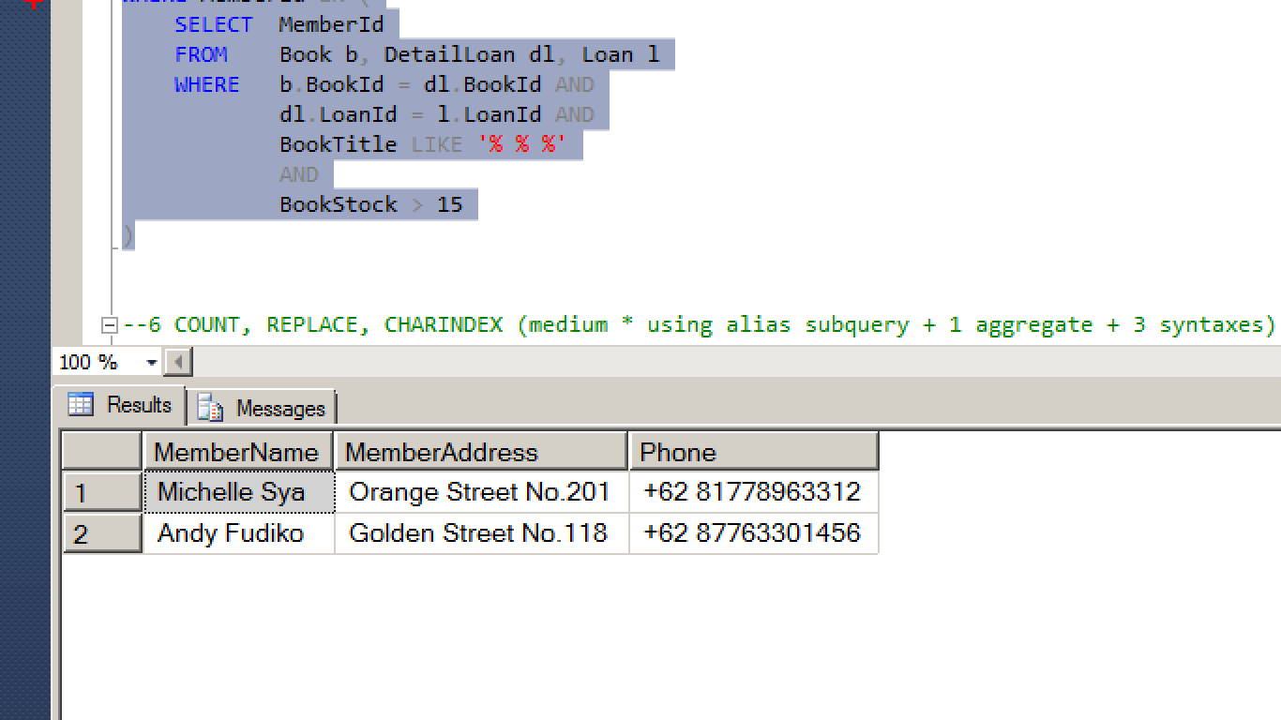

1. Display MemberId, and Count Book (obtainedfrom total number of book and ended with ‘ Book’) for every book authors which name contain ‘s’ character and last two letter of PublisherAddress is greater than 60.

**(cast, count, charindex, right, alias subquery, groupby)**

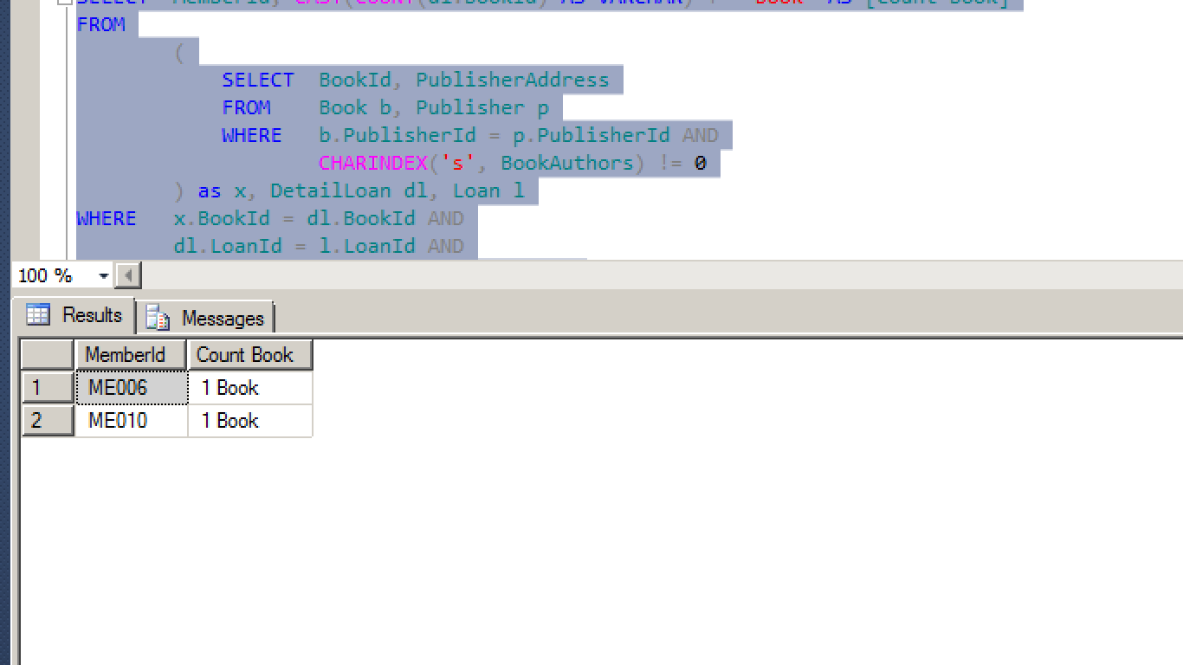

1. Create view named ‘View Book’ to display BookId, BookTitle, BookAuthors, and PublishDate (obtained from BookPublishDate in ‘dd Mon yyyy’ format) for every book which was published after 2010.

(**create view, convert, year**)

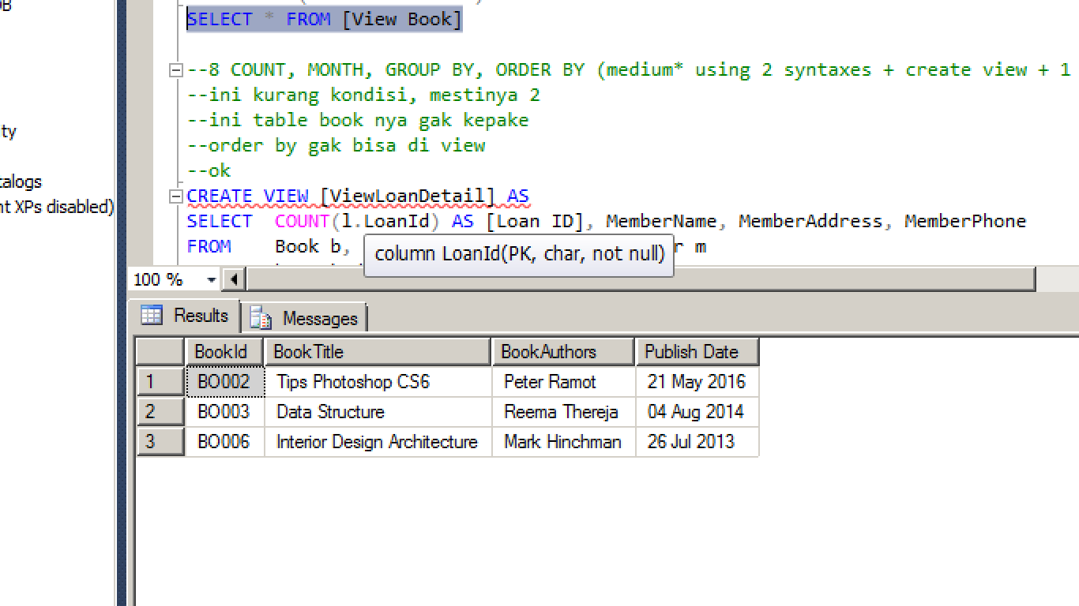

1. Create view named ‘ViewLoanDetail’ to display Total Loan(obtained from total number of loan), MemberName, MemberAddress, MemberPhone for every member who loan books after the third month and book which title is greater than 23 characters of length.

**(create view, count, month, len, groupby)**

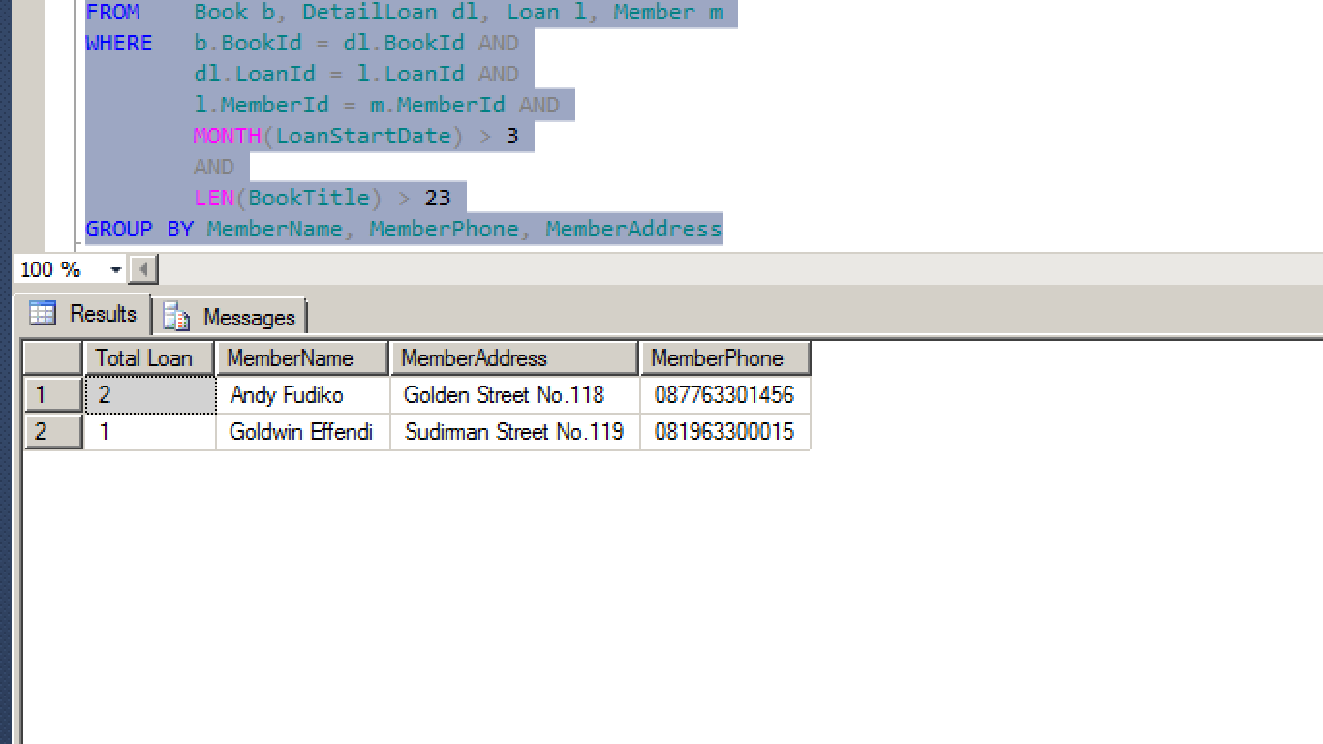

1. Add a column named ‘Gender’ on Member table with varchar(10) datatype and add a constraint named ‘CheckMemberGender’ to check the gender inputted is ‘Male’ or ‘Female’.

(**alter table, add constraint**)

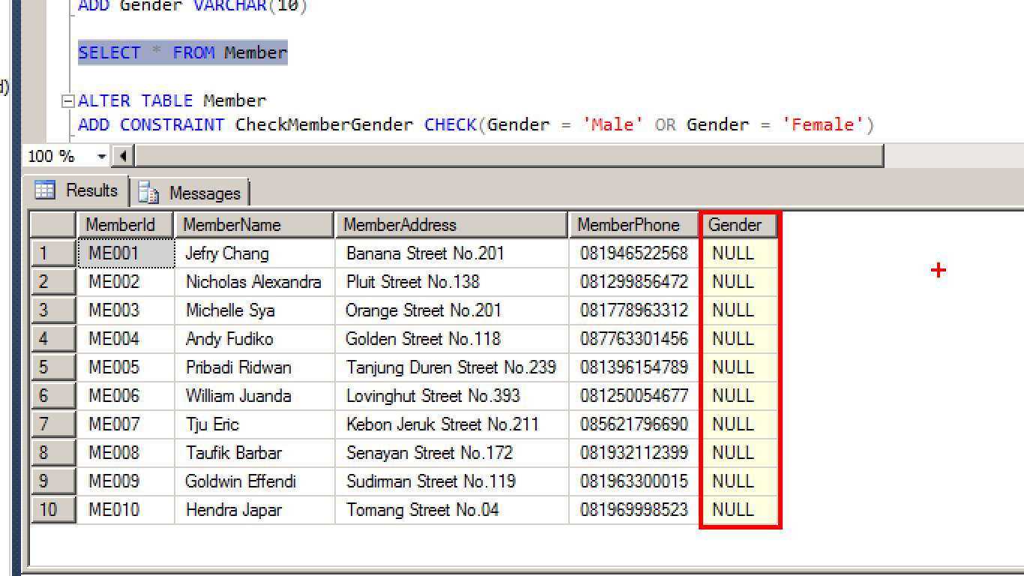

1. Delete from Book for every book which the second character of publisher name is ‘m’ or BookTypeId is ‘BT002’.

(**delete, like**)

**Before** delete:

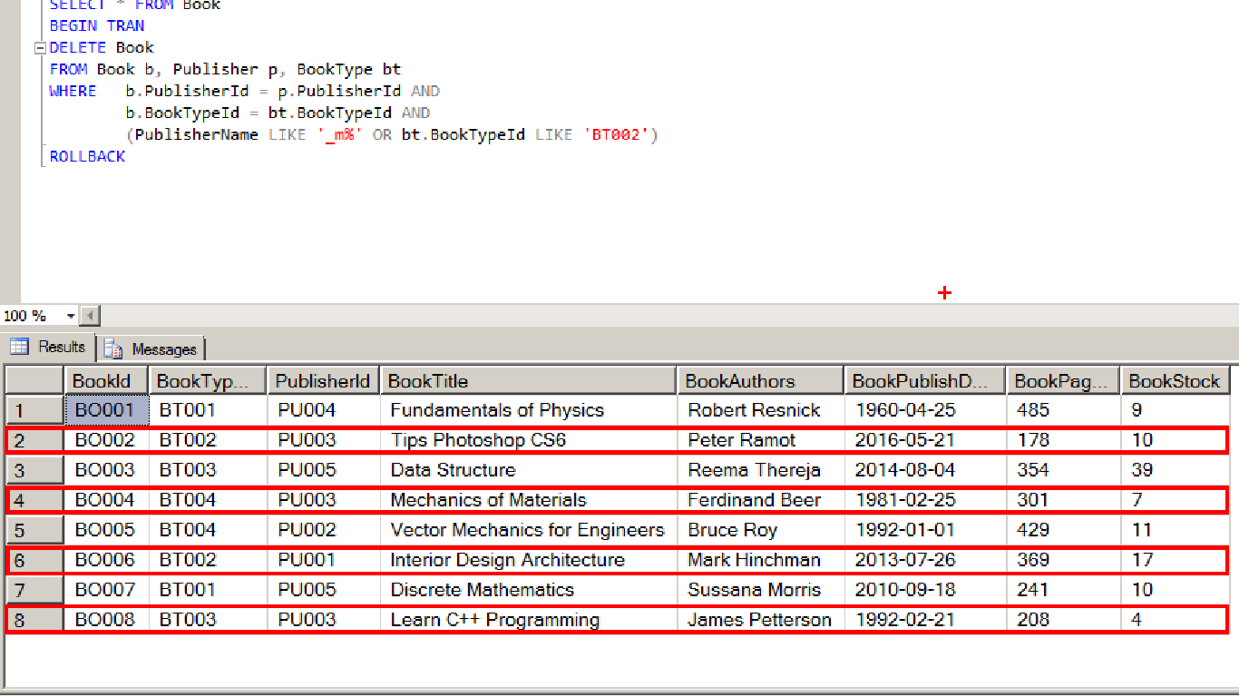

**After** delete:

