A Project Report On

**Airline Reservation System**

For

AISSCE 2018 Examination

As a Part of the Informatics Practices Course (085)

Submitted By:

**Pragun Saini**

**Roll No. : ………..**

Under The Guidance Of :

**Ms. Tripti Mehta**

**(PGT IP)**

***Certificate***

This is to certify that the Project entitled, Airline Reservation System is a bonafide work done by **Pragun Sain**i of class **XII-C** Session 2017-18 in partial fulfillment of CBSE’s AISSCE Examination 2018 and has been carried out under direct supervision and guidance of Ms. **Tripti Mehta (PGT IP)**.

***Acknowledgement***

I extend my grateful thanks to Ms. Tripti Mehta, Teacher Of Department of Informatics Practices for her guidance and useful suggestions, which helped me in completing the project work in time.

I would also like to thank all the teaching and non teaching staff of computer science department who helped me directly or indirectly in the completion of this project.

Finally, Yet importantly, I would like to express my heartfelt thanks to my beloved parents for their blessings, my friends/classmates for their help and wishes for the successful completion of this project.

Pragun Saini

***Table of contents***

**A) Introduction**

**B) System Design and Development:**

**1) Database Design**

**2) Netbeans – Forms Design and Coding**

**C) BiblioGraphy**

***Introduction***

The Project is **Airline Reservation System**. During coding and design of the software Project, **Java NetBeans IDE**, a powerful front-end tool is used for getting Graphical User Interface (GUI) based integrated platform and coding simplicity. As a back-end a powerful, open source RDBMS, **MySQL** is used as per requirement of the CBSE curriculum of Informatics Practices Course.

It requires you to login using a valid username and password to gain access to its functions.

It includes a dashboard for navigation and quick access between different forms of this application.

The application provides facility to register a Customer (User), Flights and then Book a Ticket on a flight. It allows you to add details and if need be, later modify and update them or delete them.

**System Design & Development**

## Database Design:

This software project maintains a database named **airline_reservation** which contains the following tables.

### Table Design:

The database contains 3 tables.

**Table: customers**

*Column Name Type Size*

ID **(Primary key)** Integer 10

Name Varchar 30

Gender Varchar 7

DOB Date

Address Varchar 100

**Table: flights**

*Column Name Type Size*

**ID** **(Primary Key)** Integer 10

Name Varchar 30

Source Varchar 30

Destination Varchar 30

Departure Varchar 20

Arrival Varchar 20

Charges Integer 10

Date Date

**Table: tickets**

*Column Name Type Size*

TicketNo **(Primary Key)** Integer 20

CustomerID Integer 20

CustomerName Varchar 30

Gender Varchar 10

FlightID Integer 20

FlightName Varchar 30

Source Varchar 30

Destination Varchar 30

Date Date

Seats Integer 30

Amount Integer 11

**Forms Design & Coding:**

**1) Login Form :**

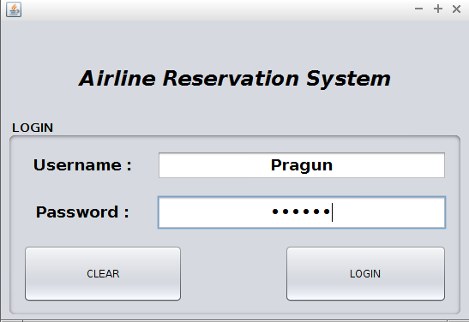

**Coding :**

import javax.swing.JoptionPane;

**Clear Button :**

private void jButton2ActionPerformed(java.awt.event.ActionEvent evt) {

tf1.setText("");

pf1.setText("");

}

**Login Button :**

private void jButton1ActionPerformed(java.awt.event.ActionEvent evt) {

String user = tf1.getText();

String pwd = new String(pf1.getPassword());

if (user.equals("Pragun") && pwd.equals("pragun")){

Dashboard d = new Dashboard();

d.setVisible(true);

close();

}

else

JOptionPane.showMessageDialog(null,"Call Security - This is an imposter");}

**2) Dashboard Form :**

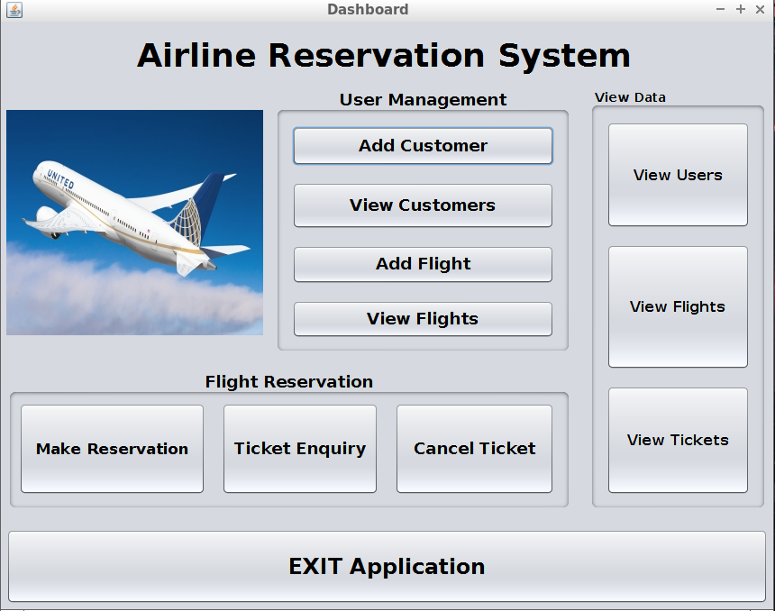

**Coding :**

**Add Customer Button :**

private void jButton1ActionPerformed(java.awt.event.ActionEvent evt) {

AddCustomer add = new AddCustomer();

add.setVisible(true);

close();

}

**View Customers Button :**

private void jButton2ActionPerformed(java.awt.event.ActionEvent evt) {

ViewCustomer view = new ViewCustomer();

view.setVisible(true);

close();

}

**Add Flights Button :**

private void jButton3ActionPerformed(java.awt.event.ActionEvent evt) {

AddFlight addf = new AddFlight();

addf.setVisible(true);

close();

}

**View Flights Button :**

private void jButton4ActionPerformed(java.awt.event.ActionEvent evt) {

ViewFlight viewf = new ViewFlight();

viewf.setVisible(true);

close();

}

**View Users Button:**

private void jButton9ActionPerformed(java.awt.event.ActionEvent evt) {

Customers cust = new Customers();

cust.setVisible(true);

close();

}

**View Flights Button :**

private void jButton10ActionPerformed(java.awt.event.ActionEvent evt) {

Flights flights = new Flights();

flights.setVisible(true);

close();

}

**View Tickets Button :**

private void jButton11ActionPerformed(java.awt.event.ActionEvent evt) {

Tickets tkts = new Tickets();

tkts.setVisible(true);

close();

}

**Reservation Button :**

private void jButton5ActionPerformed(java.awt.event.ActionEvent evt) {

Reservation reserv = new Reservation();

reserv.setVisible(true);

close();

}

**Ticket Enquiry Button :**

private void jButton6ActionPerformed(java.awt.event.ActionEvent evt) {

Enquiry enq = new Enquiry();

enq.setVisible(true);

close();

}

**Cancel Ticket Button :**

private void jButton7ActionPerformed(java.awt.event.ActionEvent evt) {

Cancel cancel = new Cancel();

cancel.setVisible(true);

close();

}

**EXIT Button :**

private void jButton8ActionPerformed(java.awt.event.ActionEvent evt) {

System.exit(0);

}

**3) Add Customer Form :**

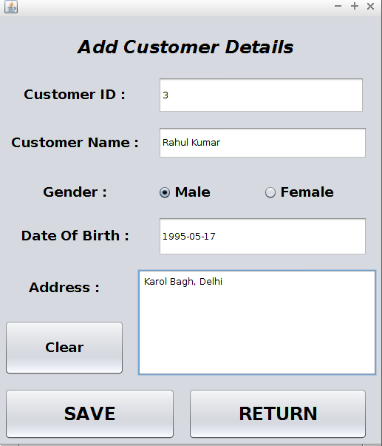

**Coding :**

import java.sql.*;

import javax.swing.JoptionPane;

Connection con = null;

Statement stmt = null;

ResultSet rs = null;

**Save Button :**

private void jButton1ActionPerformed(java.awt.event.ActionEvent evt) {

int ID = Integer.parseInt(id.getText());

String Name = name.getText();

String DOB = dob.getText();

String Gender = null;

if (male1.isSelected())

Gender = "male";

else if (female1.isSelected())

Gender = "female";

String Address = address.getText();

try{

Class.forName("java.sql.Driver");

con = DriverManager.getConnection("jdbc:mysql://localhost/airline_reservation?verifyServerCertificate=false&useSSL=true","root","pragun");

stmt = con.createStatement();

String query = "Insert into customers values(" + ID + ",'" + Name + "','" + Gender + "','" + DOB + "','" + Address + "');";

stmt.executeUpdate(query);

JOptionPane.showMessageDialog(null,"Record Saved Succesfully");

}

catch(Exception e){

JOptionPane.showMessageDialog(null,"Record could not be saved");

}

}

**Clear Button :**

private void jButton3ActionPerformed(java.awt.event.ActionEvent evt) {

id.setText("");

dob.setText("");

name.setText("");

address.setText("");

buttonGroup1.clearSelection();

}

**Return Button :**

private void jButton2ActionPerformed(java.awt.event.ActionEvent evt) {

Dashboard d = new Dashboard();

d.setVisible(true);

close();

}

private void close(){

this.setVisible(false);

this.dispose();

}

**4) View Customer Form :**

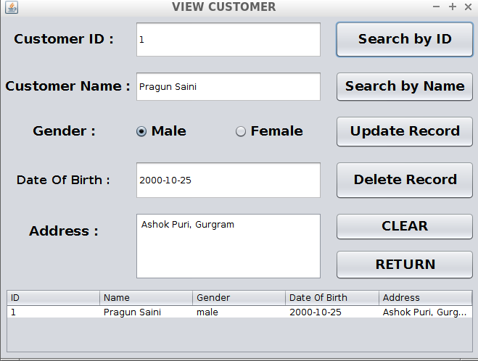

**Coding :**

import javax.swing.JOptionPane;

import java.sql.*;

import javax.swing.table.DefaultTableModel;

Connection con = null;

Statement stmt = null;

ResultSet rs = null;

**Search By ID Button :**

private void jButton1ActionPerformed(java.awt.event.ActionEvent evt) {

DefaultTableModel model = (DefaultTableModel) cust.getModel();

try {

Class.forName("java.sql.Driver");

con = DriverManager.getConnection("jdbc:mysql://localhost/airline_reservation?verifyServerCertificate=false&useSSL=true","root","pragun");

stmt = con.createStatement();

String query = "Select * from customers Where ID =" + id1.getText() + ";";

rs = stmt.executeQuery(query);

if (rs.next()){

String name = rs.getString("Name");

String dob = rs.getString("DOB");

String gender = rs.getString("Gender");

String address = rs.getString("Address");

String idx = rs.getString("ID");

model.addRow(new Object[] {idx,name,gender,dob,address});

name1.setText(name);

dob1.setText(dob);

add1.setText(address);

if (gender.equals("male"))

male1.setSelected(true);

else if (gender.equals("female"))

female1.setSelected(true);

}

else {JOptionPane.showMessageDialog(null,"No such record found");}

}

catch(Exception e) {

JOptionPane.showMessageDialog(null,"Error in Connectivity");

}

del.setEnabled(true);

up.setEnabled(true);

}

**Search By Name Button:**

private void jButton2ActionPerformed(java.awt.event.ActionEvent evt) {

DefaultTableModel model = (DefaultTableModel) cust.getModel();

try {

Class.forName("java.sql.Driver");

con = DriverManager.getConnection("jdbc:mysql://localhost/airline_reservation?verifyServerCertificate=false&useSSL=true","root","pragun");

stmt = con.createStatement();

String namex = name1.getText();

String query = "Select * from customers Where Name = '" + namex + "';";

rs = stmt.executeQuery(query);

if (rs.next()){

String name = rs.getString("Name");

String dob = rs.getString("DOB");

String gender = rs.getString("Gender");

String address = rs.getString("Address");

String idx = rs.getString("ID");

model.addRow(new Object[] {idx,name,gender,dob,address});

name1.setText(name);

dob1.setText(dob);

add1.setText(address);

if (gender.equals("male"))

male1.setSelected(true);

else if (gender.equals("female"))

female1.setSelected(true);

id1.setText(idx);

}

else {JOptionPane.showMessageDialog(null,"No such record found");}

}

catch(Exception e) {

JOptionPane.showMessageDialog(null,"Error in Connectivity");

}

del.setEnabled(true);

up.setEnabled(true);

}

**Update Record Button :**

private void upActionPerformed(java.awt.event.ActionEvent evt) {

int ans = JOptionPane.showConfirmDialog(null,"Surely wanna update the record?");

if (ans == JOptionPane.YES_OPTION) {

try{

stmt = con.createStatement();

int id = Integer.parseInt(id1.getText());

String name = name1.getText();

String gender = null;

if (male1.isSelected())

gender = "male";

else if (female1.isSelected())

gender = "female";

String dob = dob1.getText();

String address = add1.getText();

String query = "Update customers SET Name = '" + name + "', DOB = '" + dob + "', Gender = '" + gender + "', Address = '" + address + "' WHERE ID = " + id + " ;";

stmt.executeUpdate(query);

JOptionPane.showMessageDialog(null,"Record Updated Succesfully");

}

catch(Exception e) {

JOptionPane.showMessageDialog(null,"Error in table Updation");

}

}

}

**Delete Record Button :**

private void delActionPerformed(java.awt.event.ActionEvent evt) {

int ans = JOptionPane.showConfirmDialog(null,"Surely wanna delete the record?");

if (ans == JOptionPane.YES_OPTION) {

try{

stmt = con.createStatement();

int id = Integer.parseInt(id1.getText());

String query = "Delete From customers Where ID = " + id + ";";

stmt.executeUpdate(query);

JOptionPane.showMessageDialog(null,"Record Deleted Succesfully");

id1.setText("");

name1.setText("");

add1.setText("");

dob1.setText("");

buttonGroup1.clearSelection();

del.setEnabled(false);

up.setEnabled(false);

DefaultTableModel model = (DefaultTableModel) cust.getModel();

model.setRowCount(0);

}

catch(Exception e) {

JOptionPane.showMessageDialog(null,"Error in Deletion");

}

}

}

**Clear Button :**

private void jButton6ActionPerformed(java.awt.event.ActionEvent evt) {

id1.setText("");

name1.setText("");

add1.setText("");

dob1.setText("");

buttonGroup1.clearSelection();

del.setEnabled(false);

up.setEnabled(false);

DefaultTableModel model = (DefaultTableModel) cust.getModel();

model.setRowCount(0);

}

**Return Button :**

private void jButton5ActionPerformed(java.awt.event.ActionEvent evt) {

Dashboard d = new Dashboard();

d.setVisible(true);

close();

}

private void close() {

this.setVisible(false);

this.dispose();

}

**5) Add Flight Form :**

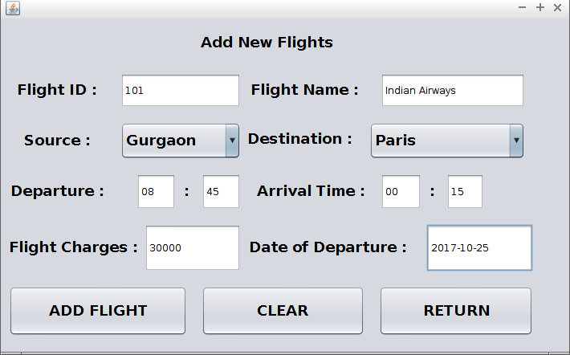

**Coding :**

import javax.swing.JOptionPane;

import java.sql.*;

Connection con = null;

Statement stmt = null;

ResultSet rs = null;

**Add Flight Button :**

private void jButton1ActionPerformed(java.awt.event.ActionEvent evt) {

int id = Integer.parseInt(fid.getText());

String name = fname.getText();

String source = (String) scb.getSelectedItem();

String destination = (String) dcb.getSelectedItem();

String HD = hd.getText();

String MD = md.getText();

String HA = ha.getText();

String MA = ma.getText();

String departure = HD + " : " + MD;

String arrival = HA + " : " + MA;

int charges = Integer.parseInt(chargesf.getText());

String date = datef.getText();

try{

Class.forName("java.sql.Driver");

con = DriverManager.getConnection("jdbc:mysql://localhost/airline_reservation?verifyServerCertificate=false&useSSL=true","root","pragun");

stmt = con.createStatement();

String query = "Insert into flights values(" + id + ",'" + name + "','" + source + "','" + destination + "','" + departure + "','" + arrival + "'," + charges + ",'" + date + "');";

stmt.executeUpdate(query);

JOptionPane.showMessageDialog(null,"Flight added successfully");

}

catch(Exception e) {

JOptionPane.showMessageDialog(null,"Flight couldn't be added");

}

}

private void mdActionPerformed(java.awt.event.ActionEvent evt) {

}

**Clear Button :**

private void jButton2ActionPerformed(java.awt.event.ActionEvent evt) {

fid.setText("");

fname.setText("");

md.setText("");

hd.setText("");

ma.setText("");

ha.setText("");

chargesf.setText("");

datef.setText("");

}

**Return Button:**

private void jButton3ActionPerformed(java.awt.event.ActionEvent evt) {

Dashboard d = new Dashboard();

d.setVisible(true);

close();

}

private void close(){

this.setVisible(false);

this.dispose(); }

**6) View Flight Form :**

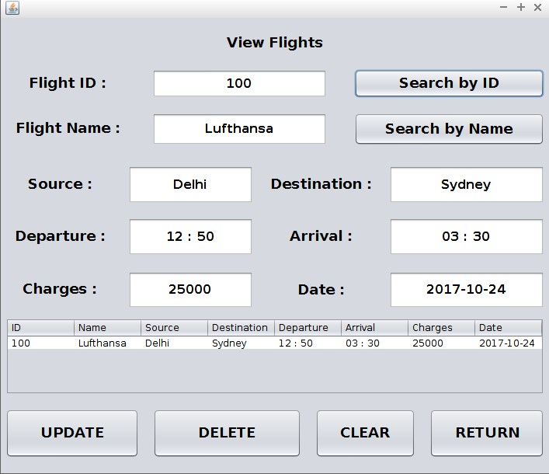

**Coding :**

import javax.swing.JOptionPane;

import java.sql.*;

import javax.swing.table.DefaultTableModel;

Connection con = null;

Statement stmt = null;

ResultSet rs = null;

**Search By ID Button :**

private void jButton1ActionPerformed(java.awt.event.ActionEvent evt) {

DefaultTableModel model = (DefaultTableModel) flightt.getModel();

try {

Class.forName("java.sql.Driver");

con = DriverManager.getConnection("jdbc:mysql://localhost/airline_reservation?verifyServerCertificate=false&useSSL=true","root","pragun");

stmt = con.createStatement();

String query = "Select * from flights Where ID =" + fid.getText() + ";";

rs = stmt.executeQuery(query);

if (rs.next()){

String name = rs.getString("Name");

String id = rs.getString("ID");

String departure = rs.getString("Departure");

String arrival = rs.getString("Arrival");

String source = rs.getString("Source");

String destination = rs.getString("Destination");

String charges = rs.getString("Charges");

String date = rs.getString("Date");

model.addRow(new Object[] {id,name,source,destination,departure,arrival,charges,date});

fid.setText(id);

fname.setText(name);

fdep.setText(departure);

farrival.setText(arrival);

fsource.setText(source);

fdest.setText(destination);

fcharges.setText(charges);

fdate.setText(date);

}

else

JOptionPane.showMessageDialog(null,"No such flight");

}

catch (Exception e){

JOptionPane.showMessageDialog(null,"Error in connectivity");

}

del.setEnabled(true);

up.setEnabled(true);

}

**Search By Name Button :**

private void jButton2ActionPerformed(java.awt.event.ActionEvent evt) {

DefaultTableModel model = (DefaultTableModel) flightt.getModel();

try {

Class.forName("java.sql.Driver");

con = DriverManager.getConnection("jdbc:mysql://localhost/airline_reservation?verifyServerCertificate=false&useSSL=true","root","pragun");

stmt = con.createStatement();

String query = "Select * from flights Where Name = '" + fname.getText() + "';";

rs = stmt.executeQuery(query);

if (rs.next()){

String name = rs.getString("Name");

String id = rs.getString("ID");

String departure = rs.getString("Departure");

String arrival = rs.getString("Arrival");

String source = rs.getString("Source");

String destination = rs.getString("Destination");

String charges = rs.getString("Charges");

String date = rs.getString("Date");

model.addRow(new Object[] {id,name,source,destination,departure,arrival,charges,date});

fid.setText(id);

fname.setText(name);

fdep.setText(departure);

farrival.setText(arrival);

fsource.setText(source);

fdest.setText(destination);

fcharges.setText(charges);

fdate.setText(date);

}

else

JOptionPane.showMessageDialog(null,"No such flight");

}

catch (Exception e){

JOptionPane.showMessageDialog(null,"Error in connectivity");

}

del.setEnabled(true);

up.setEnabled(true);

}

**Update Button :**

private void upActionPerformed(java.awt.event.ActionEvent evt) {

int ans = JOptionPane.showConfirmDialog(null,"Surely wanna update the record?");

if (ans == JOptionPane.YES_OPTION) {

try{

stmt = con.createStatement();

int id = Integer.parseInt(fid.getText());

String name = fname.getText();

String dest = fdest.getText();

String source = fsource.getText();

String dep = fdep.getText();

String arrival = farrival.getText();

int charges = Integer.parseInt(fcharges.getText());

String date = fdate.getText();

String query = "Update flights SET Name = '" + name + "', Source = '" + source + "', Destination = '" + dest + "', Departure = '" + dep + "', Arrival = '" + arrival + "', Date = '" + date + "', Charges = '" + charges + "' Where ID = " + id + ";";

stmt.executeUpdate(query);

JOptionPane.showMessageDialog(null,"Record Updated Succesfully");

}

catch(Exception e) {

JOptionPane.showMessageDialog(null,"Error in table Updation");

}

} }

**Delete Button :**

private void delActionPerformed(java.awt.event.ActionEvent evt) {

int ans = JOptionPane.showConfirmDialog(null,"Surely wanna delete the record?");

if (ans == JOptionPane.YES_OPTION) {

try{

stmt = con.createStatement();

int id = Integer.parseInt(fid.getText());

String query = "Delete From flights Where ID = " + id + ";";

stmt.executeUpdate(query);

JOptionPane.showMessageDialog(null,"Record Deleted Succesfully");

fid.setText("");

fname.setText("");

fsource.setText("");

fdest.setText("");

farrival.setText("");

fdep.setText("");

fdate.setText("");

fcharges.setText("");

DefaultTableModel model = (DefaultTableModel) flightt.getModel();

model.setRowCount(0);

del.setEnabled(false);

up.setEnabled(false);

}

catch(Exception e) {

JOptionPane.showMessageDialog(null,"Error in Deletion");

}

}

}

**Clear Button :**

private void jButton5ActionPerformed(java.awt.event.ActionEvent evt) {

fid.setText("");

fname.setText("");

fsource.setText("");

fdest.setText("");

farrival.setText("");

fdep.setText("");

fdate.setText("");

fcharges.setText("");

DefaultTableModel model = (DefaultTableModel) flightt.getModel();

model.setRowCount(0);

del.setEnabled(false);

up.setEnabled(false);

}

**Return Button :**

private void jButton6ActionPerformed(java.awt.event.ActionEvent evt) {

Dashboard d = new Dashboard();

d.setVisible(true);

close();

}

private void close() {

this.setVisible(false);

this.dispose();

}

**7) View Users Form :**

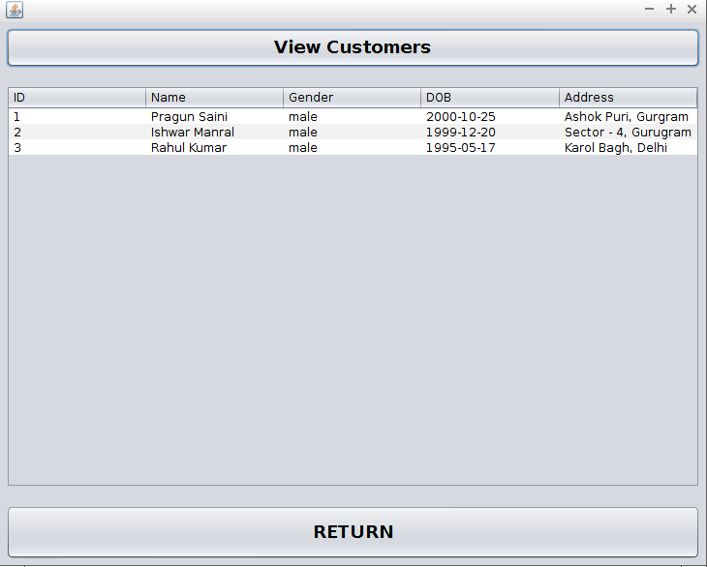

**Coding :**

import java.sql.*;

import javax.swing.JOptionPane;

import javax.swing.table.DefaultTableModel;

Connection con = null;

Statement stmt = null;

ResultSet rs = null;

**View Customers Button :**

private void jButton1ActionPerformed(java.awt.event.ActionEvent evt) {

DefaultTableModel model = (DefaultTableModel) cust.getModel();

try {

Class.forName("java.sql.Driver");

con = DriverManager.getConnection("jdbc:mysql://localhost/airline_reservation?verifyServerCertificate=false&useSSL=true","root","pragun");

stmt = con.createStatement();

String query = "Select * from customers;";

rs = stmt.executeQuery(query);

while (rs.next()){

String name = rs.getString("Name");

String dob = rs.getString("DOB");

String gender = rs.getString("Gender");

String address = rs.getString("Address");

String idx = rs.getString("ID");

model.addRow(new Object[] {idx,name,gender,dob,address});

}

}

catch(Exception e) {

JOptionPane.showMessageDialog(null,"Error in Connectivity");

}

}

**Return Button :**

private void jButton2ActionPerformed(java.awt.event.ActionEvent evt) {

Dashboard d = new Dashboard();

d.setVisible(true);

close();

}

private void close(){

this.setVisible(false);

this.dispose(); }

**8) View Flights Form :**

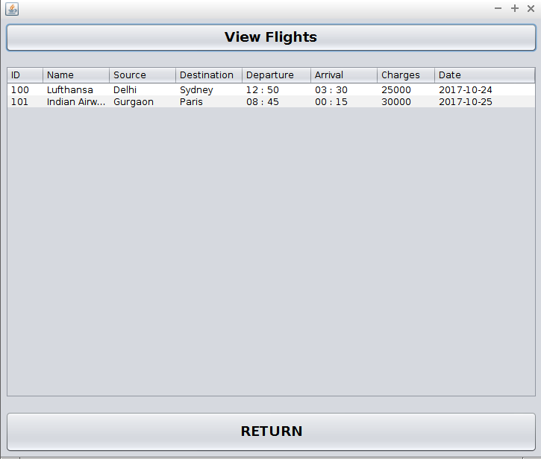

**Coding :**

import java.sql.*;

import javax.swing.JOptionPane;

import javax.swing.table.DefaultTableModel;

Connection con = null;

Statement stmt = null;

ResultSet rs = null;

**View Flights Button :**

private void jButton1ActionPerformed(java.awt.event.ActionEvent evt) {

DefaultTableModel model = (DefaultTableModel) flights.getModel();

try {

Class.forName("java.sql.Driver");

con = DriverManager.getConnection("jdbc:mysql://localhost/airline_reservation?verifyServerCertificate=false&useSSL=true","root","pragun");

stmt = con.createStatement();

String query = "Select * from flights;";

rs = stmt.executeQuery(query);

while (rs.next()){

String name = rs.getString("Name");

String id = rs.getString("ID");

String departure = rs.getString("Departure");

String arrival = rs.getString("Arrival");

String source = rs.getString("Source");

String destination = rs.getString("Destination");

String charges = rs.getString("Charges");

String date = rs.getString("Date");

model.addRow(new Object[] {id,name,source,destination,departure,arrival,charges,date});

}

}

catch (Exception e){

JOptionPane.showMessageDialog(null,"Error in connectivity");

}

}

**Return Button :**

private void jButton2ActionPerformed(java.awt.event.ActionEvent evt) {

Dashboard d = new Dashboard();

d.setVisible(true);

close();

}

private void close(){

this.setVisible(false);

this.dispose();

}

**9) View Tickets Form :**

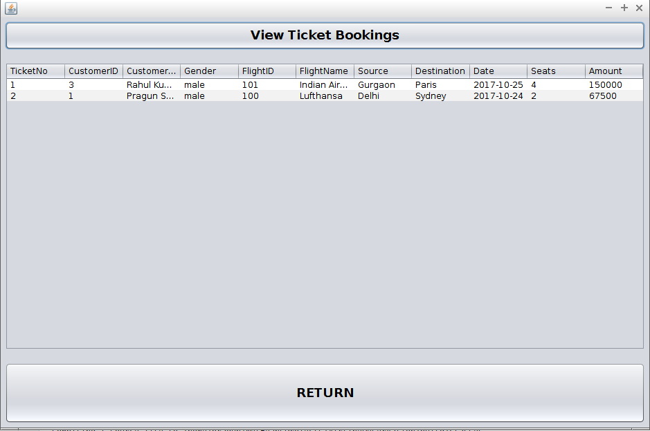

**Coding :**

import java.sql.*;

import javax.swing.JOptionPane;

import javax.swing.table.DefaultTableModel;

Connection con = null;

Statement stmt = null;

ResultSet rs = null;

**View Ticket Bookings Button :**

private void jButton1ActionPerformed(java.awt.event.ActionEvent evt) {

DefaultTableModel model = (DefaultTableModel) tkts.getModel();

try {

Class.forName("java.sql.Driver");

con = DriverManager.getConnection("jdbc:mysql://localhost/airline_reservation?verifyServerCertificate=false&useSSL=true","root","pragun");

stmt = con.createStatement();

String query = "Select * from tickets ;";

rs = stmt.executeQuery(query);

while (rs.next()){

String tickets = rs.getString("TicketNo");

String name1 = rs.getString("FlightName");

String gender2 = rs.getString("Gender");

String name2 = rs.getString("CustomerName");

String source1 = rs.getString("Source");

String dest1 = rs.getString("Destination");

String date1 = rs.getString("Date");

String id1 = rs.getString("FlightID");

String id2 = rs.getString("CustomerID");

String seats1 = rs.getString("Seats");

String amount1 = rs.getString("Amount");

model.addRow(new Object[] {tickets,id2,name2,gender2,id1,name1,source1,dest1,date1,seats1,amount1});

}

}

catch(Exception e) {

JOptionPane.showMessageDialog(null,"Error in Connectivity");

}

}

**Return Button :**

private void jButton2ActionPerformed(java.awt.event.ActionEvent evt) {

Dashboard d = new Dashboard();

d.setVisible(true);

close();

}

private void close(){

this.setVisible(false);

this.dispose();

}

**10) Reservation Form :**

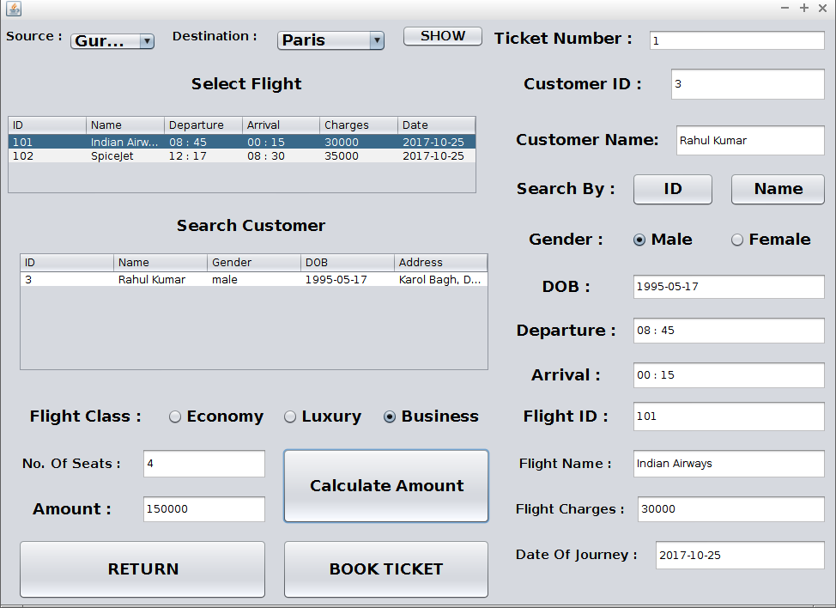

**Coding :**

import javax.swing.JOptionPane;

import java.sql.*;

import javax.swing.table.DefaultTableModel;

Connection con = null;

Statement stmt = null;

ResultSet rs = null;

**Show Button :**

private void jButton1ActionPerformed(java.awt.event.ActionEvent evt) {

DefaultTableModel model = (DefaultTableModel) flightt.getModel();

model.setRowCount(0);

try {

Class.forName("java.sql.Driver");

con = DriverManager.getConnection("jdbc:mysql://localhost/airline_reservation?verifyServerCertificate=false&useSSL=true","root","pragun");

stmt = con.createStatement();

String sourcex = (String) scb.getSelectedItem();

String destx = (String) dcb.getSelectedItem();

String query = "Select * from flights Where Source = '" + sourcex + "' AND Destination = '" + destx + "';";

rs = stmt.executeQuery(query);

while (rs.next()){

String name = rs.getString("Name");

String id = rs.getString("ID");

String departure = rs.getString("Departure");

String arrival = rs.getString("Arrival");

String charges = rs.getString("Charges");

String date = rs.getString("Date");

model.addRow(new Object[] {id,name,departure,arrival,charges,date});

}

rs.close();

stmt.close();

con.close();

}

catch (Exception e){

JOptionPane.showMessageDialog(null,"Error in connectivity");

}

}

**Search by ID button :**

private void jButton2ActionPerformed(java.awt.event.ActionEvent evt) {

DefaultTableModel model1 = (DefaultTableModel) users.getModel();

model1.setRowCount(0);

try {

Class.forName("java.sql.Driver");

con = DriverManager.getConnection("jdbc:mysql://localhost/airline_reservation?verifyServerCertificate=false&useSSL=true","root","pragun");

stmt = con.createStatement();

String query = "Select * from customers Where ID =" + id1.getText() + ";";

rs = stmt.executeQuery(query);

if (rs.next()){

String name = rs.getString("Name");

String dob = rs.getString("DOB");

String gender = rs.getString("Gender");

String address = rs.getString("Address");

String idx = rs.getString("ID");

model1.addRow(new Object[] {idx,name,gender,dob,address});

name1.setText(name);

dob1.setText(dob);

if (gender.equals("male"))

male1.setSelected(true);

else if (gender.equals("female"))

female1.setSelected(true);

rs.close();

stmt.close();

con.close();

}

else {JOptionPane.showMessageDialog(null,"No such record found");}

}

catch(Exception e) {

JOptionPane.showMessageDialog(null,"Error in Connectivity");

}

}

**Search by Name button :**

private void jButton3ActionPerformed(java.awt.event.ActionEvent evt) {

DefaultTableModel model1 = (DefaultTableModel) users.getModel();

model1.setRowCount(0);

try {

Class.forName("java.sql.Driver");

con = DriverManager.getConnection("jdbc:mysql://localhost/airline_reservation?verifyServerCertificate=false&useSSL=true","root","pragun");

stmt = con.createStatement();

String namex = name1.getText();

String query = "Select * from customers Where Name = '" + namex + "';";

rs = stmt.executeQuery(query);

if (rs.next()){

String name = rs.getString("Name");

String dob = rs.getString("DOB");

String gender = rs.getString("Gender");

String address = rs.getString("Address");

String idx = rs.getString("ID");

model1.addRow(new Object[] {idx,name,gender,dob,address});

name1.setText(name);

dob1.setText(dob);

if (gender.equals("male"))

male1.setSelected(true);

else if (gender.equals("female"))

female1.setSelected(true);

id1.setText(idx);

rs.close();

stmt.close();

con.close();

}

else {JOptionPane.showMessageDialog(null,"No such record found");}

}

catch(Exception e) {

JOptionPane.showMessageDialog(null,"Error in Connectivity");

}

}

**Calculate Amount Button :**

private void jButton4ActionPerformed(java.awt.event.ActionEvent evt) {

int charges = Integer.parseInt(fcharges.getText());

int tax = 0;

if (eco.isSelected())

tax = 15;

else if (lux.isSelected())

tax = 35;

else if (bus.isSelected())

tax = 25;

int seats = Integer.parseInt(seatsx.getText());

int cost = charges + ((charges*tax)/100);

int amount = cost*seats;

amountx.setText("" + amount);

book.setEnabled(true);

}

Book Ticket Button :

private void bookActionPerformed(java.awt.event.ActionEvent evt) {

int cust_id = Integer.parseInt(id1.getText());

String cust_name = name1.getText();

String gender = null;

if (male1.isSelected())

gender = "male";

else if (female1.isSelected())

gender = "female";

int flightid = Integer.parseInt(fid.getText());

String flightname = fname.getText();

String source = (String) scb.getSelectedItem();

String dest = (String) dcb.getSelectedItem();

int tktno = Integer.parseInt(ticketno.getText());

String date = fdate.getText();

int amount = Integer.parseInt(amountx.getText());

int seats = Integer.parseInt(seatsx.getText());

try{

Class.forName("java.sql.Driver");

con = DriverManager.getConnection("jdbc:mysql://localhost/airline_reservation?verifyServerCertificate=false&useSSL=true","root","pragun");

stmt = con.createStatement();

String query = "Insert INTO tickets values(" + tktno + "," + cust_id + ",'" + cust_name + "','" + gender + "'," + flightid + ",'" + flightname + "','" + source + "','" + dest + "','" + date + "'," + seats + "," + amount + ");";

stmt.executeUpdate(query);

JOptionPane.showMessageDialog(null,"Ticket Booked");

}

catch(Exception e){

JOptionPane.showMessageDialog(null,"Ticket could not be booked");

}

}

**Return Button :**

private void jButton6ActionPerformed(java.awt.event.ActionEvent evt) {

Dashboard d = new Dashboard();

d.setVisible(true);

close();

}

private void close(){

this.setVisible(false);

this.dispose();

}

**Code on Flights Table - selection event :**

private void flighttMouseClicked(java.awt.event.MouseEvent evt) {

int row = flightt.getSelectedRow();

String id = flightt.getModel().getValueAt(row, 0).toString();

String namet = flightt.getModel().getValueAt(row, 1).toString();

String departure = flightt.getModel().getValueAt(row, 2).toString();

String arrival = flightt.getModel().getValueAt(row, 3).toString();

String charges = flightt.getModel().getValueAt(row, 4).toString();

String date = flightt.getModel().getValueAt(row, 5).toString();

fid.setText(id);

fname.setText(namet);

fdep.setText(departure);

farrival.setText(arrival);

fcharges.setText(charges);

fdate.setText(date);

}

**11) Enquiry Form :**

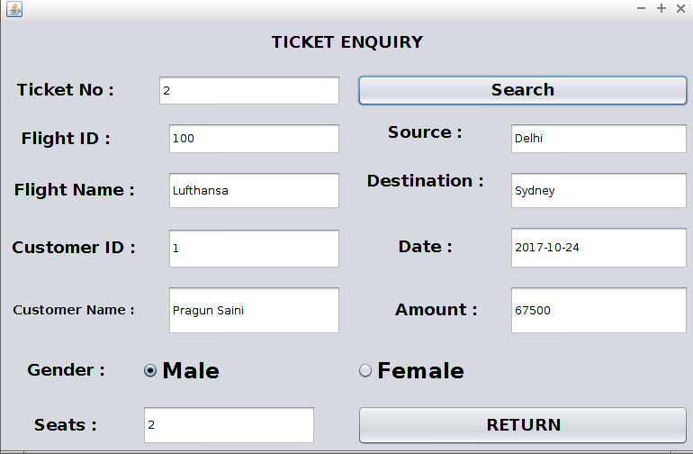

**Coding :**

import java.sql.*;

import javax.swing.JoptionPane;

Connection con = null;

Statement stmt = null;

ResultSet rs = null;

**Search Button :**

private void jButton1ActionPerformed(java.awt.event.ActionEvent evt) {

try {

Class.forName("java.sql.Driver");

con = DriverManager.getConnection("jdbc:mysql://localhost/airline_reservation?verifyServerCertificate=false&useSSL=true","root","pragun");

stmt = con.createStatement();

String query = "Select * from tickets Where TicketNo =" + ticketx.getText() + ";";

rs = stmt.executeQuery(query);

if (rs.next()){

String name1 = rs.getString("FlightName");

String gender2 = rs.getString("Gender");

String name2 = rs.getString("CustomerName");

String source1 = rs.getString("Source");

String dest1 = rs.getString("Destination");

String date1 = rs.getString("Date");

String id1 = rs.getString("FlightID");

String id2 = rs.getString("CustomerID");

String seats1 = rs.getString("Seats");

String amount1 = rs.getString("Amount");

fid.setText(id1);

fname.setText(name1);

custname.setText(name2);

custid.setText(id2);

fsource.setText(source1);

fdest.setText(dest1);

fdate.setText(date1);

amountx.setText(amount1);

seatsx.setText(seats1);

if (gender2.equals("male"))

male1.setSelected(true);

else if (gender2.equals("female"))

female1.setSelected(true);

}

else {JOptionPane.showMessageDialog(null,"No such record found");}

}

catch(Exception e) {

JOptionPane.showMessageDialog(null,"Error in Connectivity");

}

}

**Return Button :**

private void jButton2ActionPerformed(java.awt.event.ActionEvent evt) {

Dashboard d = new Dashboard();

d.setVisible(true);

close();

}

private void close(){

this.setVisible(false);

this.dispose();

}

**12) Cancel Ticket Form :**

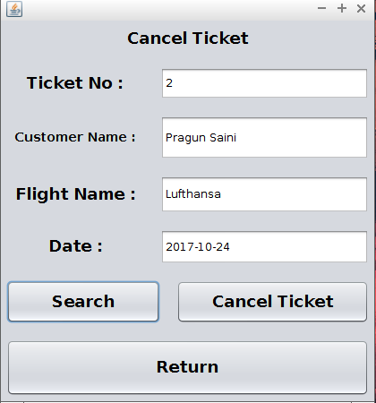

**Coding :**

import java.sql.*;

import javax.swing.JoptionPane;

Connection con = null;

Statement stmt = null;

ResultSet rs = null;

**Search Button :**

private void jButton1ActionPerformed(java.awt.event.ActionEvent evt) {

try {

Class.forName("java.sql.Driver");

con = DriverManager.getConnection("jdbc:mysql://localhost/airline_reservation?verifyServerCertificate=false&useSSL=true","root","pragun");

stmt = con.createStatement();

String query = "Select * from tickets Where TicketNo =" + ticketx.getText() + ";";

rs = stmt.executeQuery(query);

if (rs.next()){

String name1 = rs.getString("FlightName");

String name2 = rs.getString("CustomerName");

String date1 = rs.getString("Date");

fname.setText(name1);

custname.setText(name2);

fdate.setText(date1);

}

else {JOptionPane.showMessageDialog(null,"No such record found");}

}

catch(Exception e) {

JOptionPane.showMessageDialog(null,"Error in Connectivity");

}

}

**Cancel Ticket Button :**

private void jButton2ActionPerformed(java.awt.event.ActionEvent evt) {

try {

Class.forName("java.sql.Driver");

con = DriverManager.getConnection("jdbc:mysql://localhost/airline_reservation?verifyServerCertificate=false&useSSL=true","root","pragun");

stmt = con.createStatement();

String query = "Delete from tickets where TicketNo =" + ticketx.getText() + ";";

stmt.executeUpdate(query);

JOptionPane.showMessageDialog(null,"Ticket Cancelled");

}

catch(Exception e) {

JOptionPane.showMessageDialog(null,"Error in Connectivity");

}

}

**Return Button :**

private void jButton3ActionPerformed(java.awt.event.ActionEvent evt) {

Dashboard d = new Dashboard();

d.setVisible(true);

close();

}

private void close(){

this.setVisible(false);

this.dispose();

}

***BIBLIOGRAPHY***

* Informatics Practices – Sumitra Arora
* [www.google.com](http://www.google.com/)
* [www.netbeans.org](http://www.netbeans.org/)
* [www.dev.mysql.org](http://www.dev.mysql.org/)

------------------------------------------------------------------------