**Evaluation Only. Created with Aspose.Words. Copyright 2003-2023 Aspose Pty Ltd.**

**SECTION I**



**EVENTS AND PROCESSES**

In Section I, you will read about the French Revolution, the Russian Revolution, and the rise of Nazism. In different ways all these events were important in the making of the modern world.

Chapter I is on the French Revolution. Today we often take the ideas of liberty, freedom and equality for granted. But we need to remind ourselves that these ideas also have a history. By looking at the French Revolution you will read a small part of that history. The French Revolution led to the end of monarchy in France. A society based on privileges gave way to a new system of governance. The Declaration of the Rights of Man during the revolution, announced the coming of a new time. The idea that all individuals had rights and could claim equality became part of a new language of politics. These notions of equality and freedom emerged as the central ideas of a new age; but in different countries they were reinterpreted and rethought in many different ways. The anti-colonial movements in India and China, Africa and South America, produced ideas that were innovative and original, but they spoke in a language that gained currency only from the late eighteenth century.

In Chapter II, you will read about the coming of socialism in Europe, and the dramatic

events that forced the ruling monarch, Tsar Nicholas II, to give up power. The Russian

Revolution sought to change society in a different way. It raised the question of

economic equality and the well-being of workers and peasants. The chapter will tell

you about the changes that were initiated by the new Soviet government, the problems

it faced and the measures it undertook. While Soviet Russia pushed ahead with industrialisation and mechanisation of agriculture, it denied the rights of citizens **T h e F r e n c h R e v o l u**

that were essential to the working of a democratic society. The ideals of socialism,

**EVENTS AND PROCESSES**

however, became part of the anti-colonial movements in different countries. Today the Soviet Union has broken up and socialism is in crisis but through the twentieth century it has been a powerful force in the shaping of the contemporary world.

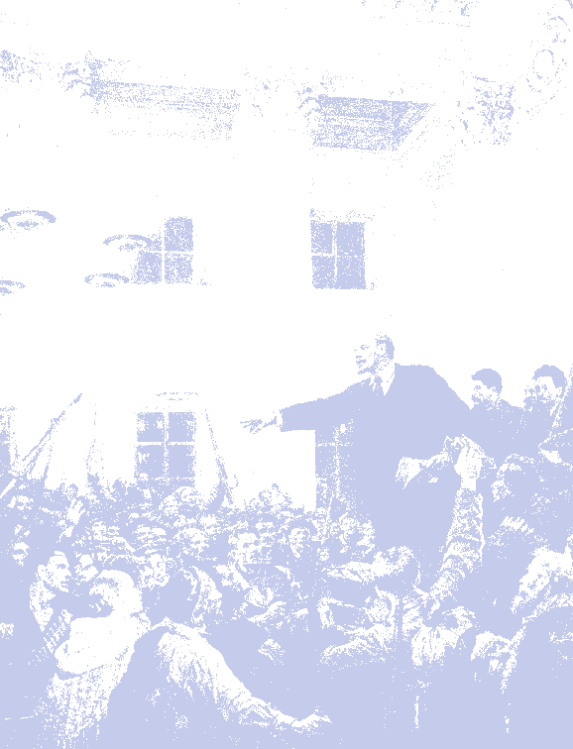

Chapter III will take you to Germany. It will discuss the rise of Hitler and the politics of Nazism. You will read about the children and women in Nazi Germany, about schools and concentration camps. You will see how Nazism denied various minorities a right to live, how it drew upon a long tradition of anti-Jewish feelings to persecute the Jews, and how it waged a relentless battle against democracy and socialism. But the story of Nazisms rise is not only about a few specific events, about massacres and killings. It is about the working of an elaborate and frightening system which operated at different levels. Some in India were impressed with the ideas of Hitler but most watched the rise of Nazism with horror.

The history of the modern world is not simply a story of the unfolding of freedom and democracy. It has also been a story of violence and tyranny, death and destruction.

**India and the Contemporary World**

**The French Revolution**



**Chapter I**

On the morning of 14 July 1789, the city of Paris was in a state of alarm. The king had commanded troops to move into the city. Rumours spread that he would soon order the army to open fire upon the citizens. Some 7,000 men and women gathered in front of the town hall and decided to form a peoples militia. They broke into a number of government buildings in search of arms.

Finally, a group of several hundred people marched towards the eastern part of the city and stormed the fortress-prison, the Bastille, where they hoped to find hoarded ammunition. In the armed fight that followed, the commander of the Bastille was killed and the prisoners released  though there were only seven of them. Yet the Bastille was hated by all, because it stood for the despotic power of the king. The fortress was demolished and its stone fragments were sold in the markets to all those who wished to keep a souvenir of its destruction.

The days that followed saw more rioting both in Paris and the countryside. Most people were protesting against the high price of bread. Much later, when historians looked back upon this time, they saw it as the beginning of a chain of events that ultimately led to the execution of the king in France, though most people at the time did not anticipate this outcome. How and why did this happen?

**T h e F r e n c h R e v o l u**

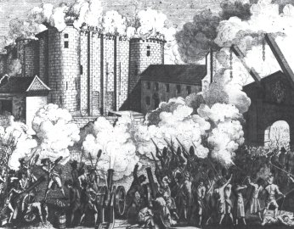

***Fig.1  Storming of the Bastille.***



*Soon after the demolition of the Bastille,*

*artists made prints commemorating the event.*

**T h e F r e n c h R e v o l u t i**

**1 French Society During the Late Eighteenth Century**



In 1774, Louis XVI of the Bourbon family of kings ascended the



throne of France. He was 20 years old and married to the Austrian 1st estate

princess Marie Antoinette. Upon his accession the new king found

an empty treasury. Long years of war had drained the financial Clergy

resources of France. Added to this was the cost of maintaining an

extravagant court at the immense palace of Versailles. Under Louis 2nd estate

XVI, France helped the thirteen American colonies to gain their Nobility independence from the common enemy, Britain. The war added more

than a billion ***livres*** to a debt that had already risen to more than 2

billion *livres*. Lenders who gave the state credit, now began to charge 3rd estate

10 per cent interest on loans. So the French government was obliged



to spend an increasing percentage of its budget on interest payments Bmofiefgirccbiahulassni,ntelsas,wscmyoeuerrnst, etc. alone. To meet its regular expenses, such as the cost of maintaining



an army, the court, running government offices or universities, the Paretiassaannsts and state was forced to increase taxes. Yet even this measure would not

have sufficed. French society in the eighteenth century was divided Small peasants,



landless labour, into three estates, and only members of the third estate paid taxes. servants

The society of estates was part of the feudal system that dated back to

the middle ages. The term Old Regime is usually used to describe the ***Fig.2  A Society of Estates.***

society and institutions of France before 1789. *Note that within the Third Estate some were*

*rich and others poor.*

Fig. 2 shows how the system of estates in French society was organised.

Peasants made up about 90 per cent of the population. However,

only a small number of them owned the land they cultivated. About

60 per cent of the land was owned by nobles, the Church and other

richer members of the third estate. The members of the first two

estates, that is, the **clergy** and the nobility, enjoyed certain privileges by

birth. The most important of these was exemption from paying taxes to

the state. The nobles further enjoyed feudal privileges. These included

feudal dues, which they extracted from the peasants. Peasants were obliged

**New words**

to render services to the lord  to work in his house and fields  to serve

in the army or to participate in building roads. Livre  Unit of currency in France,

discontinued in 1794

The Church too extracted its share of taxes called **tithes** from the peasants,

Clergy  Group of persons invested with and finally, all members of the third estate had to pay taxes to the state.

special functions in the church

These included a direct tax, called ***taille*,** and a number of indirect taxes

**India and the Contemporary World** Tithe  A tax levied by the church, comprising

which were levied on articles of everyday consumption like salt or tobacco.

one-tenth of the agricultural produce

The burden of financing activities of the state through taxes was borne

Taille  Tax to be paid directly to the state by the third estate alone.

This poor fellow brings everything, grain, fruits, money, salad. The fat lord sits there, ready to accept it all. He does not even care to grace him with a look.

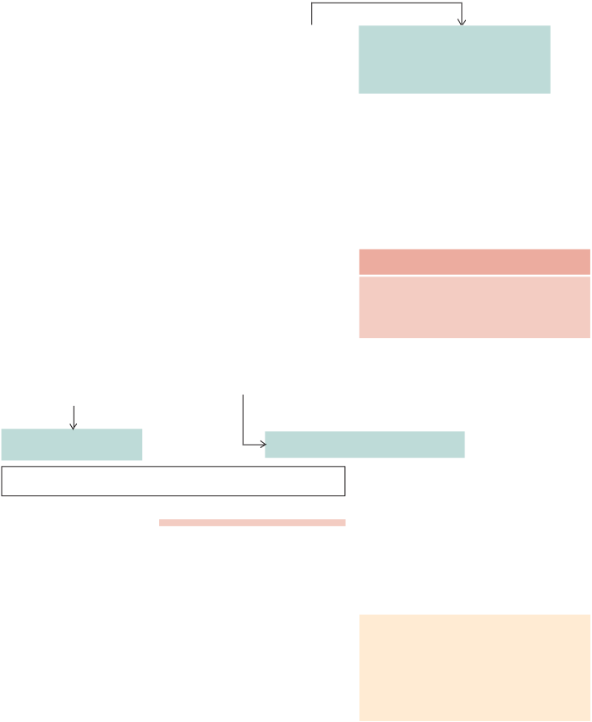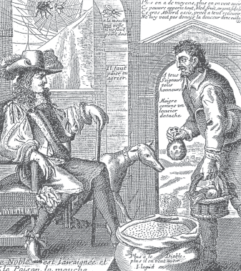

**Activity**

Explain why the artist has portrayed the nobleman as the spider and the peasant as the fly**.**

The nobleman is the spider,

The more the devil has, the more he wants. the peasant the fly.

***Fig.3  The Spider and the Fly.*** *An* ***anonymous*** *etching.*

1. **The Struggle to Survive**

The population of France rose from about 23 million in 1715 to 28

million in 1789. This led to a rapid increase in the demand for

foodgrains. Production of grains could not keep pace with the

demand. So the price of bread which was the staple diet of the majority

rose rapidly. Most workers were employed as labourers in workshops **New words**

whose owner fixed their wages. But wages did not keep pace with

the rise in prices. So the gap between the poor and the rich widened. Subsistence crisis  An extreme situation where

Things became worse whenever drought or hail reduced the harvest. the basic means of livelihood are endangered **T h e F r e n c h R e v o l u** This led to a **subsistence crisis**, something that occurred frequently Anonymous  One whose name remains

in France during the Old Regime. unknown

1. **How a Subsistence Crisis Happens**

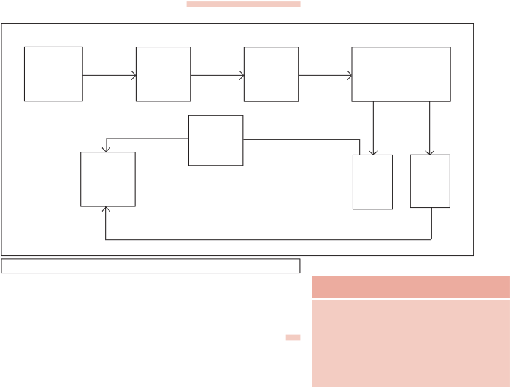

**Bad The poorest can no harvest longer buy bread**

**Disease epidemics**

***Fig.4  The course of a subsistence crisis.***

**Activity**

Fill in the blank boxes in Fig. 4 with appropriate terms from among the following:

1. **A Growing Middle Class Envisages an End to Privileges**

**Food riots, scarcity of grain, increased**

In the past, peasants and workers had participated in revolts against **number of deaths, rising food prices,** increasing taxes and food scarcity. But they lacked the means and **weaker bodies.**

programmes to carry out full-scale measures that would bring about

a change in the social and economic order. This was left to those

groups within the third estate who had become prosperous and had

access to education and new ideas.

The eighteenth century witnessed the emergence of social groups,

termed the middle class, who earned their wealth through an

expanding overseas trade and from the manufacture of goods such as

woollen and silk textiles that were either exported or bought by the

richer members of society. In addition to merchants and

manufacturers, the third estate included professions such as lawyers

or administrative officials. All of these were educated and believed

that no group in society should be privileged by birth. Rather, a

persons social position must depend on his merit. These ideas

envisaging a society based on freedom and equal laws and **India and the Co**o**ntem**p**pora**p**ry W**o**orld**rtunities for all, were put forward by philosophers such as John

Locke and Jean Jacques Rousseau. In his *Two Treatises of Government,*

Locke sought to refute the doctrine of the divine and absolute right

of the monarch. Rousseau carried the idea forward, proposing a form of government based on a social contract between people and their representatives. In *The Spirit of the Laws,* Montesquieu proposed a division of power within the government between the legislative, the executive and the judiciary. This model of government was put into force in the USA, after the thirteen colonies declared their independence from Britain. The American constitution and its guarantee of individual rights was an important example for political thinkers in France.



The ideas of these philosophers were discussed intensively in salons and coffee-houses and spread among people through books and newspapers. These were frequently read aloud in groups for the benefit of those who could not read and write. The news that Louis XVI planned to impose further taxes to be able to meet the expenses of the state generated anger and protest against the system of privileges.

***Source A***



**Accounts of lived experiences in the Old Regime**

1. Georges Danton**,** who later became active in revolutionary politics, wrote to a friend in 1793, looking back upon the time when he had just completed his studies:

I was educated in the residential college of Plessis. There I was in the company of important men  Once my studies ended, I was left with nothing. I started looking for a post. It was impossible to find one at the law courts in Paris. The choice of a career in the army was not open to me as I was not a noble by birth, nor did I have a patron. The church too could not offer me a refuge. I could not buy an office as I did not possess a sou. My old friends turned their backs to me  the system had provided us with an education without however offering a field where our talents could be utilised.

1. An Englishman, Arthur Young, travelled through France during the years from 1787 to 1789 and wrote detailed descriptions of his journeys. He often commented on what he saw.

He who decides to be served and waited upon by slaves, ill-treated slaves at that, must

be fully aware that by doing so he is placing his property and his life in a situation which is

very different from that he would be in, had he chosen the services of free and well-

treated men. And he who chooses to dine to the accompaniment of his victims groans,

should not complain if during a riot his daughter gets kidnapped or his sons throat is slit. ***Source***

**Activity** What message is Young trying to convey here? Whom does he mean when he speaks of slaves?

Who is he criticising? What dangers does he sense in the situation of 1787?

**T h e F r e n c h R e v o l u**

**2 The Outbreak of the Revolution**



Louis XVI had to increase taxes for reasons you have learnt in the



previous section. How do you think he could have gone about doing **Some important dates**

this? In France of the Old Regime the monarch did not have the 1774

power to impose taxes according to his will alone. Rather he had to Louis XVI becomes king of France, faces

empty treasury and growing discontent call a meeting of the Estates General which would then pass his within society of the Old Regime.

proposals for new taxes. The Estates General was a political body to 1789

which the three estates sent their representatives. However, the CEsotnavteo cfaotrimons oNfaEtisotnaatel sA sGseenmebralyl,, Tthheird monarch alone could decide when to call a meeting of this body. The Bastille is stormed, peasant revolts in the

countryside.

last time it was done was in 1614.

1791

A constitution is framed to limit the powers On 5 May 1789, Louis XVI called together an assembly of the Estates of the king and to guarantee basic rights to

General to pass proposals for new taxes. A resplendent hall in all human beings.

Versailles was prepared to host the delegates. The first and second 1792-93

estates sent 300 representatives each, who were seated in rows facing Fberahnecaedebdec.omes a republic, the king is each other on two sides, while the 600 members of the third estate Overthrow of the Jacobin republic, a

had to stand at the back. The third estate was represented by its more Directory rules France.

1804

prosperous and educated members. Peasants, artisans and women Napoleon becomes emperor of France, were denied entry to the assembly. However, their grievances and annexes large parts of Europe.

demands were listed in some 40,000 letters which the representatives 1815

Napoleon defeated at Waterloo.

had brought with them.

Voting in the Estates General in the past had been conducted according

to the principle that each estate had one vote. This time too Louis

XVI was determined to continue the same practice. But members of

the third estate demanded that voting now be conducted by the

assembly as a whole, where each member would have one vote. This

was one of the democratic principles put forward by philosophers

like Rousseau in his book *The Social Contract*. When the king rejected

this proposal, members of the third estate walked out of the assembly

in protest. **Activity**

The representatives of the third estate viewed themselves as spokesmen

Representatives of the Third Estate take the for the whole French nation. On 20 June they assembled in the hall

oath raising their arms in the direction of of an indoor tennis court in the grounds of Versailles. They declared Bailly, the President of the Assembly,

themselves a National Assembly and swore not to disperse till they standing on a table in the centre. Do you had drafted a constitution for France that would limit the powers of think that during the actual event Bailly

the monarch. They were led by Mirabeau and Abbé Sieyès. Mirabeau would have stood with his back to the

**India and the Co**w**ntemp**a**ora**s**ry W** **o**b**rld**orn in a noble family but was convinced of the need to do away assembled deputies? What could have

with a society of feudal privilege. He brought out a journal and been Davids intention in placing Bailly delivered powerful speeches to the crowds assembled at Versailles. (Fig.5) the way he has done?

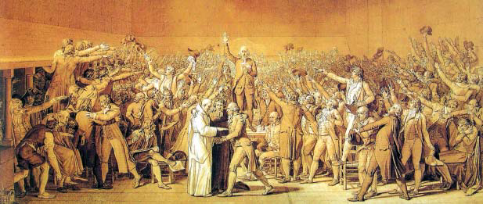

***Fig.5  The Tennis Court Oath.***



*Preparatory sketch for a large painting by Jacques-Louis David. The painting was intended to be hung in the National Assembly.*

Abbé Sieyès, originally a priest, wrote an influential pamphlet called What is the Third Estate?

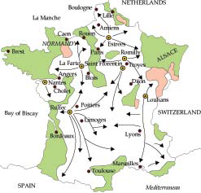

While the National Assembly was busy at Versailles drafting a constitution, the rest of France seethed with turmoil. A severe winter had meant a bad harvest; the price of bread rose, often bakers exploited the situation and hoarded supplies. After spending hours in long queues at the bakery, crowds of angry women stormed into the shops. At the same time, the king ordered troops to move into Paris. On 14 July, the agitated crowd stormed and destroyed the Bastille.

In the countryside rumours spread from village to village that the lords of the **manor** had hired bands of brigands who were on their way to destroy the ripe crops. Caught in a frenzy of fear, peasants in several districts seized hoes and pitchforks and attacked **chateaux**. They looted hoarded grain and burnt down documents containing Regions not affected by the Great Fear



records of manorial dues. A large number of nobles fled from their AEThpreeicaesspnortrefeasadgoorfaf rmitahaneinGreprveaoanltit cFeemaarolryv e1m78en9ts

homes, many of them migrating to neighbouring countries.

***Fig.6  The spread of the Great Fear.***

Faced with the power of his revolting subjects, Louis XVI finally *The map shows how bands of peasants spread*

*from one point to another.*

accorded recognition to the National Assembly and accepted the

principle that his powers would from now on be checked by a

**New words**

constitution. On the night of 4 August 1789, the Assembly passed a

decree abolishing the feudal system of obligations and taxes. Members Chateau (pl. chateaux)  Castle or stately

of the clergy too were forced to give up their privileges. Tithes were residence belonging to a king or a nobleman **T h e F r e n c h R e v o l u** abolished and lands owned by the Church were confiscated. As a Manor  An estate consisting of the lords

result, the government acquired assets worth at least 2 billion livres. lands and his mansion

**2.1 France Becomes a Constitutional Monarchy**

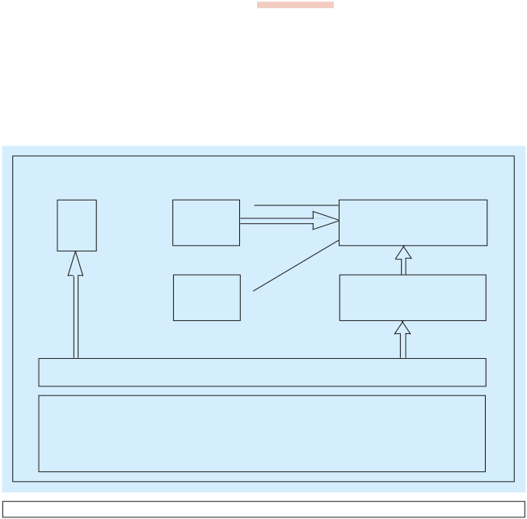

The National Assembly completed the draft of the constitution in 1791. Its main object was to limit the powers of the monarch. These powers instead of being concentrated in the hands of one person, were now separated and assigned to different institutions  the legislature, executive and judiciary. This made France a constitutional monarchy. Fig. 7 explains how the new political system worked.

**Judiciary Executive Legislature**

CONTROL



Judge King **National Assembly** (745 members)

VETO



VOTE CONTROL

**Ministers Electors** (50,000 men)



V O T E



VOTE

**Active citizens:** entitled to vote. About 4 million of a population of 28 million



**Passive citizens:** no voting rights. About 3 million men Women, children and youth below 25.



***Fig.7  The Political sytstem under the Constitution of 1791.***

The Constitution of 1791 vested the power to make laws in the

National Assembly, which was indirectly elected. That is, citizens

voted for a group of electors, who in turn chose the Assembly. Not

all citizens, however, had the right to vote. Only men above 25 years

of age who paid taxes equal to at least 3 days of a labourers wage

were given the status of active citizens, that is, they were entitled to **India and the Co**v**ntem**o**pora**t**ry**e **Wo**.**rl** **d**The remaining men and all women were classed as passive

citizens. To qualify as an elector and then as a member of the Assembly,

**This document was truncated here because it was created in the Evaluation Mode.**