**A**

**PROJECT REPORT**

**ON**

**“DAILY ROUTINE MANAGEMENT SYSTEM"**

SUBMITTED BY:

**Mr. Shelke Uday Sanjay (2124UCEM1031)**

SUBJECT:

**CORE C++ PROGRAMMING**

Under the guidance of

**Miss. ISHWARI TIRSE.**



**Department of Computer Science and Engineering**

**Sanjivani Rural Education Society's**

**SANJIVANI UNIVERSITY**

**KOPARGAON-423601, DIST: AHMEDNAGAR**

**2024-2025**

**INDEX**

|  |  |  |
| --- | --- | --- |
| **SR.**  **NO** | **CONTENT** | **PAGE NO.** |
| **1.** | **INTRODUCTION** | **3** |
| **2.** | **CODE** | **4** |
| **3.** | **OUTPUT** | **7** |
| **4.** | **CONCLUSION** | **9** |

**INTRODUCTION**

In today’s fast-paced world, managing daily tasks effectively is crucial for personal productivity and well-being. The Daily Routine Management System is a simple C++ application designed to help users organize and prioritize their daily activities. This system allows users to add tasks, view tasks and delete tasks. This system provides a simple yet effective solution for organizing daily tasks and enhancing productivity.

To develop an application for the Daily Routine Management System C++ is popular and right choice due to its user-friendly type, object-oriented design. C++ provides easy and scalable platform for building an application.

There are many benefits of C++ based Daily Routine Management System. i.e. effective task management leads to reduced stress and greater achievement of personal goals. Through its straightforward design, this application can easily expanded with additional features like remainders etc.

**CODE**

#include <iostream>

#include <vector>

#include <string>

class Task {

public:

std::string description;

Task(std::string desc) : description(desc) {}

};

class DailyRoutine {

private:

std::vector<Task> tasks;

public:

void addTask(const std::string& taskDescription) {

tasks.push_back(Task(taskDescription));

std::cout << "Task added: " << taskDescription << std::endl;

}

void viewTasks() {

if (tasks.empty()) {

std::cout << "No tasks for today." << std::endl;

return;

}

std::cout << "Today's Tasks:" << std::endl;

for (size_t i = 0; i < tasks.size(); ++i) {

std::cout << i + 1 << ". " << tasks[i].description << std::endl;

}

}

void deleteTask(int index) {

if (index < 1 || index > tasks.size()) {

std::cout << "Invalid task number." << std::endl;

return;

}

std::string removedTask = tasks[index - 1].description;

tasks.erase(tasks.begin() + index - 1);

std::cout << "Task removed: " << removedTask << std::endl;

}

};

int main() {

DailyRoutine routine;

int choice;

std::string taskDescription;

do {

std::cout << "\nDaily Routine Management\n";

std::cout << "1. Add Task\n";

std::cout << "2. View Tasks\n";

std::cout << "3. Delete Task\n";

std::cout << "4. Exit\n";

std::cout << "Enter your choice: ";

std::cin >> choice;

switch (choice) {

case 1:

std::cout << "Enter task description: ";

std::cin.ignore(); // to clear the input buffer

std::getline(std::cin, taskDescription);

routine.addTask(taskDescription);

break;

case 2:

routine.viewTasks();

break;

case 3:

int taskIndex;

std::cout << "Enter task number to delete: ";

std::cin >> taskIndex;

routine.deleteTask(taskIndex);

break;

case 4:

std::cout << "Exiting the program." << std::endl;

break;

default:

std::cout << "Invalid choice. Please try again." << std::endl;

}

} while (choice != 4);

return 0;

}

**OUTPUT**

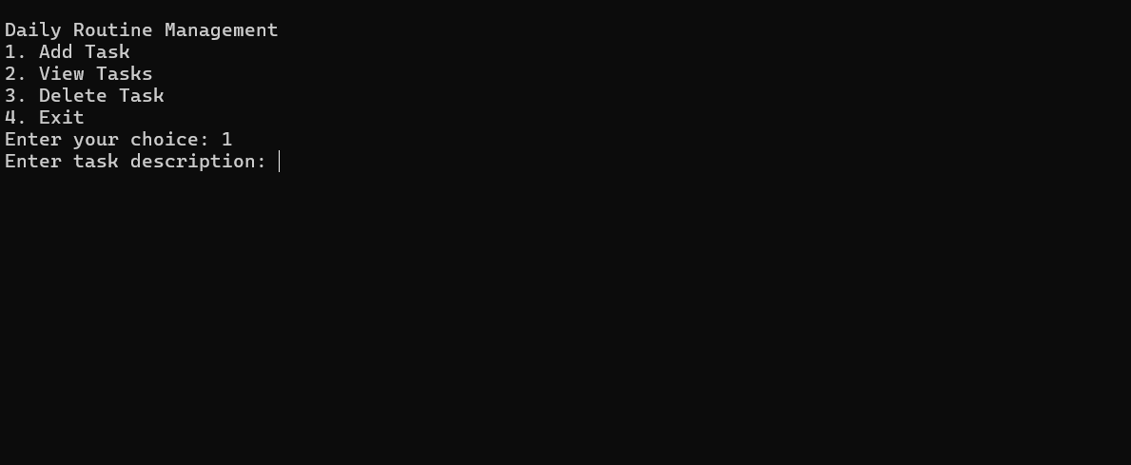

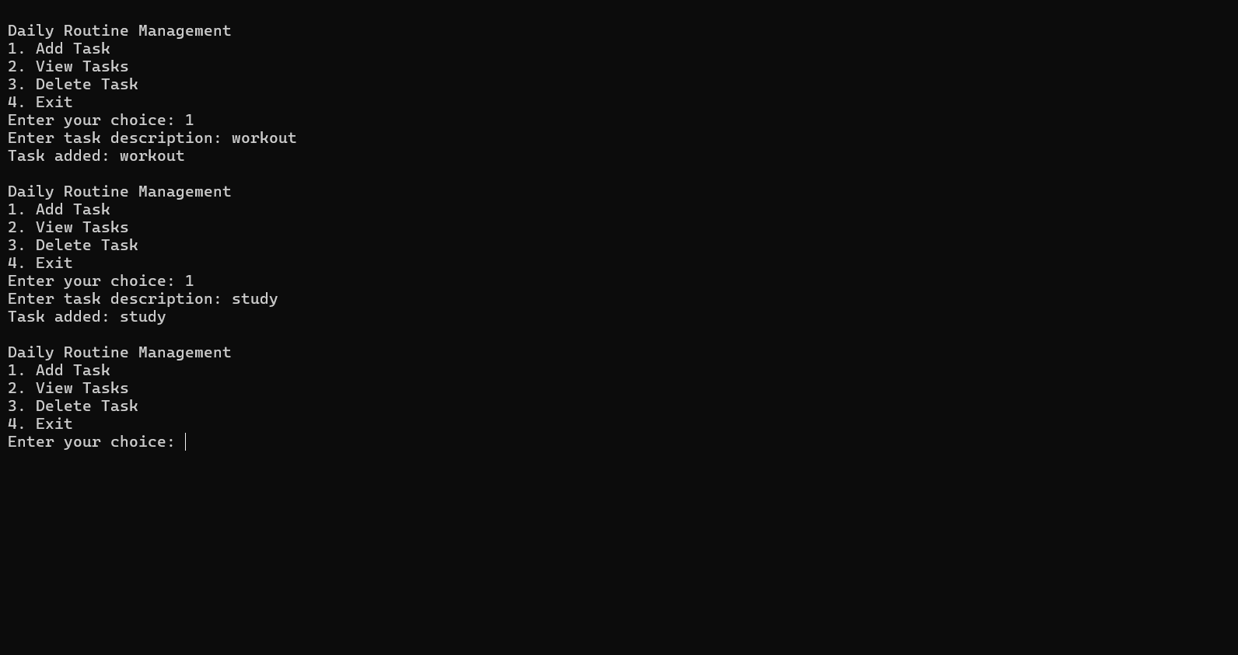

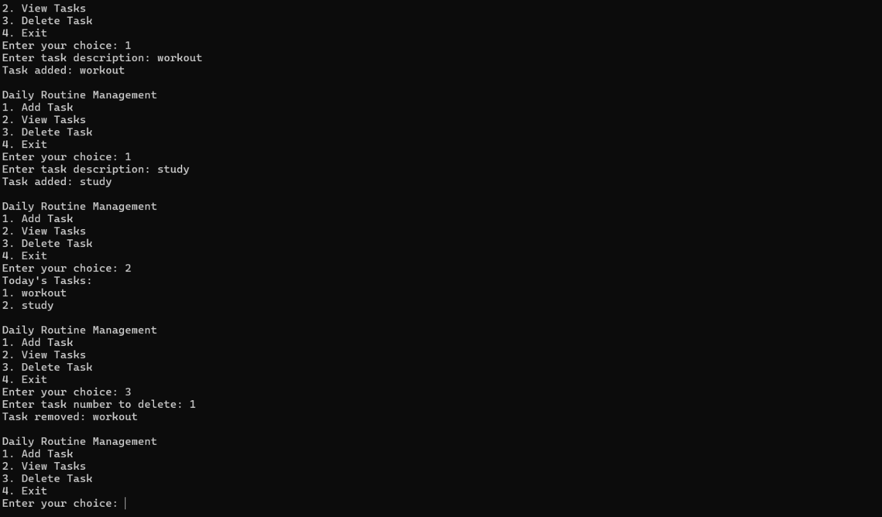

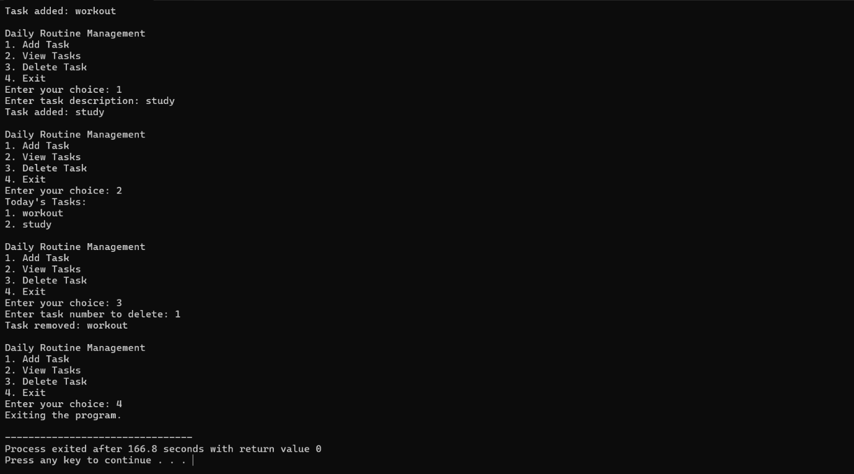

**CONCLUSION**

The Daily Routine Management Program serves as a practical tool for anyone seeking to enhance their productivity and streamline their daily activities. By providing essential features such as adding, viewing, and deleting tasks, the program empowers users to take charge of their schedules and make informed decisions about their time.

Effective time management is crucial in today's busy environment, where distractions are abundant and priorities can easily become overwhelming. This program not only helps users keep track of their tasks but also encourages them to reflect on their daily goals, leading to improved healthy Life.

Using C++ in this project is perfect choice because of its object-oriented approach.