**Travel and Tourism**

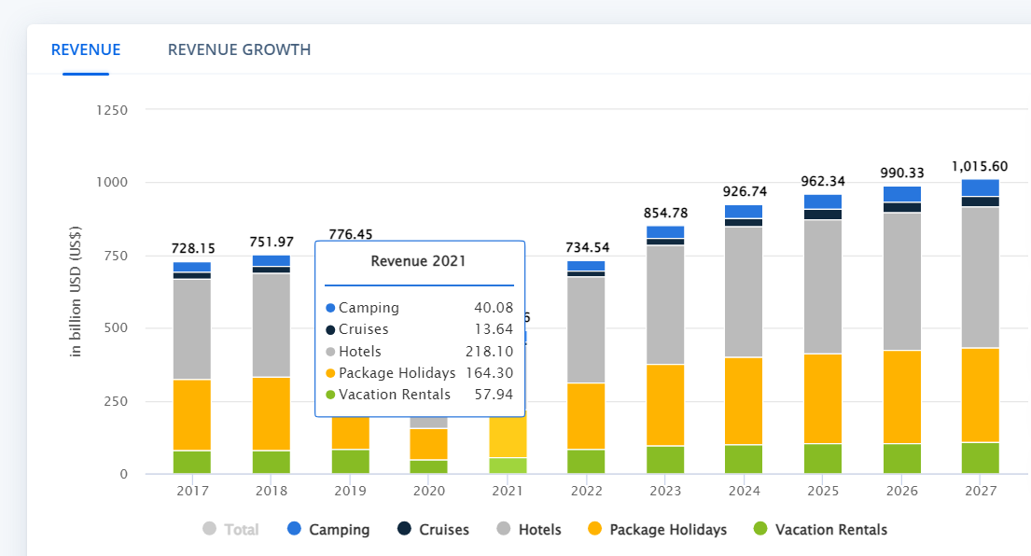

The market size of the travel and tourism sector globally reached a value of $631 billion in 2021. In recent years, the rise in the number of online travel intermediaries was aided by the growth in the number of internet users along with the demand for convenience among travelers further supported the rise in the market for online travel intermediaries.

The travel and tourism market globally grew by 43% in 2021 as the sector witnessed a recovery in the demand after easing the restrictions which were placed on account of the Outbreak of the pandemic COVID-19 and online travel intermediaries’ sharp rise in travel products as the consumers planned their travel activities after the gap of close to two years.

Meanwhile, the growth which the travel and tourism sector was going to see was reversed as the Outbreak of the COVID-19 pandemic completely devastated the industry in 2020. During the year 2020, the market value of travel and tourism globally saw a de-growth of a whopping 62%, and the sectors allied with the industry were severely impacted.

Key travel destinations among travelers globally include Machu Picchu, Galapagos Islands, Cusco City, Dubai, Thailand, Vietnam, Hong Kong, France, Italy, Istanbul, and Easter Island.

The travel and tourism market across the globe grew at a compound annual growth rate of negative 13% during the period 2017-2021.

1. Tourism Expenditure: Global tourism expenditure was estimated to be around $1.5 trillion in 2019.
2. Leading Countries: Some of the leading countries in terms of international tourist arrivals were France, Spain, the United States, China, and Italy.
3. Contribution to GDP: Travel and tourism made a significant contribution to global GDP, accounting for approximately 10.4% of the world's GDP and supporting millions of jobs.
4. Employment: The travel and tourism industry employed around 330 million people worldwide, accounting for approximately 1 in 10 jobs globally.

**Vacation Rentals**

The global vacation rental market size was valued at USD 74.64 billion in 2021 and is expected to expand at a compound annual growth rate (CAGR) of 5.3% from 2022 to 2030. Rising expenditure on travel, vacations, and accommodation among the millennials generation is driving the market. According to Copyrise, 200,000 million global tourists are millennials and they spend around USD 180 billion on travel every year.

There has been a significant drop in weekly bookings between the beginning of January and March 2020. Moreover, the number of bookings in Beijing dropped by 96%, Shanghai by 71%, Seoul by 46%, and Rome by 41%.

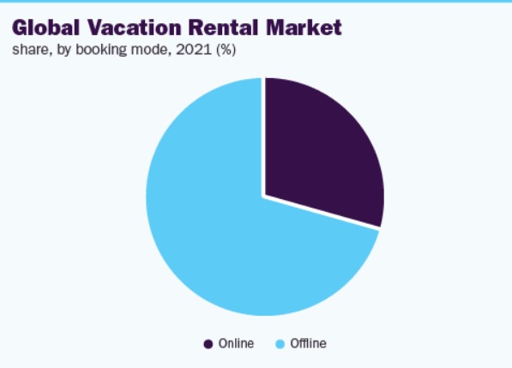

Market Growth: Prior to the pandemic, the vacation rental market was experiencing significant growth globally. According to a report by Allied Market Research, the global vacation rental market was projected to reach $170.9 billion by 2027, growing at a CAGR of 3.4% from 2020 to 2027.

Online Booking Platforms: Vacation rental platforms, such as Airbnb, VRBO (Vacation Rentals By Owner), and Booking.com, have played a crucial role in the growth of the vacation rental market. These platforms provide a convenient way for property owners to list their rentals and for travelers to book unique accommodations.

Shift in Traveler Preferences: Many travelers have shown a growing interest in vacation rentals over traditional hotel accommodations. The desire for more space, privacy, and the opportunity to experience local communities and cultures has contributed to the popularity of vacation rentals.

Major Players:

* 9flats.com Pte Ltd.
* Airbnb Inc.
* Booking Holdings Inc.
* Expedia Group Inc.
* Hotelplan Holding AG
* MakeMyTrip Pvt. Ltd.
* NOVASOL AS
* Oravel Stays Pvt. Ltd.
* TripAdvisor Inc.
* Wyndham Destinations Inc.

**CPG**

Major Verticals:

* Food and Beverage
* Personal Care and Beauty
* Household Products
* Health and Wellness
* Baby and Childcare

**Food and Beverage**

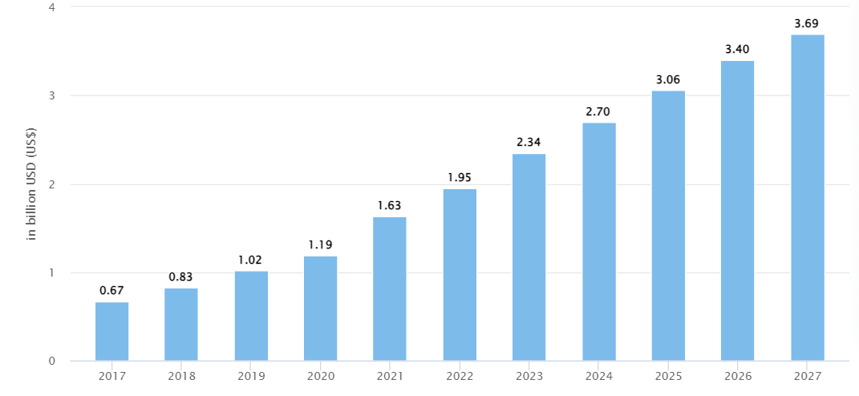

1. Global Market Size: Prior to the pandemic, the global food and beverage industry was valued at approximately $8.7 trillion in 2020, according to Euromonitor International.
2. Growth and CAGR: The food and beverage industry has shown steady growth over the years. The compound annual growth rate (CAGR) varied by region and product category but was estimated to be around 3-5%.
3. Leading Categories: The food and beverage industry is diverse, with various categories and subcategories. Some of the leading categories include dairy products, bakery products, snacks, carbonated soft drinks, packaged foods, and alcoholic beverages.

Online sales of food and beverages have been on the rise, with the convenience of e-commerce platforms and changing consumer behaviors. Many consumers have shifted to online grocery shopping and ordering food and beverages online.

The food and beverage industry's market size and growth rates vary across different regions. North America, Europe, and the Asia-Pacific region are significant markets. The Asia-Pacific region has been experiencing significant growth due to factors such as population growth, rising disposable incomes, and changing consumer preferences.

**Personal Care and Beauty**

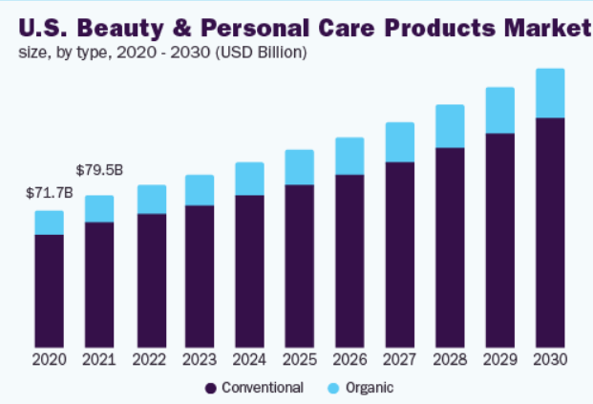

The global beauty and personal care products market size was valued at USD 482.8 billion in 2021 and is expected to expand at a compound annual growth rate (CAGR) of 7.7% from 2022 to 2030. One of the primary factors driving market expansion is the rising consciousness of consumers about their appearance. Beauty and personal care products such as skin care, color cosmetics, and hair care are becoming an integral part of daily grooming among millennials. The introduction of cosmetics with natural, non-toxic, and organic ingredients has also been boosting the market growth.

The conventional beauty and personal care segment accounted for the largest market share of 84.9% in 2021. Their low price compared to organic variants and their easy availability through various distribution channels across the globe have driven segment growth so far.

The organic segment, on the other hand, is anticipated to witness strong growth in the market. These cosmetics are formulated by using organically sourced ingredients and are safe for the skin, cruelty-free, and aid in the protection of the environment and biodiversity.

Men's grooming products have gained traction in recent years, with a growing market for products such as beard care, shaving products, skincare, and hair care specifically tailored to men's needs.

The skincare segment accounted for 33.8% of the beauty and personal care products market in 2021.

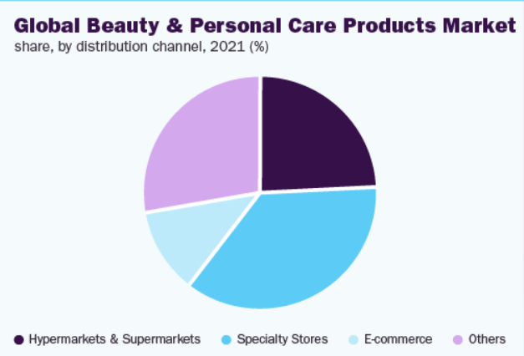

Some prominent players in the global beauty and personal care products market include:

* Unilever
* The Estée Lauder Companies Inc.
* Shiseido Co., Ltd.
* Revlon
* Procter & Gamble
* L'Oréal S.A.
* Coty Inc.
* Kao Corporation
* Avon Products, Inc.
* Oriflame Cosmetics S.A.

**Household Products**

The global household cleaners market size was valued at USD 33.8 billion in 2021 and is expected to expand at a compound annual growth rate (CAGR) of 4.9% from 2022 to 2028. This can be credited to the increasing awareness regarding hygiene among consumers.

There has been a growing focus on sustainability and eco-friendly practices in the household products industry. Consumers are increasingly seeking products with environmentally friendly formulations, recyclable packaging, and reduced use of harmful chemicals.

The household products industry has witnessed a significant shift towards e-commerce and online retailing, with consumers increasingly purchasing household products online. E-commerce platforms offer convenience, a wide range of product options, and the ability to compare prices and read reviews.

Innovative packaging, brand development, and promotion are projected to boost the sales of household cleaning products in the coming years. Growing consumer concerns about the environment and their own health have fueled the demand for environment-friendly cleaning products. Due to the lack of presence of hazardous chemicals, as well as their odor, organic products are expected to witness strong growth in demand in the coming years.

Furthermore, the explosion of online platforms such as social media and Google ads have influenced customer preferences for purchasing household cleaning products through e-commerce platforms, such as the likes of Flipkart, Walmart, Amazon, and Grofers, among others. Additionally, the rise of the online channel is predicted to be fueled by the increased penetration of high-speed internet and smartphone usage throughout the forecast period.

Key Players:

* Procter & Gamble (Cascade)
* Unilever
* Henkel AG & Co. KGaA (Pril)
* Reckitt Benckiser Group PLC (Finish)
* Colgate-Palmolive Company
* Kao Corporation
* The Clorox Company

**Health and Wellness**

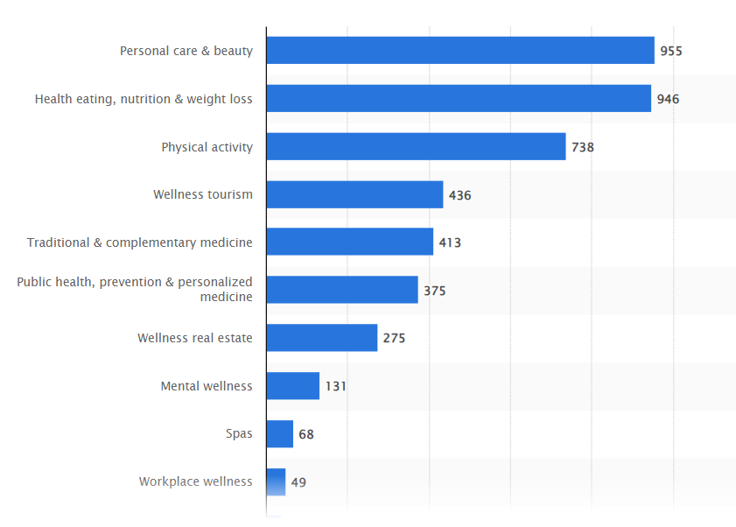

Prior to the pandemic, the global health and wellness market was valued at approximately $4.5 trillion in 2019, according to the Global Wellness Institute.

Growth and CAGR: The health and wellness industry has shown strong growth over the years. The compound annual growth rate (CAGR) varied by segment, but the industry as a whole was estimated to have a CAGR of around 6-8%.

The dietary supplements segment is a significant part of the health and wellness industry. It includes vitamins, minerals, herbal supplements, and other nutritional products. The demand for dietary supplements has been driven by factors such as increasing consumer focus on preventive health, rising awareness of the benefits of supplementation, and the aging population.

The fitness and exercise segment covers various aspects, including fitness centers, gyms, personal training, fitness equipment, and digital fitness platforms. Prior to the pandemic, there was a growing focus on physical fitness and maintaining an active lifestyle.

Wellness tourism involves travel with a focus on promoting health and well-being. This includes spa retreats, wellness resorts, meditation retreats, and wellness-focused vacations. Prior to the pandemic, wellness tourism was a growing trend, driven by increasing interest in self-care, stress reduction, and holistic wellness experiences.

Wellness tourism involves travel with a focus on promoting health and well-being. This includes spa retreats, wellness resorts, meditation retreats, and wellness-focused vacations. Prior to the pandemic, wellness tourism was a growing trend, driven by increasing interest in self-care, stress reduction, and holistic wellness experiences.

There has been a growing demand for natural and organic products within the health and wellness industry. Consumers are increasingly seeking products with clean and natural ingredients, free from artificial additives, and environmentally friendly.

The importance of mental health and mindfulness has gained significant attention. Products and services related to mental well-being, stress reduction, meditation, and mindfulness practices have become more prominent.

Key Players:

* CVS (315 Bn USD)
* UNH
* MCK
* ABC
* CAH
* CI
* ELV

**Baby and Childcare**

Prior to the pandemic, the global baby and childcare market was valued at approximately $87 billion in 2020

The baby and childcare industry have shown steady growth over the years. The compound annual growth rate (CAGR) varied by region and product category but was estimated to be around 4-6%.

Baby food and infant formula are significant segments within the baby and childcare industry. The demand for baby food products, including purees, snacks, and cereals, has been driven by factors such as increasing awareness of the importance of nutrition during early childhood and the growing number of working parents.

Diapers and baby care products, such as baby wipes, lotions, and powders, are essential components of the baby and childcare industry. These products cater to the basic needs of infants and young children and are crucial for parents' convenience and hygiene.

Baby gear and accessories include strollers, car seats, high chairs, cribs, baby monitors, and other products designed to support the care and safety of infants and young children. This segment has experienced innovation and growth, driven by advancements in product design, safety standards, and parental preferences.

The baby and childcare industry have seen a significant shift towards e-commerce and online retailing, with parents increasingly purchasing products online. E-commerce platforms offer convenience, a wide range of product options, and the ability to compare prices and read reviews.

Key Players:

* Some of the leading brands in the Indian baby care industry include Pampers, Johnson's, Himalaya, Huggies, MeeMee, Chicco, and Biotique.

**Healthcare**

Key verticals:

1. Hospitals and Clinics
2. Pharmaceuticals
3. Healthcare IT and Software

**Hospitals and Clinics**

The global hospital market was valued at over $3 trillion in 2020

Healthcare expenditure, including spending on hospitals and clinics, has been increasing globally due to factors such as population growth, aging populations, the prevalence of chronic diseases, and advances in medical technology.

The hospital market consists of both public (government-owned) and private hospitals. The distribution and proportion of public and private hospitals vary by country. In some regions, private hospitals play a significant role in healthcare service provision, while in others, public hospitals dominate.

In recent years, there has been a trend of mergers and acquisitions in the hospital industry, with larger healthcare systems acquiring smaller hospitals and clinics.

**Pharmaceuticals**

The global pharmaceutical market was valued at over $1.4 trillion in 2020

The size and growth rate of the pharmaceutical market vary across regions. Developed markets such as the United States, Europe, and Japan traditionally accounted for a significant share of pharmaceutical sales. However, emerging markets like China, India, and Brazil have been experiencing rapid growth and are expected to contribute more to the global market in the coming years.

Categories divided into : Prescription Drugs and Generic Drugs.

The pharmaceutical industry invests heavily in research and development (R&D) to discover and develop new drugs. R&D activities include preclinical and clinical trials, drug discovery, and regulatory approval processes.

**Healthcare IT and Software**

The global healthcare IT market was valued at over $250 billion in 2020

Telehealth and telemedicine services have experienced significant growth, driven by advancements in technology and the need for remote healthcare delivery. This includes virtual consultations, remote patient monitoring, and digital health platforms.

The use of data analytics and healthcare informatics has been expanding, enabling healthcare providers to gain insights from large volumes of healthcare data. Analytics helps improve clinical decision-making, population health management, and cost optimization.

**Insurance**

Major Verticals:

* Life Insurance
* Health Insurance
* Auto Insurance
* Travel Insurance

**Life Insurance**

The global life insurance market was valued at over $2.5 trillion in 2020.

The life insurance market varies in size across different regions. North America, Europe, and Asia Pacific traditionally account for significant shares of the market, while emerging markets such as China and India have seen rapid growth.

Insurance premiums recorded a growth rate of around 2.9% in 2019.

Life insurance is typically distributed through insurance agents, brokers, financial advisors, direct sales, bancassurance (insurance sold through banks), and increasingly through digital platforms.

Life insurance is often targeted towards individuals seeking financial protection for their families, wealth accumulation, retirement planning, and estate planning. Target customer segments may vary based on age, income level, and life stage.

Key Players:

* BRKB (253.9B USD)
* PNGAY
* ALIZY
* AXAHY

**Health Insurance**

The global health insurance market was valued at over $1.5 trillion in 2020.

The size and growth rate of the health insurance market vary across regions. North America, Europe, and Asia Pacific traditionally account for significant shares of the market, while emerging markets in Asia, such as China and India, have seen rapid growth.

The balance between private and public health insurance systems varies by country. Some countries rely heavily on government-funded programs, while others have a greater emphasis on private health insurance.

The health insurance industry has been undergoing digital transformation. Insurers are leveraging technology for online enrollment, claims processing, customer service, and data analytics to improve efficiency and enhance customer experience.

Key Players:

* Cigna Global
* GeoBlue Explorer
* William Russell
* IMG
* Integra

**Auto Insurance**

The global auto insurance market was valued at over $800 billion in 2020.

The auto insurance market size and dynamics vary across regions. Developed markets like North America, Europe, and Asia Pacific traditionally account for significant shares of the market, while emerging markets show potential for growth.

Insurance premiums are determined by various factors, including the insured driver's age, driving record, vehicle type, geographic location, and claims history.

Key players:

* Progressive
* State Farm
* Geico
* Allstate

**Travel Insurance**

The global travel insurance market was valued at over $18 billion in 2020.

The size and growth rate of the travel insurance market can vary across regions. North America, Europe, and Asia Pacific traditionally account for significant shares of the market, while emerging markets show potential for growth.

Travel insurance is distributed through various channels, including travel agencies, online travel booking platforms, insurance companies, and insurance aggregators.

Premiums for travel insurance can vary based on several factors, including the traveler's age, destination, trip duration, coverage limits, and the level of risk associated with the trip.

Additionally, the increasing travel laws and regulations by the government for travelers and travel insurance providers are fueling the demand for travel insurance worldwide.

Key Players:

* Allianz
* American International Group, Inc.
* AXA
* ASSICURAZIONI GENERALI S.P.A.
* USI Insurance Services, LLC
* battleface
* Insure & Go Insurance Services Limited
* Seven Corners Inc.
* Travel Insured International
* Zurich
* Delphi Financial Group, Inc.
* Ping An Insurance (Group) Company of China, Ltd.

**Banking**

Major Verticals:

* Retail banking
* Commercial banking
* Investment banking

**Retail banking**

The global **retail banking market size** was valued at **USD 1,840.77 billion in 2022** and is expected to grow at a compound annual growth rate (CAGR) of 5.6% from 2023 to 2030.

Retail banks serve individual consumers and small businesses. The customer base can vary by region and banking institution, ranging from low-income individuals to high-net-worth individuals.

Retail banking offers a wide range of services to individual customers, including personal savings and checking accounts, debit and credit cards, mortgages, personal loans, auto loans, student loans, and other consumer-oriented financial products.

Regulatory changes also play a crucial role in shaping the retail banking landscape. Governments and regulatory bodies worldwide impose strict regulations to enhance consumer protection, ensure financial stability, and promote fair practices in the banking industry.

Key Players:

* BNP Paribas
* Citigroup, Inc.
* HSBC Group
* ICBC
* JP Morgan Chase & Co.
* Bank of America Corporation
* Barclays
* China Construction Bank
* Deutsche Bank AG
* Mitsubishi UFJ Financial Group, Inc.
* Wells Fargo

**Commercial Banking**

The commercial banking sector represents a significant portion of the overall banking industry. According to Market Research Future, the global commercial banking market was valued at over $3.5 trillion in 2020.

Commercial banking offers a range of financial services tailored to the needs of businesses. This includes business loans, lines of credit, cash management solutions, trade finance, treasury services, foreign exchange, merchant services, and corporate finance advisory.

Commercial banks assess the creditworthiness and risk profile of business borrowers before extending loans or credit facilities.

Key Players:

* JPMORGAN CHASE BK
* BANK OF AMER
* CITIBANK
* WELLS FARGO
* GOLDMAN SACHS

**Investment Banking**

The global banking investment market grew from 153.49B USD to 166.2B USD in 2023 at CAGR of 8.6%.

Investment banking involves providing a range of financial services to corporations, governments, and institutional clients. This includes capital raising, mergers and acquisitions (M&A) advisory, underwriting, securities trading, asset management, and other investment-related activities.

Investment banks facilitate capital markets activities, including initial public offerings (IPOs), secondary offerings, debt issuances, and private placements. They assist clients in accessing capital by matching them with investors and helping with the issuance process.

Investment banks play a crucial role in M&A transactions. They provide strategic advice, conduct due diligence, perform valuation analysis, negotiate deals, and assist with the overall transaction process.

**Aviation**

The global aviation industry is a significant contributor to the global economy. According to the International Air Transport Association (IATA), the industry's total revenue in 2019 was approximately $838 billion.

Prior to the COVID-19 pandemic, the aviation industry experienced steady growth in passenger traffic. In 2019, global passenger numbers reached 4.5 billion, as reported by IATA. However, the pandemic had a significant impact on air travel, leading to a sharp decline in passenger numbers in 2020 and early 2021.

The global airline industry market is projected to grow at a CAGR value of 25.5% from 2022 to 2027.

Employment possibilities in the airline industry are predicted to grow by 10.8% in 2022, with increased government support in the form of capital injections, loans, delaying tax payments, and lowering tax liabilities for airlines among the factors driving market expansion throughout the forecast period.

Low-cost carriers (LCCs) have been a significant driver of growth in the aviation industry. LCCs offer affordable air travel options and have gained popularity among budget-conscious travelers.

Key Players:

## **AMERICAN AIRLINES GROUP INC**

## **DELTA AIR LINES INC**

## **SINGAPORE AIRLINES**

## **EMIRATES AIRLINE**

## **QANTAS**

**Manufacturing Industry**

The manufacturing industry is a significant contributor to the global economy. According to the World Trade Organization (WTO), manufacturing accounted for around 16% of global GDP in 2020.

The COVID-19 pandemic highlighted vulnerabilities in global manufacturing supply chains. Lockdown measures, travel restrictions, and disruptions in logistics and transportation had a significant impact on global manufacturing operations and highlighted the importance of supply chain resilience.

Manufacturers have increased their digital investment over the past few years and accelerated the adoption of emerging technologies. Companies with higher digital maturity have shown greater resilience, as did those that accelerated digitalization during the pandemic. Continued investments in advanced manufacturing technologies can help develop the required agility.

Of surveyed executives, 72% believe the persistent shortage of critical materials and the ongoing supply chain disruptions present the biggest uncertainty for the industry, even in the coming year. Manufacturers are mitigating these risks not only with increased utilization of digital technology but also with time-tested approaches including building local capacity and moving from just-in-time sourcing to create redundancy in the supply chain.

The fast-evolving environmental, social, and governance (ESG) landscape may require close monitoring in 2023 for manufacturers. Many organizations voluntarily comply with a complex network of reporting regulations, ratings, and disclosure frameworks. But regulators globally are also moving toward requiring more disclosures for nonfinancial metrics. Manufacturers are progressing toward their ESG commitments by making operational changes across their value chains.

**Tech Industry**

The global information technology (IT) market size reached around $4.8 trillion in 2020.

The tech industry employed over 12 million people in 2020, with employment projected to grow at a faster rate than other industries.

Businesses and organizations have been increasingly adopting technology solutions to enable remote work, online collaboration, e-commerce, and digital customer experiences.

global spending on public cloud services and infrastructure is projected to reach $397 billion in 2022, reflecting the increasing adoption of cloud-based solutions by businesses.

AI and machine learning technologies are being widely adopted across industries. The global AI market size was valued at around $62 billion in 2020, and it is expected to continue growing rapidly in the coming years.

The global cybersecurity market size was estimated to be around $173 billion in 2020